AI ACADEMY · WORKBOOK · ai-6/17

External side effects and recovery
Project: Grounded Learning Service

01. Recall and choose your starting point
Try the recall before opening notes. Then use a different colour or a labelled second line to correct your explanation.

Timeouts retries and cancellation
Without opening the old lesson, explain one key idea from Timeouts retries and cancellation. Give an example and a mistake that the idea helps you avoid.

My remembered idea, example and correction
________________________________________________________________
________________________________________________________________
________________________________________________________________

Planning and action selection
Without opening the old lesson, explain one key idea from Planning and action selection. Give an example and a mistake that the idea helps you avoid.

My remembered idea, example and correction
________________________________________________________________
________________________________________________________________
________________________________________________________________

Failure budgets and service objectives
Without opening the old lesson, explain one key idea from Failure budgets and service objectives. Give an example and a mistake that the idea helps you avoid.

My remembered idea, example and correction
________________________________________________________________
________________________________________________________________
________________________________________________________________

02. Practise with fading help
Use W2: Trace the worked case for External side effects and recovery. Record the answer once; the lesson and workbook refer to the same attempt.
Given inputs | Procedure I chose | Middle steps | Result and check

The step I completed without help, and the hint I needed
________________________________________________________________
________________________________________________________________
________________________________________________________________

03. Individual reasoning check
Use the worked case for External side effects and recovery. Proposed explanation: “The worked result establishes every future case”. Decide whether this explanation is supported. Point to the step or supplied fact that decides; explain your repair if needed.

My explanation before partner discussion
________________________________________________________________
________________________________________________________________
________________________________________________________________
________________________________________________________________

04. Independent transfer case

Independent case: Apply a new case independently
A payment-like classroom token transfer has unknown status after network loss. Should the mock repeat immediately?

My independent explanation, trace and limits
________________________________________________________________
________________________________________________________________
________________________________________________________________
________________________________________________________________
________________________________________________________________
________________________________________________________________
________________________________________________________________
Attempt this case before feedback. Record any help. Earlier examples below are further practice; a case already practised with feedback cannot establish fresh transfer.

05. W1 Explain the mechanism
Explain the weekly mechanism in your own words. Use the worked scenario to name its input, decision rule and output.

My reasoning and evidence
________________________________________________________________
________________________________________________________________
________________________________________________________________
________________________________________________________________
________________________________________________________________
________________________________________________________________

06. W2 Trace the worked case
A booking is committed in storage, but response delivery times out. Caller asks to repeat. Show the intermediate steps and give the conclusion with its scope.

My reasoning and evidence
________________________________________________________________
________________________________________________________________
________________________________________________________________
________________________________________________________________
________________________________________________________________
________________________________________________________________
________________________________________________________________

07. W3 Audit the limit
A report omits this qualification: A compensating action is itself a side effect requiring authority; recovery does not silently permit deletion or refund. Explain how omitting it could change a reader's interpretation, and write an accurate replacement.

My reasoning and evidence
________________________________________________________________
________________________________________________________________
________________________________________________________________
________________________________________________________________
________________________________________________________________
________________________________________________________________

08. W4 Apply a new case independently
A payment-like classroom token transfer has unknown status after network loss. Should the mock repeat immediately?

My reasoning and evidence
________________________________________________________________
________________________________________________________________
________________________________________________________________
________________________________________________________________
________________________________________________________________
________________________________________________________________
________________________________________________________________
________________________________________________________________

09. W5 Design a revealing follow-up
For the worked scenario, propose one additional case that could reveal a failure, describe its expected outcome before running it, and explain what would need to remain fixed for a fair comparison. Do not reuse W4 as a new final test after receiving feedback.

My reasoning and evidence
________________________________________________________________
________________________________________________________________
________________________________________________________________
________________________________________________________________
________________________________________________________________
________________________________________________________________
________________________________________________________________

10. Project checkpoint and reflection
Add a labelled external side effects and recovery evidence sheet to Grounded Learning Service. Show how you can explain the mechanism and terminology of external side effects and recovery. Use the supplied fictional case and keep its inputs, intermediate steps, calculation or prediction, and limitation. Connect this record to last week’s record; a matching answer without a trace is insufficient.

My project change, supporting evidence and remaining limit
________________________________________________________________
________________________________________________________________
________________________________________________________________
________________________________________________________________
________________________________________________________________
________________________________________________________________

11. Feedback, return check and learning record
Evidence | My record
Worked alone / hint / model
First step I repaired and why
New case checked later; date and result
What I can now explain without notes
One remaining question
Revisit this idea with your teacher after a delay. Familiarity is different from explaining and using it on a changed case.

12. Pictorial case practice: External side effects and recovery
Recover an uncertain print job. A badge printer loses its reply after receiving a print request.
Job key J6 identifies one badge. The printer supports status lookup by key; missing acknowledgement leaves outcome unknown.
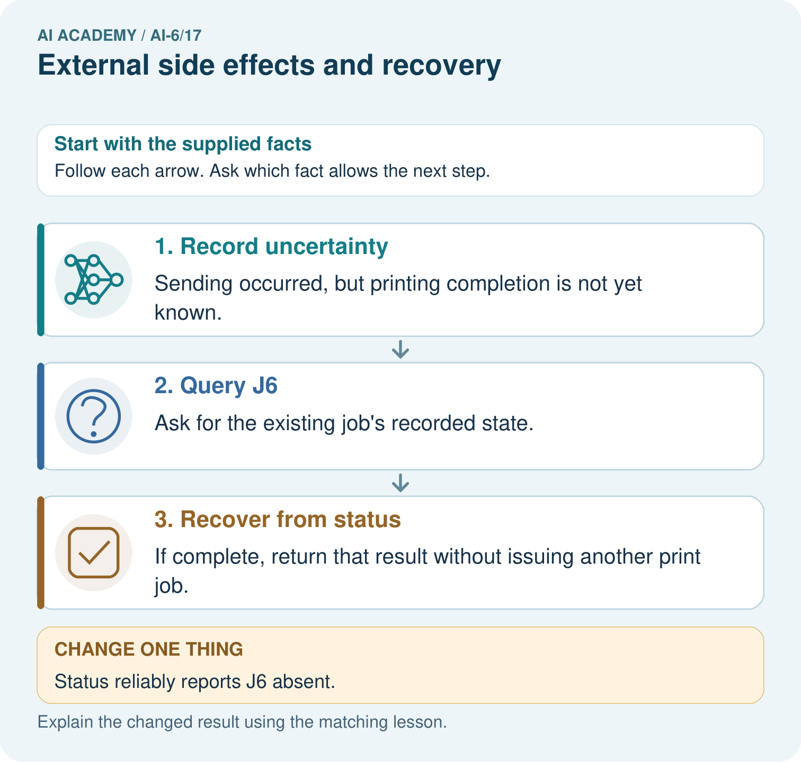
Distinguish a missing printer acknowledgement from confirmed failure. What should happen if J6 is complete, and what evidence changes when J6 is reliably reported absent?

My picture-based explanation and changed-case prediction
________________________________________________________________
________________________________________________________________
________________________________________________________________
________________________________________________________________
________________________________________________________________
________________________________________________________________
Support used: alone / hint / worked example. This record is practice evidence.
Project connection: For the Grounded Learning Service, retain an annotated trace and the changed-case result. Name the contract or evidence that makes the deciding step valid, so another team can review it.

