AI ACADEMY · WORKBOOK · ai-6/18

Untrusted input boundaries
Project: Grounded Learning Service

01. Recall and choose your starting point
Try the recall before opening notes. Then use a different colour or a labelled second line to correct your explanation.

External side effects and recovery
Without opening the old lesson, explain one key idea from External side effects and recovery. Give an example and a mistake that the idea helps you avoid.

My remembered idea, example and correction
________________________________________________________________
________________________________________________________________
________________________________________________________________

Approval gates and idempotency
Without opening the old lesson, explain one key idea from Approval gates and idempotency. Give an example and a mistake that the idea helps you avoid.

My remembered idea, example and correction
________________________________________________________________
________________________________________________________________
________________________________________________________________

Logs traces and privacy
Without opening the old lesson, explain one key idea from Logs traces and privacy. Give an example and a mistake that the idea helps you avoid.

My remembered idea, example and correction
________________________________________________________________
________________________________________________________________
________________________________________________________________

02. Practise with fading help
Use W2: Trace the worked case for Untrusted input boundaries. Record the answer once; the lesson and workbook refer to the same attempt.
Given inputs | Procedure I chose | Middle steps | Result and check

The step I completed without help, and the hint I needed
________________________________________________________________
________________________________________________________________
________________________________________________________________

03. Individual reasoning check
Use the worked case for Untrusted input boundaries. Proposed explanation: “The worked result establishes every future case”. Decide whether this explanation is supported. Point to the step or supplied fact that decides; explain your repair if needed.

My explanation before partner discussion
________________________________________________________________
________________________________________________________________
________________________________________________________________
________________________________________________________________

04. Independent transfer case

Independent case: Changed independent case
Input format is exactly one ASCII uppercase letter followed by one digit, with no trimming. Evaluate C0, c0, C00, "C0 ", and None. Does a valid format grant access?

My independent explanation, trace and limits
________________________________________________________________
________________________________________________________________
________________________________________________________________
________________________________________________________________
________________________________________________________________
________________________________________________________________
________________________________________________________________
Attempt this case before feedback. Record any help. Earlier examples below are further practice; a case already practised with feedback cannot establish fresh transfer.

05. W1 Explain the mechanism
Explain the weekly mechanism in your own words. Use the worked scenario to name its input, decision rule and output.

My reasoning and evidence
________________________________________________________________
________________________________________________________________
________________________________________________________________
________________________________________________________________
________________________________________________________________
________________________________________________________________

06. W2 Trace the worked case
Inputs A1 and delete_all() are supplied to room lookup. Show the intermediate steps and give the conclusion with its scope.

My reasoning and evidence
________________________________________________________________
________________________________________________________________
________________________________________________________________
________________________________________________________________
________________________________________________________________
________________________________________________________________
________________________________________________________________

07. W3 Audit the limit
A report omits this qualification: A format check does not grant resource access; authorisation follows separately. Explain how omitting it could change a reader's interpretation, and write an accurate replacement.

My reasoning and evidence
________________________________________________________________
________________________________________________________________
________________________________________________________________
________________________________________________________________
________________________________________________________________
________________________________________________________________

08. W4 Apply a new case independently
Classify B2, b2, B22 and B2; DROP under the exact format.

My reasoning and evidence
________________________________________________________________
________________________________________________________________
________________________________________________________________
________________________________________________________________
________________________________________________________________
________________________________________________________________
________________________________________________________________
________________________________________________________________

09. W5 Design a revealing follow-up
For the worked scenario, propose one additional case that could reveal a failure, describe its expected outcome before running it, and explain what would need to remain fixed for a fair comparison. Do not reuse W4 as a new final test after receiving feedback.

My reasoning and evidence
________________________________________________________________
________________________________________________________________
________________________________________________________________
________________________________________________________________
________________________________________________________________
________________________________________________________________
________________________________________________________________

10. Project checkpoint and reflection
Add a labelled untrusted input boundaries evidence sheet to Grounded Learning Service. Show how you can explain the mechanism and terminology of untrusted input boundaries. Use the supplied fictional case and keep its inputs, intermediate steps, calculation or prediction, and limitation. Connect this record to last week’s record; a matching answer without a trace is insufficient.

My project change, supporting evidence and remaining limit
________________________________________________________________
________________________________________________________________
________________________________________________________________
________________________________________________________________
________________________________________________________________
________________________________________________________________

11. Feedback, return check and learning record
Evidence | My record
Worked alone / hint / model
First step I repaired and why
New case checked later; date and result
What I can now explain without notes
One remaining question
Revisit this idea with your teacher after a delay. Familiarity is different from explaining and using it on a changed case.

12. Pictorial case practice: Untrusted input boundaries
Check shape before permission. A toy tool accepts exactly one ASCII lowercase letter followed by one digit, with no trimming.
Inputs h3, H3, h30 and "h3 ". Shape acceptance never grants access by itself.
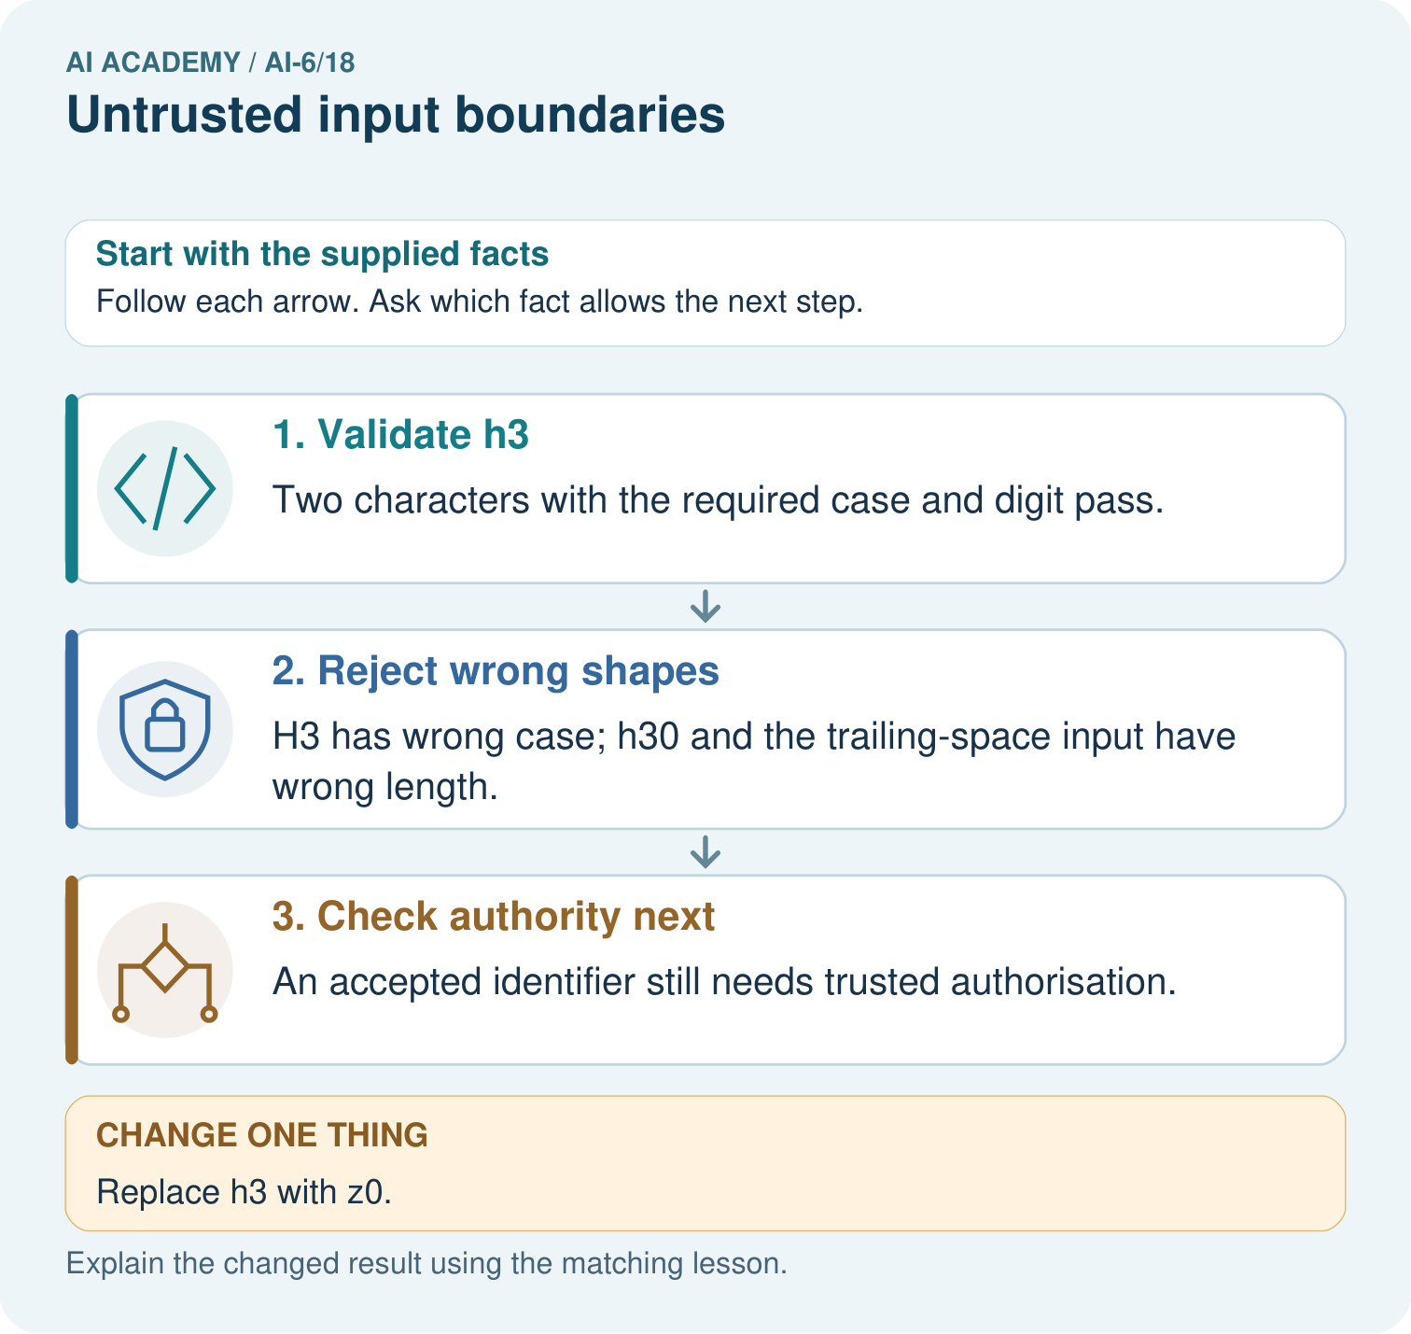
Classify h3, H3, h30 and the trailing-space input by the stated shape contract. Does a valid z0 grant record access, and which separate gate still remains?

My picture-based explanation and changed-case prediction
________________________________________________________________
________________________________________________________________
________________________________________________________________
________________________________________________________________
________________________________________________________________
________________________________________________________________
Support used: alone / hint / worked example. This record is practice evidence.
Project connection: For the Grounded Learning Service, retain an annotated trace and the changed-case result. Name the contract or evidence that makes the deciding step valid, so another team can review it.

