AI ACADEMY · WORKBOOK · ai-6/30

Security and privacy review
Project: Grounded Learning Service

01. Recall and choose your starting point
Try the recall before opening notes. Then use a different colour or a labelled second line to correct your explanation.

Performance and cost experiments
Without opening the old lesson, explain one key idea from Performance and cost experiments. Give an example and a mistake that the idea helps you avoid.

My remembered idea, example and correction
________________________________________________________________
________________________________________________________________
________________________________________________________________

Human escalation workflows
Without opening the old lesson, explain one key idea from Human escalation workflows. Give an example and a mistake that the idea helps you avoid.

My remembered idea, example and correction
________________________________________________________________
________________________________________________________________
________________________________________________________________

Release and rollback
Without opening the old lesson, explain one key idea from Release and rollback. Give an example and a mistake that the idea helps you avoid.

My remembered idea, example and correction
________________________________________________________________
________________________________________________________________
________________________________________________________________

02. Practise with fading help
Use W2: Trace the worked case for Security and privacy review. Record the answer once; the lesson and workbook refer to the same attempt.
Given inputs | Procedure I chose | Middle steps | Result and check

The step I completed without help, and the hint I needed
________________________________________________________________
________________________________________________________________
________________________________________________________________

03. Individual reasoning check
Use the worked case for Security and privacy review. Proposed explanation: “The worked result establishes every future case”. Decide whether this explanation is supported. Point to the step or supplied fact that decides; explain your repair if needed.

My explanation before partner discussion
________________________________________________________________
________________________________________________________________
________________________________________________________________
________________________________________________________________

04. Independent transfer case

Independent case: Apply a new case independently
Service blocks direct teacher lookup but diagnostic export includes full teacher answers. Identify defect and a test.

My independent explanation, trace and limits
________________________________________________________________
________________________________________________________________
________________________________________________________________
________________________________________________________________
________________________________________________________________
________________________________________________________________
________________________________________________________________
Attempt this case before feedback. Record any help. Earlier examples below are further practice; a case already practised with feedback cannot establish fresh transfer.

05. W1 Explain the mechanism
Explain the weekly mechanism in your own words. Use the worked scenario to name its input, decision rule and output.

My reasoning and evidence
________________________________________________________________
________________________________________________________________
________________________________________________________________
________________________________________________________________
________________________________________________________________
________________________________________________________________

06. W2 Trace the worked case
Output denies teacher guide, but cache contains it under a student-accessible key. Show the intermediate steps and give the conclusion with its scope.

My reasoning and evidence
________________________________________________________________
________________________________________________________________
________________________________________________________________
________________________________________________________________
________________________________________________________________
________________________________________________________________
________________________________________________________________

07. W3 Audit the limit
A report omits this qualification: Review findings are bounded by tested paths and threat assumptions, not a proof of complete security. Explain how omitting it could change a reader's interpretation, and write an accurate replacement.

My reasoning and evidence
________________________________________________________________
________________________________________________________________
________________________________________________________________
________________________________________________________________
________________________________________________________________
________________________________________________________________

08. W4 Apply a new case independently
Service blocks direct teacher lookup but diagnostic export includes full teacher answers. Identify defect and a test.

My reasoning and evidence
________________________________________________________________
________________________________________________________________
________________________________________________________________
________________________________________________________________
________________________________________________________________
________________________________________________________________
________________________________________________________________
________________________________________________________________

09. W5 Design a revealing follow-up
For the worked scenario, propose one additional case that could reveal a failure, describe its expected outcome before running it, and explain what would need to remain fixed for a fair comparison. Do not reuse W4 as a new final test after receiving feedback.

My reasoning and evidence
________________________________________________________________
________________________________________________________________
________________________________________________________________
________________________________________________________________
________________________________________________________________
________________________________________________________________
________________________________________________________________

10. Project checkpoint and reflection
Add a labelled security and privacy review evidence sheet to Grounded Learning Service. Show how you can explain the mechanism and terminology of security and privacy review. Use the supplied fictional case and keep its inputs, intermediate steps, calculation or prediction, and limitation. Connect this record to last week’s record; a matching answer without a trace is insufficient.

My project change, supporting evidence and remaining limit
________________________________________________________________
________________________________________________________________
________________________________________________________________
________________________________________________________________
________________________________________________________________
________________________________________________________________

11. Feedback, return check and learning record
Evidence | My record
Worked alone / hint / model
First step I repaired and why
New case checked later; date and result
What I can now explain without notes
One remaining question
Revisit this idea with your teacher after a delay. Familiarity is different from explaining and using it on a changed case.

12. Pictorial case practice: Security and privacy review
Review a private note’s path. A revision service reads a learner’s private practice note; analytics need counts only.
Only the learner and assigned teacher may read note text. The dashboard is authorised for aggregate counts, not notes.
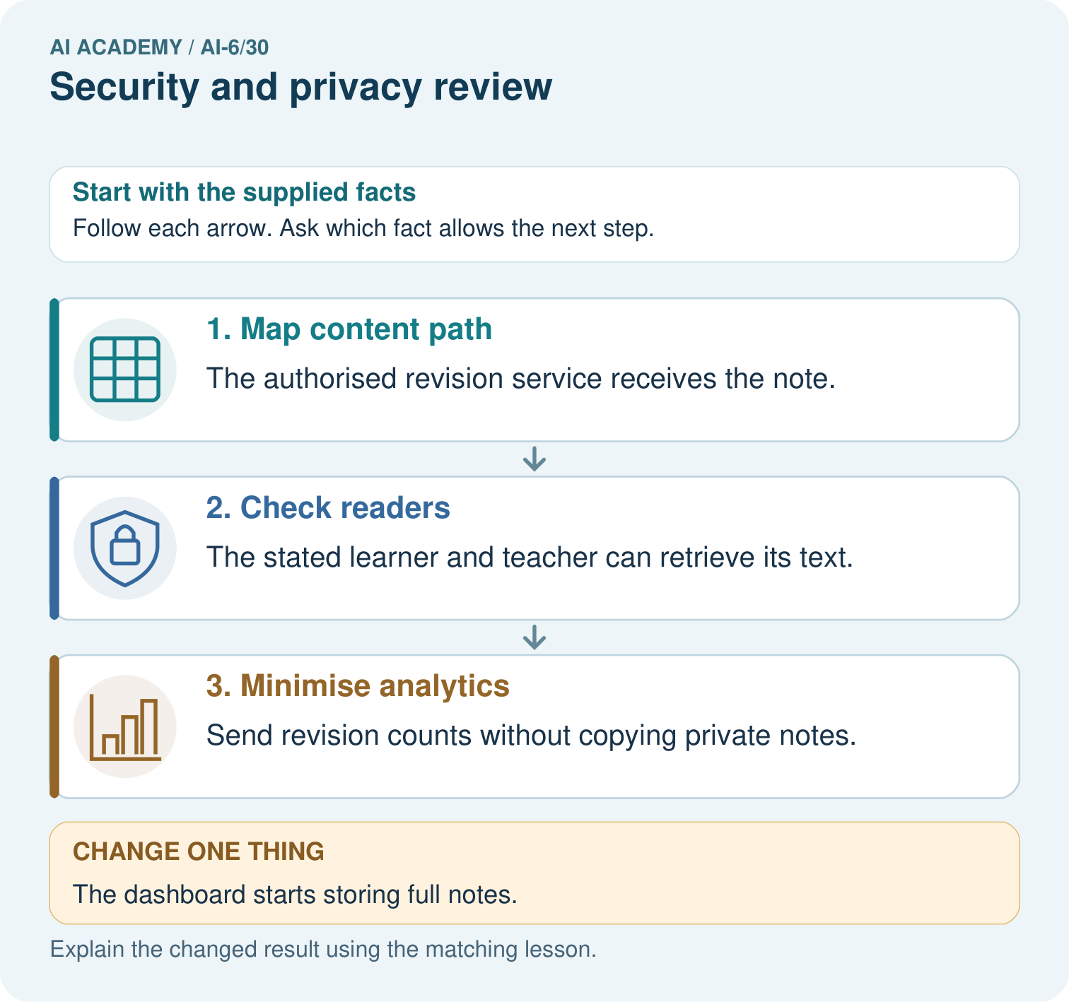
Trace private note content and analytics counts to their permitted readers. Why is storing full notes in the dashboard outside this design, and what risk can remain for tiny-group counts?

My picture-based explanation and changed-case prediction
________________________________________________________________
________________________________________________________________
________________________________________________________________
________________________________________________________________
________________________________________________________________
________________________________________________________________
Support used: alone / hint / worked example. This record is practice evidence.
Project connection: For the Grounded Learning Service, retain an annotated trace and the changed-case result. Name the contract or evidence that makes the deciding step valid, so another team can review it.

