AI ACADEMY · WORKBOOK · ai-6/36

Engineering demonstration and defense
Project: Grounded Learning Service

01. Recall and choose your starting point
Try the recall before opening notes. Then use a different colour or a labelled second line to correct your explanation.

Capstone release review
Without opening the old lesson, explain one key idea from Capstone release review. Give an example and a mistake that the idea helps you avoid.

My remembered idea, example and correction
________________________________________________________________
________________________________________________________________
________________________________________________________________

Capstone service implementation
Without opening the old lesson, explain one key idea from Capstone service implementation. Give an example and a mistake that the idea helps you avoid.

My remembered idea, example and correction
________________________________________________________________
________________________________________________________________
________________________________________________________________

Security and privacy review
Without opening the old lesson, explain one key idea from Security and privacy review. Give an example and a mistake that the idea helps you avoid.

My remembered idea, example and correction
________________________________________________________________
________________________________________________________________
________________________________________________________________

02. Practise with fading help
Use W2: Trace the worked case for Engineering demonstration and defense. Record the answer once; the lesson and workbook refer to the same attempt.
Given inputs | Procedure I chose | Middle steps | Result and check

The step I completed without help, and the hint I needed
________________________________________________________________
________________________________________________________________
________________________________________________________________

03. Individual reasoning check
Use the worked case for Engineering demonstration and defense. Proposed explanation: “The worked result establishes every future case”. Decide whether this explanation is supported. Point to the step or supplied fact that decides; explain your repair if needed.

My explanation before partner discussion
________________________________________________________________
________________________________________________________________
________________________________________________________________
________________________________________________________________

04. Independent transfer case

Independent case: Apply a new case independently
Defense records8/10 case passes, no unauthorised calls in those traces and successful local rollback. What can be claimed?

My independent explanation, trace and limits
________________________________________________________________
________________________________________________________________
________________________________________________________________
________________________________________________________________
________________________________________________________________
________________________________________________________________
________________________________________________________________
Attempt this case before feedback. Record any help. Earlier examples below are further practice; a case already practised with feedback cannot establish fresh transfer.

05. W1 Explain the mechanism
Explain the weekly mechanism in your own words. Use the worked scenario to name its input, decision rule and output.

My reasoning and evidence
________________________________________________________________
________________________________________________________________
________________________________________________________________
________________________________________________________________
________________________________________________________________
________________________________________________________________

06. W2 Trace the worked case
Demo succeeds on three cases using mocked storage. Presenter claims real network reliability and production security. Show the intermediate steps and give the conclusion with its scope.

My reasoning and evidence
________________________________________________________________
________________________________________________________________
________________________________________________________________
________________________________________________________________
________________________________________________________________
________________________________________________________________
________________________________________________________________

07. W3 Audit the limit
A report omits this qualification: A defense earns credibility through traceable scope and honest failures, not universal guarantees. Explain how omitting it could change a reader's interpretation, and write an accurate replacement.

My reasoning and evidence
________________________________________________________________
________________________________________________________________
________________________________________________________________
________________________________________________________________
________________________________________________________________
________________________________________________________________

08. W4 Apply a new case independently
Defense records8/10 case passes, no unauthorised calls in those traces and successful local rollback. What can be claimed?

My reasoning and evidence
________________________________________________________________
________________________________________________________________
________________________________________________________________
________________________________________________________________
________________________________________________________________
________________________________________________________________
________________________________________________________________
________________________________________________________________

09. W5 Design a revealing follow-up
For the worked scenario, propose one additional case that could reveal a failure, describe its expected outcome before running it, and explain what would need to remain fixed for a fair comparison. Do not reuse W4 as a new final test after receiving feedback.

My reasoning and evidence
________________________________________________________________
________________________________________________________________
________________________________________________________________
________________________________________________________________
________________________________________________________________
________________________________________________________________
________________________________________________________________

10. Project checkpoint and reflection
For Grounded Learning Service, use this week’s independent task as a rehearsal for the final evidence pack: Defense records8/10 case passes, no unauthorised calls in those traces and successful local rollback. What can be claimed? Keep actual observations separate from expected results, preserve failures, compare a baseline and explain the limits.

My project change, supporting evidence and remaining limit
________________________________________________________________
________________________________________________________________
________________________________________________________________
________________________________________________________________
________________________________________________________________
________________________________________________________________

11. Feedback, return check and learning record
Evidence | My record
Worked alone / hint / model
First step I repaired and why
New case checked later; date and result
What I can now explain without notes
One remaining question
Revisit this idea with your teacher after a delay. Familiarity is different from explaining and using it on a changed case.

12. Pictorial case practice: Engineering demonstration and defense
Defend one complete service trace. At the demonstration, a challenger asks how a room answer was produced and what the bot cannot do.
Approved card V7 says club V uses room E. All trusted tools are read-only.
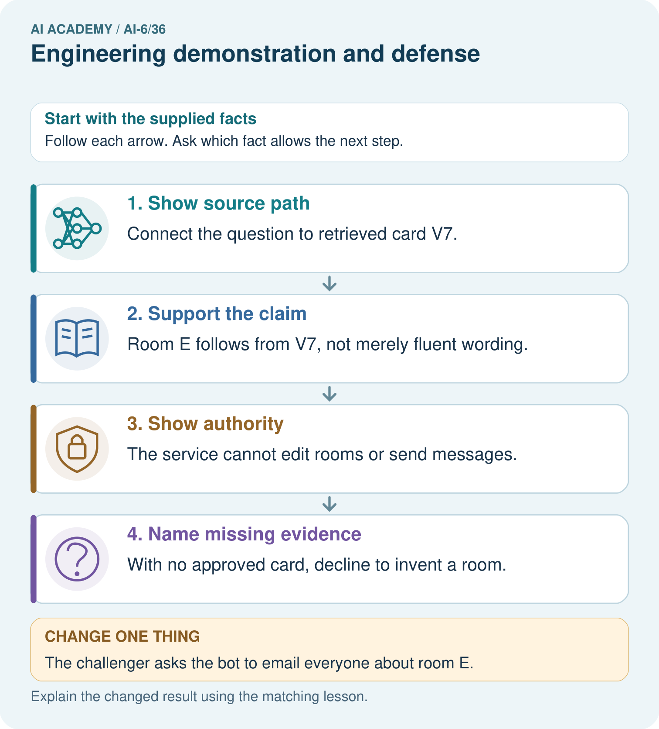
Locate V7, room E and read-only scope in the demonstration. Which evidence supports the answer, and why must a request to email everyone still be refused?

My picture-based explanation and changed-case prediction
________________________________________________________________
________________________________________________________________
________________________________________________________________
________________________________________________________________
________________________________________________________________
________________________________________________________________
Support used: alone / hint / worked example. This record is practice evidence.
Project connection: For the Grounded Learning Service, retain an annotated trace and the changed-case result. Name the contract or evidence that makes the deciding step valid, so another team can review it.

