AI ACADEMY · WORKBOOK · ai-7/2

Reading a research claim
Project: Reproducible AI Research Study

01. Recall and choose your starting point
Try the recall before opening notes. Then use a different colour or a labelled second line to correct your explanation.

A question that evidence can answer
Without opening the old lesson, explain one key idea from A question that evidence can answer. Give an example and a mistake that the idea helps you avoid.

My remembered idea, example and correction
________________________________________________________________
________________________________________________________________
________________________________________________________________

02. Practise with fading help
Use W2: Trace the worked case for Reading a research claim. Record the answer once; the lesson and workbook refer to the same attempt.
Given inputs | Procedure I chose | Middle steps | Result and check

The step I completed without help, and the hint I needed
________________________________________________________________
________________________________________________________________
________________________________________________________________

03. Individual reasoning check
Use the worked case for Reading a research claim. Proposed explanation: “The worked result establishes every future case”. Decide whether this explanation is supported. Point to the step or supplied fact that decides; explain your repair if needed.

My explanation before partner discussion
________________________________________________________________
________________________________________________________________
________________________________________________________________
________________________________________________________________

04. Independent transfer case

Independent case: Apply a new case independently
Report claims universal speed after median2 seconds versus3 on four local fixtures. Audit scope.

My independent explanation, trace and limits
________________________________________________________________
________________________________________________________________
________________________________________________________________
________________________________________________________________
________________________________________________________________
________________________________________________________________
________________________________________________________________
Attempt this case before feedback. Record any help. Earlier examples below are further practice; a case already practised with feedback cannot establish fresh transfer.

05. W1 Explain the mechanism
Explain the weekly mechanism in your own words. Use the worked scenario to name its input, decision rule and output.

My reasoning and evidence
________________________________________________________________
________________________________________________________________
________________________________________________________________
________________________________________________________________
________________________________________________________________
________________________________________________________________

06. W2 Trace the worked case
A fictional report says method B is better after6/8 supported answers versus baseline5/8 on the same constructed cases. Show the intermediate steps and give the conclusion with its scope.

My reasoning and evidence
________________________________________________________________
________________________________________________________________
________________________________________________________________
________________________________________________________________
________________________________________________________________
________________________________________________________________
________________________________________________________________

07. W3 Audit the limit
A report omits this qualification: A numerical improvement can be real in the sample while the broader claim remains unsupported. Explain how omitting it could change a reader's interpretation, and write an accurate replacement.

My reasoning and evidence
________________________________________________________________
________________________________________________________________
________________________________________________________________
________________________________________________________________
________________________________________________________________
________________________________________________________________

08. W4 Apply a new case independently
Report claims universal speed after median2 seconds versus3 on four local fixtures. Audit scope.

My reasoning and evidence
________________________________________________________________
________________________________________________________________
________________________________________________________________
________________________________________________________________
________________________________________________________________
________________________________________________________________
________________________________________________________________
________________________________________________________________

09. W5 Design a revealing follow-up
For the worked scenario, propose one additional case that could reveal a failure, describe its expected outcome before running it, and explain what would need to remain fixed for a fair comparison. Do not reuse W4 as a new final test after receiving feedback.

My reasoning and evidence
________________________________________________________________
________________________________________________________________
________________________________________________________________
________________________________________________________________
________________________________________________________________
________________________________________________________________
________________________________________________________________

10. Project checkpoint and reflection
Add a labelled reading a research claim evidence sheet to Reproducible AI Research Study. Show how you can explain the mechanism and terminology of reading a research claim. Use the supplied fictional case and keep its inputs, intermediate steps, calculation or prediction, and limitation. Connect this record to last week’s record; a matching answer without a trace is insufficient.

My project change, supporting evidence and remaining limit
________________________________________________________________
________________________________________________________________
________________________________________________________________
________________________________________________________________
________________________________________________________________
________________________________________________________________

11. Feedback, return check and learning record
Evidence | My record
Worked alone / hint / model
First step I repaired and why
New case checked later; date and result
What I can now explain without notes
One remaining question
Revisit this idea with your teacher after a delay. Familiarity is different from explaining and using it on a changed case.

12. Pictorial case practice: Reading a research claim
Read a claim with its denominator. A fictional paper headline says a prompt is twice as effective. Its table reports four correct cases instead of two.
Baseline: 2/10 correct. New prompt: 4/10 on the same ten cases. Scoring is fixed.
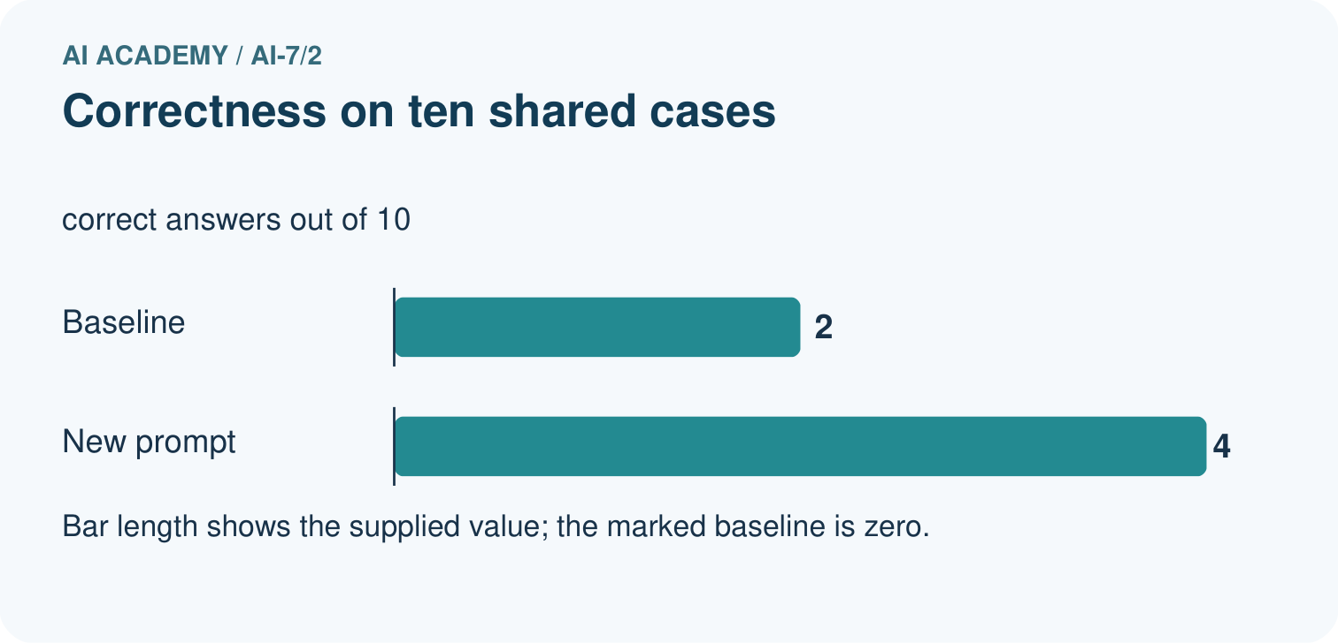
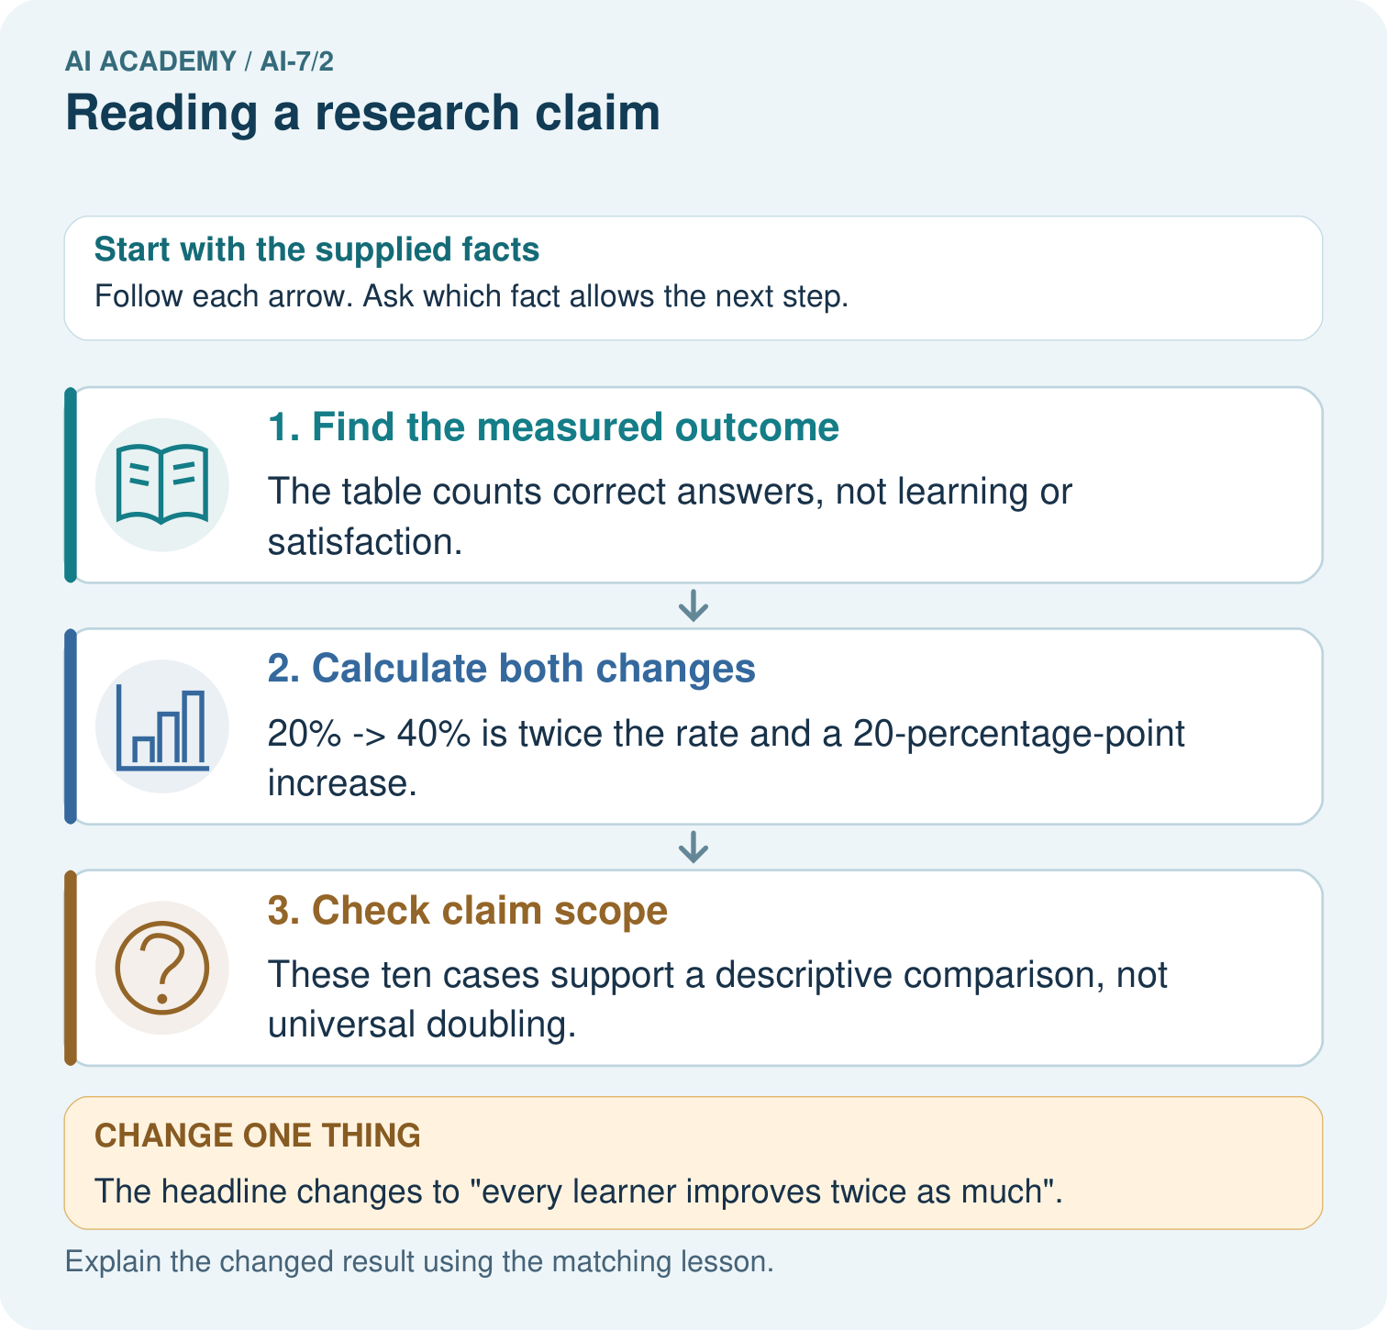
Calculate the baseline and new rates for 2/10 and 4/10. Explain both twice the rate and the percentage-point change, and say why neither measures every learner’s improvement.

My picture-based explanation and changed-case prediction
________________________________________________________________
________________________________________________________________
________________________________________________________________
________________________________________________________________
________________________________________________________________
________________________________________________________________
Support used: alone / hint / worked example. This record is practice evidence.
Project connection: For the Reproducible AI Research Study, retain an annotated worked trace and the changed-case reasoning. Connect the claim to its records, units and assumptions so another investigator can challenge or reproduce it.

