AI ACADEMY · WORKBOOK · ai-7/7

Hypotheses and measurable outcomes
Project: Reproducible AI Research Study

01. Recall and choose your starting point
Try the recall before opening notes. Then use a different colour or a labelled second line to correct your explanation.

A literature comparison matrix
Without opening the old lesson, explain one key idea from A literature comparison matrix. Give an example and a mistake that the idea helps you avoid.

My remembered idea, example and correction
________________________________________________________________
________________________________________________________________
________________________________________________________________

Methods results and limitations
Without opening the old lesson, explain one key idea from Methods results and limitations. Give an example and a mistake that the idea helps you avoid.

My remembered idea, example and correction
________________________________________________________________
________________________________________________________________
________________________________________________________________

A question that evidence can answer
Without opening the old lesson, explain one key idea from A question that evidence can answer. Give an example and a mistake that the idea helps you avoid.

My remembered idea, example and correction
________________________________________________________________
________________________________________________________________
________________________________________________________________

02. Practise with fading help
Use W2: Trace the worked case for Hypotheses and measurable outcomes. Record the answer once; the lesson and workbook refer to the same attempt.
Given inputs | Procedure I chose | Middle steps | Result and check

The step I completed without help, and the hint I needed
________________________________________________________________
________________________________________________________________
________________________________________________________________

03. Individual reasoning check
Use the worked case for Hypotheses and measurable outcomes. Proposed explanation: “The worked result establishes every future case”. Decide whether this explanation is supported. Point to the step or supplied fact that decides; explain your repair if needed.

My explanation before partner discussion
________________________________________________________________
________________________________________________________________
________________________________________________________________
________________________________________________________________

04. Independent transfer case

Independent case: Apply a new case independently
Before running12 cases, you expect B support to exceed A. Write primary metric and one falsifying result.

My independent explanation, trace and limits
________________________________________________________________
________________________________________________________________
________________________________________________________________
________________________________________________________________
________________________________________________________________
________________________________________________________________
________________________________________________________________
Attempt this case before feedback. Record any help. Earlier examples below are further practice; a case already practised with feedback cannot establish fresh transfer.

05. W1 Explain the mechanism
Explain the weekly mechanism in your own words. Use the worked scenario to name its input, decision rule and output.

My reasoning and evidence
________________________________________________________________
________________________________________________________________
________________________________________________________________
________________________________________________________________
________________________________________________________________
________________________________________________________________

06. W2 Trace the worked case
After seeing faster responses, the team changes its primary claim from support improvement to speed improvement. Show the intermediate steps and give the conclusion with its scope.

My reasoning and evidence
________________________________________________________________
________________________________________________________________
________________________________________________________________
________________________________________________________________
________________________________________________________________
________________________________________________________________
________________________________________________________________

07. W3 Audit the limit
A report omits this qualification: A hypothesis can fail honestly; changing it after results does not erase the original test. Explain how omitting it could change a reader's interpretation, and write an accurate replacement.

My reasoning and evidence
________________________________________________________________
________________________________________________________________
________________________________________________________________
________________________________________________________________
________________________________________________________________
________________________________________________________________

08. W4 Apply a new case independently
Before running12 cases, you expect B support to exceed A. Write primary metric and one falsifying result.

My reasoning and evidence
________________________________________________________________
________________________________________________________________
________________________________________________________________
________________________________________________________________
________________________________________________________________
________________________________________________________________
________________________________________________________________
________________________________________________________________

09. W5 Design a revealing follow-up
For the worked scenario, propose one additional case that could reveal a failure, describe its expected outcome before running it, and explain what would need to remain fixed for a fair comparison. Do not reuse W4 as a new final test after receiving feedback.

My reasoning and evidence
________________________________________________________________
________________________________________________________________
________________________________________________________________
________________________________________________________________
________________________________________________________________
________________________________________________________________
________________________________________________________________

10. Project checkpoint and reflection
Add a labelled hypotheses and measurable outcomes evidence sheet to Reproducible AI Research Study. Show how you can explain the mechanism and terminology of hypotheses and measurable outcomes. Use the supplied fictional case and keep its inputs, intermediate steps, calculation or prediction, and limitation. Connect this record to last week’s record; a matching answer without a trace is insufficient.

My project change, supporting evidence and remaining limit
________________________________________________________________
________________________________________________________________
________________________________________________________________
________________________________________________________________
________________________________________________________________
________________________________________________________________

11. Feedback, return check and learning record
Evidence | My record
Worked alone / hint / model
First step I repaired and why
New case checked later; date and result
What I can now explain without notes
One remaining question
Revisit this idea with your teacher after a delay. Familiarity is different from explaining and using it on a changed case.

12. Pictorial case practice: Hypotheses and measurable outcomes
Write a testable hypothesis before scoring. A team predicts that a retrieval rule will reduce unsupported answers on a fixed validation set.
Ten cases are reserved. Unsupported means a factual claim absent from the approved card. Prediction: B has fewer unsupported cases than A.
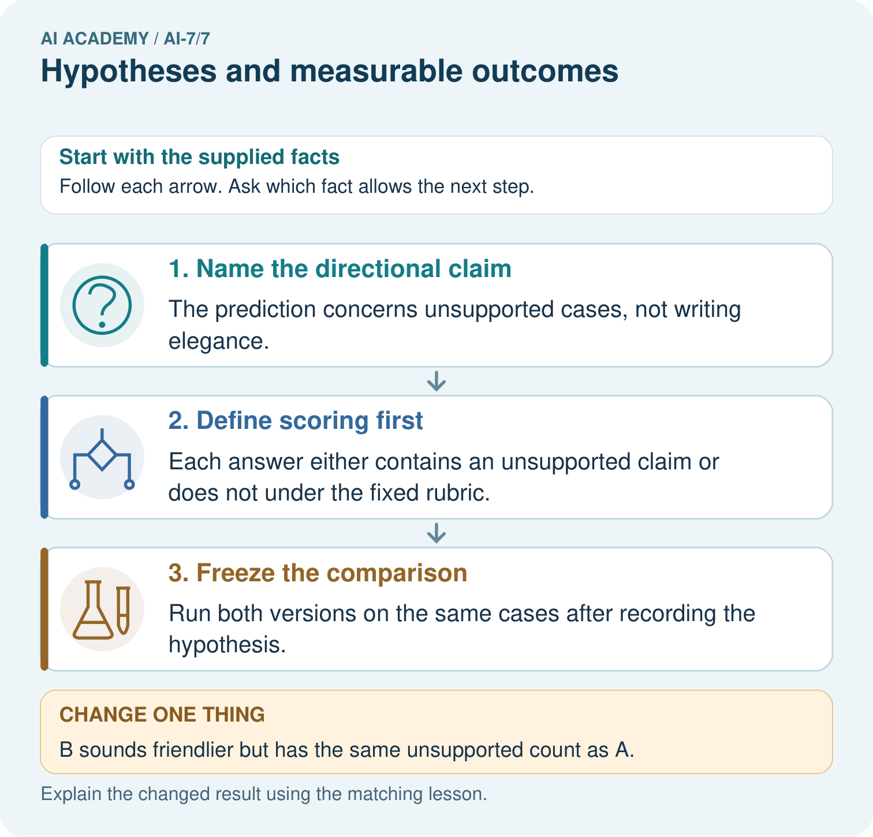
Name the predicted outcome and how unsupported is scored. If B sounds friendlier but ties A’s unsupported count, does the recorded improvement hypothesis receive support?

My picture-based explanation and changed-case prediction
________________________________________________________________
________________________________________________________________
________________________________________________________________
________________________________________________________________
________________________________________________________________
________________________________________________________________
Support used: alone / hint / worked example. This record is practice evidence.
Project connection: For the Reproducible AI Research Study, retain an annotated worked trace and the changed-case reasoning. Connect the claim to its records, units and assumptions so another investigator can challenge or reproduce it.

