AI ACADEMY · WORKBOOK · ai-7/18

Dataset and benchmark limitations
Project: Reproducible AI Research Study

01. Recall and choose your starting point
Try the recall before opening notes. Then use a different colour or a labelled second line to correct your explanation.

Sensitivity analysis
Without opening the old lesson, explain one key idea from Sensitivity analysis. Give an example and a mistake that the idea helps you avoid.

My remembered idea, example and correction
________________________________________________________________
________________________________________________________________
________________________________________________________________

Multiple comparisons
Without opening the old lesson, explain one key idea from Multiple comparisons. Give an example and a mistake that the idea helps you avoid.

My remembered idea, example and correction
________________________________________________________________
________________________________________________________________
________________________________________________________________

Uncertainty intervals
Without opening the old lesson, explain one key idea from Uncertainty intervals. Give an example and a mistake that the idea helps you avoid.

My remembered idea, example and correction
________________________________________________________________
________________________________________________________________
________________________________________________________________

02. Practise with fading help
Use W2: Trace the worked case for Dataset and benchmark limitations. Record the answer once; the lesson and workbook refer to the same attempt.
Given inputs | Procedure I chose | Middle steps | Result and check

The step I completed without help, and the hint I needed
________________________________________________________________
________________________________________________________________
________________________________________________________________

03. Individual reasoning check
Use the worked case for Dataset and benchmark limitations. Proposed explanation: “The worked result establishes every future case”. Decide whether this explanation is supported. Point to the step or supplied fact that decides; explain your repair if needed.

My explanation before partner discussion
________________________________________________________________
________________________________________________________________
________________________________________________________________
________________________________________________________________

04. Independent transfer case

Independent case: Apply a new case independently
Twelve rows include four copies of one source and eight others. Count unique units and name one coverage concern.

My independent explanation, trace and limits
________________________________________________________________
________________________________________________________________
________________________________________________________________
________________________________________________________________
________________________________________________________________
________________________________________________________________
________________________________________________________________
Attempt this case before feedback. Record any help. Earlier examples below are further practice; a case already practised with feedback cannot establish fresh transfer.

05. W1 Explain the mechanism
Explain the weekly mechanism in your own words. Use the worked scenario to name its input, decision rule and output.

My reasoning and evidence
________________________________________________________________
________________________________________________________________
________________________________________________________________
________________________________________________________________
________________________________________________________________
________________________________________________________________

06. W2 Trace the worked case
Ten benchmark rows include three copies of one source and seven other unique sources. Show the intermediate steps and give the conclusion with its scope.

My reasoning and evidence
________________________________________________________________
________________________________________________________________
________________________________________________________________
________________________________________________________________
________________________________________________________________
________________________________________________________________
________________________________________________________________

07. W3 Audit the limit
A report omits this qualification: Benchmark success does not establish performance on a deployment population missing from its design. Explain how omitting it could change a reader's interpretation, and write an accurate replacement.

My reasoning and evidence
________________________________________________________________
________________________________________________________________
________________________________________________________________
________________________________________________________________
________________________________________________________________
________________________________________________________________

08. W4 Apply a new case independently
Twelve rows include four copies of one source and eight others. Count unique units and name one coverage concern.

My reasoning and evidence
________________________________________________________________
________________________________________________________________
________________________________________________________________
________________________________________________________________
________________________________________________________________
________________________________________________________________
________________________________________________________________
________________________________________________________________

09. W5 Design a revealing follow-up
For the worked scenario, propose one additional case that could reveal a failure, describe its expected outcome before running it, and explain what would need to remain fixed for a fair comparison. Do not reuse W4 as a new final test after receiving feedback.

My reasoning and evidence
________________________________________________________________
________________________________________________________________
________________________________________________________________
________________________________________________________________
________________________________________________________________
________________________________________________________________
________________________________________________________________

10. Project checkpoint and reflection
Add a labelled dataset and benchmark limitations evidence sheet to Reproducible AI Research Study. Show how you can explain the mechanism and terminology of dataset and benchmark limitations. Use the supplied fictional case and keep its inputs, intermediate steps, calculation or prediction, and limitation. Connect this record to last week’s record; a matching answer without a trace is insufficient.

My project change, supporting evidence and remaining limit
________________________________________________________________
________________________________________________________________
________________________________________________________________
________________________________________________________________
________________________________________________________________
________________________________________________________________

11. Feedback, return check and learning record
Evidence | My record
Worked alone / hint / model
First step I repaired and why
New case checked later; date and result
What I can now explain without notes
One remaining question
Revisit this idea with your teacher after a delay. Familiarity is different from explaining and using it on a changed case.

12. Pictorial case practice: Dataset and benchmark limitations
A benchmark can miss the intended setting. A plant model is evaluated on clean indoor photos but proposed for shaded outdoor photos.
Indoor benchmark: 9/10 correct. No outdoor cases are present. The same model is intended for both.
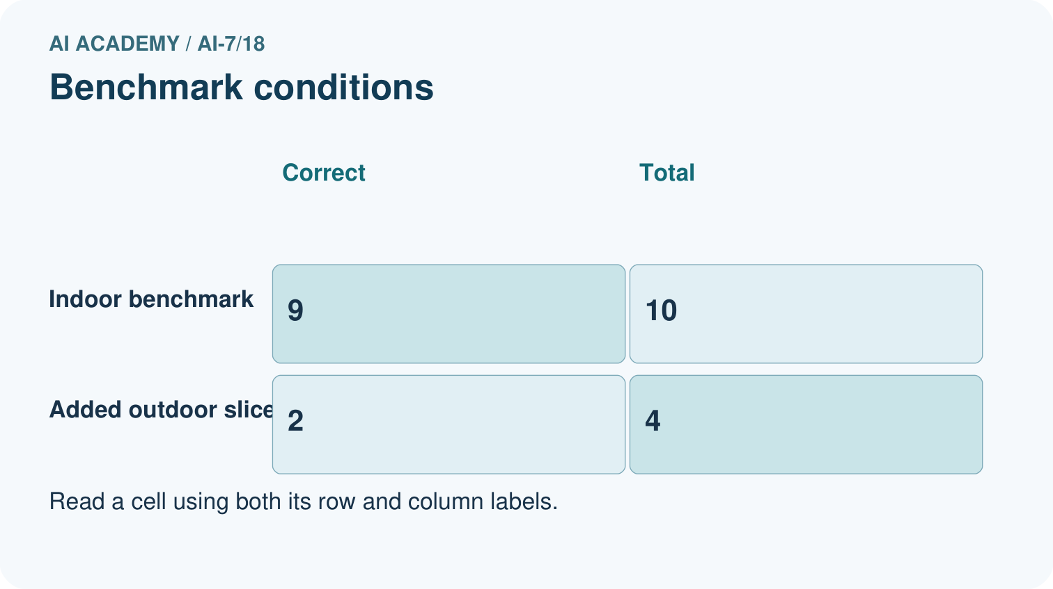
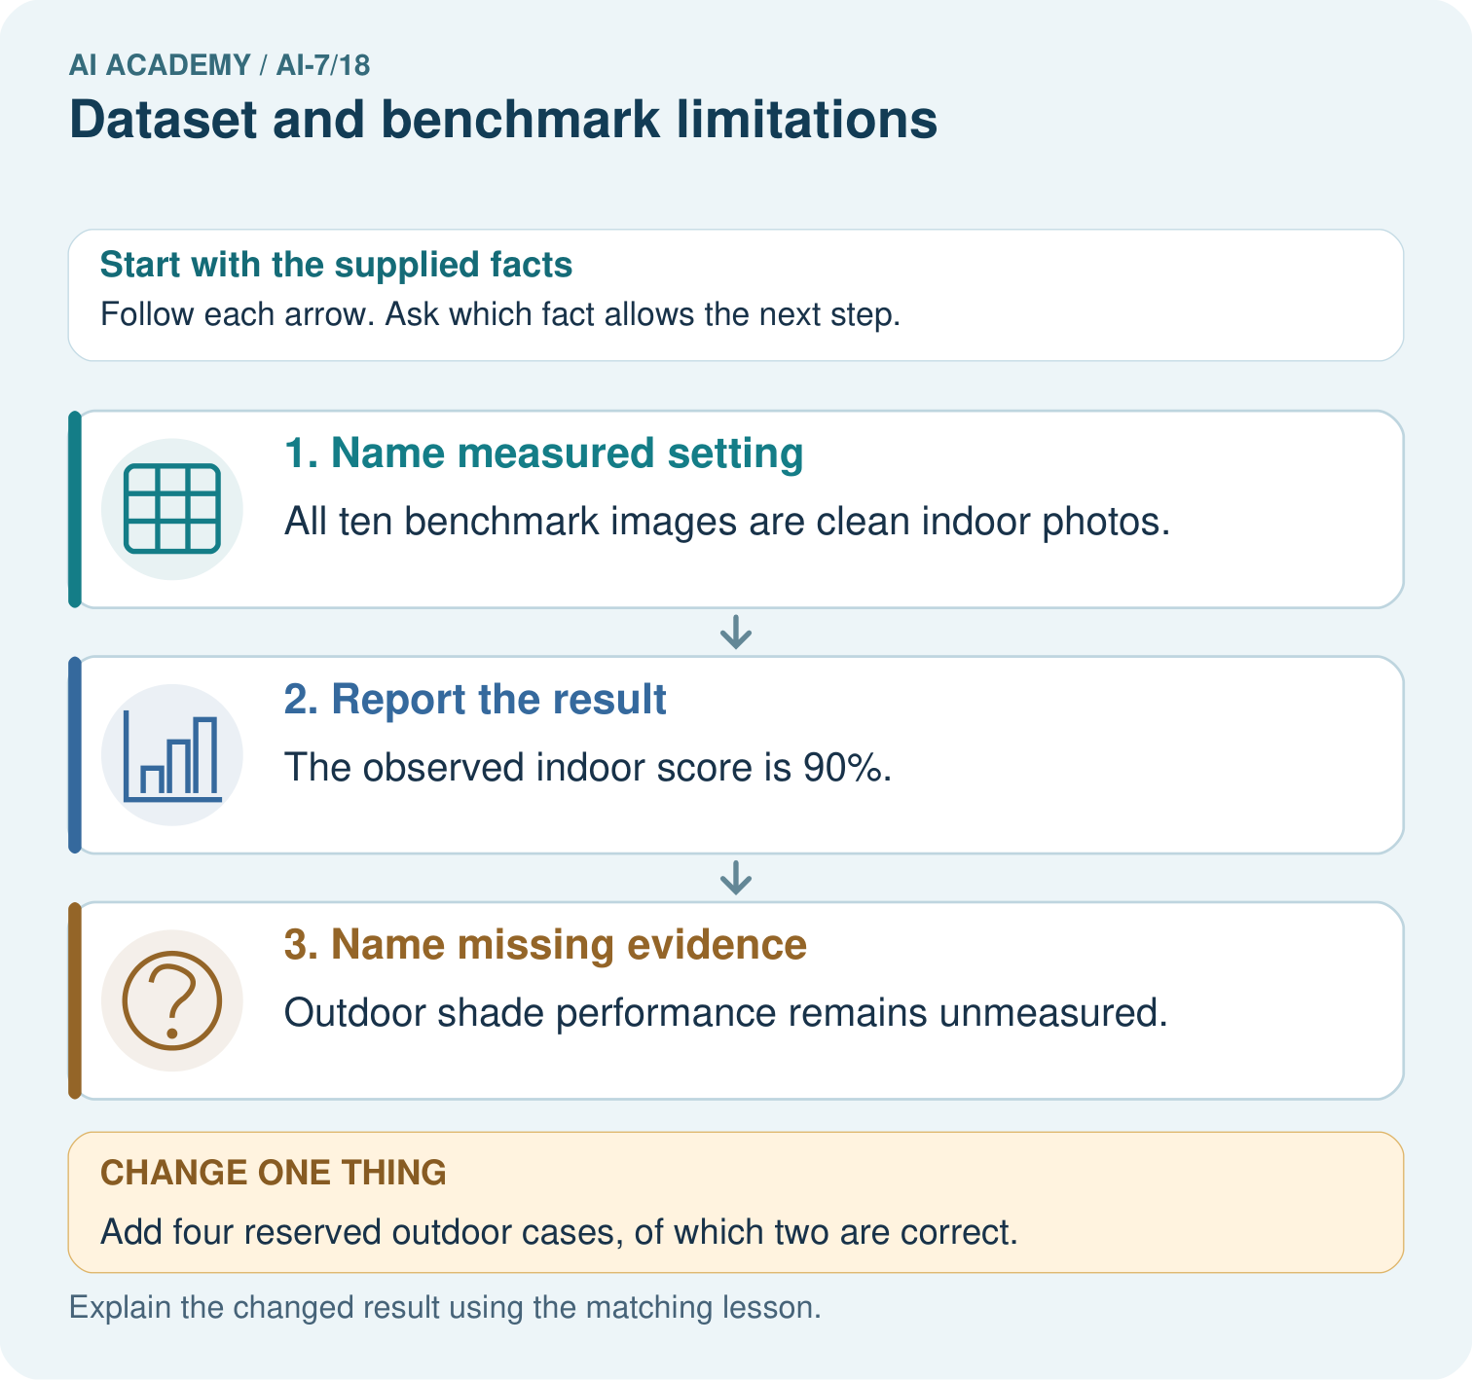
Report the indoor benchmark with its denominator and missing condition. After two correct outdoor cases out of four are added, what slice rate is supported and what remains uncertain?

My picture-based explanation and changed-case prediction
________________________________________________________________
________________________________________________________________
________________________________________________________________
________________________________________________________________
________________________________________________________________
________________________________________________________________
Support used: alone / hint / worked example. This record is practice evidence.
Project connection: For the Reproducible AI Research Study, retain an annotated worked trace and the changed-case reasoning. Connect the claim to its records, units and assumptions so another investigator can challenge or reproduce it.

