AI ACADEMY · WORKBOOK · ai-7/19

Research ethics and consent
Project: Reproducible AI Research Study

01. Recall and choose your starting point
Try the recall before opening notes. Then use a different colour or a labelled second line to correct your explanation.

Dataset and benchmark limitations
Without opening the old lesson, explain one key idea from Dataset and benchmark limitations. Give an example and a mistake that the idea helps you avoid.

My remembered idea, example and correction
________________________________________________________________
________________________________________________________________
________________________________________________________________

Ablation studies
Without opening the old lesson, explain one key idea from Ablation studies. Give an example and a mistake that the idea helps you avoid.

My remembered idea, example and correction
________________________________________________________________
________________________________________________________________
________________________________________________________________

Effect size and practical importance
Without opening the old lesson, explain one key idea from Effect size and practical importance. Give an example and a mistake that the idea helps you avoid.

My remembered idea, example and correction
________________________________________________________________
________________________________________________________________
________________________________________________________________

02. Practise with fading help
Use W2: Trace the worked case for Research ethics and consent. Record the answer once; the lesson and workbook refer to the same attempt.
Given inputs | Procedure I chose | Middle steps | Result and check

The step I completed without help, and the hint I needed
________________________________________________________________
________________________________________________________________
________________________________________________________________

03. Individual reasoning check
Use the worked case for Research ethics and consent. Proposed explanation: “The worked result establishes every future case”. Decide whether this explanation is supported. Point to the step or supplied fact that decides; explain your repair if needed.

My explanation before partner discussion
________________________________________________________________
________________________________________________________________
________________________________________________________________
________________________________________________________________

04. Independent transfer case

Independent case: Apply a new case independently
A fictional policy requires opt-in; proposal treats silence as agreement and grades participation. Audit.

My independent explanation, trace and limits
________________________________________________________________
________________________________________________________________
________________________________________________________________
________________________________________________________________
________________________________________________________________
________________________________________________________________
________________________________________________________________
Attempt this case before feedback. Record any help. Earlier examples below are further practice; a case already practised with feedback cannot establish fresh transfer.

05. W1 Explain the mechanism
Explain the weekly mechanism in your own words. Use the worked scenario to name its input, decision rule and output.

My reasoning and evidence
________________________________________________________________
________________________________________________________________
________________________________________________________________
________________________________________________________________
________________________________________________________________
________________________________________________________________

06. W2 Trace the worked case
Proposal automatically copies student essays into a study because they were submitted for grading. Show the intermediate steps and give the conclusion with its scope.

My reasoning and evidence
________________________________________________________________
________________________________________________________________
________________________________________________________________
________________________________________________________________
________________________________________________________________
________________________________________________________________
________________________________________________________________

07. W3 Audit the limit
A report omits this qualification: This classroom policy exercise does not determine real legal or institutional requirements. Explain how omitting it could change a reader's interpretation, and write an accurate replacement.

My reasoning and evidence
________________________________________________________________
________________________________________________________________
________________________________________________________________
________________________________________________________________
________________________________________________________________
________________________________________________________________

08. W4 Apply a new case independently
A fictional policy requires opt-in; proposal treats silence as agreement and grades participation. Audit.

My reasoning and evidence
________________________________________________________________
________________________________________________________________
________________________________________________________________
________________________________________________________________
________________________________________________________________
________________________________________________________________
________________________________________________________________
________________________________________________________________

09. W5 Design a revealing follow-up
For the worked scenario, propose one additional case that could reveal a failure, describe its expected outcome before running it, and explain what would need to remain fixed for a fair comparison. Do not reuse W4 as a new final test after receiving feedback.

My reasoning and evidence
________________________________________________________________
________________________________________________________________
________________________________________________________________
________________________________________________________________
________________________________________________________________
________________________________________________________________
________________________________________________________________

10. Project checkpoint and reflection
Add a labelled research ethics and consent evidence sheet to Reproducible AI Research Study. Show how you can explain the mechanism and terminology of research ethics and consent. Use the supplied fictional case and keep its inputs, intermediate steps, calculation or prediction, and limitation. Connect this record to last week’s record; a matching answer without a trace is insufficient.

My project change, supporting evidence and remaining limit
________________________________________________________________
________________________________________________________________
________________________________________________________________
________________________________________________________________
________________________________________________________________
________________________________________________________________

11. Feedback, return check and learning record
Evidence | My record
Worked alone / hint / model
First step I repaired and why
New case checked later; date and result
What I can now explain without notes
One remaining question
Revisit this idea with your teacher after a delay. Familiarity is different from explaining and using it on a changed case.

12. Pictorial case practice: Research ethics and consent
Consent is specific, not universal. A fictional study asks adults to submit anonymous drawings for one pattern-recognition investigation.
Consent covers this study only. It excludes public posting of originals and unrelated face-recognition research.
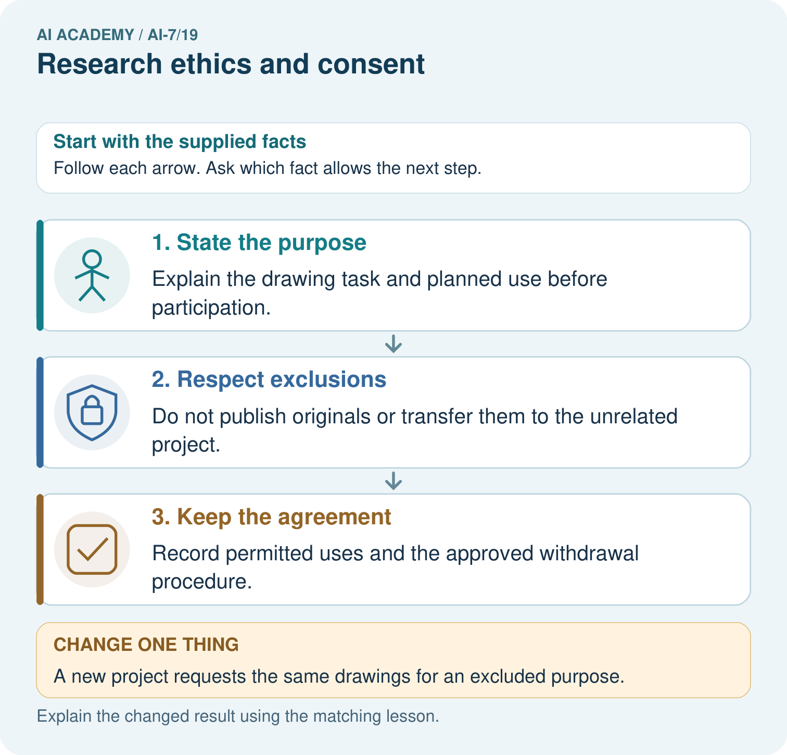
Identify which uses the drawing consent permits and excludes. Can the unrelated project reuse the drawings under this agreement, and what new authorisation would be needed?

My picture-based explanation and changed-case prediction
________________________________________________________________
________________________________________________________________
________________________________________________________________
________________________________________________________________
________________________________________________________________
________________________________________________________________
Support used: alone / hint / worked example. This record is practice evidence.
Project connection: For the Reproducible AI Research Study, retain an annotated worked trace and the changed-case reasoning. Connect the claim to its records, units and assumptions so another investigator can challenge or reproduce it.

