AI ACADEMY · WORKBOOK · ai-7/26

Inspecting failures and anomalies
Project: Reproducible AI Research Study

01. Recall and choose your starting point
Try the recall before opening notes. Then use a different colour or a labelled second line to correct your explanation.

Running the primary experiment
Without opening the old lesson, explain one key idea from Running the primary experiment. Give an example and a mistake that the idea helps you avoid.

My remembered idea, example and correction
________________________________________________________________
________________________________________________________________
________________________________________________________________

Power and resource tradeoffs
Without opening the old lesson, explain one key idea from Power and resource tradeoffs. Give an example and a mistake that the idea helps you avoid.

My remembered idea, example and correction
________________________________________________________________
________________________________________________________________
________________________________________________________________

Privacy and data governance
Without opening the old lesson, explain one key idea from Privacy and data governance. Give an example and a mistake that the idea helps you avoid.

My remembered idea, example and correction
________________________________________________________________
________________________________________________________________
________________________________________________________________

02. Practise with fading help
Use W2: Trace the worked case for Inspecting failures and anomalies. Record the answer once; the lesson and workbook refer to the same attempt.
Given inputs | Procedure I chose | Middle steps | Result and check

The step I completed without help, and the hint I needed
________________________________________________________________
________________________________________________________________
________________________________________________________________

03. Individual reasoning check
Use the worked case for Inspecting failures and anomalies. Proposed explanation: “The worked result establishes every future case”. Decide whether this explanation is supported. Point to the step or supplied fact that decides; explain your repair if needed.

My explanation before partner discussion
________________________________________________________________
________________________________________________________________
________________________________________________________________
________________________________________________________________

04. Independent transfer case

Independent case: Apply a new case independently
Values2, 3, 4, 20 are valid. Compute mean and median and propose an honest investigation.

My independent explanation, trace and limits
________________________________________________________________
________________________________________________________________
________________________________________________________________
________________________________________________________________
________________________________________________________________
________________________________________________________________
________________________________________________________________
Attempt this case before feedback. Record any help. Earlier examples below are further practice; a case already practised with feedback cannot establish fresh transfer.

05. W1 Explain the mechanism
Explain the weekly mechanism in your own words. Use the worked scenario to name its input, decision rule and output.

My reasoning and evidence
________________________________________________________________
________________________________________________________________
________________________________________________________________
________________________________________________________________
________________________________________________________________
________________________________________________________________

06. W2 Trace the worked case
Durations1, 2, 2, 15 seconds are all valid traces. Team deletes15 as an outlier without a rule. Show the intermediate steps and give the conclusion with its scope.

My reasoning and evidence
________________________________________________________________
________________________________________________________________
________________________________________________________________
________________________________________________________________
________________________________________________________________
________________________________________________________________
________________________________________________________________

07. W3 Audit the limit
A report omits this qualification: Post-hoc exclusion based on an unwanted outcome can distort the conclusion. Explain how omitting it could change a reader's interpretation, and write an accurate replacement.

My reasoning and evidence
________________________________________________________________
________________________________________________________________
________________________________________________________________
________________________________________________________________
________________________________________________________________
________________________________________________________________

08. W4 Apply a new case independently
Values2, 3, 4, 20 are valid. Compute mean and median and propose an honest investigation.

My reasoning and evidence
________________________________________________________________
________________________________________________________________
________________________________________________________________
________________________________________________________________
________________________________________________________________
________________________________________________________________
________________________________________________________________
________________________________________________________________

09. W5 Design a revealing follow-up
For the worked scenario, propose one additional case that could reveal a failure, describe its expected outcome before running it, and explain what would need to remain fixed for a fair comparison. Do not reuse W4 as a new final test after receiving feedback.

My reasoning and evidence
________________________________________________________________
________________________________________________________________
________________________________________________________________
________________________________________________________________
________________________________________________________________
________________________________________________________________
________________________________________________________________

10. Project checkpoint and reflection
Add a labelled inspecting failures and anomalies evidence sheet to Reproducible AI Research Study. Show how you can explain the mechanism and terminology of inspecting failures and anomalies. Use the supplied fictional case and keep its inputs, intermediate steps, calculation or prediction, and limitation. Connect this record to last week’s record; a matching answer without a trace is insufficient.

My project change, supporting evidence and remaining limit
________________________________________________________________
________________________________________________________________
________________________________________________________________
________________________________________________________________
________________________________________________________________
________________________________________________________________

11. Feedback, return check and learning record
Evidence | My record
Worked alone / hint / model
First step I repaired and why
New case checked later; date and result
What I can now explain without notes
One remaining question
Revisit this idea with your teacher after a delay. Familiarity is different from explaining and using it on a changed case.

12. Pictorial case practice: Inspecting failures and anomalies
Inspect an anomaly without erasing it. A timing study records four runs and notices one unusually long duration.
Durations are 2,2,2,10 seconds. Logs show a source timeout on the fourth run. The plan includes timeouts in reporting.
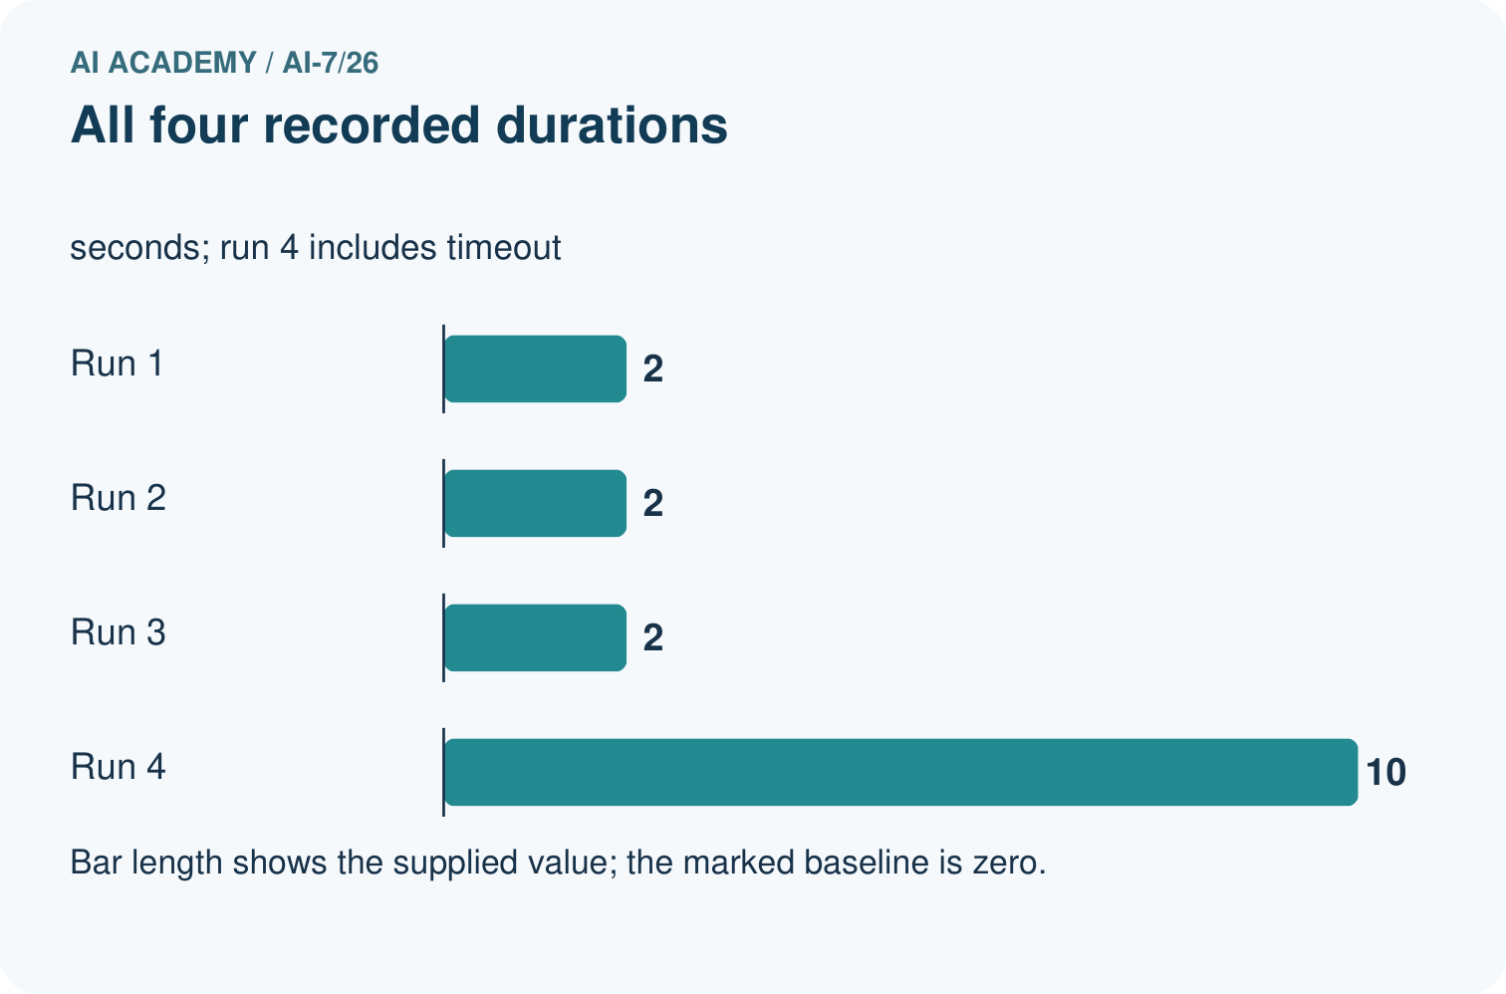
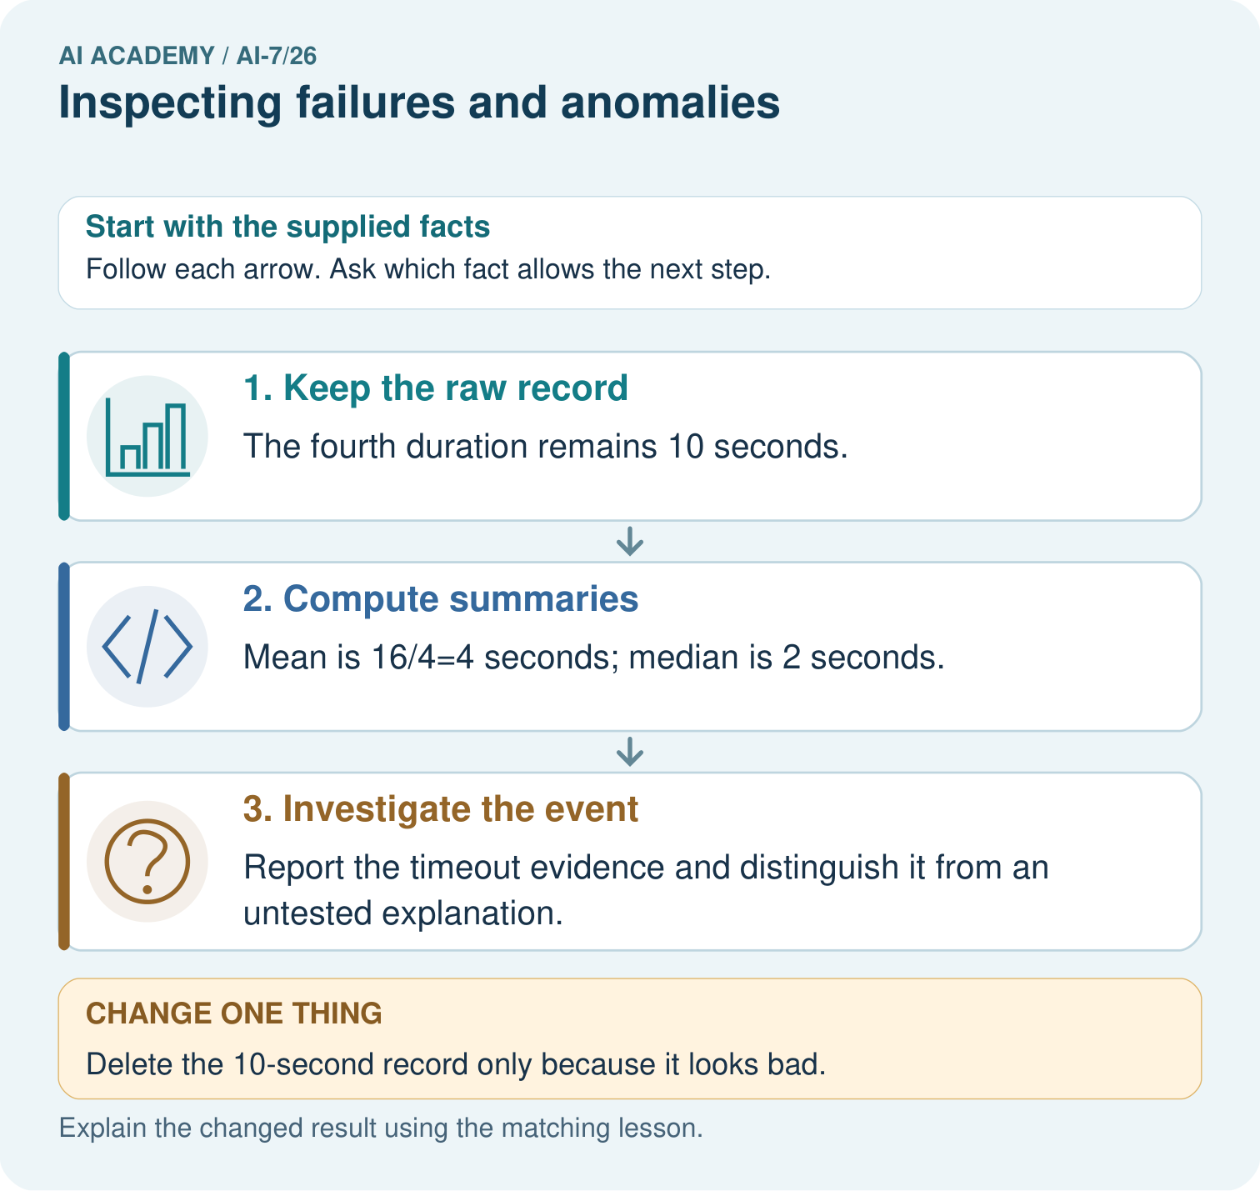
Calculate mean and median for 2,2,2,10. What does the timeout log establish, and why is deleting that inconvenient record incompatible with the stated plan?

My picture-based explanation and changed-case prediction
________________________________________________________________
________________________________________________________________
________________________________________________________________
________________________________________________________________
________________________________________________________________
________________________________________________________________
Support used: alone / hint / worked example. This record is practice evidence.
Project connection: For the Reproducible AI Research Study, retain an annotated worked trace and the changed-case reasoning. Connect the claim to its records, units and assumptions so another investigator can challenge or reproduce it.

