AI ACADEMY · WORKBOOK · ai-7/33

Independent reproduction check
Project: Reproducible AI Research Study

01. Recall and choose your starting point
Try the recall before opening notes. Then use a different colour or a labelled second line to correct your explanation.

Peer review and response
Without opening the old lesson, explain one key idea from Peer review and response. Give an example and a mistake that the idea helps you avoid.

My remembered idea, example and correction
________________________________________________________________
________________________________________________________________
________________________________________________________________

Writing the methods section
Without opening the old lesson, explain one key idea from Writing the methods section. Give an example and a mistake that the idea helps you avoid.

My remembered idea, example and correction
________________________________________________________________
________________________________________________________________
________________________________________________________________

Robustness across conditions
Without opening the old lesson, explain one key idea from Robustness across conditions. Give an example and a mistake that the idea helps you avoid.

My remembered idea, example and correction
________________________________________________________________
________________________________________________________________
________________________________________________________________

02. Practise with fading help
Use W2: Trace the worked case for Independent reproduction check. Record the answer once; the lesson and workbook refer to the same attempt.
Given inputs | Procedure I chose | Middle steps | Result and check

The step I completed without help, and the hint I needed
________________________________________________________________
________________________________________________________________
________________________________________________________________

03. Individual reasoning check
Use the worked case for Independent reproduction check. Proposed explanation: “The worked result establishes every future case”. Decide whether this explanation is supported. Point to the step or supplied fact that decides; explain your repair if needed.

My explanation before partner discussion
________________________________________________________________
________________________________________________________________
________________________________________________________________
________________________________________________________________

04. Independent transfer case

Independent case: Apply a new case independently
Reproducer uses different validation split because no split IDs were provided. Diagnose.

My independent explanation, trace and limits
________________________________________________________________
________________________________________________________________
________________________________________________________________
________________________________________________________________
________________________________________________________________
________________________________________________________________
________________________________________________________________
Attempt this case before feedback. Record any help. Earlier examples below are further practice; a case already practised with feedback cannot establish fresh transfer.

05. W1 Explain the mechanism
Explain the weekly mechanism in your own words. Use the worked scenario to name its input, decision rule and output.

My reasoning and evidence
________________________________________________________________
________________________________________________________________
________________________________________________________________
________________________________________________________________
________________________________________________________________
________________________________________________________________

06. W2 Trace the worked case
Operator gets different MSE because the supplied script averages absolute errors while paper names squared error. Show the intermediate steps and give the conclusion with its scope.

My reasoning and evidence
________________________________________________________________
________________________________________________________________
________________________________________________________________
________________________________________________________________
________________________________________________________________
________________________________________________________________
________________________________________________________________

07. W3 Audit the limit
A report omits this qualification: A successful reproduction repeats the original evidence and may preserve its original design limitations. Explain how omitting it could change a reader's interpretation, and write an accurate replacement.

My reasoning and evidence
________________________________________________________________
________________________________________________________________
________________________________________________________________
________________________________________________________________
________________________________________________________________
________________________________________________________________

08. W4 Apply a new case independently
Reproducer uses different validation split because no split IDs were provided. Diagnose.

My reasoning and evidence
________________________________________________________________
________________________________________________________________
________________________________________________________________
________________________________________________________________
________________________________________________________________
________________________________________________________________
________________________________________________________________
________________________________________________________________

09. W5 Design a revealing follow-up
For the worked scenario, propose one additional case that could reveal a failure, describe its expected outcome before running it, and explain what would need to remain fixed for a fair comparison. Do not reuse W4 as a new final test after receiving feedback.

My reasoning and evidence
________________________________________________________________
________________________________________________________________
________________________________________________________________
________________________________________________________________
________________________________________________________________
________________________________________________________________
________________________________________________________________

10. Project checkpoint and reflection
For Reproducible AI Research Study, use this week’s independent task as a rehearsal for the final evidence pack: Reproducer uses different validation split because no split IDs were provided. Diagnose. Keep actual observations separate from expected results, preserve failures, compare a baseline and explain the limits.

My project change, supporting evidence and remaining limit
________________________________________________________________
________________________________________________________________
________________________________________________________________
________________________________________________________________
________________________________________________________________
________________________________________________________________

11. Feedback, return check and learning record
Evidence | My record
Worked alone / hint / model
First step I repaired and why
New case checked later; date and result
What I can now explain without notes
One remaining question
Revisit this idea with your teacher after a delay. Familiarity is different from explaining and using it on a changed case.

12. Pictorial case practice: Independent reproduction check
An independent rerun with a disagreement. A second team follows the saved protocol on the same fixed data and obtains a different score.
Original correct count is 5/6. Rerun is 4/6. Case Q3 is the only scoring disagreement. No new model outputs are generated.
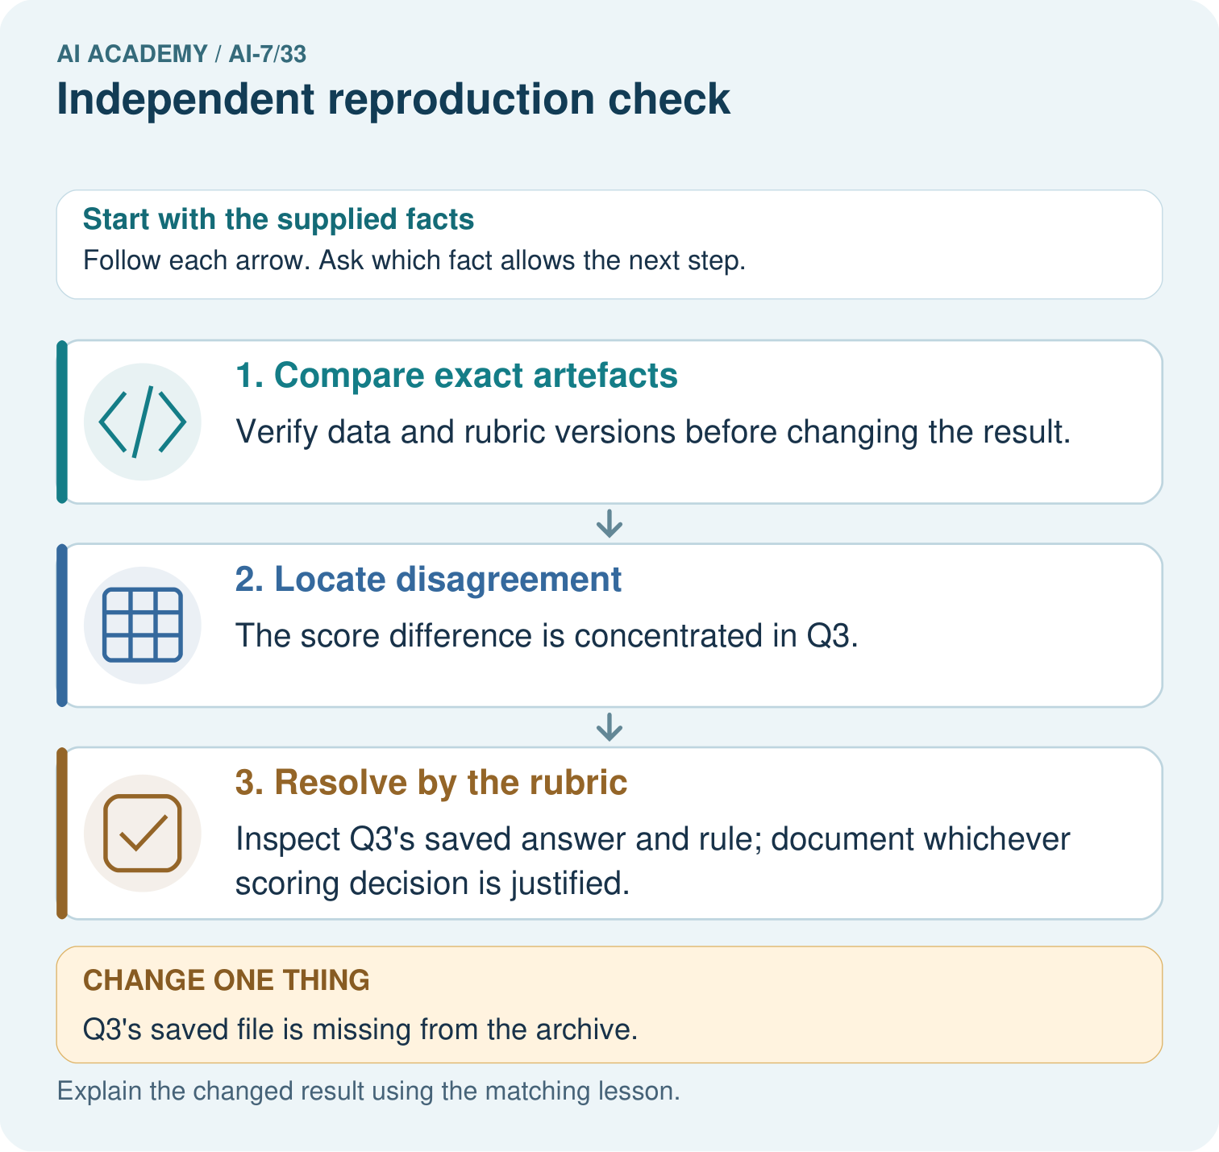
Locate the Q3 scoring disagreement between 5/6 and 4/6. What should the teams inspect before choosing a score, and what limitation follows if the saved Q3 file is missing?

My picture-based explanation and changed-case prediction
________________________________________________________________
________________________________________________________________
________________________________________________________________
________________________________________________________________
________________________________________________________________
________________________________________________________________
Support used: alone / hint / worked example. This record is practice evidence.
Project connection: For the Reproducible AI Research Study, retain an annotated worked trace and the changed-case reasoning. Connect the claim to its records, units and assumptions so another investigator can challenge or reproduce it.

