AI ACADEMY · WORKBOOK · ai-7/35

Presentation and challenge session
Project: Reproducible AI Research Study

01. Recall and choose your starting point
Try the recall before opening notes. Then use a different colour or a labelled second line to correct your explanation.

Final project manuscript
Without opening the old lesson, explain one key idea from Final project manuscript. Give an example and a mistake that the idea helps you avoid.

My remembered idea, example and correction
________________________________________________________________
________________________________________________________________
________________________________________________________________

Peer review and response
Without opening the old lesson, explain one key idea from Peer review and response. Give an example and a mistake that the idea helps you avoid.

My remembered idea, example and correction
________________________________________________________________
________________________________________________________________
________________________________________________________________

Figures that preserve evidence
Without opening the old lesson, explain one key idea from Figures that preserve evidence. Give an example and a mistake that the idea helps you avoid.

My remembered idea, example and correction
________________________________________________________________
________________________________________________________________
________________________________________________________________

02. Practise with fading help
Use W2: Trace the worked case for Presentation and challenge session. Record the answer once; the lesson and workbook refer to the same attempt.
Given inputs | Procedure I chose | Middle steps | Result and check

The step I completed without help, and the hint I needed
________________________________________________________________
________________________________________________________________
________________________________________________________________

03. Individual reasoning check
Use the worked case for Presentation and challenge session. Proposed explanation: “The worked result establishes every future case”. Decide whether this explanation is supported. Point to the step or supplied fact that decides; explain your repair if needed.

My explanation before partner discussion
________________________________________________________________
________________________________________________________________
________________________________________________________________
________________________________________________________________

04. Independent transfer case

Independent case: Apply a new case independently
Audience asks if result holds on mobile; only desktop was tested. Give an honest answer.

My independent explanation, trace and limits
________________________________________________________________
________________________________________________________________
________________________________________________________________
________________________________________________________________
________________________________________________________________
________________________________________________________________
________________________________________________________________
Attempt this case before feedback. Record any help. Earlier examples below are further practice; a case already practised with feedback cannot establish fresh transfer.

05. W1 Explain the mechanism
Explain the weekly mechanism in your own words. Use the worked scenario to name its input, decision rule and output.

My reasoning and evidence
________________________________________________________________
________________________________________________________________
________________________________________________________________
________________________________________________________________
________________________________________________________________
________________________________________________________________

06. W2 Trace the worked case
A presenter shows one perfect output after a20-case study with14 passes. Show the intermediate steps and give the conclusion with its scope.

My reasoning and evidence
________________________________________________________________
________________________________________________________________
________________________________________________________________
________________________________________________________________
________________________________________________________________
________________________________________________________________
________________________________________________________________

07. W3 Audit the limit
A report omits this qualification: A confident response should not replace missing evidence with speculation. Explain how omitting it could change a reader's interpretation, and write an accurate replacement.

My reasoning and evidence
________________________________________________________________
________________________________________________________________
________________________________________________________________
________________________________________________________________
________________________________________________________________
________________________________________________________________

08. W4 Apply a new case independently
Audience asks if result holds on mobile; only desktop was tested. Give an honest answer.

My reasoning and evidence
________________________________________________________________
________________________________________________________________
________________________________________________________________
________________________________________________________________
________________________________________________________________
________________________________________________________________
________________________________________________________________
________________________________________________________________

09. W5 Design a revealing follow-up
For the worked scenario, propose one additional case that could reveal a failure, describe its expected outcome before running it, and explain what would need to remain fixed for a fair comparison. Do not reuse W4 as a new final test after receiving feedback.

My reasoning and evidence
________________________________________________________________
________________________________________________________________
________________________________________________________________
________________________________________________________________
________________________________________________________________
________________________________________________________________
________________________________________________________________

10. Project checkpoint and reflection
For Reproducible AI Research Study, use this week’s independent task as a rehearsal for the final evidence pack: Audience asks if result holds on mobile; only desktop was tested. Give an honest answer. Keep actual observations separate from expected results, preserve failures, compare a baseline and explain the limits.

My project change, supporting evidence and remaining limit
________________________________________________________________
________________________________________________________________
________________________________________________________________
________________________________________________________________
________________________________________________________________
________________________________________________________________

11. Feedback, return check and learning record
Evidence | My record
Worked alone / hint / model
First step I repaired and why
New case checked later; date and result
What I can now explain without notes
One remaining question
Revisit this idea with your teacher after a delay. Familiarity is different from explaining and using it on a changed case.

12. Pictorial case practice: Presentation and challenge session
Answer a challenge without inventing evidence. At the presentation, a reviewer asks whether the model works on a different camera.
The project tested twelve photos from camera A only. Ten were correct; no camera B records exist.
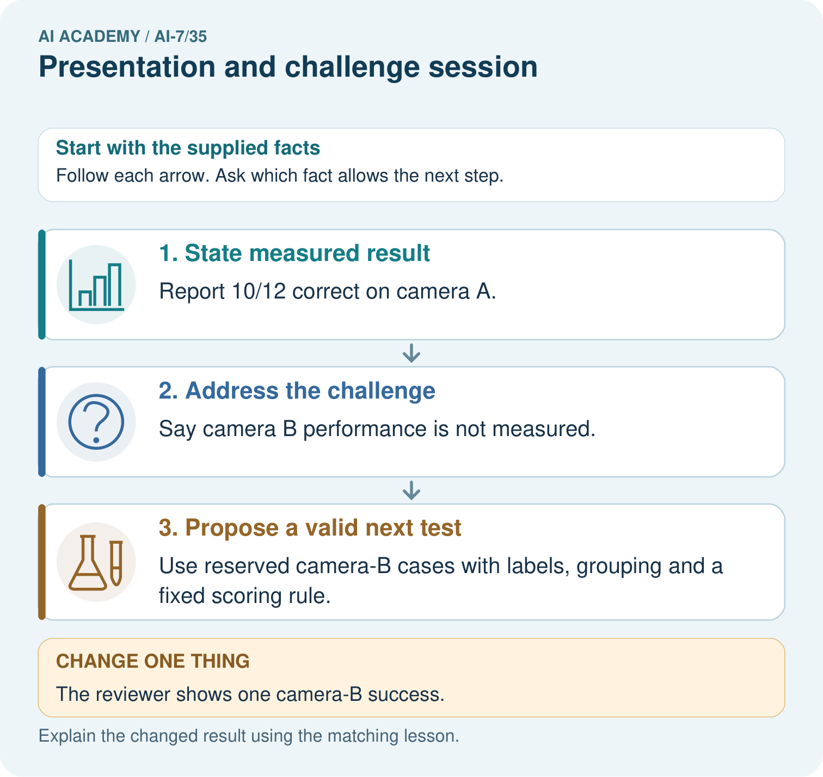
Answer the camera-B challenge using only the twelve camera-A records. Why is one displayed camera-B success a demonstration rather than broad evidence of camera-B reliability?

My picture-based explanation and changed-case prediction
________________________________________________________________
________________________________________________________________
________________________________________________________________
________________________________________________________________
________________________________________________________________
________________________________________________________________
Support used: alone / hint / worked example. This record is practice evidence.
Project connection: For the Reproducible AI Research Study, retain an annotated worked trace and the changed-case reasoning. Connect the claim to its records, units and assumptions so another investigator can challenge or reproduce it.

