AI ACADEMY · WORKBOOK · python-bridge/1

From a paper algorithm to Python
Project: Python readiness portfolio

01. Recall and choose your starting point
Try the recall before opening notes. Then use a different colour or a labelled second line to correct your explanation.
Four packs contain six counters each. What steps find and show the total?

My starting explanation
________________________________________________________________
________________________________________________________________
________________________________________________________________

02. Practise with fading help
Use W2: Predict then observe for From a paper algorithm to Python. Record the answer once; the lesson and workbook refer to the same attempt.
Given inputs | Procedure I chose | Middle steps | Result and check

The step I completed without help, and the hint I needed
________________________________________________________________
________________________________________________________________
________________________________________________________________

03. Individual reasoning check
Use the worked case for From a paper algorithm to Python. Proposed explanation: “An equals sign displays the answer”. Decide whether this explanation is supported. Point to the step or supplied fact that decides; explain your repair if needed.

My explanation before partner discussion
________________________________________________________________
________________________________________________________________
________________________________________________________________
________________________________________________________________

04. Independent transfer case

Independent case: Trace variables and a change
Predict the printed value. Change only packs to 5 and predict again. Explain which statements apply a written rule.
packs = 3
per_pack = 7
total = packs * per_pack
print(total)

My independent explanation, trace and limits
________________________________________________________________
________________________________________________________________
________________________________________________________________
________________________________________________________________
________________________________________________________________
________________________________________________________________
________________________________________________________________
Attempt this case before feedback. Record any help. Earlier examples below are further practice; a case already practised with feedback cannot establish fresh transfer.

05. W1 Connect the paper steps to Python
Write the complete four-line script for 4 packs of 6. Beside each line explain what it does. Which line displays information?

My reasoning and evidence
________________________________________________________________
________________________________________________________________
________________________________________________________________
________________________________________________________________
________________________________________________________________
________________________________________________________________

06. W2 Predict then observe
Make records for 4 packs of 6, then 5 packs of 6. Predict before running. Record actual output, any error and what changed. If working on paper, label both results as traces.

My reasoning and evidence
________________________________________________________________
________________________________________________________________
________________________________________________________________
________________________________________________________________
________________________________________________________________
________________________________________________________________

07. W3 Explain an order error
Move print(total) to the first line of a fresh script. Predict what happens and why. Put the lines back into an order that meets the requirement.

My reasoning and evidence
________________________________________________________________
________________________________________________________________
________________________________________________________________
________________________________________________________________
________________________________________________________________
________________________________________________________________

08. W4 Transfer the procedure independently
A fictional shelf has 3 trays of 7 tiles each. Write a four-line Python script using trays, per_tray and tiles. Predict its output. Then change only trays to 0 and predict again. Explain why adding the two quantities is wrong.

My reasoning and evidence
________________________________________________________________
________________________________________________________________
________________________________________________________________
________________________________________________________________
________________________________________________________________
________________________________________________________________
________________________________________________________________

09. W5 Keep an honest conclusion
Explain the difference between a successful run and a correct calculation. State one limit of this program and what you would keep so another person can check your work.

My reasoning and evidence
________________________________________________________________
________________________________________________________________
________________________________________________________________
________________________________________________________________
________________________________________________________________
________________________________________________________________

10. Project checkpoint and reflection
Add a labelled from a paper algorithm to python evidence sheet to Python readiness portfolio. Show how you can translate a short paper calculation into a python script. Use the supplied fictional case and keep its inputs, intermediate steps, calculation or prediction, and limitation. Connect this record to last week’s record; a matching answer without a trace is insufficient.

My project change, supporting evidence and remaining limit
________________________________________________________________
________________________________________________________________
________________________________________________________________
________________________________________________________________
________________________________________________________________
________________________________________________________________

11. Feedback, return check and learning record
Evidence | My record
Worked alone / hint / model
First step I repaired and why
New case checked later; date and result
What I can now explain without notes
One remaining question
Revisit this idea with your teacher after a delay. Familiarity is different from explaining and using it on a changed case.

12. Pictorial case practice: From a paper algorithm to Python
Convert a seed-count algorithm. The paper plan counts seeds in identical trays, then adds a labelled spare tray.
Python 3: trays=4; per_tray=6; spare=2; total=trays*per_tray+spare; print(total). All quantities count seeds.
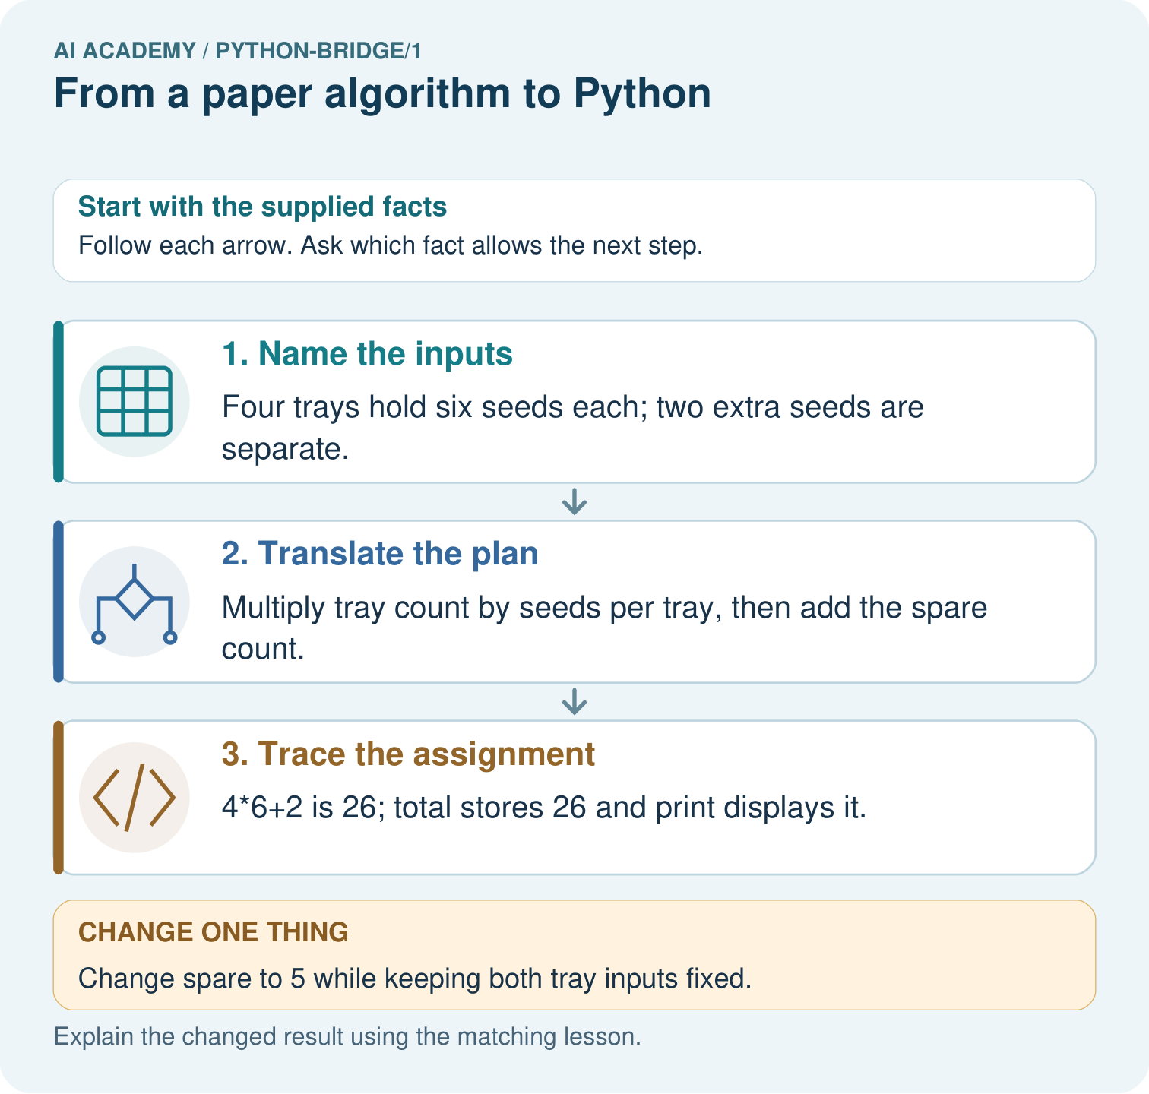
Match each paper quantity to its Python name. Why does the spare count get added once, and what prints when spare is five?

My picture-based explanation and changed-case prediction
________________________________________________________________
________________________________________________________________
________________________________________________________________
________________________________________________________________
________________________________________________________________
________________________________________________________________
Support used: alone / hint / worked example. This record is practice evidence.
Project connection: For Python readiness before the Responsible Plant Classifier, retain a trace of the values, the predicted outputs and the changed-case explanation. Use actual Python 3 results to check the prediction after reasoning first.

