AI ACADEMY · WORKBOOK · python-bridge/6

Loops and trace tables
Project: Python readiness portfolio

01. Recall and choose your starting point
Try the recall before opening notes. Then use a different colour or a labelled second line to correct your explanation.

Branching and boundary tests
Without opening the old lesson, explain one key idea from Branching and boundary tests. Give an example and a mistake that the idea helps you avoid.

My remembered idea, example and correction
________________________________________________________________
________________________________________________________________
________________________________________________________________

Expressions and operator order
Without opening the old lesson, explain one key idea from Expressions and operator order. Give an example and a mistake that the idea helps you avoid.

My remembered idea, example and correction
________________________________________________________________
________________________________________________________________
________________________________________________________________

02. Practise with fading help
Use W2: Trace before running for Loops and trace tables. Record the answer once; the lesson and workbook refer to the same attempt.
Given inputs | Procedure I chose | Middle steps | Result and check

The step I completed without help, and the hint I needed
________________________________________________________________
________________________________________________________________
________________________________________________________________

03. Individual reasoning check
Use the worked case for Loops and trace tables. Proposed explanation: “The stop value is included”. Decide whether this explanation is supported. Point to the step or supplied fact that decides; explain your repair if needed.

My explanation before partner discussion
________________________________________________________________
________________________________________________________________
________________________________________________________________
________________________________________________________________

04. Independent transfer case

Independent case: Count iterations and a stopping point
List every value visited and each running total. Then predict the result for range(2,2).
total = 0
for value in range(2, 6):
total = total + value
print(total)

My independent explanation, trace and limits
________________________________________________________________
________________________________________________________________
________________________________________________________________
________________________________________________________________
________________________________________________________________
________________________________________________________________
________________________________________________________________
Attempt this case before feedback. Record any help. Earlier examples below are further practice; a case already practised with feedback cannot establish fresh transfer.

05. W1 Explain the range
List the values supplied by range(2, 5) and explain why 5 is absent. How many times does its body run?

My reasoning and evidence
________________________________________________________________
________________________________________________________________
________________________________________________________________
________________________________________________________________
________________________________________________________________
________________________________________________________________

06. W2 Trace before running
Copy the worked script. Change the range to range(2, 5). Record turn, total before and total after each iteration. Predict the single output, then run and compare.

My reasoning and evidence
________________________________________________________________
________________________________________________________________
________________________________________________________________
________________________________________________________________
________________________________________________________________
________________________________________________________________

07. W3 Repair the reset
For the faulty script with range(1, 4), record total after each addition. Explain the wrong final output and remove only the faulty reset.

My reasoning and evidence
________________________________________________________________
________________________________________________________________
________________________________________________________________
________________________________________________________________
________________________________________________________________
________________________________________________________________

08. W4 Build a repeated addition independently
A box starts with 5 counters. Each round adds 2 counters. Use rounds = 3, an initialized total and for turn in range(rounds). Print the final total once after the loop. Trace the totals and predict fresh runs with rounds 0, 1 and 3. Assume rounds is a nonnegative integer.

My reasoning and evidence
________________________________________________________________
________________________________________________________________
________________________________________________________________
________________________________________________________________
________________________________________________________________
________________________________________________________________
________________________________________________________________
________________________________________________________________

09. W5 Check a contract limitation
In your counter script, range(-2) performs no iterations. Does returning the initial 5 make negative rounds valid? Explain what the script checks and what it assumes.

My reasoning and evidence
________________________________________________________________
________________________________________________________________
________________________________________________________________
________________________________________________________________
________________________________________________________________
________________________________________________________________

10. Project checkpoint and reflection
Add a labelled loops and trace tables evidence sheet to Python readiness portfolio. Show how you can trace variable values before and after each loop iteration. Use the supplied fictional case and keep its inputs, intermediate steps, calculation or prediction, and limitation. Connect this record to last week’s record; a matching answer without a trace is insufficient.

My project change, supporting evidence and remaining limit
________________________________________________________________
________________________________________________________________
________________________________________________________________
________________________________________________________________
________________________________________________________________
________________________________________________________________

11. Feedback, return check and learning record
Evidence | My record
Worked alone / hint / model
First step I repaired and why
New case checked later; date and result
What I can now explain without notes
One remaining question
Revisit this idea with your teacher after a delay. Familiarity is different from explaining and using it on a changed case.

12. Pictorial case practice: Loops and trace tables
Accumulate a short range. A running total adds the integers visited by range(1,5).
Python 3: total=0; for value in range(1,5): total+=value; print(total). The print is after the loop.
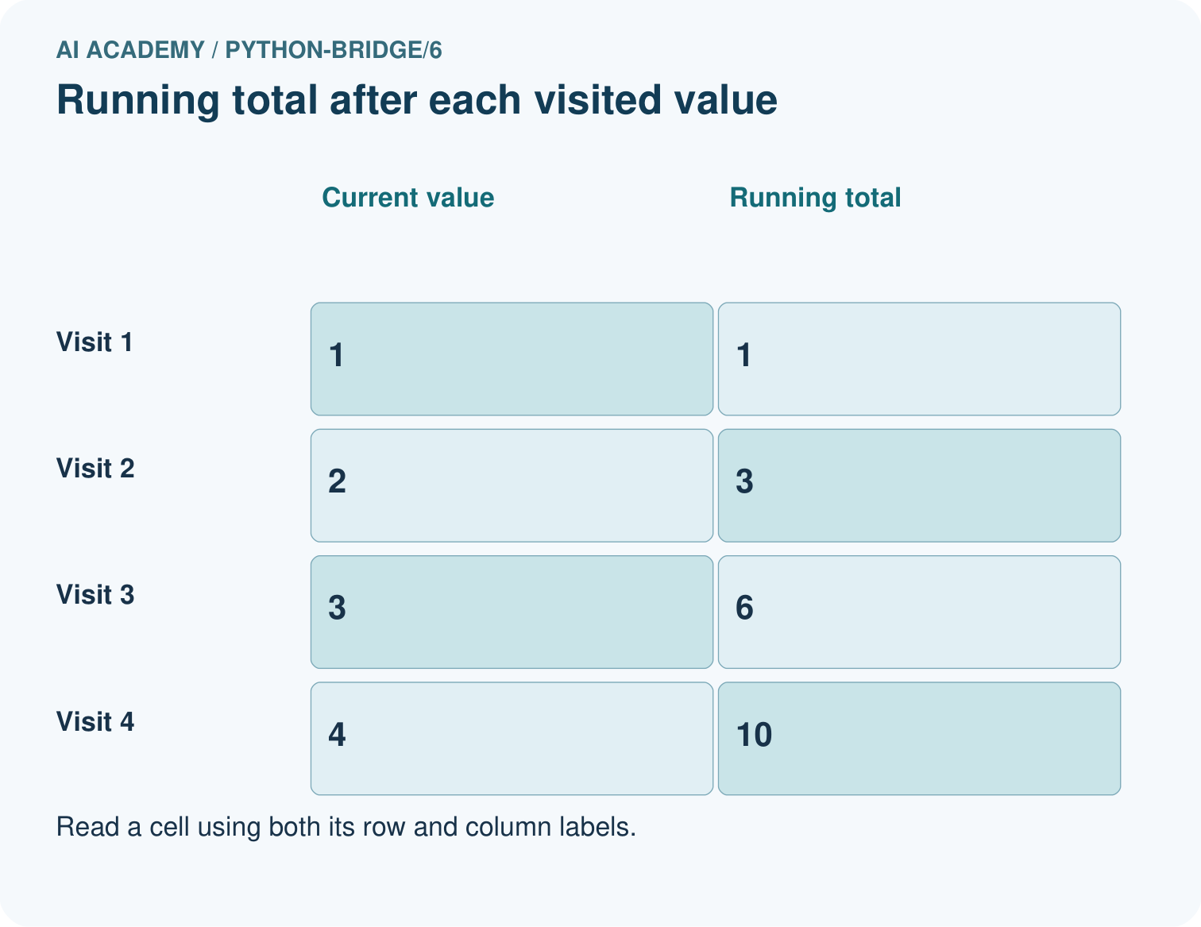
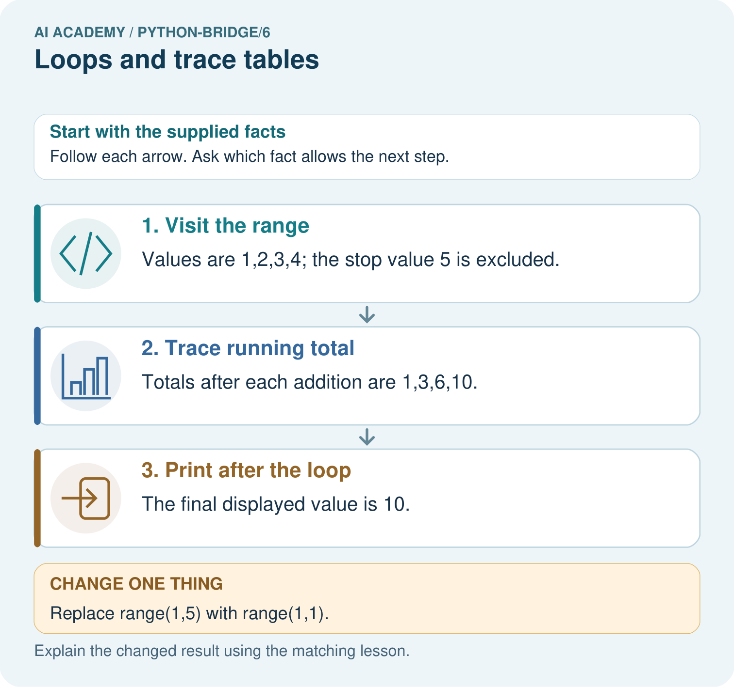
List the four visited values and their running totals. Explain why 5 is absent and what prints for range(1,1).

My picture-based explanation and changed-case prediction
________________________________________________________________
________________________________________________________________
________________________________________________________________
________________________________________________________________
________________________________________________________________
________________________________________________________________
Support used: alone / hint / worked example. This record is practice evidence.
Project connection: For Python readiness before the Responsible Plant Classifier, retain a trace of the values, the predicted outputs and the changed-case explanation. Use actual Python 3 results to check the prediction after reasoning first.

