AI ACADEMY · WORKBOOK · python-bridge/7

Lists and indexing
Project: Python readiness portfolio

01. Recall and choose your starting point
Try the recall before opening notes. Then use a different colour or a labelled second line to correct your explanation.

Loops and trace tables
Without opening the old lesson, explain one key idea from Loops and trace tables. Give an example and a mistake that the idea helps you avoid.

My remembered idea, example and correction
________________________________________________________________
________________________________________________________________
________________________________________________________________

Boolean conditions
Without opening the old lesson, explain one key idea from Boolean conditions. Give an example and a mistake that the idea helps you avoid.

My remembered idea, example and correction
________________________________________________________________
________________________________________________________________
________________________________________________________________

From a paper algorithm to Python
Without opening the old lesson, explain one key idea from From a paper algorithm to Python. Give an example and a mistake that the idea helps you avoid.

My remembered idea, example and correction
________________________________________________________________
________________________________________________________________
________________________________________________________________

02. Practise with fading help
Use W2: Trace an update for Lists and indexing. Record the answer once; the lesson and workbook refer to the same attempt.
Given inputs | Procedure I chose | Middle steps | Result and check

The step I completed without help, and the hint I needed
________________________________________________________________
________________________________________________________________
________________________________________________________________

03. Individual reasoning check
Use the worked case for Lists and indexing. Proposed explanation: “Length is the last nonnegative index”. Decide whether this explanation is supported. Point to the step or supplied fact that decides; explain your repair if needed.

My explanation before partner discussion
________________________________________________________________
________________________________________________________________
________________________________________________________________
________________________________________________________________

04. Independent transfer case

Independent case: Distinguish a value from an index
Predict the three outputs. If the second print uses values[3] instead, where does execution stop and which later output is not produced?
values = [4, 9, 2]
print(values[1])
print(values[-1])
print(len(values))

My independent explanation, trace and limits
________________________________________________________________
________________________________________________________________
________________________________________________________________
________________________________________________________________
________________________________________________________________
________________________________________________________________
________________________________________________________________
Attempt this case before feedback. Record any help. Earlier examples below are further practice; a case already practised with feedback cannot establish fresh transfer.

05. W1 Separate index and value
For counts = [4, 7, 4], give the length, valid nonnegative indices and value at index 1. Explain how the two items with value 4 differ.

My reasoning and evidence
________________________________________________________________
________________________________________________________________
________________________________________________________________
________________________________________________________________
________________________________________________________________
________________________________________________________________

06. W2 Trace an update
Start with counts = [4, 7, 4]. Run counts[0] = 6. Write the resulting list, its length and the value at index 2. Predict before running.

My reasoning and evidence
________________________________________________________________
________________________________________________________________
________________________________________________________________
________________________________________________________________
________________________________________________________________
________________________________________________________________

07. W3 Repair a position mistake
A learner loops with for count in counts and tries to read counts[count] for counts = [4, 7, 4]. Identify the first attempted index and error. Explain how to print each value directly.

My reasoning and evidence
________________________________________________________________
________________________________________________________________
________________________________________________________________
________________________________________________________________
________________________________________________________________
________________________________________________________________

08. W4 Process new data independently
Start with readings = [3, 0, 3, 2]. Replace the second item with 5 using its index. Write a loop that adds all updated readings and prints one final total. Trace every update of the total. Then test the summing part alone on [] and [6].

My reasoning and evidence
________________________________________________________________
________________________________________________________________
________________________________________________________________
________________________________________________________________
________________________________________________________________
________________________________________________________________
________________________________________________________________
________________________________________________________________

09. W5 Keep the information you need
Compare [1, 5, 2] and [5, 1, 2]. State their totals and first items. Would storing only the total answer which first item was larger? Explain.

My reasoning and evidence
________________________________________________________________
________________________________________________________________
________________________________________________________________
________________________________________________________________
________________________________________________________________
________________________________________________________________

10. Project checkpoint and reflection
Add a labelled lists and indexing evidence sheet to Python readiness portfolio. Show how you can distinguish a list index from the value stored at that position. Use the supplied fictional case and keep its inputs, intermediate steps, calculation or prediction, and limitation. Connect this record to last week’s record; a matching answer without a trace is insufficient.

My project change, supporting evidence and remaining limit
________________________________________________________________
________________________________________________________________
________________________________________________________________
________________________________________________________________
________________________________________________________________
________________________________________________________________

11. Feedback, return check and learning record
Evidence | My record
Worked alone / hint / model
First step I repaired and why
New case checked later; date and result
What I can now explain without notes
One remaining question
Revisit this idea with your teacher after a delay. Familiarity is different from explaining and using it on a changed case.

12. Pictorial case practice: Lists and indexing
Indexes are positions, not values. A list of shelf counts is read by position.
Python 3: counts=[6,1,8]; print(counts[0]); print(counts[-1]); print(len(counts)).
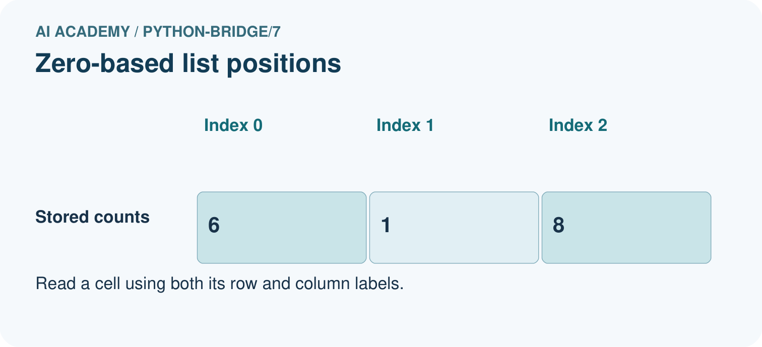
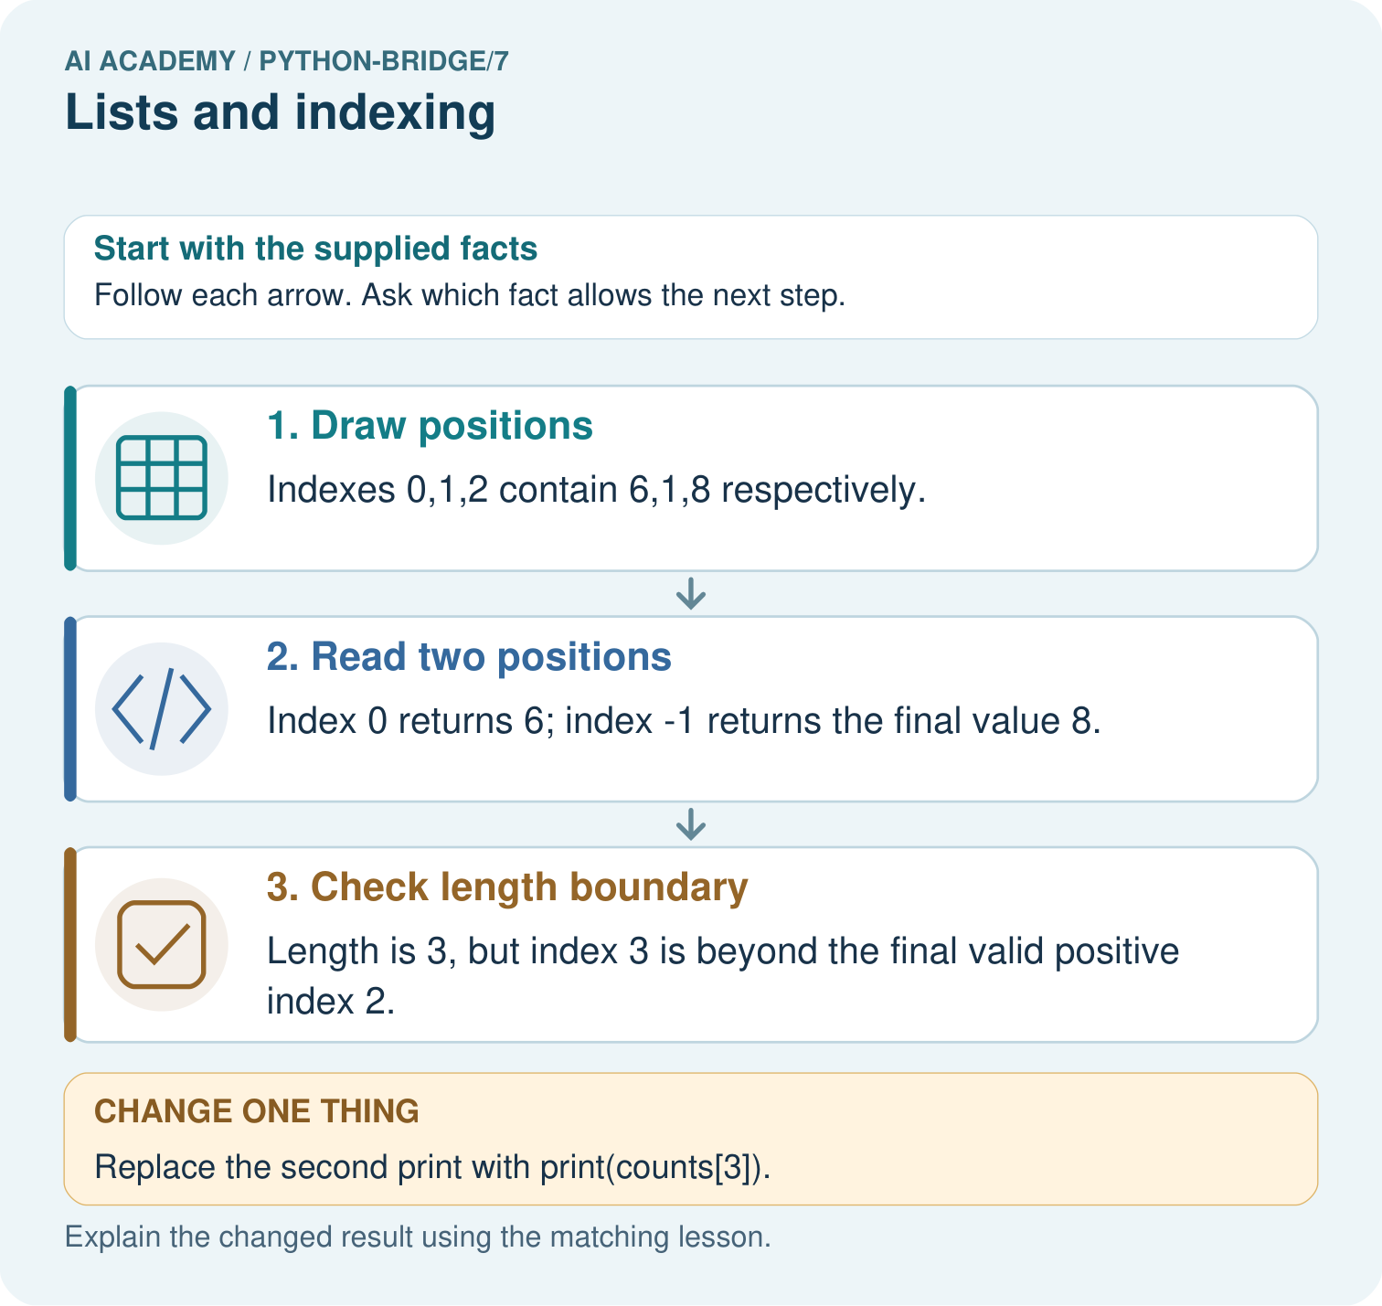
Label the three index positions. Predict all original outputs, then name the first output and stopping point after using index 3.

My picture-based explanation and changed-case prediction
________________________________________________________________
________________________________________________________________
________________________________________________________________
________________________________________________________________
________________________________________________________________
________________________________________________________________
Support used: alone / hint / worked example. This record is practice evidence.
Project connection: For Python readiness before the Responsible Plant Classifier, retain a trace of the values, the predicted outputs and the changed-case explanation. Use actual Python 3 results to check the prediction after reasoning first.

