AI ACADEMY · WORKBOOK · python-bridge/8

Functions and arguments
Project: Python readiness portfolio

01. Recall and choose your starting point
Try the recall before opening notes. Then use a different colour or a labelled second line to correct your explanation.

Lists and indexing
Without opening the old lesson, explain one key idea from Lists and indexing. Give an example and a mistake that the idea helps you avoid.

My remembered idea, example and correction
________________________________________________________________
________________________________________________________________
________________________________________________________________

Branching and boundary tests
Without opening the old lesson, explain one key idea from Branching and boundary tests. Give an example and a mistake that the idea helps you avoid.

My remembered idea, example and correction
________________________________________________________________
________________________________________________________________
________________________________________________________________

Values variables and types
Without opening the old lesson, explain one key idea from Values variables and types. Give an example and a mistake that the idea helps you avoid.

My remembered idea, example and correction
________________________________________________________________
________________________________________________________________
________________________________________________________________

02. Practise with fading help
Use W2: Follow the execution order for Functions and arguments. Record the answer once; the lesson and workbook refer to the same attempt.
Given inputs | Procedure I chose | Middle steps | Result and check

The step I completed without help, and the hint I needed
________________________________________________________________
________________________________________________________________
________________________________________________________________

03. Individual reasoning check
Use the worked case for Functions and arguments. Proposed explanation: “Writing def runs the body immediately”. Decide whether this explanation is supported. Point to the step or supplied fact that decides; explain your repair if needed.

My explanation before partner discussion
________________________________________________________________
________________________________________________________________
________________________________________________________________
________________________________________________________________

04. Independent transfer case

Independent case: Match positional arguments to parameters
Predict both returned and printed values, showing which argument supplies first and second. What is displayed if the program contains only the function definition and no calls? Why does swapping these arguments change the result?
def difference(first, second):
return first - second
print(difference(11, 4))
print(difference(4, 11))

My independent explanation, trace and limits
________________________________________________________________
________________________________________________________________
________________________________________________________________
________________________________________________________________
________________________________________________________________
________________________________________________________________
________________________________________________________________
Attempt this case before feedback. Record any help. Earlier examples below are further practice; a case already practised with feedback cannot establish fresh transfer.

05. W1 Label the parts
In def show_remaining(capacity, used), identify the function name and parameters. In show_remaining(15, 6), identify the arguments and their matching parameters.

My reasoning and evidence
________________________________________________________________
________________________________________________________________
________________________________________________________________
________________________________________________________________
________________________________________________________________
________________________________________________________________

06. W2 Follow the execution order
Using the correct definition, predict show_remaining(8, 3), show_remaining(8, 8) and show_remaining(8, 0) in that order. Explain what happens if the file contains only the definition.

My reasoning and evidence
________________________________________________________________
________________________________________________________________
________________________________________________________________
________________________________________________________________
________________________________________________________________
________________________________________________________________

07. W3 Repair ignored arguments
The faulty body calculates 12 - 4 regardless of the call. State the output and expected output for show_remaining(11, 2). Repair the expression and name an earlier call to rerun.

My reasoning and evidence
________________________________________________________________
________________________________________________________________
________________________________________________________________
________________________________________________________________
________________________________________________________________
________________________________________________________________

08. W4 Create a new function independently
Each sealed box contains 6 counters. Define show_stock(boxes, loose) to print the total counters using its two parameters. Assume nonnegative integer arguments. Call it with (3, 2), (0, 2) and (3, 0). Predict each output and explain why show_stock(2, 3) is a different case.

My reasoning and evidence
________________________________________________________________
________________________________________________________________
________________________________________________________________
________________________________________________________________
________________________________________________________________
________________________________________________________________
________________________________________________________________
________________________________________________________________

09. W5 State the input assumption
The correct subtraction function prints -1 for show_remaining(4, 5). Does successful execution make this a valid cupboard record? Explain what the function assumes and what needs checking.

My reasoning and evidence
________________________________________________________________
________________________________________________________________
________________________________________________________________
________________________________________________________________
________________________________________________________________
________________________________________________________________

10. Project checkpoint and reflection
Add a labelled functions and arguments evidence sheet to Python readiness portfolio. Show how you can distinguish a function definition from a function call. Use the supplied fictional case and keep its inputs, intermediate steps, calculation or prediction, and limitation. Connect this record to last week’s record; a matching answer without a trace is insufficient.

My project change, supporting evidence and remaining limit
________________________________________________________________
________________________________________________________________
________________________________________________________________
________________________________________________________________
________________________________________________________________
________________________________________________________________

11. Feedback, return check and learning record
Evidence | My record
Worked alone / hint / model
First step I repaired and why
New case checked later; date and result
What I can now explain without notes
One remaining question
Revisit this idea with your teacher after a delay. Familiarity is different from explaining and using it on a changed case.

12. Pictorial case practice: Functions and arguments
Match arguments to parameters. A function prints the difference between capacity and reserved spaces.
Python 3: def show_free(capacity,reserved): print(capacity-reserved). Calls: show_free(11,3); show_free(3,11).
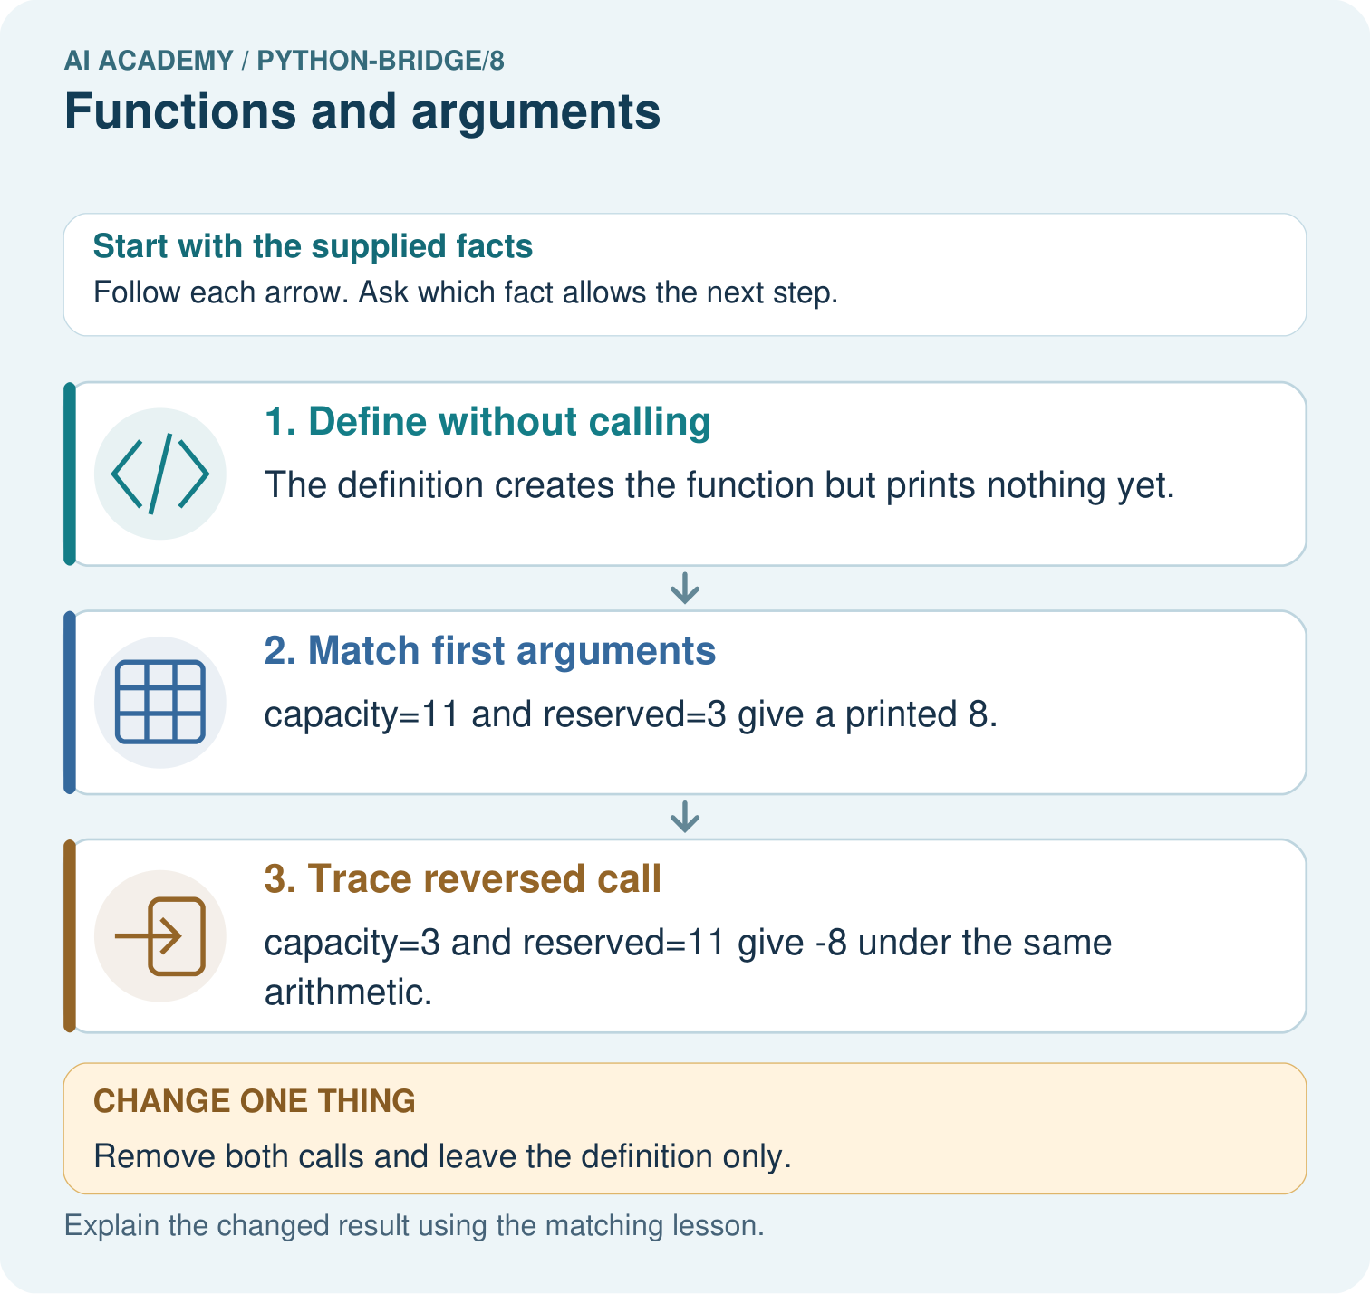
Match every argument to a parameter for the two calls. Why do outputs differ, and what prints when both calls are removed?

My picture-based explanation and changed-case prediction
________________________________________________________________
________________________________________________________________
________________________________________________________________
________________________________________________________________
________________________________________________________________
________________________________________________________________
Support used: alone / hint / worked example. This record is practice evidence.
Project connection: For Python readiness before the Responsible Plant Classifier, retain a trace of the values, the predicted outputs and the changed-case explanation. Use actual Python 3 results to check the prediction after reasoning first.

