AI ACADEMY · WORKBOOK · python-bridge/10

Dictionaries and records
Project: Python readiness portfolio

01. Recall and choose your starting point
Try the recall before opening notes. Then use a different colour or a labelled second line to correct your explanation.

Return values and local state
Without opening the old lesson, explain one key idea from Return values and local state. Give an example and a mistake that the idea helps you avoid.

My remembered idea, example and correction
________________________________________________________________
________________________________________________________________
________________________________________________________________

Lists and indexing
Without opening the old lesson, explain one key idea from Lists and indexing. Give an example and a mistake that the idea helps you avoid.

My remembered idea, example and correction
________________________________________________________________
________________________________________________________________
________________________________________________________________

Boolean conditions
Without opening the old lesson, explain one key idea from Boolean conditions. Give an example and a mistake that the idea helps you avoid.

My remembered idea, example and correction
________________________________________________________________
________________________________________________________________
________________________________________________________________

02. Practise with fading help
Use W2: Trace an update for Dictionaries and records. Record the answer once; the lesson and workbook refer to the same attempt.
Given inputs | Procedure I chose | Middle steps | Result and check

The step I completed without help, and the hint I needed
________________________________________________________________
________________________________________________________________
________________________________________________________________

03. Individual reasoning check
Use the worked case for Dictionaries and records. Proposed explanation: “A successful run proves the conclusion”. Decide whether this explanation is supported. Point to the step or supplied fact that decides; explain your repair if needed.

My explanation before partner discussion
________________________________________________________________
________________________________________________________________
________________________________________________________________
________________________________________________________________

04. Independent transfer case

Independent case: Read, update and pass a dictionary record
Predict the three outputs and trace the named-field update. Explain why zero and a missing count produce different results. If the condition becomes if not count, which supplied record is first handled incorrectly?
def describe(record):
count = record.get("count")
if count is None:
return "missing"
return count
record = {"count": 0}
print(describe(record))
record["count"] = 3
print(describe(record))
print(describe({}))

My independent explanation, trace and limits
________________________________________________________________
________________________________________________________________
________________________________________________________________
________________________________________________________________
________________________________________________________________
________________________________________________________________
________________________________________________________________
Attempt this case before feedback. Record any help. Earlier examples below are further practice; a case already practised with feedback cannot establish fresh transfer.

05. W1 Identify fields
For {"name": "Red", "capacity": 9, "used": 2}, state the keys, value of used and remaining spaces.

My reasoning and evidence
________________________________________________________________
________________________________________________________________
________________________________________________________________
________________________________________________________________
________________________________________________________________
________________________________________________________________

06. W2 Trace an update
Change the Red record used to 9. State remaining spaces and whether capacity changes.

My reasoning and evidence
________________________________________________________________
________________________________________________________________
________________________________________________________________
________________________________________________________________
________________________________________________________________
________________________________________________________________

07. W3 Repair a lookup
The code reads record["Used"] from the Red record. Explain the error and repair it without adding a field.

My reasoning and evidence
________________________________________________________________
________________________________________________________________
________________________________________________________________
________________________________________________________________
________________________________________________________________
________________________________________________________________

08. W4 Build a record independently
Create a Green record with capacity 15 and used 6. Pass its fields to remaining and store the result. Update used to 10 and repeat. Predict both results.

My reasoning and evidence
________________________________________________________________
________________________________________________________________
________________________________________________________________
________________________________________________________________
________________________________________________________________
________________________________________________________________
________________________________________________________________
________________________________________________________________

09. W5 Check the contract
A record has capacity 3 and used 4. It gives -1 spaces without an error. Should it be accepted? Explain.

My reasoning and evidence
________________________________________________________________
________________________________________________________________
________________________________________________________________
________________________________________________________________
________________________________________________________________
________________________________________________________________

10. Project checkpoint and reflection
Add a labelled dictionaries and records evidence sheet to Python readiness portfolio. Show how you can read and update named dictionary fields. Use the supplied fictional case and keep its inputs, intermediate steps, calculation or prediction, and limitation. Connect this record to last week’s record; a matching answer without a trace is insufficient.

My project change, supporting evidence and remaining limit
________________________________________________________________
________________________________________________________________
________________________________________________________________
________________________________________________________________
________________________________________________________________
________________________________________________________________

11. Feedback, return check and learning record
Evidence | My record
Worked alone / hint / model
First step I repaired and why
New case checked later; date and result
What I can now explain without notes
One remaining question
Revisit this idea with your teacher after a delay. Familiarity is different from explaining and using it on a changed case.

12. Pictorial case practice: Dictionaries and records
A zero field is still present. A dictionary record describes a shelf. The program distinguishes missing data from an actual zero.
Python 3: shelf={"count":0,"name":"Atlas"}; print(shelf["count"]); print(shelf.get("price")); print("count" in shelf).
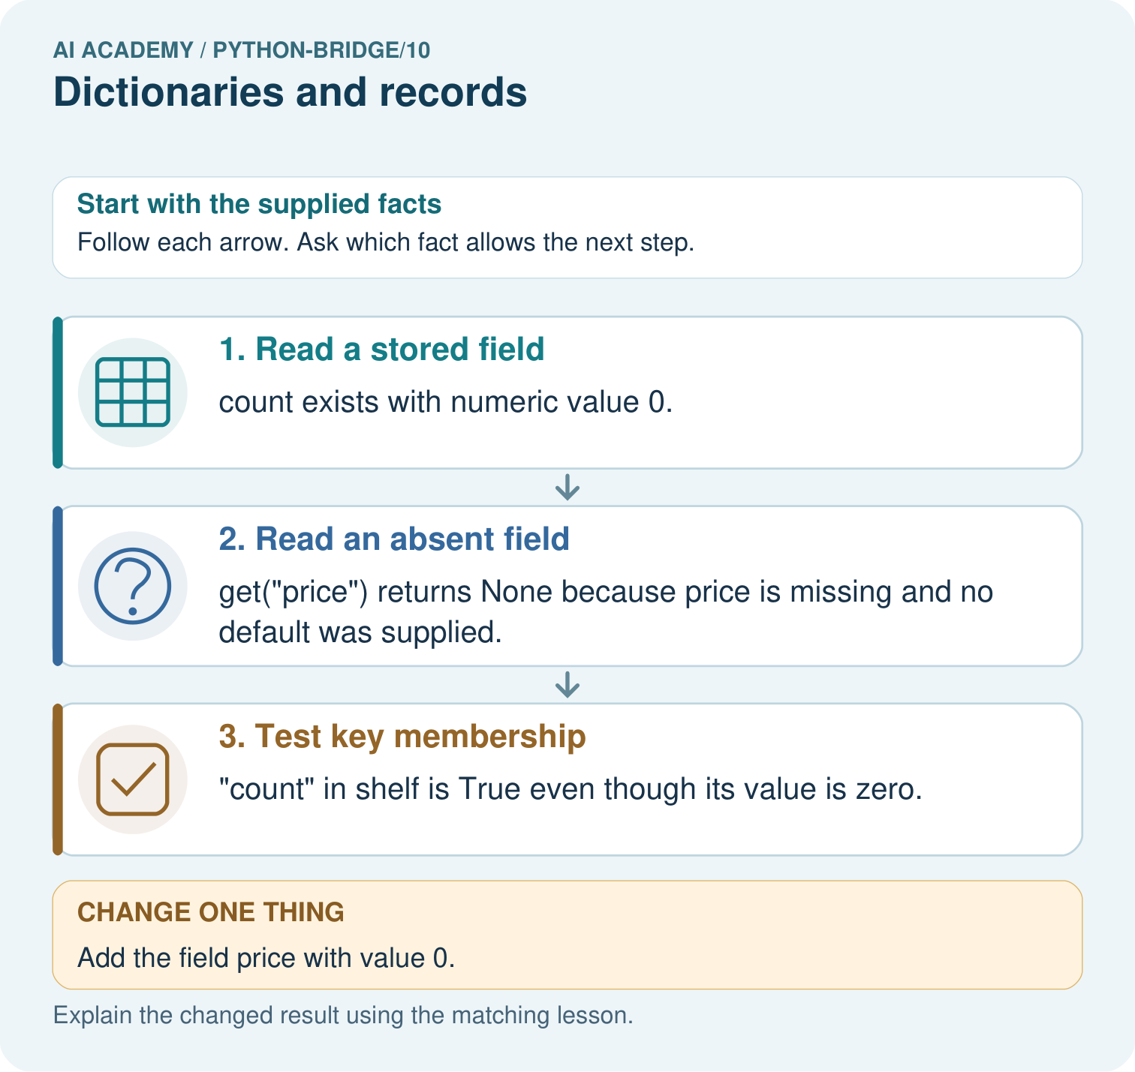
Predict all three original outputs. Explain the difference between count=0 and missing price, then predict the lookup after price=0 is added.

My picture-based explanation and changed-case prediction
________________________________________________________________
________________________________________________________________
________________________________________________________________
________________________________________________________________
________________________________________________________________
________________________________________________________________
Support used: alone / hint / worked example. This record is practice evidence.
Project connection: For Python readiness before the Responsible Plant Classifier, retain a trace of the values, the predicted outputs and the changed-case explanation. Use actual Python 3 results to check the prediction after reasoning first.

