AI ACADEMY · WORKBOOK · python-bridge/12

Testing and debugging functions
Project: Python readiness portfolio

01. Recall and choose your starting point
Try the recall before opening notes. Then use a different colour or a labelled second line to correct your explanation.

Reading structured data
Without opening the old lesson, explain one key idea from Reading structured data. Give an example and a mistake that the idea helps you avoid.

My remembered idea, example and correction
________________________________________________________________
________________________________________________________________
________________________________________________________________

Return values and local state
Without opening the old lesson, explain one key idea from Return values and local state. Give an example and a mistake that the idea helps you avoid.

My remembered idea, example and correction
________________________________________________________________
________________________________________________________________
________________________________________________________________

Loops and trace tables
Without opening the old lesson, explain one key idea from Loops and trace tables. Give an example and a mistake that the idea helps you avoid.

My remembered idea, example and correction
________________________________________________________________
________________________________________________________________
________________________________________________________________

02. Practise with fading help
Use W2: Find a revealing case for Testing and debugging functions. Record the answer once; the lesson and workbook refer to the same attempt.
Given inputs | Procedure I chose | Middle steps | Result and check

The step I completed without help, and the hint I needed
________________________________________________________________
________________________________________________________________
________________________________________________________________

03. Individual reasoning check
Use the worked case for Testing and debugging functions. Proposed explanation: “A successful run proves the conclusion”. Decide whether this explanation is supported. Point to the step or supplied fact that decides; explain your repair if needed.

My explanation before partner discussion
________________________________________________________________
________________________________________________________________
________________________________________________________________
________________________________________________________________

04. Independent transfer case

Independent case: Use boundary tests to reveal a function defect
Predict the output. If the function mistakenly uses x<=10, identify the first failing assertion and whether the final print happens. State the repair and which earlier tests must be rerun. Do these cases prove all input types are handled?
def below_limit(x):
return x < 10
assert below_limit(9) is True
assert below_limit(10) is False
assert below_limit(11) is False
print("three checks passed")

My independent explanation, trace and limits
________________________________________________________________
________________________________________________________________
________________________________________________________________
________________________________________________________________
________________________________________________________________
________________________________________________________________
________________________________________________________________
Attempt this case before feedback. Record any help. Earlier examples below are further practice; a case already practised with feedback cannot establish fresh transfer.

05. W1 Write expectations
Give expected results for remaining(6, 2), remaining(6, 6) and remaining(6, 0).

My reasoning and evidence
________________________________________________________________
________________________________________________________________
________________________________________________________________
________________________________________________________________
________________________________________________________________
________________________________________________________________

06. W2 Find a revealing case
A faulty function always returns 4. Which of your three cases pass and fail?

My reasoning and evidence
________________________________________________________________
________________________________________________________________
________________________________________________________________
________________________________________________________________
________________________________________________________________
________________________________________________________________

07. W3 Repair and retest
A faulty function adds capacity and used. For (6, 2), state actual and expected. Repair it and name a regression case.

My reasoning and evidence
________________________________________________________________
________________________________________________________________
________________________________________________________________
________________________________________________________________
________________________________________________________________
________________________________________________________________

08. W4 Test a new function independently
Define stock(packs, loose) to return packs * 4 + loose. Create expected tests for (2, 3), (0, 3), (2, 0), then show which detects a faulty packs + loose body.

My reasoning and evidence
________________________________________________________________
________________________________________________________________
________________________________________________________________
________________________________________________________________
________________________________________________________________
________________________________________________________________
________________________________________________________________
________________________________________________________________

09. W5 Limit the conclusion
All three stock tests pass. Does that prove correct handling of negative counts?

My reasoning and evidence
________________________________________________________________
________________________________________________________________
________________________________________________________________
________________________________________________________________
________________________________________________________________
________________________________________________________________

10. Project checkpoint and reflection
Add a labelled testing and debugging functions evidence sheet to Python readiness portfolio. Show how you can design revealing tests for a function. Use the supplied fictional case and keep its inputs, intermediate steps, calculation or prediction, and limitation. Connect this record to last week’s record; a matching answer without a trace is insufficient.

My project change, supporting evidence and remaining limit
________________________________________________________________
________________________________________________________________
________________________________________________________________
________________________________________________________________
________________________________________________________________
________________________________________________________________

11. Feedback, return check and learning record
Evidence | My record
Worked alone / hint / model
First step I repaired and why
New case checked later; date and result
What I can now explain without notes
One remaining question
Revisit this idea with your teacher after a delay. Familiarity is different from explaining and using it on a changed case.

12. Pictorial case practice: Testing and debugging functions
Use a test that catches the boundary bug. A function should classify an integer as tiny exactly when it is less than three.
Python 3 intended function: return x<3. Test cases: (2,True),(3,False),(4,False). Candidate bug: return x<=3.
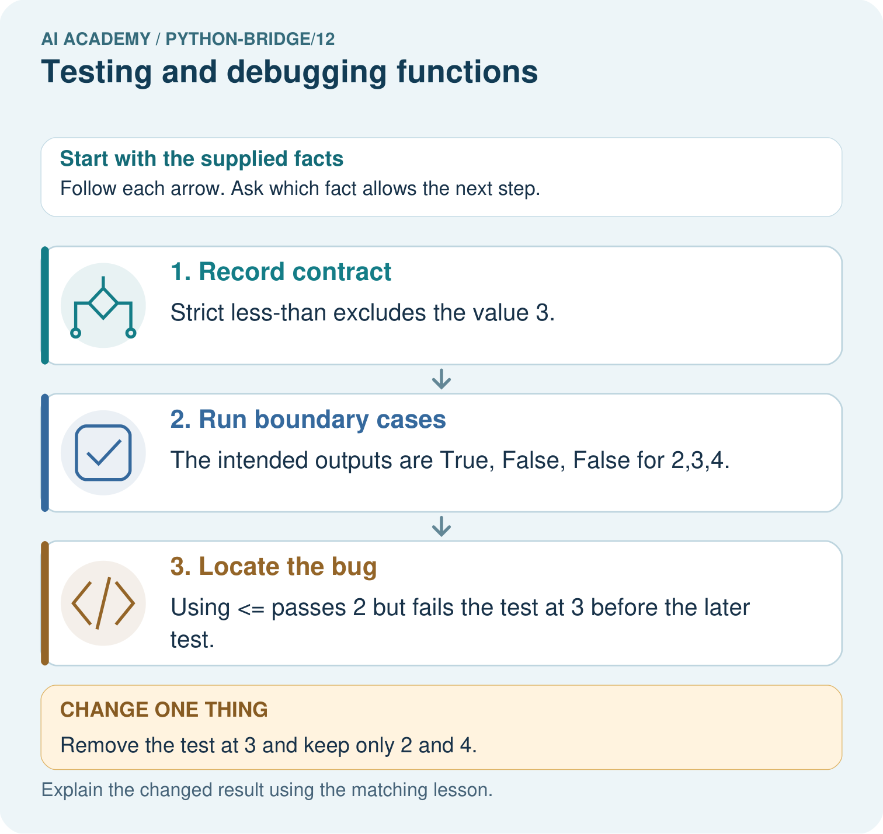
Predict the three correct outputs. Which test first catches <=, and why do tests at only two and four miss the bug?

My picture-based explanation and changed-case prediction
________________________________________________________________
________________________________________________________________
________________________________________________________________
________________________________________________________________
________________________________________________________________
________________________________________________________________
Support used: alone / hint / worked example. This record is practice evidence.
Project connection: For Python readiness before the Responsible Plant Classifier, retain a trace of the values, the predicted outputs and the changed-case explanation. Use actual Python 3 results to check the prediction after reasoning first.

