AI ACADEMY · STUDENT · ai-1/31

Design the Decision Process
Project: Helpful Classroom Sorter

Before you start
Week 10: AND, OR and ordered branches change outcomes.

01. Your mission

Your learning target
I can design a decision process that covers valid, invalid and no-match requests.
I can trace changing state and explain why the search stops.
I can preserve both compatibility conditions and the agreed first-match rule.

Remember before reading
Close your notes first. A rough first answer helps us choose the right starting point; it is not a score for your ability.
Without opening the old lesson, explain one key idea from Choose Inputs and Outputs. Give an example and a mistake that the idea helps you avoid.
Without opening the old lesson, explain one key idea from Humans Set Boundaries. Give an example and a mistake that the idea helps you avoid.
Without opening the old lesson, explain one key idea from Generate, Retrieve, or Calculate?. Give an example and a mistake that the idea helps you avoid.
After trying, check the relevant lesson or ask your teacher. Change the part of your explanation that the evidence shows was wrong.
Rules or learned patterns must connect inputs to outputs transparently.
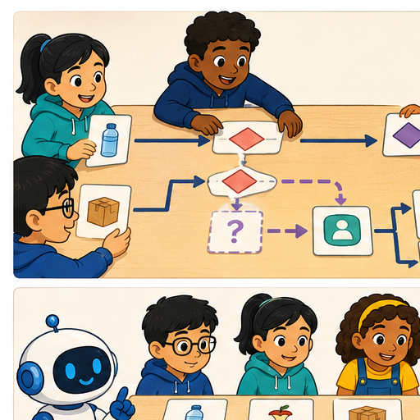
LEARNING TARGET Rule: if paper then P, otherwise M. Inputs are paper, metal, glass and unknown. Repair the rule for paper and metal trays without inventing a glass tray. Trace all four inputs.
Learner name:

Readiness for the connected explanation
For the activity project, how does a blank time differ from a valid request for zero minutes?

This week’s end goal
By the end, I can design a complete decision flow with validation, search and stopping.

02. Notice the evidence
PICTURE STORY

Look Closely Before You Explain
Pictures give clues; evidence tells us what the clues mean.

MYSTERY A transparent sorter first checks item type, then one disambiguating feature, then sends unclear items to review.

What do you notice?
Name three visible details without explaining them yet.
Circle the detail most connected to the system's decision.
Name one detail that may be decoration or distraction.
Make a first prediction and state the clue that supports it.
My observations, prediction, and evidence:
GOOD THINKING A prediction can change when stronger evidence appears.

A closer explanation
A complete process says what happens for every kind of request in the task. It must handle a fitting activity, no fitting activity and unusable input. We will design a paper algorithm before building the prototype. Its decisions use the requirements from Week 30, so a different drawing should not silently change what counts as correct.
Keep the same catalogue order: B1 Bookmark drawing, 10 minutes, quiet Yes; B2 Story circle, 8 minutes, quiet No; B3 Pattern puzzle, 12 minutes, quiet Yes; B4 Tower challenge, 15 minutes, quiet No. These are fixed paper-model values with materials assumed available. Valid input is a whole number of minutes from 0 to 30 and Quiet required Yes or No.
A candidate fits when its required minutes are no more than the available minutes and either quiet is not required or the activity is quiet. Both parts must hold. The output is the first fitting activity in catalogue order, with a reason, or a clear no-match result. Invalid or missing input produces a clarification request. None of these outputs books materials or publishes a message.

03. See how it works
VISUAL MECHANISM

Input → Process → Output
Follow the information instead of imagining magic inside the machine.
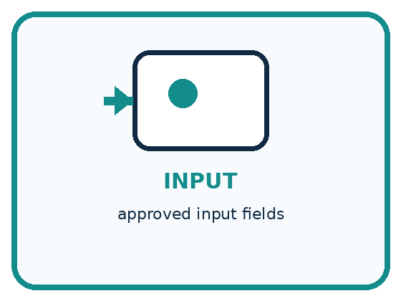
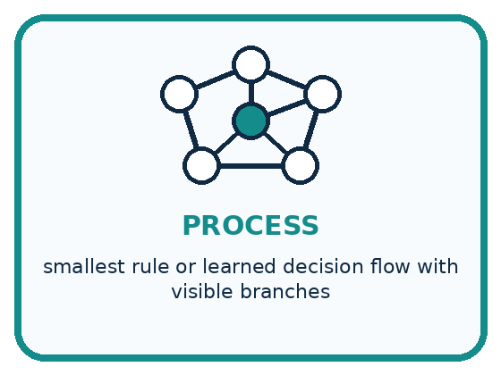
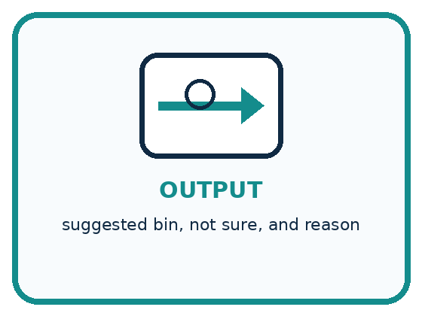
INPUT approved input fields
PROCESS smallest rule or learned decision flow with visible branches
OUTPUT suggested bin, not sure, and reason
CORE IDEA Rules or learned patterns must connect inputs to outputs transparently.
UNDER THE HOOD A decision process operationalizes the interface contract. Simplicity improves testability and explanation, but oversimplification can erase relevant distinctions. Learned components need explicit data, threshold, and fallback documentation.
Draw a fresh example with all three stages:

A closer explanation

Four paths through the recommender
Condition reached | Next action | Where the path ends
Input missing or invalid | Ask for corrected input | Stop this run
Candidate fails a check | Move to the next row | Continue search
Candidate passes both | Suggest it with a reason | Stop this run
All rows checked and failed | Report no match | Stop this run
Failing one candidate continues the search. No match is justified only after the valid request has no fitting candidate.
Begin by checking the request. If minutes are missing, outside 0 to 30 or not a whole number, ask for a whole number in that range. If the quiet field is not Yes or No, ask for one of those values. State the fields needing correction and stop this run. When a corrected request arrives, validate it as a new run rather than continuing with old candidate state.
For a valid request, start at B1. Check time and the quiet condition for the current candidate. If both pass, output that candidate and stop. If either fails, move forward exactly one row. After B4 fails, there is no next row, so output no match and stop. Never jump back to B1 within the same search.

Connect the picture and the explanation
Point to the input, the deciding step and the result in this week’s visual. Explain the same step in ordinary words. A picture helps when you can say what each part represents.

04. Compare the cases
PICTURE GALLERY

Four Cases, Four Clues
Use the visual cue, then read the evidence carefully.
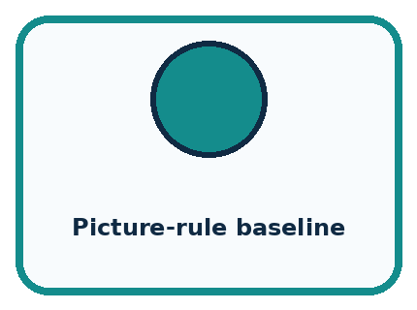
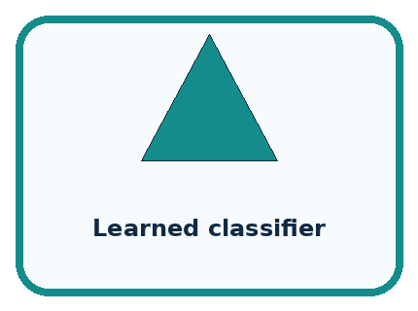
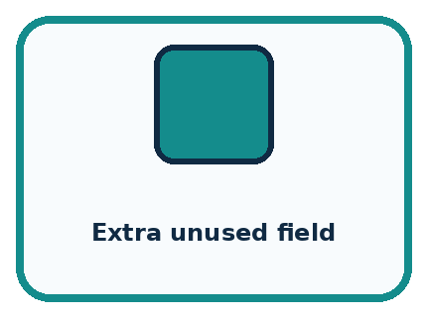
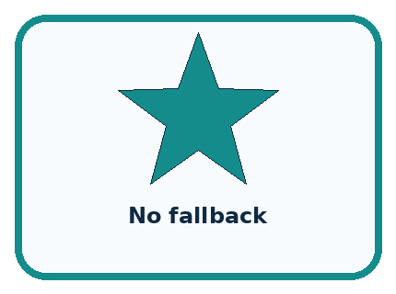
CASE 1 — Picture-rule baseline Clue: direct visible branches. Meaning: easy to inspect.
CASE 2 — Learned classifier Clue: patterns from examples. Meaning: needs data evidence.
CASE 3 — Extra unused field Clue: never changes path. Meaning: remove.
CASE 4 — No fallback Clue: forces ambiguous label. Meaning: add review.
BOUNDARY Transparent does not mean correct; the flow still needs testing.
Which two pictures are easiest to confuse? What evidence separates them?

Change one thing in the pictured case
Change: Increase scissors needed to 3.
Prediction: K3 is selected.
Reason: K1 lacks glue; K2 has only 2 scissors; K3 has glue and 4.

05. Words that unlock the idea
VOCABULARY

Words You Can See and Use
The badge is a memory cue; the definition does the real thinking work.
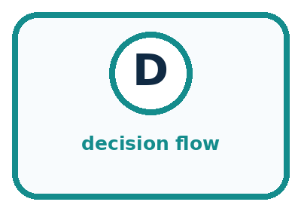
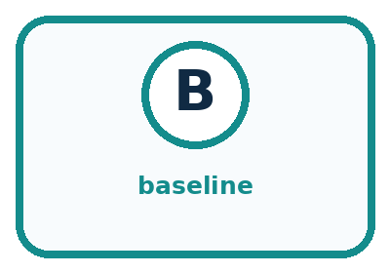
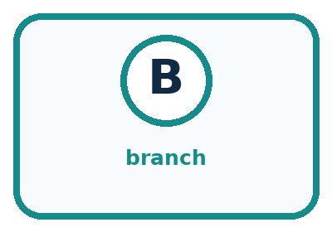
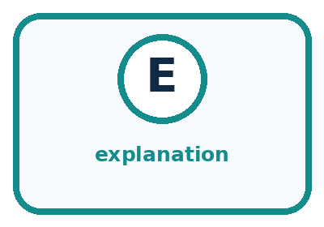
Word | Meaning | My example
decision flow | ordered path connecting inputs to outputs
baseline | simple method used for comparison
branch | path chosen by a condition
explanation | traceable reason for an output

Misconception detective
CLAIM TO REPAIR A longer flow must be more capable.
Use one vocabulary word and one piece of evidence to repair it:
WORD POWER A strong definition helps you decide something in a new case.

Words used in the closer explanation
Word | Meaning
Validation | Checking an input against the agreed rules before using it
Candidate | An option currently being checked
State | Information that records the process’s current position or values
Termination | Reaching a point where the process stops

06. Follow a worked example
WORKED EXAMPLE

Watch the Reasoning, Not Just the Answer
Every step connects a claim to observable evidence.

CASE A transparent sorter first checks item type, then one disambiguating feature, then sends unclear items to review.
STEP 1 — OBSERVE approved input fields
STEP 2 — TRACE smallest rule or learned decision flow with visible branches
STEP 3 — CONCLUDE suggested bin, not sure, and reason
MODEL REASONING Start with a baseline whose branches can be read aloud. Each input must affect a decision or be removed. Add not-sure and review paths, then explain when a learned component would earn its added complexity.
DO NOT OVERCLAIM Transparent does not mean correct; the flow still needs testing.
What new evidence could change this answer?

A closer explanation
Stage for 9 minutes and Quiet required No | Evidence | Next state or output
Validate | 9 is a whole number in range; No is valid | Current candidate B1
Check B1 | 10 minutes is more than 9 | Move to B2
Check B2 | 8 is no more than 9; quiet is not required | Suggest B2 and stop
The current candidate changes from B1 to B2. The request values stay the same. After B2 passes, the process stops: it does not replace B2 with a later fitting row. This early stop preserves the first-match rule and gives the same required suggestion as the manual baseline, which marked every row before selecting the first fit.
Termination needs a reason. There are only four rows, each failed check moves to the next row, and no row is revisited. A valid request therefore examines at most four candidates. A success can stop sooner. Invalid input stops before the search. Merely drawing an arrow around a loop is not enough; the state must make progress toward an end.

Learn from the worked case
Cover the result before checking it. Say what is given, choose the procedure, and follow one step at a time. Then uncover the result and explain your first mismatch. Ask why a step is allowed, not only what number it produces.

A pictorial worked case: Design the Decision Process
A fictional worksheet routes craft kits by required glue and number of scissors.

The facts we will use
K1: glue No, scissors 2. K2: glue Yes, scissors 2. K3: glue Yes, scissors 4.
Request: glue required Yes, scissors needed 2. Return first kit meeting both requirements.
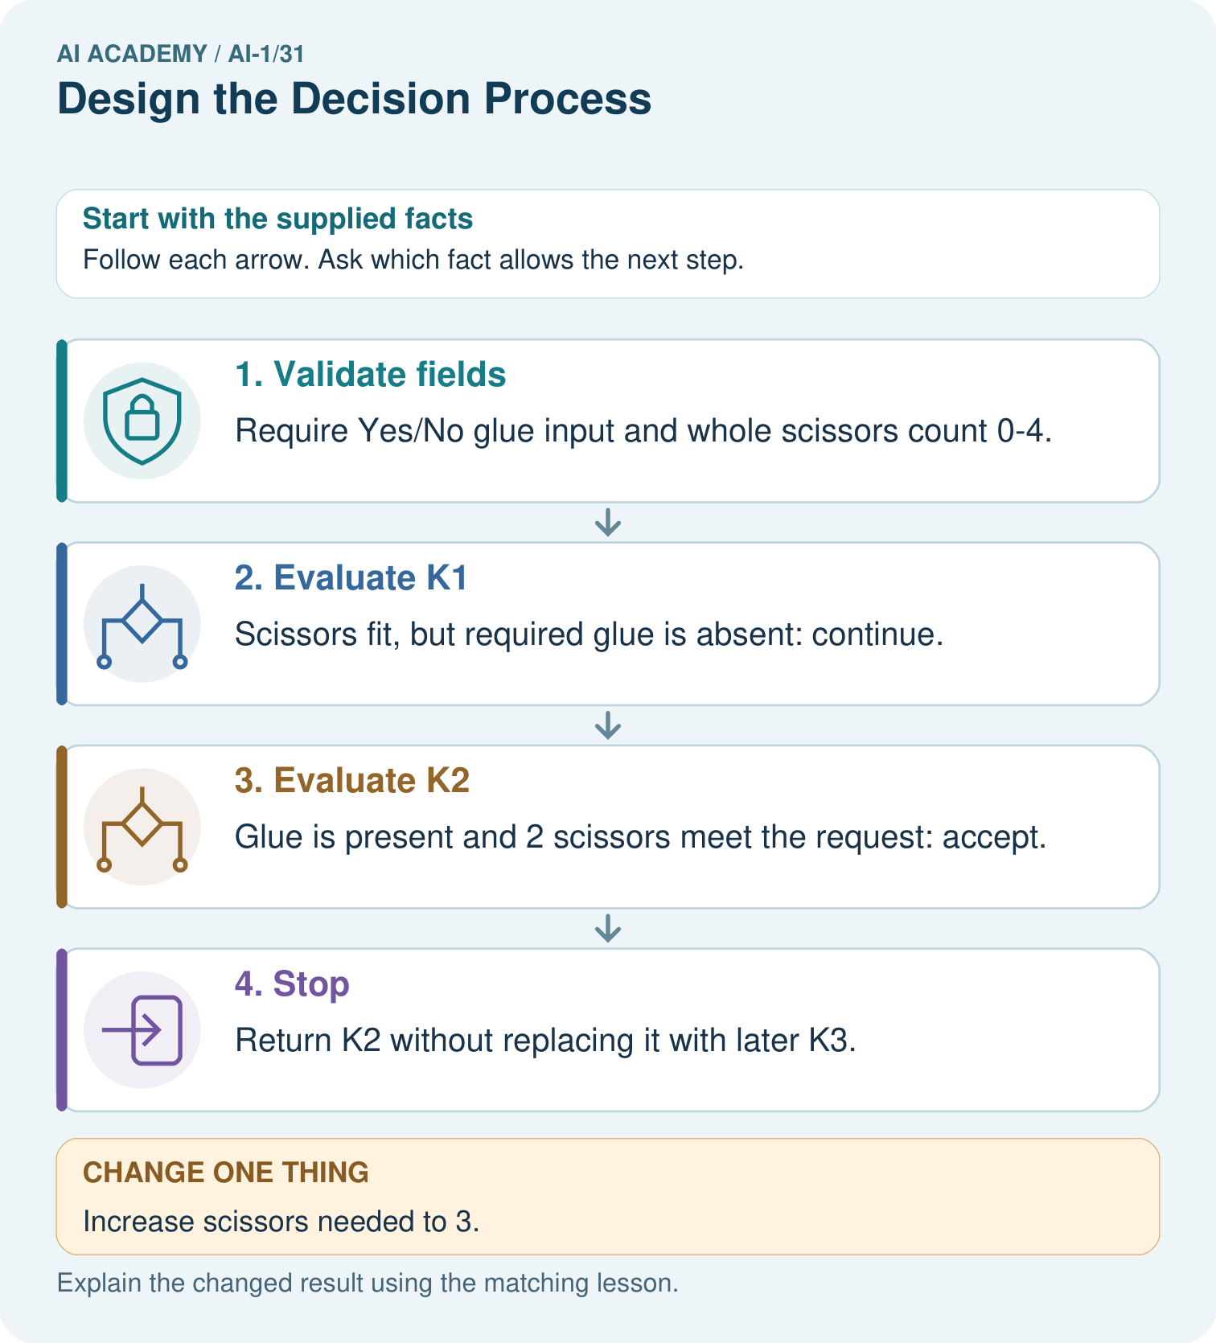

Read the picture one step at a time
Step | What happens and why
1. Validate fields | Require Yes/No glue input and whole scissors count 0–4.
2. Evaluate K1 | Scissors fit, but required glue is absent: continue.
3. Evaluate K2 | Glue is present and 2 scissors meet the request: accept.
4. Stop | Return K2 without replacing it with later K3.
Match each pictured step to the supplied facts. This is a worked teaching case, not an independent assessment.

Why this result follows
A complete decision process specifies what to do after each result. One passing requirement is insufficient. After a kit passes both, stopping preserves the first-match contract; automatically choosing the largest later kit would implement a different rule. A full scan with no accepted kit returns no match.

What this example does not establish
A correct flow depends on accurate catalogue entries and the declared requirements; the picture does not verify inventory.
Read the labelled picture: Where does the first original rejection occur, and why is K3 not originally selected?
Change one thing: Increase scissors needed to 3. Predict the result before checking the explanation. What remains the same?

07. Find and repair a mistake
COMPARE

Same Result, Different Reason
A comparison helps reveal the true concept boundary.
Case | Evidence | What it shows
Picture-rule baseline | direct visible branches | easy to inspect
Learned classifier | patterns from examples | needs data evidence
Extra unused field | never changes path | remove
No fallback | forces ambiguous label | add review

Repair two tempting claims
CLAIM A A longer flow must be more capable.
Repair:
CLAIM B A learned model does not need a visible fallback or explanation.
Repair:
STRONG ANSWER FRAME I claim ______ because the evidence shows ______. The process is ______. One limit is ______.

A closer explanation
An explanation should identify the checks that actually justified the result. For example, B2 fits the 9-minute No request because its 8-minute duration fits and quiet was not required. Do not add “you will love it”, which was neither an input nor a tested condition. For no match, report that no catalogue row met both conditions; a trace can show why.
Save a labelled version of the process with its validation, candidate order, conditions, state changes and stopping points. A partner should be able to follow it without asking you to fill a missing step. Next week the paper prototype will turn this design into instruction cards and a trace record. Keep any final evaluation cases reserved while developing the design.

A design finds B1 compatible for 15 minutes No but keeps searching and returns B4 instead. Is B4 compatible? Does this output meet the full task requirements? Explain the difference and give the required output
________________________________________________________________
________________________________________________________________
________________________________________________________________
________________________________________________________________

08. Practise together
GUIDED PRACTICE

Try It, Check It, Explain It
Use support now so you can succeed independently later.

Explain how the picture story demonstrates this idea: Rules or learned patterns must connect inputs to outputs transparently.
Use a fresh example to explain decision flow.
Trace a new input → process → output example.
Find and repair the error in: A learned model does not need a visible fallback or explanation.
Invent one edge case and name the safe response.
PARTNER CHECK Point to the evidence. Do not accept an answer that only repeats the vocabulary word.

A closer explanation
Consider the mistaken instruction “If B1 fails, report no match.” It would miss B2 on the 9-minute No request. Another mistake is “If time fits or quiet fits, suggest the activity.” That could allow an activity that takes too long merely because it is quiet. Use a concrete request to show which requirement a design breaks.

Trace 9 minutes with Quiet required Yes through every candidate. State the reason each fails and the final output. Then explain what would happen if a failed candidate were checked again without moving to the next row. Finally, state the first step for 31 minutes with Quiet required No
________________________________________________________________
________________________________________________________________
________________________________________________________________
________________________________________________________________
________________________________________________________________
________________________________________________________________
________________________________________________________________
A process must also distinguish the meaning of No from a requirement for noise. When Quiet required is No, a quiet candidate can still pass. For 11 minutes No, B1 fits and comes first, even though B2 also fits. An instruction to reject all quiet activities when No is selected would change the task.

Practise with less help: Track the current candidate
Use workbook W2 for the connected example “Designing a complete decision process”. First fill the input and rule boxes. Try the middle steps before asking for a hint. After a hint, try the next step yourself.
Plan | Do | Check
What is given? Which rule or procedure applies? | Record each intermediate step. | Does the result follow? What remains unknown?
Explain your trace to a partner. Your partner points to one step to check. Swap roles on the next case. Each person writes their own explanation.

Check your reasoning
Use the worked case for Designing a complete decision process. Proposed explanation: “One failed row proves no match”. Decide whether this explanation is supported. Point to the step or supplied fact that decides; explain your repair if needed.
Answer on your own before discussion. If you are unsure, say which step you need help with.

Explain the picture
Where does the first original rejection occur, and why is K3 not originally selected?

My explanation using a pictured step and the given facts
________________________________________________________________
________________________________________________________________
________________________________________________________________
________________________________________________________________
This is supported practice. Keep the separately named independent case for an attempt before feedback.

09. Run the investigation
EXPLORER LAB

Smallest Useful Flow
Predict first, test honestly, and explain what the evidence means.
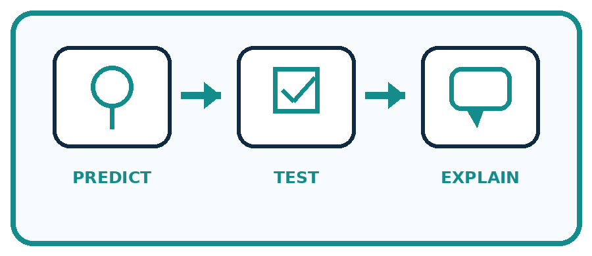
State your prediction before the result is known.
Complete the task: Create and trace the smallest useful decision flow.
Keep a normal case and an edge case clearly separated.
Record what happened—even when it does not match your prediction.
Explain the result, one limitation, and the next useful test.
Case | Prediction | Observed result | What it means
Normal
Edge
INDEPENDENCE After support is removed, repeat the proof with a fresh case.

Plan → try → check
Before trying: what do I expect, and why? While trying: which step could first go wrong? Afterwards: what did I actually observe, and what should change? Keep “not run” if you only traced the procedure.

10. Build your understanding
PRACTICE LADDER

Climb from Recall to Defense
Each step asks for a stronger kind of understanding.
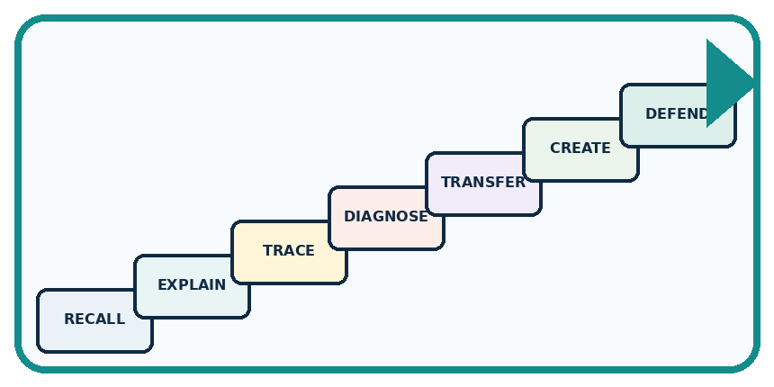
RECALL Define decision flow.
EXPLAIN Rules or learned patterns must connect inputs to outputs transparently.
TRACE Show the input, process, and output.
DIAGNOSE Repair: A longer flow must be more capable.
TRANSFER Apply the idea to a new home or classroom case.
CREATE Design one revealing test.
DEFEND Give a claim, evidence, mechanism, limit, and safe action.
RETRY RULE A coached answer becomes mastery only after you solve a different case independently.

11. Connect your project
PROJECT

Helpful Classroom Sorter
Build one coherent system across the year, one evidence-based decision at a time.
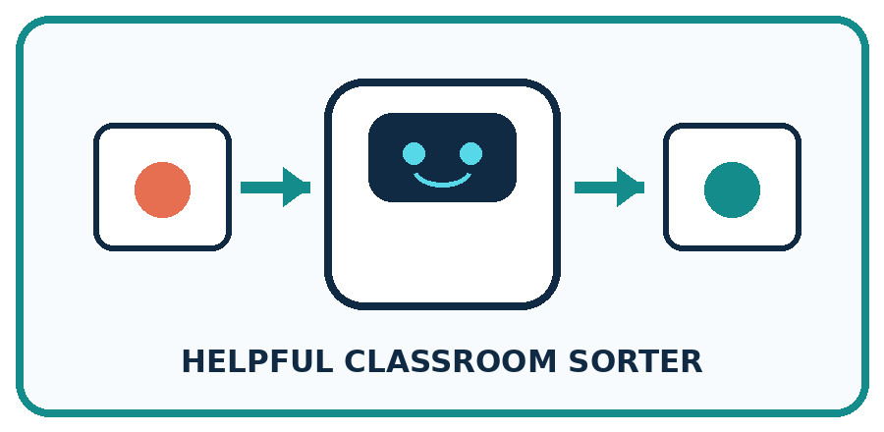
THIS WEEK'S CHECKPOINT Complete the sorter v1 decision flow and annotate every branch with the evidence it uses.
What real classroom need does this serve?
What information is necessary—and what should stay private?
What happens inside the process?
What normal and edge cases will you test?
When should it say not sure or ask a person?

RESPONSIBLE DESIGN Transparent does not mean correct; the flow still needs testing.
My project decision:

Evidence for your project
Draw the sorter’s decision branches, loop-back arrows, final outputs and invalid-input path so every valid case can terminate.

12. Show what you know
MASTERY

Fresh-Case Independent Proof
Complete this after teaching and guided practice have ended.
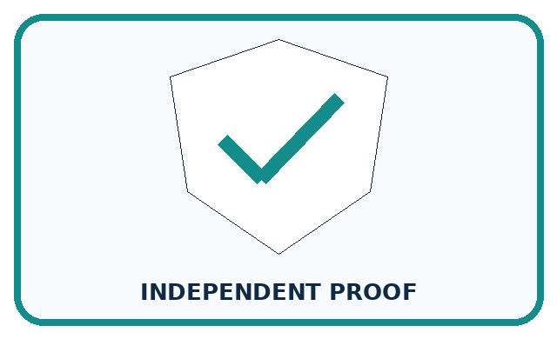
REQUIRED PROOF Create and trace the smallest useful decision flow across normal, missing, and ambiguous inputs.
□ Name or draw the fresh case.
□ Trace input, process, and output.
□ State the conclusion and strongest evidence.
□ Name one limit, failure, missing clue, or fairness/privacy concern.
□ Explain one safe next action or improvement.
Independent evidence:
SELF-CHECK Start with a baseline whose branches can be read aloud. Each input must affect a decision or be removed. Add not-sure and review paths, then explain when a learned component would earn its added complexity.
My level: □ Not yet □ With one hint □ Independently □ I can teach it
NEXT BRIDGE Carry today's evidence habit into: Build a Paper Prototype.

13. Study a complete case

Week 31 Worked case
Use the supplied details to practise the weekly concept before attempting the independent question. This case extends the illustrated lesson.

The situation
A rule sends paper to P and everything else to M. Inputs include paper, metal and glass.

The question
Trace glass and repair the rule.

Worked explanation
Glass incorrectly goes to M. Add an explicit metal check and a glass or review branch. Otherwise includes all remaining cases.

Explain it in your own words
Which detail supports the answer, and why does it matter?

Write or draw your reasoning and evidence.
________________________________________________________________
________________________________________________________________
________________________________________________________________
________________________________________________________________
________________________________________________________________

Trace the supplied case visually

Otherwise includes every remaining case
Evidence or stage | Value or result
Paper | Yes → P
Not paper, metal | Yes → M
Not paper, not metal | Glass or review
A rule sends paper to P and everything else to M. Inputs include paper, metal and glass.
Trace glass and repair the rule.
Glass incorrectly goes to M. Add an explicit metal check and a glass or review branch. Otherwise includes all remaining cases.

14. Try a new case independently

Independent case: Design a complete room decision process
A new paper catalogue lists C1 first, capacity 4, quiet Yes; C2 second, capacity 8, quiet No. Valid requests give a whole group size from 1 to 10 and Quiet required Yes or No. A room fits if capacity is at least group size and the quiet condition is met; choose the first fit. Write a complete process with validation, search, state change and stopping rules. Trace 6 people No and explain the outcome for a blank quiet field. No booking takes place.

My independent explanation, trace and limits
________________________________________________________________
________________________________________________________________
________________________________________________________________
________________________________________________________________
________________________________________________________________
________________________________________________________________
________________________________________________________________
Attempt this case before feedback. Record any help. Earlier examples below are further practice; a case already practised with feedback cannot establish fresh transfer.

Week 31 Independent application
Close the worked explanation. Apply the idea to this different question without copying.
Write a decision process: a clear pencil goes to the pencil tray, a clear book to the shelf, and an unknown object to review. Trace a lunch box.
My answer, with a trace, calculation or supporting evidence

Write or draw your reasoning and evidence.
________________________________________________________________
________________________________________________________________
________________________________________________________________
________________________________________________________________
________________________________________________________________

Create and test
Change one relevant detail. Predict the result before testing. Include a boundary or missing-information case when it helps reveal a limit.
My changed input and expected result

Write or draw your reasoning and evidence.
________________________________________________________________
________________________________________________________________
________________________________________________________________
________________________________________________________________
________________________________________________________________

Connect to your project
Complete the sorter v1 decision flow and annotate every branch with the evidence it uses.
The evidence I will keep

Write or draw your reasoning and evidence.
________________________________________________________________
________________________________________________________________
________________________________________________________________
________________________________________________________________
________________________________________________________________
Your teacher has the independent answer and scoring criteria. Complete the matching workbook week to keep your practice evidence together.

Transfer practice from the original programme
Rule: if paper then P, otherwise M. Inputs are paper, metal, glass and unknown. Repair the rule for paper and metal trays without inventing a glass tray. Trace all four inputs.

Explain the mechanism, evidence and one limit.
________________________________________________________________
________________________________________________________________
________________________________________________________________
________________________________________________________________
________________________________________________________________
________________________________________________________________
________________________________________________________________

Use feedback to improve
Attempt the independent case before hints. Record whether you worked alone, used a hint or followed a model. After feedback, fix the first unsupported step and explain why it changed. A later check uses a changed case, not a copied answer.

15. Your lesson route
Start with this question: A fictional worksheet routes craft kits by required glue and number of scissors.
By the end, I can | How I will show it
Design a decision process that covers valid, invalid and no-match requests | Explain the deciding step, show a trace or test, and state one limit.
Trace changing state and explain why the search stops | Explain the deciding step, show a trace or test, and state one limit.
Preserve both compatibility conditions and the agreed first-match rule | Explain the deciding step, show a trace or test, and state one limit.
Remember → watch and explain → try with help → investigate → try independently → keep project evidence. Your teacher may spread this lesson across several classes.
Keep your first prediction. Compare it with what the evidence shows and explain any change.

16. Finish and return
Close your notes. Explain this goal in your own words: Design a decision process that covers valid, invalid and no-match requests

My deciding step, evidence and one remaining question
________________________________________________________________
________________________________________________________________
________________________________________________________________
________________________________________________________________
________________________________________________________________
If you are unsure, return to the worked picture and explain one arrow. If you are ready, change an input or assumption and justify your prediction.
Save your workbook evidence. At the next review, try a different case before opening your old answer.

