AI ACADEMY · STUDENT · ai-2/24

Feedback Loops
Project: Transparent Book Recommender

Before you start
Week 19: collected observations depend on who or what was selected.

01. Your mission

Your learning target
I can implement a deterministic recommender.
I can handle ties and no eligible options.
I can explain recommendations with their limits.

Remember before reading
Close your notes first. A rough first answer helps us choose the right starting point; it is not a score for your ability.
Without opening the old lesson, explain one key idea from Recommendation Scores. Give an example and a mistake that the idea helps you avoid.
Without opening the old lesson, explain one key idea from Similarity by Selected Traits. Give an example and a mistake that the idea helps you avoid.
Without opening the old lesson, explain one key idea from Missing Data. Give an example and a mistake that the idea helps you avoid.
After trying, check the relevant lesson or ask your teacher. Change the part of your explanation that the evidence shows was wrong.
Week 24: Feedback Loops
Recommendations influence behavior, which then becomes new data.
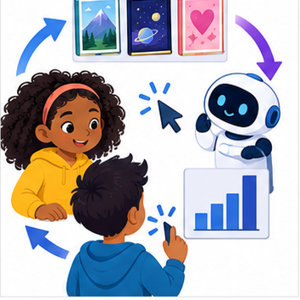
THINKER MISSION
Map how repeated clicks can narrow future suggestions.
Thinker name and date:

Write or draw your reasoning and evidence.
________________________________________________________________
________________________________________________________________
________________________________________________________________
________________________________________________________________
________________________________________________________________

Readiness for the connected explanation
An option violates a hard duration limit but has the best score. Should it win?

This week’s end goal
By the end, I can explain how recommendation exposure can create a feedback loop.

02. Notice the evidence
PICTURE STORY
Notice → Predict → Explain
Begin with visible evidence. Do not explain more than the picture and information support.
MYSTERY
The learners must use feedback loops to solve a problem. What information do they have? What decision or calculation do they make? What would count as evidence that it worked?
Three observations (what you can point to):

Write or draw your reasoning and evidence.
________________________________________________________________
________________________________________________________________
________________________________________________________________
________________________________________________________________
________________________________________________________________
My prediction and the clue supporting it:

Write or draw your reasoning and evidence.
________________________________________________________________
________________________________________________________________
________________________________________________________________
________________________________________________________________
________________________________________________________________

A closer explanation
Build a fictional activity recommender using last week's score. Require duration at most a supplied limit. On a tie choose the alphabetically first name. This makes the outcome reproducible rather than dependent on input order. Assume unique names and validated numeric fields.

03. See how it works
VISUAL MECHANISM
Input → Process → Output
Trace the information. At each stage, ask what changed and how you could test it.
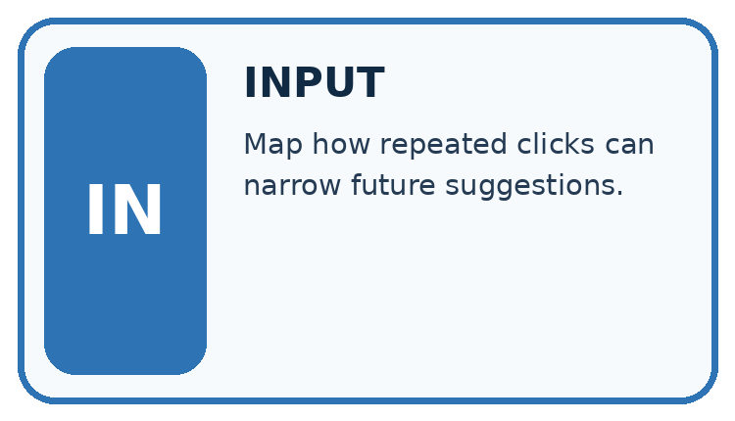
↓
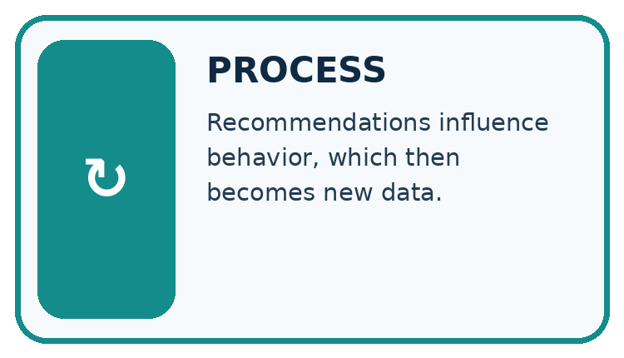
↓
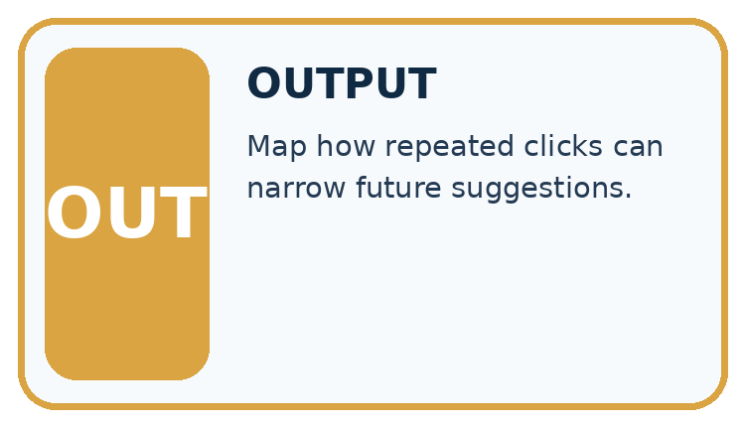
Which stage could fail even when the other two are correct? Explain:

Write or draw your reasoning and evidence.
________________________________________________________________
________________________________________________________________
________________________________________________________________
________________________________________________________________
________________________________________________________________

A closer explanation
def recommend(items, limit):
best = None
best_score = None
for item in items:
if item["minutes"] <= limit:
score = 2 * item["fun"] + item["learning"]
if (best is None or score > best_score
or (score == best_score and item["name"] < best)):
best = item["name"]
best_score = score
return best
items = [{"name": "B", "fun": 3, "learning": 2, "minutes": 10},
{"name": "A", "fun": 2, "learning": 4, "minutes": 9}]
print(recommend(items, 10))

Follow the evidence
Step or case | Evidence | Meaning
B | Eligible score 8 | Temporary best B
A | Eligible score 8 | Alphabetical tie gives A
Read each row from left to right and connect the evidence to the stated rule.
The function prints nothing; the caller prints A. best starts as None to mean no eligible option found. Python short-circuits or: when best is None, later comparisons in that condition need not run. After selecting an item, best_score is numeric. An empty list or no eligible item returns None.

Trace the best-so-far record
Write a trace table with item, eligible, score and best-so-far. In the worked list, B qualifies and scores 8, so B becomes the current best. A also qualifies and scores 8. The scores tie, so the written alphabetical rule changes the best to A. Starting with A gives the same final answer. If no item qualifies, best stays None; do not invent a winner or quietly relax the limit.

Connect the picture and the explanation
Point to the input, the deciding step and the result in this week’s visual. Explain the same step in ordinary words. A picture helps when you can say what each part represents.

04. Compare the cases
CASE GALLERY
Four Tests, Four Kinds of Evidence
A system is not understood until it survives more than one comfortable example.


NORMAL CASE: predict and name evidence. BOUNDARY CASE: predict and name evidence.


MISSING INFORMATION: predict and name evidence. TRANSFER CASE: predict and name evidence.
Which case is most likely to reveal a hidden assumption? Why?

Write or draw your reasoning and evidence.
________________________________________________________________
________________________________________________________________
________________________________________________________________
________________________________________________________________
________________________________________________________________

Change one thing in the pictured case
Change: On a planned trial, show B once and record no click.
Prediction: B gains one exposure but still zero clicks.
Reason: The observation now supports a nonclick on that display, not a permanent dislike.

05. Words that unlock the idea
VOCABULARY LAB
Words You Can Use to Reason
A definition matters when you can recognize the idea, use it, and contrast it with a near-miss.
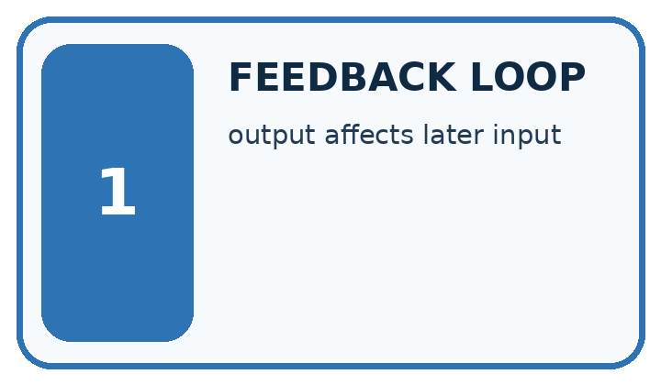
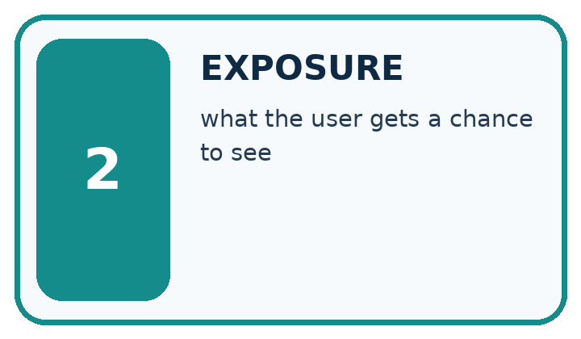
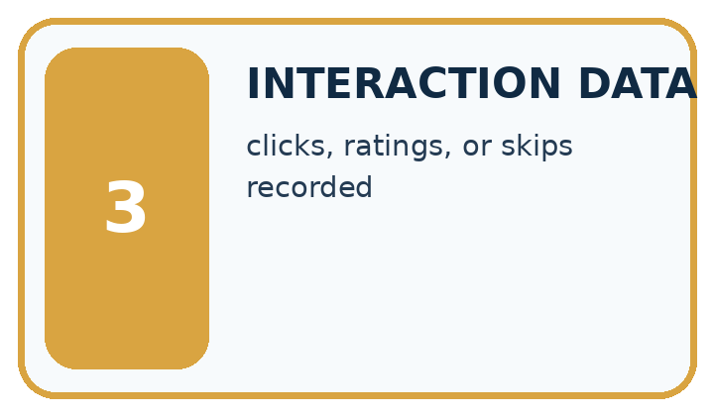
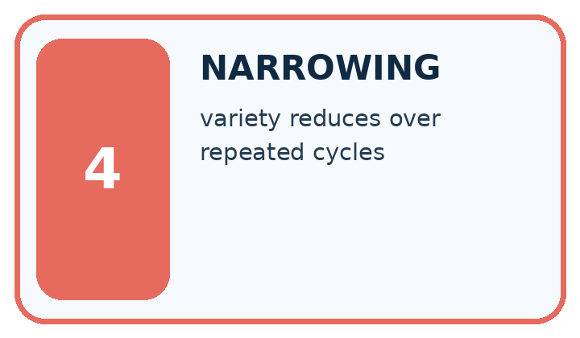
Word | My own example | Not this / boundary
feedback loop | A cycle in which outputs affect later inputs and therefore future outputs.
exposure | The opportunity to see or encounter an item, which can affect later choices.
interaction data | Records of what people were shown and how they acted, such as views, clicks or corrections.
narrowing | Reducing the allowed choices, scope or interpretation of a task.

Words used in the closer explanation
Word | Meaning
Recommender | A procedure that suggests options using a stated policy
Tie | Two options have the same comparison score
Deterministic | The same inputs and rules produce the same result
Explanation | Evidence describing how a result was obtained

06. Follow a worked example
WORKED EVIDENCE
Reason Step by Step
Predict first. Then check each step. A correct answer without visible reasoning is incomplete evidence.
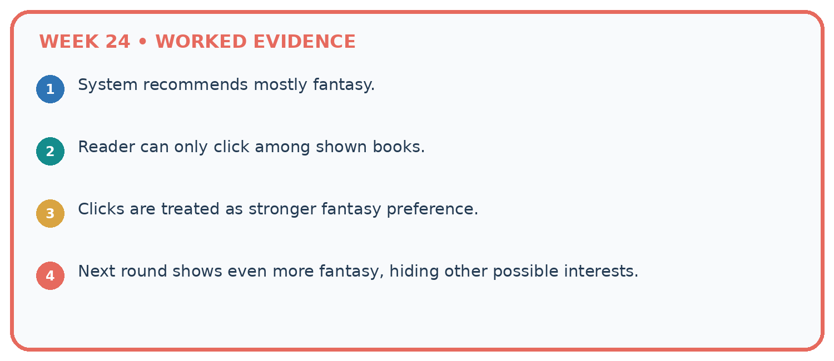
1. System recommends mostly fantasy.
2. Reader can only click among shown books.
3. Clicks are treated as stronger fantasy preference.
4. Next round shows even more fantasy, hiding other possible interests.
Recalculate, retrace, or restate the reasoning in your own representation:

Write or draw your reasoning and evidence.
________________________________________________________________
________________________________________________________________
________________________________________________________________
________________________________________________________________
________________________________________________________________
CHECK Did the evidence answer the exact question? Did the total, path, or source record stay consistent?

A closer explanation

Predict the result if the list order is reversed, and if the limit is 8.
________________________________________________________________
________________________________________________________________
________________________________________________________________
________________________________________________________________
________________________________________________________________
________________________________________________________________

Learn from the worked case
Cover the result before checking it. Say what is given, choose the procedure, and follow one step at a time. Then uncover the result and explain your first mismatch. Ask why a step is allowed, not only what number it produces.

A pictorial worked case: Feedback Loops
A fictional catalogue repeatedly recommends two books using observed clicks.

The facts we will use
Initially each click count is 0. Equal counts choose earlier ID A over B.
Only the recommended book is shown. In an invented three-round record, A is shown and clicked each round; B is never shown.
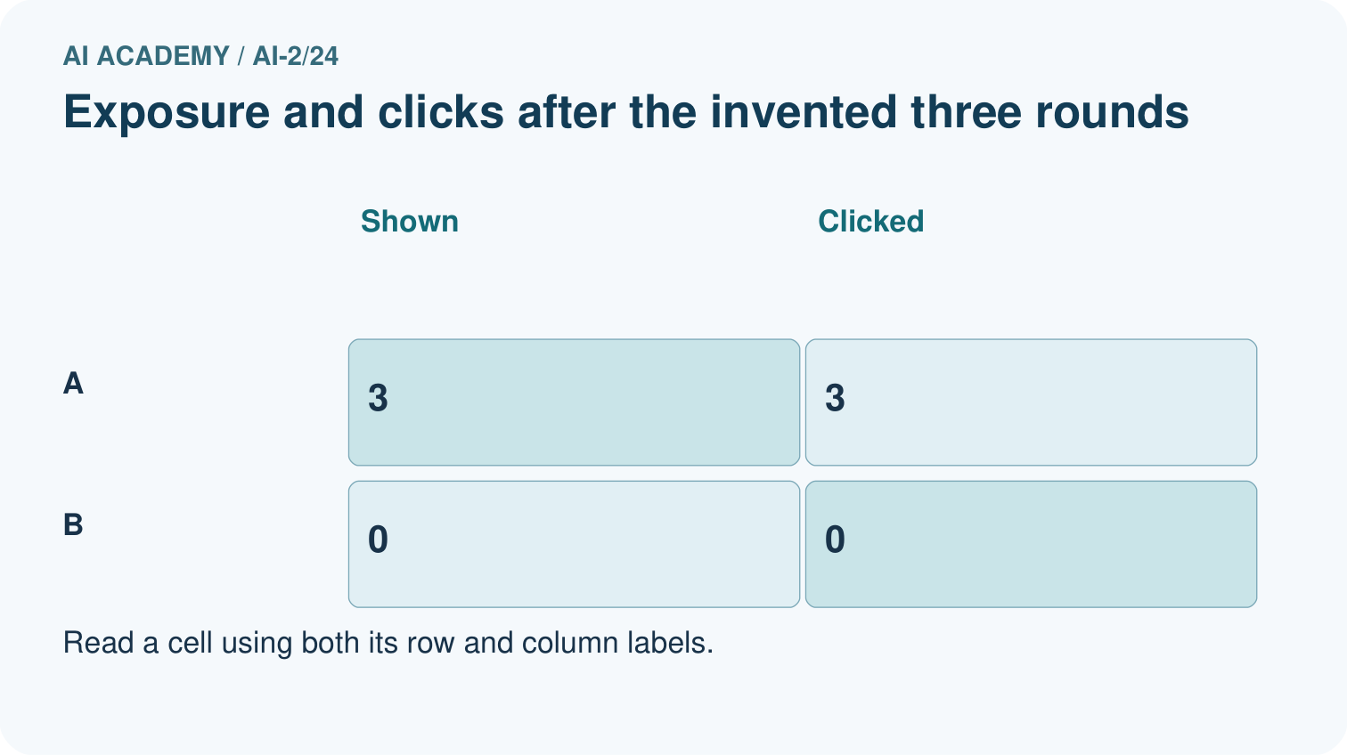
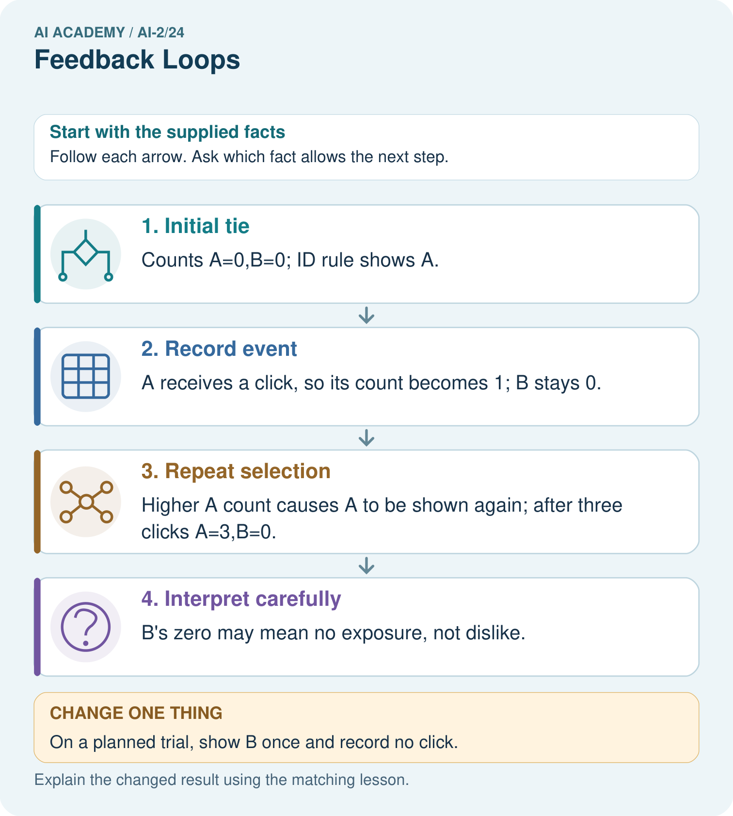

Read the picture one step at a time
Step | What happens and why
1. Initial tie | Counts A=0,B=0; ID rule shows A.
2. Record event | A receives a click, so its count becomes 1; B stays 0.
3. Repeat selection | Higher A count causes A to be shown again; after three clicks A=3,B=0.
4. Interpret carefully | B’s zero may mean no exposure, not dislike.
Match each pictured step to the supplied facts. This is a worked teaching case, not an independent assessment.

Why this result follows
The selection policy changes which evidence is available. A accumulates clicks partly because the system gives it every opportunity, while B has none. These records cannot compare enjoyment of two equally exposed books. Keep display counts separate from click counts; investigate alternatives with a teacher-approved exposure plan rather than treating zero as negative feedback.

What this example does not establish
A click can reflect curiosity or a mistake; even equal exposure does not reveal every reason for selection.
Read the labelled picture: What extra field would reveal why comparing raw clicks is misleading?
Change one thing: On a planned trial, show B once and record no click. Predict the result before checking the explanation. What remains the same?

07. Find and repair a mistake
ERROR DETECTIVE
Compare → Diagnose → Repair
Do not patch the answer. Find the earliest unsupported assumption, wrong step, or weak evidence.
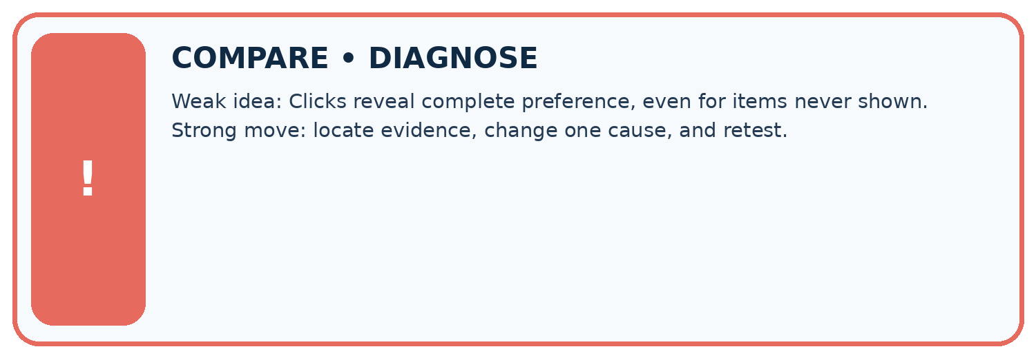
Evidence record | Expected | Actual | Likely cause / next test
normal case | works
boundary case | stated rule
missing input | safe response
fresh transfer | generalizes
Repair one cause. Why is this repair better than changing several things?

Write or draw your reasoning and evidence.
________________________________________________________________
________________________________________________________________
________________________________________________________________
________________________________________________________________
________________________________________________________________

A closer explanation
The recommendation follows a written scoring policy. It does not learn preferences, prove learning benefit or authorize an action. Display the chosen rule and let a person review whether an option is suitable.

Write a one-sentence explanation of X winning without calling it objectively best.
________________________________________________________________
________________________________________________________________
________________________________________________________________
________________________________________________________________
________________________________________________________________
________________________________________________________________

08. Practise together
LOGIC STUDIO
Trace Before You Run
Block code, pseudocode, tables, and diagrams are different ways to expose the same reasoning.

SET evidence_record
PREDICT expected_result
RUN one normal case and one boundary case
COMPARE actual_result with expected_result
IF different: locate first cause; change one factor; RETEST
EXPLAIN result, limitation, and next safe step
Trace one input. Which line changes the state or chooses a path?

Write or draw your reasoning and evidence.
________________________________________________________________
________________________________________________________________
________________________________________________________________
________________________________________________________________
________________________________________________________________

A closer explanation
Updating best on score >= best_score makes the last tied item win, so reordering can change results. Use the explicit name comparison for ties. Test both orders and a no-match case after the repair.

Practise with less help: Handle no match
Use workbook W2 for the connected example “Implementing a recommender”. First fill the input and rule boxes. Try the middle steps before asking for a hint. After a hint, try the next step yourself.
Plan | Do | Check
What is given? Which rule or procedure applies? | Record each intermediate step. | Does the result follow? What remains unknown?
Explain your trace to a partner. Your partner points to one step to check. Swap roles on the next case. Each person writes their own explanation.

Check your reasoning
Use the worked case for Implementing a recommender. Proposed explanation: “A successful run proves the conclusion”. Decide whether this explanation is supported. Point to the step or supplied fact that decides; explain your repair if needed.
Answer on your own before discussion. If you are unsure, say which step you need help with.

Explain the picture
What extra field would reveal why comparing raw clicks is misleading?

My explanation using a pictured step and the given facts
________________________________________________________________
________________________________________________________________
________________________________________________________________
________________________________________________________________
This is supported practice. Keep the separately named independent case for an attempt before feedback.

09. Run the investigation
EVIDENCE LAB
Predict → Test → Record → Explain
Keep expected and actual results separate. Surprises are useful data when recorded honestly.
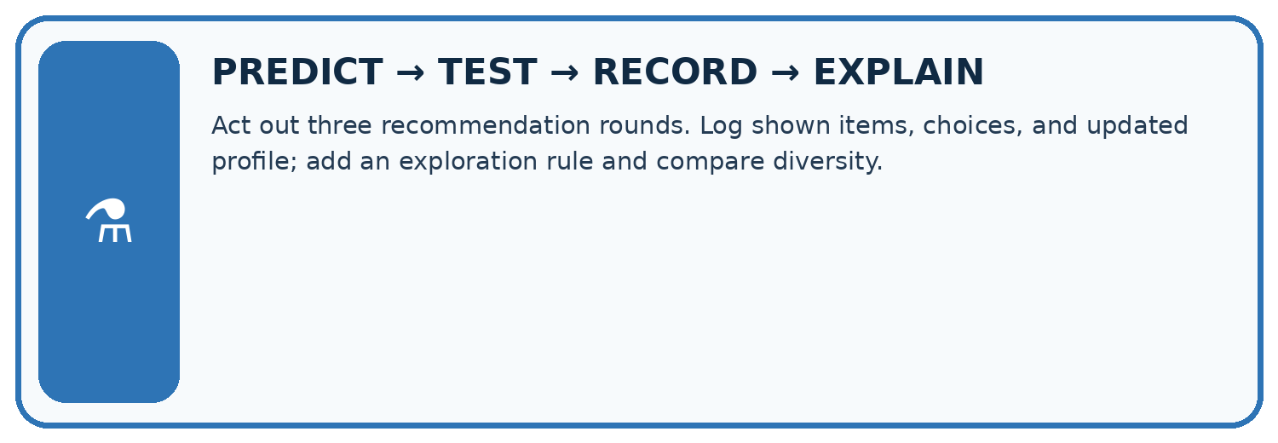
Act out three recommendation rounds. Log shown items, choices, and updated profile; add an exploration rule and compare diversity.
Test / input | Prediction | Actual | Evidence / calculation | Change or keep?
normal
boundary
missing
fresh transfer
What did the hardest test teach you that the normal test did not?

Write or draw your reasoning and evidence.
________________________________________________________________
________________________________________________________________
________________________________________________________________
________________________________________________________________
________________________________________________________________

Plan → try → check
Before trying: what do I expect, and why? While trying: which step could first go wrong? Afterwards: what did I actually observe, and what should change? Keep “not run” if you only traced the procedure.

10. Build your understanding
MASTERY
From Knowing the Word to Owning the Idea
Move upward only when you can produce evidence without copying the worked example.

1 • NAME: Define the concept without repeating the textbook.
2 • TRACE: Show the information, state, branch, calculation, or evidence path.
3 • APPLY: Solve a different example independently.
4 • CHALLENGE: Find a boundary case, counterexample, or unfair outcome.
5 • EXPLAIN LIMITS: Say when the result should not be trusted or used alone.
My strongest evidence of independent understanding:

Write or draw your reasoning and evidence.
________________________________________________________________
________________________________________________________________
________________________________________________________________
________________________________________________________________
________________________________________________________________

11. Connect your project
CUMULATIVE PROJECT
Transparent Book Recommender
Every week adds one inspectable piece. The system must show how it reached a result.
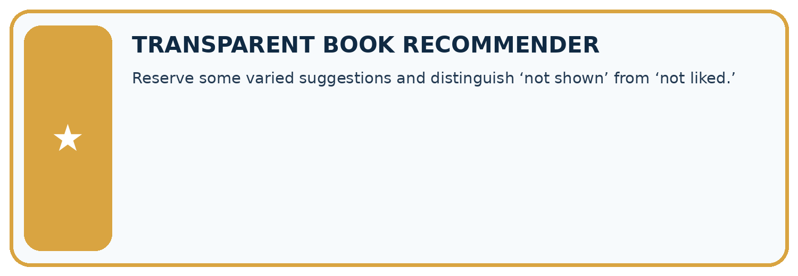
THIS WEEK’S CHECKPOINT Reserve some varied suggestions and distinguish ‘not shown’ from ‘not liked.’
SYSTEM MAP Reader need → allowed inputs → transparent rule or score → ranked candidates → explanation → test record → human decision
What will you add, change, or verify in the project this week?

Write or draw your reasoning and evidence.
________________________________________________________________
________________________________________________________________
________________________________________________________________
________________________________________________________________
________________________________________________________________
What should remain under human control?

Write or draw your reasoning and evidence.
________________________________________________________________
________________________________________________________________
________________________________________________________________
________________________________________________________________
________________________________________________________________
RESPONSIBLE DESIGN Collect only necessary information. Show uncertainty and limits. Never confuse a ranking with a fact about a person.

Evidence for your project
Log recommender exposure, choice and explicit feedback separately; consider whether its own policy narrows future evidence.

12. Show what you know
INDEPENDENT MASTERY PROOF
Explain • Transfer • Test • Defend
Complete this page without copying the worked example. Your reasoning matters more than decoration.
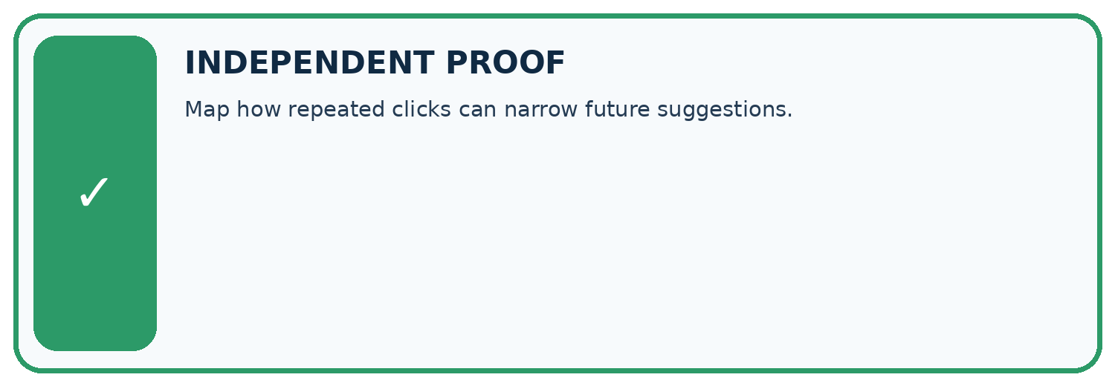
CHALLENGE Map how repeated clicks can narrow future suggestions.
1. My fresh example, trace, calculation, or design:

Write or draw your reasoning and evidence.
________________________________________________________________
________________________________________________________________
________________________________________________________________
________________________________________________________________
________________________________________________________________
2. My evidence that it works (include a boundary or missing-data case):

Write or draw your reasoning and evidence.
________________________________________________________________
________________________________________________________________
________________________________________________________________
________________________________________________________________
________________________________________________________________
3. One limitation, fairness concern, or situation needing human review:

Write or draw your reasoning and evidence.
________________________________________________________________
________________________________________________________________
________________________________________________________________
________________________________________________________________
________________________________________________________________
SELF-CHECK □ I explained the mechanism □ I used evidence □ I tested a fresh case □ I named a limitation □ I can answer ‘why?’

13. Study a complete case

Week 24 Worked case
Use the supplied details to practise the weekly concept before attempting the independent question. This case extends the illustrated lesson.

The situation
A recommender shows only adventure books, uses clicks to learn and then shows more adventure.

The question
Explain the feedback loop.

Worked explanation
Exposure affects clicks; clicks affect future exposure. Record what was shown and offer controlled variety.

Explain it in your own words
Which detail supports the answer, and why does it matter?

Write or draw your reasoning and evidence.
________________________________________________________________
________________________________________________________________
________________________________________________________________
________________________________________________________________
________________________________________________________________

Trace the supplied case visually

Exposure affects the feedback you collect
Evidence or stage | Value or result
Show adventure | Limits visible choices
Observe clicks | Only among shown items
Update preferences | Uses those clicks
Show more adventure | Repeats the exposure pattern
A recommender shows only adventure books, uses clicks to learn and then shows more adventure.
Explain the feedback loop.
Exposure affects clicks; clicks affect future exposure. Record what was shown and offer controlled variety.

14. Try a new case independently

Independent case: Implement independently
Use the function with X (fun 4, learning 1, minutes 12), Y (3,3,10), Z (5,5,13), limit 12. Predict the winner, reverse the list and retest. Also test limit 9.

My independent explanation, trace and limits
________________________________________________________________
________________________________________________________________
________________________________________________________________
________________________________________________________________
________________________________________________________________
________________________________________________________________
________________________________________________________________
Attempt this case before feedback. Record any help. Earlier examples below are further practice; a case already practised with feedback cannot establish fresh transfer.

Week 24 Independent application
Close the worked explanation. Apply the idea to this different question without copying.
Only space books are shown, so nearly every click is on space. Can these clicks prove readers dislike other topics? Explain the loop.
My answer, with a trace, calculation or supporting evidence

Write or draw your reasoning and evidence.
________________________________________________________________
________________________________________________________________
________________________________________________________________
________________________________________________________________
________________________________________________________________

Create and test
Change one relevant detail. Predict the result before testing. Include a boundary or missing-information case when it helps reveal a limit.
My changed input and expected result

Write or draw your reasoning and evidence.
________________________________________________________________
________________________________________________________________
________________________________________________________________
________________________________________________________________
________________________________________________________________

Connect to your project
Reserve some varied suggestions and distinguish ‘not shown’ from ‘not liked.’
The evidence I will keep

Write or draw your reasoning and evidence.
________________________________________________________________
________________________________________________________________
________________________________________________________________
________________________________________________________________
________________________________________________________________
Your teacher has the independent answer and scoring criteria. Complete the matching workbook week to keep your practice evidence together.

Transfer practice from the original programme
A recommender shows poetry in 2 slots and adventure in 20. Poetry gets 1 click; adventure gets 6. Compute clicks per shown slot and explain why neither rate alone proves preference.

Explain the mechanism, evidence and one limit.
________________________________________________________________
________________________________________________________________
________________________________________________________________
________________________________________________________________
________________________________________________________________
________________________________________________________________
________________________________________________________________

Use feedback to improve
Attempt the independent case before hints. Record whether you worked alone, used a hint or followed a model. After feedback, fix the first unsupported step and explain why it changed. A later check uses a changed case, not a copied answer.

15. Your lesson route
Start with this question: A fictional catalogue repeatedly recommends two books using observed clicks.
By the end, I can | How I will show it
Implement a deterministic recommender | Explain the deciding step, show a trace or test, and state one limit.
Handle ties and no eligible options | Explain the deciding step, show a trace or test, and state one limit.
Explain recommendations with their limits | Explain the deciding step, show a trace or test, and state one limit.
Remember → watch and explain → try with help → investigate → try independently → keep project evidence. Your teacher may spread this lesson across several classes.
Keep your first prediction. Compare it with what the evidence shows and explain any change.

16. Finish and return
Close your notes. Explain this goal in your own words: Implement a deterministic recommender

My deciding step, evidence and one remaining question
________________________________________________________________
________________________________________________________________
________________________________________________________________
________________________________________________________________
________________________________________________________________
If you are unsure, return to the worked picture and explain one arrow. If you are ready, change an input or assumption and justify your prediction.
Save your workbook evidence. At the next review, try a different case before opening your old answer.

