AI ACADEMY · STUDENT · ai-2/25

Text as Pieces
Project: Transparent Book Recommender

Before you start
AI-1 Week 5: a representation needs agreed encoding rules.

01. Your mission

Your learning target
I can encode and decode text under an explicit toy vocabulary.
I can explain how segmentation changes sequence length.
I can handle unsupported characters without silently deleting information.

Remember before reading
Close your notes first. A rough first answer helps us choose the right starting point; it is not a score for your ability.
Without opening the old lesson, explain one key idea from Feedback Loops. Give an example and a mistake that the idea helps you avoid.
Without opening the old lesson, explain one key idea from Nearest Neighbor Reasoning. Give an example and a mistake that the idea helps you avoid.
Without opening the old lesson, explain one key idea from Sampling and Representation. Give an example and a mistake that the idea helps you avoid.
After trying, check the relevant lesson or ask your teacher. Change the part of your explanation that the evidence shows was wrong.
Week 25: Text as Pieces
Language systems process tokens and patterns rather than whole human meanings.
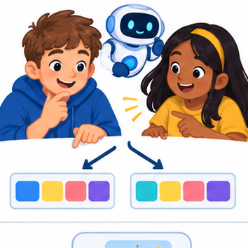
THINKER MISSION
Tokenize tricky phrases and compare alternate splits.
Thinker name and date:

Write or draw your reasoning and evidence.
________________________________________________________________
________________________________________________________________
________________________________________________________________
________________________________________________________________
________________________________________________________________

Readiness for the connected explanation
What information conditions a next-token distribution?

This week’s end goal
By the end, I can encode and decode text using a specified vocabulary and matching rule.

02. Notice the evidence
PICTURE STORY
Notice → Predict → Explain
Begin with visible evidence. Do not explain more than the picture and information support.
MYSTERY
The learners must use text as pieces to solve a problem. What information do they have? What decision or calculation do they make? What would count as evidence that it worked?
Three observations (what you can point to):

Write or draw your reasoning and evidence.
________________________________________________________________
________________________________________________________________
________________________________________________________________
________________________________________________________________
________________________________________________________________
My prediction and the clue supporting it:

Write or draw your reasoning and evidence.
________________________________________________________________
________________________________________________________________
________________________________________________________________
________________________________________________________________
________________________________________________________________

A closer explanation
Tokens need not be words. A classroom tokenizer can use an exact, case-sensitive vocabulary and greedily choose the longest matching token from left to right. This is a toy rule, not a claim about every production tokenizer. Define IDs: 0=end, 1=cat, 2=c, 3=a, 4=t, 5=s, 6=space, 7=sat. The space token represents one literal space. The end token is a special terminator, not ordinary text.
At each position choose the longest matching ordinary token. If no token matches, stop and report the unsupported character and its position. Do not delete the character or guess a replacement. IDs identify entries; a larger ID does not mean a token is more valuable or more similar.

03. See how it works
VISUAL MECHANISM
Input → Process → Output
Trace the information. At each stage, ask what changed and how you could test it.
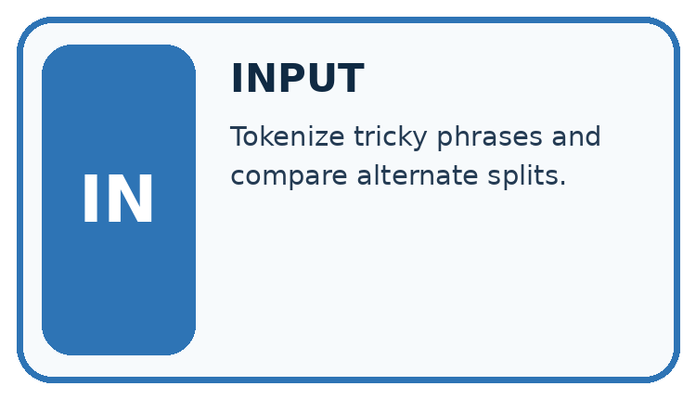
↓
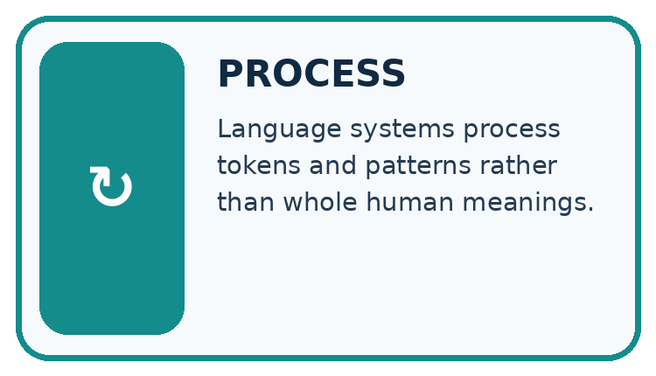
↓
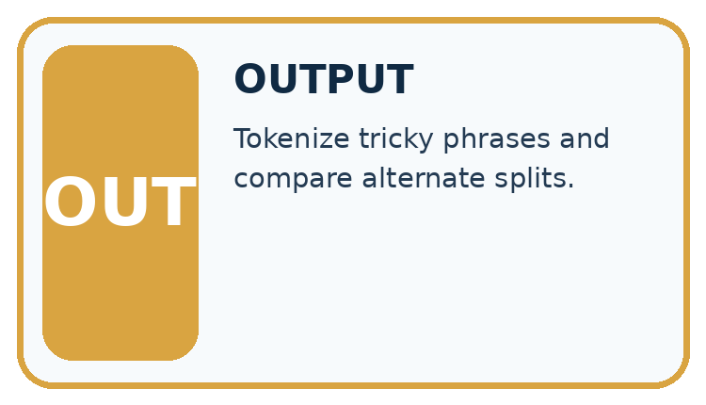
Which stage could fail even when the other two are correct? Explain:

Write or draw your reasoning and evidence.
________________________________________________________________
________________________________________________________________
________________________________________________________________
________________________________________________________________
________________________________________________________________

A closer explanation
Remaining text | Chosen token | ID
cats sat | cat | 1
s sat | s | 5
sat | space | 6
sat | sat | 7
The encoding of cats sat is [1,5,6,7], followed by [0] only if the protocol appends an end token. Decoding concatenates the ordinary token strings to recover cats sat. Count four text tokens, or five sequence items with the end marker included; always state the counting convention. The two written words do not imply two tokens.

Keep the evidence roles separate
Plan or input | Procedure | Permitted conclusion
Exact text: cats sat | Longest-match encoding | IDs 1, 5, 6, 7
IDs 1, 5, 6, 7 | Concatenate token strings | Exact text: cats sat
Exact text: Cat | No match for uppercase C | Report unsupported input
Encoding preserves supported characters and makes unsupported input explicit.

Connect the picture and the explanation
Point to the input, the deciding step and the result in this week’s visual. Explain the same step in ordinary words. A picture helps when you can say what each part represents.

04. Compare the cases
CASE GALLERY
Four Tests, Four Kinds of Evidence
A system is not understood until it survives more than one comfortable example.


NORMAL CASE: predict and name evidence. BOUNDARY CASE: predict and name evidence.


MISSING INFORMATION: predict and name evidence. TRANSFER CASE: predict and name evidence.
Which case is most likely to reveal a hidden assumption? Why?

Write or draw your reasoning and evidence.
________________________________________________________________
________________________________________________________________
________________________________________________________________
________________________________________________________________
________________________________________________________________

Change one thing in the pictured case
Change: Use a character vocabulary covering b,o,k,s and space instead.
Prediction: The same phrase uses ten character tokens.
Reason: There are five letters, one space and four letters; its decoded text remains unchanged.

05. Words that unlock the idea
VOCABULARY LAB
Words You Can Use to Reason
A definition matters when you can recognize the idea, use it, and contrast it with a near-miss.
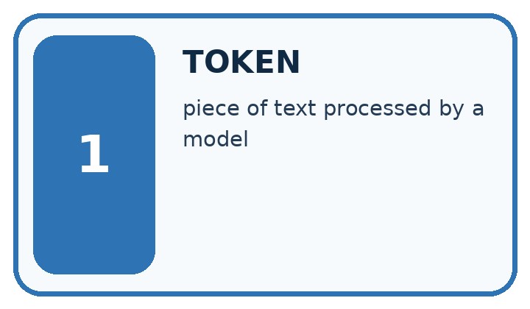
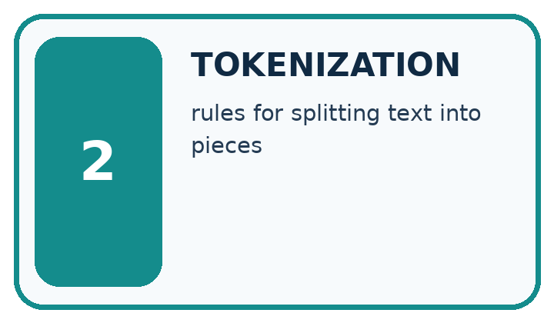
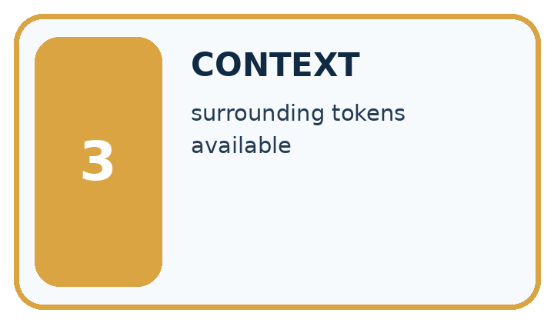
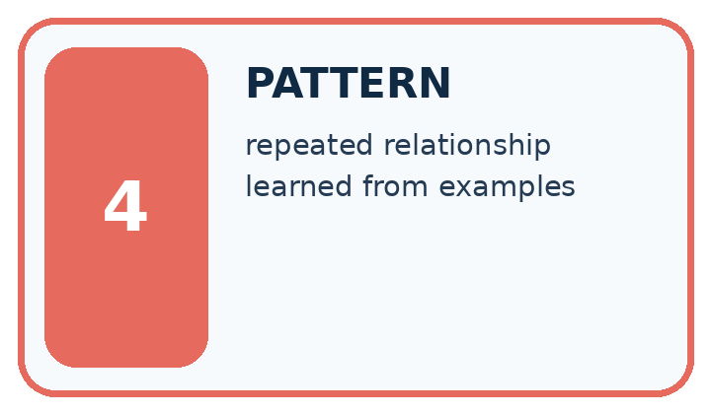
Word | My own example | Not this / boundary
token | A unit of encoded text processed by a language model, which may be a word, part of a word or punctuation.
tokenization | Converting text into the token units of a particular tokenizer.
context | Information available around a task that helps interpret or answer it.
pattern | A relationship or regularity observed in examples.

Words used in the closer explanation
Word | Meaning
Vocabulary | The permitted tokens and their identifiers
Encoding | Mapping source text into a token sequence under a specified rule
Decoding | Mapping a token sequence back to text under a specified rule

06. Follow a worked example
WORKED EVIDENCE
Reason Step by Step
Predict first. Then check each step. A correct answer without visible reasoning is incomplete evidence.
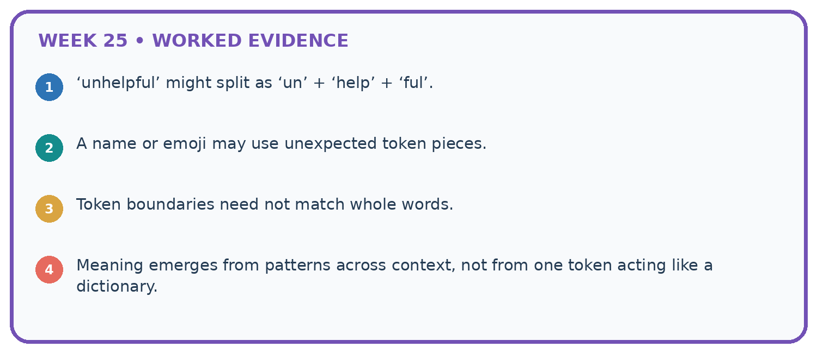
1. ‘unhelpful’ might split as ‘un’ + ‘help’ + ‘ful’.
2. A name or emoji may use unexpected token pieces.
3. Token boundaries need not match whole words.
4. Meaning emerges from patterns across context, not from one token acting like a dictionary.
Recalculate, retrace, or restate the reasoning in your own representation:

Write or draw your reasoning and evidence.
________________________________________________________________
________________________________________________________________
________________________________________________________________
________________________________________________________________
________________________________________________________________
CHECK Did the evidence answer the exact question? Did the total, path, or source record stay consistent?

A closer explanation
A character-only vocabulary c,a,t,s,space could encode cats sat as c,a,t,s,space,s,a,t: eight text tokens. The original vocabulary uses four. Both decode to the same source text. Sequence length is a property of the text, vocabulary and encoding rule together. Counts from different tokenizers are not automatically comparable.
In this vocabulary, sat is chosen over s because it is longer. The toy longest-match rule is defined explicitly. Real tokenizers may use different algorithms, byte encodings and special-token policies. Never infer an unknown tokenizer’s count from word count alone.

Learn from the worked case
Cover the result before checking it. Say what is given, choose the procedure, and follow one step at a time. Then uncover the result and explain your first mismatch. Ask why a step is allowed, not only what number it produces.

A pictorial worked case: Text as Pieces
A fictional tokenizer converts a short catalogue phrase into tokens.

The facts we will use
Vocabulary entries: book, books and the space character. At each position choose the longest matching entry; preserve the actual space.
Text is “books book”. Exclamation marks have no token; zero-based character positions are used.
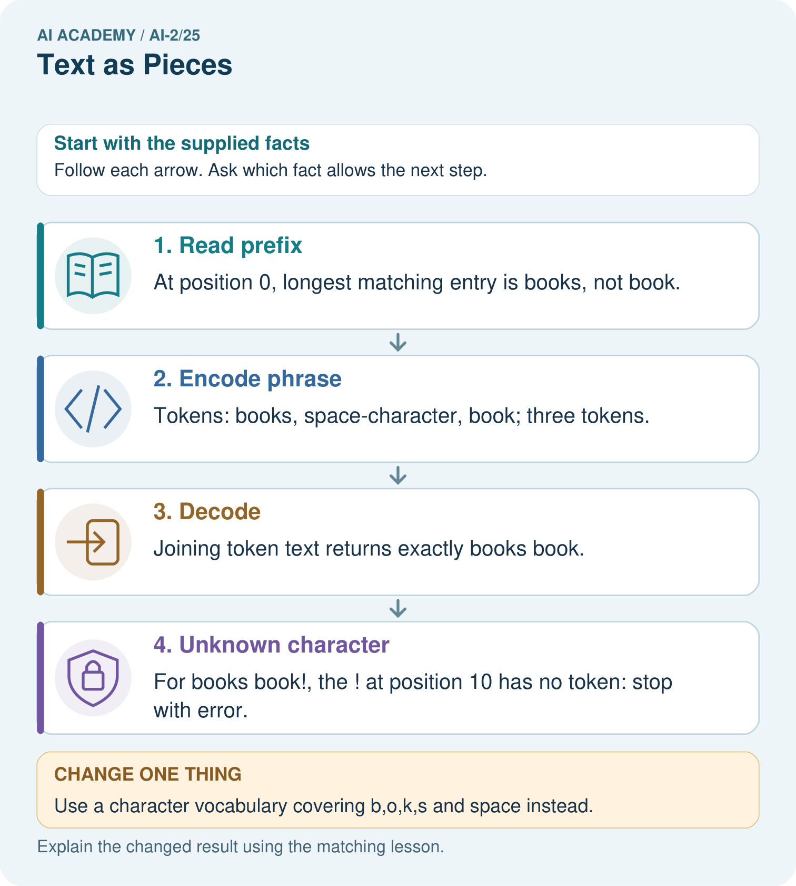

Read the picture one step at a time
Step | What happens and why
1. Read prefix | At position 0, longest matching entry is books, not book.
2. Encode phrase | Tokens: books, space-character, book; three tokens.
3. Decode | Joining token text returns exactly books book.
4. Unknown character | For books book!, the ! at position 10 has no token: stop with error.
Match each pictured step to the supplied facts. This is a worked teaching case, not an independent assessment.

Why this result follows
A token is defined by the vocabulary and encoding rule; it need not be one word or one character. Longest matching matters where vocabulary entries overlap. Counting text tokens here does not count letters. Preserve spaces during decoding so the reconstructed text matches the original exactly.

What this example does not establish
This deterministic toy tokenizer omits real subword training, Unicode handling and model-specific special tokens.
Read the labelled picture: Why is the unknown ! at position 10 rather than position 9?
Change one thing: Use a character vocabulary covering b,o,k,s and space instead. Predict the result before checking the explanation. What remains the same?

07. Find and repair a mistake
ERROR DETECTIVE
Compare → Diagnose → Repair
Do not patch the answer. Find the earliest unsupported assumption, wrong step, or weak evidence.
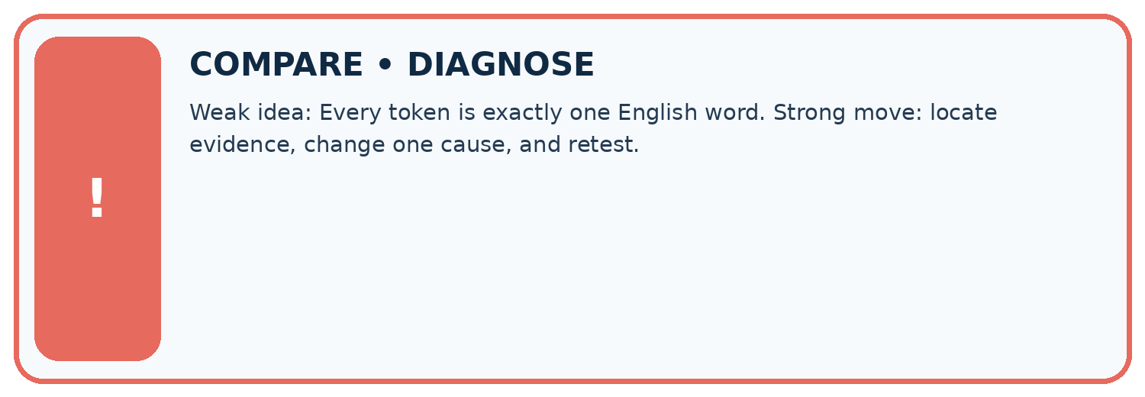
Evidence record | Expected | Actual | Likely cause / next test
normal case | works
boundary case | stated rule
missing input | safe response
fresh transfer | generalizes
Repair one cause. Why is this repair better than changing several things?

Write or draw your reasoning and evidence.
________________________________________________________________
________________________________________________________________
________________________________________________________________
________________________________________________________________
________________________________________________________________

A closer explanation
Decoding round trips check representation, not factual meaning. A supported spelling can be false; an unsupported character can be important. Record the vocabulary version, rule and special-token convention when comparing counts or reproducing model inputs. Whitespace, case and punctuation are part of this exact toy input contract.

Exit: a program drops ! from cat! and announces a successful round trip. Identify the changed information and the honest response.
________________________________________________________________
________________________________________________________________
________________________________________________________________
________________________________________________________________
________________________________________________________________

08. Practise together
LOGIC STUDIO
Trace Before You Run
Block code, pseudocode, tables, and diagrams are different ways to expose the same reasoning.

SET evidence_record
PREDICT expected_result
RUN one normal case and one boundary case
COMPARE actual_result with expected_result
IF different: locate first cause; change one factor; RETEST
EXPLAIN result, limitation, and next safe step
Trace one input. Which line changes the state or chooses a path?

Write or draw your reasoning and evidence.
________________________________________________________________
________________________________________________________________
________________________________________________________________
________________________________________________________________
________________________________________________________________

A closer explanation
Supported case: cat encodes [1]; c at encodes [2,6,3,4]. A space changes both the character sequence and the possible matches. The input Cat is unsupported at position 0 because uppercase C has no entry. The input cat! encodes cat, then fails on ! at position 3; a partial encoding must not be reported as complete success.

Guided: encode c at, count its text tokens and explain how cat! should be reported.
________________________________________________________________
________________________________________________________________
________________________________________________________________
________________________________________________________________
________________________________________________________________

Practise with less help: Encode and decode
Use workbook W2 for the connected example “Tokenisation and vocabulary”. First fill the input and rule boxes. Try the middle steps before asking for a hint. After a hint, try the next step yourself.
Plan | Do | Check
What is given? Which rule or procedure applies? | Record each intermediate step. | Does the result follow? What remains unknown?
Explain your trace to a partner. Your partner points to one step to check. Swap roles on the next case. Each person writes their own explanation.

Check your reasoning
Use the worked case for Tokenisation and vocabulary. Proposed explanation: “A token always equals a word”. Decide whether this explanation is supported. Point to the step or supplied fact that decides; explain your repair if needed.
Answer on your own before discussion. If you are unsure, say which step you need help with.

Explain the picture
Why is the unknown ! at position 10 rather than position 9?

My explanation using a pictured step and the given facts
________________________________________________________________
________________________________________________________________
________________________________________________________________
________________________________________________________________
This is supported practice. Keep the separately named independent case for an attempt before feedback.

09. Run the investigation
EVIDENCE LAB
Predict → Test → Record → Explain
Keep expected and actual results separate. Surprises are useful data when recorded honestly.
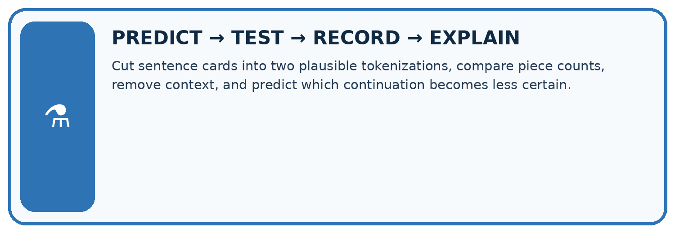
Cut sentence cards into two plausible tokenizations, compare piece counts, remove context, and predict which continuation becomes less certain.
Test / input | Prediction | Actual | Evidence / calculation | Change or keep?
normal
boundary
missing
fresh transfer
What did the hardest test teach you that the normal test did not?

Write or draw your reasoning and evidence.
________________________________________________________________
________________________________________________________________
________________________________________________________________
________________________________________________________________
________________________________________________________________

Plan → try → check
Before trying: what do I expect, and why? While trying: which step could first go wrong? Afterwards: what did I actually observe, and what should change? Keep “not run” if you only traced the procedure.

10. Build your understanding
MASTERY
From Knowing the Word to Owning the Idea
Move upward only when you can produce evidence without copying the worked example.

1 • NAME: Define the concept without repeating the textbook.
2 • TRACE: Show the information, state, branch, calculation, or evidence path.
3 • APPLY: Solve a different example independently.
4 • CHALLENGE: Find a boundary case, counterexample, or unfair outcome.
5 • EXPLAIN LIMITS: Say when the result should not be trusted or used alone.
My strongest evidence of independent understanding:

Write or draw your reasoning and evidence.
________________________________________________________________
________________________________________________________________
________________________________________________________________
________________________________________________________________
________________________________________________________________

11. Connect your project
CUMULATIVE PROJECT
Transparent Book Recommender
Every week adds one inspectable piece. The system must show how it reached a result.
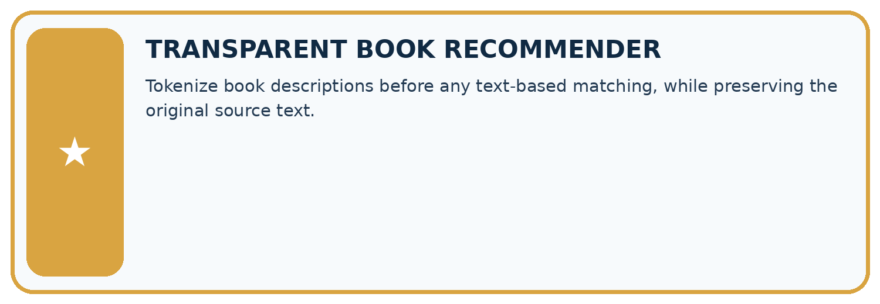
THIS WEEK’S CHECKPOINT Tokenize book descriptions before any text-based matching, while preserving the original source text.
SYSTEM MAP Reader need → allowed inputs → transparent rule or score → ranked candidates → explanation → test record → human decision
What will you add, change, or verify in the project this week?

Write or draw your reasoning and evidence.
________________________________________________________________
________________________________________________________________
________________________________________________________________
________________________________________________________________
________________________________________________________________
What should remain under human control?

Write or draw your reasoning and evidence.
________________________________________________________________
________________________________________________________________
________________________________________________________________
________________________________________________________________
________________________________________________________________
RESPONSIBLE DESIGN Collect only necessary information. Show uncertainty and limits. Never confuse a ranking with a fact about a person.

Evidence for your project
Document the recommender’s text representation and unknown-token behavior rather than assuming every model counts words identically.

12. Show what you know
INDEPENDENT MASTERY PROOF
Explain • Transfer • Test • Defend
Complete this page without copying the worked example. Your reasoning matters more than decoration.
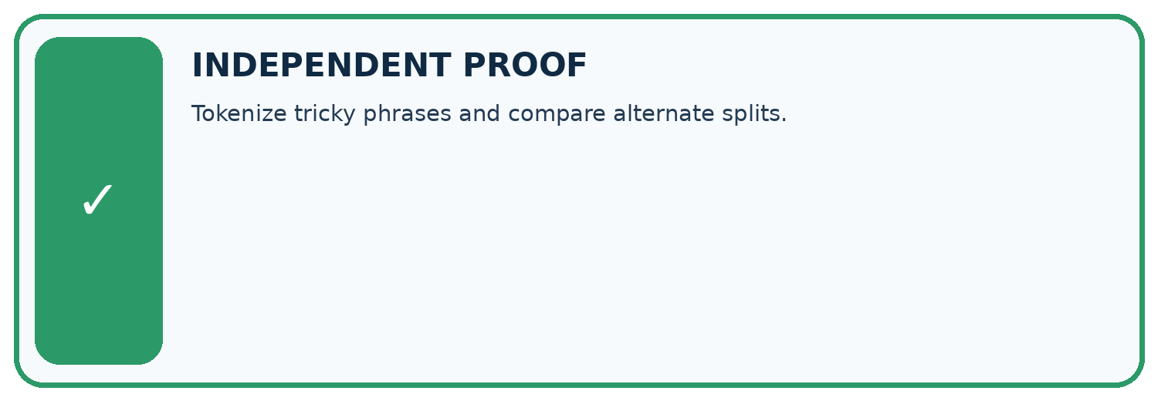
CHALLENGE Tokenize tricky phrases and compare alternate splits.
1. My fresh example, trace, calculation, or design:

Write or draw your reasoning and evidence.
________________________________________________________________
________________________________________________________________
________________________________________________________________
________________________________________________________________
________________________________________________________________
2. My evidence that it works (include a boundary or missing-data case):

Write or draw your reasoning and evidence.
________________________________________________________________
________________________________________________________________
________________________________________________________________
________________________________________________________________
________________________________________________________________
3. One limitation, fairness concern, or situation needing human review:

Write or draw your reasoning and evidence.
________________________________________________________________
________________________________________________________________
________________________________________________________________
________________________________________________________________
________________________________________________________________
SELF-CHECK □ I explained the mechanism □ I used evidence □ I tested a fresh case □ I named a limitation □ I can answer ‘why?’

13. Study a complete case

Week 25 Worked case
Use the supplied details to practise the weekly concept before attempting the independent question. This case extends the illustrated lesson.

The situation
Toy tokenizer A splits rainbows as [rain][bow][s]; B uses [rainbows].

The question
Count tokens and state the limit of the example.

Worked explanation
Three versus one. Token count depends on tokenizer; tokens need not equal words or letters.

Explain it in your own words
Which detail supports the answer, and why does it matter?

Write or draw your reasoning and evidence.
________________________________________________________________
________________________________________________________________
________________________________________________________________
________________________________________________________________
________________________________________________________________

Trace the supplied case visually

One word can have different token counts
Evidence or stage | Value or result
Tokenizer A | rain / bow / s
Tokenizer B | rainbows
Toy tokenizer A splits rainbows as [rain][bow][s]; B uses [rainbows].
Count tokens and state the limit of the example.
Three versus one. Token count depends on tokenizer; tokens need not equal words or letters.

14. Try a new case independently

Independent case: Trace a new input independently
Under the original vocabulary encode sat cats, decode it and count text tokens. Then trace sat cat! and state the exact failure position using zero-based character positions.

My independent explanation, trace and limits
________________________________________________________________
________________________________________________________________
________________________________________________________________
________________________________________________________________
________________________________________________________________
________________________________________________________________
________________________________________________________________
Attempt this case before feedback. Record any help. Earlier examples below are further practice; a case already practised with feedback cannot establish fresh transfer.

Week 25 Independent application
Close the worked explanation. Apply the idea to this different question without copying.
A classroom tokenizer splits sunflower into sun and flower. How many pieces result? Must every real tokenizer split it the same way?
My answer, with a trace, calculation or supporting evidence

Write or draw your reasoning and evidence.
________________________________________________________________
________________________________________________________________
________________________________________________________________
________________________________________________________________
________________________________________________________________

Create and test
Change one relevant detail. Predict the result before testing. Include a boundary or missing-information case when it helps reveal a limit.
My changed input and expected result

Write or draw your reasoning and evidence.
________________________________________________________________
________________________________________________________________
________________________________________________________________
________________________________________________________________
________________________________________________________________

Connect to your project
Tokenize book descriptions before any text-based matching, while preserving the original source text.
The evidence I will keep

Write or draw your reasoning and evidence.
________________________________________________________________
________________________________________________________________
________________________________________________________________
________________________________________________________________
________________________________________________________________
Your teacher has the independent answer and scoring criteria. Complete the matching workbook week to keep your practice evidence together.

Transfer practice from the original programme
Toy tokenizer A splits 'unhelpful' into un/help/ful; B keeps it whole. Count tokens for each and explain why a three-word sentence need not use three tokens.

Explain the mechanism, evidence and one limit.
________________________________________________________________
________________________________________________________________
________________________________________________________________
________________________________________________________________
________________________________________________________________
________________________________________________________________
________________________________________________________________

Use feedback to improve
Attempt the independent case before hints. Record whether you worked alone, used a hint or followed a model. After feedback, fix the first unsupported step and explain why it changed. A later check uses a changed case, not a copied answer.

15. Your lesson route
Start with this question: A fictional tokenizer converts a short catalogue phrase into tokens.
By the end, I can | How I will show it
Encode and decode text under an explicit toy vocabulary | Explain the deciding step, show a trace or test, and state one limit.
Explain how segmentation changes sequence length | Explain the deciding step, show a trace or test, and state one limit.
Handle unsupported characters without silently deleting information | Explain the deciding step, show a trace or test, and state one limit.
Remember → watch and explain → try with help → investigate → try independently → keep project evidence. Your teacher may spread this lesson across several classes.
Keep your first prediction. Compare it with what the evidence shows and explain any change.

16. Finish and return
Close your notes. Explain this goal in your own words: Encode and decode text under an explicit toy vocabulary

My deciding step, evidence and one remaining question
________________________________________________________________
________________________________________________________________
________________________________________________________________
________________________________________________________________
________________________________________________________________
If you are unsure, return to the worked picture and explain one arrow. If you are ready, change an input or assumption and justify your prediction.
Save your workbook evidence. At the next review, try a different case before opening your old answer.

