AI ACADEMY · STUDENT · ai-2/27

Predictive vs Generative
Project: Transparent Book Recommender

Before you start
AI-1 Week 25: distinguish inventing, finding and calculating.

01. Your mission

Your learning target
I can distinguish discriminative prediction from generation by inspecting the requested output.
I can calculate an empirical next-token distribution from counted continuations.
I can separate next-token fit from factual support and downstream usefulness.

Remember before reading
Close your notes first. A rough first answer helps us choose the right starting point; it is not a score for your ability.
Without opening the old lesson, explain one key idea from Image and Voice Pipelines. Give an example and a mistake that the idea helps you avoid.
Without opening the old lesson, explain one key idea from Feedback Loops. Give an example and a mistake that the idea helps you avoid.
Without opening the old lesson, explain one key idea from Similarity by Selected Traits. Give an example and a mistake that the idea helps you avoid.
After trying, check the relevant lesson or ask your teacher. Change the part of your explanation that the evidence shows was wrong.
Week 27: Predictive vs Generative
Predictive systems select a target; generative systems construct new output.
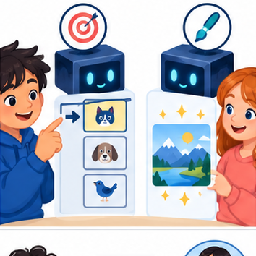
THINKER MISSION
Match problems to classifier, predictor, or generator.
Thinker name and date:

Write or draw your reasoning and evidence.
________________________________________________________________
________________________________________________________________
________________________________________________________________
________________________________________________________________
________________________________________________________________

Readiness for the connected explanation
What is the difference between a model prediction and evidence that a statement is true?

This week’s end goal
By the end, I can distinguish a generated continuation from a prediction checked against the world.

02. Notice the evidence
PICTURE STORY
Notice → Predict → Explain
Begin with visible evidence. Do not explain more than the picture and information support.
MYSTERY
The learners must use predictive vs generative to solve a problem. What information do they have? What decision or calculation do they make? What would count as evidence that it worked?
Three observations (what you can point to):

Write or draw your reasoning and evidence.
________________________________________________________________
________________________________________________________________
________________________________________________________________
________________________________________________________________
________________________________________________________________
My prediction and the clue supporting it:

Write or draw your reasoning and evidence.
________________________________________________________________
________________________________________________________________
________________________________________________________________
________________________________________________________________
________________________________________________________________

A closer explanation
A classifier might map a message to the label request or report. A text generator instead produces a sequence, predicting a distribution over the next token given a prefix. Both make predictions, but the training targets and permitted outputs differ. One application can combine generation with a classifier, retrieval and human approval. Calling a whole product “generative” does not describe every component.
The objective defines what training attempts to fit. Next-token fit rewards matching observed continuations; it does not directly certify that an answer is true, well sourced or permitted. A fluent completion is still an output to evaluate against the task.

03. See how it works
VISUAL MECHANISM
Input → Process → Output
Trace the information. At each stage, ask what changed and how you could test it.
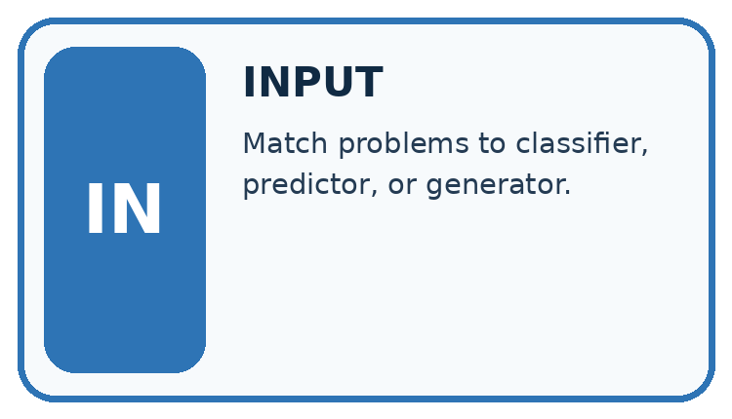
↓
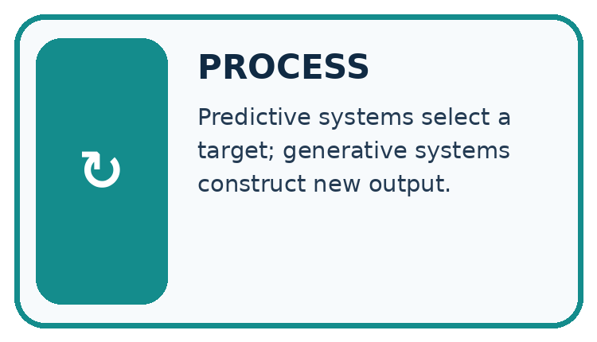
↓
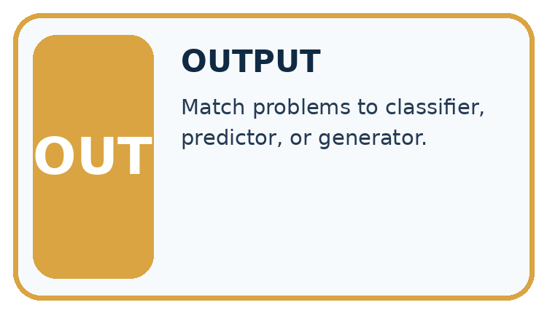
Which stage could fail even when the other two are correct? Explain:

Write or draw your reasoning and evidence.
________________________________________________________________
________________________________________________________________
________________________________________________________________
________________________________________________________________
________________________________________________________________

A closer explanation
Prefix | Continuation | Count
The marker is | red | 6
The marker is | blue | 3
The marker is | green | 1
There are ten observed continuations. The empirical probabilities are red 6/10 = 0.6, blue 3/10 = 0.3, green 1/10 = 0.1. They are nonnegative and sum to 1. A simple frequentist classroom model uses these relative counts as its next-token distribution. These probabilities describe the supplied corpus counts, not the current colour of any actual marker.

Keep the evidence roles separate
Plan or input | Procedure | Permitted conclusion
Ten corpus continuations | Count red 6, blue 3, green 1 | Distribution 0.6, 0.3, 0.1
Prefix: The marker is | Select a next token | An output, not an observation
Current marker question | Check direct evidence | Colour claim needs support
The continuation model and a factual observation have different evidence sources.

Connect the picture and the explanation
Point to the input, the deciding step and the result in this week’s visual. Explain the same step in ordinary words. A picture helps when you can say what each part represents.

04. Compare the cases
CASE GALLERY
Four Tests, Four Kinds of Evidence
A system is not understood until it survives more than one comfortable example.


NORMAL CASE: predict and name evidence. BOUNDARY CASE: predict and name evidence.


MISSING INFORMATION: predict and name evidence. TRANSFER CASE: predict and name evidence.
Which case is most likely to reveal a hidden assumption? Why?

Write or draw your reasoning and evidence.
________________________________________________________________
________________________________________________________________
________________________________________________________________
________________________________________________________________
________________________________________________________________

Change one thing in the pictured case
Change: Change the training table to full 2, empty 7, unknown 1.
Prediction: Greedy output becomes empty with probability 0.7.
Reason: The continuation distribution changed; the independently observed box has not changed.

05. Words that unlock the idea
VOCABULARY LAB
Words You Can Use to Reason
A definition matters when you can recognize the idea, use it, and contrast it with a near-miss.
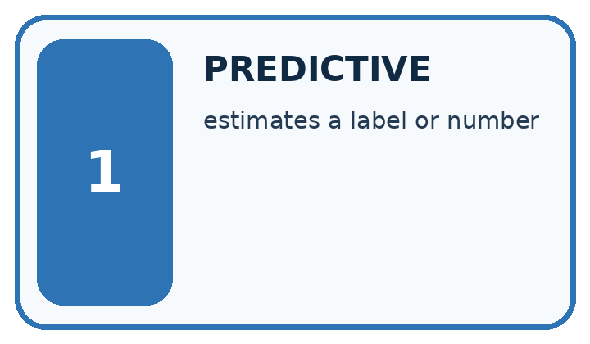
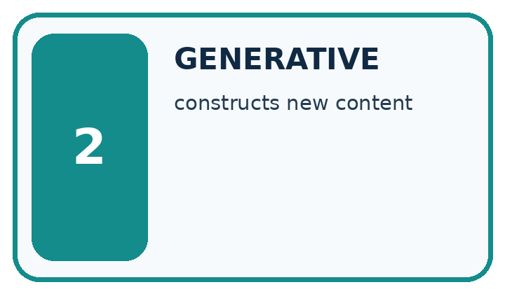
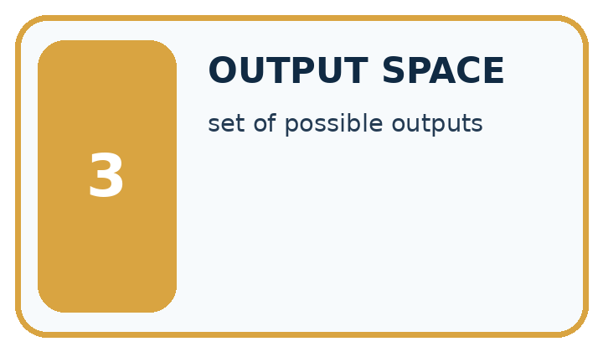
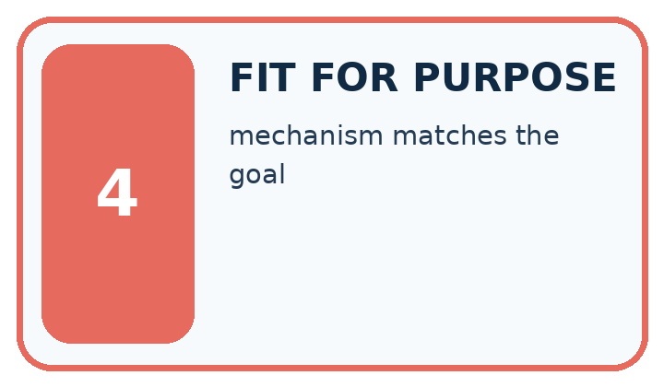
Word | My own example | Not this / boundary
predictive | Estimating a target from supplied inputs.
generative | Producing new content from learned patterns and supplied conditions.
output space | The set or range of outputs a system can produce for a task.
fit for purpose | Suitable for the stated users, task, conditions and consequences.

Words used in the closer explanation
Word | Meaning
Generative objective | A training aim concerned with producing or modelling possible outputs
Discriminative objective | A training aim mapping inputs to a specified target such as a label
Conditional distribution | Probabilities for alternatives given stated information
Autoregressive generation | Producing a sequence one next item at a time using preceding items

06. Follow a worked example
WORKED EVIDENCE
Reason Step by Step
Predict first. Then check each step. A correct answer without visible reasoning is incomplete evidence.
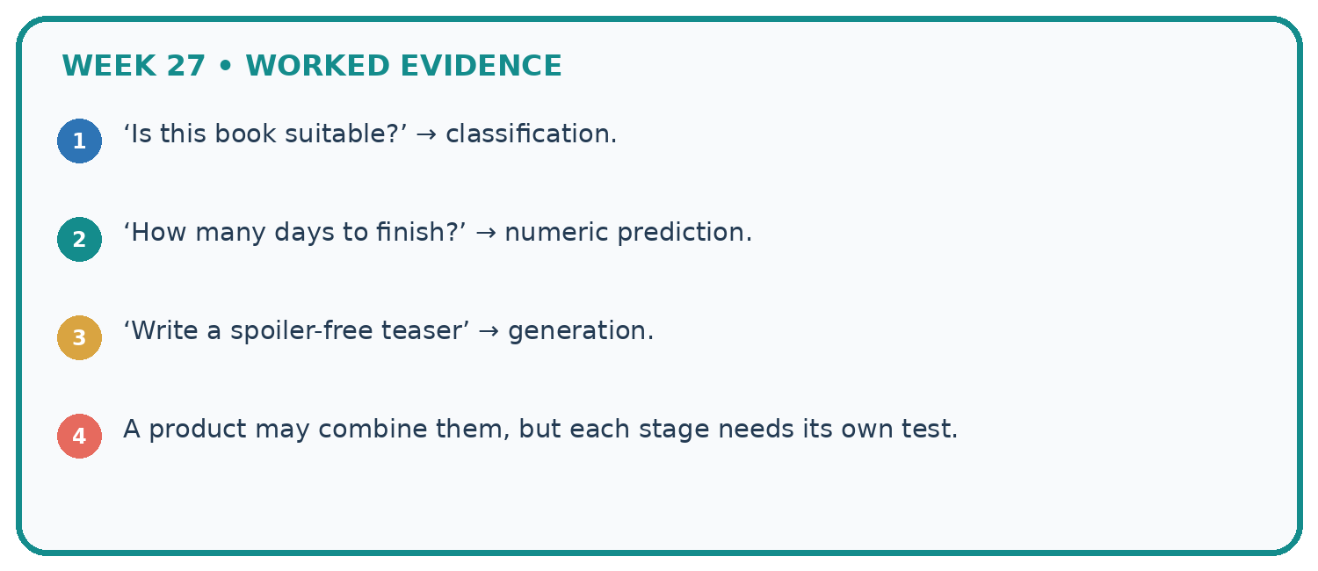
1. ‘Is this book suitable?’ → classification.
2. ‘How many days to finish?’ → numeric prediction.
3. ‘Write a spoiler-free teaser’ → generation.
4. A product may combine them, but each stage needs its own test.
Recalculate, retrace, or restate the reasoning in your own representation:

Write or draw your reasoning and evidence.
________________________________________________________________
________________________________________________________________
________________________________________________________________
________________________________________________________________
________________________________________________________________
CHECK Did the evidence answer the exact question? Did the total, path, or source record stay consistent?

A closer explanation
After producing red, the next step conditions on the expanded prefix “The marker is red”. A second table might give an end token probability 0.8 and the token today probability 0.2. A generated sequence can stop at the end token or continue. Do not reuse the first-step table unchanged after adding a token unless the model explicitly ignores the new prefix.
A separate classifier can return red as a label from an image; that is a different input and target from continuing text. A downstream evaluation asks whether the system correctly reports the current marker. It must include ground truth or sources and appropriate failure handling, not just count plausible phrases.

Learn from the worked case
Cover the result before checking it. Say what is given, choose the procedure, and follow one step at a time. Then uncover the result and explain your first mismatch. Ask why a step is allowed, not only what number it produces.

A pictorial worked case: Predictive vs Generative
A fictional toy generator predicts the next word after “The box is”.

The facts we will use
Observed training continuations: full 6, empty 3, unknown 1.
Use counts divided by total 10. The current physical box is separately checked and found empty.
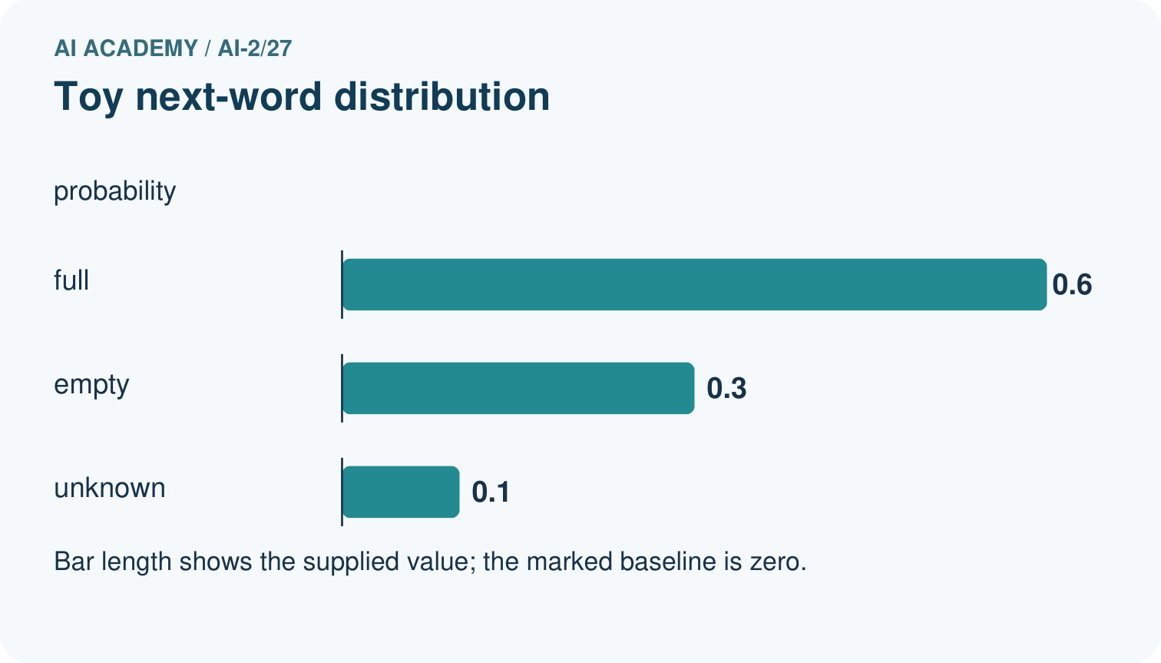
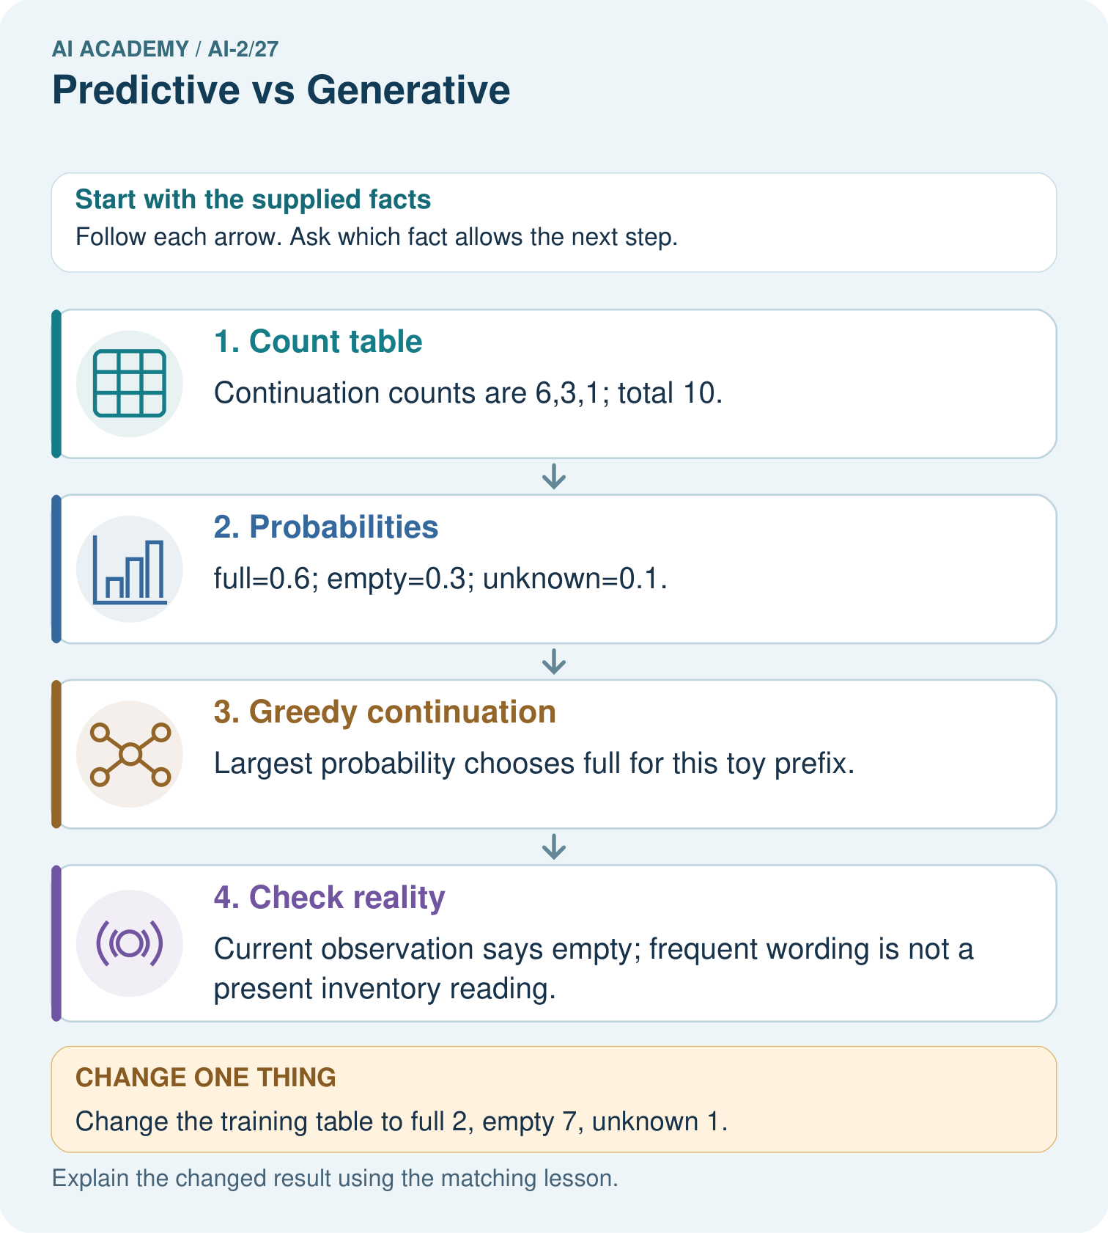

Read the picture one step at a time
Step | What happens and why
1. Count table | Continuation counts are 6,3,1; total 10.
2. Probabilities | full=0.6; empty=0.3; unknown=0.1.
3. Greedy continuation | Largest probability chooses full for this toy prefix.
4. Check reality | Current observation says empty; frequent wording is not a present inventory reading.
Match each pictured step to the supplied facts. This is a worked teaching case, not an independent assessment.

Why this result follows
The table predicts a continuation in a text exercise, not the contents of the current box. Generating the most frequent token is a model-defined decision. A factual inventory statement needs current evidence. The numerical table is intentionally small; real generative systems condition on richer context and do not simply consult these three counts.

What this example does not establish
A one-step toy distribution does not describe every predictive or generative model or validate factual accuracy.
Read the labelled picture: Does matching the physical box in the changed table prove the generator measures boxes?
Change one thing: Change the training table to full 2, empty 7, unknown 1. Predict the result before checking the explanation. What remains the same?

07. Find and repair a mistake
ERROR DETECTIVE
Compare → Diagnose → Repair
Do not patch the answer. Find the earliest unsupported assumption, wrong step, or weak evidence.
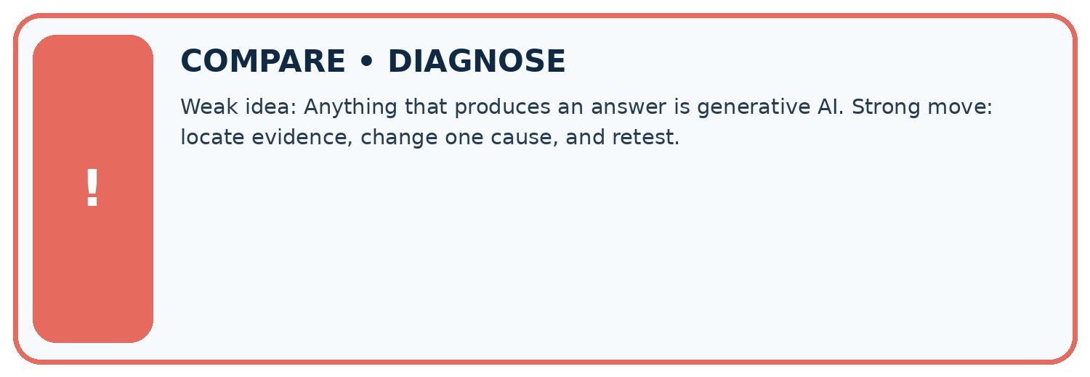
Evidence record | Expected | Actual | Likely cause / next test
normal case | works
boundary case | stated rule
missing input | safe response
fresh transfer | generalizes
Repair one cause. Why is this repair better than changing several things?

Write or draw your reasoning and evidence.
________________________________________________________________
________________________________________________________________
________________________________________________________________
________________________________________________________________
________________________________________________________________

A closer explanation
Keep three questions separate: did the model fit continuation data; did the output satisfy the requested format or task; and are factual claims supported? A system that drafts a fictional description has different criteria from one reporting a live measurement. Record the source and time when a claim refers to changing conditions. No AI account is needed to reason about these distinctions.

Exit: a team says “the highest-probability continuation proves the current fact”. Name the evidence they actually have and the evidence still needed.
________________________________________________________________
________________________________________________________________
________________________________________________________________
________________________________________________________________
________________________________________________________________

08. Practise together
LOGIC STUDIO
Trace Before You Run
Block code, pseudocode, tables, and diagrams are different ways to expose the same reasoning.

SET evidence_record
PREDICT expected_result
RUN one normal case and one boundary case
COMPARE actual_result with expected_result
IF different: locate first cause; change one factor; RETEST
EXPLAIN result, limitation, and next safe step
Trace one input. Which line changes the state or chooses a path?

Write or draw your reasoning and evidence.
________________________________________________________________
________________________________________________________________
________________________________________________________________
________________________________________________________________
________________________________________________________________

A closer explanation
Supported case: the prefix “The door is” is followed in a tiny corpus by open four times and closed once. The empirical probabilities are 4/5 and 1/5. A current sensor reports closed. Selecting the most frequent continuation open would be plausible under the corpus model but inconsistent with the sensor observation.

Guided: compute both probabilities and explain why selecting open does not establish the current door state.
________________________________________________________________
________________________________________________________________
________________________________________________________________
________________________________________________________________
________________________________________________________________

Practise with less help: Compute the distribution
Use workbook W2 for the connected example “Generative and predictive objectives”. First fill the input and rule boxes. Try the middle steps before asking for a hint. After a hint, try the next step yourself.
Plan | Do | Check
What is given? Which rule or procedure applies? | Record each intermediate step. | Does the result follow? What remains unknown?
Explain your trace to a partner. Your partner points to one step to check. Swap roles on the next case. Each person writes their own explanation.

Check your reasoning
Use the worked case for Generative and predictive objectives. Proposed explanation: “Generative models do not predict”. Decide whether this explanation is supported. Point to the step or supplied fact that decides; explain your repair if needed.
Answer on your own before discussion. If you are unsure, say which step you need help with.

Explain the picture
Does matching the physical box in the changed table prove the generator measures boxes?

My explanation using a pictured step and the given facts
________________________________________________________________
________________________________________________________________
________________________________________________________________
________________________________________________________________
This is supported practice. Keep the separately named independent case for an attempt before feedback.

09. Run the investigation
EVIDENCE LAB
Predict → Test → Record → Explain
Keep expected and actual results separate. Surprises are useful data when recorded honestly.
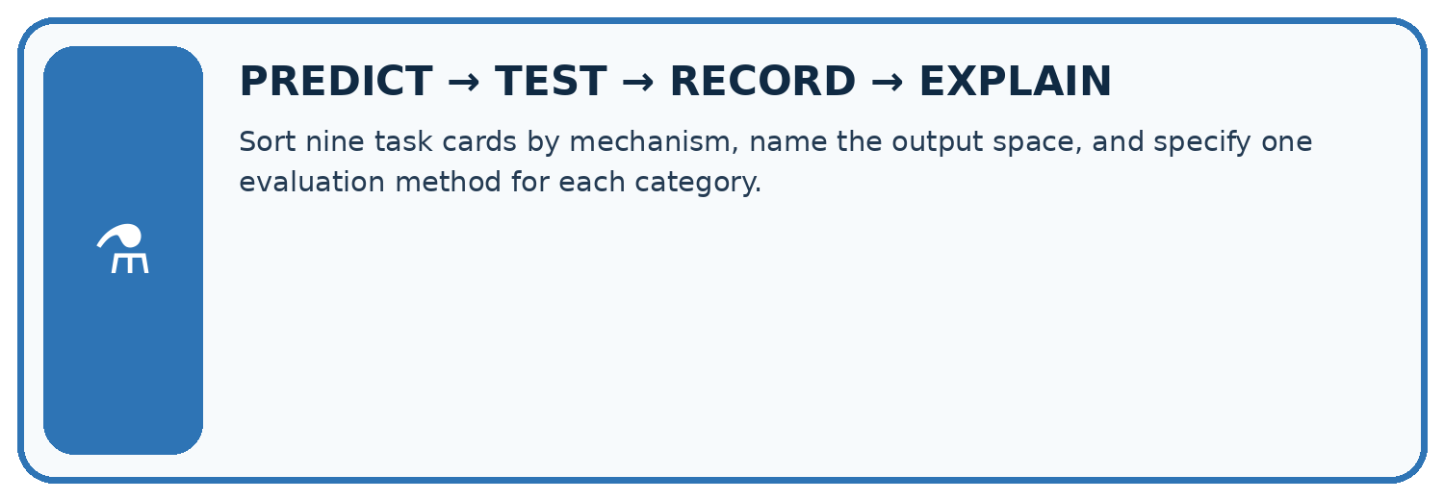
Sort nine task cards by mechanism, name the output space, and specify one evaluation method for each category.
Test / input | Prediction | Actual | Evidence / calculation | Change or keep?
normal
boundary
missing
fresh transfer
What did the hardest test teach you that the normal test did not?

Write or draw your reasoning and evidence.
________________________________________________________________
________________________________________________________________
________________________________________________________________
________________________________________________________________
________________________________________________________________

Plan → try → check
Before trying: what do I expect, and why? While trying: which step could first go wrong? Afterwards: what did I actually observe, and what should change? Keep “not run” if you only traced the procedure.

10. Build your understanding
MASTERY
From Knowing the Word to Owning the Idea
Move upward only when you can produce evidence without copying the worked example.

1 • NAME: Define the concept without repeating the textbook.
2 • TRACE: Show the information, state, branch, calculation, or evidence path.
3 • APPLY: Solve a different example independently.
4 • CHALLENGE: Find a boundary case, counterexample, or unfair outcome.
5 • EXPLAIN LIMITS: Say when the result should not be trusted or used alone.
My strongest evidence of independent understanding:

Write or draw your reasoning and evidence.
________________________________________________________________
________________________________________________________________
________________________________________________________________
________________________________________________________________
________________________________________________________________

11. Connect your project
CUMULATIVE PROJECT
Transparent Book Recommender
Every week adds one inspectable piece. The system must show how it reached a result.
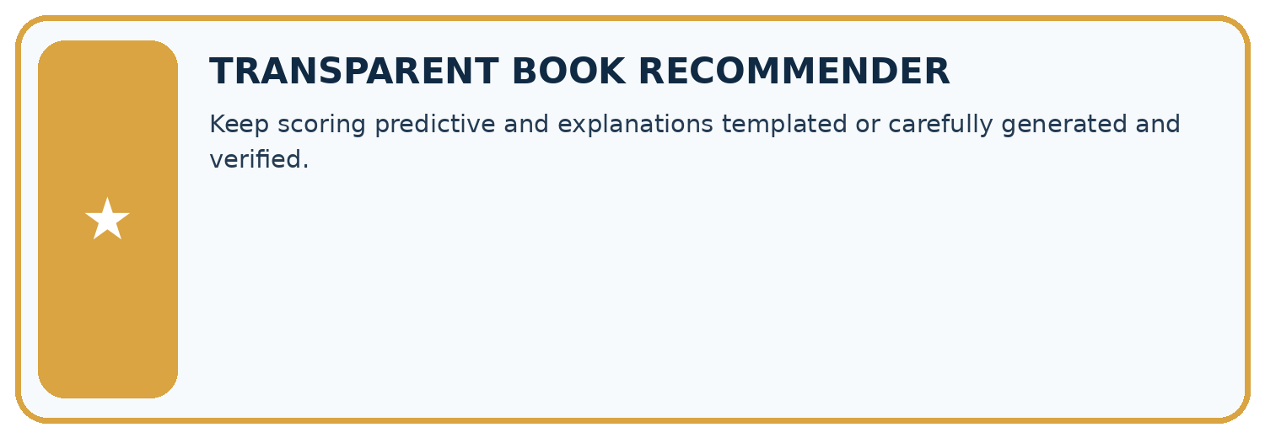
THIS WEEK’S CHECKPOINT Keep scoring predictive and explanations templated or carefully generated and verified.
SYSTEM MAP Reader need → allowed inputs → transparent rule or score → ranked candidates → explanation → test record → human decision
What will you add, change, or verify in the project this week?

Write or draw your reasoning and evidence.
________________________________________________________________
________________________________________________________________
________________________________________________________________
________________________________________________________________
________________________________________________________________
What should remain under human control?

Write or draw your reasoning and evidence.
________________________________________________________________
________________________________________________________________
________________________________________________________________
________________________________________________________________
________________________________________________________________
RESPONSIBLE DESIGN Collect only necessary information. Show uncertainty and limits. Never confuse a ranking with a fact about a person.

Evidence for your project
Use approved book facts for recommender explanations; generated fluency is not a replacement for catalogue evidence.

12. Show what you know
INDEPENDENT MASTERY PROOF
Explain • Transfer • Test • Defend
Complete this page without copying the worked example. Your reasoning matters more than decoration.
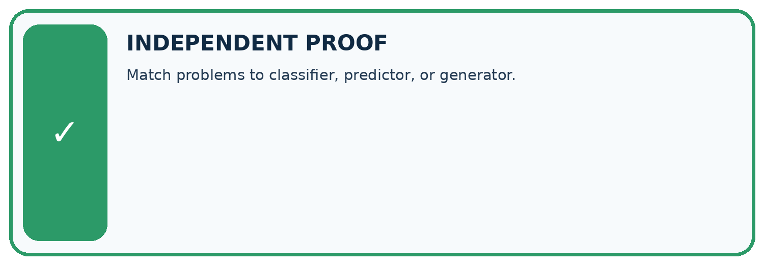
CHALLENGE Match problems to classifier, predictor, or generator.
1. My fresh example, trace, calculation, or design:

Write or draw your reasoning and evidence.
________________________________________________________________
________________________________________________________________
________________________________________________________________
________________________________________________________________
________________________________________________________________
2. My evidence that it works (include a boundary or missing-data case):

Write or draw your reasoning and evidence.
________________________________________________________________
________________________________________________________________
________________________________________________________________
________________________________________________________________
________________________________________________________________
3. One limitation, fairness concern, or situation needing human review:

Write or draw your reasoning and evidence.
________________________________________________________________
________________________________________________________________
________________________________________________________________
________________________________________________________________
________________________________________________________________
SELF-CHECK □ I explained the mechanism □ I used evidence □ I tested a fresh case □ I named a limitation □ I can answer ‘why?’

13. Study a complete case

Week 27 Worked case
Use the supplied details to practise the weekly concept before attempting the independent question. This case extends the illustrated lesson.

The situation
A labels genre; B writes a new blurb; C computes 24/6.

The question
Distinguish operations.

Worked explanation
A predicts a category, B generates text, C calculates 4. Products may combine them.

Explain it in your own words
Which detail supports the answer, and why does it matter?

Write or draw your reasoning and evidence.
________________________________________________________________
________________________________________________________________
________________________________________________________________
________________________________________________________________
________________________________________________________________

Trace the supplied case visually

Three operations in one book helper
Evidence or stage | Value or result
Classify | Select a genre label
Generate | Write a new blurb
Calculate | 24 divided by 6 equals 4
A labels genre; B writes a new blurb; C computes 24/6.
Distinguish operations.
A predicts a category, B generates text, C calculates 4. Products may combine them.

14. Try a new case independently

Independent case: Analyse a new corpus independently
For prefix The signal is, counts are high 2, low 5, unknown 3. Compute all probabilities and the most frequent continuation. A current measurement reports high. State what the most frequent continuation does and does not establish.

My independent explanation, trace and limits
________________________________________________________________
________________________________________________________________
________________________________________________________________
________________________________________________________________
________________________________________________________________
________________________________________________________________
________________________________________________________________
Attempt this case before feedback. Record any help. Earlier examples below are further practice; a case already practised with feedback cannot establish fresh transfer.

Week 27 Independent application
Close the worked explanation. Apply the idea to this different question without copying.
One model labels a review positive or negative; another writes a new review. Which classifies and which generates? Must generated text be true?
My answer, with a trace, calculation or supporting evidence

Write or draw your reasoning and evidence.
________________________________________________________________
________________________________________________________________
________________________________________________________________
________________________________________________________________
________________________________________________________________

Create and test
Change one relevant detail. Predict the result before testing. Include a boundary or missing-information case when it helps reveal a limit.
My changed input and expected result

Write or draw your reasoning and evidence.
________________________________________________________________
________________________________________________________________
________________________________________________________________
________________________________________________________________
________________________________________________________________

Connect to your project
Keep scoring predictive and explanations templated or carefully generated and verified.
The evidence I will keep

Write or draw your reasoning and evidence.
________________________________________________________________
________________________________________________________________
________________________________________________________________
________________________________________________________________
________________________________________________________________
Your teacher has the independent answer and scoring criteria. Complete the matching workbook week to keep your practice evidence together.

Transfer practice from the original programme
A tool retrieves a book description, predicts a genre, then writes a new blurb. Identify each operation and give one distinct failure to check at each stage.

Explain the mechanism, evidence and one limit.
________________________________________________________________
________________________________________________________________
________________________________________________________________
________________________________________________________________
________________________________________________________________
________________________________________________________________
________________________________________________________________

Use feedback to improve
Attempt the independent case before hints. Record whether you worked alone, used a hint or followed a model. After feedback, fix the first unsupported step and explain why it changed. A later check uses a changed case, not a copied answer.

15. Your lesson route
Start with this question: A fictional toy generator predicts the next word after “The box is”.
By the end, I can | How I will show it
Distinguish discriminative prediction from generation by inspecting the requested output | Explain the deciding step, show a trace or test, and state one limit.
Calculate an empirical next-token distribution from counted continuations | Explain the deciding step, show a trace or test, and state one limit.
Separate next-token fit from factual support and downstream usefulness | Explain the deciding step, show a trace or test, and state one limit.
Remember → watch and explain → try with help → investigate → try independently → keep project evidence. Your teacher may spread this lesson across several classes.
Keep your first prediction. Compare it with what the evidence shows and explain any change.

16. Finish and return
Close your notes. Explain this goal in your own words: Distinguish discriminative prediction from generation by inspecting the requested output

My deciding step, evidence and one remaining question
________________________________________________________________
________________________________________________________________
________________________________________________________________
________________________________________________________________
________________________________________________________________
If you are unsure, return to the worked picture and explain one arrow. If you are ready, change an input or assumption and justify your prediction.
Save your workbook evidence. At the next review, try a different case before opening your old answer.

