AI ACADEMY · STUDENT · ai-3/9

Prompt Evaluation
Project: Verified Study Buddy

Before you start
AI-2 Week 28: compare prompts on the same inputs and criteria.

01. Your mission

Your learning target
I can explain the mechanism and terminology of controlled prompt experiments.
I can apply the stated procedure to a new case with a traceable result.
I can identify an assumption or limitation and design a revealing follow-up.

Remember before reading
Close your notes first. A rough first answer helps us choose the right starting point; it is not a score for your ability.
Without opening the old lesson, explain one key idea from Structured Output and Schemas. Give an example and a mistake that the idea helps you avoid.
Without opening the old lesson, explain one key idea from Examples and Rubrics. Give an example and a mistake that the idea helps you avoid.
Without opening the old lesson, explain one key idea from Tokens and Context. Give an example and a mistake that the idea helps you avoid.
After trying, check the relevant lesson or ask your teacher. Change the part of your explanation that the evidence shows was wrong.
Week 9: Prompt Evaluation
Prompt claims require a fixed test set and repeatable scoring.
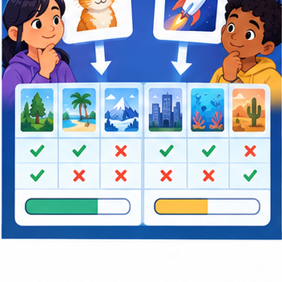
CREATOR MISSION
A/B test two prompts across six cases.
Creator name and date:

Write or draw your reasoning and evidence.
________________________________________________________________
________________________________________________________________
________________________________________________________________
________________________________________________________________
________________________________________________________________

Readiness for the connected explanation
Recall Structured outputs and validation. Explain why a recorded result needs its input conditions and evidence source before it can support a claim.

This week’s end goal
By the end, I can evaluate prompts with paired cases and a predeclared mandatory criterion.

02. Notice the evidence
PICTURE STORY
Notice → Predict → Explain
Begin with visible evidence. Do not explain more than the picture and information support.
MYSTERY
The learners must use prompt evaluation to solve a problem. What information do they have? What decision or calculation do they make? What would count as evidence that it worked?
Three observations (what you can point to):

Write or draw your reasoning and evidence.
________________________________________________________________
________________________________________________________________
________________________________________________________________
________________________________________________________________
________________________________________________________________
My prediction and the clue supporting it:

Write or draw your reasoning and evidence.
________________________________________________________________
________________________________________________________________
________________________________________________________________
________________________________________________________________
________________________________________________________________

A closer explanation
A prompt experiment compares complete specifications using the same task cases. Define success before inspecting outputs; change one intended instruction and preserve other settings.
Begin by writing the question the procedure is intended to answer. Identify the information already supplied, the information it will produce and the information still missing. These are constructed classroom examples; they do not require live accounts, private records or an external service. Do not treat a plausible explanation as a measured outcome.

03. See how it works
VISUAL MECHANISM
Input → Process → Output
Trace the information. At each stage, ask what changed and how you could test it.
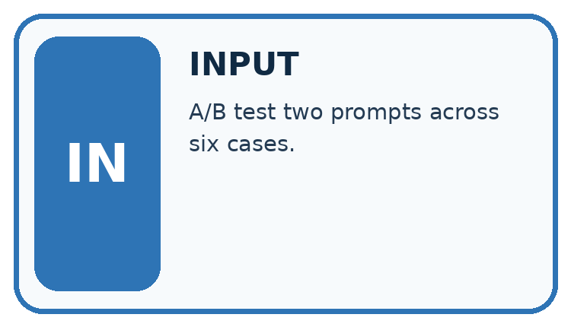
↓
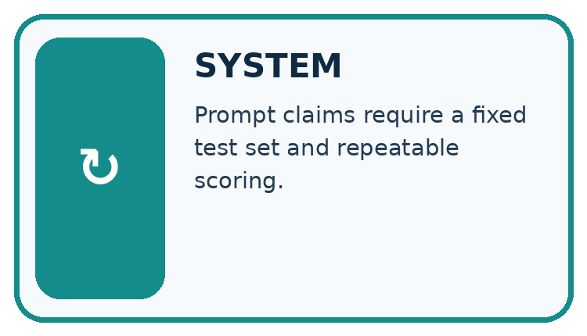
↓
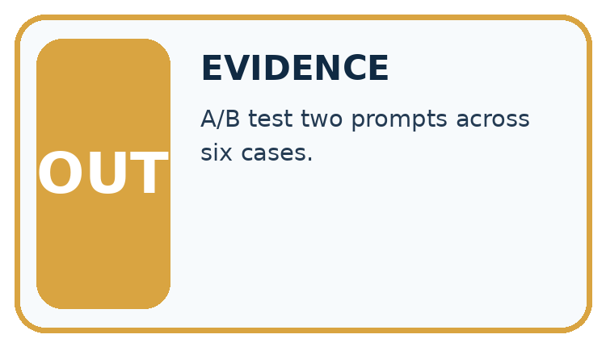
Which stage could fail even when the other two are correct? Explain:

Write or draw your reasoning and evidence.
________________________________________________________________
________________________________________________________________
________________________________________________________________
________________________________________________________________
________________________________________________________________

A closer explanation
Evaluate both prompts on paired cases with fixed model/version, source records, output contract and scoring rubric. Use development results for selection, then reserve new final cases. Score each case rather than counting attractive sentences.

Controlled prompt experiments — evidence trace
Input and scope | Check or calculation | Conclusion and limit
On six development cases P passes cases 1, 2, 3, 4; Q passes 1, 2, 3, 5, 6. Missing-approval cases are 4 and 6. Compare totals and condition results. | Evaluate both prompts on paired cases with fixed model/version, source records, output contract and scoring rubric. | P passes 4/6 and Q 5/6. P passes one of two missing-approval cases, Q also one of two.
The figure connects this chapter's worked input, declared procedure and result. Read the complete worked reasoning for qualifiers and intermediate steps; the abbreviated labels do not replace that reasoning.
Before applying the procedure, write its units, denominator or decision boundary where relevant. A partner should be able to repeat each step using the same inputs. If a required input is absent or violates the stated contract, record that condition explicitly instead of quietly replacing it with a convenient value.

Connect the picture and the explanation
Point to the input, the deciding step and the result in this week’s visual. Explain the same step in ordinary words. A picture helps when you can say what each part represents.

04. Compare the cases
CASE GALLERY
Four Tests, Four Kinds of Evidence
A system is not understood until it survives more than one comfortable example.


NORMAL CASE: predict and name evidence. BOUNDARY CASE: predict and name evidence.


MISSING INFORMATION: predict and name evidence. TRANSFER CASE: predict and name evidence.
Which case is most likely to reveal a hidden assumption? Why?

Write or draw your reasoning and evidence.
________________________________________________________________
________________________________________________________________
________________________________________________________________
________________________________________________________________
________________________________________________________________

Change one thing in the pictured case
Change: Remove the gate and retain total passes as the only criterion.
Prediction: The record is a tie; another predeclared tie policy or further development evidence is needed.
Reason: Both prompts have four passes on six questions.

05. Words that unlock the idea
VOCABULARY LAB
Words You Can Use to Reason
A definition matters when you can recognize the idea, use it, and contrast it with a near-miss.
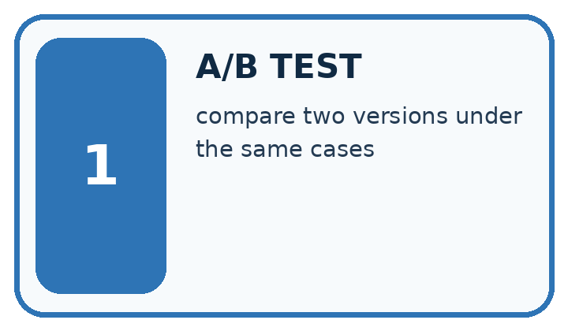
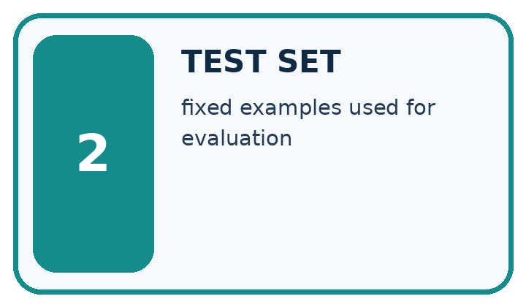
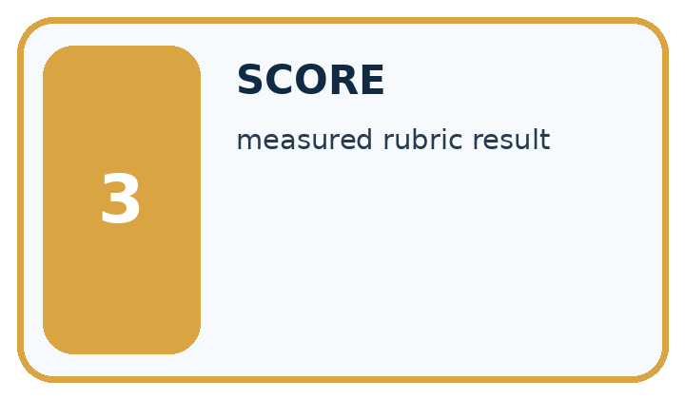
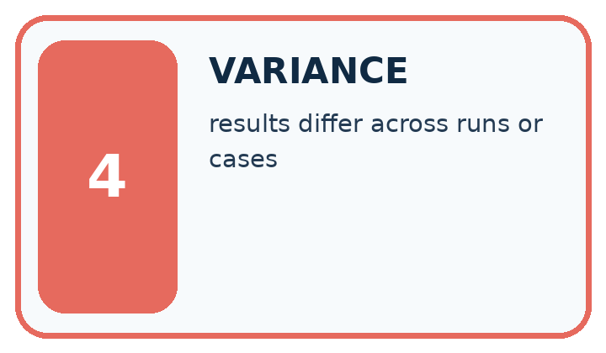
Word | My own example | Not this / boundary
A/B test | A comparison of two versions using a planned assignment of comparable cases and the same outcome measure.
test set | Data reserved for evaluating a selected system; final test data must not influence its development.
score | A numerical value assigned using a specified rule; it is not automatically a probability.
variance | A measure of spread around a mean; informally, variation across repeated results. Specify which meaning is intended.

Words used in the closer explanation
Word | Meaning
Paired case | The same case evaluated under each compared procedure
Rubric | Prespecified criteria for judging an output
Regression | A previously passing condition that fails after a change

06. Follow a worked example
WORKED EVIDENCE
Reason Step by Step
Predict first. Then check each step. A correct answer without visible reasoning is incomplete evidence.
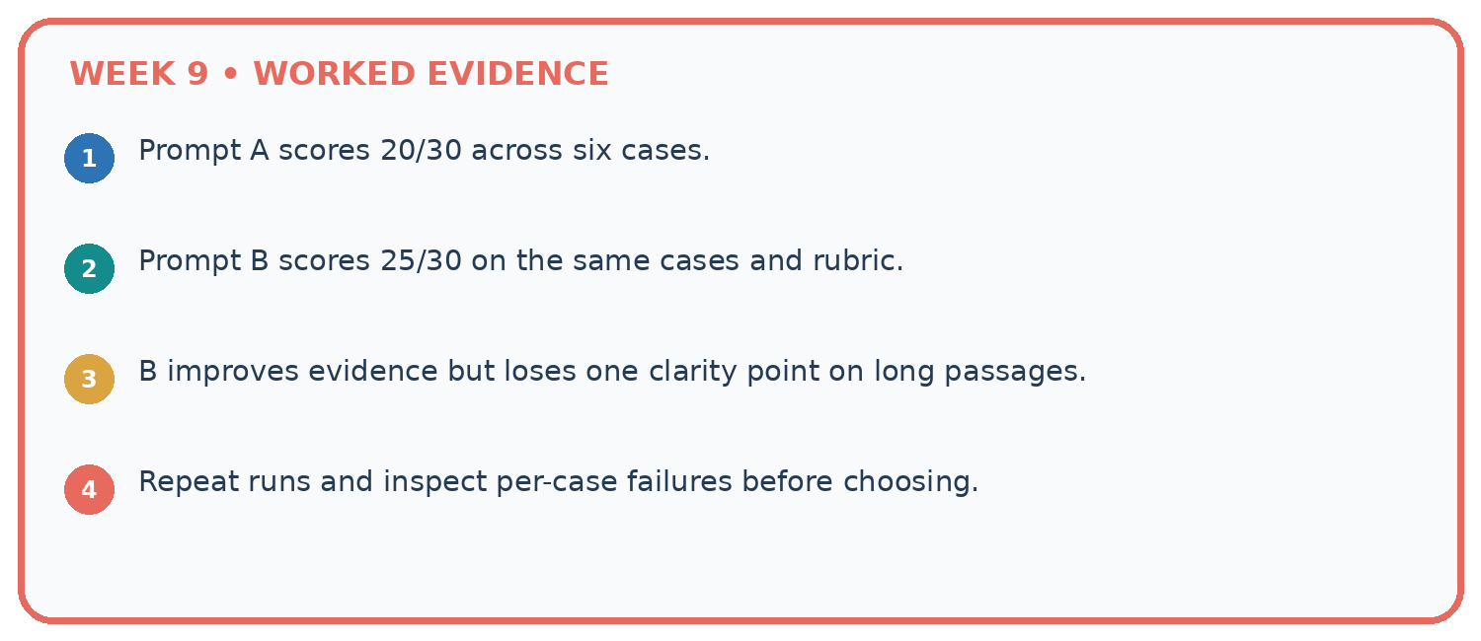
1. Prompt A scores 20/30 across six cases.
2. Prompt B scores 25/30 on the same cases and rubric.
3. B improves evidence but loses one clarity point on long passages.
4. Repeat runs and inspect per-case failures before choosing.
Recalculate, retrace, or restate the reasoning in your own representation:

Write or draw your reasoning and evidence.
________________________________________________________________
________________________________________________________________
________________________________________________________________
________________________________________________________________
________________________________________________________________
CHECK Did the evidence answer the exact question? Did the total, path, or source record stay consistent?

A closer explanation
On six development cases P passes cases 1, 2, 3, 4; Q passes 1, 2, 3, 5, 6. Missing-approval cases are 4 and 6. Compare totals and condition results.
P passes 4/6 and Q 5/6. P passes one of two missing-approval cases, Q also one of two. Q improves the aggregate while leaving this condition unchanged.
Compare the intermediate evidence with the final statement. Explain why each number or decision follows from the stated inputs. The conclusion belongs to this scenario and procedure; changing the inputs, evaluation population or authority can change what it establishes. Retain the raw record so a later revision can be compared honestly.

Learn from the worked case
Cover the result before checking it. Say what is given, choose the procedure, and follow one step at a time. Then uncover the result and explain your first mismatch. Ask why a step is allowed, not only what number it produces.

A pictorial worked case: Prompt Evaluation
A fictional Study Buddy compares two prompts across six development questions.

The facts we will use
A passes cases 1,2,3,4. B passes 1,2,5,6. Cases 5 and 6 require refusing unsupported claims.
Mandatory selection gate: pass both refusal cases. All cases use fixed sources and one common rubric.
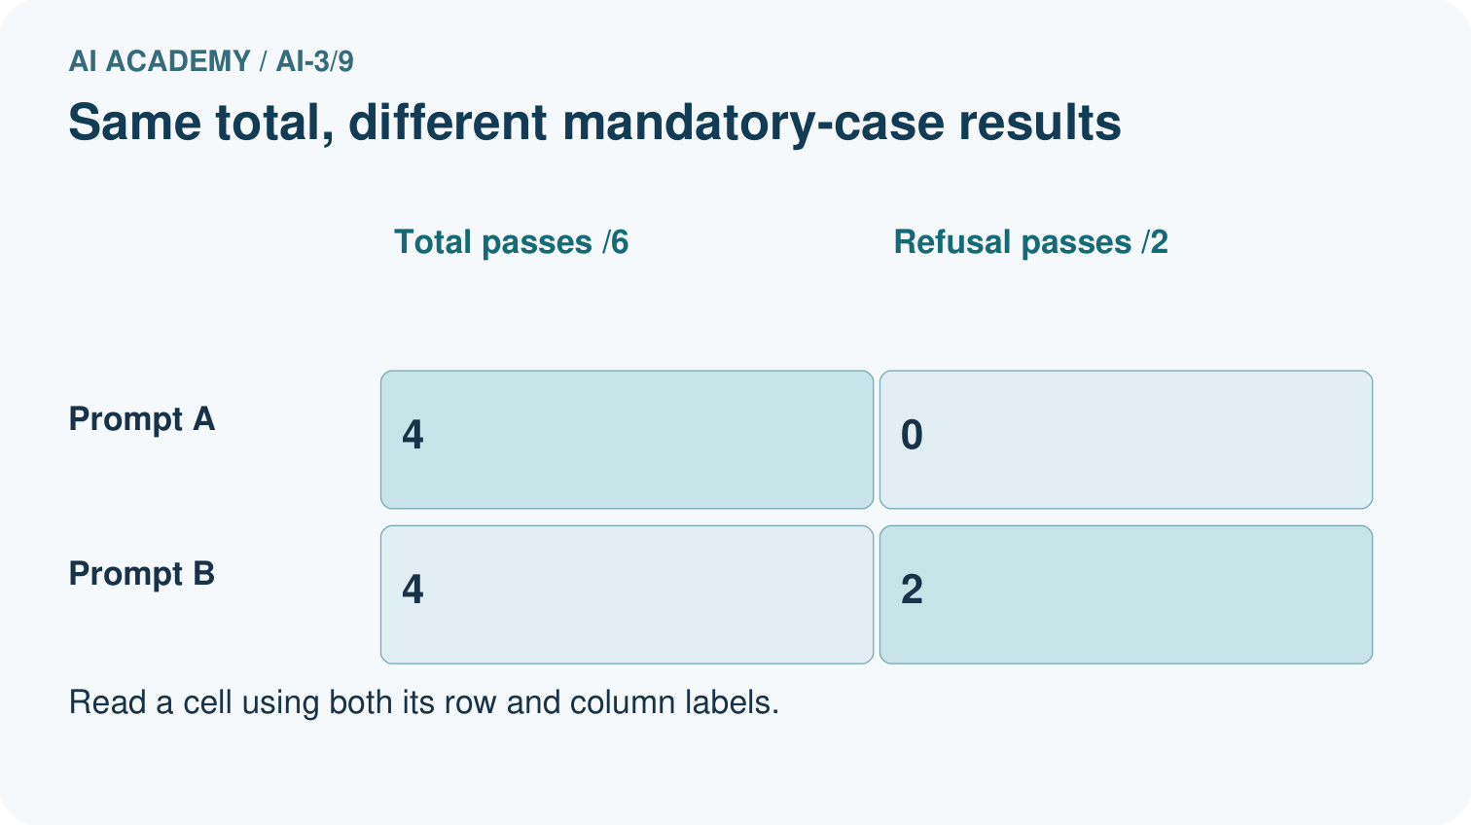
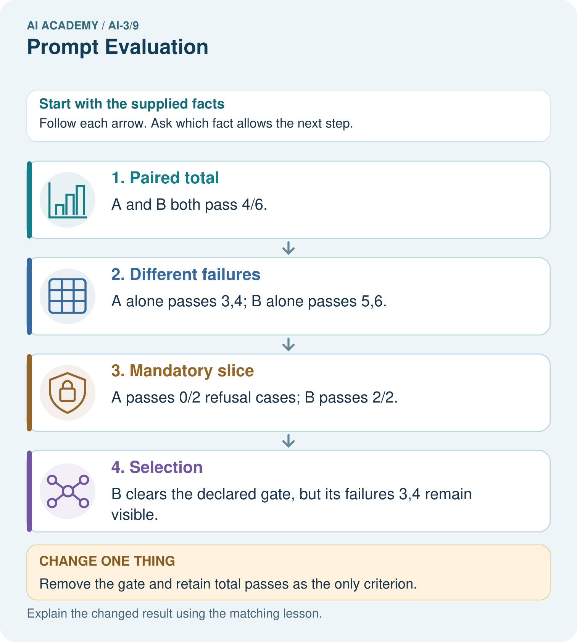

Read the picture one step at a time
Step | What happens and why
1. Paired total | A and B both pass 4/6.
2. Different failures | A alone passes 3,4; B alone passes 5,6.
3. Mandatory slice | A passes 0/2 refusal cases; B passes 2/2.
4. Selection | B clears the declared gate, but its failures 3,4 remain visible.
Match each pictured step to the supplied facts. This is a worked teaching case, not an independent assessment.

Why this result follows
Equal totals do not imply equal behavior. The predeclared gate expresses an important requirement instead of choosing a criterion after seeing the result. Selecting B is justified under that rule, not by claiming it is best on every question. After development, freeze the chosen prompt and test new questions, including both ordinary and unsupported cases.

What this example does not establish
Six invented development outcomes do not measure real model performance or prove a gain in student understanding.
Read the labelled picture: Why is B’s selection defensible here without calling it universally superior?
Change one thing: Remove the gate and retain total passes as the only criterion. Predict the result before checking the explanation. What remains the same?

07. Find and repair a mistake
ERROR DETECTIVE
Compare → Diagnose → Repair
Do not patch the answer. Find the earliest unsupported assumption, wrong step, or weak evidence.
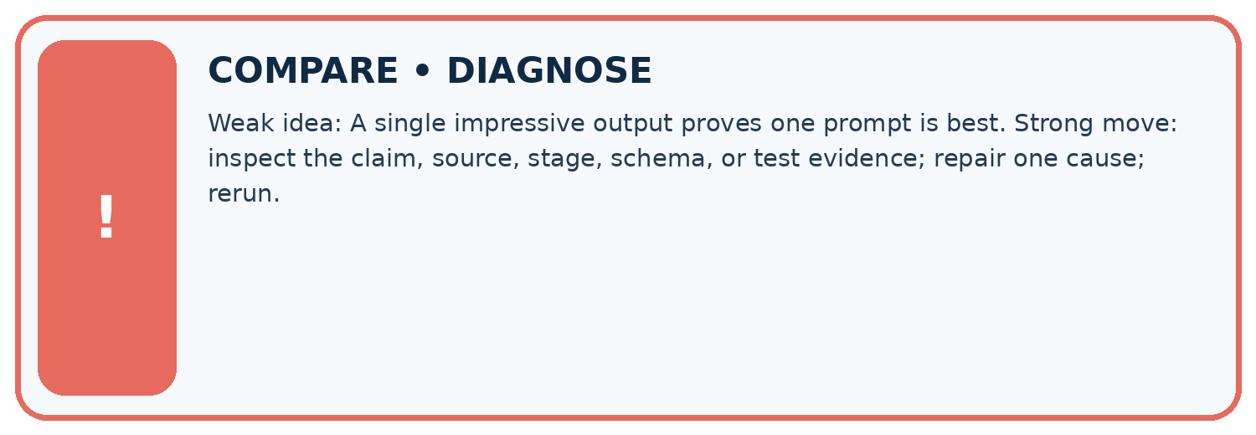
Evidence record | Expected | Actual | Likely cause / next test
normal case | works
boundary case | stated rule
missing input | safe response
fresh transfer | generalizes
Repair one cause. Why is this repair better than changing several things?

Write or draw your reasoning and evidence.
________________________________________________________________
________________________________________________________________
________________________________________________________________
________________________________________________________________
________________________________________________________________

A closer explanation
Complete the supported workbook tasks before attempting W4 independently. Record any hints or help used. After feedback, use the teacher's fresh retry rather than copying the earlier answer. For a project, select a relevant new case, predict the outcome from the declared rule and preserve the result alongside any revision.

Exit: propose one revealing change to the worked scenario. State the expected outcome and the evidence that would make you revise your explanation.
________________________________________________________________
________________________________________________________________
________________________________________________________________
________________________________________________________________
________________________________________________________________

08. Practise together
LOGIC STUDIO
Specify Before You Run
Prompts, schemas, retrieval, tool calls, and code are inspectable parts of one AI product.

SET task, audience, constraints, output_schema
LOAD approved_context or retrieval_result
CALL model or allowed_tool
VALIDATE fields, claims, citations, and safety
IF evidence missing: ask, retrieve, or abstain
RETURN useful output + source trail + limitations
Trace one input. Which line changes the state or chooses a path?

Write or draw your reasoning and evidence.
________________________________________________________________
________________________________________________________________
________________________________________________________________
________________________________________________________________
________________________________________________________________

A closer explanation
Prompt selection on development cases cannot be reported as independent final performance.
A useful check asks what would make the reasoning fail. Distinguish a failure to execute the declared procedure from a weakness in the procedure itself. The first may require a correction; the second requires an explicitly revised method and new evidence. Preserve unsuccessful cases so an improved result cannot hide the original problem.

Guided: restate the worked result, then name the assumption or limitation that prevents a broader conclusion.
________________________________________________________________
________________________________________________________________
________________________________________________________________
________________________________________________________________
________________________________________________________________

Practise with less help: Trace the worked case
Use workbook W2 for the connected example “Controlled prompt experiments”. First fill the input and rule boxes. Try the middle steps before asking for a hint. After a hint, try the next step yourself.
Plan | Do | Check
What is given? Which rule or procedure applies? | Record each intermediate step. | Does the result follow? What remains unknown?
Explain your trace to a partner. Your partner points to one step to check. Swap roles on the next case. Each person writes their own explanation.

Check your reasoning
Use the worked case for Controlled prompt experiments. Proposed explanation: “The worked result establishes every future case”. Decide whether this explanation is supported. Point to the step or supplied fact that decides; explain your repair if needed.
Answer on your own before discussion. If you are unsure, say which step you need help with.

Explain the picture
Why is B’s selection defensible here without calling it universally superior?

My explanation using a pictured step and the given facts
________________________________________________________________
________________________________________________________________
________________________________________________________________
________________________________________________________________
This is supported practice. Keep the separately named independent case for an attempt before feedback.

09. Run the investigation
EVIDENCE LAB
Predict → Test → Record → Explain
Keep expected and actual results separate. Surprises are useful data when recorded honestly.
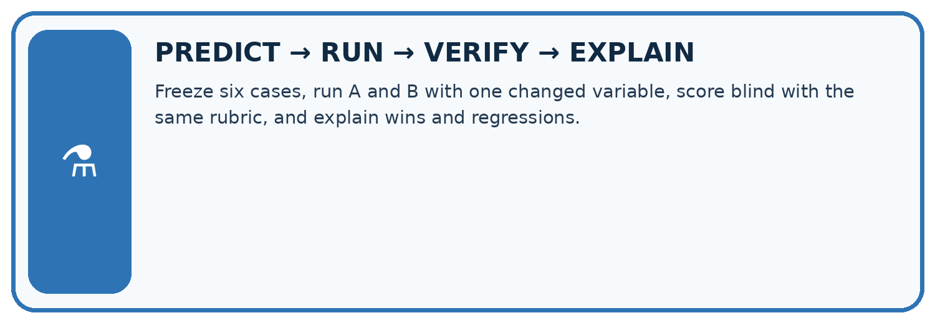
Freeze six cases, run A and B with one changed variable, score blind with the same rubric, and explain wins and regressions.
Test / input | Prediction | Actual | Evidence / calculation | Change or keep?
normal
boundary
missing
fresh transfer
What did the hardest test teach you that the normal test did not?

Write or draw your reasoning and evidence.
________________________________________________________________
________________________________________________________________
________________________________________________________________
________________________________________________________________
________________________________________________________________

Plan → try → check
Before trying: what do I expect, and why? While trying: which step could first go wrong? Afterwards: what did I actually observe, and what should change? Keep “not run” if you only traced the procedure.

10. Build your understanding
MASTERY
From Knowing the Word to Owning the Idea
Move upward only when you can produce evidence without copying the worked example.

1 • NAME: Define the concept without repeating the textbook.
2 • TRACE: Show the information, state, branch, calculation, or evidence path.
3 • APPLY: Solve a different example independently.
4 • CHALLENGE: Find a boundary case, counterexample, or unfair outcome.
5 • EXPLAIN LIMITS: Say when the result should not be trusted or used alone.
My strongest evidence of independent understanding:

Write or draw your reasoning and evidence.
________________________________________________________________
________________________________________________________________
________________________________________________________________
________________________________________________________________
________________________________________________________________

11. Connect your project
CUMULATIVE PROJECT
Verified Study Buddy
Every week adds one inspectable piece. The system must show how it reached a result.
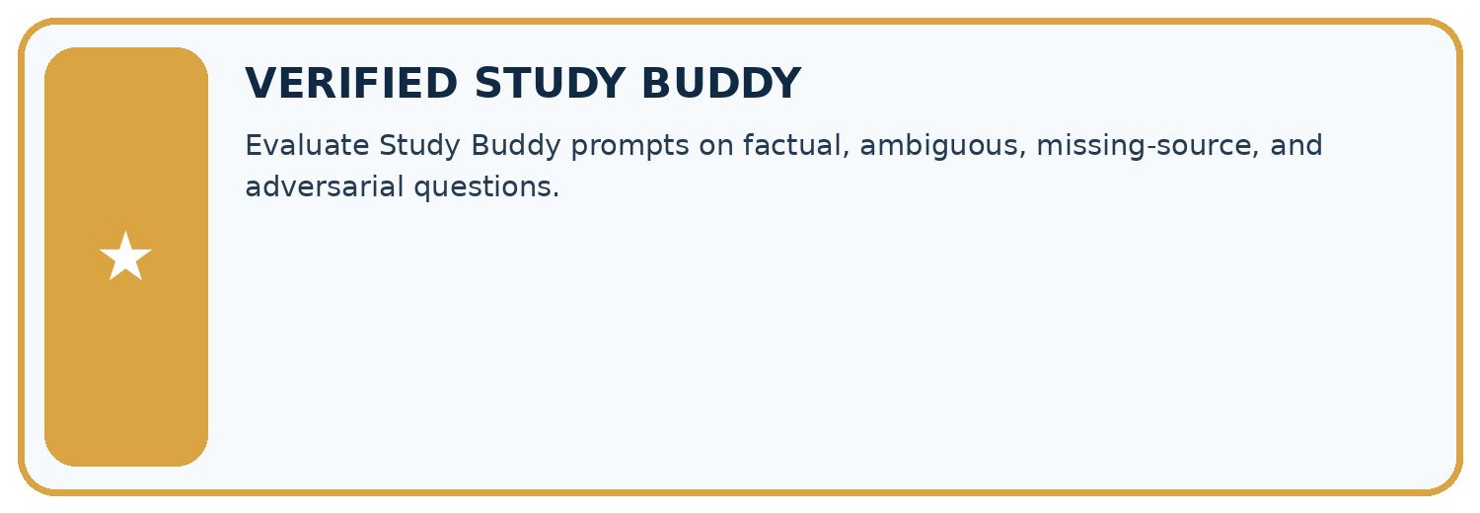
THIS WEEK’S CHECKPOINT Evaluate Study Buddy prompts on factual, ambiguous, missing-source, and adversarial questions.
SYSTEM MAP Learner need → prompt/schema → approved sources/retrieval → model/tool → structured answer → verification → human decision
What will you add, change, or verify in the project this week?

Write or draw your reasoning and evidence.
________________________________________________________________
________________________________________________________________
________________________________________________________________
________________________________________________________________
________________________________________________________________
What should remain under human control?

Write or draw your reasoning and evidence.
________________________________________________________________
________________________________________________________________
________________________________________________________________
________________________________________________________________
________________________________________________________________
RESPONSIBLE DESIGN Collect only necessary information. Show uncertainty and limits. Never confuse fluent output with verified truth.

Evidence for your project
Use Study Buddy case matrices with explicit priorities, source support gates and fresh final questions.

12. Show what you know
INDEPENDENT MASTERY PROOF
Explain • Transfer • Test • Defend
Complete this page without copying the worked example. Your reasoning matters more than decoration.
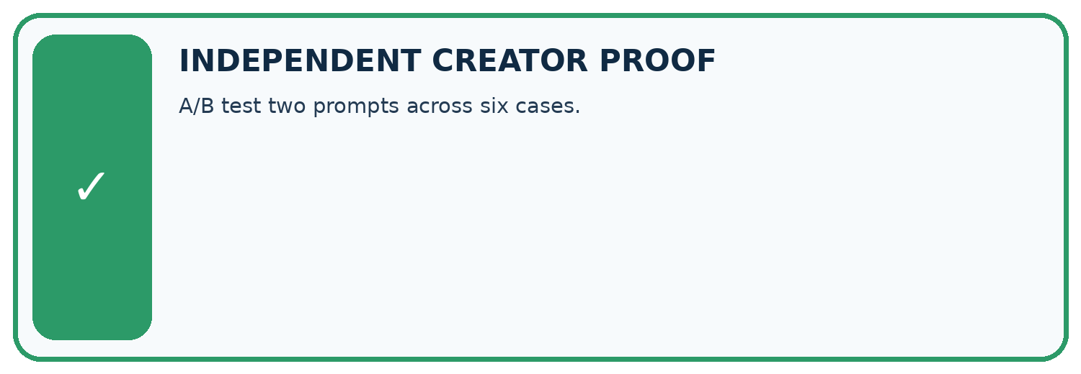
CHALLENGE A/B test two prompts across six cases.
1. My fresh example, trace, calculation, or design:

Write or draw your reasoning and evidence.
________________________________________________________________
________________________________________________________________
________________________________________________________________
________________________________________________________________
________________________________________________________________
2. My evidence that it works (include a boundary or missing-data case):

Write or draw your reasoning and evidence.
________________________________________________________________
________________________________________________________________
________________________________________________________________
________________________________________________________________
________________________________________________________________
3. One limitation, fairness concern, or situation needing human review:

Write or draw your reasoning and evidence.
________________________________________________________________
________________________________________________________________
________________________________________________________________
________________________________________________________________
________________________________________________________________
SELF-CHECK □ I explained the mechanism □ I used evidence □ I tested a fresh case □ I named a limitation □ I can answer ‘why?’

13. Study a complete case

Week 9 Worked case
Use the supplied details to practise the weekly concept before attempting the independent question. This case extends the illustrated lesson.

The situation
On five fixed questions, A passes four and B passes three; B looks more attractive.

The question
What conclusion is supported?

Worked explanation
A has 4/5 versus B's 3/5 on this set. Appearance is separate. Broaden cases and repeat stochastic trials before generalising.

Explain it in your own words
Which detail supports the answer, and why does it matter?

Write or draw your reasoning and evidence.
________________________________________________________________
________________________________________________________________
________________________________________________________________
________________________________________________________________
________________________________________________________________

Trace the supplied case visually

Evaluate prompts on the same questions
Evidence or stage | Value or result
Prompt A | 4/5
Prompt B | 3/5
On five fixed questions, A passes four and B passes three; B looks more attractive.
What conclusion is supported?
A has 4/5 versus B's 3/5 on this set. Appearance is separate. Broaden cases and repeat stochastic trials before generalising.

14. Try a new case independently

Independent case: Changed independent case
Five validation tasks have pass results A:1,1,1,0,0 and B:0,1,0,1,1. Compare performance and explain what is required before choosing a prompt.

My independent explanation, trace and limits
________________________________________________________________
________________________________________________________________
________________________________________________________________
________________________________________________________________
________________________________________________________________
________________________________________________________________
________________________________________________________________
Attempt this case before feedback. Record any help. Earlier examples below are further practice; a case already practised with feedback cannot establish fresh transfer.

Week 9 Independent application
Close the worked explanation. Apply the idea to this different question without copying.
Prompt A passes 8 of 10 tasks; B passes 9 of 10 but fails the only source-checking task. A source check is mandatory. Which can be accepted as-is?
My answer, with a trace, calculation or supporting evidence

Write or draw your reasoning and evidence.
________________________________________________________________
________________________________________________________________
________________________________________________________________
________________________________________________________________
________________________________________________________________

Create and test
Change one relevant detail. Predict the result before testing. Include a boundary or missing-information case when it helps reveal a limit.
My changed input and expected result

Write or draw your reasoning and evidence.
________________________________________________________________
________________________________________________________________
________________________________________________________________
________________________________________________________________
________________________________________________________________

Connect to your project
Evaluate Study Buddy prompts on factual, ambiguous, missing-source, and adversarial questions.
The evidence I will keep

Write or draw your reasoning and evidence.
________________________________________________________________
________________________________________________________________
________________________________________________________________
________________________________________________________________
________________________________________________________________
Your teacher has the independent answer and scoring criteria. Complete the matching workbook week to keep your practice evidence together.

Transfer practice from the original programme
On four shared tasks, A scores 1,1,0,1 and B scores 1,0,1,1. Their totals tie. What should you inspect before choosing? Define a final evaluation step.

Explain the mechanism, evidence and one limit.
________________________________________________________________
________________________________________________________________
________________________________________________________________
________________________________________________________________
________________________________________________________________
________________________________________________________________
________________________________________________________________

Use feedback to improve
Attempt the independent case before hints. Record whether you worked alone, used a hint or followed a model. After feedback, fix the first unsupported step and explain why it changed. A later check uses a changed case, not a copied answer.

15. Your lesson route
Start with this question: A fictional Study Buddy compares two prompts across six development questions.
By the end, I can | How I will show it
Explain the mechanism and terminology of controlled prompt experiments | Explain the deciding step, show a trace or test, and state one limit.
Apply the stated procedure to a new case with a traceable result | Explain the deciding step, show a trace or test, and state one limit.
Identify an assumption or limitation and design a revealing follow-up | Explain the deciding step, show a trace or test, and state one limit.
Remember → watch and explain → try with help → investigate → try independently → keep project evidence. Your teacher may spread this lesson across several classes.
Keep your first prediction. Compare it with what the evidence shows and explain any change.

16. Finish and return
Close your notes. Explain this goal in your own words: Explain the mechanism and terminology of controlled prompt experiments

My deciding step, evidence and one remaining question
________________________________________________________________
________________________________________________________________
________________________________________________________________
________________________________________________________________
________________________________________________________________
If you are unsure, return to the worked picture and explain one arrow. If you are ready, change an input or assumption and justify your prediction.
Save your workbook evidence. At the next review, try a different case before opening your old answer.

