AI ACADEMY · STUDENT · ai-3/18

Retrieval Augmented Generation
Project: Verified Study Buddy

Before you start
Week 17: distinguish retrieving evidence from phrasing an answer.

01. Your mission

Your learning target
I can explain the mechanism and terminology of building a grounded answer.
I can apply the stated procedure to a new case with a traceable result.
I can identify an assumption or limitation and design a revealing follow-up.

Remember before reading
Close your notes first. A rough first answer helps us choose the right starting point; it is not a score for your ability.
Without opening the old lesson, explain one key idea from Model Memory vs Retrieval. Give an example and a mistake that the idea helps you avoid.
Without opening the old lesson, explain one key idea from Source Quality. Give an example and a mistake that the idea helps you avoid.
Without opening the old lesson, explain one key idea from Speech and Audio Systems. Give an example and a mistake that the idea helps you avoid.
After trying, check the relevant lesson or ask your teacher. Change the part of your explanation that the evidence shows was wrong.
Week 18: Retrieval-Augmented Generation
RAG retrieves passages, then generates an answer grounded in them.
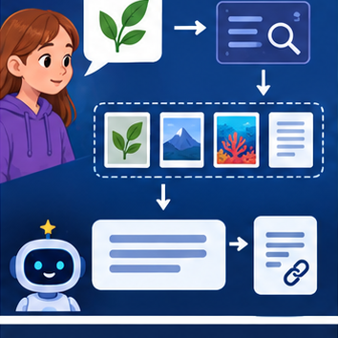
CREATOR MISSION
Trace query → retrieve → select → answer → cite.
Creator name and date:

Write or draw your reasoning and evidence.
________________________________________________________________
________________________________________________________________
________________________________________________________________
________________________________________________________________
________________________________________________________________

Readiness for the connected explanation
Recall Ranking and retrieval evaluation. Explain why a recorded result needs its input conditions and evidence source before it can support a claim.

Readiness for Chunking and document structure
Recall Retrieval and indexing. Explain why a recorded result needs its input conditions and evidence source before it can support a claim.

My readiness explanation
________________________________________________________________
________________________________________________________________
________________________________________________________________

Readiness for Lexical and vector retrieval
Recall Chunking and document structure. Explain why a recorded result needs its input conditions and evidence source before it can support a claim.

My readiness explanation
________________________________________________________________
________________________________________________________________
________________________________________________________________

This week’s end goal
By the end, I can explain retrieval augmented generation using a traced example and a stated limitation.

02. Notice the evidence
PICTURE STORY
Notice → Predict → Explain
Begin with visible evidence. Do not explain more than the picture and information support.
MYSTERY
The learners must use retrieval-augmented generation to solve a problem. What information do they have? What decision or calculation do they make? What would count as evidence that it worked?
Three observations (what you can point to):

Write or draw your reasoning and evidence.
________________________________________________________________
________________________________________________________________
________________________________________________________________
________________________________________________________________
________________________________________________________________
My prediction and the clue supporting it:

Write or draw your reasoning and evidence.
________________________________________________________________
________________________________________________________________
________________________________________________________________
________________________________________________________________
________________________________________________________________

A closer explanation
A grounded answer connects each factual claim to evidence actually retrieved for the task. Retrieval success does not automatically make generation faithful.
Begin by writing the question the procedure is intended to answer. Identify the information already supplied, the information it will produce and the information still missing. These are constructed classroom examples; they do not require live accounts, private records or an external service. Do not treat a plausible explanation as a measured outcome.

Apply the connected idea: Chunking and document structure
Chunking divides documents into retrievable units. A useful chunk retains enough structure to interpret a passage, including headers and exceptions.
Begin by writing the question the procedure is intended to answer. Identify the information already supplied, the information it will produce and the information still missing. These are constructed classroom examples; they do not require live accounts, private records or an external service. Do not treat a plausible explanation as a measured outcome.

Apply the connected idea: Lexical and vector retrieval
Lexical retrieval matches terms; vector retrieval compares numerical representations. Each can fail when the representation misses the relevant distinction.
Begin by writing the question the procedure is intended to answer. Identify the information already supplied, the information it will produce and the information still missing. These are constructed classroom examples; they do not require live accounts, private records or an external service. Do not treat a plausible explanation as a measured outcome.

03. See how it works
VISUAL MECHANISM
Input → Process → Output
Trace the information. At each stage, ask what changed and how you could test it.
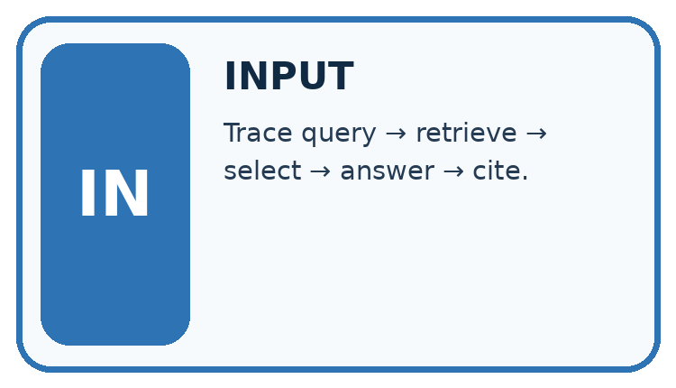
↓
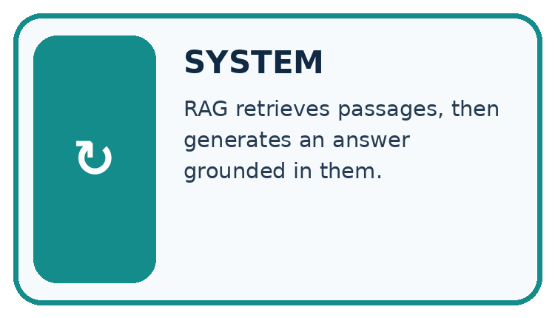
↓
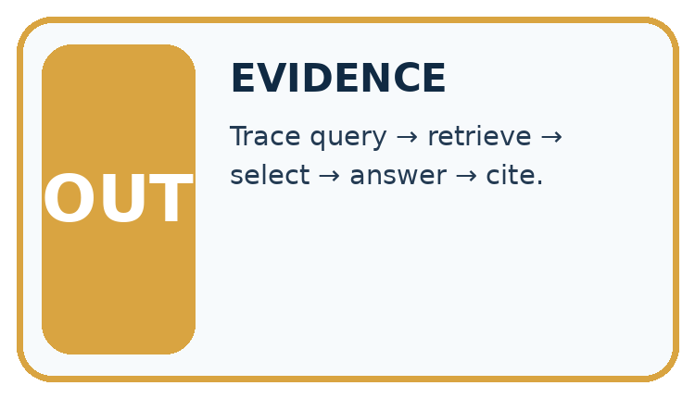
Which stage could fail even when the other two are correct? Explain:

Write or draw your reasoning and evidence.
________________________________________________________________
________________________________________________________________
________________________________________________________________
________________________________________________________________
________________________________________________________________

A closer explanation
Build a claim-evidence table before final wording. Preserve source versions and qualifiers, omit unsupported claims or explicitly state the gap, then validate the answer against the table.

Building a grounded answer — evidence trace
Input and scope | Check or calculation | Conclusion and limit
Current source P approves room C; Q lists C capacity 10. Draft says room C is approved, seats 10 and offers lunch. | Build a claim-evidence table before final wording. Preserve source versions and qualifiers, omit unsupported claims or explicitly state the gap, then validate the answer against the table. | Approval and capacity are supported by P and Q; lunch lacks evidence. A grounded answer reports the first two claims and does not invent lunch.
The figure connects this chapter's worked input, declared procedure and result. Read the complete worked reasoning for qualifiers and intermediate steps; the abbreviated labels do not replace that reasoning.
Before applying the procedure, write its units, denominator or decision boundary where relevant. A partner should be able to repeat each step using the same inputs. If a required input is absent or violates the stated contract, record that condition explicitly instead of quietly replacing it with a convenient value.

Apply the connected idea: Chunking and document structure
Give each chunk its document/version ID, section and offsets. Preserve qualifiers or link adjacent material. Overlap can repeat information; repeated chunks are not independent sources.

Chunking and document structure — evidence trace
Input and scope | Check or calculation | Conclusion and limit
A notice says capacity 20, followed by during maintenance capacity 8. Separate chunks contain each sentence but retrieval returns only the first. | Give each chunk its document/version ID, section and offsets. Preserve qualifiers or link adjacent material. Overlap can repeat information; repeated chunks are not independent sources. | The first chunk alone lacks the applicable exception. Retrieve the linked condition and determine maintenance status before asserting capacity 20.
The figure connects this chapter's worked input, declared procedure and result. Read the complete worked reasoning for qualifiers and intermediate steps; the abbreviated labels do not replace that reasoning.
Before applying the procedure, write its units, denominator or decision boundary where relevant. A partner should be able to repeat each step using the same inputs. If a required input is absent or violates the stated contract, record that condition explicitly instead of quietly replacing it with a convenient value.

Apply the connected idea: Lexical and vector retrieval
For a toy lexical score, count distinct query terms present after lowercase exact-word matching. For a toy vector score use a stated dot product. Compare relevance using independent judgments, not score magnitude alone.

Lexical and vector retrieval — evidence trace
Input and scope | Check or calculation | Conclusion and limit
Query terms red sensor. D1 text red sensor manual; D2 text red paint. Their lexical scores are 2 and 1. Vector query [1, 0], D1=[.4, .9], D2=[.8, .1]. | For a toy lexical score, count distinct query terms present after lowercase exact-word matching. For a toy vector score use a stated dot product. Compare relevance using independent judgments, not score magnitude alone. | Lexical ranks D1 first; dot product ranks D2 first (.8 versus .4). The supplied task relevance favours the sensor manual; vector ranking alone does not prove relevance.
The figure connects this chapter's worked input, declared procedure and result. Read the complete worked reasoning for qualifiers and intermediate steps; the abbreviated labels do not replace that reasoning.
Before applying the procedure, write its units, denominator or decision boundary where relevant. A partner should be able to repeat each step using the same inputs. If a required input is absent or violates the stated contract, record that condition explicitly instead of quietly replacing it with a convenient value.

Connect the picture and the explanation
Point to the input, the deciding step and the result in this week’s visual. Explain the same step in ordinary words. A picture helps when you can say what each part represents.

04. Compare the cases
CASE GALLERY
Four Tests, Four Kinds of Evidence
A system is not understood until it survives more than one comfortable example.


NORMAL CASE: predict and name evidence. BOUNDARY CASE: predict and name evidence.


MISSING INFORMATION: predict and name evidence. TRANSFER CASE: predict and name evidence.
Which case is most likely to reveal a hidden assumption? Why?

Write or draw your reasoning and evidence.
________________________________________________________________
________________________________________________________________
________________________________________________________________
________________________________________________________________
________________________________________________________________

Change one thing in the pictured case
Change: The question asks exactly how long this ice takes to melt.
Prediction: Say that S4 does not provide a time.
Reason: A general change of state does not determine a duration for an unspecified sample.

05. Words that unlock the idea
VOCABULARY LAB
Words You Can Use to Reason
A definition matters when you can recognize the idea, use it, and contrast it with a near-miss.
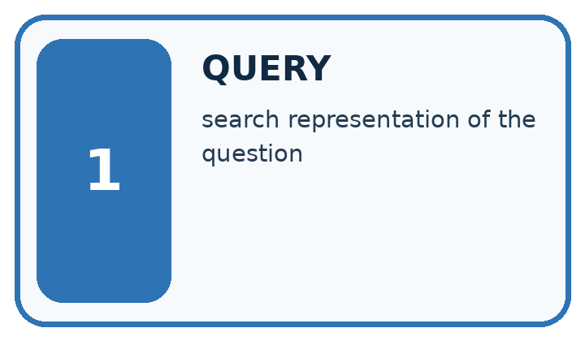
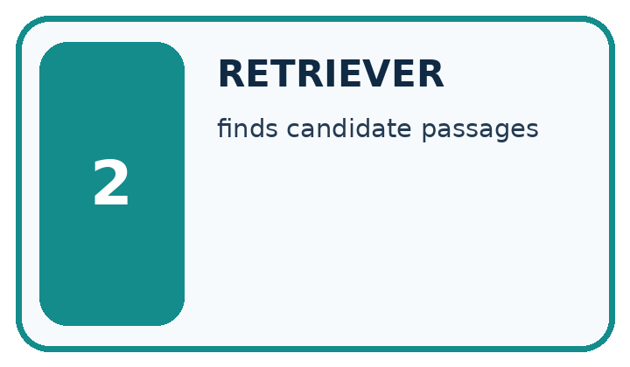
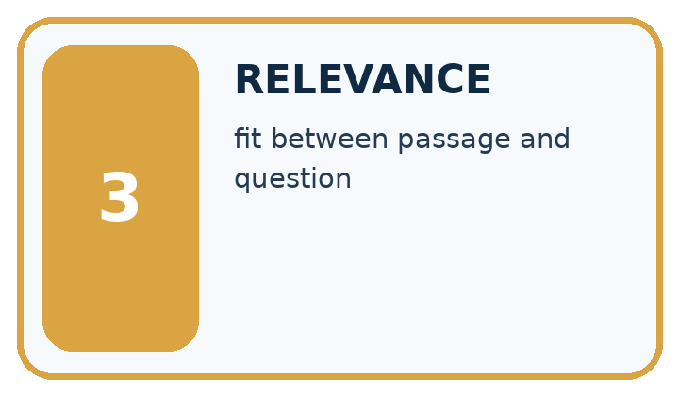
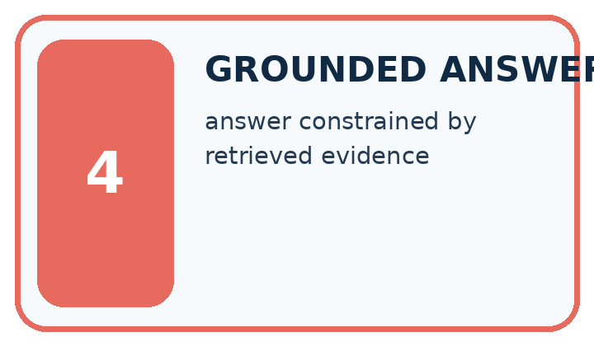
Word | My own example | Not this / boundary
query | A question or search request used to obtain information.
retriever | The component that searches for and selects source material relevant to a query.
relevance | How directly information helps answer the stated question or perform the task.
grounded answer | An answer whose factual claims are supported by identified evidence relevant to the question.

Words used in the closer explanation
Word | Meaning
Grounded claim | A claim supported by the available task evidence
Qualifier | A condition restricting a statement
Evidence table | A mapping from each claim to its supporting record

Terms for Chunking and document structure
Term | Meaning
Chunk | A retrievable unit from a document
Overlap | Content repeated in adjacent chunks
Offset | A location linking a chunk to the original source

Terms for Lexical and vector retrieval
Term | Meaning
Lexical match | Matching query terms to stored text
Vector retrieval | Ranking numerical representations using a declared similarity
Relevance judgment | An assessment of usefulness for the particular query

06. Follow a worked example
WORKED EVIDENCE
Reason Step by Step
Predict first. Then check each step. A correct answer without visible reasoning is incomplete evidence.
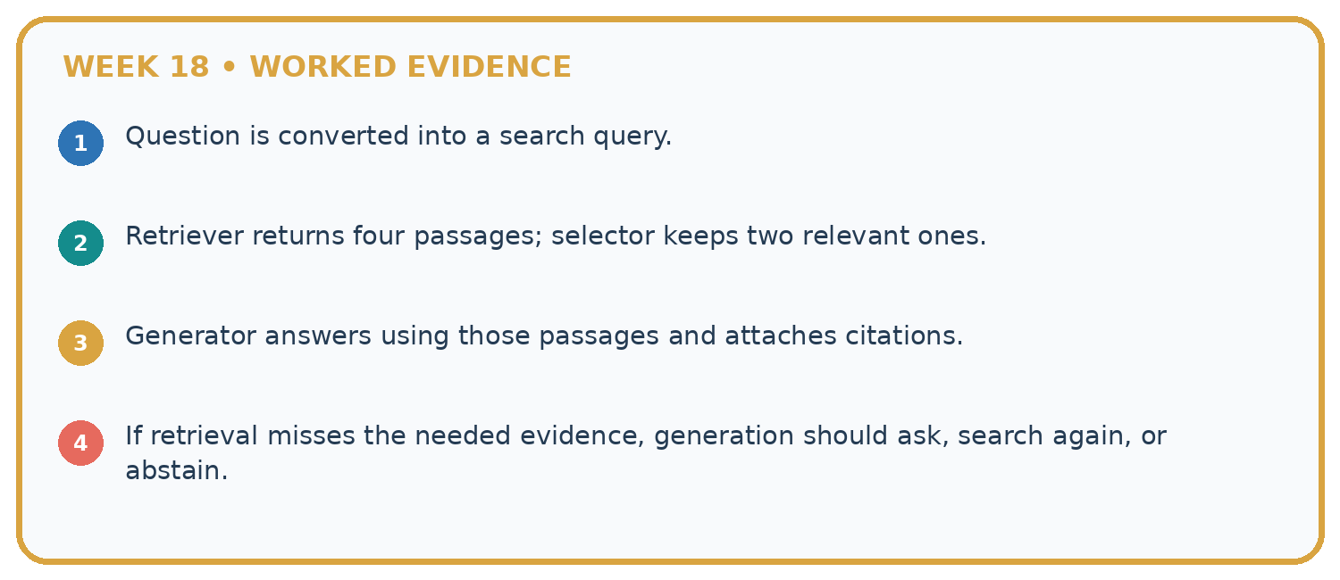
1. Question is converted into a search query.
2. Retriever returns four passages; selector keeps two relevant ones.
3. Generator answers using those passages and attaches citations.
4. If retrieval misses the needed evidence, generation should ask, search again, or abstain.
Recalculate, retrace, or restate the reasoning in your own representation:

Write or draw your reasoning and evidence.
________________________________________________________________
________________________________________________________________
________________________________________________________________
________________________________________________________________
________________________________________________________________
CHECK Did the evidence answer the exact question? Did the total, path, or source record stay consistent?

A closer explanation
Current source P approves room C; Q lists C capacity 10. Draft says room C is approved, seats 10 and offers lunch.
Approval and capacity are supported by P and Q; lunch lacks evidence. A grounded answer reports the first two claims and does not invent lunch.
Compare the intermediate evidence with the final statement. Explain why each number or decision follows from the stated inputs. The conclusion belongs to this scenario and procedure; changing the inputs, evaluation population or authority can change what it establishes. Retain the raw record so a later revision can be compared honestly.

Apply the connected idea: Chunking and document structure
A notice says capacity 20, followed by during maintenance capacity 8. Separate chunks contain each sentence but retrieval returns only the first.
The first chunk alone lacks the applicable exception. Retrieve the linked condition and determine maintenance status before asserting capacity 20.
Compare the intermediate evidence with the final statement. Explain why each number or decision follows from the stated inputs. The conclusion belongs to this scenario and procedure; changing the inputs, evaluation population or authority can change what it establishes. Retain the raw record so a later revision can be compared honestly.

Apply the connected idea: Lexical and vector retrieval
Query terms red sensor. D1 text red sensor manual; D2 text red paint. Their lexical scores are 2 and 1. Vector query [1, 0], D1=[.4, .9], D2=[.8, .1].
Lexical ranks D1 first; dot product ranks D2 first (.8 versus .4). The supplied task relevance favours the sensor manual; vector ranking alone does not prove relevance.
Compare the intermediate evidence with the final statement. Explain why each number or decision follows from the stated inputs. The conclusion belongs to this scenario and procedure; changing the inputs, evaluation population or authority can change what it establishes. Retain the raw record so a later revision can be compared honestly.

Learn from the worked case
Cover the result before checking it. Say what is given, choose the procedure, and follow one step at a time. Then uncover the result and explain your first mismatch. Ask why a step is allowed, not only what number it produces.

A pictorial worked case: Retrieval Augmented Generation
Turn a short science source into an answer with a visible claim-to-source map.

The facts we will use
Approved note S4 says: ice is solid water; warming can melt ice into liquid water. No temperature or speed is supplied.
All inputs and outcomes in this worked example are invented classroom data; no real model run is claimed.
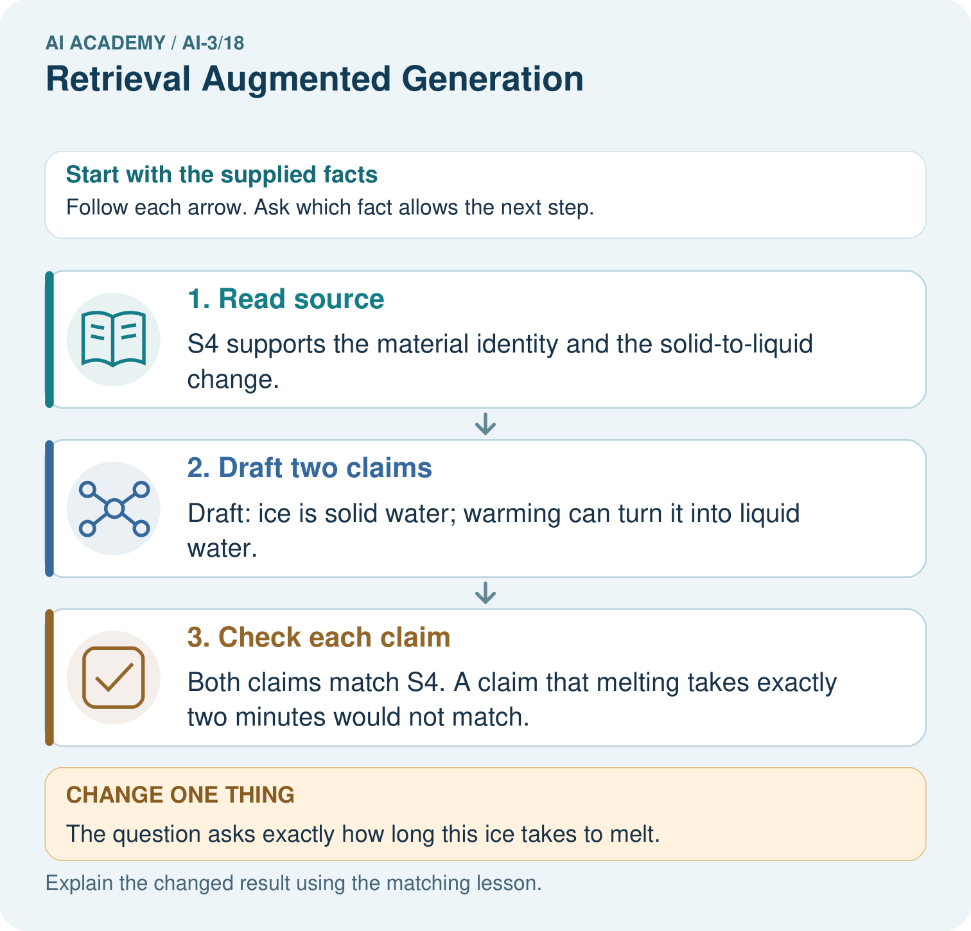

Read the picture one step at a time
Step | What happens and why
1. Read source | S4 supports the material identity and the solid-to-liquid change.
2. Draft two claims | Draft: ice is solid water; warming can turn it into liquid water.
3. Check each claim | Both claims match S4. A claim that melting takes exactly two minutes would not match.
Match each pictured step to the supplied facts. This is a worked teaching case, not an independent assessment.

Why this result follows
Read the picture in order. Both claims match S4. A claim that melting takes exactly two minutes would not match. The arrows show which recorded input or intermediate result each decision uses. Explain the deciding step aloud before checking the changed case; pointing to the final answer alone does not show how it follows.

What this example does not establish
This source-grounding exercise does not establish that every source is complete or scientifically authoritative.
Read the labelled picture: Which part of the source supports a two-minute melting claim? Point to the relevant step in the picture, then write the changed result and the rule or evidence that supports it.
Change one thing: The question asks exactly how long this ice takes to melt. Predict the result before checking the explanation. What remains the same?

07. Find and repair a mistake
ERROR DETECTIVE
Compare → Diagnose → Repair
Do not patch the answer. Find the earliest unsupported assumption, wrong step, or weak evidence.
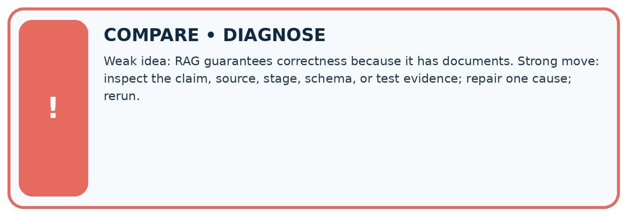
Evidence record | Expected | Actual | Likely cause / next test
normal case | works
boundary case | stated rule
missing input | safe response
fresh transfer | generalizes
Repair one cause. Why is this repair better than changing several things?

Write or draw your reasoning and evidence.
________________________________________________________________
________________________________________________________________
________________________________________________________________
________________________________________________________________
________________________________________________________________

A closer explanation
Complete the supported workbook tasks before attempting W4 independently. Record any hints or help used. After feedback, use the teacher's fresh retry rather than copying the earlier answer. For a project, select a relevant new case, predict the outcome from the declared rule and preserve the result alongside any revision.

Exit: propose one revealing change to the worked scenario. State the expected outcome and the evidence that would make you revise your explanation.
________________________________________________________________
________________________________________________________________
________________________________________________________________
________________________________________________________________
________________________________________________________________

Apply the connected idea: Chunking and document structure
Complete the supported workbook tasks before attempting W4 independently. Record any hints or help used. After feedback, use the teacher's fresh retry rather than copying the earlier answer. For a project, select a relevant new case, predict the outcome from the declared rule and preserve the result alongside any revision.

Exit: propose one revealing change to the worked scenario. State the expected outcome and the evidence that would make you revise your explanation.
________________________________________________________________
________________________________________________________________
________________________________________________________________
________________________________________________________________
________________________________________________________________

Apply the connected idea: Lexical and vector retrieval
Complete the supported workbook tasks before attempting W4 independently. Record any hints or help used. After feedback, use the teacher's fresh retry rather than copying the earlier answer. For a project, select a relevant new case, predict the outcome from the declared rule and preserve the result alongside any revision.

Exit: propose one revealing change to the worked scenario. State the expected outcome and the evidence that would make you revise your explanation.
________________________________________________________________
________________________________________________________________
________________________________________________________________
________________________________________________________________
________________________________________________________________

08. Practise together
LOGIC STUDIO
Specify Before You Run
Prompts, schemas, retrieval, tool calls, and code are inspectable parts of one AI product.

SET task, audience, constraints, output_schema
LOAD approved_context or retrieval_result
CALL model or allowed_tool
VALIDATE fields, claims, citations, and safety
IF evidence missing: ask, retrieve, or abstain
RETURN useful output + source trail + limitations
Trace one input. Which line changes the state or chooses a path?

Write or draw your reasoning and evidence.
________________________________________________________________
________________________________________________________________
________________________________________________________________
________________________________________________________________
________________________________________________________________

A closer explanation
Grounding requires support for the exact claim, including conditions; attaching a source name is insufficient.
A useful check asks what would make the reasoning fail. Distinguish a failure to execute the declared procedure from a weakness in the procedure itself. The first may require a correction; the second requires an explicitly revised method and new evidence. Preserve unsuccessful cases so an improved result cannot hide the original problem.

Guided: restate the worked result, then name the assumption or limitation that prevents a broader conclusion.
________________________________________________________________
________________________________________________________________
________________________________________________________________
________________________________________________________________
________________________________________________________________

Apply the connected idea: Chunking and document structure
Smaller chunks can improve selectivity while losing necessary qualifiers; chunk size alone is not retrieval quality.
A useful check asks what would make the reasoning fail. Distinguish a failure to execute the declared procedure from a weakness in the procedure itself. The first may require a correction; the second requires an explicitly revised method and new evidence. Preserve unsuccessful cases so an improved result cannot hide the original problem.

Guided: restate the worked result, then name the assumption or limitation that prevents a broader conclusion.
________________________________________________________________
________________________________________________________________
________________________________________________________________
________________________________________________________________
________________________________________________________________

Apply the connected idea: Lexical and vector retrieval
Similarity and relevance are different quantities; exact terminology, metadata and permissions may be necessary.
A useful check asks what would make the reasoning fail. Distinguish a failure to execute the declared procedure from a weakness in the procedure itself. The first may require a correction; the second requires an explicitly revised method and new evidence. Preserve unsuccessful cases so an improved result cannot hide the original problem.

Guided: restate the worked result, then name the assumption or limitation that prevents a broader conclusion.
________________________________________________________________
________________________________________________________________
________________________________________________________________
________________________________________________________________
________________________________________________________________

Practise with less help: Trace the worked case
Use workbook W2 for the connected example “Building a grounded answer”. First fill the input and rule boxes. Try the middle steps before asking for a hint. After a hint, try the next step yourself.
Plan | Do | Check
What is given? Which rule or procedure applies? | Record each intermediate step. | Does the result follow? What remains unknown?
Explain your trace to a partner. Your partner points to one step to check. Swap roles on the next case. Each person writes their own explanation.

Check your reasoning
Use the worked case for Building a grounded answer. Proposed explanation: “The worked result establishes every future case”. Decide whether this explanation is supported. Point to the step or supplied fact that decides; explain your repair if needed.
Answer on your own before discussion. If you are unsure, say which step you need help with.

Practise the connected topic: Chunking and document structure
Use its named workbook W2. Identify the given inputs, try the middle steps with less help, then explain your trace. Check this claim before group discussion: The worked result establishes every future case

Practise the connected topic: Lexical and vector retrieval
Use its named workbook W2. Identify the given inputs, try the middle steps with less help, then explain your trace. Check this claim before group discussion: The worked result establishes every future case

Explain the picture
Which part of the source supports a two-minute melting claim? Point to the relevant step in the picture, then write the changed result and the rule or evidence that supports it.

My explanation using a pictured step and the given facts
________________________________________________________________
________________________________________________________________
________________________________________________________________
________________________________________________________________
This is supported practice. Keep the separately named independent case for an attempt before feedback.

09. Run the investigation
EVIDENCE LAB
Predict → Test → Record → Explain
Keep expected and actual results separate. Surprises are useful data when recorded honestly.
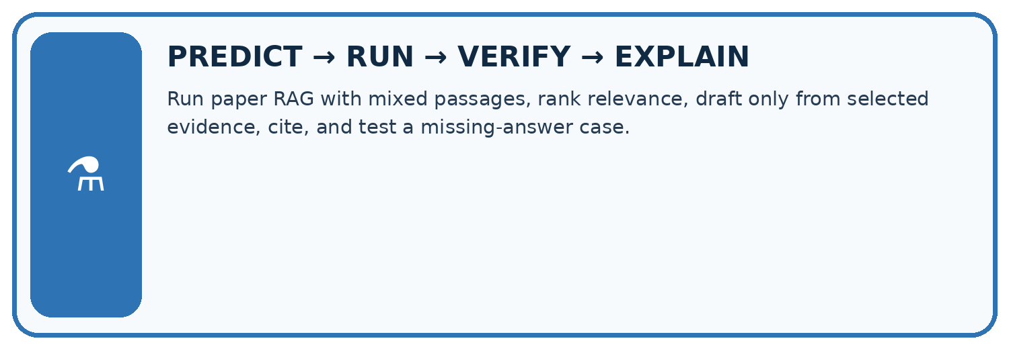
Run paper RAG with mixed passages, rank relevance, draft only from selected evidence, cite, and test a missing-answer case.
Test / input | Prediction | Actual | Evidence / calculation | Change or keep?
normal
boundary
missing
fresh transfer
What did the hardest test teach you that the normal test did not?

Write or draw your reasoning and evidence.
________________________________________________________________
________________________________________________________________
________________________________________________________________
________________________________________________________________
________________________________________________________________

Plan → try → check
Before trying: what do I expect, and why? While trying: which step could first go wrong? Afterwards: what did I actually observe, and what should change? Keep “not run” if you only traced the procedure.

10. Build your understanding
MASTERY
From Knowing the Word to Owning the Idea
Move upward only when you can produce evidence without copying the worked example.

1 • NAME: Define the concept without repeating the textbook.
2 • TRACE: Show the information, state, branch, calculation, or evidence path.
3 • APPLY: Solve a different example independently.
4 • CHALLENGE: Find a boundary case, counterexample, or unfair outcome.
5 • EXPLAIN LIMITS: Say when the result should not be trusted or used alone.
My strongest evidence of independent understanding:

Write or draw your reasoning and evidence.
________________________________________________________________
________________________________________________________________
________________________________________________________________
________________________________________________________________
________________________________________________________________

11. Connect your project
CUMULATIVE PROJECT
Verified Study Buddy
Every week adds one inspectable piece. The system must show how it reached a result.
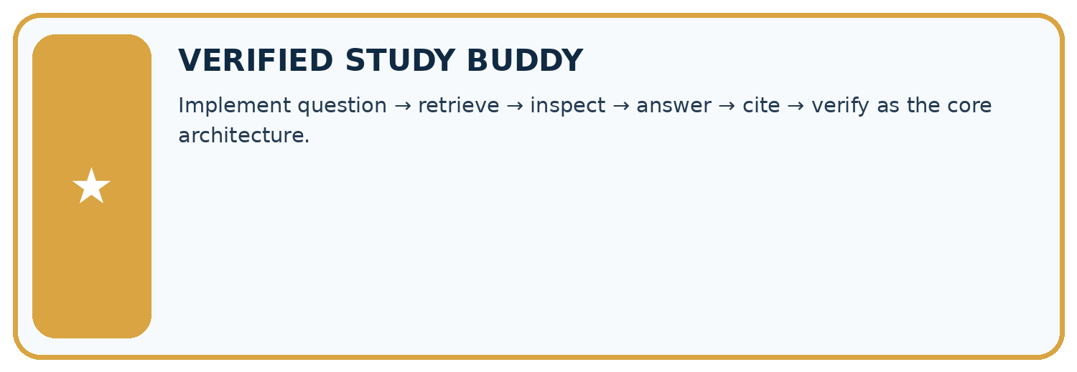
THIS WEEK’S CHECKPOINT Implement question → retrieve → inspect → answer → cite → verify as the core architecture.
SYSTEM MAP Learner need → prompt/schema → approved sources/retrieval → model/tool → structured answer → verification → human decision
What will you add, change, or verify in the project this week?

Write or draw your reasoning and evidence.
________________________________________________________________
________________________________________________________________
________________________________________________________________
________________________________________________________________
________________________________________________________________
What should remain under human control?

Write or draw your reasoning and evidence.
________________________________________________________________
________________________________________________________________
________________________________________________________________
________________________________________________________________
________________________________________________________________
RESPONSIBLE DESIGN Collect only necessary information. Show uncertainty and limits. Never confuse fluent output with verified truth.

Evidence for your project
For your Verified Study Buddy, save the input, procedure, observed result and limitation of this check. Label this worked example as practice; use a different, previously unreviewed case when checking independent understanding.

12. Show what you know
INDEPENDENT MASTERY PROOF
Explain • Transfer • Test • Defend
Complete this page without copying the worked example. Your reasoning matters more than decoration.
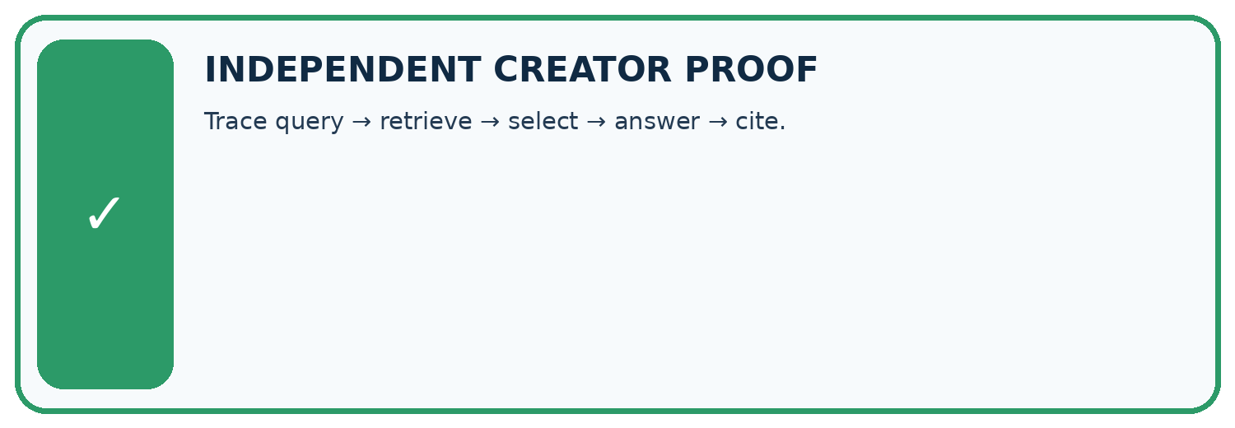
CHALLENGE Trace query → retrieve → select → answer → cite.
1. My fresh example, trace, calculation, or design:

Write or draw your reasoning and evidence.
________________________________________________________________
________________________________________________________________
________________________________________________________________
________________________________________________________________
________________________________________________________________
2. My evidence that it works (include a boundary or missing-data case):

Write or draw your reasoning and evidence.
________________________________________________________________
________________________________________________________________
________________________________________________________________
________________________________________________________________
________________________________________________________________
3. One limitation, fairness concern, or situation needing human review:

Write or draw your reasoning and evidence.
________________________________________________________________
________________________________________________________________
________________________________________________________________
________________________________________________________________
________________________________________________________________
SELF-CHECK □ I explained the mechanism □ I used evidence □ I tested a fresh case □ I named a limitation □ I can answer ‘why?’

13. Study a complete case

Week 18 Worked case
Use the supplied details to practise the weekly concept before attempting the independent question. This case extends the illustrated lesson.

The situation
Note A says library opens at 9. Note B says returns go in the blue box.

The question
Answer opening time with evidence.

Worked explanation
Answer 9 with note A. Retrieval supplies evidence and generation phrases it. B does not support opening time.

Explain it in your own words
Which detail supports the answer, and why does it matter?

Write or draw your reasoning and evidence.
________________________________________________________________
________________________________________________________________
________________________________________________________________
________________________________________________________________
________________________________________________________________

Trace the supplied case visually

Use the passage that answers the question
Evidence or stage | Value or result
Question | When does the library open?
Retrieve | Note A says opens at 9
Compose | Library opens at 9
Verify | Note A supports opening time
Note A says library opens at 9. Note B says returns go in the blue box.
Answer opening time with evidence.
Answer 9 with note A. Retrieval supplies evidence and generation phrases it. B does not support opening time.

14. Try a new case independently

Independent case: Apply a new case independently
Source A approves room H; B lists H capacity 7, except maintenance limit 4. Maintenance status is unknown. Write a grounded response.

My independent explanation, trace and limits
________________________________________________________________
________________________________________________________________
________________________________________________________________
________________________________________________________________
________________________________________________________________
________________________________________________________________
________________________________________________________________
Attempt this case before feedback. Record any help. Earlier examples below are further practice; a case already practised with feedback cannot establish fresh transfer.

Week 18 Independent application
Close the worked explanation. Apply the idea to this different question without copying.
A retrieved passage says the club meets Tuesday; it says nothing about cost. The assistant answers Tuesday, free entry. Which part is grounded and what should replace the unsupported part?
My answer, with a trace, calculation or supporting evidence

Write or draw your reasoning and evidence.
________________________________________________________________
________________________________________________________________
________________________________________________________________
________________________________________________________________
________________________________________________________________

Create and test
Change one relevant detail. Predict the result before testing. Include a boundary or missing-information case when it helps reveal a limit.
My changed input and expected result

Write or draw your reasoning and evidence.
________________________________________________________________
________________________________________________________________
________________________________________________________________
________________________________________________________________
________________________________________________________________

Connect to your project
Implement question → retrieve → inspect → answer → cite → verify as the core architecture.
The evidence I will keep

Write or draw your reasoning and evidence.
________________________________________________________________
________________________________________________________________
________________________________________________________________
________________________________________________________________
________________________________________________________________
Your teacher has the independent answer and scoring criteria. Complete the matching workbook week to keep your practice evidence together.

Transfer practice from the original programme
Sources: A='Library opens 9'; B='Cafe opens 8'; C='Library closes 5'. A question asks when the library opens. The retriever returns only B and C. What should the generator do?

Explain the mechanism, evidence and one limit.
________________________________________________________________
________________________________________________________________
________________________________________________________________
________________________________________________________________
________________________________________________________________
________________________________________________________________
________________________________________________________________

Use feedback to improve
Attempt the independent case before hints. Record whether you worked alone, used a hint or followed a model. After feedback, fix the first unsupported step and explain why it changed. A later check uses a changed case, not a copied answer.

15. Your lesson route
Start with this question: Turn a short science source into an answer with a visible claim-to-source map.
By the end, I can | How I will show it
Explain the mechanism and terminology of building a grounded answer | Explain the deciding step, show a trace or test, and state one limit.
Apply the stated procedure to a new case with a traceable result | Explain the deciding step, show a trace or test, and state one limit.
Identify an assumption or limitation and design a revealing follow-up | Explain the deciding step, show a trace or test, and state one limit.
Remember → watch and explain → try with help → investigate → try independently → keep project evidence. Your teacher may spread this lesson across several classes.
Keep your first prediction. Compare it with what the evidence shows and explain any change.

16. Finish and return
Close your notes. Explain this goal in your own words: Explain the mechanism and terminology of building a grounded answer

My deciding step, evidence and one remaining question
________________________________________________________________
________________________________________________________________
________________________________________________________________
________________________________________________________________
________________________________________________________________
If you are unsure, return to the worked picture and explain one arrow. If you are ready, change an input or assumption and justify your prediction.
Save your workbook evidence. At the next review, try a different case before opening your old answer.

