AI ACADEMY · STUDENT · ai-3/35

Capstone Evaluate and Improve
Project: Verified Study Buddy

Before you start
AI-2 Week 35: a repair can introduce a regression.

01. Your mission

Your learning target
I can explain the mechanism and terminology of capstone evaluation and revision.
I can apply the stated procedure to a new case with a traceable result.
I can identify an assumption or limitation and design a revealing follow-up.

Remember before reading
Close your notes first. A rough first answer helps us choose the right starting point; it is not a score for your ability.
Without opening the old lesson, explain one key idea from Capstone Build. Give an example and a mistake that the idea helps you avoid.
Without opening the old lesson, explain one key idea from Human AI Workflow. Give an example and a mistake that the idea helps you avoid.
Without opening the old lesson, explain one key idea from Copyright and Provenance. Give an example and a mistake that the idea helps you avoid.
After trying, check the relevant lesson or ask your teacher. Change the part of your explanation that the evidence shows was wrong.
Week 35: Capstone Evaluate and Improve
Improvements must follow measured failures on a fixed eval set.
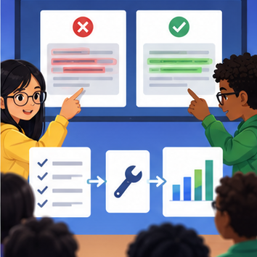
CREATOR MISSION
Run tests, repair one cause, and compare scores.
Creator name and date:

Write or draw your reasoning and evidence.
________________________________________________________________
________________________________________________________________
________________________________________________________________
________________________________________________________________
________________________________________________________________

Readiness for the connected explanation
Recall Capstone grounded assistant. Explain why a recorded result needs its input conditions and evidence source before it can support a claim.

Readiness for Latency cost and resource use
Recall Human review and consequential use. Explain why a recorded result needs its input conditions and evidence source before it can support a claim.

My readiness explanation
________________________________________________________________
________________________________________________________________
________________________________________________________________

This week’s end goal
By the end, I can explain capstone evaluate and improve using a traced example and a stated limitation.

02. Notice the evidence
PICTURE STORY
Notice → Predict → Explain
Begin with visible evidence. Do not explain more than the picture and information support.
MYSTERY
The learners must use capstone evaluate and improve to solve a problem. What information do they have? What decision or calculation do they make? What would count as evidence that it worked?
Three observations (what you can point to):

Write or draw your reasoning and evidence.
________________________________________________________________
________________________________________________________________
________________________________________________________________
________________________________________________________________
________________________________________________________________
My prediction and the clue supporting it:

Write or draw your reasoning and evidence.
________________________________________________________________
________________________________________________________________
________________________________________________________________
________________________________________________________________
________________________________________________________________

A closer explanation
Capstone evaluation compares the frozen assistant with a baseline on reserved cases and preserves failures. Revision uses observed errors but needs fresh evidence for new final claims.
Begin by writing the question the procedure is intended to answer. Identify the information already supplied, the information it will produce and the information still missing. These are constructed classroom examples; they do not require live accounts, private records or an external service. Do not treat a plausible explanation as a measured outcome.

Apply the connected idea: Latency cost and resource use
Latency, cost and quality are distinct measurements. Report the timing boundary, request counts and complete outcomes instead of a single attractive average.
Begin by writing the question the procedure is intended to answer. Identify the information already supplied, the information it will produce and the information still missing. These are constructed classroom examples; they do not require live accounts, private records or an external service. Do not treat a plausible explanation as a measured outcome.

03. See how it works
VISUAL MECHANISM
Input → Process → Output
Trace the information. At each stage, ask what changed and how you could test it.
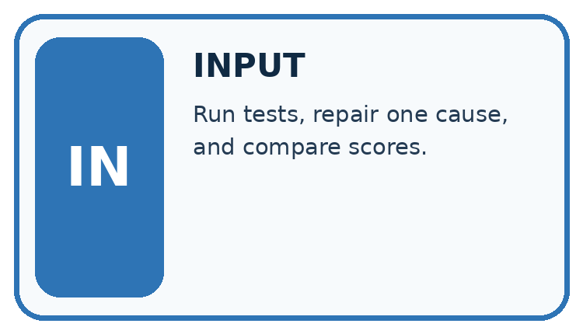
↓
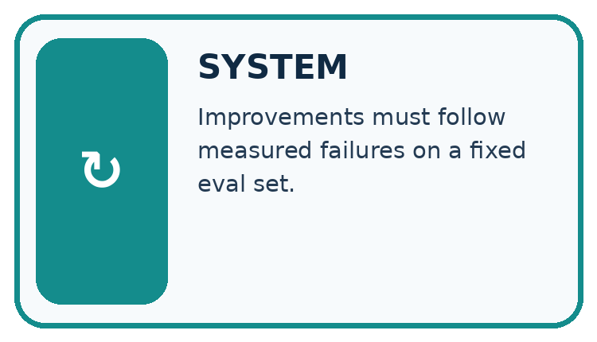
↓
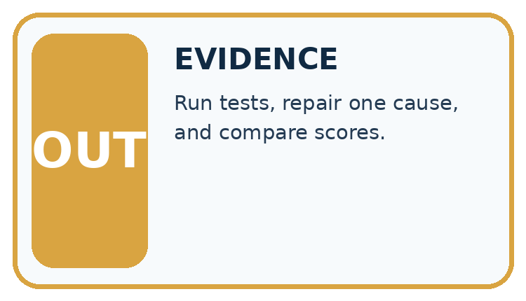
Which stage could fail even when the other two are correct? Explain:

Write or draw your reasoning and evidence.
________________________________________________________________
________________________________________________________________
________________________________________________________________
________________________________________________________________
________________________________________________________________

A closer explanation
Report paired case outcomes, condition rates and permission violations separately. A critical access failure can block release even when overall pass rate rises. Never overwrite the original final run.

Capstone evaluation and revision — evidence trace
Input and scope | Check or calculation | Conclusion and limit
On ten final cases baseline passes seven and assistant eight. One assistant failure exposes a teacher-only source to a student. | Report paired case outcomes, condition rates and permission violations separately. A critical access failure can block release even when overall pass rate rises. Never overwrite the original final run. | Rates 70% and 80%, gain 10 percentage points. The access violation blocks the declared release policy; aggregate improvement does not excuse it.
The figure connects this chapter's worked input, declared procedure and result. Read the complete worked reasoning for qualifiers and intermediate steps; the abbreviated labels do not replace that reasoning.
Before applying the procedure, write its units, denominator or decision boundary where relevant. A partner should be able to repeat each step using the same inputs. If a required input is absent or violates the stated contract, record that condition explicitly instead of quietly replacing it with a convenient value.

Apply the connected idea: Latency cost and resource use
In this fictional tariff input costs 2 credits per 1000 units and output 6 credits per 1000. Sum per-request costs; separately calculate elapsed duration from start/end records. Do not label credits as a current provider price.

Latency cost and resource use — evidence trace
Input and scope | Check or calculation | Conclusion and limit
A request uses 500 input units and 200 output units; starts at 10.0 seconds and finishes at 13.5. | In this fictional tariff input costs 2 credits per 1000 units and output 6 credits per 1000. Sum per-request costs; separately calculate elapsed duration from start/end records. Do not label credits as a current provider price. | Input cost 1 credit; output 1.2; total 2.2 credits. Elapsed 3.5 seconds within the recorded boundary. Quality is unmeasured.
The figure connects this chapter's worked input, declared procedure and result. Read the complete worked reasoning for qualifiers and intermediate steps; the abbreviated labels do not replace that reasoning.
Before applying the procedure, write its units, denominator or decision boundary where relevant. A partner should be able to repeat each step using the same inputs. If a required input is absent or violates the stated contract, record that condition explicitly instead of quietly replacing it with a convenient value.

Connect the picture and the explanation
Point to the input, the deciding step and the result in this week’s visual. Explain the same step in ordinary words. A picture helps when you can say what each part represents.

04. Compare the cases
CASE GALLERY
Four Tests, Four Kinds of Evidence
A system is not understood until it survives more than one comfortable example.


NORMAL CASE: predict and name evidence. BOUNDARY CASE: predict and name evidence.


MISSING INFORMATION: predict and name evidence. TRANSFER CASE: predict and name evidence.
Which case is most likely to reveal a hidden assumption? Why?

Write or draw your reasoning and evidence.
________________________________________________________________
________________________________________________________________
________________________________________________________________
________________________________________________________________
________________________________________________________________

Change one thing in the pictured case
Change: A repaired candidate passes 6/8 with zero restricted-note exposures.
Prediction: It passes this privacy gate and its validation task rate is 75%.
Reason: A smaller task total does not override the mandatory boundary; fresh final checks are still needed.

05. Words that unlock the idea
VOCABULARY LAB
Words You Can Use to Reason
A definition matters when you can recognize the idea, use it, and contrast it with a near-miss.
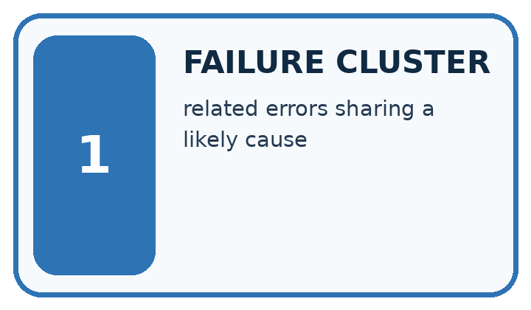
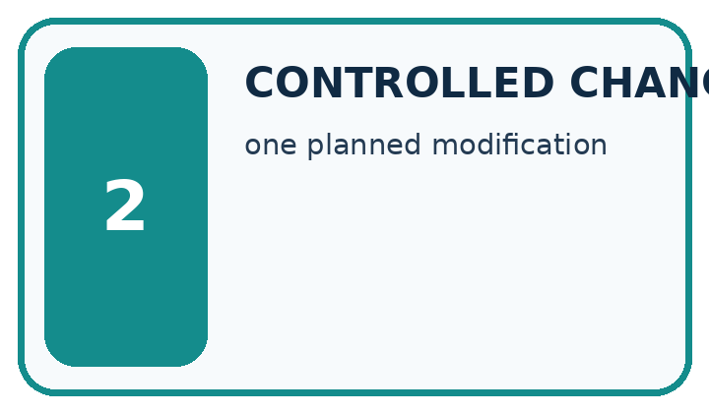
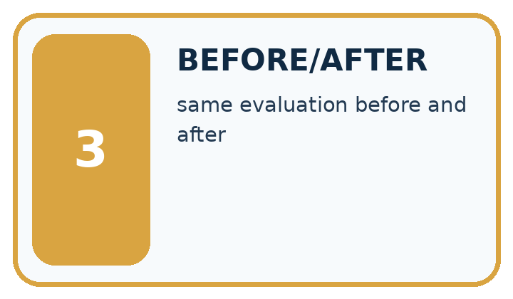
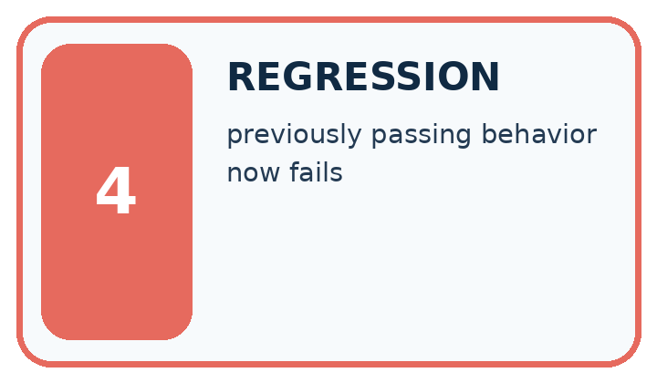
Word | My own example | Not this / boundary
failure cluster | A group of failures sharing a relevant pattern or condition.
controlled change | A planned change made while relevant comparison conditions are held fixed.
before/after | Results recorded prior to and following a change; other changes can affect the comparison.
regression | In testing, a new failure introduced by a change; in modelling, prediction of a numeric target. Use the meaning indicated by the lesson.

Words used in the closer explanation
Word | Meaning
Release gate | A required condition before a package or service is approved
Failure record | A preserved account of an unsuccessful case
Revision evaluation | Evidence collected after modifying a procedure

Terms for Latency cost and resource use
Term | Meaning
Latency | Elapsed time within a stated measurement boundary
Tariff | A declared rate for accounting
Quality constraint | A task outcome required alongside resource performance

06. Follow a worked example
WORKED EVIDENCE
Reason Step by Step
Predict first. Then check each step. A correct answer without visible reasoning is incomplete evidence.
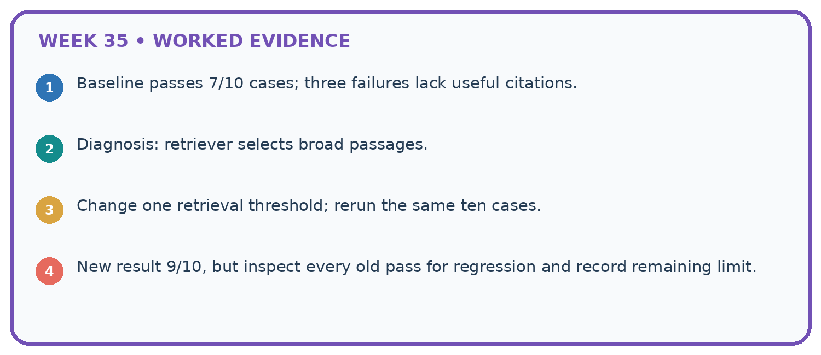
1. Baseline passes 7/10 cases; three failures lack useful citations.
2. Diagnosis: retriever selects broad passages.
3. Change one retrieval threshold; rerun the same ten cases.
4. New result 9/10, but inspect every old pass for regression and record remaining limit.
Recalculate, retrace, or restate the reasoning in your own representation:

Write or draw your reasoning and evidence.
________________________________________________________________
________________________________________________________________
________________________________________________________________
________________________________________________________________
________________________________________________________________
CHECK Did the evidence answer the exact question? Did the total, path, or source record stay consistent?

A closer explanation
On ten final cases baseline passes seven and assistant eight. One assistant failure exposes a teacher-only source to a student.
Rates 70% and 80%, gain 10 percentage points. The access violation blocks the declared release policy; aggregate improvement does not excuse it.
Compare the intermediate evidence with the final statement. Explain why each number or decision follows from the stated inputs. The conclusion belongs to this scenario and procedure; changing the inputs, evaluation population or authority can change what it establishes. Retain the raw record so a later revision can be compared honestly.

Apply the connected idea: Latency cost and resource use
A request uses 500 input units and 200 output units; starts at 10.0 seconds and finishes at 13.5.
Input cost 1 credit; output 1.2; total 2.2 credits. Elapsed 3.5 seconds within the recorded boundary. Quality is unmeasured.
Compare the intermediate evidence with the final statement. Explain why each number or decision follows from the stated inputs. The conclusion belongs to this scenario and procedure; changing the inputs, evaluation population or authority can change what it establishes. Retain the raw record so a later revision can be compared honestly.

Learn from the worked case
Cover the result before checking it. Say what is given, choose the procedure, and follow one step at a time. Then uncover the result and explain your first mismatch. Ask why a step is allowed, not only what number it produces.

A pictorial worked case: Capstone Evaluate and Improve
Choose a study-buddy revision using task performance and a mandatory privacy gate.

The facts we will use
On eight fixed validation cases, baseline passes 5 and candidate passes 7. One candidate response includes a restricted teacher note; privacy requires zero such exposures.
All inputs and outcomes in this worked example are invented classroom data; no real model run is claimed.
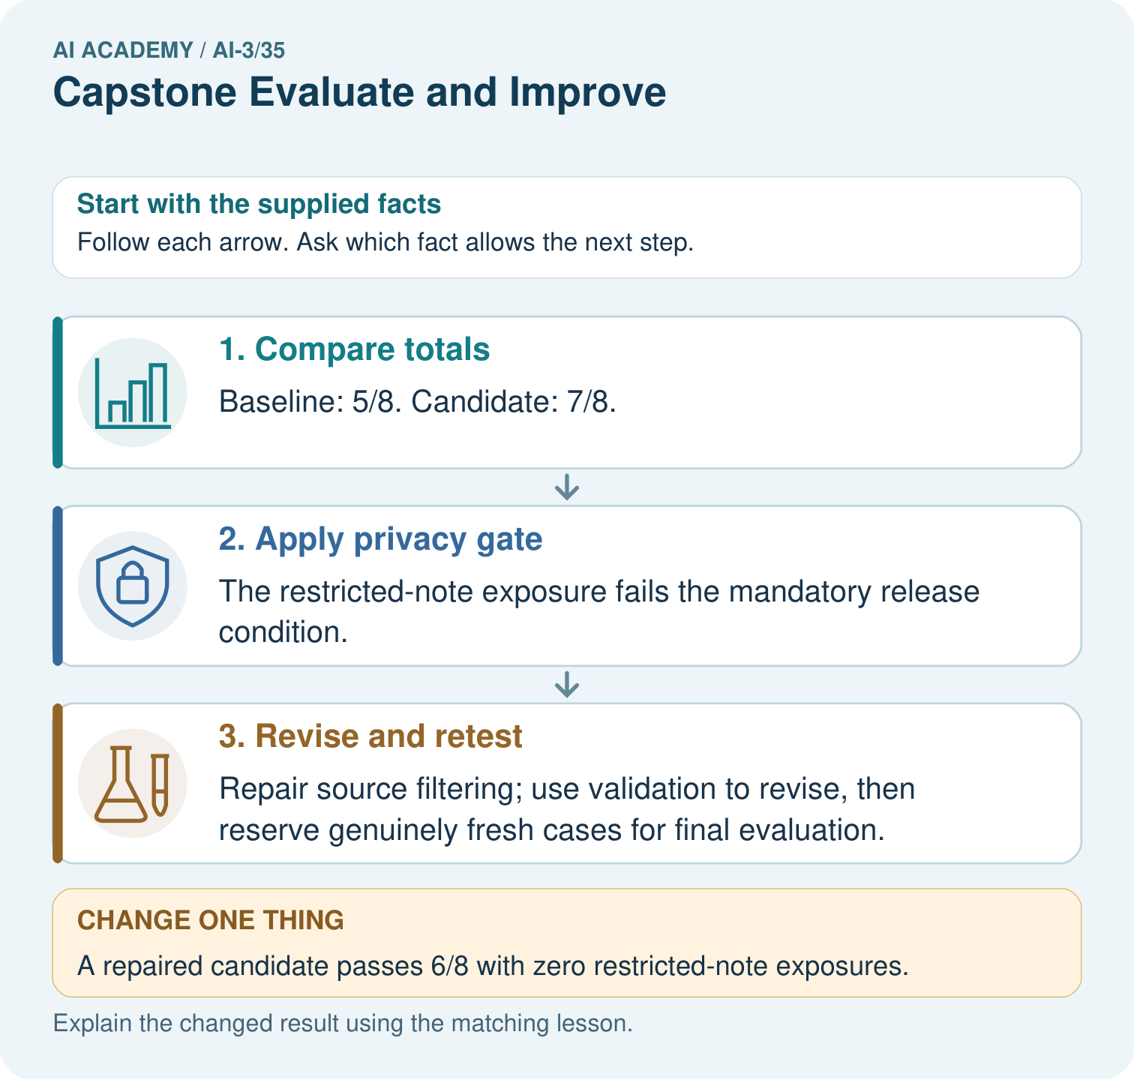

Read the picture one step at a time
Step | What happens and why
1. Compare totals | Baseline: 5/8. Candidate: 7/8.
2. Apply privacy gate | The restricted-note exposure fails the mandatory release condition.
3. Revise and retest | Repair source filtering; use validation to revise, then reserve genuinely fresh cases for final evaluation.
Match each pictured step to the supplied facts. This is a worked teaching case, not an independent assessment.

Why this result follows
Read the picture in order. Repair source filtering; use validation to revise, then reserve genuinely fresh cases for final evaluation. The arrows show which recorded input or intermediate result each decision uses. Explain the deciding step aloud before checking the changed case; pointing to the final answer alone does not show how it follows.

What this example does not establish
Passing a limited privacy test is bounded evidence, not a guarantee against all future disclosure.
Read the labelled picture: May the team call the repaired validation cases an untouched final test? Point to the relevant step in the picture, then write the changed result and the rule or evidence that supports it.
Change one thing: A repaired candidate passes 6/8 with zero restricted-note exposures. Predict the result before checking the explanation. What remains the same?

07. Find and repair a mistake
ERROR DETECTIVE
Compare → Diagnose → Repair
Do not patch the answer. Find the earliest unsupported assumption, wrong step, or weak evidence.
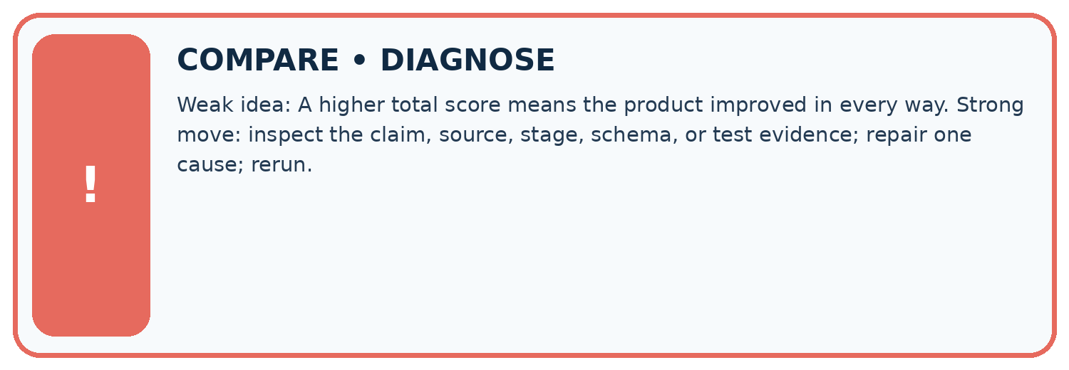
Evidence record | Expected | Actual | Likely cause / next test
normal case | works
boundary case | stated rule
missing input | safe response
fresh transfer | generalizes
Repair one cause. Why is this repair better than changing several things?

Write or draw your reasoning and evidence.
________________________________________________________________
________________________________________________________________
________________________________________________________________
________________________________________________________________
________________________________________________________________

A closer explanation
Complete the supported workbook tasks before attempting W4 independently. Record any hints or help used. After feedback, use the teacher's fresh retry rather than copying the earlier answer. For a project, select a relevant new case, predict the outcome from the declared rule and preserve the result alongside any revision.

Exit: propose one revealing change to the worked scenario. State the expected outcome and the evidence that would make you revise your explanation.
________________________________________________________________
________________________________________________________________
________________________________________________________________
________________________________________________________________
________________________________________________________________

Apply the connected idea: Latency cost and resource use
Complete the supported workbook tasks before attempting W4 independently. Record any hints or help used. After feedback, use the teacher's fresh retry rather than copying the earlier answer. For a project, select a relevant new case, predict the outcome from the declared rule and preserve the result alongside any revision.

Exit: propose one revealing change to the worked scenario. State the expected outcome and the evidence that would make you revise your explanation.
________________________________________________________________
________________________________________________________________
________________________________________________________________
________________________________________________________________
________________________________________________________________

08. Practise together
LOGIC STUDIO
Specify Before You Run
Prompts, schemas, retrieval, tool calls, and code are inspectable parts of one AI product.

SET task, audience, constraints, output_schema
LOAD approved_context or retrieval_result
CALL model or allowed_tool
VALIDATE fields, claims, citations, and safety
IF evidence missing: ask, retrieve, or abstain
RETURN useful output + source trail + limitations
Trace one input. Which line changes the state or chooses a path?

Write or draw your reasoning and evidence.
________________________________________________________________
________________________________________________________________
________________________________________________________________
________________________________________________________________
________________________________________________________________

A closer explanation
A revised procedure evaluated on inspected cases cannot be described as newly independent final testing.
A useful check asks what would make the reasoning fail. Distinguish a failure to execute the declared procedure from a weakness in the procedure itself. The first may require a correction; the second requires an explicitly revised method and new evidence. Preserve unsuccessful cases so an improved result cannot hide the original problem.

Guided: restate the worked result, then name the assumption or limitation that prevents a broader conclusion.
________________________________________________________________
________________________________________________________________
________________________________________________________________
________________________________________________________________
________________________________________________________________

Apply the connected idea: Latency cost and resource use
Resource comparisons require matched task conditions and quality evidence; a cheaper failing system is not automatically better.
A useful check asks what would make the reasoning fail. Distinguish a failure to execute the declared procedure from a weakness in the procedure itself. The first may require a correction; the second requires an explicitly revised method and new evidence. Preserve unsuccessful cases so an improved result cannot hide the original problem.

Guided: restate the worked result, then name the assumption or limitation that prevents a broader conclusion.
________________________________________________________________
________________________________________________________________
________________________________________________________________
________________________________________________________________
________________________________________________________________

Practise with less help: Trace the worked case
Use workbook W2 for the connected example “Capstone evaluation and revision”. First fill the input and rule boxes. Try the middle steps before asking for a hint. After a hint, try the next step yourself.
Plan | Do | Check
What is given? Which rule or procedure applies? | Record each intermediate step. | Does the result follow? What remains unknown?
Explain your trace to a partner. Your partner points to one step to check. Swap roles on the next case. Each person writes their own explanation.

Check your reasoning
Use the worked case for Capstone evaluation and revision. Proposed explanation: “The worked result establishes every future case”. Decide whether this explanation is supported. Point to the step or supplied fact that decides; explain your repair if needed.
Answer on your own before discussion. If you are unsure, say which step you need help with.

Practise the connected topic: Latency cost and resource use
Use its named workbook W2. Identify the given inputs, try the middle steps with less help, then explain your trace. Check this claim before group discussion: The worked result establishes every future case

Explain the picture
May the team call the repaired validation cases an untouched final test? Point to the relevant step in the picture, then write the changed result and the rule or evidence that supports it.

My explanation using a pictured step and the given facts
________________________________________________________________
________________________________________________________________
________________________________________________________________
________________________________________________________________
This is supported practice. Keep the separately named independent case for an attempt before feedback.

09. Run the investigation
EVIDENCE LAB
Predict → Test → Record → Explain
Keep expected and actual results separate. Surprises are useful data when recorded honestly.
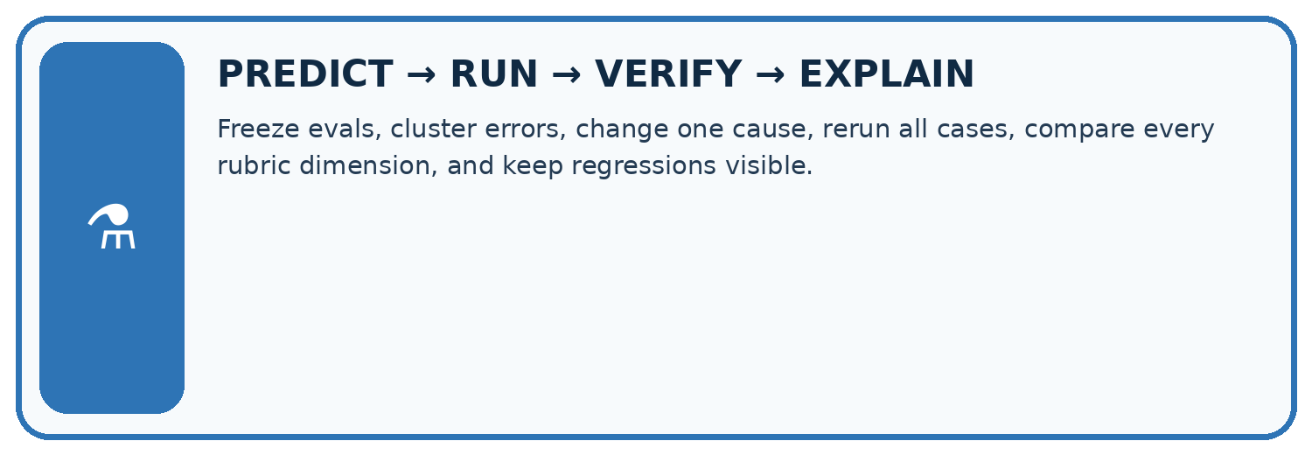
Freeze evals, cluster errors, change one cause, rerun all cases, compare every rubric dimension, and keep regressions visible.
Test / input | Prediction | Actual | Evidence / calculation | Change or keep?
normal
boundary
missing
fresh transfer
What did the hardest test teach you that the normal test did not?

Write or draw your reasoning and evidence.
________________________________________________________________
________________________________________________________________
________________________________________________________________
________________________________________________________________
________________________________________________________________

Plan → try → check
Before trying: what do I expect, and why? While trying: which step could first go wrong? Afterwards: what did I actually observe, and what should change? Keep “not run” if you only traced the procedure.

10. Build your understanding
MASTERY
From Knowing the Word to Owning the Idea
Move upward only when you can produce evidence without copying the worked example.

1 • NAME: Define the concept without repeating the textbook.
2 • TRACE: Show the information, state, branch, calculation, or evidence path.
3 • APPLY: Solve a different example independently.
4 • CHALLENGE: Find a boundary case, counterexample, or unfair outcome.
5 • EXPLAIN LIMITS: Say when the result should not be trusted or used alone.
My strongest evidence of independent understanding:

Write or draw your reasoning and evidence.
________________________________________________________________
________________________________________________________________
________________________________________________________________
________________________________________________________________
________________________________________________________________

11. Connect your project
CUMULATIVE PROJECT
Verified Study Buddy
Every week adds one inspectable piece. The system must show how it reached a result.
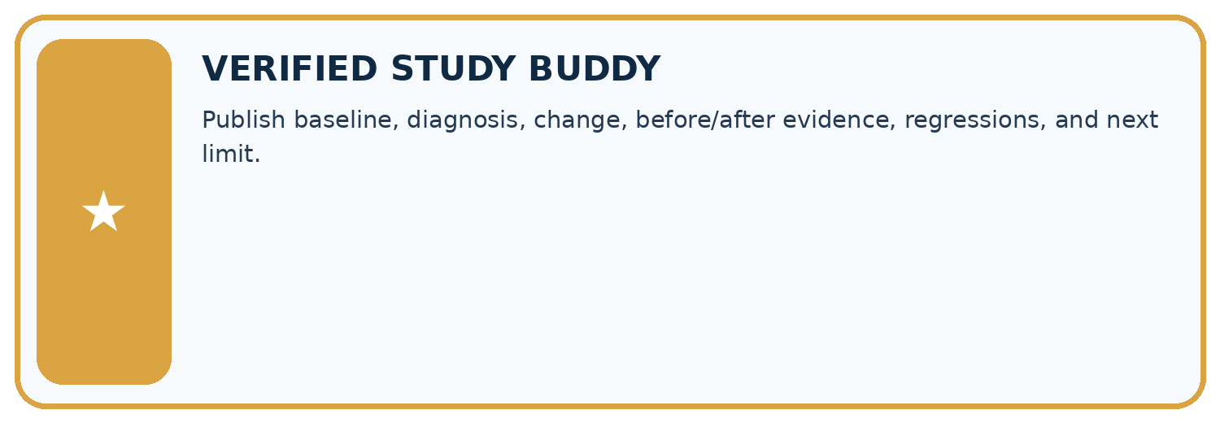
THIS WEEK’S CHECKPOINT Publish baseline, diagnosis, change, before/after evidence, regressions, and next limit.
SYSTEM MAP Learner need → prompt/schema → approved sources/retrieval → model/tool → structured answer → verification → human decision
What will you add, change, or verify in the project this week?

Write or draw your reasoning and evidence.
________________________________________________________________
________________________________________________________________
________________________________________________________________
________________________________________________________________
________________________________________________________________
What should remain under human control?

Write or draw your reasoning and evidence.
________________________________________________________________
________________________________________________________________
________________________________________________________________
________________________________________________________________
________________________________________________________________
RESPONSIBLE DESIGN Collect only necessary information. Show uncertainty and limits. Never confuse fluent output with verified truth.

Evidence for your project
For your Verified Study Buddy, save the input, procedure, observed result and limitation of this check. Label this worked example as practice; use a different, previously unreviewed case when checking independent understanding.

12. Show what you know
INDEPENDENT MASTERY PROOF
Explain • Transfer • Test • Defend
Complete this page without copying the worked example. Your reasoning matters more than decoration.
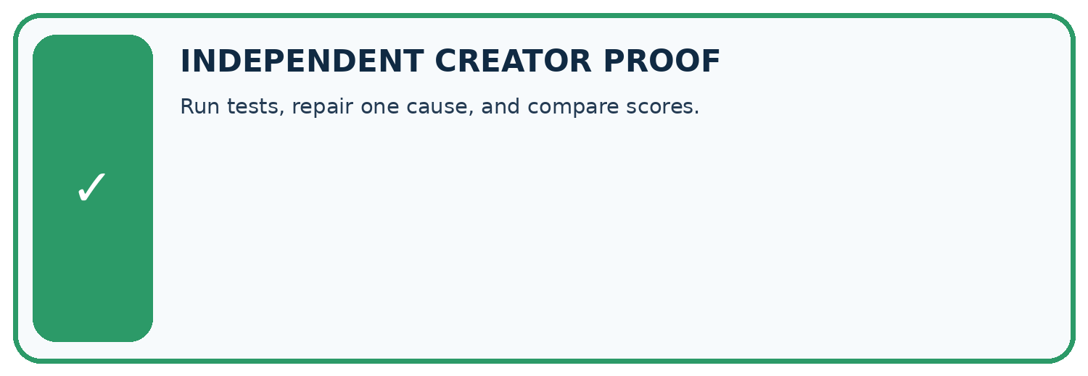
CHALLENGE Run tests, repair one cause, and compare scores.
1. My fresh example, trace, calculation, or design:

Write or draw your reasoning and evidence.
________________________________________________________________
________________________________________________________________
________________________________________________________________
________________________________________________________________
________________________________________________________________
2. My evidence that it works (include a boundary or missing-data case):

Write or draw your reasoning and evidence.
________________________________________________________________
________________________________________________________________
________________________________________________________________
________________________________________________________________
________________________________________________________________
3. One limitation, fairness concern, or situation needing human review:

Write or draw your reasoning and evidence.
________________________________________________________________
________________________________________________________________
________________________________________________________________
________________________________________________________________
________________________________________________________________
SELF-CHECK □ I explained the mechanism □ I used evidence □ I tested a fresh case □ I named a limitation □ I can answer ‘why?’

13. Study a complete case

Week 35 Worked case
Use the supplied details to practise the weekly concept before attempting the independent question. This case extends the illustrated lesson.

The situation
A revision improves supported answers from 6/10 to 8/10 on a development set.

The question
What belongs in the report?

Worked explanation
Before/after results, exact change, errors and fixed conditions; evaluate the chosen version on fresh final cases and report failures.

Explain it in your own words
Which detail supports the answer, and why does it matter?

Write or draw your reasoning and evidence.
________________________________________________________________
________________________________________________________________
________________________________________________________________
________________________________________________________________
________________________________________________________________

Trace the supplied case visually

Compare supported answers on fixed cases
Evidence or stage | Value or result
Before | 6/10
After | 8/10
A revision improves supported answers from 6/10 to 8/10 on a development set.
What belongs in the report?
Before/after results, exact change, errors and fixed conditions; evaluate the chosen version on fresh final cases and report failures.

14. Try a new case independently

Independent case: Apply a new case independently
Twelve final cases baseline passes nine, candidate ten; candidate makes one unauthorised booking. Policy requires zero unauthorised actions. Decide release and revision evidence.

My independent explanation, trace and limits
________________________________________________________________
________________________________________________________________
________________________________________________________________
________________________________________________________________
________________________________________________________________
________________________________________________________________
________________________________________________________________
Attempt this case before feedback. Record any help. Earlier examples below are further practice; a case already practised with feedback cannot establish fresh transfer.

Week 35 Independent application
Close the worked explanation. Apply the idea to this different question without copying.
A revision improves four factual questions but fails two previously successful abstention cases. What should the evaluation report?
My answer, with a trace, calculation or supporting evidence

Write or draw your reasoning and evidence.
________________________________________________________________
________________________________________________________________
________________________________________________________________
________________________________________________________________
________________________________________________________________

Create and test
Change one relevant detail. Predict the result before testing. Include a boundary or missing-information case when it helps reveal a limit.
My changed input and expected result

Write or draw your reasoning and evidence.
________________________________________________________________
________________________________________________________________
________________________________________________________________
________________________________________________________________
________________________________________________________________

Connect to your project
Publish baseline, diagnosis, change, before/after evidence, regressions, and next limit.
The evidence I will keep

Write or draw your reasoning and evidence.
________________________________________________________________
________________________________________________________________
________________________________________________________________
________________________________________________________________
________________________________________________________________
Your teacher has the independent answer and scoring criteria. Complete the matching workbook week to keep your practice evidence together.

Transfer practice from the original programme
An assistant improves from 6/10 to 8/10 on reused development questions, but now answers one formerly safe unanswerable case with a guess. Assess the change and specify final testing.

Explain the mechanism, evidence and one limit.
________________________________________________________________
________________________________________________________________
________________________________________________________________
________________________________________________________________
________________________________________________________________
________________________________________________________________
________________________________________________________________

Use feedback to improve
Attempt the independent case before hints. Record whether you worked alone, used a hint or followed a model. After feedback, fix the first unsupported step and explain why it changed. A later check uses a changed case, not a copied answer.

15. Your lesson route
Start with this question: Choose a study-buddy revision using task performance and a mandatory privacy gate.
By the end, I can | How I will show it
Explain the mechanism and terminology of capstone evaluation and revision | Explain the deciding step, show a trace or test, and state one limit.
Apply the stated procedure to a new case with a traceable result | Explain the deciding step, show a trace or test, and state one limit.
Identify an assumption or limitation and design a revealing follow-up | Explain the deciding step, show a trace or test, and state one limit.
Remember → watch and explain → try with help → investigate → try independently → keep project evidence. Your teacher may spread this lesson across several classes.
Keep your first prediction. Compare it with what the evidence shows and explain any change.

16. Finish and return
Close your notes. Explain this goal in your own words: Explain the mechanism and terminology of capstone evaluation and revision

My deciding step, evidence and one remaining question
________________________________________________________________
________________________________________________________________
________________________________________________________________
________________________________________________________________
________________________________________________________________
If you are unsure, return to the worked picture and explain one arrow. If you are ready, change an input or assumption and justify your prediction.
Save your workbook evidence. At the next review, try a different case before opening your old answer.

