AI ACADEMY · STUDENT · ai-4/1

The ML Lifecycle
Project: Responsible Plant Classifier

Before you start
AI-2 Week 11: training, selection and final evaluation use different evidence.

01. Your mission

Your learning target
I can distinguish fitting a rule from applying a fixed rule.
I can trace a small learning lifecycle with separate data.
I can report test evidence with its limits.

Remember before reading
Close your notes first. A rough first answer helps us choose the right starting point; it is not a score for your ability.
Without opening the old lesson, explain one key idea from Creator Defense. Give an example and a mistake that the idea helps you avoid.
After trying, check the relevant lesson or ask your teacher. Change the part of your explanation that the evidence shows was wrong.
Machine learning is an evidence cycle: define a prediction problem, prepare examples, fit a model, evaluate on unseen data, and improve one diagnosed cause.
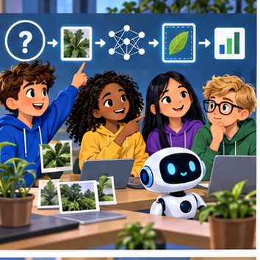
LEARNING TARGET A team labels photos, fits a model and celebrates one correct new photo. List the missing evaluation steps and define the intended use before testing.
Builder name and experiment date:

Readiness for the connected explanation
A fixed rule matches 3 labels out of 4 tested cases. What fraction is correct, and does that prove it works on all future cases?

This week’s end goal
By the end, I can explain the ml lifecycle using a traced example and a stated limitation.

02. Notice the evidence
PICTURE ENTRY

Notice → Predict → Explain
Begin with visible evidence; do not explain more than the picture and information support.
MYSTERY The team must use the ml lifecycle to solve a model-building problem. What information do they have? What important evidence is still missing?
Name three visible details without interpreting them.
Predict the data, model, or evaluation decision being made.
Identify one hidden assumption that could change the result.
State what evidence would confirm or reject your prediction.
My prediction and supporting evidence:

A closer explanation
In Grade 7 you programmed an activity chooser using a rule supplied by a person. This week you will choose a rule by comparing its predictions with labelled examples. This small supervised learning task makes the learning process visible: people define the task and possible rules; training data determines which candidate fits best.
Imagine fictional practice cards with a measured width x and a category label, 0 or 1. Width uses invented units. We want to predict the category of another card from its width. The labels are provided observations in this exercise, not values generated by our prediction code. These invented cards demonstrate a method; they provide no evidence about real objects or students.
Purpose | Width x | Observed label
Training | 1 | 0
Training | 3 | 0
Training | 5 | 1
Training | 7 | 1
Held out for later testing | 2 | 0
Held out for later testing | 6 | 1
Before fitting, set aside the final two cards. They are visible here so you can follow the complete example, but do not use them to choose a rule. Our candidates predict 1 when width is at least 2, 4 or 6, and 0 otherwise. Choose the candidate with the fewest training mistakes. If candidates tie, choose the smaller threshold; fix this rule before testing.

03. See how it works
ML MECHANISM

Input → Model → Evidence
Trace the information, fitted behavior, and evaluation proof separately.
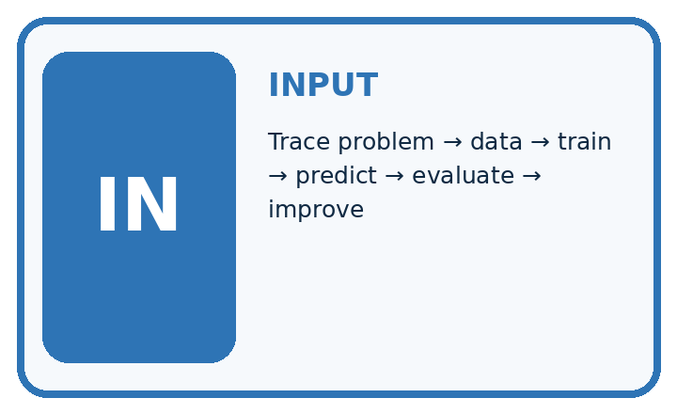
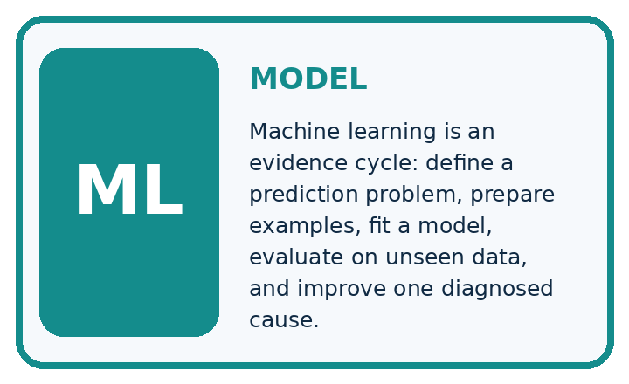
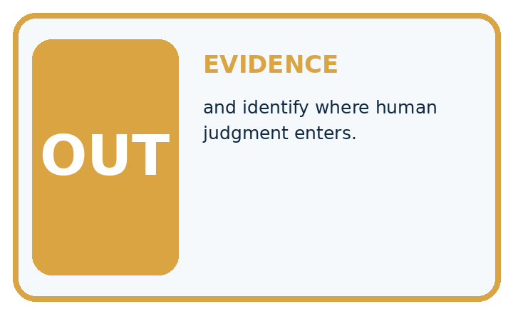
QUESTION Trace problem → data → train → predict → evaluate → improve, and identify where human judgment enters.
MODEL IDEA Machine learning is an evidence cycle: define a prediction problem, prepare examples, fit a model, evaluate on unseen data, and improve one diagnosed cause.
PROOF NEEDED Use an unseen case, visible calculation, error analysis, and a stated limitation.
UNDER THE HOOD Goal: classify a leaf as healthy or spotted for a classroom plant helper. Prepare labeled leaf examples and reserve unseen test examples.
Draw a fresh data → model → prediction → evaluation trace:

A closer explanation
train = [(1, 0), (3, 0), (5, 1), (7, 1)]
# Predict 1 when x is at least the threshold; otherwise 0.
def predict(x, threshold):
return int(x >= threshold)
for threshold in [2, 4, 6]:
errors = 0
for x, label in train:
if predict(x, threshold) != label:
errors = errors + 1
print(threshold, errors)
int(True) is 1 and int(False) is 0. For threshold 2, the training predictions are 0, 1, 1, 1: the width 3 card is wrong. For threshold 4, they are 0, 0, 1, 1: none is wrong. For threshold 6, they are 0, 0, 0, 1: the width 5 card is wrong. The printed rows are 2 1, then 4 0, then 6 1. Select threshold 4 using this training evidence and record it. The loop reports errors; the learner makes and records the selection.

Keep fitting and testing separate
Stage | Information used | Record
Define and split | Task and candidate rules | Training and test cards
Fit and freeze | Training labels only | Threshold 4 selected
Test and report | Two held out cards | 2 correct out of 2
Read down the stages. Test results may inform later development, but they must not silently change the rule being tested.

Connect the picture and the explanation
Point to the input, the deciding step and the result in this week’s visual. Explain the same step in ordinary words. A picture helps when you can say what each part represents.

04. Compare the cases
EVALUATION DESIGN

Four Tests, Four Kinds of Evidence
A system is not understood until it survives more than one comfortable example.




NORMAL Expected data and expected behavior.
BOUNDARY Value close to a threshold, ambiguous label, or uncertain prediction.
MISSING Necessary field, label, source, or measurement is unavailable.
SHIFTED New lighting, species, device, subgroup, or time condition.
RELEASE RULE Passing one case never proves generalization. Predefine expected behavior for all four categories.
Which case most threatens today's claim, and why?

Change one thing in the pictured case
Change: The fresh width-6 leaf is actually healthy.
Prediction: The frozen model is correct on 1/2 test leaves.
Reason: The supplied reference changed; moving the cutoff after seeing this test would reuse final evidence for development.

05. Words that unlock the idea
VOCABULARY

Words You Can Calculate and Defend
A definition matters when it lets you interpret a new dataset, model, or result.
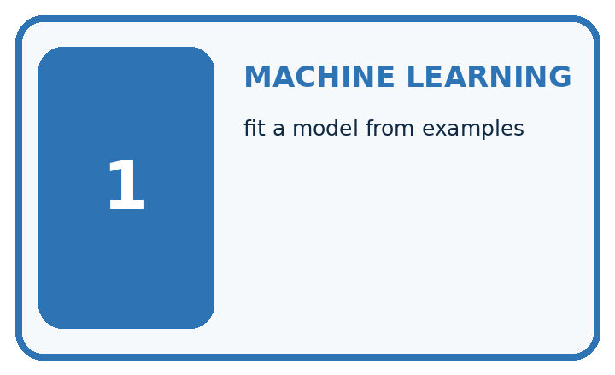
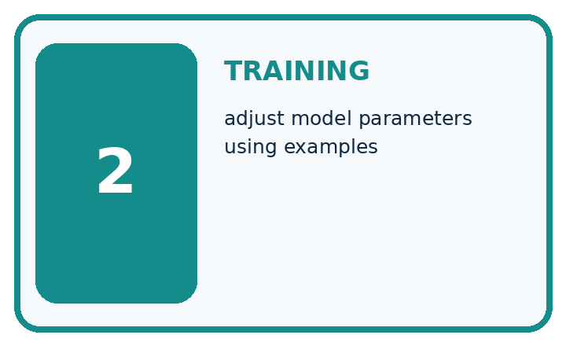
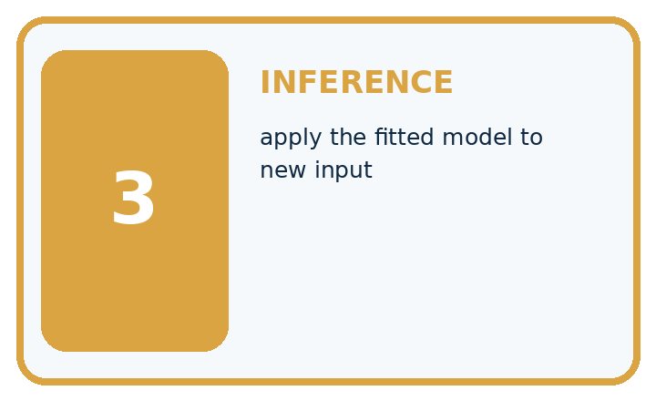
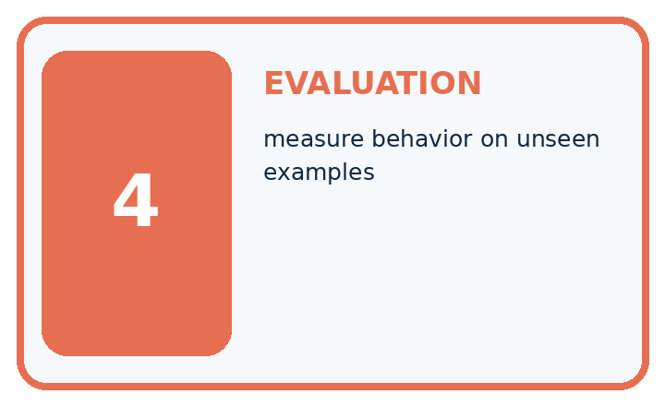
Term | Precise meaning | My ML example
machine learning | fit a model from examples
training | adjust model parameters using examples
inference | apply the fitted model to new input
evaluation | measure behavior on unseen examples
MISCONCEPTION TO REPAIR Training once and seeing one correct prediction proves the model works.
Repair the claim using a definition, calculation, or test record:

Words used in the closer explanation
Word | Meaning
Feature | An input value used to make a prediction
Label | An observed target value supplied for an example
Training | Using examples to select or adjust a model
Held out data | Examples reserved from fitting and model choices for evaluation

06. Follow a worked example
WORKED EVIDENCE

Reason Step by Step
Predict first. Then check each step. A correct answer without visible evidence cannot be audited.
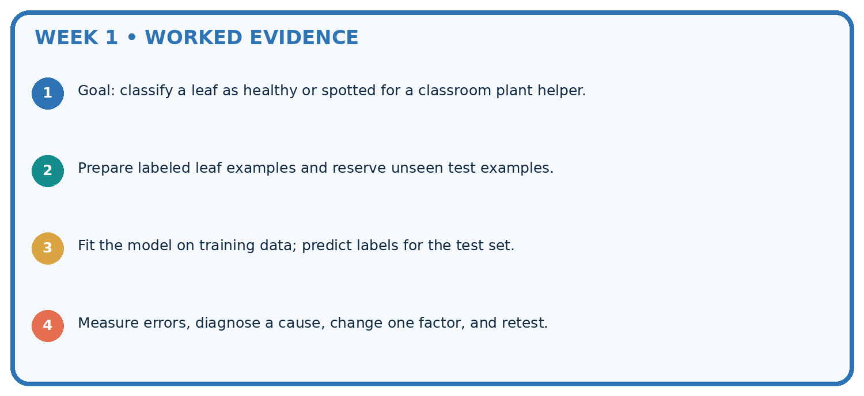
STEP 1 Goal: classify a leaf as healthy or spotted for a classroom plant helper.
STEP 2 Prepare labeled leaf examples and reserve unseen test examples.
STEP 3 Fit the model on training data; predict labels for the test set.
STEP 4 Measure errors, diagnose a cause, change one factor, and retest.
CHECK Verify the denominator, unit, split, class definition, and data version before interpreting a score.
Recalculate, retrace, or restate the evidence independently:

A closer explanation
Freeze means do not change the chosen threshold during this evaluation. With threshold 4, widths 2 and 6 receive predictions 0 and 1. Compare them with the held out labels: both match. Report 2 correct out of 2 held out cards. Training results and test results answer different questions: did the rule fit the examples used to select it, and how did that fixed rule perform on these separate examples?

Keep threshold 4 fixed. An additional card has width 4 and observed label 0. Predict its category, decide whether it is correct, and update the held out count from 2 of 2.
________________________________________________________________
________________________________________________________________
________________________________________________________________
________________________________________________________________
________________________________________________________________

Learn from the worked case
Cover the result before checking it. Say what is given, choose the procedure, and follow one step at a time. Then uncover the result and explain your first mismatch. Ask why a step is allowed, not only what number it produces.

A pictorial worked case: The ML Lifecycle
Follow one complete plant-classifier lifecycle without tuning on the final test.

The facts we will use
Toy training leaves have widths 1 healthy, 3 healthy, 5 spotted, 7 spotted. Candidates predict spotted at width>=2 or >=4.
All inputs and outcomes in this worked example are invented classroom data; no real model run is claimed.
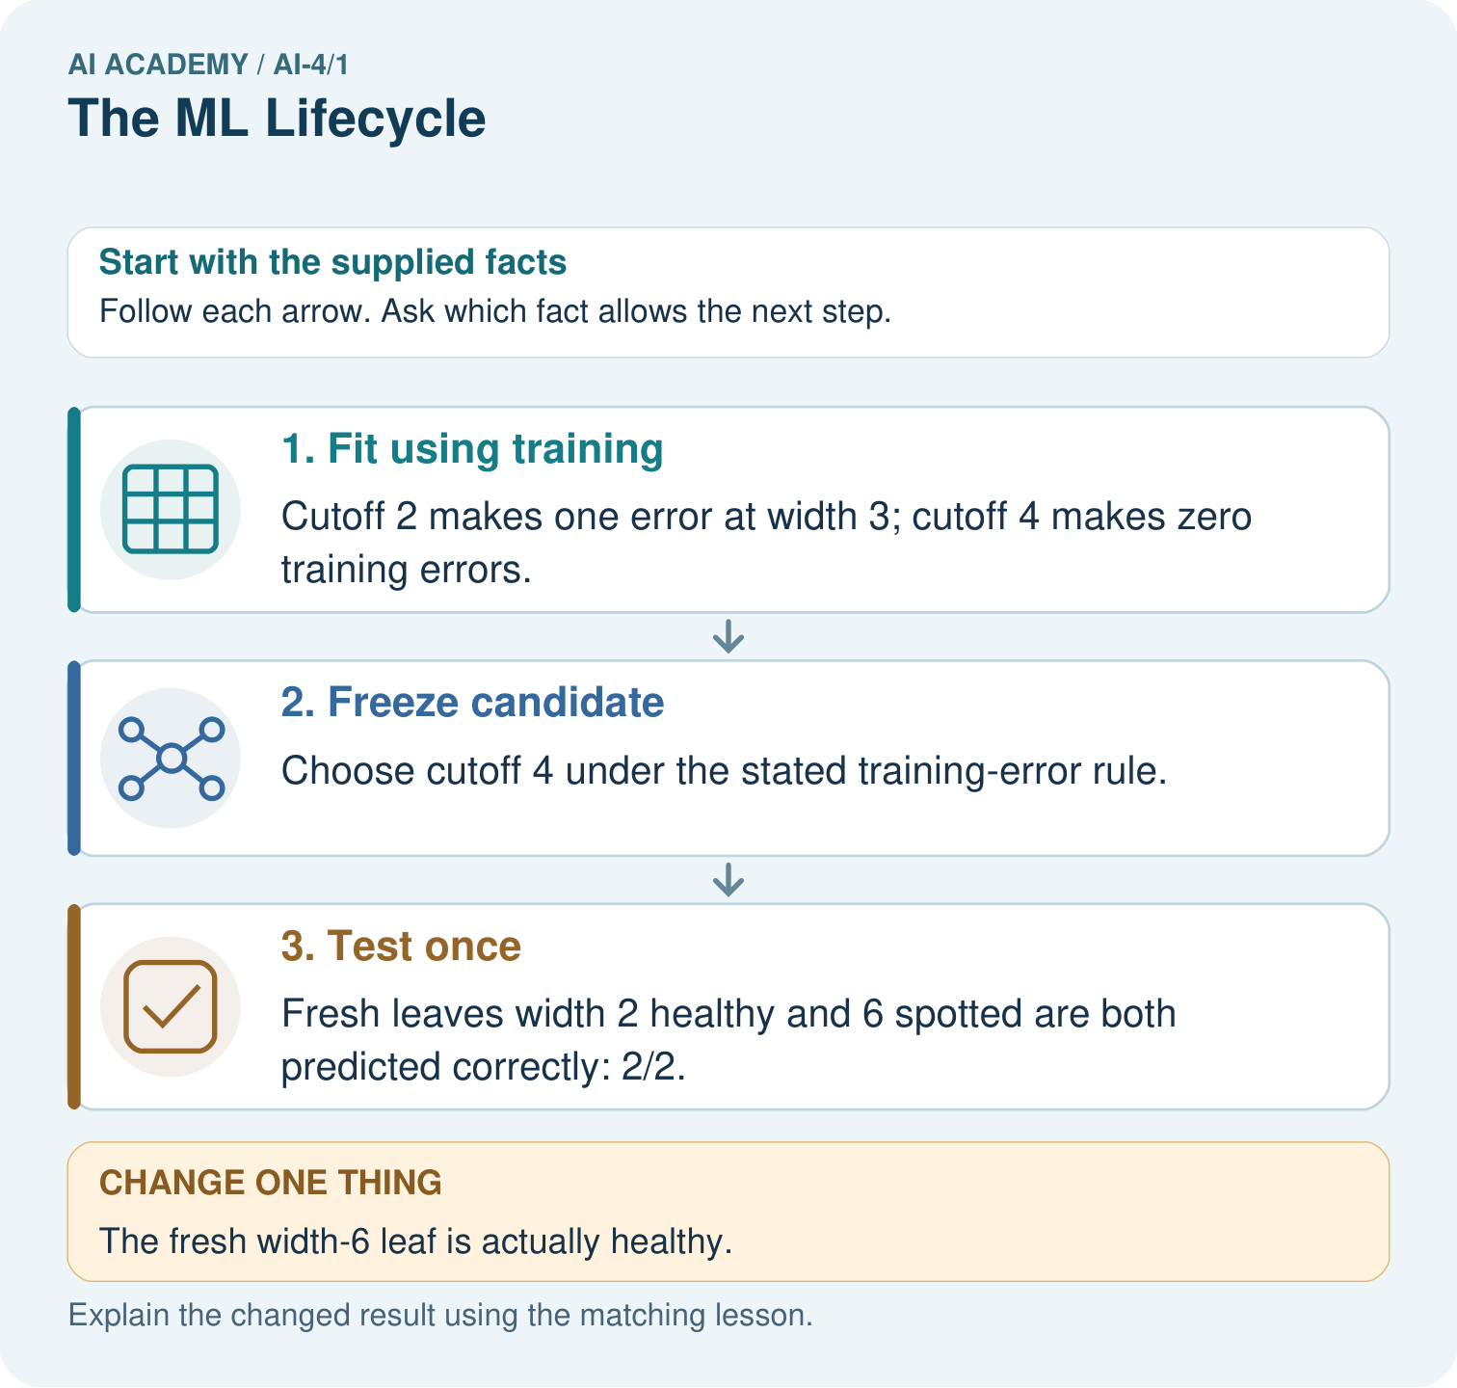

Read the picture one step at a time
Step | What happens and why
1. Fit using training | Cutoff 2 makes one error at width 3; cutoff 4 makes zero training errors.
2. Freeze candidate | Choose cutoff 4 under the stated training-error rule.
3. Test once | Fresh leaves width 2 healthy and 6 spotted are both predicted correctly: 2/2.
Match each pictured step to the supplied facts. This is a worked teaching case, not an independent assessment.

Why this result follows
Read the picture in order. Fresh leaves width 2 healthy and 6 spotted are both predicted correctly: 2/2. The arrows show which recorded input or intermediate result each decision uses. Explain the deciding step aloud before checking the changed case; pointing to the final answer alone does not show how it follows.

What this example does not establish
Two invented test leaves cannot establish useful real-world plant classification.
Read the labelled picture: Should the team silently retune on the changed test? Point to the relevant step in the picture, then write the changed result and the rule or evidence that supports it.
Change one thing: The fresh width-6 leaf is actually healthy. Predict the result before checking the explanation. What remains the same?

07. Find and repair a mistake
ERROR DETECTIVE

Compare → Diagnose → Repair
Do not patch the answer. Find the earliest unsupported assumption, data problem, or experiment error.
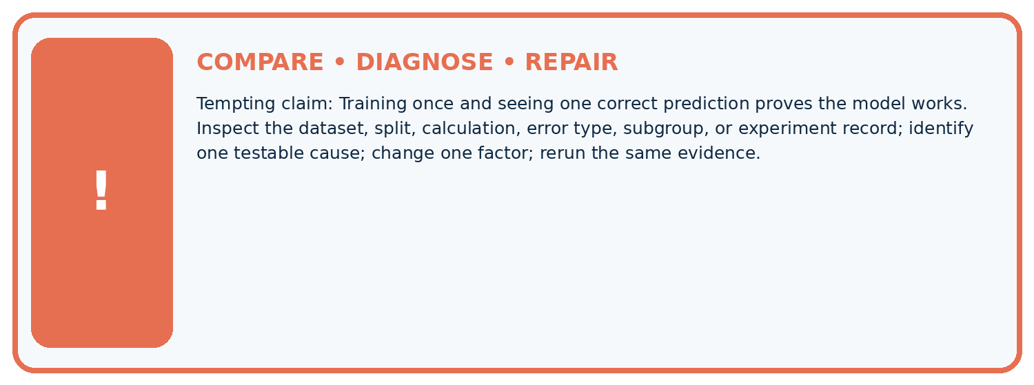
Evidence record | Expected | Actual | Likely cause / next test
normal case | passes
boundary case | defined behavior
missing case | safe fallback
shifted case | measured limit
CLAIM TO CHALLENGE Training once and seeing one correct prediction proves the model works.
Diagnose one cause and name the cleanest next experiment:

A closer explanation
This threshold model learned only a choice among three candidate values. People supplied the feature, labels, candidate family and tie rule. Learning does not imply understanding, and perfect training performance does not guarantee good predictions. Two correct test cards are too few to establish reliable performance for a broader population. Even a larger score would depend on how examples were collected and what use was intended.

Your report says the fixed model matched 2 of 2 held out cards. Write one supported claim, one claim this does not support, and one sensible next step.
________________________________________________________________
________________________________________________________________
________________________________________________________________
________________________________________________________________
________________________________________________________________

08. Practise together
ML STUDIO

Specify Before You Run
A trustworthy result can be reproduced from the recorded data, code, settings, and evaluation rule.


Experiment record
QUESTION + intended use + success threshold
DATA version + grouped split + leakage check
CODE/preprocessing + features + model + settings + seed
METRICS + positive class + units + denominators
PREDICTIONS + errors + subgroup slices + limitations
HUMAN reviewer + release, revise, limit, or stop decision
Write the minimum record needed to reproduce today's result:

A closer explanation
A learner sees the width 4 test error, changes the threshold to 5, and reports the same cards as a fresh final test. The test labels have now influenced the model. Keep the original 2 of 3 result for the original rule. Record the change as development, then reserve genuinely unused examples for a later evaluation. Do not delete the difficult card or rename reused cards as new evidence.
A lifecycle continues after fitting: define the intended use, prepare and separate data, fit, evaluate, review the limits, and monitor any approved use. Evaluation can send us back to development. That return needs an honest record and a new final evaluation; it does not erase the earlier error.

Practise with less help: Trace one candidate
Use workbook W2 for the connected example “The machine learning lifecycle”. First fill the input and rule boxes. Try the middle steps before asking for a hint. After a hint, try the next step yourself.
Plan | Do | Check
What is given? Which rule or procedure applies? | Record each intermediate step. | Does the result follow? What remains unknown?
Explain your trace to a partner. Your partner points to one step to check. Swap roles on the next case. Each person writes their own explanation.

Check your reasoning
Use the worked case for The machine learning lifecycle. Proposed explanation: “The model wrote its own task”. Decide whether this explanation is supported. Point to the step or supplied fact that decides; explain your repair if needed.
Answer on your own before discussion. If you are unsure, say which step you need help with.

Explain the picture
Should the team silently retune on the changed test? Point to the relevant step in the picture, then write the changed result and the rule or evidence that supports it.

My explanation using a pictured step and the given facts
________________________________________________________________
________________________________________________________________
________________________________________________________________
________________________________________________________________
This is supported practice. Keep the separately named independent case for an attempt before feedback.

09. Run the investigation
EVIDENCE LAB

Predict → Run → Calculate → Interpret
Keep the test conditions fixed, record every result, and change only one planned factor.
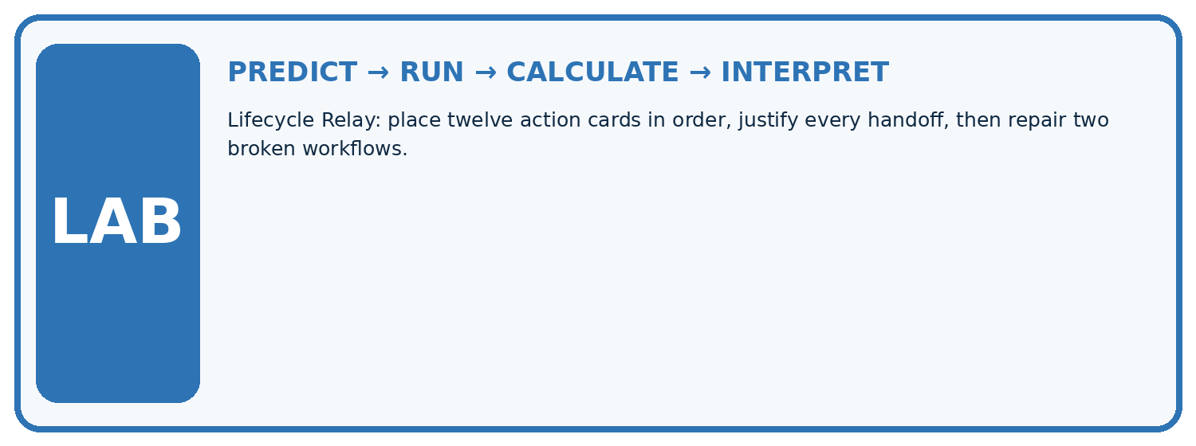
1. Write the hypothesis and expected evidence before running.
2. Lifecycle Relay: place twelve action cards in order, justify every handoff, then repair two broken workflows.
3. Run one normal, one boundary, one missing, and one shifted case.
4. Calculate the metric from raw counts or row-level errors.
5. Interpret what changed, what did not, and what remains unsafe or unknown.
Case | Prediction | Actual | Calculation / evidence | Meaning / next test
Normal
Boundary
Missing
Shifted

Plan → try → check
Before trying: what do I expect, and why? While trying: which step could first go wrong? Afterwards: what did I actually observe, and what should change? Keep “not run” if you only traced the procedure.

10. Build your understanding
MASTERY

From Knowing the Word to Owning the Idea
Move upward only when you can produce evidence without copying the example.

DEFINE Use all four terms precisely: machine learning, training, inference, evaluation.
CALCULATE Reproduce the worked evidence with units and denominator.
TRACE Explain the data, code or decision path.
DIAGNOSE Training once and seeing one correct prediction proves the model works.
TRANSFER Solve a fresh dataset or model case.
IMPROVE Change one cause and rerun fixed evidence.
DEFEND State intended use, metric, limitation, and human responsibility.
MASTERY RULE A coached calculation becomes mastery only after a different case is completed independently.

11. Connect your project
CUMULATIVE PROJECT

Responsible Plant Classifier
Every week adds one reviewable artifact to the same evidence-based capstone.
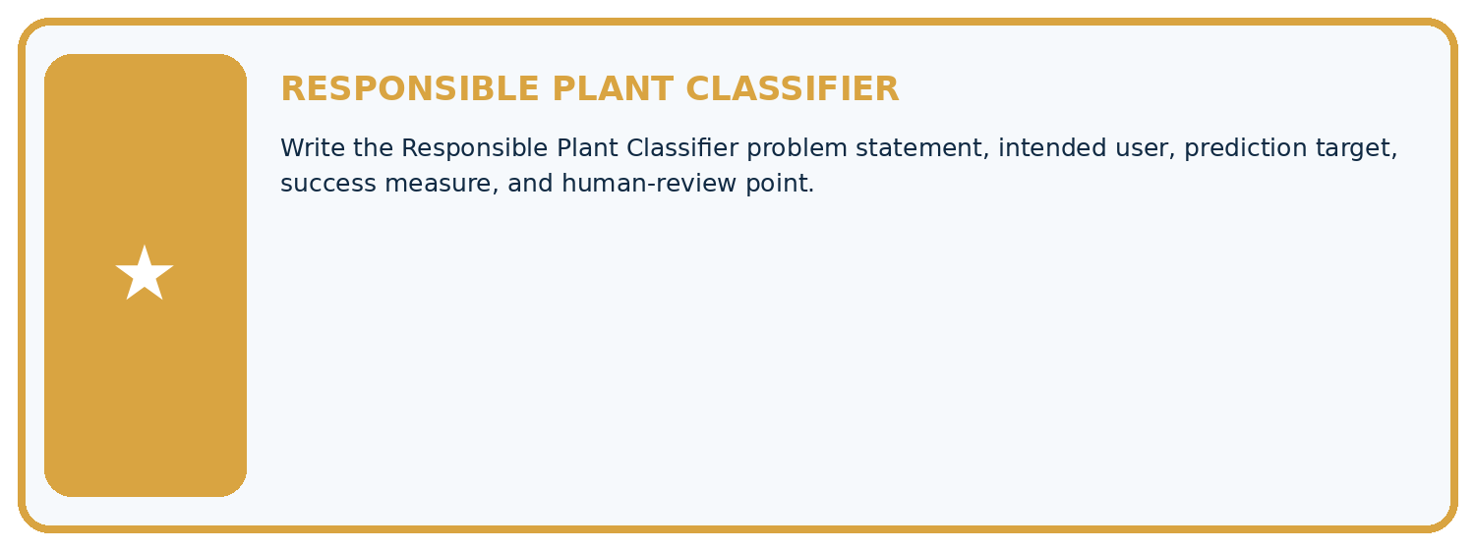
THIS WEEK'S CHECKPOINT Write the Responsible Plant Classifier problem statement, intended user, prediction target, success measure, and human-review point.
Which requirement or risk does this artifact address?
Which dataset, split, code, and metric version does it use?
What normal and shifted cases were tested?
What remains uncertain or weak?
What decision still belongs to a teacher or qualified human?
RESPONSIBLE RELEASE Never use this classroom prototype for medical, pesticide, agricultural, or other consequential decisions.
My evidence-linked project decision:

Evidence for your project
For your Responsible Plant Classifier, save the input, procedure, observed result and limitation of this check. Label this worked example as practice; use a different, previously unreviewed case when checking independent understanding.

12. Show what you know
INDEPENDENT PROOF

Explain • Calculate • Transfer • Defend
Complete this with a fresh case after guided practice and compare it with the mastery criteria.
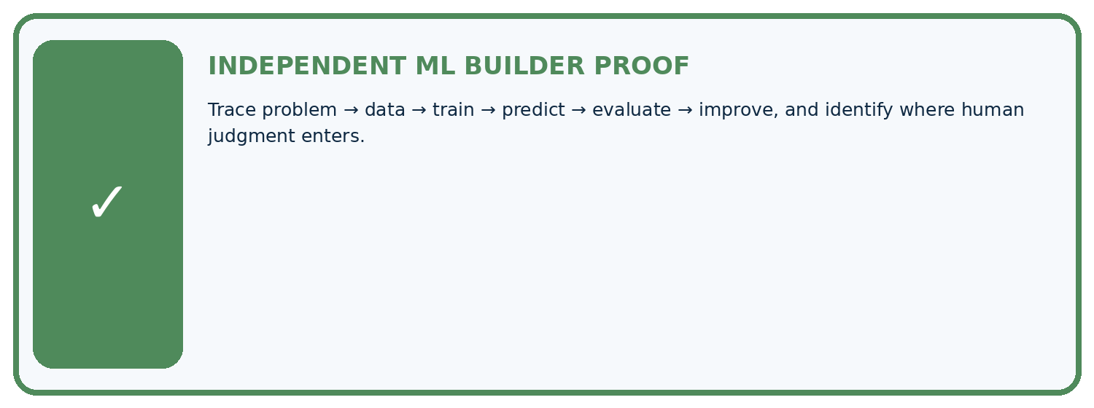
REQUIRED PROOF Trace problem → data → train → predict → evaluate → improve, and identify where human judgment enters.
□ Define the task, feature/target roles, and intended-use boundary.
□ Show the calculation, code trace, or experiment record.
□ Test a normal case and one revealing boundary, missing, or shifted case.
□ Diagnose one failure without changing several factors at once.
□ Name a limitation, fairness concern, and the human-review action.
Independent evidence and defense:
My level: □ Not yet □ With one hint □ Independently □ I can teach and defend it
NEXT BRIDGE Carry the experiment evidence into: Features, Labels, Targets.

13. Study a complete case

Week 1 Worked case
Use the supplied details to practise the weekly concept before attempting the independent question. This case extends the illustrated lesson.

The situation
A team labels leaf photos, trains a healthy/spotted classifier and shows one correct prediction.

The question
Order the lifecycle and identify missing evidence.

Worked explanation
Define use and labels, collect data, separate evaluation data, train, predict, evaluate and improve. One correct result is insufficient. Test unseen varied cases and retain human responsibility.

Explain it in your own words
Which detail supports the answer, and why does it matter?

Write or draw your reasoning and evidence.
________________________________________________________________
________________________________________________________________
________________________________________________________________
________________________________________________________________
________________________________________________________________

Trace the supplied case visually

Evidence drives the ML lifecycle
Evidence or stage | Value or result
Define | Intended use and labels
Prepare | Collect and separate evaluation data
Train | Fit on training data
Evaluate | Inspect unseen results
Revise | Change a cause and retest
A team labels leaf photos, trains a healthy/spotted classifier and shows one correct prediction.
Order the lifecycle and identify missing evidence.
Define use and labels, collect data, separate evaluation data, train, predict, evaluate and improve. One correct result is insufficient. Test unseen varied cases and retain human responsibility.

14. Try a new case independently

Independent case: Fit and evaluate independently
New training cards are (width 2, label 0), (4, 0), (6, 1), (8, 1). Candidates are 3, 5 and 7. Predict 1 when width is at least the threshold. Count training mistakes, select the fewest with smaller threshold breaking ties, and record the choice before testing. Held out cards are (3, 0), (7, 1), (5, 0). Give each test prediction, the correct count and a limited conclusion.

My independent explanation, trace and limits
________________________________________________________________
________________________________________________________________
________________________________________________________________
________________________________________________________________
________________________________________________________________
________________________________________________________________
________________________________________________________________
Attempt this case before feedback. Record any help. Earlier examples below are further practice; a case already practised with feedback cannot establish fresh transfer.

Week 1 Independent application
Close the worked explanation. Apply the idea to this different question without copying.
A team selects a model before deciding what outcome to predict or where the data comes from. Name two missing lifecycle decisions and their effect.
My answer, with a trace, calculation or supporting evidence

Write or draw your reasoning and evidence.
________________________________________________________________
________________________________________________________________
________________________________________________________________
________________________________________________________________
________________________________________________________________

Create and test
Change one relevant detail. Predict the result before testing. Include a boundary or missing-information case when it helps reveal a limit.
My changed input and expected result

Write or draw your reasoning and evidence.
________________________________________________________________
________________________________________________________________
________________________________________________________________
________________________________________________________________
________________________________________________________________

Connect to your project
Write the Responsible Plant Classifier problem statement, intended user, prediction target, success measure, and human-review point.
The evidence I will keep

Write or draw your reasoning and evidence.
________________________________________________________________
________________________________________________________________
________________________________________________________________
________________________________________________________________
________________________________________________________________
Your teacher has the independent answer and scoring criteria. Complete the matching workbook week to keep your practice evidence together.

Transfer practice from the original programme
A team labels photos, fits a model and celebrates one correct new photo. List the missing evaluation steps and define the intended use before testing.

Explain the mechanism, evidence and one limit.
________________________________________________________________
________________________________________________________________
________________________________________________________________
________________________________________________________________
________________________________________________________________
________________________________________________________________
________________________________________________________________

Use feedback to improve
Attempt the independent case before hints. Record whether you worked alone, used a hint or followed a model. After feedback, fix the first unsupported step and explain why it changed. A later check uses a changed case, not a copied answer.

15. Your lesson route
Start with this question: Follow one complete plant-classifier lifecycle without tuning on the final test.
By the end, I can | How I will show it
Distinguish fitting a rule from applying a fixed rule | Explain the deciding step, show a trace or test, and state one limit.
Trace a small learning lifecycle with separate data | Explain the deciding step, show a trace or test, and state one limit.
Report test evidence with its limits | Explain the deciding step, show a trace or test, and state one limit.
Remember → watch and explain → try with help → investigate → try independently → keep project evidence. Your teacher may spread this lesson across several classes.
Keep your first prediction. Compare it with what the evidence shows and explain any change.

16. Finish and return
Close your notes. Explain this goal in your own words: Distinguish fitting a rule from applying a fixed rule

My deciding step, evidence and one remaining question
________________________________________________________________
________________________________________________________________
________________________________________________________________
________________________________________________________________
________________________________________________________________
If you are unsure, return to the worked picture and explain one arrow. If you are ready, change an input or assumption and justify your prediction.
Save your workbook evidence. At the next review, try a different case before opening your old answer.

