AI ACADEMY · STUDENT · ai-4/8

Leakage
Project: Responsible Plant Classifier

Before you start
Week 2: exclude information unavailable in the intended prediction setting.

01. Your mission

Your learning target
I can choose a split unit that matches the intended prediction claim.
I can keep related examples together and audit group overlap.
I can record split roles counts and limits before model evaluation.

Remember before reading
Close your notes first. A rough first answer helps us choose the right starting point; it is not a score for your ability.
Without opening the old lesson, explain one key idea from Sampling and Intended Use. Give an example and a mistake that the idea helps you avoid.
Without opening the old lesson, explain one key idea from Inspect Before Modeling. Give an example and a mistake that the idea helps you avoid.
Without opening the old lesson, explain one key idea from Features, Labels, Targets. Give an example and a mistake that the idea helps you avoid.
After trying, check the relevant lesson or ask your teacher. Change the part of your explanation that the evidence shows was wrong.
Leakage occurs when a feature exposes the target through information that would be unavailable, created later, or derived from the answer at real prediction time.
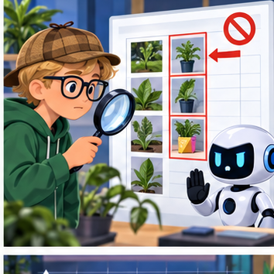
LEARNING TARGET Five photos of each leaf are randomly split by file into train and test. Why can accuracy be optimistic? Give a corrected grouping rule.
Builder name and experiment date:

Readiness for the connected explanation
Why does agreement between two annotators not prove their labels are correct?

Readiness for Scaling without leakage
What determines the nearest training neighbour, and which examples belong in the stored neighbour pool?

My readiness explanation
________________________________________________________________
________________________________________________________________
________________________________________________________________

This week’s end goal
By the end, I can explain leakage using a traced example and a stated limitation.

02. Notice the evidence
PICTURE ENTRY

Notice → Predict → Explain
Begin with visible evidence; do not explain more than the picture and information support.
MYSTERY The team must use leakage to solve a model-building problem. What information do they have? What important evidence is still missing?
Name three visible details without interpreting them.
Predict the data, model, or evaluation decision being made.
Identify one hidden assumption that could change the result.
State what evidence would confirm or reject your prediction.
My prediction and supporting evidence:

A closer explanation
A model may seem successful when its test examples closely resemble examples it already learned from. Imagine several pictures taken seconds apart during one robot trip. They have different picture IDs but share a route, lighting and objects. This week you will assign entire trips to separate sets and explain what the resulting evaluation could measure. No model is fitted in this lesson.
Our invented twelve-row dataset contains frame descriptions from six trips. Each row is one frame; the group is its trip ID. The proposed claim concerns new trips on the same practice route under similar conditions. We therefore keep all frames from a trip in one set. To claim success on new routes, grouping only by trip would not be enough.
Trip group | Frame IDs | Assigned role
A | A1 A2 A3 | Training
B | B1 B2 | Training
C | C1 | Training
D | D1 D2 | Validation
E | E1 E2 | Test
F | F1 F2 | Test
This small fictional assignment is for learning split design, not evidence of real performance. Each frame belongs to one group and one set. Store frame and trip IDs as metadata for auditing; do not assume an ID is an appropriate prediction input.

Apply the connected idea: Scaling without leakage
Last week we compared one numeric feature. With two features, their numerical ranges can give one feature much more influence. Scaling changes those contributions. We will learn a minimum and range for each feature from training only, then reuse them for every example.
These fictional trips have a distance reading in cm, a brightness reading in sensor units and a reviewed lane label. Features are available before prediction; labels are separate evidence. Related trips have already been grouped before splitting. For this exercise use k=1, add absolute differences across the two features, and break equal distances by alphabetical ID.
ID and label | Distance cm | Brightness units
A clear | 10 | 200
B blocked | 20 | 100
C blocked | 20 | 200
For query (11,120), raw distances to A,B,C are 1+80=81, 9+20=29 and 9+80=89. B wins and predicts blocked. Adding these different units is an unscaled numerical choice; the large brightness range strongly affects it. Scaling offers another explicit distance choice, not proof of which features matter.

03. See how it works
ML MECHANISM

Input → Model → Evidence
Trace the information, fitted behavior, and evaluation proof separately.
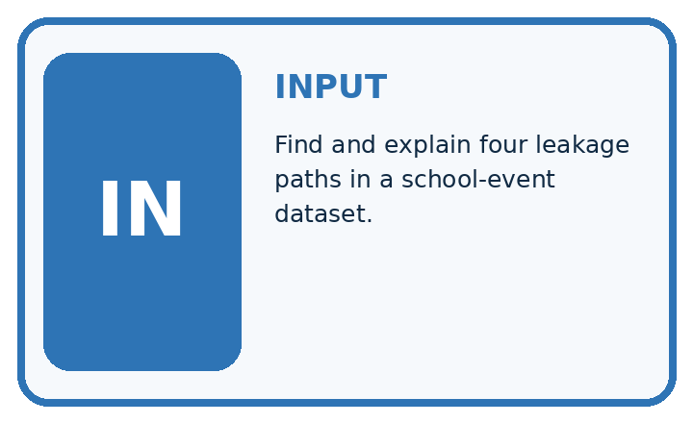
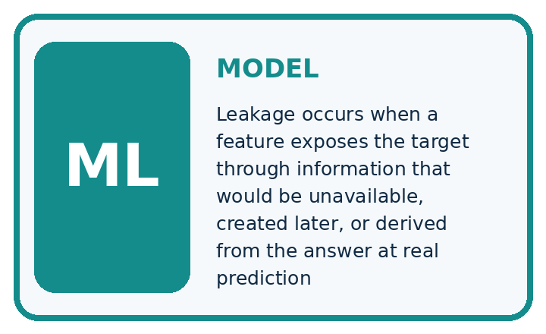
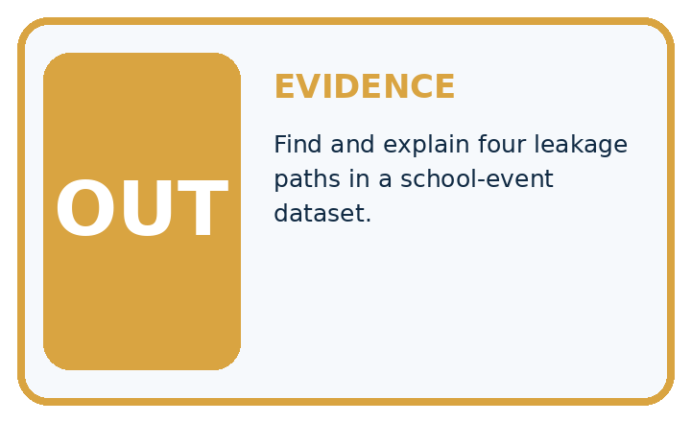
QUESTION Find and explain four leakage paths in a school-event dataset.
MODEL IDEA Leakage occurs when a feature exposes the target through information that would be unavailable, created later, or derived from the answer at real prediction time.
PROOF NEEDED Use an unseen case, visible calculation, error analysis, and a stated limitation.
UNDER THE HOOD A leaf file name contains 'diseased'—the answer is hidden in the input. Treatment outcome was recorded after diagnosis, so it is unavailable at prediction time.
Draw a fresh data → model → prediction → evaluation trace:

A closer explanation
Training data fits the model. Validation data helps compare choices such as candidate rules. Keep the test set for a final check after those choices are fixed. A learner who repeatedly changes the model after seeing test results has used that set for development; its score is no longer an untouched final check.
train_groups = {"A", "B", "C"}
valid_groups = {"D"}
test_groups = {"E", "F"}
shared = ((train_groups & valid_groups)
| (train_groups & test_groups)
| (valid_groups & test_groups))
print(sorted(shared))
print(len(train_groups), len(valid_groups),
len(test_groups))
The first line of output is []: no trip ID is shared between any pair of sets. The second is 3 1 2: training, validation and test contain three, one and two trip groups. The symbol & finds shared values and | combines sets. These are group counts, not frame counts.

Keep each trip in one role
Whole groups | Role | Purpose
A B C with all frames | Training | Fit from examples
D with all frames | Validation | Compare choices
E F with all frames | Test | Final check after choices
Keep related frames together. Separate group IDs prevent this form of overlap; they do not prove that every other source of leakage is absent.
This audit assumes the lists correctly describe every frame assignment. It cannot find an omitted frame, a wrong trip ID, a copied image with a different ID or a feature containing the answer. Check the assignment table and source records too.

Apply the connected idea: Scaling without leakage
train = [(10, 200), (20, 100), (20, 200)]
low = [min(row[j] for row in train) for j in range(2)]
span = [max(row[j] for row in train) - low[j]
for j in range(2)]
if 0 in span:
raise ValueError("Review a constant training feature")
def transform(row):
return tuple((row[j] - low[j]) / span[j]
for j in range(2))
scaled_train = [transform(row) for row in train]
query = (11, 120)
print(low, span)
print(scaled_train)
print(transform(query))
For each feature use scaled value = (value minus training minimum) divided by training range. range(2) visits feature positions 0 and 1. The code prints [10, 100] [10, 100], then [(0.0, 1.0), (1.0, 0.0), (1.0, 1.0)], then (0.1, 0.2). Each minimum becomes 0 and each maximum becomes 1.
The first calculations fit low and span from train. transform uses those stored values without learning new ones. The code assumes nonempty training rows with exactly two finite numeric features; it does not check all inputs. Its explicit zero-range guard stops division by zero so a constant feature can be reviewed. This is a classroom policy, not a claim that every library stops this way.

Connect the picture and the explanation
Point to the input, the deciding step and the result in this week’s visual. Explain the same step in ordinary words. A picture helps when you can say what each part represents.

04. Compare the cases
EVALUATION DESIGN

Four Tests, Four Kinds of Evidence
A system is not understood until it survives more than one comfortable example.




NORMAL Expected data and expected behavior.
BOUNDARY Value close to a threshold, ambiguous label, or uncertain prediction.
MISSING Necessary field, label, source, or measurement is unavailable.
SHIFTED New lighting, species, device, subgroup, or time condition.
RELEASE RULE Passing one case never proves generalization. Predefine expected behavior for all four categories.
Which case most threatens today's claim, and why?

Change one thing in the pictured case
Change: Move Fir’s first view into training while retaining its other two in test.
Prediction: The unseen-plant evaluation is compromised.
Reason: Fir’s identity now appears in training; different view IDs do not remove the shared plant relationship.

05. Words that unlock the idea
VOCABULARY

Words You Can Calculate and Defend
A definition matters when it lets you interpret a new dataset, model, or result.
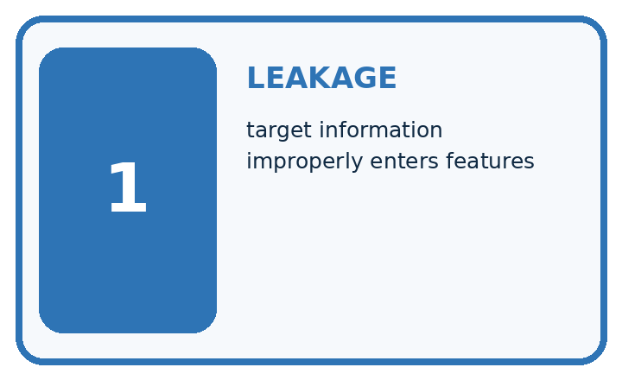
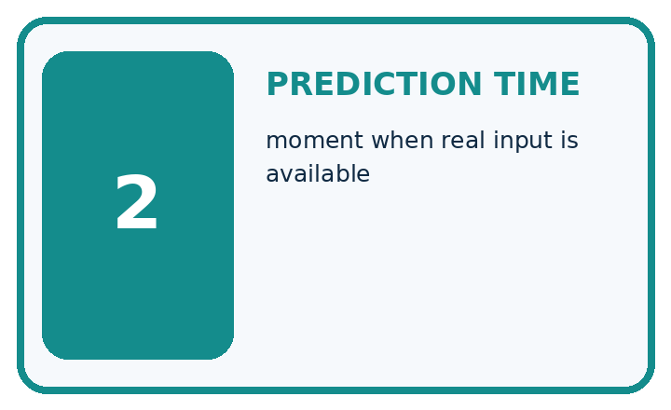
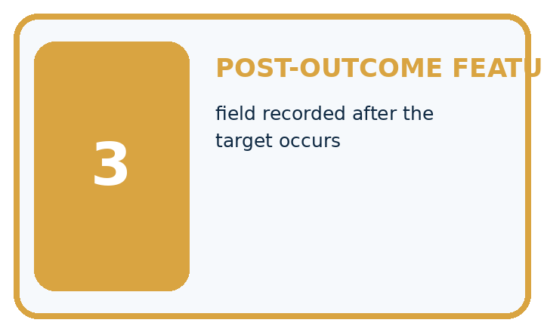
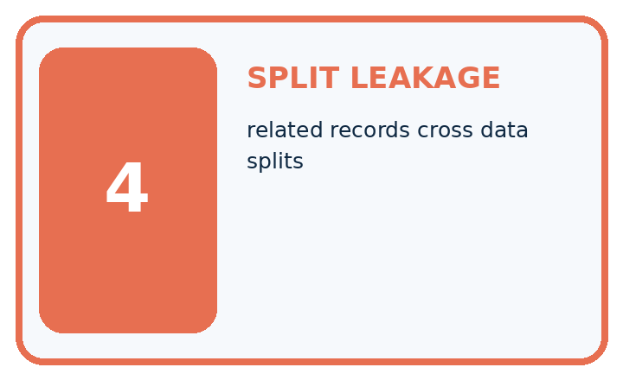
Term | Precise meaning | My ML example
leakage | target information improperly enters features
prediction time | moment when real input is available
post-outcome feature | field recorded after the target occurs
split leakage | related records cross data splits
MISCONCEPTION TO REPAIR A highly accurate feature should be kept even when it would not exist during real use.
Repair the claim using a definition, calculation, or test record:

Words used in the closer explanation
Word | Meaning
Training set | Examples used to fit a model
Validation set | Separate examples used to compare choices during development
Test set | Held out examples used for final evaluation after choices are fixed
Group | Related examples that must stay together for a stated evaluation goal

Terms for Scaling without leakage
Term | Meaning
Range | The largest training value minus the smallest for one feature
Fit | Learn and store values from training data
Transform | Apply a stored calculation to feature values
Leakage | Use information that should be unavailable while developing or evaluating a prediction method

06. Follow a worked example
WORKED EVIDENCE

Reason Step by Step
Predict first. Then check each step. A correct answer without visible evidence cannot be audited.
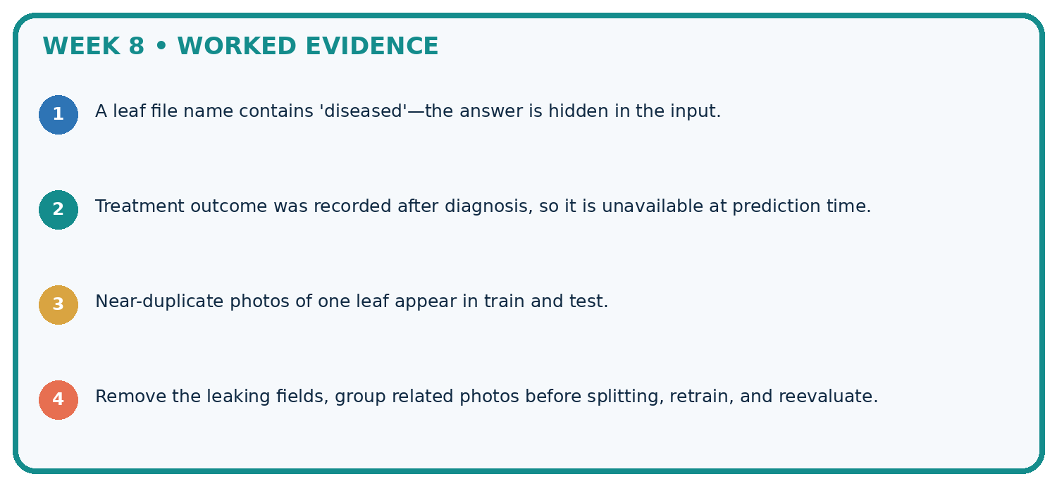
STEP 1 A leaf file name contains 'diseased'—the answer is hidden in the input.
STEP 2 Treatment outcome was recorded after diagnosis, so it is unavailable at prediction time.
STEP 3 Near-duplicate photos of one leaf appear in train and test.
STEP 4 Remove the leaking fields, group related photos before splitting, retrain, and reevaluate.
CHECK Verify the denominator, unit, split, class definition, and data version before interpreting a score.
Recalculate, retrace, or restate the evidence independently:

A closer explanation
Suppose A1 and A2 are in training while A3 is in test. The frame IDs differ, but A appears in both sets. Shuffling the rows does not remove this relationship. For our new-trip claim, move all A frames to one chosen role and record the revised assignment before evaluating a model. Do not copy A3 into both roles.
Audit that every source frame occurs exactly once, no group crosses roles and the assigned counts sum to the source count. In our worked plan the row counts are six training, two validation and four test: twelve total. A fixed random seed can reproduce a random split, but it cannot make a flawed grouping choice fair.

A learner moves D2 from validation to training but leaves D1 in validation. Give the new row counts and shared trip ID. Explain why different frame IDs and a fixed seed do not repair the overlap.
________________________________________________________________
________________________________________________________________
________________________________________________________________
________________________________________________________________
________________________________________________________________
A split record names the prediction goal, source version, group definition, exact assignments, row and group counts, date and any random method or seed used. For this hand-assigned example, record that there was no random sampling. Keep label-rule versions and unresolved review statuses traceable as in Week 5.

Apply the connected idea: Scaling without leakage

One stored scale for every split
Examples | Operation | Stored values
Training only | Fit minima and ranges | low 10 100 span 10 100
Training examples | Transform each row | Reuse low and span
Validation and new | Transform each row | Reuse low and span
Only training examples determine the scale. Transform validation and new examples using the same stored feature order, minima and ranges.
The scaled query is (0.1,0.2). Distances to scaled A,B,C are 0.1+0.8=0.9, 0.9+0.2=1.1 and 0.9+0.8=1.7. A now wins and predicts clear. We changed feature contributions; we did not change any reference label. Compare scaled queries with scaled training rows, never with raw training rows.

Show why raw distance selects B but scaled distance selects A for (11,120). Which stored numbers must remain fixed when the next query arrives?
________________________________________________________________
________________________________________________________________
________________________________________________________________
________________________________________________________________
Equal training ranges after scaling do not establish equal real-world importance. Outliers affect minima and ranges. Scaling does not repair wrong labels, missing information or an unsuitable distance measure.

Learn from the worked case
Cover the result before checking it. Say what is given, choose the procedure, and follow one step at a time. Then uncover the result and explain your first mismatch. Ask why a step is allowed, not only what number it produces.

A pictorial worked case: Leakage
Split by plant identity when testing generalisation to new plants.

The facts we will use
Plants Cedar, Elm and Fir each have three views. Aim: recognise previously unseen plants. Plan: Cedar and Elm train; Fir final test.
All inputs and outcomes in this worked example are invented classroom data; no real model run is claimed.
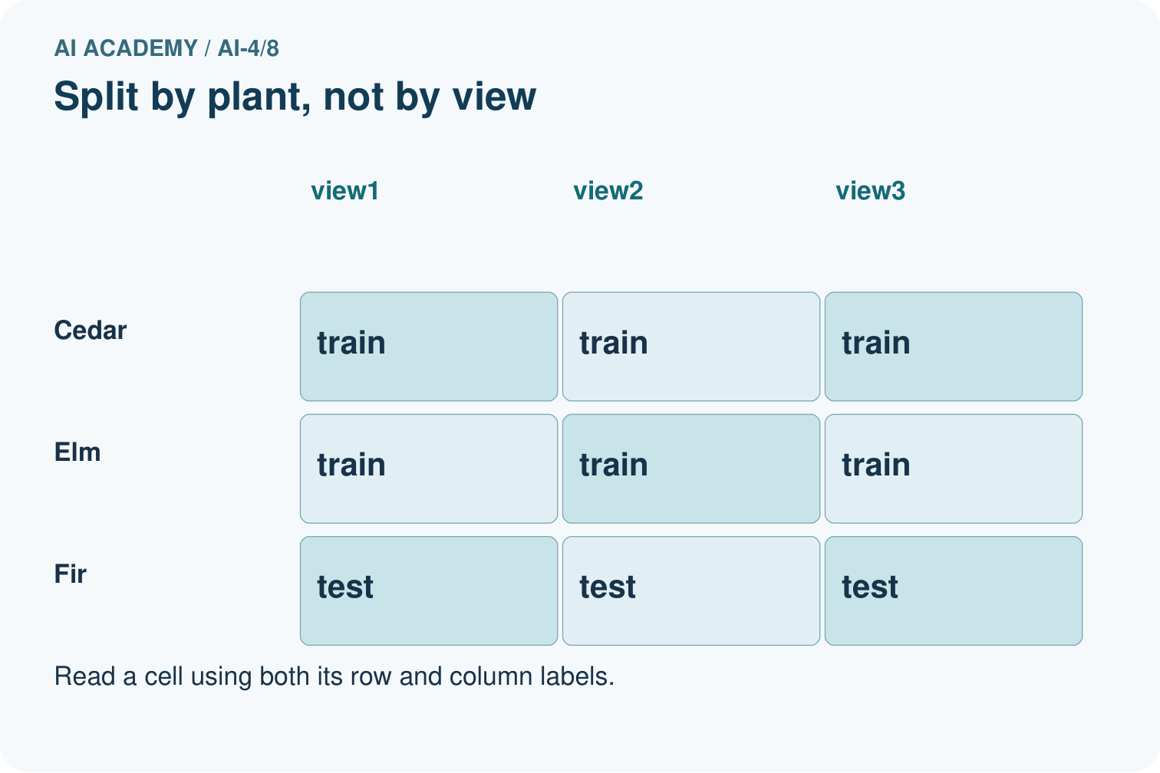
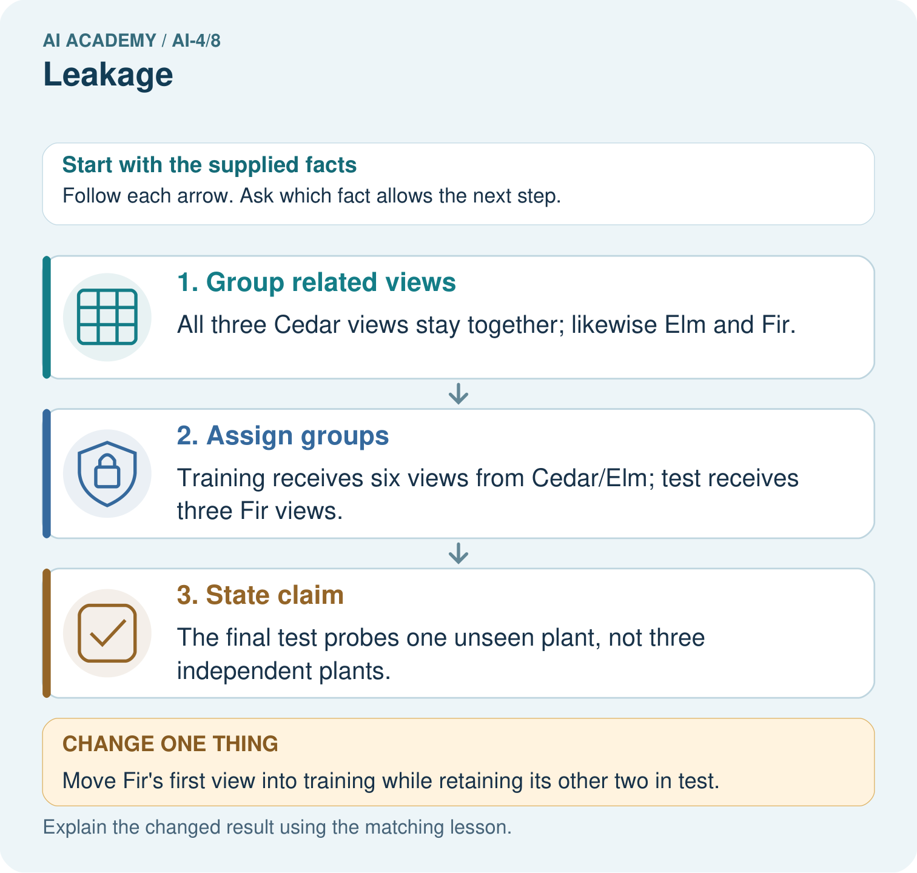

Read the picture one step at a time
Step | What happens and why
1. Group related views | All three Cedar views stay together; likewise Elm and Fir.
2. Assign groups | Training receives six views from Cedar/Elm; test receives three Fir views.
3. State claim | The final test probes one unseen plant, not three independent plants.
Match each pictured step to the supplied facts. This is a worked teaching case, not an independent assessment.

Why this result follows
Read the picture in order. The final test probes one unseen plant, not three independent plants. The arrows show which recorded input or intermediate result each decision uses. Explain the deciding step aloud before checking the changed case; pointing to the final answer alone does not show how it follows.

What this example does not establish
A correct group split still needs enough representative plants; this tiny exercise is not a reliable population estimate.
Read the labelled picture: How many independently new plant identities are in the original test? Point to the relevant step in the picture, then write the changed result and the rule or evidence that supports it.
Change one thing: Move Fir’s first view into training while retaining its other two in test. Predict the result before checking the explanation. What remains the same?

07. Find and repair a mistake
ERROR DETECTIVE

Compare → Diagnose → Repair
Do not patch the answer. Find the earliest unsupported assumption, data problem, or experiment error.
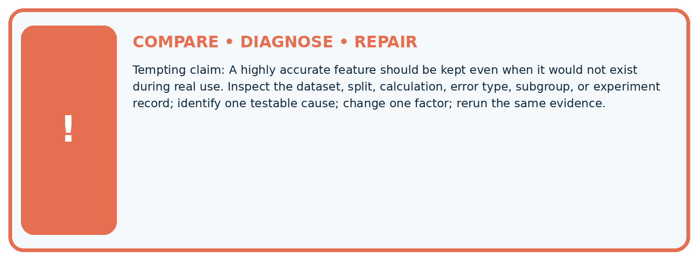
Evidence record | Expected | Actual | Likely cause / next test
normal case | passes
boundary case | defined behavior
missing case | safe fallback
shifted case | measured limit
CLAIM TO CHALLENGE A highly accurate feature should be kept even when it would not exist during real use.
Diagnose one cause and name the cleanest next experiment:

A closer explanation
Fit learned preprocessing, such as scaling values using an average, on training data and apply the stored transformation to the other sets. Using the full dataset to learn such values would let held out information influence development. We will implement preprocessing later; group separation alone does not solve that issue.
Record exclusions and label-review policies before scoring. Do not remove difficult test cases because they reduce the score. If a genuine data error requires repair, document it and its effect on the evaluation rather than claiming the old test stayed untouched. Next week you will build a simple baseline using these split roles.

All trip IDs are separate, but every trip uses the same route. Can you claim the model works on unseen routes? Explain the limitation and propose a split unit for that new claim.
________________________________________________________________
________________________________________________________________
________________________________________________________________
________________________________________________________________
________________________________________________________________

Apply the connected idea: Scaling without leakage
Record the split, feature names and units, feature order, minima, ranges, constant-feature policy, distance, k and tie rule. Keep the scale with the stored training examples. New data uses the same calculation. If development choices change, document them and reserve a separate final test. Next week combines these steps into one reproducible classifier pipeline.
If a feature is constant in training, its range is zero. This example stops for review. One documented option is to omit that feature everywhere and update the recorded feature list; do not divide by zero or invent a scale using validation values. Library policies differ, so inspect and record the one actually used.

A learner finds minima and ranges using all rows, then splits them and says there is no leakage because labels were never used. Explain the error and give the correct order of operations.
________________________________________________________________
________________________________________________________________
________________________________________________________________
________________________________________________________________

08. Practise together
ML STUDIO

Specify Before You Run
A trustworthy result can be reproduced from the recorded data, code, settings, and evaluation rule.


Experiment record
QUESTION + intended use + success threshold
DATA version + grouped split + leakage check
CODE/preprocessing + features + model + settings + seed
METRICS + positive class + units + denominators
PREDICTIONS + errors + subgroup slices + limitations
HUMAN reviewer + release, revise, limit, or stop decision
Write the minimum record needed to reproduce today's result:

A closer explanation
For new trips on a familiar route, holding out whole trips addresses within-trip similarity. For new routes, hold out entire routes so all their trips stay together. For forecasting future events, a time-respecting split may be needed: training on later events to predict earlier ones would not represent that intended use. The evaluation question determines the separation.
There is no universal percentage that makes a split valid. Large groups can make row counts unequal. Check that the sets can support the intended comparison, including enough relevant cases and labels, without moving individual related frames just to hit a percentage. This twelve-row example is too small to justify a reliable performance claim.

Apply the connected idea: Scaling without leakage
Keep the training scale and k=1 fixed. Validation rows are (11,120,clear), (19,190,blocked), (12,80,clear). Their scaled feature pairs are (0.1,0.2), (0.9,0.9), (0.2,-0.2). Nearest IDs are A,C,B, so predictions clear,blocked,blocked score 2/3. The training-majority blocked baseline gets 1/3. These three examples do not establish general superiority.
The last brightness value scales to -0.2 because 80 is below the training minimum 100. New values can fall outside 0 to 1; do not refit or silently clip them. Including validation features in minima or ranges leaks evaluation information even without labels. Fitting a separate scale on validation also changes coordinates and breaks the intended comparison.

Practise with less help: Distinguish frames from groups
Use workbook W2 for the connected example “Splits and related examples”. First fill the input and rule boxes. Try the middle steps before asking for a hint. After a hint, try the next step yourself.
Plan | Do | Check
What is given? Which rule or procedure applies? | Record each intermediate step. | Does the result follow? What remains unknown?
Explain your trace to a partner. Your partner points to one step to check. Swap roles on the next case. Each person writes their own explanation.

Check your reasoning
Use the worked case for Splits and related examples. Proposed explanation: “Different row IDs mean independent examples”. Decide whether this explanation is supported. Point to the step or supplied fact that decides; explain your repair if needed.
Answer on your own before discussion. If you are unsure, say which step you need help with.

Practise the connected topic: Scaling without leakage
Use its named workbook W2. Identify the given inputs, try the middle steps with less help, then explain your trace. Check this claim before group discussion: Every transformed value must lie between 0 and 1

Explain the picture
How many independently new plant identities are in the original test? Point to the relevant step in the picture, then write the changed result and the rule or evidence that supports it.

My explanation using a pictured step and the given facts
________________________________________________________________
________________________________________________________________
________________________________________________________________
________________________________________________________________
This is supported practice. Keep the separately named independent case for an attempt before feedback.

09. Run the investigation
EVIDENCE LAB

Predict → Run → Calculate → Interpret
Keep the test conditions fixed, record every result, and change only one planned factor.
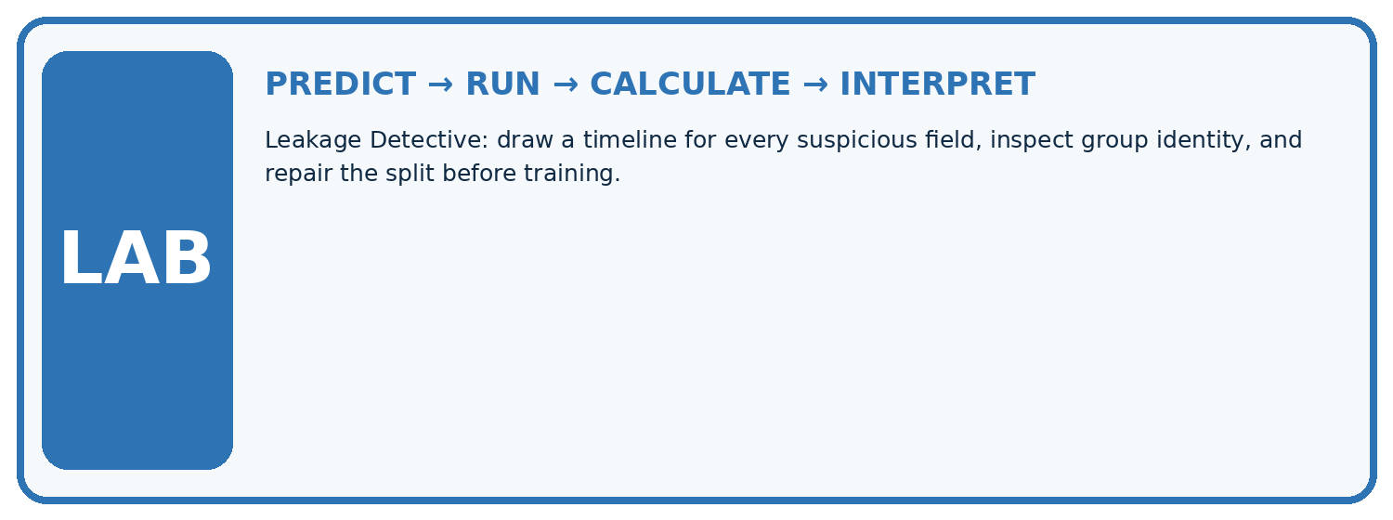
1. Write the hypothesis and expected evidence before running.
2. Leakage Detective: draw a timeline for every suspicious field, inspect group identity, and repair the split before training.
3. Run one normal, one boundary, one missing, and one shifted case.
4. Calculate the metric from raw counts or row-level errors.
5. Interpret what changed, what did not, and what remains unsafe or unknown.
Case | Prediction | Actual | Calculation / evidence | Meaning / next test
Normal
Boundary
Missing
Shifted

Plan → try → check
Before trying: what do I expect, and why? While trying: which step could first go wrong? Afterwards: what did I actually observe, and what should change? Keep “not run” if you only traced the procedure.

10. Build your understanding
MASTERY

From Knowing the Word to Owning the Idea
Move upward only when you can produce evidence without copying the example.

DEFINE Use all four terms precisely: leakage, prediction time, post-outcome feature, split leakage.
CALCULATE Reproduce the worked evidence with units and denominator.
TRACE Explain the data, code or decision path.
DIAGNOSE A highly accurate feature should be kept even when it would not exist during real use.
TRANSFER Solve a fresh dataset or model case.
IMPROVE Change one cause and rerun fixed evidence.
DEFEND State intended use, metric, limitation, and human responsibility.
MASTERY RULE A coached calculation becomes mastery only after a different case is completed independently.

11. Connect your project
CUMULATIVE PROJECT

Responsible Plant Classifier
Every week adds one reviewable artifact to the same evidence-based capstone.
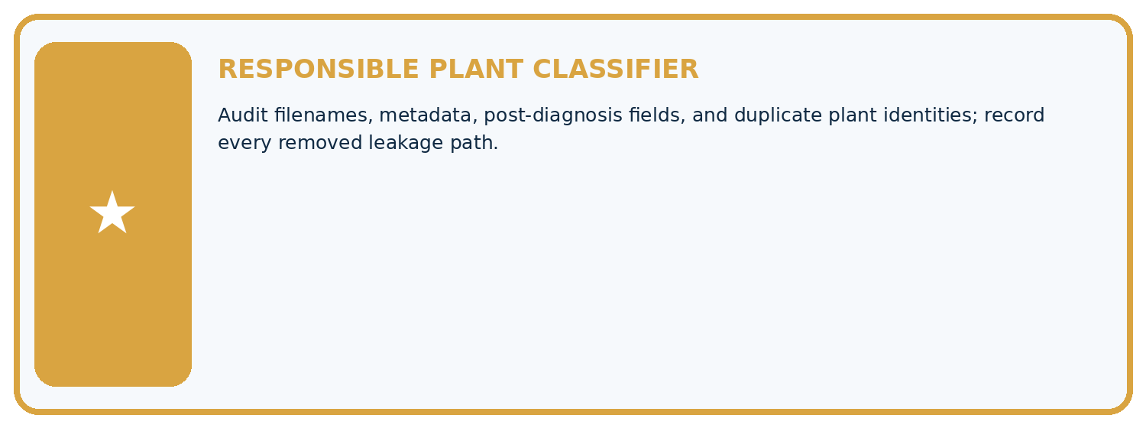
THIS WEEK'S CHECKPOINT Audit filenames, metadata, post-diagnosis fields, and duplicate plant identities; record every removed leakage path.
Which requirement or risk does this artifact address?
Which dataset, split, code, and metric version does it use?
What normal and shifted cases were tested?
What remains uncertain or weak?
What decision still belongs to a teacher or qualified human?
RESPONSIBLE RELEASE Never use this classroom prototype for medical, pesticide, agricultural, or other consequential decisions.
My evidence-linked project decision:

Evidence for your project
For your Responsible Plant Classifier, save the input, procedure, observed result and limitation of this check. Label this worked example as practice; use a different, previously unreviewed case when checking independent understanding.

12. Show what you know
INDEPENDENT PROOF

Explain • Calculate • Transfer • Defend
Complete this with a fresh case after guided practice and compare it with the mastery criteria.
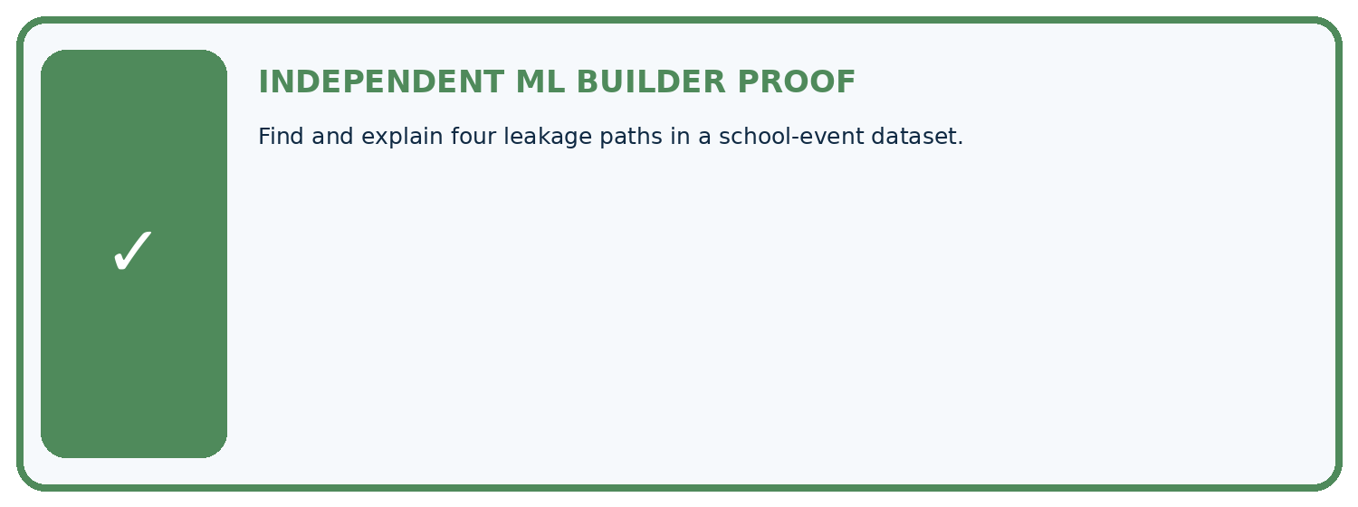
REQUIRED PROOF Find and explain four leakage paths in a school-event dataset.
□ Define the task, feature/target roles, and intended-use boundary.
□ Show the calculation, code trace, or experiment record.
□ Test a normal case and one revealing boundary, missing, or shifted case.
□ Diagnose one failure without changing several factors at once.
□ Name a limitation, fairness concern, and the human-review action.
Independent evidence and defense:
My level: □ Not yet □ With one hint □ Independently □ I can teach and defend it
NEXT BRIDGE Carry the experiment evidence into: Dataset Cards.

13. Study a complete case

Week 8 Worked case
Use the supplied details to practise the weekly concept before attempting the independent question. This case extends the illustrated lesson.

The situation
Ten photos per leaf are randomly split so one leaf appears in train and test.

The question
Explain and repair leakage.

Worked explanation
Related views make evaluation familiar. Split by leaf identity before fitting or learned preprocessing; keep all views together.

Explain it in your own words
Which detail supports the answer, and why does it matter?

Write or draw your reasoning and evidence.
________________________________________________________________
________________________________________________________________
________________________________________________________________
________________________________________________________________
________________________________________________________________

Trace the supplied case visually

Keep related views in the same partition
Evidence or stage | Value or result
Leaf A, all views | 10
Leaf B, all views | 10
Leaf C, all views | 10
Ten photos per leaf are randomly split so one leaf appears in train and test.
Explain and repair leakage.
Related views make evaluation familiar. Split by leaf identity before fitting or learned preprocessing; keep all views together.

14. Try a new case independently

Independent case: Changed independent case
Each of five plants has four photos. A random photo split puts different views of every plant in both training and test sets. Explain the problem and repair.

My independent explanation, trace and limits
________________________________________________________________
________________________________________________________________
________________________________________________________________
________________________________________________________________
________________________________________________________________
________________________________________________________________
________________________________________________________________
Attempt this case before feedback. Record any help. Earlier examples below are further practice; a case already practised with feedback cannot establish fresh transfer.

Week 8 Independent application
Close the worked explanation. Apply the idea to this different question without copying.
A feature records the expert's final species decision, made after the prediction time. Why is this leakage, and what should happen to it?
My answer, with a trace, calculation or supporting evidence

Write or draw your reasoning and evidence.
________________________________________________________________
________________________________________________________________
________________________________________________________________
________________________________________________________________
________________________________________________________________

Create and test
Change one relevant detail. Predict the result before testing. Include a boundary or missing-information case when it helps reveal a limit.
My changed input and expected result

Write or draw your reasoning and evidence.
________________________________________________________________
________________________________________________________________
________________________________________________________________
________________________________________________________________
________________________________________________________________

Connect to your project
Audit filenames, metadata, post-diagnosis fields, and duplicate plant identities; record every removed leakage path.
The evidence I will keep

Write or draw your reasoning and evidence.
________________________________________________________________
________________________________________________________________
________________________________________________________________
________________________________________________________________
________________________________________________________________
Your teacher has the independent answer and scoring criteria. Complete the matching workbook week to keep your practice evidence together.

Transfer practice from the original programme
Five photos of each leaf are randomly split by file into train and test. Why can accuracy be optimistic? Give a corrected grouping rule.

Explain the mechanism, evidence and one limit.
________________________________________________________________
________________________________________________________________
________________________________________________________________
________________________________________________________________
________________________________________________________________
________________________________________________________________
________________________________________________________________

Use feedback to improve
Attempt the independent case before hints. Record whether you worked alone, used a hint or followed a model. After feedback, fix the first unsupported step and explain why it changed. A later check uses a changed case, not a copied answer.

15. Your lesson route
Start with this question: Split by plant identity when testing generalisation to new plants.
By the end, I can | How I will show it
Choose a split unit that matches the intended prediction claim | Explain the deciding step, show a trace or test, and state one limit.
Keep related examples together and audit group overlap | Explain the deciding step, show a trace or test, and state one limit.
Record split roles counts and limits before model evaluation | Explain the deciding step, show a trace or test, and state one limit.
Remember → watch and explain → try with help → investigate → try independently → keep project evidence. Your teacher may spread this lesson across several classes.
Keep your first prediction. Compare it with what the evidence shows and explain any change.

16. Finish and return
Close your notes. Explain this goal in your own words: Choose a split unit that matches the intended prediction claim

My deciding step, evidence and one remaining question
________________________________________________________________
________________________________________________________________
________________________________________________________________
________________________________________________________________
________________________________________________________________
If you are unsure, return to the worked picture and explain one arrow. If you are ready, change an input or assumption and justify your prediction.
Save your workbook evidence. At the next review, try a different case before opening your old answer.

