AI ACADEMY · STUDENT · ai-4/20

Mean, Median, and Baselines
Project: Responsible Plant Classifier

Before you start
Week 4: mean divides a sum by the count; median is the middle sorted value.

01. Your mission

Your learning target
I can fit mean and median constant baselines on training targets.
I can compare constant predictions on separate records.
I can keep fitted constants independent of evaluation answers.

Remember before reading
Close your notes first. A rough first answer helps us choose the right starting point; it is not a score for your ability.
Without opening the old lesson, explain one key idea from Regression and Residuals. Give an example and a mistake that the idea helps you avoid.
Without opening the old lesson, explain one key idea from Precision and Recall. Give an example and a mistake that the idea helps you avoid.
Without opening the old lesson, explain one key idea from Scores and Calibration Intuition. Give an example and a mistake that the idea helps you avoid.
After trying, check the relevant lesson or ask your teacher. Change the part of your explanation that the evidence shows was wrong.
Mean and median are transparent regression baselines; outliers affect them differently.

LEARNING TARGET For training targets [1,3,11], compute mean and median constant baselines. Compare total absolute training error for each. Where must final performance be measured?
Builder name and experiment date:

Readiness for the connected explanation
Why can signed residuals hide error size?

This week’s end goal
By the end, I can explain mean, median, and baselines using a traced example and a stated limitation.

02. Notice the evidence
PICTURE ENTRY

Notice → Predict → Explain
Begin with visible evidence; do not explain more than the picture and information support.
MYSTERY The team must use mean, median, and baselines to solve a model-building problem. What information do they have? What important evidence is still missing?
Name three visible details without interpreting them.
Predict the data, model, or evaluation decision being made.
Identify one hidden assumption that could change the result.
State what evidence would confirm or reject your prediction.
My prediction and supporting evidence:

A closer explanation
Before a complex regression model, fit a simple constant predictor. A mean baseline uses the training average. A median baseline uses the middle training target. They ignore features but provide a comparison that is easy to reproduce. Evaluation targets must not determine the constants.
Use fictional classroom data throughout this investigation. Keep the task, units, reference labels and data split visible as you reason. Earlier weeks supplied the model-building process; this week examines constant prediction baselines.

03. See how it works
ML MECHANISM

Input → Model → Evidence
Trace the information, fitted behavior, and evaluation proof separately.
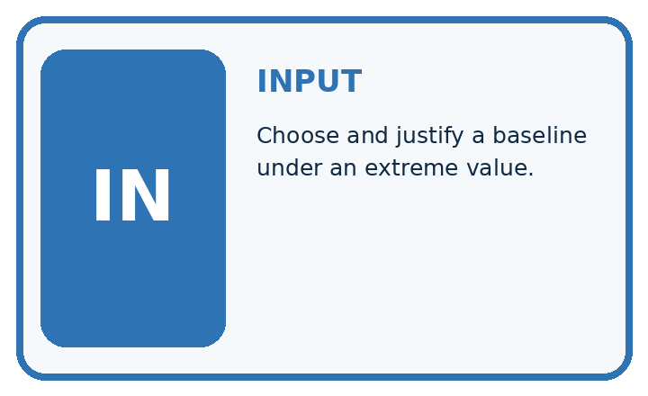
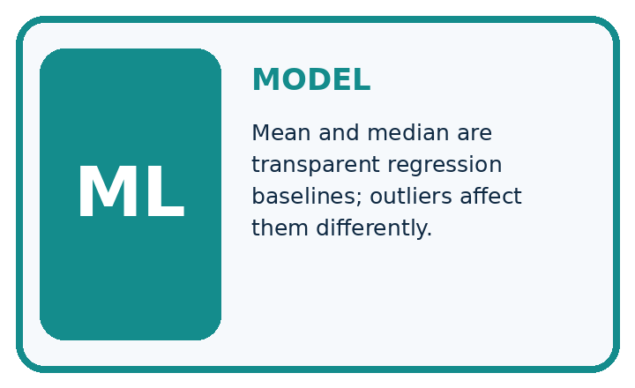
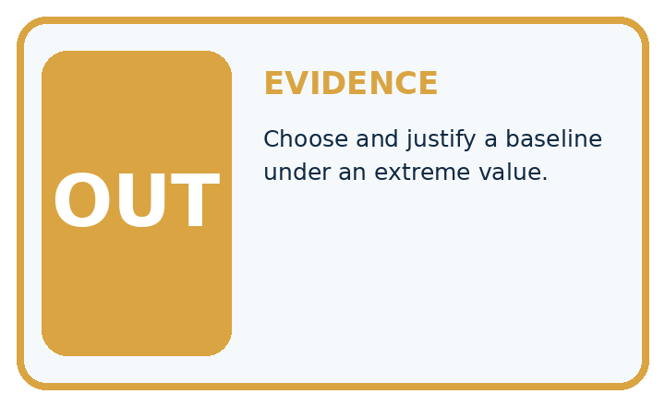
QUESTION Choose and justify a baseline under an extreme value.
MODEL IDEA Mean and median are transparent regression baselines; outliers affect them differently.
PROOF NEEDED Use an unseen case, visible calculation, error analysis, and a stated limitation.
UNDER THE HOOD Heights are 10, 11, 12, 13, and 54 cm. Mean = 100 ÷ 5 = 20 cm.
Draw a fresh data → model → prediction → evaluation trace:

A closer explanation
Training targets [2, 4, 6, 12] have mean 24/4=6 and median (4+6)/2=5. On separate targets [4, 8], the mean baseline predicts [6, 6] with absolute errors [2, 2], averaging 2. The median baseline predicts [5, 5] with errors [1, 3], also averaging 2.
from statistics import mean, median
training = [2, 4, 6, 12]
validation = [4, 8]
for name, value in [("mean", mean(training)),
("median", median(training))]:
mae = mean(abs(y - value) for y in validation)
print(name, value, mae)
# Both validation MAEs are 2; constants differ.
Trace the calculation on paper before running this optional Python check. Use the stated fictional inputs and compare intermediate values. The code checks this example; your independent workbook case uses different evidence.

Connect the picture and the explanation
Point to the input, the deciding step and the result in this week’s visual. Explain the same step in ordinary words. A picture helps when you can say what each part represents.

04. Compare the cases
EVALUATION DESIGN

Four Tests, Four Kinds of Evidence
A system is not understood until it survives more than one comfortable example.




NORMAL Expected data and expected behavior.
BOUNDARY Value close to a threshold, ambiguous label, or uncertain prediction.
MISSING Necessary field, label, source, or measurement is unavailable.
SHIFTED New lighting, species, device, subgroup, or time condition.
RELEASE RULE Passing one case never proves generalization. Predefine expected behavior for all four categories.
Which case most threatens today's claim, and why?

Change one thing in the pictured case
Change: Replace training 20 with 8 while keeping evaluation unchanged.
Prediction: Both fitted constants become5 cm and both evaluation MAEs remain3 cm.
Reason: Mean is now20/4=5; median stays5. The earlier training outlier affected the mean.

05. Words that unlock the idea
VOCABULARY

Words You Can Calculate and Defend
A definition matters when it lets you interpret a new dataset, model, or result.
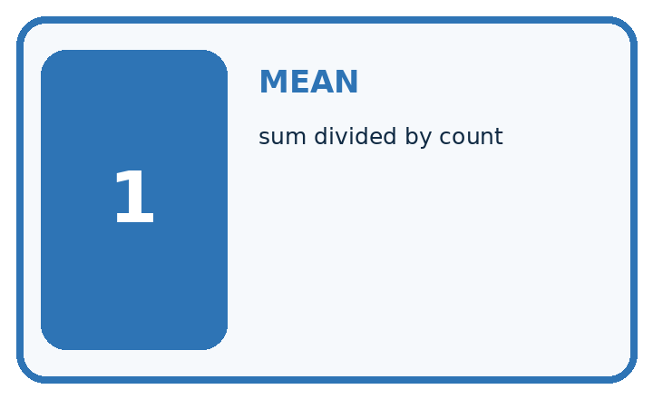
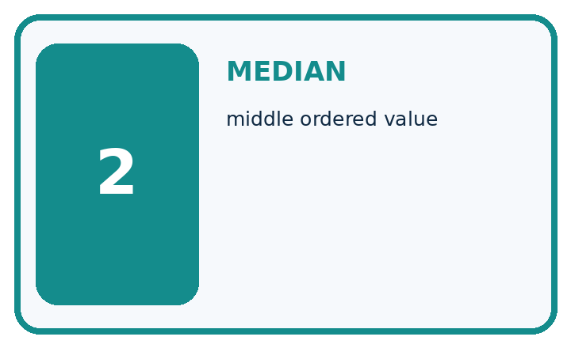
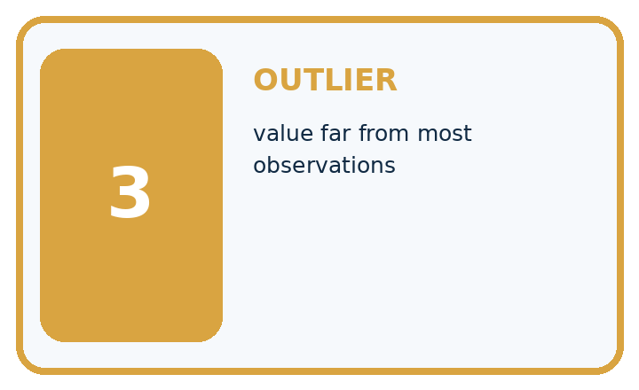
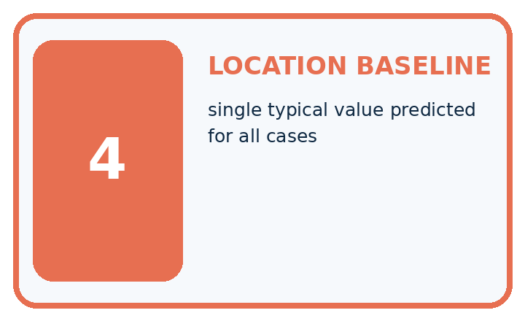
Term | Precise meaning | My ML example
mean | sum divided by count
median | middle ordered value
outlier | value far from most observations
location baseline | single typical value predicted for all cases
MISCONCEPTION TO REPAIR The mean is always the fairest and most scientific summary.
Repair the claim using a definition, calculation, or test record:

Words used in the closer explanation
Word | Meaning
Constant baseline | One fixed prediction for every query
Training mean | Sum of training targets divided by their count
Training median | Middle value of sorted training targets
Absolute error | Magnitude of observed minus predicted

06. Follow a worked example
WORKED EVIDENCE

Reason Step by Step
Predict first. Then check each step. A correct answer without visible evidence cannot be audited.
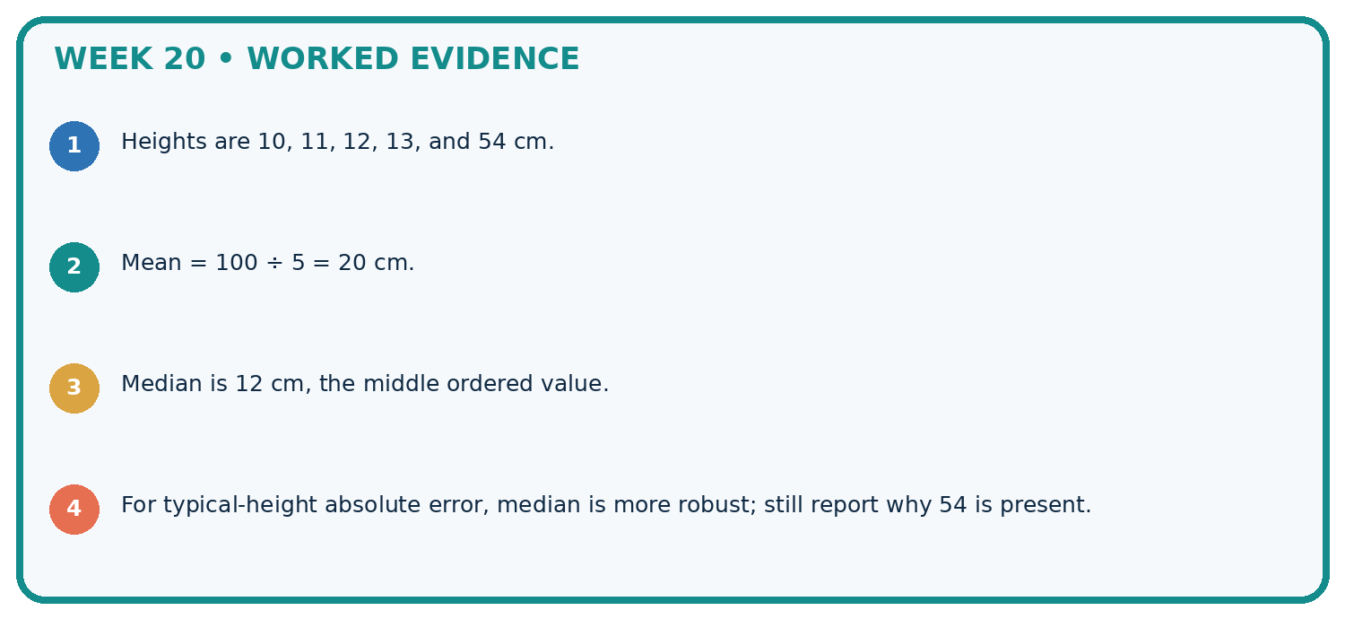
STEP 1 Heights are 10, 11, 12, 13, and 54 cm.
STEP 2 Mean = 100 ÷ 5 = 20 cm.
STEP 3 Median is 12 cm, the middle ordered value.
STEP 4 For typical-height absolute error, median is more robust; still report why 54 is present.
CHECK Verify the denominator, unit, split, class definition, and data version before interpreting a score.
Recalculate, retrace, or restate the evidence independently:

A closer explanation

Constant prediction baselines at a glance
Part | Evidence or action | Interpretation
Training targets | Fit mean 6 | Freeze constant
Training targets | Fit median 5 | Freeze constant
Evaluation targets | Compare fixed predictions | Both MAE 2 here
Mean and median answer different training objectives. A mean minimizes total squared error among constants; a median minimizes total absolute error. This does not guarantee either wins on a new evaluation set. With extreme values, the mean can move much more than the median.

Calculate MAE for both baselines on [4, 8]. Explain the steps or evidence behind your response.
________________________________________________________________
________________________________________________________________
________________________________________________________________
________________________________________________________________

Learn from the worked case
Cover the result before checking it. Say what is given, choose the procedure, and follow one step at a time. Then uncover the result and explain your first mismatch. Ask why a step is allowed, not only what number it produces.

A pictorial worked case: Mean, Median, and Baselines
Fit two constant height baselines and compare them on held-out examples.

The facts we will use
Training heights [2, 4, 6, 20] cm. Evaluation heights [4, 10] cm. Fit constants only from training.
All inputs and outcomes in this worked example are invented classroom data; no real model run is claimed.
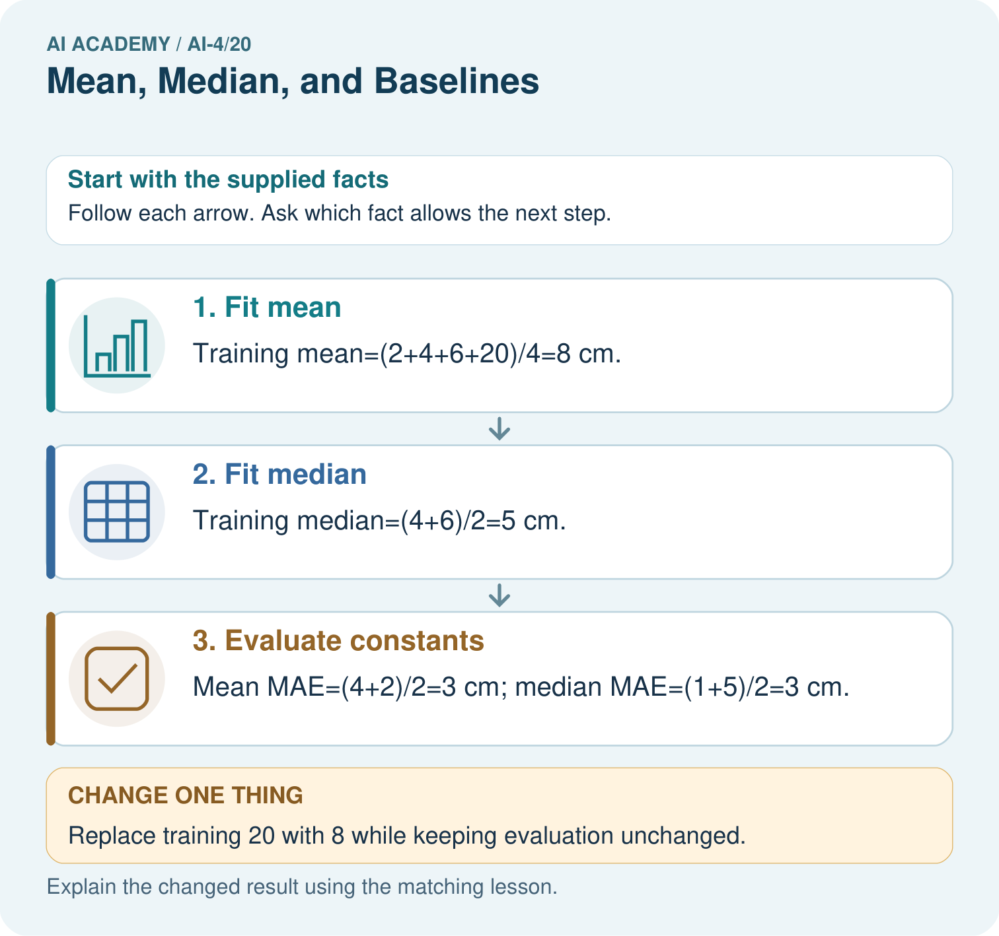

Read the picture one step at a time
Step | What happens and why
1. Fit mean | Training mean=(2+4+6+20)/4=8 cm.
2. Fit median | Training median=(4+6)/2=5 cm.
3. Evaluate constants | Mean MAE=(4+2)/2=3 cm; median MAE=(1+5)/2=3 cm.
Match each pictured step to the supplied facts. This is a worked teaching case, not an independent assessment.

Why this result follows
Read the picture in order. Mean MAE=(4+2)/2=3 cm; median MAE=(1+5)/2=3 cm. The arrows show which recorded input or intermediate result each decision uses. Explain the deciding step aloud before checking the changed case; pointing to the final answer alone does not show how it follows.

What this example does not establish
Mean and median have different loss properties, but their held-out performance depends on the particular evaluation cases.
Read the labelled picture: Does either original baseline win under evaluation MAE? Point to the relevant step in the picture, then write the changed result and the rule or evidence that supports it.
Change one thing: Replace training 20 with 8 while keeping evaluation unchanged. Predict the result before checking the explanation. What remains the same?

07. Find and repair a mistake
ERROR DETECTIVE

Compare → Diagnose → Repair
Do not patch the answer. Find the earliest unsupported assumption, data problem, or experiment error.
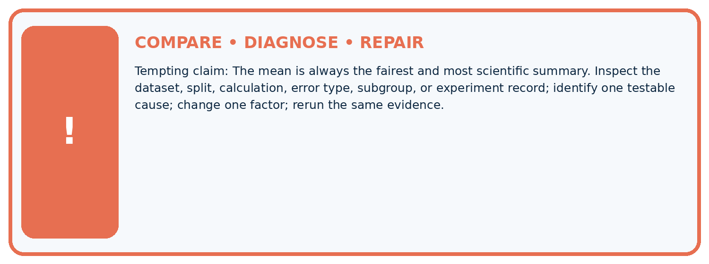
Evidence record | Expected | Actual | Likely cause / next test
normal case | passes
boundary case | defined behavior
missing case | safe fallback
shifted case | measured limit
CLAIM TO CHALLENGE The mean is always the fairest and most scientific summary.
Diagnose one cause and name the cleanest next experiment:

A closer explanation
For an even number of values, this course averages the two middle values to report one median. Keep a frozen baseline across comparisons and show its evaluation score. A model that fails to beat it may still reveal a data or metric issue worth investigating.

Why not predict the evaluation mean as the baseline?
________________________________________________________________
________________________________________________________________
________________________________________________________________
________________________________________________________________

08. Practise together
ML STUDIO

Specify Before You Run
A trustworthy result can be reproduced from the recorded data, code, settings, and evaluation rule.


Experiment record
QUESTION + intended use + success threshold
DATA version + grouped split + leakage check
CODE/preprocessing + features + model + settings + seed
METRICS + positive class + units + denominators
PREDICTIONS + errors + subgroup slices + limitations
HUMAN reviewer + release, revise, limit, or stop decision
Write the minimum record needed to reproduce today's result:

A closer explanation
Replacing training 12 by 40 gives mean 13 and median 5. That change is a data change to record and investigate, not an instruction to delete an inconvenient observation. Decide whether the extreme value is valid using the measurement policy and provenance.

Practise with less help: Score separately
Use workbook W2 for the connected example “Constant prediction baselines”. First fill the input and rule boxes. Try the middle steps before asking for a hint. After a hint, try the next step yourself.
Plan | Do | Check
What is given? Which rule or procedure applies? | Record each intermediate step. | Does the result follow? What remains unknown?
Explain your trace to a partner. Your partner points to one step to check. Swap roles on the next case. Each person writes their own explanation.

Check your reasoning
Use the worked case for Constant prediction baselines. Proposed explanation: “A final answer is enough”. Decide whether this explanation is supported. Point to the step or supplied fact that decides; explain your repair if needed.
Answer on your own before discussion. If you are unsure, say which step you need help with.

Explain the picture
Does either original baseline win under evaluation MAE? Point to the relevant step in the picture, then write the changed result and the rule or evidence that supports it.

My explanation using a pictured step and the given facts
________________________________________________________________
________________________________________________________________
________________________________________________________________
________________________________________________________________
This is supported practice. Keep the separately named independent case for an attempt before feedback.

09. Run the investigation
EVIDENCE LAB

Predict → Run → Calculate → Interpret
Keep the test conditions fixed, record every result, and change only one planned factor.
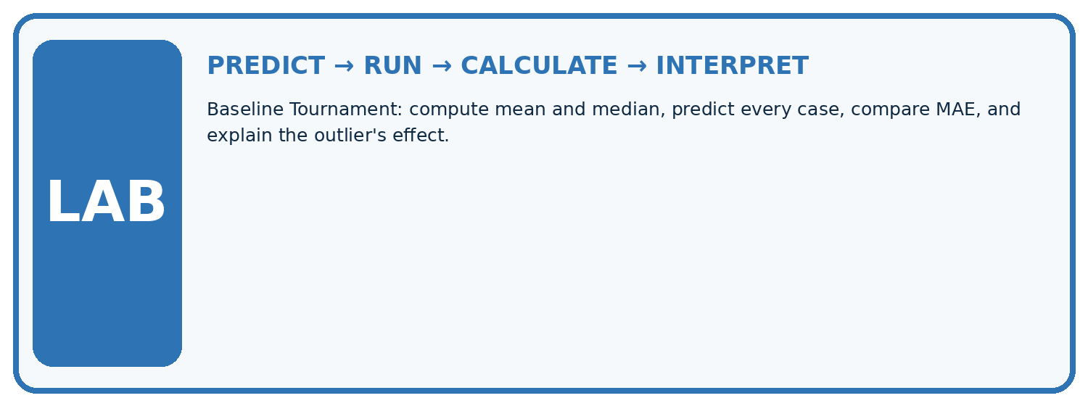
1. Write the hypothesis and expected evidence before running.
2. Baseline Tournament: compute mean and median, predict every case, compare MAE, and explain the outlier's effect.
3. Run one normal, one boundary, one missing, and one shifted case.
4. Calculate the metric from raw counts or row-level errors.
5. Interpret what changed, what did not, and what remains unsafe or unknown.
Case | Prediction | Actual | Calculation / evidence | Meaning / next test
Normal
Boundary
Missing
Shifted

Plan → try → check
Before trying: what do I expect, and why? While trying: which step could first go wrong? Afterwards: what did I actually observe, and what should change? Keep “not run” if you only traced the procedure.

10. Build your understanding
MASTERY

From Knowing the Word to Owning the Idea
Move upward only when you can produce evidence without copying the example.

DEFINE Use all four terms precisely: mean, median, outlier, location baseline.
CALCULATE Reproduce the worked evidence with units and denominator.
TRACE Explain the data, code or decision path.
DIAGNOSE The mean is always the fairest and most scientific summary.
TRANSFER Solve a fresh dataset or model case.
IMPROVE Change one cause and rerun fixed evidence.
DEFEND State intended use, metric, limitation, and human responsibility.
MASTERY RULE A coached calculation becomes mastery only after a different case is completed independently.

11. Connect your project
CUMULATIVE PROJECT

Responsible Plant Classifier
Every week adds one reviewable artifact to the same evidence-based capstone.
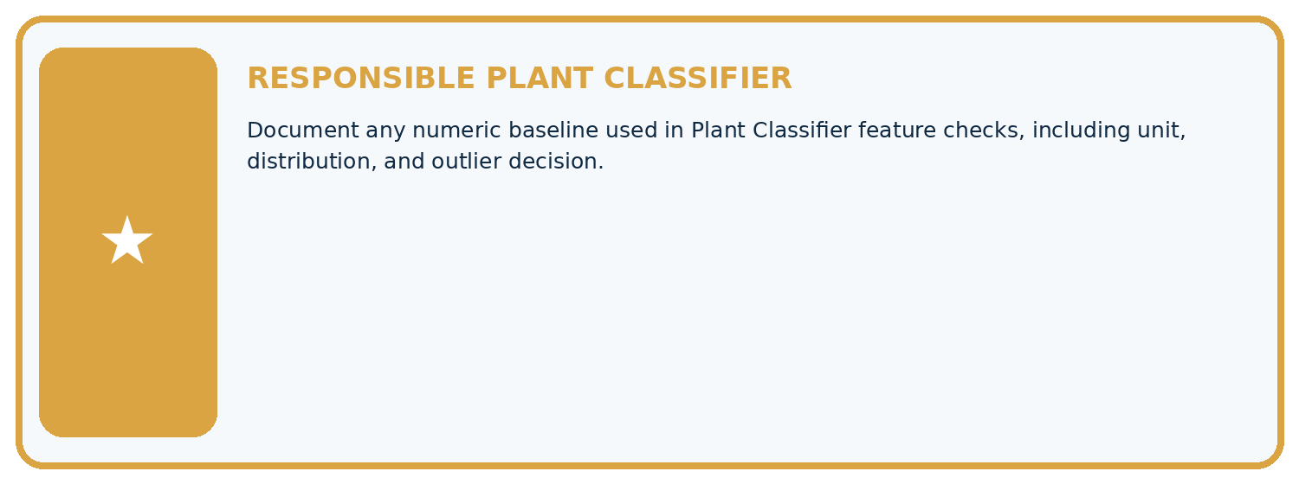
THIS WEEK'S CHECKPOINT Document any numeric baseline used in Plant Classifier feature checks, including unit, distribution, and outlier decision.
Which requirement or risk does this artifact address?
Which dataset, split, code, and metric version does it use?
What normal and shifted cases were tested?
What remains uncertain or weak?
What decision still belongs to a teacher or qualified human?
RESPONSIBLE RELEASE Never use this classroom prototype for medical, pesticide, agricultural, or other consequential decisions.
My evidence-linked project decision:

Evidence for your project
For your Responsible Plant Classifier, save the input, procedure, observed result and limitation of this check. Label this worked example as practice; use a different, previously unreviewed case when checking independent understanding.

12. Show what you know
INDEPENDENT PROOF

Explain • Calculate • Transfer • Defend
Complete this with a fresh case after guided practice and compare it with the mastery criteria.
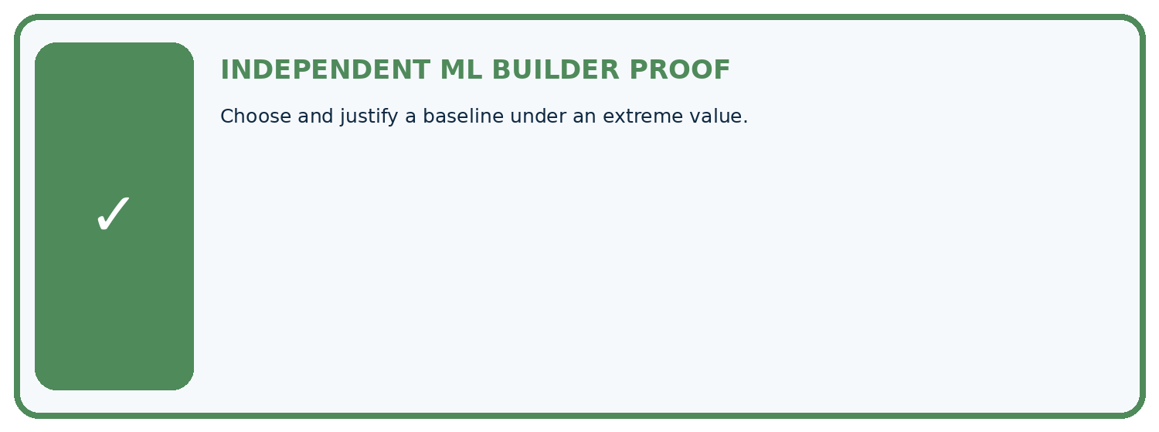
REQUIRED PROOF Choose and justify a baseline under an extreme value.
□ Define the task, feature/target roles, and intended-use boundary.
□ Show the calculation, code trace, or experiment record.
□ Test a normal case and one revealing boundary, missing, or shifted case.
□ Diagnose one failure without changing several factors at once.
□ Name a limitation, fairness concern, and the human-review action.
Independent evidence and defense:
My level: □ Not yet □ With one hint □ Independently □ I can teach and defend it
NEXT BRIDGE Carry the experiment evidence into: Absolute Error and MAE.

13. Study a complete case

Week 20 Worked case
Use the supplied details to practise the weekly concept before attempting the independent question. This case extends the illustrated lesson.

The situation
Training heights are 2,4,12 cm. Compare constant mean and median baselines.

The question
Compute both and training absolute errors.

Worked explanation
Mean=6, median=4. Mean errors 4,2,6 total12; median errors 2,0,8 total10. Median minimises absolute error here.

Explain it in your own words
Which detail supports the answer, and why does it matter?

Write or draw your reasoning and evidence.
________________________________________________________________
________________________________________________________________
________________________________________________________________
________________________________________________________________
________________________________________________________________

Trace the supplied case visually

Mean and median baselines use the same observations
Evidence or stage | Value or result
Observation A | 2
Observation B | 4
Observation C | 12
Mean baseline | 6
Median baseline | 4
Training heights are 2,4,12 cm. Compare constant mean and median baselines.
Compute both and training absolute errors.
Mean=6, median=4. Mean errors 4,2,6 total12; median errors 2,0,8 total10. Median minimises absolute error here.

14. Try a new case independently

Independent case: Apply independently
Training [1, 3, 5, 15], evaluation [3, 9]. Fit both constants and calculate MAE.

My independent explanation, trace and limits
________________________________________________________________
________________________________________________________________
________________________________________________________________
________________________________________________________________
________________________________________________________________
________________________________________________________________
________________________________________________________________
Attempt this case before feedback. Record any help. Earlier examples below are further practice; a case already practised with feedback cannot establish fresh transfer.

Week 20 Independent application
Close the worked explanation. Apply the idea to this different question without copying.
For training heights 2, 3 and 10 cm, calculate mean and median. Which constant is less influenced by the high value?
My answer, with a trace, calculation or supporting evidence

Write or draw your reasoning and evidence.
________________________________________________________________
________________________________________________________________
________________________________________________________________
________________________________________________________________
________________________________________________________________

Create and test
Change one relevant detail. Predict the result before testing. Include a boundary or missing-information case when it helps reveal a limit.
My changed input and expected result

Write or draw your reasoning and evidence.
________________________________________________________________
________________________________________________________________
________________________________________________________________
________________________________________________________________
________________________________________________________________

Connect to your project
Document any numeric baseline used in Plant Classifier feature checks, including unit, distribution, and outlier decision.
The evidence I will keep

Write or draw your reasoning and evidence.
________________________________________________________________
________________________________________________________________
________________________________________________________________
________________________________________________________________
________________________________________________________________
Your teacher has the independent answer and scoring criteria. Complete the matching workbook week to keep your practice evidence together.

Transfer practice from the original programme
For training targets [1,3,11], compute mean and median constant baselines. Compare total absolute training error for each. Where must final performance be measured?

Explain the mechanism, evidence and one limit.
________________________________________________________________
________________________________________________________________
________________________________________________________________
________________________________________________________________
________________________________________________________________
________________________________________________________________
________________________________________________________________

Use feedback to improve
Attempt the independent case before hints. Record whether you worked alone, used a hint or followed a model. After feedback, fix the first unsupported step and explain why it changed. A later check uses a changed case, not a copied answer.

15. Your lesson route
Start with this question: Fit two constant height baselines and compare them on held-out examples.
By the end, I can | How I will show it
Fit mean and median constant baselines on training targets | Explain the deciding step, show a trace or test, and state one limit.
Compare constant predictions on separate records | Explain the deciding step, show a trace or test, and state one limit.
Keep fitted constants independent of evaluation answers | Explain the deciding step, show a trace or test, and state one limit.
Remember → watch and explain → try with help → investigate → try independently → keep project evidence. Your teacher may spread this lesson across several classes.
Keep your first prediction. Compare it with what the evidence shows and explain any change.

16. Finish and return
Close your notes. Explain this goal in your own words: Fit mean and median constant baselines on training targets

My deciding step, evidence and one remaining question
________________________________________________________________
________________________________________________________________
________________________________________________________________
________________________________________________________________
________________________________________________________________
If you are unsure, return to the worked picture and explain one arrow. If you are ready, change an input or assumption and justify your prediction.
Save your workbook evidence. At the next review, try a different case before opening your old answer.

