AI ACADEMY · STUDENT · ai-4/33

Model Cards and Human Review
Project: Responsible Plant Classifier

Before you start
Week 31: a single overall metric hides conditions and failure types.

01. Your mission

Your learning target
I can write a model card whose claims match evidence.
I can separate intended use from unsupported use.
I can review a card for missing evaluation details.

Remember before reading
Close your notes first. A rough first answer helps us choose the right starting point; it is not a score for your ability.
Without opening the old lesson, explain one key idea from Proxy Features and Fairness. Give an example and a mistake that the idea helps you avoid.
Without opening the old lesson, explain one key idea from Improve Generalization. Give an example and a mistake that the idea helps you avoid.
Without opening the old lesson, explain one key idea from Overfitting. Give an example and a mistake that the idea helps you avoid.
After trying, check the relevant lesson or ask your teacher. Change the part of your explanation that the evidence shows was wrong.
A model card defines intended use, evidence, limitations, risks, decision boundaries, monitoring, and human escalation.

LEARNING TARGET Draft five model-card headings for a classroom leaf classifier. Why must the card state that its labels are classroom categories rather than professional plant diagnosis?
Builder name and experiment date:

Readiness for the connected explanation
What should remain visible after an evaluation?

This week’s end goal
By the end, I can explain model cards and human review using a traced example and a stated limitation.

02. Notice the evidence
PICTURE ENTRY

Notice → Predict → Explain
Begin with visible evidence; do not explain more than the picture and information support.
MYSTERY The team must use model cards and human review to solve a model-building problem. What information do they have? What important evidence is still missing?
Name three visible details without interpreting them.
Predict the data, model, or evaluation decision being made.
Identify one hidden assumption that could change the result.
State what evidence would confirm or reject your prediction.
My prediction and supporting evidence:

A closer explanation
A model card helps another person understand what was built and what evidence exists. It is a record, not a certificate of safety. Link statements to saved data and run records. Use unknown or not evaluated where evidence is absent instead of filling gaps with optimistic language.
Use fictional classroom data throughout this investigation. Keep the task, units, reference labels and data split visible as you reason. Earlier weeks supplied the model-building process; this week examines model cards and review.

03. See how it works
ML MECHANISM

Input → Model → Evidence
Trace the information, fitted behavior, and evaluation proof separately.
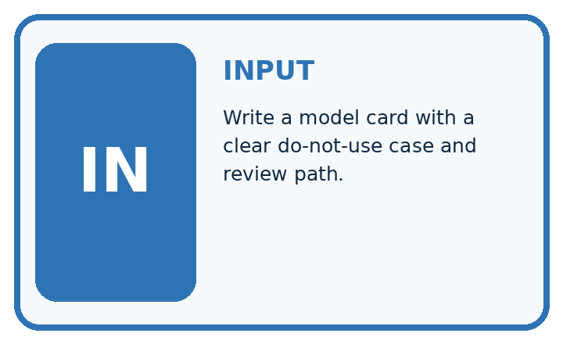
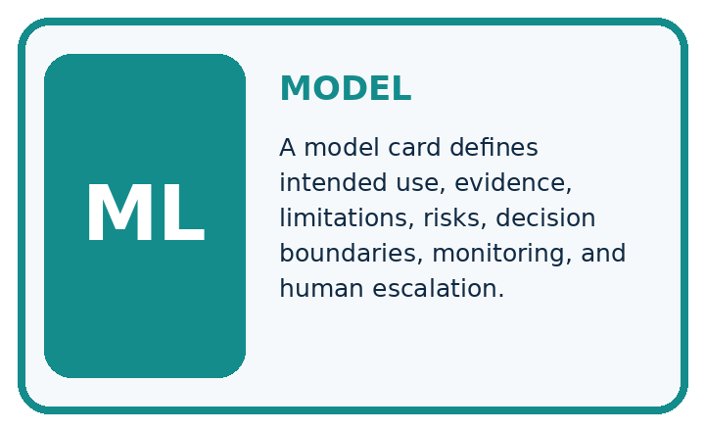
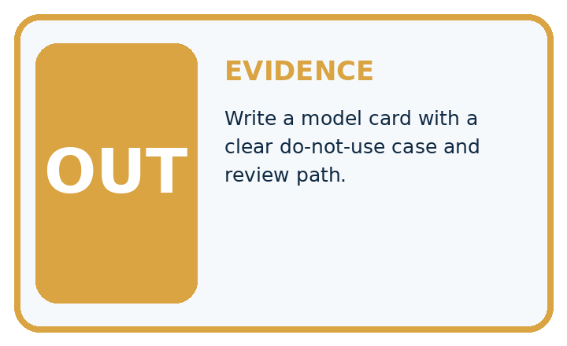
QUESTION Write a model card with a clear do-not-use case and review path.
MODEL IDEA A model card defines intended use, evidence, limitations, risks, decision boundaries, monitoring, and human escalation.
PROOF NEEDED Use an unseen case, visible calculation, error analysis, and a stated limitation.
UNDER THE HOOD Intended use: classroom exploration of visible leaf spotting. Evidence: test metrics, confusion matrix, subgroup slices, and data version.
Draw a fresh data → model → prediction → evaluation trace:

A closer explanation
Example card: classroom parcel classifier v 1; purpose: compare toy classification methods on fictional clear/blocked labels. Training 40, validation 20, test 12 with separate record groups. Frozen test TN 7 FP 1 FN 2 TP 2, blocked positive: accuracy 9/12, precision 2/3, recall 2/4. Always-clear baseline scores 8/12. No real parcel or student decision is supported.
Before continuing, underline the decision rule and circle the evidence that supports the conclusion. Explain the example to a partner without replacing the counts or conditions with a stronger claim. Keep the distinction between an observed result and a proposed next step.

Connect the picture and the explanation
Point to the input, the deciding step and the result in this week’s visual. Explain the same step in ordinary words. A picture helps when you can say what each part represents.

04. Compare the cases
EVALUATION DESIGN

Four Tests, Four Kinds of Evidence
A system is not understood until it survives more than one comfortable example.




NORMAL Expected data and expected behavior.
BOUNDARY Value close to a threshold, ambiguous label, or uncertain prediction.
MISSING Necessary field, label, source, or measurement is unavailable.
SHIFTED New lighting, species, device, subgroup, or time condition.
RELEASE RULE Passing one case never proves generalization. Predefine expected behavior for all four categories.
Which case most threatens today's claim, and why?

Change one thing in the pictured case
Change: The publicity sentence becomes “80% accurate for every plant”.
Prediction: Reject that unbounded statement.
Reason: The measured rate belongs to twenty related indoor photos, not every plant or setting.

05. Words that unlock the idea
VOCABULARY

Words You Can Calculate and Defend
A definition matters when it lets you interpret a new dataset, model, or result.
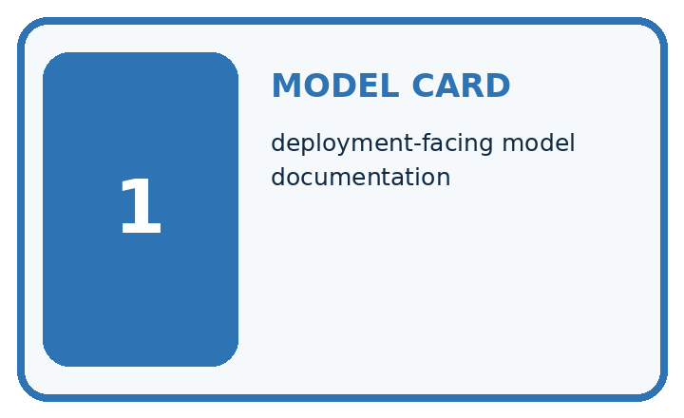
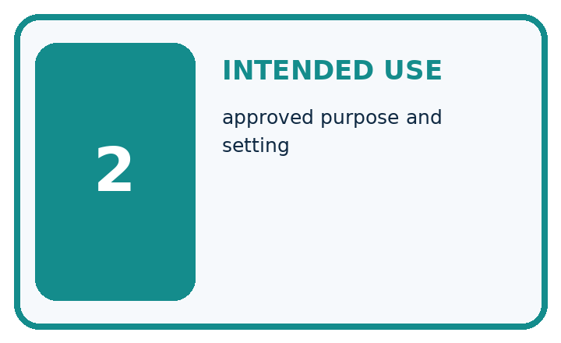
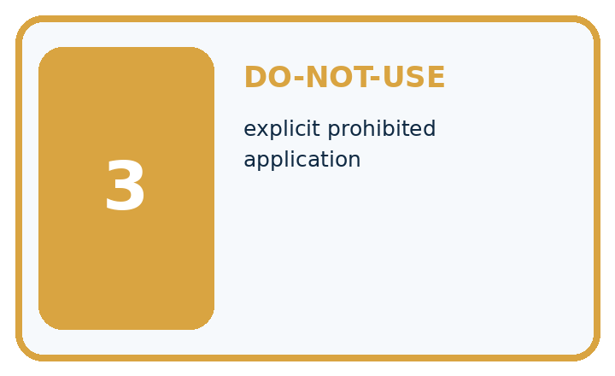
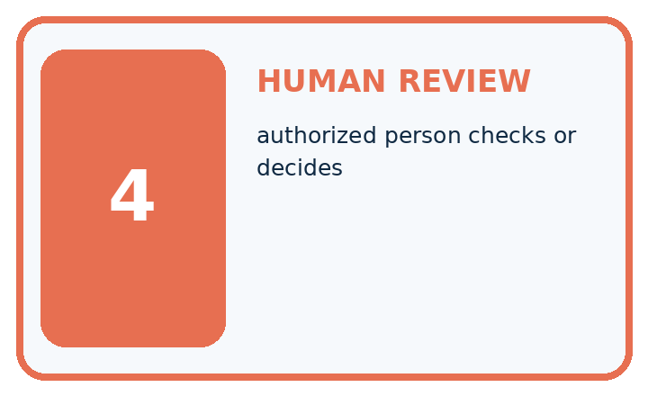
Term | Precise meaning | My ML example
model card | deployment-facing model documentation
intended use | approved purpose and setting
do-not-use | explicit prohibited application
human review | authorized person checks or decides
MISCONCEPTION TO REPAIR A disclaimer at the bottom of the screen is a complete safety plan.
Repair the claim using a definition, calculation, or test record:

Words used in the closer explanation
Word | Meaning
Model card | A concise structured account of a model and its limits
Intended use | The purpose and conditions the evidence supports
Out-of-scope use | A purpose for which the model is not supported
Review status | The current state of checks and unresolved issues

06. Follow a worked example
WORKED EVIDENCE

Reason Step by Step
Predict first. Then check each step. A correct answer without visible evidence cannot be audited.
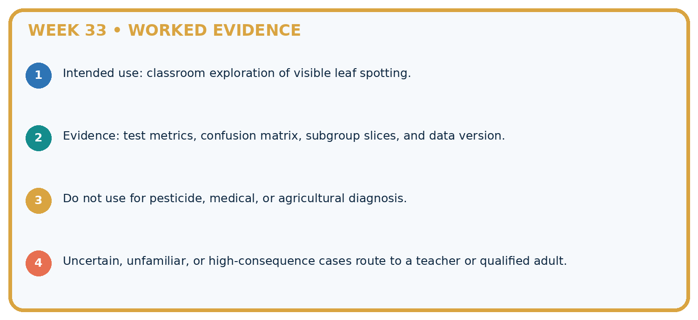
STEP 1 Intended use: classroom exploration of visible leaf spotting.
STEP 2 Evidence: test metrics, confusion matrix, subgroup slices, and data version.
STEP 3 Do not use for pesticide, medical, or agricultural diagnosis.
STEP 4 Uncertain, unfamiliar, or high-consequence cases route to a teacher or qualified adult.
CHECK Verify the denominator, unit, split, class definition, and data version before interpreting a score.
Recalculate, retrace, or restate the evidence independently:

A closer explanation

Model cards and review at a glance
Part | Evidence or action | Interpretation
Purpose and version | Toy classifier v 1 | Fictional data only
Evidence | 12 held-out cases | Full matrix and baseline
Limits and review | No real decisions | List unresolved coverage
The model card should name feature availability, preprocessing fitted on training, model settings, reference-label rules and test date. Include subgroup coverage if evaluated; otherwise say it was not assessed. Describe relevant failure examples without exposing personal information.

Verify the worked accuracy, precision and recall. Explain the steps or evidence behind your response.
________________________________________________________________
________________________________________________________________
________________________________________________________________
________________________________________________________________

Learn from the worked case
Cover the result before checking it. Say what is given, choose the procedure, and follow one step at a time. Then uncover the result and explain your first mismatch. Ask why a step is allowed, not only what number it produces.

A pictorial worked case: Model Cards and Human Review
Write a model card whose performance statement can be traced to a concrete evaluation.

The facts we will use
Toy v = 3 classifier scored16/20 on five unseen plants with four views each, under indoor tablet lighting. Baseline scored14/20.
All inputs and outcomes in this worked example are invented classroom data; no real model run is claimed.
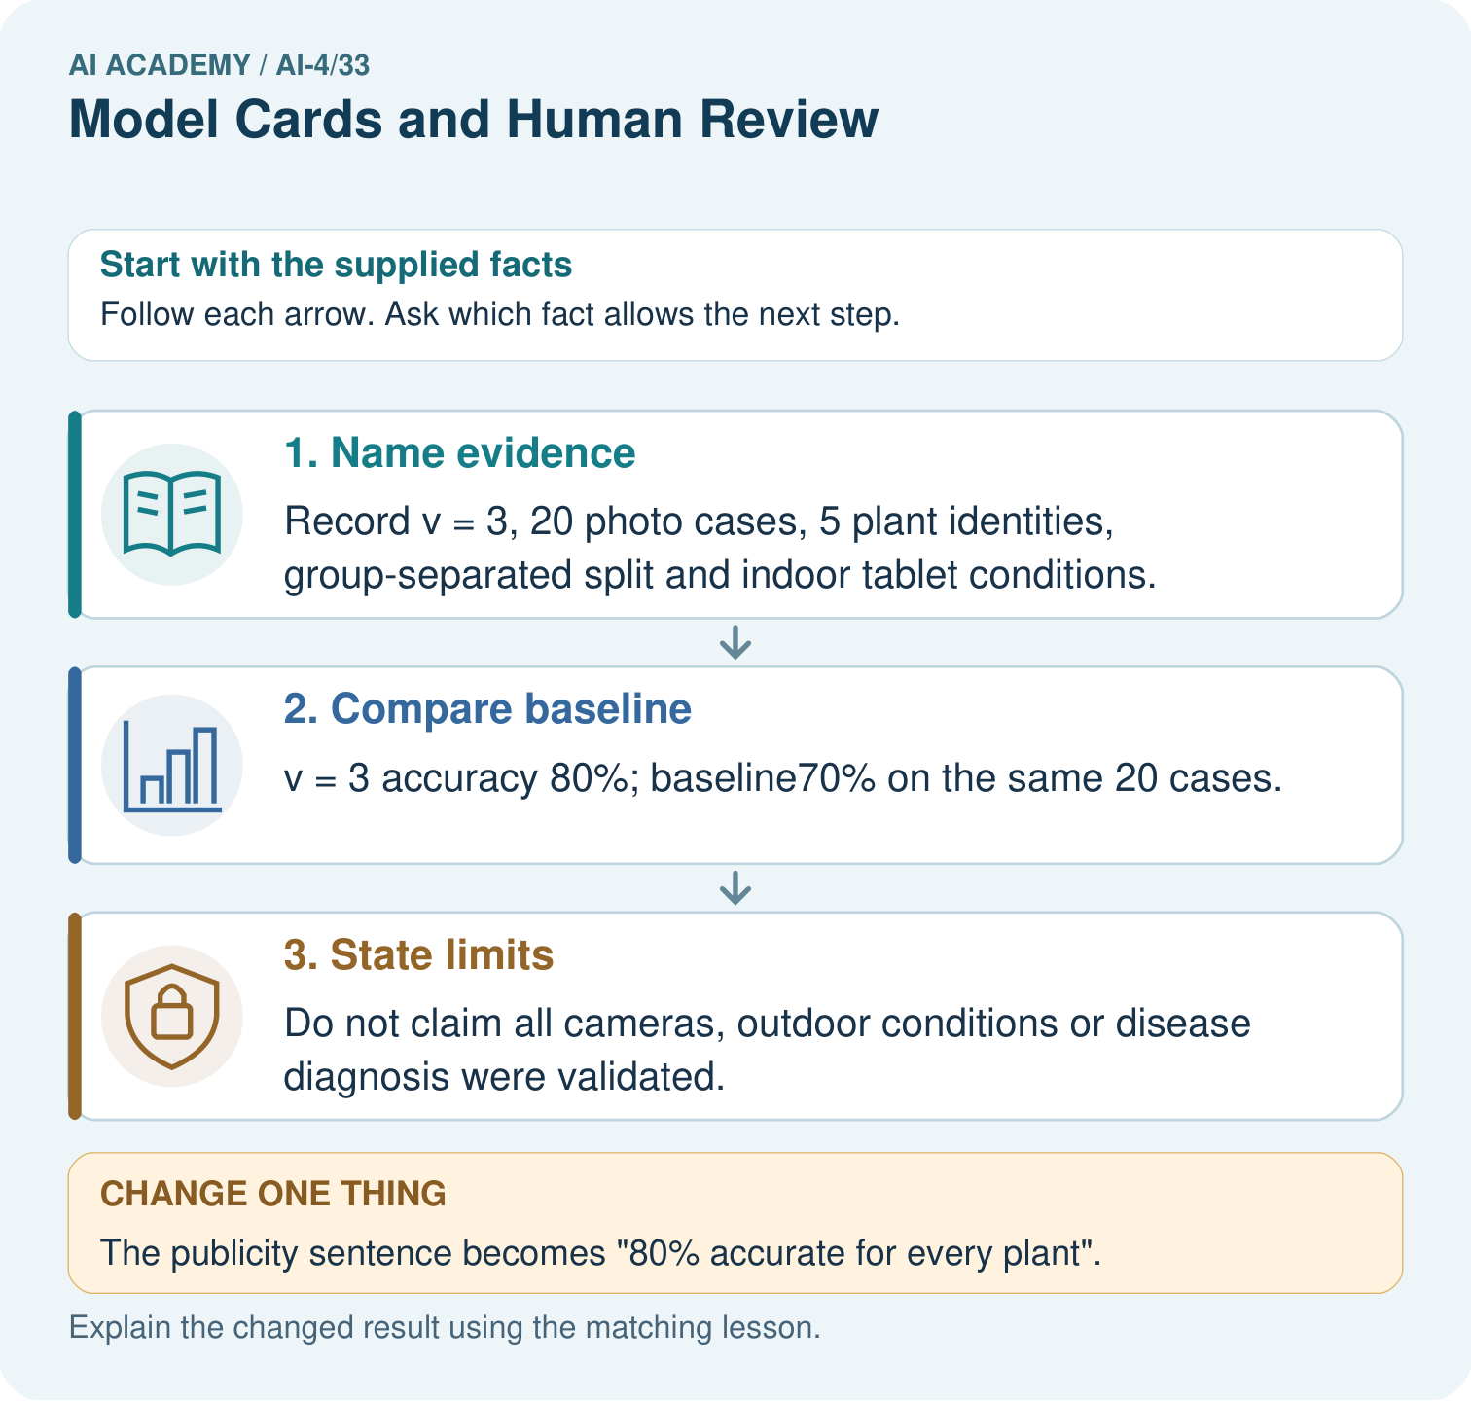

Read the picture one step at a time
Step | What happens and why
1. Name evidence | Record v = 3, 20 photo cases, 5 plant identities, group-separated split and indoor tablet conditions.
2. Compare baseline | v = 3 accuracy 80%; baseline70% on the same 20 cases.
3. State limits | Do not claim all cameras, outdoor conditions or disease diagnosis were validated.
Match each pictured step to the supplied facts. This is a worked teaching case, not an independent assessment.

Why this result follows
Read the picture in order. Do not claim all cameras, outdoor conditions or disease diagnosis were validated. The arrows show which recorded input or intermediate result each decision uses. Explain the deciding step aloud before checking the changed case; pointing to the final answer alone does not show how it follows.

What this example does not establish
A model card communicates evidence; it is not certification of safety, fairness or suitability for consequential plant decisions.
Read the labelled picture: Write a bounded replacement for the publicity sentence. Point to the relevant step in the picture, then write the changed result and the rule or evidence that supports it.
Change one thing: The publicity sentence becomes “80% accurate for every plant”. Predict the result before checking the explanation. What remains the same?

07. Find and repair a mistake
ERROR DETECTIVE

Compare → Diagnose → Repair
Do not patch the answer. Find the earliest unsupported assumption, data problem, or experiment error.
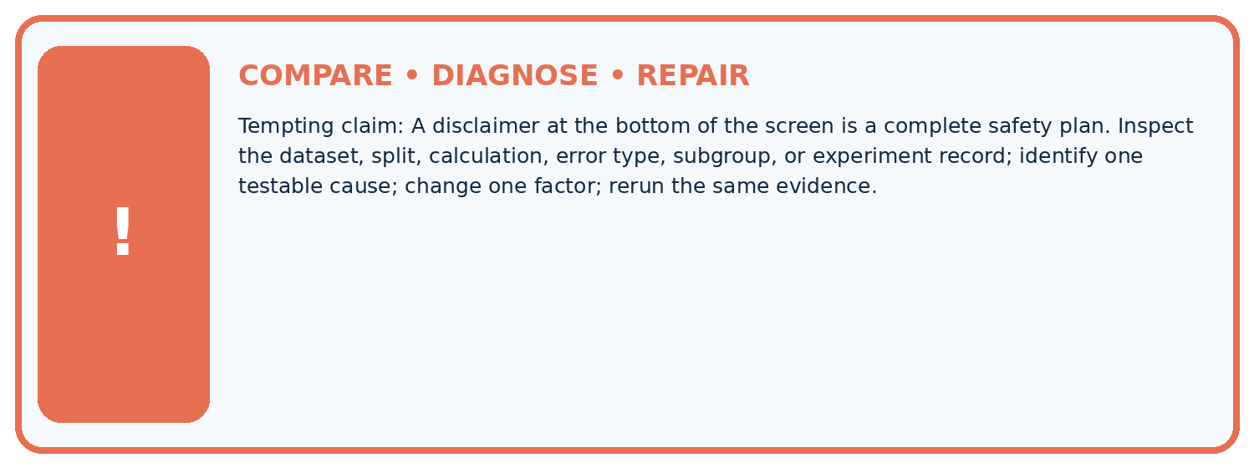
Evidence record | Expected | Actual | Likely cause / next test
normal case | passes
boundary case | defined behavior
missing case | safe fallback
shifted case | measured limit
CLAIM TO CHALLENGE A disclaimer at the bottom of the screen is a complete safety plan.
Diagnose one cause and name the cleanest next experiment:

A closer explanation
Do not claim a synthetic classroom dataset represents every school or age group. Missing calibration, subgroup or shift evidence must remain explicit. A useful card may conclude that the model should stay a classroom demonstration.

What should change in a card after a threshold revision?
________________________________________________________________
________________________________________________________________
________________________________________________________________
________________________________________________________________

08. Practise together
ML STUDIO

Specify Before You Run
A trustworthy result can be reproduced from the recorded data, code, settings, and evaluation rule.


Experiment record
QUESTION + intended use + success threshold
DATA version + grouped split + leakage check
CODE/preprocessing + features + model + settings + seed
METRICS + positive class + units + denominators
PREDICTIONS + errors + subgroup slices + limitations
HUMAN reviewer + release, revise, limit, or stop decision
Write the minimum record needed to reproduce today's result:

A closer explanation
A peer reviewer traces one headline number back to the saved predictions, checks denominators and looks for mismatches between intended use and evidence. Record requested changes and whether each was resolved. A card must be updated when its model, data or intended use changes.

Practise with less help: Check arithmetic
Use workbook W2 for the connected example “Model cards and review”. First fill the input and rule boxes. Try the middle steps before asking for a hint. After a hint, try the next step yourself.
Plan | Do | Check
What is given? Which rule or procedure applies? | Record each intermediate step. | Does the result follow? What remains unknown?
Explain your trace to a partner. Your partner points to one step to check. Swap roles on the next case. Each person writes their own explanation.

Check your reasoning
Use the worked case for Model cards and review. Proposed explanation: “A final answer is enough”. Decide whether this explanation is supported. Point to the step or supplied fact that decides; explain your repair if needed.
Answer on your own before discussion. If you are unsure, say which step you need help with.

Explain the picture
Write a bounded replacement for the publicity sentence. Point to the relevant step in the picture, then write the changed result and the rule or evidence that supports it.

My explanation using a pictured step and the given facts
________________________________________________________________
________________________________________________________________
________________________________________________________________
________________________________________________________________
This is supported practice. Keep the separately named independent case for an attempt before feedback.

09. Run the investigation
EVIDENCE LAB

Predict → Run → Calculate → Interpret
Keep the test conditions fixed, record every result, and change only one planned factor.
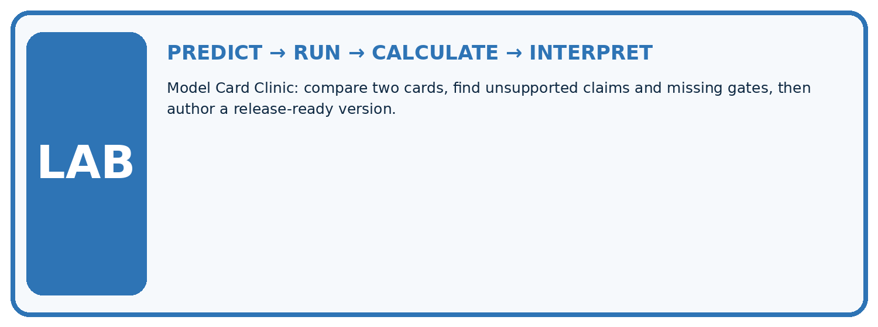
1. Write the hypothesis and expected evidence before running.
2. Model Card Clinic: compare two cards, find unsupported claims and missing gates, then author a release-ready version.
3. Run one normal, one boundary, one missing, and one shifted case.
4. Calculate the metric from raw counts or row-level errors.
5. Interpret what changed, what did not, and what remains unsafe or unknown.
Case | Prediction | Actual | Calculation / evidence | Meaning / next test
Normal
Boundary
Missing
Shifted

Plan → try → check
Before trying: what do I expect, and why? While trying: which step could first go wrong? Afterwards: what did I actually observe, and what should change? Keep “not run” if you only traced the procedure.

10. Build your understanding
MASTERY

From Knowing the Word to Owning the Idea
Move upward only when you can produce evidence without copying the example.

DEFINE Use all four terms precisely: model card, intended use, do-not-use, human review.
CALCULATE Reproduce the worked evidence with units and denominator.
TRACE Explain the data, code or decision path.
DIAGNOSE A disclaimer at the bottom of the screen is a complete safety plan.
TRANSFER Solve a fresh dataset or model case.
IMPROVE Change one cause and rerun fixed evidence.
DEFEND State intended use, metric, limitation, and human responsibility.
MASTERY RULE A coached calculation becomes mastery only after a different case is completed independently.

11. Connect your project
CUMULATIVE PROJECT

Responsible Plant Classifier
Every week adds one reviewable artifact to the same evidence-based capstone.
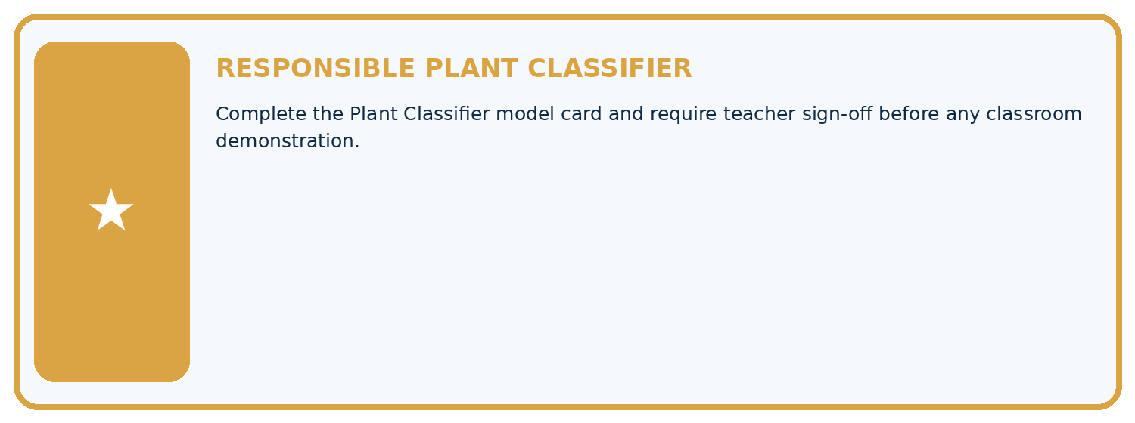
THIS WEEK'S CHECKPOINT Complete the Plant Classifier model card and require teacher sign-off before any classroom demonstration.
Which requirement or risk does this artifact address?
Which dataset, split, code, and metric version does it use?
What normal and shifted cases were tested?
What remains uncertain or weak?
What decision still belongs to a teacher or qualified human?
RESPONSIBLE RELEASE Never use this classroom prototype for medical, pesticide, agricultural, or other consequential decisions.
My evidence-linked project decision:

Evidence for your project
For your Responsible Plant Classifier, save the input, procedure, observed result and limitation of this check. Label this worked example as practice; use a different, previously unreviewed case when checking independent understanding.

12. Show what you know
INDEPENDENT PROOF

Explain • Calculate • Transfer • Defend
Complete this with a fresh case after guided practice and compare it with the mastery criteria.
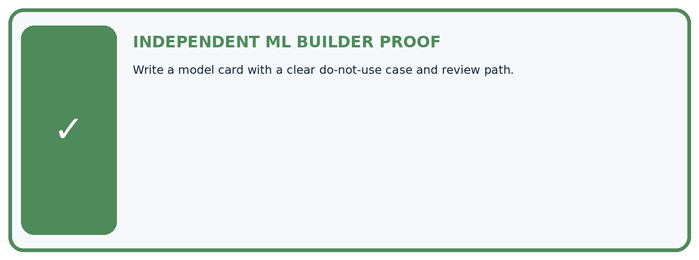
REQUIRED PROOF Write a model card with a clear do-not-use case and review path.
□ Define the task, feature/target roles, and intended-use boundary.
□ Show the calculation, code trace, or experiment record.
□ Test a normal case and one revealing boundary, missing, or shifted case.
□ Diagnose one failure without changing several factors at once.
□ Name a limitation, fairness concern, and the human-review action.
Independent evidence and defense:
My level: □ Not yet □ With one hint □ Independently □ I can teach and defend it
NEXT BRIDGE Carry the experiment evidence into: Capstone Dataset and Baseline.

13. Study a complete case

Week 33 Worked case
Use the supplied details to practise the weekly concept before attempting the independent question. This case extends the illustrated lesson.

The situation
A model card says healthy/spotted,80% accuracy only.

The question
Add responsible-use evidence.

Worked explanation
Intended users/conditions, labels/data, evaluation sets/metrics, class/subgroup results, versions, limitations, excluded uses and human review. Classroom classification is not professional diagnosis.

Explain it in your own words
Which detail supports the answer, and why does it matter?

Write or draw your reasoning and evidence.
________________________________________________________________
________________________________________________________________
________________________________________________________________
________________________________________________________________
________________________________________________________________

Trace the supplied case visually

A model card supports responsible review
Evidence or stage | Value or result
Purpose | Users, conditions and excluded uses
Evidence | Data, labels, metrics and subgroup results
Version | System and evaluation identity
Limits | Failure conditions and human review
A model card says healthy/spotted,80% accuracy only.
Add responsible-use evidence.
Intended users/conditions, labels/data, evaluation sets/metrics, class/subgroup results, versions, limitations, excluded uses and human review. Classroom classification is not professional diagnosis.

14. Try a new case independently

Independent case: Apply independently
Review this card: model v 2, 90 percent accurate, works for every school. No dataset size, split or baseline is given. Write a correction request with a bounded replacement claim.

My independent explanation, trace and limits
________________________________________________________________
________________________________________________________________
________________________________________________________________
________________________________________________________________
________________________________________________________________
________________________________________________________________
________________________________________________________________
Attempt this case before feedback. Record any help. Earlier examples below are further practice; a case already practised with feedback cannot establish fresh transfer.

Week 33 Independent application
Close the worked explanation. Apply the idea to this different question without copying.
A model card says 90% accuracy but gives no intended use, data conditions or human-review rule. What should be added before classroom use?
My answer, with a trace, calculation or supporting evidence

Write or draw your reasoning and evidence.
________________________________________________________________
________________________________________________________________
________________________________________________________________
________________________________________________________________
________________________________________________________________

Create and test
Change one relevant detail. Predict the result before testing. Include a boundary or missing-information case when it helps reveal a limit.
My changed input and expected result

Write or draw your reasoning and evidence.
________________________________________________________________
________________________________________________________________
________________________________________________________________
________________________________________________________________
________________________________________________________________

Connect to your project
Complete the Plant Classifier model card and require teacher sign-off before any classroom demonstration.
The evidence I will keep

Write or draw your reasoning and evidence.
________________________________________________________________
________________________________________________________________
________________________________________________________________
________________________________________________________________
________________________________________________________________
Your teacher has the independent answer and scoring criteria. Complete the matching workbook week to keep your practice evidence together.

Transfer practice from the original programme
Draft five model-card headings for a classroom leaf classifier. Why must the card state that its labels are classroom categories rather than professional plant diagnosis?

Explain the mechanism, evidence and one limit.
________________________________________________________________
________________________________________________________________
________________________________________________________________
________________________________________________________________
________________________________________________________________
________________________________________________________________
________________________________________________________________

Use feedback to improve
Attempt the independent case before hints. Record whether you worked alone, used a hint or followed a model. After feedback, fix the first unsupported step and explain why it changed. A later check uses a changed case, not a copied answer.

15. Your lesson route
Start with this question: Write a model card whose performance statement can be traced to a concrete evaluation.
By the end, I can | How I will show it
Write a model card whose claims match evidence | Explain the deciding step, show a trace or test, and state one limit.
Separate intended use from unsupported use | Explain the deciding step, show a trace or test, and state one limit.
Review a card for missing evaluation details | Explain the deciding step, show a trace or test, and state one limit.
Remember → watch and explain → try with help → investigate → try independently → keep project evidence. Your teacher may spread this lesson across several classes.
Keep your first prediction. Compare it with what the evidence shows and explain any change.

16. Finish and return
Close your notes. Explain this goal in your own words: Write a model card whose claims match evidence

My deciding step, evidence and one remaining question
________________________________________________________________
________________________________________________________________
________________________________________________________________
________________________________________________________________
________________________________________________________________
If you are unsure, return to the worked picture and explain one arrow. If you are ready, change an input or assumption and justify your prediction.
Save your workbook evidence. At the next review, try a different case before opening your old answer.

