AI ACADEMY · STUDENT · ai-4/35

Capstone Train, Analyze, Improve
Project: Responsible Plant Classifier

Before you start
Week 26: a reproducible comparison identifies data, version and settings.

01. Your mission

Your learning target
I can run a frozen final evaluation with complete accounting.
I can separate error analysis from an untouched-test claim.
I can document revisions and their evidence status.

Remember before reading
Close your notes first. A rough first answer helps us choose the right starting point; it is not a score for your ability.
Without opening the old lesson, explain one key idea from Capstone Dataset and Baseline. Give an example and a mistake that the idea helps you avoid.
Without opening the old lesson, explain one key idea from Proxy Features and Fairness. Give an example and a mistake that the idea helps you avoid.
Without opening the old lesson, explain one key idea from Feature Engineering. Give an example and a mistake that the idea helps you avoid.
After trying, check the relevant lesson or ask your teacher. Change the part of your explanation that the evidence shows was wrong.
One evidence-based improvement follows a reproducible training run, metric audit, error clusters, and subgroup analysis.

LEARNING TARGET A new model reduces validation errors from 8 to 5 but the team also removed three hard cases. Can improvement be attributed to the model? Propose a repair to the experiment.
Builder name and experiment date:

Readiness for the connected explanation
What changes after final-test labels inform a revision?

This week’s end goal
By the end, I can explain capstone train, analyze, improve using a traced example and a stated limitation.

02. Notice the evidence
PICTURE ENTRY

Notice → Predict → Explain
Begin with visible evidence; do not explain more than the picture and information support.
MYSTERY The team must use capstone train, analyze, improve to solve a model-building problem. What information do they have? What important evidence is still missing?
Name three visible details without interpreting them.
Predict the data, model, or evaluation decision being made.
Identify one hidden assumption that could change the result.
State what evidence would confirm or reject your prediction.
My prediction and supporting evidence:

A closer explanation
The teacher releases final-test labels only after checking the freeze record. Score baseline and candidate on the same planned rows. Save every prediction, denominator and failure. Do not edit a model while reading labels and then present only the edited version as the original test.
Use fictional classroom data throughout this investigation. Keep the task, units, reference labels and data split visible as you reason. Earlier weeks supplied the model-building process; this week examines capstone evaluation and revision.

03. See how it works
ML MECHANISM

Input → Model → Evidence
Trace the information, fitted behavior, and evaluation proof separately.
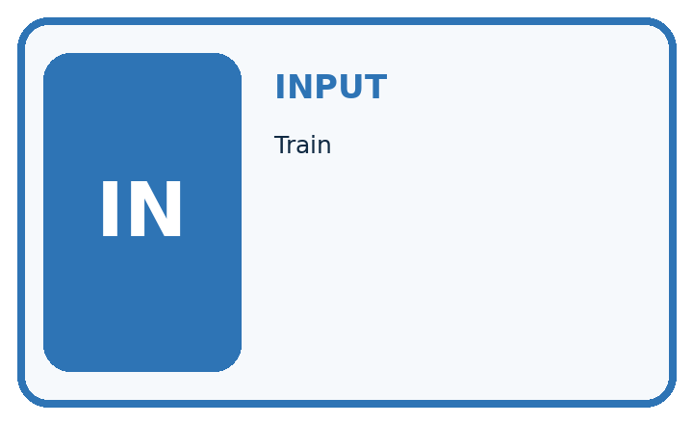
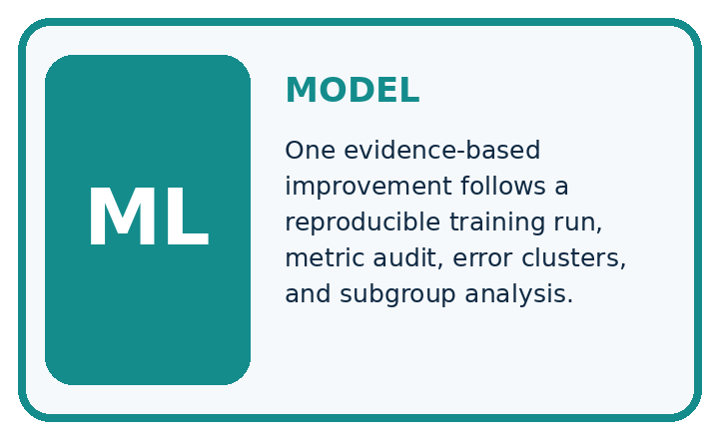
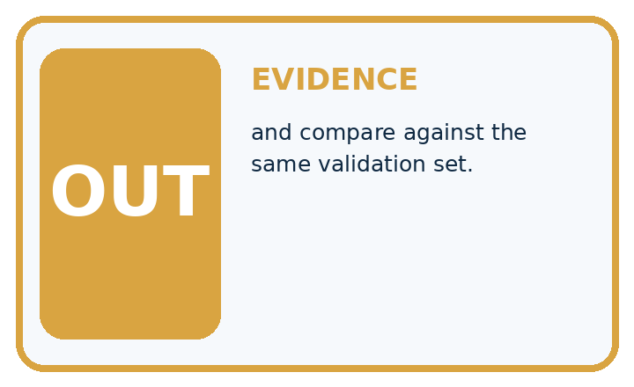
QUESTION Train, audit, change one factor, and compare against the same validation set.
MODEL IDEA One evidence-based improvement follows a reproducible training run, metric audit, error clusters, and subgroup analysis.
PROOF NEEDED Use an unseen case, visible calculation, error analysis, and a stated limitation.
UNDER THE HOOD Model v1 passes 14/20 validation cases; evening accuracy is 40%. The six failed cases are low-light cases. One of those same six also has a disputed reference label; that is an overlapping review flag, not a seventh failed case.
Draw a fresh data → model → prediction → evaluation trace:

A closer explanation
Illustrative frozen test has 12 rows: candidate[[7, 1],[2, 2]], baseline[[8, 0],[4, 0]], blocked positive. Candidate accuracy 9/12=75 percent, precision 2/3 and recall 2/4; baseline accuracy 8/12 about 66.7 percent. The candidate adds one false alarm and misses two rather than four blocked cases.
Before continuing, underline the decision rule and circle the evidence that supports the conclusion. Explain the example to a partner without replacing the counts or conditions with a stronger claim. Keep the distinction between an observed result and a proposed next step.

Connect the picture and the explanation
Point to the input, the deciding step and the result in this week’s visual. Explain the same step in ordinary words. A picture helps when you can say what each part represents.

04. Compare the cases
EVALUATION DESIGN

Four Tests, Four Kinds of Evidence
A system is not understood until it survives more than one comfortable example.




NORMAL Expected data and expected behavior.
BOUNDARY Value close to a threshold, ambiguous label, or uncertain prediction.
MISSING Necessary field, label, source, or measurement is unavailable.
SHIFTED New lighting, species, device, subgroup, or time condition.
RELEASE RULE Passing one case never proves generalization. Predefine expected behavior for all four categories.
Which case most threatens today's claim, and why?

Change one thing in the pictured case
Change: A revision fixes one miss but creates two extra false alarms.
Prediction: TP 5, FN 1, FP 3, TN 7 gives 12/16=75% accuracy and 5/6 recall.
Reason: Recall rises while accuracy falls; the preferred revision depends on declared error consequences.

05. Words that unlock the idea
VOCABULARY

Words You Can Calculate and Defend
A definition matters when it lets you interpret a new dataset, model, or result.
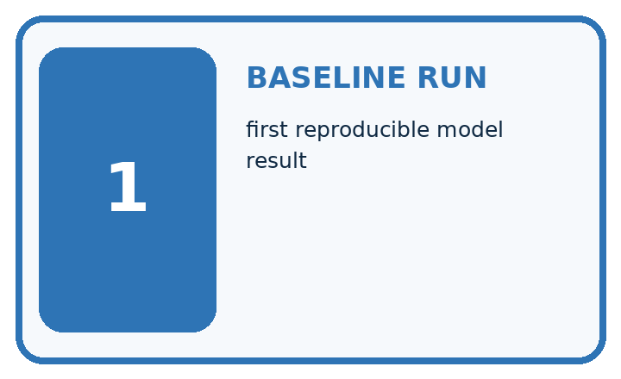
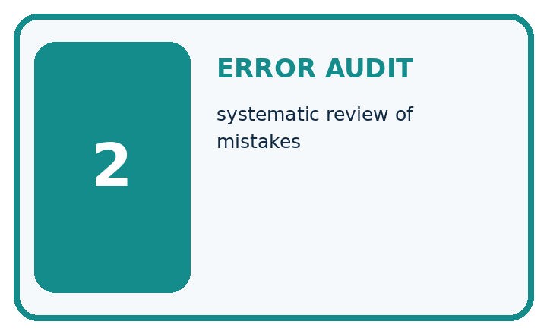
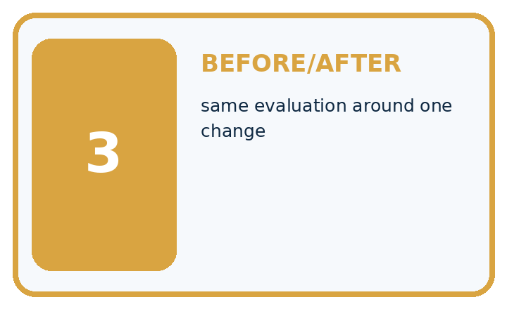
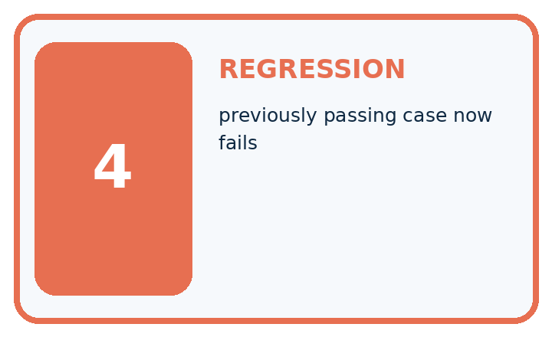
Term | Precise meaning | My ML example
baseline run | first reproducible model result
error audit | systematic review of mistakes
before/after | same evaluation around one change
regression | previously passing case now fails
MISCONCEPTION TO REPAIR A higher overall score proves every important aspect improved.
Repair the claim using a definition, calculation, or test record:

Words used in the closer explanation
Word | Meaning
Final evaluation | Assessment of the frozen procedure on held-out evidence
Error audit | A documented inspection of mistakes and missing predictions
Revision log | A record of changes, reasons and affected evidence
Evidence status | Whether a result is development, untouched test or post-test reuse

06. Follow a worked example
WORKED EVIDENCE

Reason Step by Step
Predict first. Then check each step. A correct answer without visible evidence cannot be audited.

Four-step worked evidence for Week 35: Capstone Train, Analyze, Improve
Step | Evidence and reasoning
1 | Model v1 passes 14/20 validation cases; evening accuracy is 40%.
2 | The six failed cases are low-light cases. One of those same six also has a disputed reference label; that is an overlapping review flag, not a seventh failed case.
3 | Add reviewed low-light training examples while freezing features and model settings.
4 | Model v2 passes 17/20; evening rises to 70%; inspect every old pass and record remaining limits.
Trace these corrected steps. Keep the stated metric, assumptions and interpretation when you change the case.
STEP 1 Model v1 passes 14/20 validation cases; evening accuracy is 40%.
STEP 2 The six failed cases are low-light cases. One of those same six also has a disputed reference label; that is an overlapping review flag, not a seventh failed case.
STEP 3 Add reviewed low-light training examples while freezing features and model settings.
STEP 4 Model v2 passes 17/20; evening rises to 70%; inspect every old pass and record remaining limits.
CHECK Verify the denominator, unit, split, class definition, and data version before interpreting a score.
Recalculate, retrace, or restate the evidence independently:

A closer explanation

Capstone evaluation and revision at a glance
Part | Evidence or action | Interpretation
Frozen version | Saved before labels | Candidate v 1
First test | 9 correct of 12 | Report full error table
Proposed revision | Uses observed errors | Needs fresh evaluation
Compare the result with validation without claiming they should be identical. Check error types and coverage. A one-case accuracy difference on twelve rows supports a cautious classroom comparison, not a general reliability guarantee. Keep the original prediction ledger unchanged.

What does the one-correct-case improvement establish? Explain the steps or evidence behind your response.
________________________________________________________________
________________________________________________________________
________________________________________________________________
________________________________________________________________

Learn from the worked case
Cover the result before checking it. Say what is given, choose the procedure, and follow one step at a time. Then uncover the result and explain your first mismatch. Ask why a step is allowed, not only what number it produces.

A pictorial worked case: Capstone Train, Analyze, Improve
Choose the next capstone revision from explicit false alarms and misses.

The facts we will use
Positive=spotted. CandidateTP4, FN 2, FP 1, TN 9; baselineTP0, FN 6, FP 0, TN 10. Both evaluate the same16 cases.
All inputs and outcomes in this worked example are invented classroom data; no real model run is claimed.
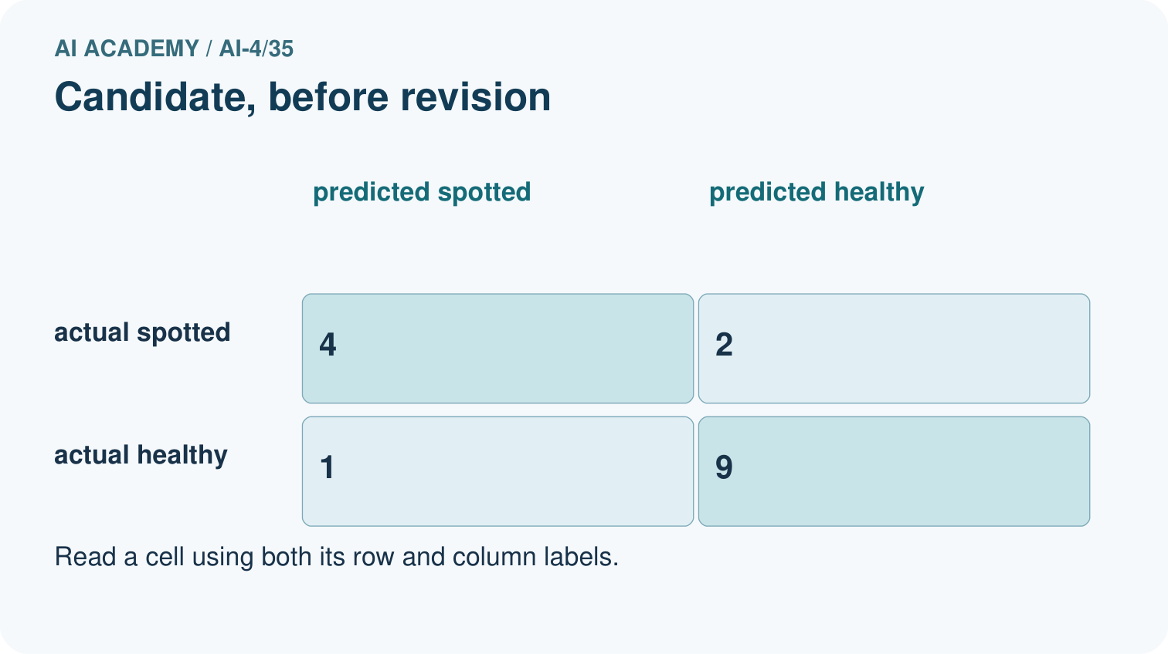
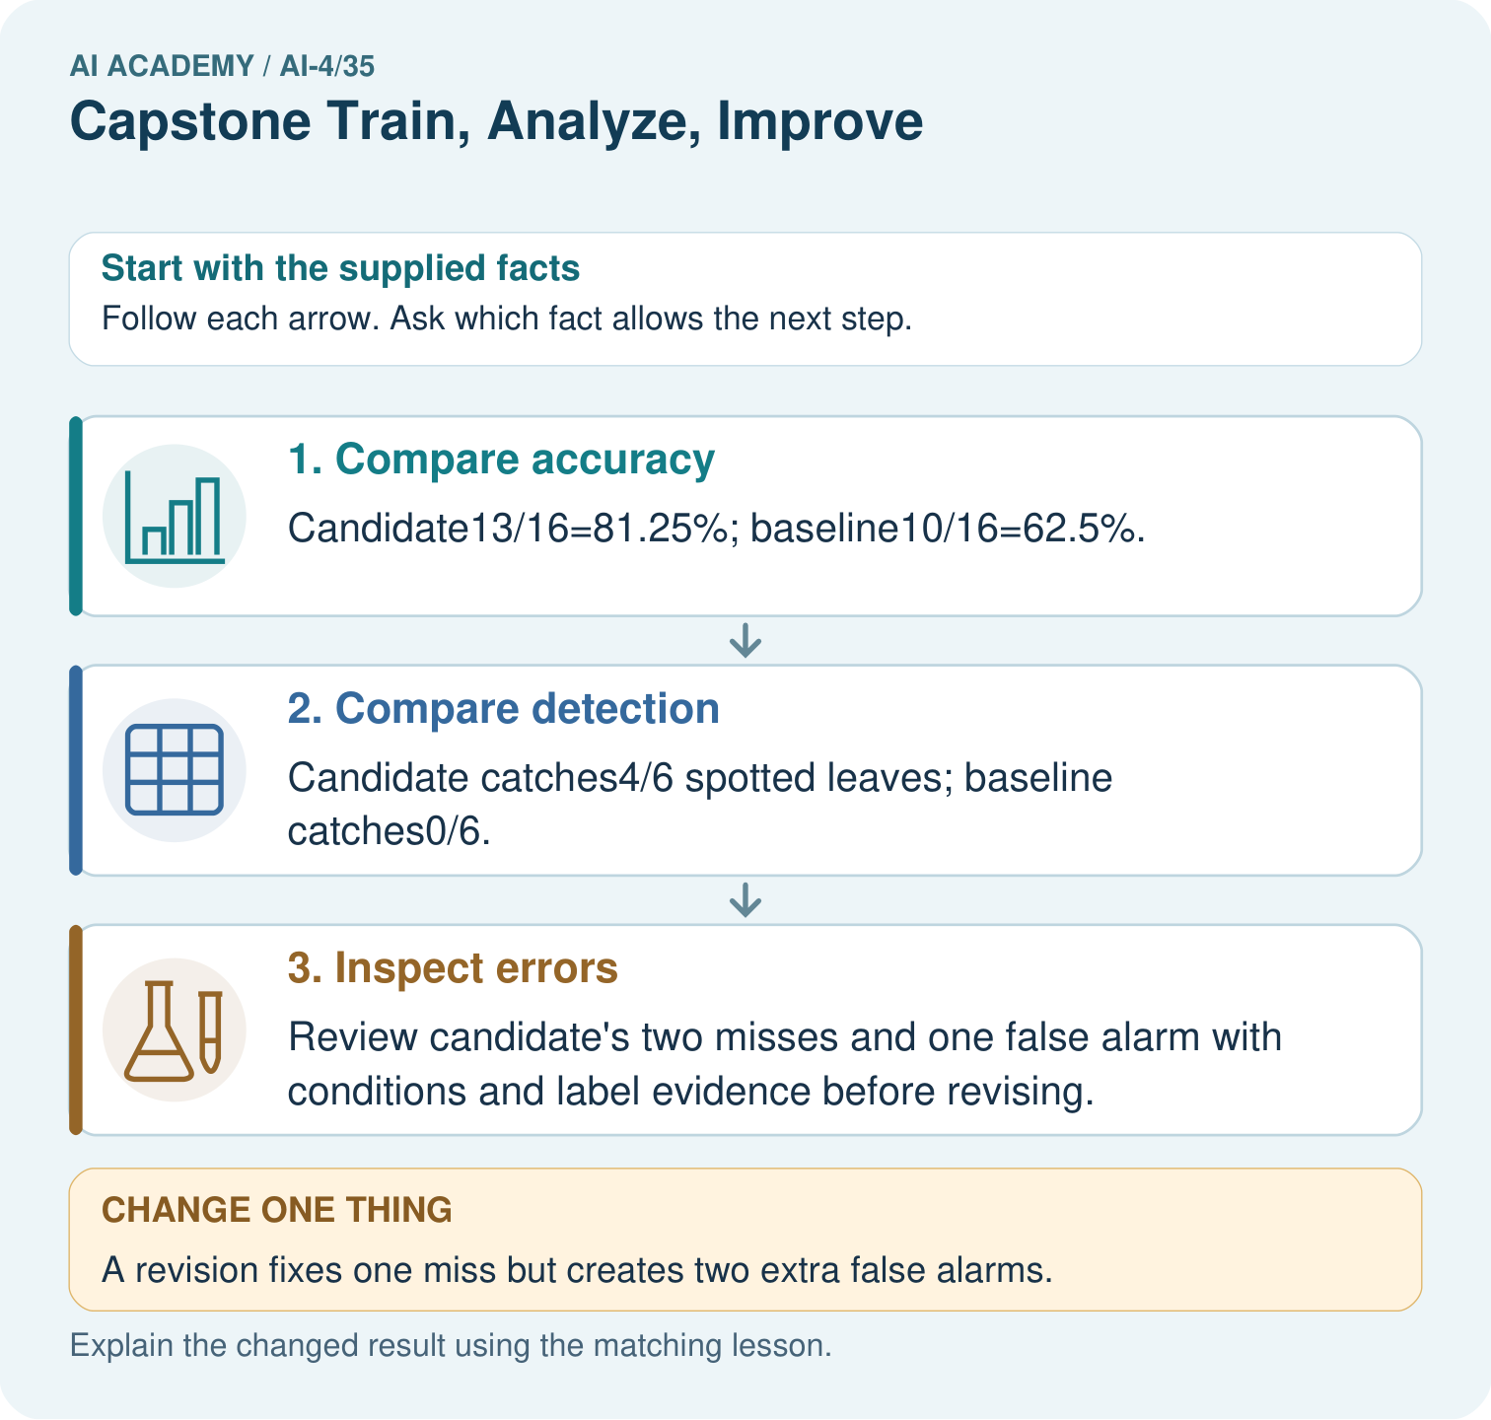

Read the picture one step at a time
Step | What happens and why
1. Compare accuracy | Candidate13/16=81.25%; baseline10/16=62.5%.
2. Compare detection | Candidate catches4/6 spotted leaves; baseline catches0/6.
3. Inspect errors | Review candidate’s two misses and one false alarm with conditions and label evidence before revising.
Match each pictured step to the supplied facts. This is a worked teaching case, not an independent assessment.

Why this result follows
Read the picture in order. Review candidate’s two misses and one false alarm with conditions and label evidence before revising. The arrows show which recorded input or intermediate result each decision uses. Explain the deciding step aloud before checking the changed case; pointing to the final answer alone does not show how it follows.

What this example does not establish
Any case-driven revision makes these records development evidence for that revision; reserve a fresh final set.
Read the labelled picture: Why is “the revision is better” incomplete? Point to the relevant step in the picture, then write the changed result and the rule or evidence that supports it.
Change one thing: A revision fixes one miss but creates two extra false alarms. Predict the result before checking the explanation. What remains the same?

07. Find and repair a mistake
ERROR DETECTIVE

Compare → Diagnose → Repair
Do not patch the answer. Find the earliest unsupported assumption, data problem, or experiment error.
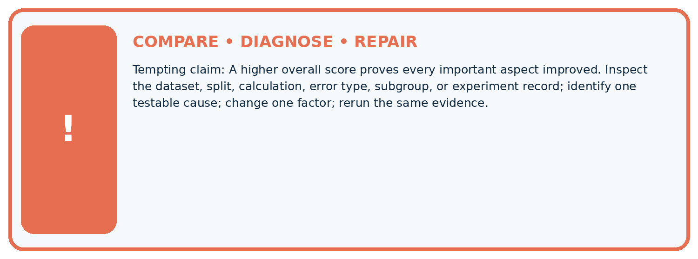
Evidence record | Expected | Actual | Likely cause / next test
normal case | passes
boundary case | defined behavior
missing case | safe fallback
shifted case | measured limit
CLAIM TO CHALLENGE A higher overall score proves every important aspect improved.
Diagnose one cause and name the cleanest next experiment:

A closer explanation
Submit the frozen test report, error audit, revision proposal and updated model card. A revision proposal may conclude that more appropriate data or a simpler baseline is preferable. If no fresh test is available, stop at a transparent proposal instead of claiming the revision has been independently validated.

What must remain visible when version 2 is proposed without a fresh test?
________________________________________________________________
________________________________________________________________
________________________________________________________________
________________________________________________________________

08. Practise together
ML STUDIO

Specify Before You Run
A trustworthy result can be reproduced from the recorded data, code, settings, and evaluation rule.


Experiment record
QUESTION + intended use + success threshold
DATA version + grouped split + leakage check
CODE/preprocessing + features + model + settings + seed
METRICS + positive class + units + denominators
PREDICTIONS + errors + subgroup slices + limitations
HUMAN reviewer + release, revise, limit, or stop decision
Write the minimum record needed to reproduce today's result:

A closer explanation
If dim examples account for both misses, record that observation and inspect collection conditions. It is a hypothesis for investigation, not proof that lighting caused the failures. A proposed feature or model change creates version 2. Scores on the same inspected test must be labelled post-test development.

Practise with less help: Audit a difference
Use workbook W2 for the connected example “Capstone evaluation and revision”. First fill the input and rule boxes. Try the middle steps before asking for a hint. After a hint, try the next step yourself.
Plan | Do | Check
What is given? Which rule or procedure applies? | Record each intermediate step. | Does the result follow? What remains unknown?
Explain your trace to a partner. Your partner points to one step to check. Swap roles on the next case. Each person writes their own explanation.

Check your reasoning
Use the worked case for Capstone evaluation and revision. Proposed explanation: “A final answer is enough”. Decide whether this explanation is supported. Point to the step or supplied fact that decides; explain your repair if needed.
Answer on your own before discussion. If you are unsure, say which step you need help with.

Explain the picture
Why is “the revision is better” incomplete? Point to the relevant step in the picture, then write the changed result and the rule or evidence that supports it.

My explanation using a pictured step and the given facts
________________________________________________________________
________________________________________________________________
________________________________________________________________
________________________________________________________________
This is supported practice. Keep the separately named independent case for an attempt before feedback.

09. Run the investigation
EVIDENCE LAB

Predict → Run → Calculate → Interpret
Keep the test conditions fixed, record every result, and change only one planned factor.
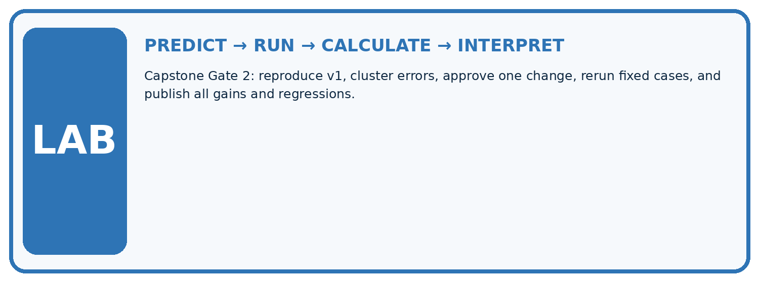
1. Write the hypothesis and expected evidence before running.
2. Capstone Gate 2: reproduce v1, cluster errors, approve one change, rerun fixed cases, and publish all gains and regressions.
3. Run one normal, one boundary, one missing, and one shifted case.
4. Calculate the metric from raw counts or row-level errors.
5. Interpret what changed, what did not, and what remains unsafe or unknown.
Case | Prediction | Actual | Calculation / evidence | Meaning / next test
Normal
Boundary
Missing
Shifted

Plan → try → check
Before trying: what do I expect, and why? While trying: which step could first go wrong? Afterwards: what did I actually observe, and what should change? Keep “not run” if you only traced the procedure.

10. Build your understanding
MASTERY

From Knowing the Word to Owning the Idea
Move upward only when you can produce evidence without copying the example.

DEFINE Use all four terms precisely: baseline run, error audit, before/after, regression.
CALCULATE Reproduce the worked evidence with units and denominator.
TRACE Explain the data, code or decision path.
DIAGNOSE A higher overall score proves every important aspect improved.
TRANSFER Solve a fresh dataset or model case.
IMPROVE Change one cause and rerun fixed evidence.
DEFEND State intended use, metric, limitation, and human responsibility.
MASTERY RULE A coached calculation becomes mastery only after a different case is completed independently.

11. Connect your project
CUMULATIVE PROJECT

Responsible Plant Classifier
Every week adds one reviewable artifact to the same evidence-based capstone.
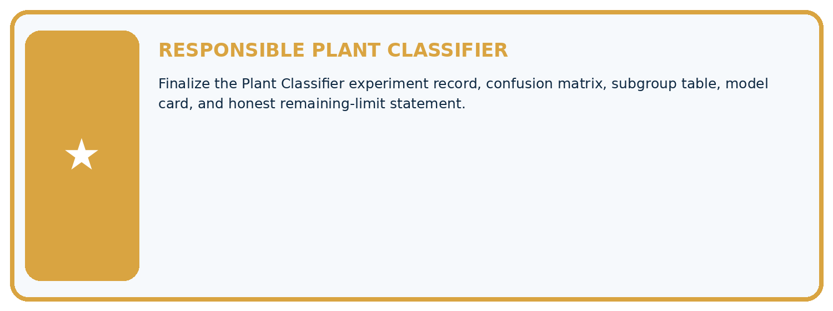
THIS WEEK'S CHECKPOINT Finalize the Plant Classifier experiment record, confusion matrix, subgroup table, model card, and honest remaining-limit statement.
Which requirement or risk does this artifact address?
Which dataset, split, code, and metric version does it use?
What normal and shifted cases were tested?
What remains uncertain or weak?
What decision still belongs to a teacher or qualified human?
RESPONSIBLE RELEASE Never use this classroom prototype for medical, pesticide, agricultural, or other consequential decisions.
My evidence-linked project decision:

Evidence for your project
For your Responsible Plant Classifier, save the input, procedure, observed result and limitation of this check. Label this worked example as practice; use a different, previously unreviewed case when checking independent understanding.

12. Show what you know
INDEPENDENT PROOF

Explain • Calculate • Transfer • Defend
Complete this with a fresh case after guided practice and compare it with the mastery criteria.
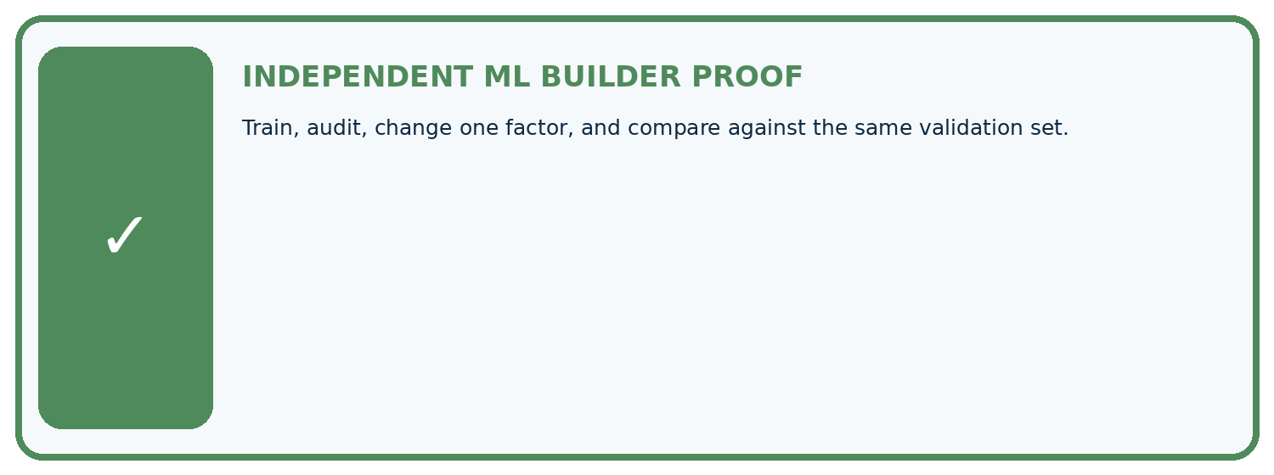
REQUIRED PROOF Train, audit, change one factor, and compare against the same validation set.
□ Define the task, feature/target roles, and intended-use boundary.
□ Show the calculation, code trace, or experiment record.
□ Test a normal case and one revealing boundary, missing, or shifted case.
□ Diagnose one failure without changing several factors at once.
□ Name a limitation, fairness concern, and the human-review action.
Independent evidence and defense:
My level: □ Not yet □ With one hint □ Independently □ I can teach and defend it
NEXT BRIDGE Carry the experiment evidence into: ML Builder Expo.

13. Study a complete case

Week 35 Worked case
Use the supplied details to practise the weekly concept before attempting the independent question. This case extends the illustrated lesson.

The situation
Baseline validation accuracy70%; model80%; most remaining errors are dim images.

The question
Plan improvement evidence.

Worked explanation
Keep partitions fixed, inspect dim-image errors, change one factor and compare the same validation criteria/slices. Reserve final test.

Explain it in your own words
Which detail supports the answer, and why does it matter?

Write or draw your reasoning and evidence.
________________________________________________________________
________________________________________________________________
________________________________________________________________
________________________________________________________________
________________________________________________________________

Trace the supplied case visually

Keep improvement evidence comparable
Evidence or stage | Value or result
Baseline | Seventy percent validation accuracy
Model | Eighty percent on the same set
Error slice | Many failures in dim images
Next revision | Change one factor and retain final test
Baseline validation accuracy70%; model80%; most remaining errors are dim images.
Plan improvement evidence.
Keep partitions fixed, inspect dim-image errors, change one factor and compare the same validation criteria/slices. Reserve final test.

14. Try a new case independently

Independent case: Apply independently
Frozen candidate[[6, 2],[1, 3]] and baseline[[8, 0],[4, 0]] on 12 cases. Compute candidate metrics and compare error types.

My independent explanation, trace and limits
________________________________________________________________
________________________________________________________________
________________________________________________________________
________________________________________________________________
________________________________________________________________
________________________________________________________________
________________________________________________________________
Attempt this case before feedback. Record any help. Earlier examples below are further practice; a case already practised with feedback cannot establish fresh transfer.

Week 35 Independent application
Close the worked explanation. Apply the idea to this different question without copying.
A revision raises overall validation accuracy from 80% to 84% but lowers dim-light accuracy from 60% to 40%. How should the improvement claim change?
My answer, with a trace, calculation or supporting evidence

Write or draw your reasoning and evidence.
________________________________________________________________
________________________________________________________________
________________________________________________________________
________________________________________________________________
________________________________________________________________

Create and test
Change one relevant detail. Predict the result before testing. Include a boundary or missing-information case when it helps reveal a limit.
My changed input and expected result

Write or draw your reasoning and evidence.
________________________________________________________________
________________________________________________________________
________________________________________________________________
________________________________________________________________
________________________________________________________________

Connect to your project
Finalize the Plant Classifier experiment record, confusion matrix, subgroup table, model card, and honest remaining-limit statement.
The evidence I will keep

Write or draw your reasoning and evidence.
________________________________________________________________
________________________________________________________________
________________________________________________________________
________________________________________________________________
________________________________________________________________
Your teacher has the independent answer and scoring criteria. Complete the matching workbook week to keep your practice evidence together.

Transfer practice from the original programme
A new model reduces validation errors from 8 to 5 but the team also removed three hard cases. Can improvement be attributed to the model? Propose a repair to the experiment.

Explain the mechanism, evidence and one limit.
________________________________________________________________
________________________________________________________________
________________________________________________________________
________________________________________________________________
________________________________________________________________
________________________________________________________________
________________________________________________________________

Use feedback to improve
Attempt the independent case before hints. Record whether you worked alone, used a hint or followed a model. After feedback, fix the first unsupported step and explain why it changed. A later check uses a changed case, not a copied answer.

15. Your lesson route
Start with this question: Choose the next capstone revision from explicit false alarms and misses.
By the end, I can | How I will show it
Run a frozen final evaluation with complete accounting | Explain the deciding step, show a trace or test, and state one limit.
Separate error analysis from an untouched-test claim | Explain the deciding step, show a trace or test, and state one limit.
Document revisions and their evidence status | Explain the deciding step, show a trace or test, and state one limit.
Remember → watch and explain → try with help → investigate → try independently → keep project evidence. Your teacher may spread this lesson across several classes.
Keep your first prediction. Compare it with what the evidence shows and explain any change.

16. Finish and return
Close your notes. Explain this goal in your own words: Run a frozen final evaluation with complete accounting

My deciding step, evidence and one remaining question
________________________________________________________________
________________________________________________________________
________________________________________________________________
________________________________________________________________
________________________________________________________________
If you are unsure, return to the worked picture and explain one arrow. If you are ready, change an input or assumption and justify your prediction.
Save your workbook evidence. At the next review, try a different case before opening your old answer.

