AI ACADEMY · STUDENT · ai-5/3

Bias terms and decision boundaries
Project: Image-pattern Network Investigation

Before you start
For w = [2, -1] and x = [3, 5], what are the contributions and dot product?

01. Your mission

Your learning target
I can calculate a weighted score with a bias term.
I can locate and test a two-feature decision boundary.
I can explain how changing the bias shifts a boundary without training.

Remember before reading
Close your notes first. A rough first answer helps us choose the right starting point; it is not a score for your ability.
Without opening the old lesson, explain one key idea from Dot products and weighted sums. Give an example and a mistake that the idea helps you avoid.
After trying, check the relevant lesson or ask your teacher. Change the part of your explanation that the evidence shows was wrong.
This week you will practise:
Calculate a weighted score with a bias term
Locate and test a two-feature decision boundary
Explain how changing the bias shifts a boundary without training

Retrieve what you already know
For w = [2, -1] and x = [3, 5], what are the contributions and dot product?

My starting explanation
________________________________________________________________
________________________________________________________________
________________________________________________________________

This week’s end goal
By the end, I can explain bias terms and decision boundaries using a traced example and a stated limitation.

02. Notice the evidence
Use the fictional parcel schema [width in cm, height in cm]. Our model computes z = 2 times width - height - 3. The weights are [2, -1]; the bias b is -3. Compute the weighted sum first, then add the bias once. The result is an affine score: a weighted sum plus a constant offset.
Now declare a classification rule: predict class 1 when z is at least 0, and class 0 when z is below 0. Equality belongs to class 1. These are invented categories for arithmetic practice, not a real parcel decision. The weights and bias are supplied, so this is a forward calculation, not training.
Input [width, height] | Score z | Prediction
[4, 2] | 8 - 2 - 3 = 3 | 1
[2, 4] | 4 - 4 - 3 = -3 | 0
[3, 3] | 6 - 3 - 3 = 0 | 1 at equality
A bias is a mathematical parameter. It is not the same use of the word as unfair treatment; numerical offset alone does not establish whether a system is fair.

List the given facts and one fact that is not supplied.
________________________________________________________________
________________________________________________________________
________________________________________________________________

03. See how it works
Set z to zero to locate the boundary: 2 times width - height - 3 = 0, so height = 2 times width - 3. Plot width on the horizontal axis and height on the vertical axis. Boundary points include (2, 1), (3, 3) and (4, 5). Join them with a straight line and label the axes in cm.
At width 3, height 2 gives score 1 and class 1; height 3 gives score 0 and class 1; height 4 gives score -1 and class 0. Under this axis convention class 1 lies on or below the boundary. One point on each side checks that orientation.
def classify(width, height, bias=-3):
score = 2 * width - height + bias
return score, int(score >= 0)
for height in [2, 3, 4]:
print(classify(3, height))
# (1, 1), (0, 1), (-1, 0)
The code assumes valid numerical measurements in the agreed units. Changing >= to > changes the equality case, even though the drawn line remains in the same place.

Connect the picture and the explanation
Point to the input, the deciding step and the result in this week’s visual. Explain the same step in ordinary words. A picture helps when you can say what each part represents.

04. Compare the cases

Compare a familiar case with a changed case
For the worked model, find boundary points at width 2 and width 4. Test [4, 4] and [4, 6] to identify the class on each side.

Keep the procedure fixed. Explain what changed in the inputs and result.
________________________________________________________________
________________________________________________________________
________________________________________________________________
________________________________________________________________
________________________________________________________________

Change one thing in the pictured case
Change: Change bias from-3 to-1.
Prediction: A score becomes2 and B score 0; both predict class 1.
Reason: Increasing bias by2 adds2 to every score without changing the weights.

05. Words that unlock the idea
Word | Meaning
Bias term | An additive parameter applied after a weighted sum
Decision boundary | Input locations where the declared classification rule changes class
Affine function | A weighted sum plus a constant offset
Threshold rule | A stated comparison that converts a score into a class

Use two terms to explain a step in this week’s example.
________________________________________________________________
________________________________________________________________
________________________________________________________________

06. Follow a worked example

Hold the weights fixed while shifting the boundary
Bias | Score at [3, 3] | Boundary equation
b is -3 | 6 - 3 - 3 gives 0 | height = 2 width - 3
b is -1 | 6 - 3 - 1 gives 2 | height = 2 width - 1
Increase b by 2 | Every score rises by 2 | Slope remains 2
The boundary moves parallel to itself because the weights stay fixed. An increased score does not always change a class: only inputs crossing the declared threshold change.

For [3, 4], compare z and prediction with bias -3 and bias -1. Explain which parameter changed.
________________________________________________________________
________________________________________________________________
________________________________________________________________
________________________________________________________________

Learn from the worked case
Cover the result before checking it. Say what is given, choose the procedure, and follow one step at a time. Then uncover the result and explain your first mismatch. Ask why a step is allowed, not only what number it produces.

A pictorial worked case: Bias terms and decision boundaries
Move a toy boundary with a bias while keeping its input weights fixed.

The facts we will use
Score z=2u-v-3; predict class 1 when z>=0. InputsA=[2, 1], B=[1, 1].
All inputs and outcomes in this worked example are invented classroom data; no real model run is claimed.
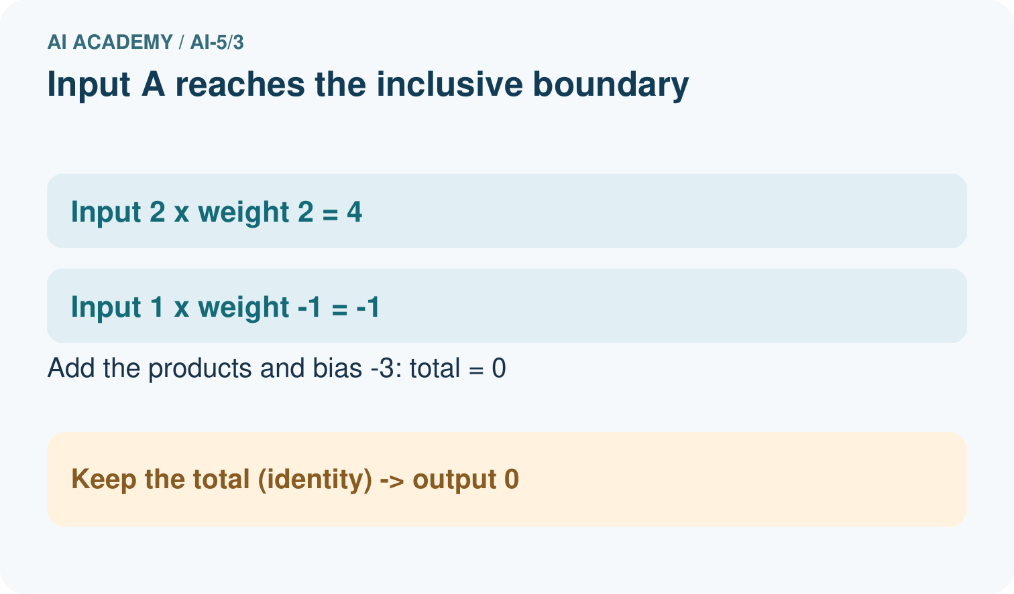
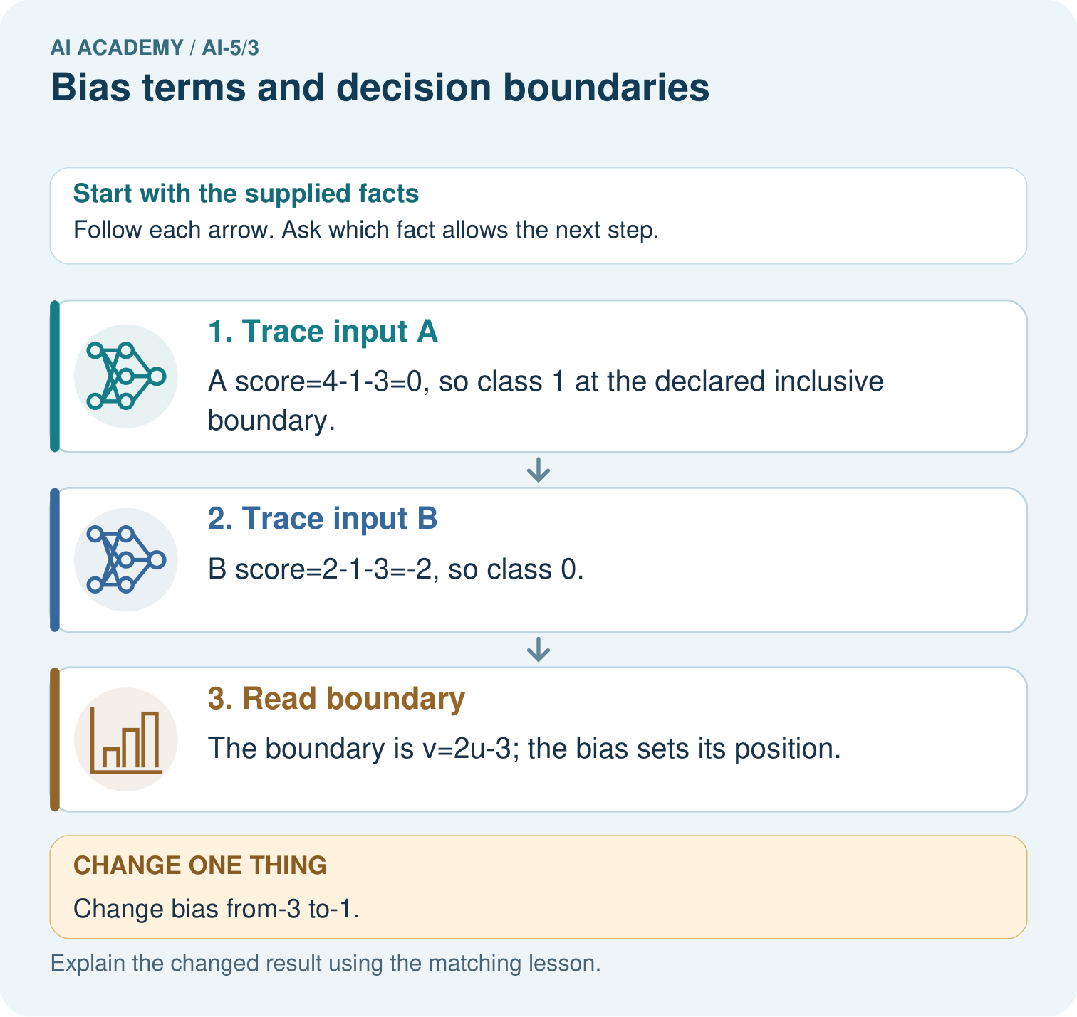

Read the picture one step at a time
Step | What happens and why
1. Trace input A | A score=4-1-3=0, so class 1 at the declared inclusive boundary.
2. Trace input B | B score=2-1-3=-2, so class 0.
3. Read boundary | The boundary is v=2u-3; the bias sets its position.
Match each pictured step to the supplied facts. This is a worked teaching case, not an independent assessment.

Why this result follows
The bias adds the same offset after the input contributions. It moves the dividing line without changing the weights that set the line’s orientation. Class 1 includes score zero under our stated rule. That is why B changes class when the bias rises by two: its score moves from minus two onto the included boundary.

What this example does not establish
A linear boundary is a toy classifier rule. Raw score size does not automatically describe confidence or probability.
Read the labelled picture: Is B positive under the original or changed model? Point to the relevant step in the picture, then write the changed result and the rule or evidence that supports it.
Change one thing: Change bias from-3 to-1. Predict the result before checking the explanation. What remains the same?

07. Find and repair a mistake
Without a bias, this score would be z = 2 times width - height and its zero line would pass through (0, 0). The offset lets the boundary move away from the origin. In this parcel schema zero dimensions are invalid measurements; the origin is still useful as a point on the extended mathematical graph.
Changing bias from -3 to -1 increases every score by 2, but does not rotate the line. Changing a weight can rotate or otherwise change the boundary. Neither change is automatically an improvement. To compare models, retain labels, a declared metric, the same evaluation records and the separate training, validation and test roles.

Locate the earliest unsupported step
At [3, 3], compare prediction under z >= 0 with prediction under z > 0. Does changing this comparison move the zero line?

State one repair and the checks you would rerun.
________________________________________________________________
________________________________________________________________
________________________________________________________________
________________________________________________________________
________________________________________________________________
________________________________________________________________

08. Practise together
Use z = 2 times width - height - 3 at [5, 4]. Give the weighted sum, bias, final score and prediction under z >= 0.

For [3, 4], compare z and prediction with bias -3 and bias -1. Explain which parameter changed.
________________________________________________________________
________________________________________________________________
________________________________________________________________
________________________________________________________________

Explain your prediction to a partner before comparing results.
________________________________________________________________
________________________________________________________________
________________________________________________________________
________________________________________________________________

Practise with less help: Plot and label the boundary
Use workbook W2 for the connected example “Bias terms and decision boundaries”. First fill the input and rule boxes. Try the middle steps before asking for a hint. After a hint, try the next step yourself.
Plan | Do | Check
What is given? Which rule or procedure applies? | Record each intermediate step. | Does the result follow? What remains unknown?
Explain your trace to a partner. Your partner points to one step to check. Swap roles on the next case. Each person writes their own explanation.

Check your reasoning
Use the worked case for Bias terms and decision boundaries. Proposed explanation: “Add bias to each contribution”. Decide whether this explanation is supported. Point to the step or supplied fact that decides; explain your repair if needed.
Answer on your own before discussion. If you are unsure, say which step you need help with.

Explain the picture
Is B positive under the original or changed model? Point to the relevant step in the picture, then write the changed result and the rule or evidence that supports it.

My explanation using a pictured step and the given facts
________________________________________________________________
________________________________________________________________
________________________________________________________________
________________________________________________________________
This is supported practice. Keep the separately named independent case for an attempt before feedback.

09. Run the investigation

Predict, investigate and preserve the evidence
For the worked model, find boundary points at width 2 and width 4. Test [4, 4] and [4, 6] to identify the class on each side.
def classify(width, height, bias=-3):
score = 2 * width - height + bias
return score, int(score >= 0)
for height in [2, 3, 4]:
print(classify(3, height))
# (1, 1), (0, 1), (-1, 0)
Record | Your evidence
Given input and fixed rule
Prediction before checking
Actual result, or “not run”
First mismatch and one explanation
Boundary or missing input and expected response
On paper, trace the supplied procedure. If code is provided, predict before running it in a local practice file. Never write an expected answer as though it were an observed run.

Plan → try → check
Before trying: what do I expect, and why? While trying: which step could first go wrong? Afterwards: what did I actually observe, and what should change? Keep “not run” if you only traced the procedure.

10. Build your understanding

Explain → apply → challenge
Use z = 2 times width - height - 3 at [5, 4]. Give the weighted sum, bias, final score and prediction under z >= 0.
At [3, 3], compare prediction under z >= 0 with prediction under z > 0. Does changing this comparison move the zero line?
A teammate says that raising b must improve the model because all scores rise. What information is needed before accepting an improvement claim?

Explain which evidence supports your conclusion and which claim remains unproved.
________________________________________________________________
________________________________________________________________
________________________________________________________________
________________________________________________________________
________________________________________________________________

11. Connect your project
Add a labelled bias terms and decision boundaries evidence sheet to Image-pattern Network Investigation. Show how you can calculate a weighted score with a bias term. Use the supplied fictional case and keep its inputs, intermediate steps, calculation or prediction, and limitation. Connect this record to last week’s record; a matching answer without a trace is insufficient.
Project evidence | Record
Component and version
Inputs permitted at prediction time
Trace and comparison with earlier work
Failure, limit and human review

Evidence for your project
For your Image-pattern Network Investigation, save the input, procedure, observed result and limitation of this check. Label this worked example as practice; use a different, previously unreviewed case when checking independent understanding.

12. Show what you know
The boundary states what this particular formula predicts. It does not establish the true classes of all possible inputs. A point very far from the line need not have a reliable prediction when the model, features or data are inappropriate. The raw score is not calibrated confidence or a physical distance from the line.

A team changes b after seeing final-test mistakes and reports the same cases as an untouched test of the new model. Explain the error and the next step.
________________________________________________________________
________________________________________________________________
________________________________________________________________
________________________________________________________________
Next week, we transform scores with activation functions before discussing layers.
A teammate says that raising b must improve the model because all scores rise. What information is needed before accepting an improvement claim?

My limited claim and a useful next check
________________________________________________________________
________________________________________________________________
________________________________________________________________
________________________________________________________________

13. Study a complete case

Complete evidence record

Hold the weights fixed while shifting the boundary
Bias | Score at [3, 3] | Boundary equation
b is -3 | 6 - 3 - 3 gives 0 | height = 2 width - 3
b is -1 | 6 - 3 - 1 gives 2 | height = 2 width - 1
Increase b by 2 | Every score rises by 2 | Slope remains 2
The boundary moves parallel to itself because the weights stay fixed. An increased score does not always change a class: only inputs crossing the declared threshold change.
Follow the input through the stated procedure to its result. Cover the result first, predict it, then explain every intermediate step. The text/table accompanies the figure so the example can be read without colour.

My complete trace of the worked case
________________________________________________________________
________________________________________________________________
________________________________________________________________
________________________________________________________________
________________________________________________________________
________________________________________________________________

14. Try a new case independently

Independent case: Analyse a new model independently
A new model has w = [-1, 2], b = -2, inputs [u, v] and class 1 when z >= 0. Calculate scores and classes for [2, 1], [2, 2], [2, 3]. Write the boundary as v in terms of u. Then change only b to 0 and recompute [2, 1].

My independent explanation, trace and limits
________________________________________________________________
________________________________________________________________
________________________________________________________________
________________________________________________________________
________________________________________________________________
________________________________________________________________
________________________________________________________________
Attempt this case before feedback. Record any help. Earlier examples below are further practice; a case already practised with feedback cannot establish fresh transfer.

Attempt this without hints
A new model has w = [-1, 2], b = -2, inputs [u, v] and class 1 when z >= 0. Calculate scores and classes for [2, 1], [2, 2], [2, 3]. Write the boundary as v in terms of u. Then change only b to 0 and recompute [2, 1].

My independent procedure, result and limitation
________________________________________________________________
________________________________________________________________
________________________________________________________________
________________________________________________________________
________________________________________________________________
________________________________________________________________
________________________________________________________________
________________________________________________________________
Record support used: none, hint or teacher explanation. After feedback, a different case is needed to demonstrate independence.

Use feedback to improve
Attempt the independent case before hints. Record whether you worked alone, used a hint or followed a model. After feedback, fix the first unsupported step and explain why it changed. A later check uses a changed case, not a copied answer.

15. Your lesson route
Start with this question: Move a toy boundary with a bias while keeping its input weights fixed.
By the end, I can | How I will show it
Calculate a weighted score with a bias term | Explain the deciding step, show a trace or test, and state one limit.
Locate and test a two-feature decision boundary | Explain the deciding step, show a trace or test, and state one limit.
Explain how changing the bias shifts a boundary without training | Explain the deciding step, show a trace or test, and state one limit.
Remember → watch and explain → try with help → investigate → try independently → keep project evidence. Your teacher may spread this lesson across several classes.
Keep your first prediction. Compare it with what the evidence shows and explain any change.

16. Finish and return
Close your notes. Explain this goal in your own words: Calculate a weighted score with a bias term

My deciding step, evidence and one remaining question
________________________________________________________________
________________________________________________________________
________________________________________________________________
________________________________________________________________
________________________________________________________________
If you are unsure, return to the worked picture and explain one arrow. If you are ready, change an input or assumption and justify your prediction.
Save your workbook evidence. At the next review, try a different case before opening your old answer.

