AI ACADEMY · STUDENT · ai-5/5

Composing layers
Project: Image-pattern Network Investigation

Before you start
For z = -2 and z = 3, what does ReLU return? Does this operation itself assign a class?

01. Your mission

Your learning target
I can trace how one layer supplies the next layer inputs.
I can check that connected layer dimensions and feature order agree.
I can explain why intermediate activations are not automatically class predictions.

Remember before reading
Close your notes first. A rough first answer helps us choose the right starting point; it is not a score for your ability.
Without opening the old lesson, explain one key idea from Activation functions. Give an example and a mistake that the idea helps you avoid.
Without opening the old lesson, explain one key idea from Dot products and weighted sums. Give an example and a mistake that the idea helps you avoid.
After trying, check the relevant lesson or ask your teacher. Change the part of your explanation that the evidence shows was wrong.
This week you will practise:
Trace how one layer supplies the next layer inputs
Check that connected layer dimensions and feature order agree
Explain why intermediate activations are not automatically class predictions

Retrieve what you already know
For z = -2 and z = 3, what does ReLU return? Does this operation itself assign a class?

My starting explanation
________________________________________________________________
________________________________________________________________
________________________________________________________________

This week’s end goal
By the end, I can explain composing layers using a traced example and a stated limitation.

02. Notice the evidence
A network connects layers so that the output vector of one layer becomes the input vector of the next. Use a fictional numerical input x = [x1, x2]. The first layer computes z1 = x1 - x2 and z2 = x1 + x2 - 2, then applies ReLU separately: h1 = max(0, z1), h2 = max(0, z2). Its output is the ordered vector h = [h1, h2].
The next layer computes y = 2h1 - h2 + 1. It receives h, not the original x. It uses weights [2, -1] and bias 1, with identity as its output activation. This is a two-layer computation when counting the layers with weights; an input placeholder is not counted here. All parameters are supplied, so this lesson performs no training.
Stage | Input size | Output size
First layer with ReLU | 2 components | 2 components
Output layer with identity | 2 components | 1 component
The two first-layer units both receive the same original x. They can be calculated in either order. Only after both activations are available do we evaluate the output layer.

List the given facts and one fact that is not supplied.
________________________________________________________________
________________________________________________________________
________________________________________________________________

03. See how it works
Take x = [3, 1]. First compute z1 = 3 - 1 = 2 and z2 = 3 + 1 - 2 = 2. ReLU gives h = [2, 2]. The output layer receives exactly this ordered pair and returns y = 2 times 2 - 2 + 1 = 3. Record z, h and y separately so that a correct final number cannot hide an incorrect intermediate step.
def forward(x):
if len(x) != 2:
raise ValueError("Expected two input components")
x1, x2 = x
z = [x1 - x2, x1 + x2 - 2]
h = [max(0, value) for value in z]
y = 2 * h[0] - h[1] + 1
return z, h, y
print(forward([3, 1])) # ([2, 2], [2, 2], 3)
print(forward([1, 3])) # ([-2, 2], [0, 2], -1)
The code assumes numeric inputs with the agreed meaning. Its length check does not validate units or field order. Python indices 0 and 1 correspond to the first and second hidden components. There is no feedback from y into h during this forward calculation.

Connect the picture and the explanation
Point to the input, the deciding step and the result in this week’s visual. Explain the same step in ordinary words. A picture helps when you can say what each part represents.

04. Compare the cases

Compare a familiar case with a changed case
A revised hidden layer returns [h1, h2, h3]. The output layer still has weights [2, -1]. Explain the mismatch and what must be specified before calculation.

Keep the procedure fixed. Explain what changed in the inputs and result.
________________________________________________________________
________________________________________________________________
________________________________________________________________
________________________________________________________________
________________________________________________________________

Change one thing in the pictured case
Change: Change only v from 3 to1.
Prediction: h1 stays2, h2 becomes0, y becomes2.
Reason: The second hidden unit’s preactivation reaches0 while the first unit is unchanged.

05. Words that unlock the idea
Word | Meaning
Layer | A group of computations that maps an input vector to an output vector
Hidden activation | An intermediate value computed inside a network
Composition | Applying one function to the output of another
Forward calculation | Computing successive values from an input using fixed parameters

Use two terms to explain a step in this week’s example.
________________________________________________________________
________________________________________________________________
________________________________________________________________

06. Follow a worked example

Complete each stage before using its output
Available input | Computation | Value passed on
x is [3, 1] | Both first layer scores | z is [2, 2]
z is [2, 2] | ReLU on each component | h is [2, 2]
h is [2, 2] | 2h1 - h2 + 1 | y is 3
Read the rows from top to bottom. The first two rows together form the hidden layer; the final row is the output layer. Each row shows the values actually passed to the next stage.

Trace x = [1, 1]. Record z1, z2, h1, h2 and y. Explain why using x directly in the output formula would be a different model.
________________________________________________________________
________________________________________________________________
________________________________________________________________
________________________________________________________________

Learn from the worked case
Cover the result before checking it. Say what is given, choose the procedure, and follow one step at a time. Then uncover the result and explain your first mismatch. Ask why a step is allowed, not only what number it produces.

A pictorial worked case: Composing layers
Compose two hidden detectors before one output instead of skipping a layer.

The facts we will use
For input [u, v], h1=ReLU(u-2), h2=ReLU(v-1), y=h1-h2. Input [4, 3].
All inputs and outcomes in this worked example are invented classroom data; no real model run is claimed.
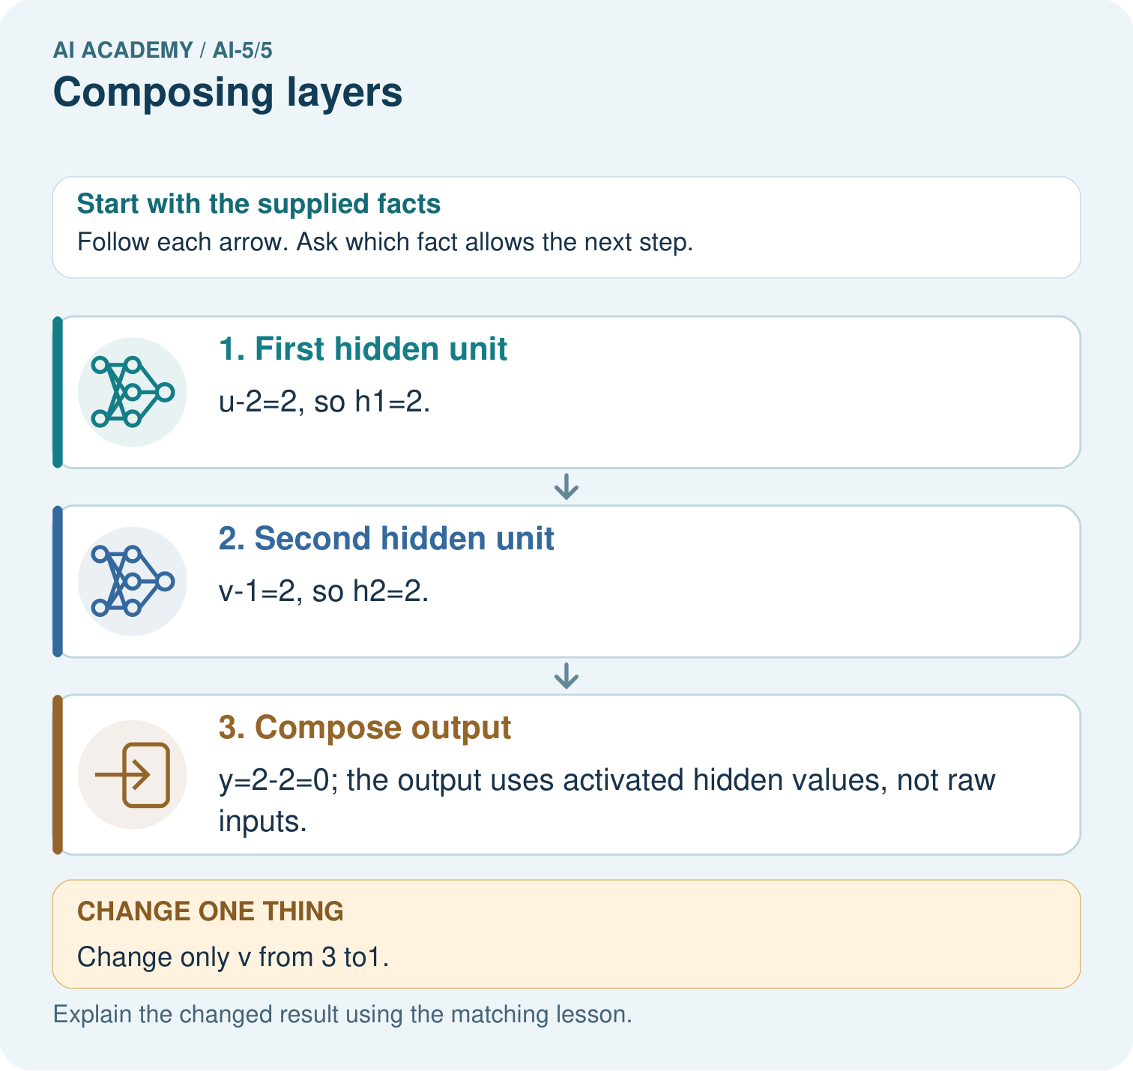

Read the picture one step at a time
Step | What happens and why
1. First hidden unit | u-2=2, so h1=2.
2. Second hidden unit | v-1=2, so h2=2.
3. Compose output | y=2-2=0; the output uses activated hidden values, not raw inputs.
Match each pictured step to the supplied facts. This is a worked teaching case, not an independent assessment.

Why this result follows
Composition means one layer’s result becomes the next layer’s input. Compute both hidden units before combining them. At [4,3], their equal outputs cancel. Lowering only the second input removes its positive hidden contribution, so subtracting it no longer reduces the output. The final subtraction must use activated hidden values rather than the raw measurements.

What this example does not establish
Hand-composed detectors illustrate layer order; they are not evidence of a learned or biologically realistic neural mechanism.
Read the labelled picture: What intermediate value explains the changed output? Point to the relevant step in the picture, then write the changed result and the rule or evidence that supports it.
Change one thing: Change only v from 3 to1. Predict the result before checking the explanation. What remains the same?

07. Find and repair a mistake
The output layer expects two inputs because its two weights match h1 and h2. If the hidden layer is redesigned to return three activations, the output layer needs a compatible three-input definition. Silently dropping an activation or inventing a third weight does not preserve the stated model.
Order matters even when lengths match. For x = [4, 1], h = [3, 3] happens to be unchanged by swapping, so that case cannot reveal an order bug. For x = [3, 0], h = [3, 1] gives y = 6. Swapping only those hidden values gives 2 times 1 - 3 + 1 = 0. Swapping both the values and their matching weights would preserve the dot product.
Keeping the output layer fixed, replacing ReLU with identity changes the model. For x = [1, 3], identity gives h = [-2, 2] and y = -5; ReLU gives h = [0, 2] and y = -1. More layers or a different activation do not establish better predictions without valid evaluation.

Locate the earliest unsupported step
Compare hidden vectors for x = [4, 1] and x = [3, 0]. Which input reveals a bug that swaps h1 and h2 but keeps output weights unchanged? Give correct and swapped outputs for that input.

State one repair and the checks you would rerun.
________________________________________________________________
________________________________________________________________
________________________________________________________________
________________________________________________________________
________________________________________________________________
________________________________________________________________

08. Practise together
For x = [1, 3], write both scores, both ReLU activations and y using the lesson model.

Trace x = [1, 1]. Record z1, z2, h1, h2 and y. Explain why using x directly in the output formula would be a different model.
________________________________________________________________
________________________________________________________________
________________________________________________________________
________________________________________________________________

Explain your prediction to a partner before comparing results.
________________________________________________________________
________________________________________________________________
________________________________________________________________
________________________________________________________________

Practise with less help: Repair a dimension mismatch
Use workbook W2 for the connected example “Composing layers”. First fill the input and rule boxes. Try the middle steps before asking for a hint. After a hint, try the next step yourself.
Plan | Do | Check
What is given? Which rule or procedure applies? | Record each intermediate step. | Does the result follow? What remains unknown?
Explain your trace to a partner. Your partner points to one step to check. Swap roles on the next case. Each person writes their own explanation.

Check your reasoning
Use the worked case for Composing layers. Proposed explanation: “The second hidden unit receives the first hidden unit output”. Decide whether this explanation is supported. Point to the step or supplied fact that decides; explain your repair if needed.
Answer on your own before discussion. If you are unsure, say which step you need help with.

Explain the picture
What intermediate value explains the changed output? Point to the relevant step in the picture, then write the changed result and the rule or evidence that supports it.

My explanation using a pictured step and the given facts
________________________________________________________________
________________________________________________________________
________________________________________________________________
________________________________________________________________
This is supported practice. Keep the separately named independent case for an attempt before feedback.

09. Run the investigation

Predict, investigate and preserve the evidence
A revised hidden layer returns [h1, h2, h3]. The output layer still has weights [2, -1]. Explain the mismatch and what must be specified before calculation.
def forward(x):
if len(x) != 2:
raise ValueError("Expected two input components")
x1, x2 = x
z = [x1 - x2, x1 + x2 - 2]
h = [max(0, value) for value in z]
y = 2 * h[0] - h[1] + 1
return z, h, y
print(forward([3, 1])) # ([2, 2], [2, 2], 3)
print(forward([1, 3])) # ([-2, 2], [0, 2], -1)
Record | Your evidence
Given input and fixed rule
Prediction before checking
Actual result, or “not run”
First mismatch and one explanation
Boundary or missing input and expected response
On paper, trace the supplied procedure. If code is provided, predict before running it in a local practice file. Never write an expected answer as though it were an observed run.

Plan → try → check
Before trying: what do I expect, and why? While trying: which step could first go wrong? Afterwards: what did I actually observe, and what should change? Keep “not run” if you only traced the procedure.

10. Build your understanding

Explain → apply → challenge
For x = [1, 3], write both scores, both ReLU activations and y using the lesson model.
Compare hidden vectors for x = [4, 1] and x = [3, 0]. Which input reveals a bug that swaps h1 and h2 but keeps output weights unchanged? Give correct and swapped outputs for that input.
Use the lesson model to verify h and y for [0, 1] and [0, 2]. Could a fixed later layer receiving only h distinguish the two original inputs?

Explain which evidence supports your conclusion and which claim remains unproved.
________________________________________________________________
________________________________________________________________
________________________________________________________________
________________________________________________________________
________________________________________________________________

11. Connect your project
Add a labelled composing layers evidence sheet to Image-pattern Network Investigation. Show how you can trace how one layer supplies the next layer inputs. Use the supplied fictional case and keep its inputs, intermediate steps, calculation or prediction, and limitation. Connect this record to last week’s record; a matching answer without a trace is insufficient.
Project evidence | Record
Component and version
Inputs permitted at prediction time
Trace and comparison with earlier work
Failure, limit and human review

Evidence for your project
For your Image-pattern Network Investigation, save the input, procedure, observed result and limitation of this check. Label this worked example as practice; use a different, previously unreviewed case when checking independent understanding.

12. Show what you know
The computed y is a numerical output, not a verified probability or a class by itself. If we separately declare class 1 when y >= 0 and class 0 otherwise, the worked inputs [3, 1] and [1, 3] receive classes 1 and 0. Their true labels are not supplied, so these calculations do not measure accuracy.
A hidden value is a computed feature. We should not name h1 as confidence or h2 as danger without evidence for that interpretation. Distinct inputs may also produce the same hidden vector: [0, 1] and [0, 2] both give h = [0, 0] and y = 1. A later deterministic layer seeing only h cannot recover the lost distinction.

A team says its output is correct because all layers connect and its code runs. Which claim has it checked, and what evidence is still missing?
________________________________________________________________
________________________________________________________________
________________________________________________________________
________________________________________________________________
Next week uses longer forward-pass tables to locate the first incorrect intermediate value and check complete network calculations.
Use the lesson model to verify h and y for [0, 1] and [0, 2]. Could a fixed later layer receiving only h distinguish the two original inputs?

My limited claim and a useful next check
________________________________________________________________
________________________________________________________________
________________________________________________________________
________________________________________________________________

13. Study a complete case

Complete evidence record

Complete each stage before using its output
Available input | Computation | Value passed on
x is [3, 1] | Both first layer scores | z is [2, 2]
z is [2, 2] | ReLU on each component | h is [2, 2]
h is [2, 2] | 2h1 - h2 + 1 | y is 3
Read the rows from top to bottom. The first two rows together form the hidden layer; the final row is the output layer. Each row shows the values actually passed to the next stage.
Follow the input through the stated procedure to its result. Cover the result first, predict it, then explain every intermediate step. The text/table accompanies the figure so the example can be read without colour.

My complete trace of the worked case
________________________________________________________________
________________________________________________________________
________________________________________________________________
________________________________________________________________
________________________________________________________________
________________________________________________________________

14. Try a new case independently

Independent case: Compose a new network independently
A new model takes [u, v]. Compute a = ReLU(u + v - 3), b = ReLU(u - v), then q = a + 2b - 1. Trace both inputs [2, 1] and [1, 2], including scores before ReLU. Apply class 1 when q >= 0. State the hidden and output vector sizes.

My independent explanation, trace and limits
________________________________________________________________
________________________________________________________________
________________________________________________________________
________________________________________________________________
________________________________________________________________
________________________________________________________________
________________________________________________________________
Attempt this case before feedback. Record any help. Earlier examples below are further practice; a case already practised with feedback cannot establish fresh transfer.

Attempt this without hints
A new model takes [u, v]. Compute a = ReLU(u + v - 3), b = ReLU(u - v), then q = a + 2b - 1. Trace both inputs [2, 1] and [1, 2], including scores before ReLU. Apply class 1 when q >= 0. State the hidden and output vector sizes.

My independent procedure, result and limitation
________________________________________________________________
________________________________________________________________
________________________________________________________________
________________________________________________________________
________________________________________________________________
________________________________________________________________
________________________________________________________________
________________________________________________________________
Record support used: none, hint or teacher explanation. After feedback, a different case is needed to demonstrate independence.

Use feedback to improve
Attempt the independent case before hints. Record whether you worked alone, used a hint or followed a model. After feedback, fix the first unsupported step and explain why it changed. A later check uses a changed case, not a copied answer.

15. Your lesson route
Start with this question: Compose two hidden detectors before one output instead of skipping a layer.
By the end, I can | How I will show it
Trace how one layer supplies the next layer inputs | Explain the deciding step, show a trace or test, and state one limit.
Check that connected layer dimensions and feature order agree | Explain the deciding step, show a trace or test, and state one limit.
Explain why intermediate activations are not automatically class predictions | Explain the deciding step, show a trace or test, and state one limit.
Remember → watch and explain → try with help → investigate → try independently → keep project evidence. Your teacher may spread this lesson across several classes.
Keep your first prediction. Compare it with what the evidence shows and explain any change.

16. Finish and return
Close your notes. Explain this goal in your own words: Trace how one layer supplies the next layer inputs

My deciding step, evidence and one remaining question
________________________________________________________________
________________________________________________________________
________________________________________________________________
________________________________________________________________
________________________________________________________________
If you are unsure, return to the worked picture and explain one arrow. If you are ready, change an input or assumption and justify your prediction.
Save your workbook evidence. At the next review, try a different case before opening your old answer.

