AI ACADEMY · STUDENT · ai-5/11

Updating parameters
Project: Image-pattern Network Investigation

Before you start
For x = 2, target 3, w = 1 and b = 0, what is the squared-loss gradient in order [w, b]?

01. Your mission

Your learning target
I can apply a learning rate to an ordered gradient.
I can update all parameters from the same saved state.
I can verify the new loss and identify overshooting.

Remember before reading
Close your notes first. A rough first answer helps us choose the right starting point; it is not a score for your ability.
Without opening the old lesson, explain one key idea from Gradients with a numerical check. Give an example and a mistake that the idea helps you avoid.
Without opening the old lesson, explain one key idea from Loss functions. Give an example and a mistake that the idea helps you avoid.
Without opening the old lesson, explain one key idea from Composing layers. Give an example and a mistake that the idea helps you avoid.
After trying, check the relevant lesson or ask your teacher. Change the part of your explanation that the evidence shows was wrong.
This week you will practise:
Apply a learning rate to an ordered gradient
Update all parameters from the same saved state
Verify the new loss and identify overshooting

Retrieve what you already know
For x = 2, target 3, w = 1 and b = 0, what is the squared-loss gradient in order [w, b]?

My starting explanation
________________________________________________________________
________________________________________________________________
________________________________________________________________

This week’s end goal
By the end, I can explain updating parameters using a traced example and a stated limitation.

02. Notice the evidence
Gradient descent uses new parameter = old parameter - learning rate times its gradient entry. The minus sign chooses the locally downhill direction for a positive learning rate. A negative gradient therefore increases the corresponding parameter.
Keep the Week 10 example: x = 2, target 3, y = 2w + b and L = (y - 3) squared. At [w, b] = [1, 0], the loss is 1 and gradient is [-4, -2]. With learning rate 0.1, new w = 1 - 0.1 times -4 = 1.4 and new b = 0 - 0.1 times -2 = 0.2.
Quantity | Before update | After update
Parameters [w, b] | [1, 0] | [1.4, 0.2]
Prediction | 2 | 3
Squared loss | 1 | 0
This particular step reaches zero loss on one example. It does not establish a unique parameter solution, successful learning on other examples or a generally ideal learning rate.

List the given facts and one fact that is not supplied.
________________________________________________________________
________________________________________________________________
________________________________________________________________

03. See how it works
def step(w, b, rate):
residual = 2 * w + b - 3
dw, db = 4 * residual, 2 * residual
new_w = w - rate * dw
new_b = b - rate * db
new_loss = (2 * new_w + new_b - 3) ** 2
return new_w, new_b, new_loss
for rate in [0.0, 0.05, 0.1, 0.3]:
print(rate, tuple(round(v, 6)
for v in step(1, 0, rate)))
Predict the rows: unchanged parameters and loss 1 at rate 0; [1.2, 0.1] and loss 0.25 at rate 0.05; [1.4, 0.2] and loss 0 at rate 0.1; [2.2, 0.6] and loss 4 at rate 0.3. The helper performs one step on this fixed example; it assumes numeric inputs and does not choose a learning rate for you.

Connect the picture and the explanation
Point to the input, the deciding step and the result in this week’s visual. Explain the same step in ordinary words. A picture helps when you can say what each part represents.

04. Compare the cases

Compare a familiar case with a changed case
For the lesson start [1, 0], apply rate 0.3 and calculate prediction and loss.

Keep the procedure fixed. Explain what changed in the inputs and result.
________________________________________________________________
________________________________________________________________
________________________________________________________________
________________________________________________________________
________________________________________________________________

Change one thing in the pictured case
Change: Set learning rate 0.2 from the same starting point.
Prediction: New w=2.6, b=1.8, y=7, squared loss 4: no improvement.
Reason: The larger update jumps to an equally distant point on the opposite side of the target.

05. Words that unlock the idea
Word | Meaning
Learning rate | A multiplier that controls the size of a gradient update
Gradient descent | Updating parameters in the direction opposite the gradient
Simultaneous update | Computing all new parameter values from the same old state
Overshoot | A step that moves too far and can increase the objective

Use two terms to explain a step in this week’s example.
________________________________________________________________
________________________________________________________________
________________________________________________________________

06. Follow a worked example

Use one gradient for one parameter snapshot
Stage | Saved values | Action
Before the step | w is 1 and b is 0 | Compute gradient [-4, -2]
Apply rate 0.1 | Use both old parameters | Produce [1.4, 0.2]
After the step | Use both new parameters | Recompute loss 0
Read top to bottom. All gradient entries come from the same old model. The final row evaluates the fully updated model rather than mixing old and new coordinates.

Starting again from [1, 0], use learning rate 0.05. Show both new parameters, the new prediction and the new loss.
________________________________________________________________
________________________________________________________________
________________________________________________________________
________________________________________________________________

Learn from the worked case
Cover the result before checking it. Say what is given, choose the procedure, and follow one step at a time. Then uncover the result and explain your first mismatch. Ask why a step is allowed, not only what number it produces.

A pictorial worked case: Updating parameters
Use one explicit gradient update and then recompute the loss.

The facts we will use
Model y=2w+b, target 5. Start w=1, b=1; learning rate 0.05. Initial y=3, error y−target=−2, squared loss 4.
All inputs and outcomes in this worked example are invented classroom data; no real model run is claimed.
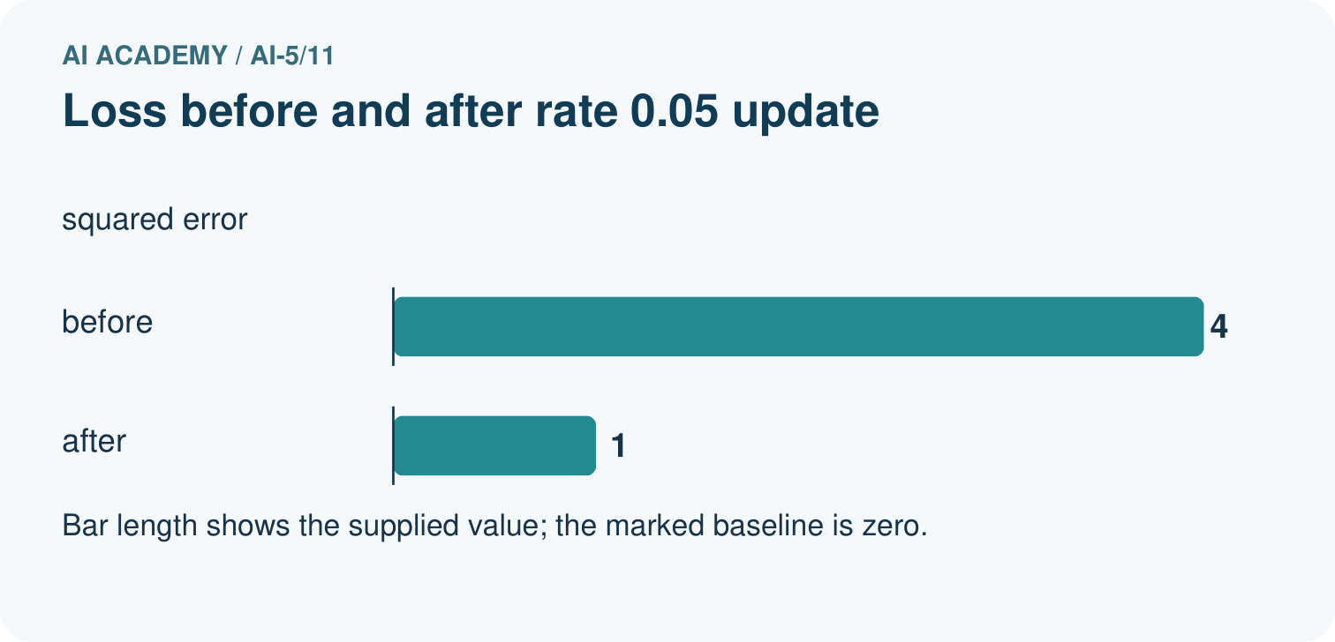
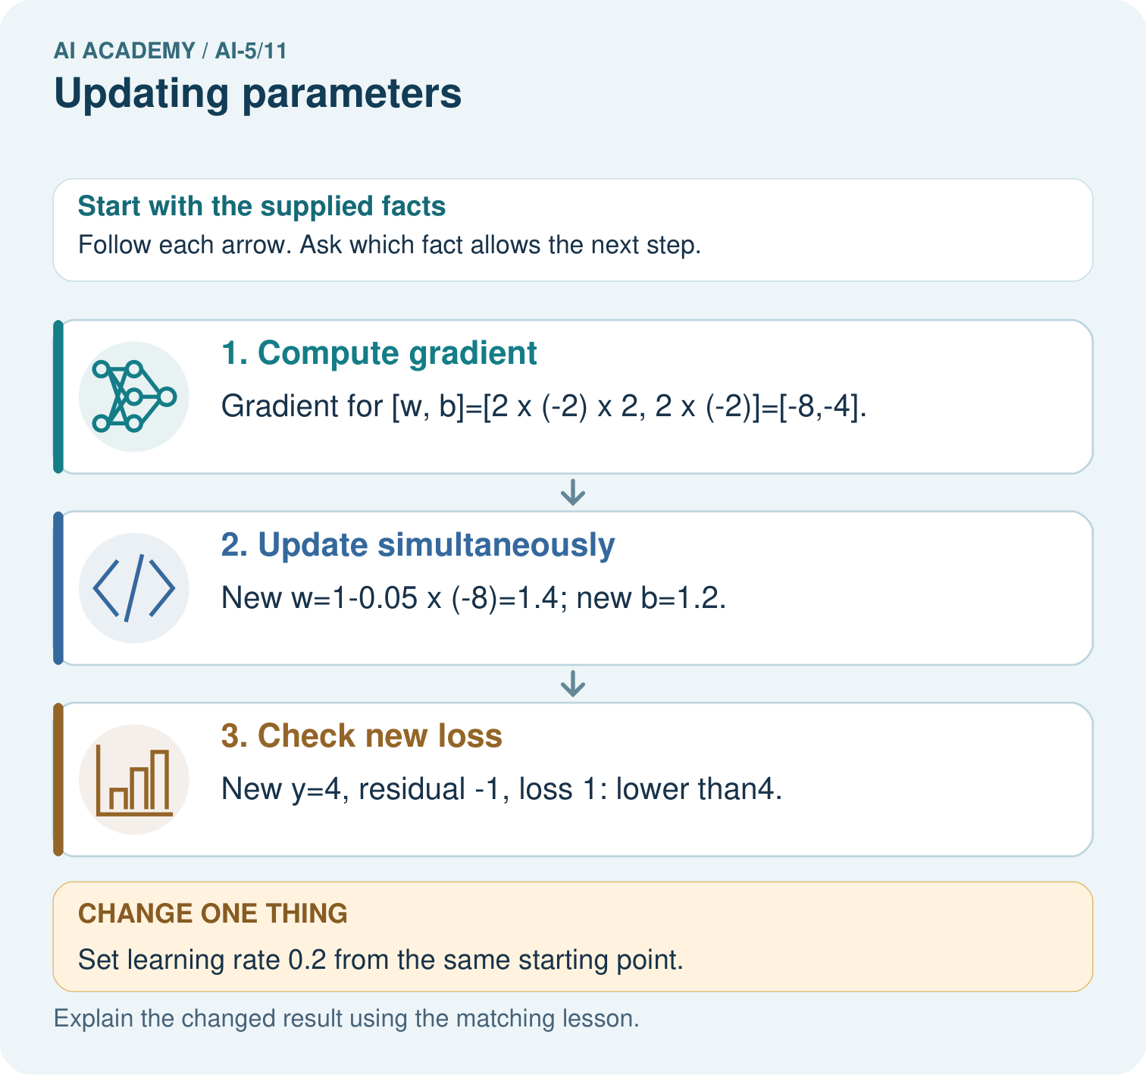

Read the picture one step at a time
Step | What happens and why
1. Compute gradient | Gradient for [w, b]=[2×(-2)×2, 2×(-2)]=[-8,-4].
2. Update simultaneously | New w=1-0.05×(-8)=1.4; new b=1.2.
3. Check new loss | New y=4, residual -1, loss 1: lower than4.
Match each pictured step to the supplied facts. This is a worked teaching case, not an independent assessment.

Why this result follows
Gradient descent subtracts learning rate times gradient. A negative gradient makes this subtraction increase the parameter. Compute both gradients at the original [w,b] before updating either one. The small step brings the prediction closer to five, reducing squared error. A larger step can cross the target and undo that gain, so the new prediction and loss must be recalculated.

What this example does not establish
One successful toy update is not evidence of convergence for a real network or generalisation to unseen data.
Read the labelled picture: Why must new loss be recomputed rather than assumed smaller? Point to the relevant step in the picture, then write the changed result and the rule or evidence that supports it.
Change one thing: Set learning rate 0.2 from the same starting point. Predict the result before checking the explanation. What remains the same?

07. Find and repair a mistake
Suppose a program first changes w to 1.4, then recomputes the bias gradient using new w and old b. Its residual is now -0.2, so its bias gradient is -0.4 and new b becomes 0.04. Prediction becomes 2.84 and loss 0.0256. That is a different procedure from the declared simultaneous step, even though it also lowered this loss.
An excessive rate can increase loss. At rate 0.3, both coordinates move in the locally suggested direction but prediction jumps to 5 and loss rises from 1 to 4. Always evaluate and record the result. Later lessons compare learning-rate behaviour across repeated updates.

Locate the earliest unsupported step
Explain why recomputing the bias gradient after changing w is not the simultaneous update specified here.

State one repair and the checks you would rerun.
________________________________________________________________
________________________________________________________________
________________________________________________________________
________________________________________________________________
________________________________________________________________
________________________________________________________________

08. Practise together
Starting with parameter a = 2, gradient -3 and learning rate 0.2, calculate the new a.

Starting again from [1, 0], use learning rate 0.05. Show both new parameters, the new prediction and the new loss.
________________________________________________________________
________________________________________________________________
________________________________________________________________
________________________________________________________________

Explain your prediction to a partner before comparing results.
________________________________________________________________
________________________________________________________________
________________________________________________________________
________________________________________________________________

Practise with less help: Detect overshooting
Use workbook W2 for the connected example “Updating parameters”. First fill the input and rule boxes. Try the middle steps before asking for a hint. After a hint, try the next step yourself.
Plan | Do | Check
What is given? Which rule or procedure applies? | Record each intermediate step. | Does the result follow? What remains unknown?
Explain your trace to a partner. Your partner points to one step to check. Swap roles on the next case. Each person writes their own explanation.

Check your reasoning
Use the worked case for Updating parameters. Proposed explanation: “Subtracting a negative gradient decreases the parameter”. Decide whether this explanation is supported. Point to the step or supplied fact that decides; explain your repair if needed.
Answer on your own before discussion. If you are unsure, say which step you need help with.

Explain the picture
Why must new loss be recomputed rather than assumed smaller? Point to the relevant step in the picture, then write the changed result and the rule or evidence that supports it.

My explanation using a pictured step and the given facts
________________________________________________________________
________________________________________________________________
________________________________________________________________
________________________________________________________________
This is supported practice. Keep the separately named independent case for an attempt before feedback.

09. Run the investigation

Predict, investigate and preserve the evidence
For the lesson start [1, 0], apply rate 0.3 and calculate prediction and loss.
def step(w, b, rate):
residual = 2 * w + b - 3
dw, db = 4 * residual, 2 * residual
new_w = w - rate * dw
new_b = b - rate * db
new_loss = (2 * new_w + new_b - 3) ** 2
return new_w, new_b, new_loss
for rate in [0.0, 0.05, 0.1, 0.3]:
print(rate, tuple(round(v, 6)
for v in step(1, 0, rate)))
Record | Your evidence
Given input and fixed rule
Prediction before checking
Actual result, or “not run”
First mismatch and one explanation
Boundary or missing input and expected response
On paper, trace the supplied procedure. If code is provided, predict before running it in a local practice file. Never write an expected answer as though it were an observed run.

Plan → try → check
Before trying: what do I expect, and why? While trying: which step could first go wrong? Afterwards: what did I actually observe, and what should change? Keep “not run” if you only traced the procedure.

10. Build your understanding

Explain → apply → challenge
Starting with parameter a = 2, gradient -3 and learning rate 0.2, calculate the new a.
Explain why recomputing the bias gradient after changing w is not the simultaneous update specified here.
At a point with gradient [0, 0], what does this update do? Does that alone prove a global minimum on any loss surface?

Explain which evidence supports your conclusion and which claim remains unproved.
________________________________________________________________
________________________________________________________________
________________________________________________________________
________________________________________________________________
________________________________________________________________

11. Connect your project
Add a labelled updating parameters evidence sheet to Image-pattern Network Investigation. Show how you can apply a learning rate to an ordered gradient. Use the supplied fictional case and keep its inputs, intermediate steps, calculation or prediction, and limitation. Connect this record to last week’s record; a matching answer without a trace is insufficient.
Project evidence | Record
Component and version
Inputs permitted at prediction time
Trace and comparison with earlier work
Failure, limit and human review

Evidence for your project
For your Image-pattern Network Investigation, save the input, procedure, observed result and limitation of this check. Label this worked example as practice; use a different, previously unreviewed case when checking independent understanding.

12. Show what you know
A lower loss after a step supports progress on the objective and examples used for that step. It does not show that a model is safe, calibrated or better on unseen data. Keep the data split fixed and never use final-test labels to compute training gradients.

A teammate says any update that lowers loss is a correct implementation of simultaneous gradient descent. Use the mixed-state example to evaluate that claim.
________________________________________________________________
________________________________________________________________
________________________________________________________________
________________________________________________________________
Next week repeats the forward, loss, gradient and update cycle in a small network with a clearly stated stopping budget.
At a point with gradient [0, 0], what does this update do? Does that alone prove a global minimum on any loss surface?

My limited claim and a useful next check
________________________________________________________________
________________________________________________________________
________________________________________________________________
________________________________________________________________

13. Study a complete case

Complete evidence record

Use one gradient for one parameter snapshot
Stage | Saved values | Action
Before the step | w is 1 and b is 0 | Compute gradient [-4, -2]
Apply rate 0.1 | Use both old parameters | Produce [1.4, 0.2]
After the step | Use both new parameters | Recompute loss 0
Read top to bottom. All gradient entries come from the same old model. The final row evaluates the fully updated model rather than mixing old and new coordinates.
Follow the input through the stated procedure to its result. Cover the result first, predict it, then explain every intermediate step. The text/table accompanies the figure so the example can be read without colour.

My complete trace of the worked case
________________________________________________________________
________________________________________________________________
________________________________________________________________
________________________________________________________________
________________________________________________________________
________________________________________________________________

14. Try a new case independently

Independent case: Update a new model independently
Use x = 1, target 4, w = 1, b = 1, squared loss and learning rate 0.1. Compute prediction, residual, gradient [2 times residual times x, 2 times residual], new parameters and new loss.

My independent explanation, trace and limits
________________________________________________________________
________________________________________________________________
________________________________________________________________
________________________________________________________________
________________________________________________________________
________________________________________________________________
________________________________________________________________
Attempt this case before feedback. Record any help. Earlier examples below are further practice; a case already practised with feedback cannot establish fresh transfer.

Attempt this without hints
Use x = 1, target 4, w = 1, b = 1, squared loss and learning rate 0.1. Compute prediction, residual, gradient [2 times residual times x, 2 times residual], new parameters and new loss.

My independent procedure, result and limitation
________________________________________________________________
________________________________________________________________
________________________________________________________________
________________________________________________________________
________________________________________________________________
________________________________________________________________
________________________________________________________________
________________________________________________________________
Record support used: none, hint or teacher explanation. After feedback, a different case is needed to demonstrate independence.

Use feedback to improve
Attempt the independent case before hints. Record whether you worked alone, used a hint or followed a model. After feedback, fix the first unsupported step and explain why it changed. A later check uses a changed case, not a copied answer.

15. Your lesson route
Start with this question: Use one explicit gradient update and then recompute the loss.
By the end, I can | How I will show it
Apply a learning rate to an ordered gradient | Explain the deciding step, show a trace or test, and state one limit.
Update all parameters from the same saved state | Explain the deciding step, show a trace or test, and state one limit.
Verify the new loss and identify overshooting | Explain the deciding step, show a trace or test, and state one limit.
Remember → watch and explain → try with help → investigate → try independently → keep project evidence. Your teacher may spread this lesson across several classes.
Keep your first prediction. Compare it with what the evidence shows and explain any change.

16. Finish and return
Close your notes. Explain this goal in your own words: Apply a learning rate to an ordered gradient

My deciding step, evidence and one remaining question
________________________________________________________________
________________________________________________________________
________________________________________________________________
________________________________________________________________
________________________________________________________________
If you are unsure, return to the worked picture and explain one arrow. If you are ready, change an input or assumption and justify your prediction.
Save your workbook evidence. At the next review, try a different case before opening your old answer.

