AI ACADEMY · STUDENT · ai-5/13

Batching and epochs
Project: Image-pattern Network Investigation

Before you start
Week 12 printed states numbered 0 to 4. How many parameter updates occurred?

01. Your mission

Your learning target
I can distinguish an example a batch an update and an epoch.
I can trace parameter changes across successive batches.
I can calculate update counts and aggregate unequal batch losses correctly.

Remember before reading
Close your notes first. A rough first answer helps us choose the right starting point; it is not a score for your ability.
Without opening the old lesson, explain one key idea from Training a small network. Give an example and a mistake that the idea helps you avoid.
Without opening the old lesson, explain one key idea from Gradients with a numerical check. Give an example and a mistake that the idea helps you avoid.
Without opening the old lesson, explain one key idea from Parameters and architecture. Give an example and a mistake that the idea helps you avoid.
After trying, check the relevant lesson or ask your teacher. Change the part of your explanation that the evidence shows was wrong.
This week you will practise:
Distinguish an example a batch an update and an epoch
Trace parameter changes across successive batches
Calculate update counts and aggregate unequal batch losses correctly

Retrieve what you already know
Week 12 printed states numbered 0 to 4. How many parameter updates occurred?

My starting explanation
________________________________________________________________
________________________________________________________________
________________________________________________________________

This week’s end goal
By the end, I can explain batching and epochs using a traced example and a stated limitation.

02. Notice the evidence
In Week 12 every update used both training examples. We now keep the same network h = ReLU(x), y = vh, with only v trained, and divide the data into batches. In this lesson each nonempty batch produces exactly one update. An epoch visits every training example exactly once, without replacement. These rules make the counts unambiguous.
Imagine five fictional records A through E in fixed order. With batch size 2, the groups are [A, B], [C, D] and [E]. Keep the smaller last batch. One epoch has three batches and three updates; two epochs have six updates and ten example visits.
Training rows | Batch size | Batch lengths | Updates per epoch
5 | 2 | 2, 2, 1 | 3
5 | 5 | 5 | 1
5 | 1 | 1, 1, 1, 1, 1 | 5
When the last batch is retained, updates per epoch equal the row count divided by batch size rounded up. A program that drops the final incomplete batch follows a different rule and omits examples in that pass. Record the rule instead of silently changing the denominator.

List the given facts and one fact that is not supplied.
________________________________________________________________
________________________________________________________________
________________________________________________________________

03. See how it works
Use the two fictional pairs A = (1, 2) and B = (2, 4), start v = 0 and rate 0.1. For one pair with hidden value h, squared-error gradient is 2 times (vh - target) times h. For a batch, average these gradients at the same current v. Apply one update, then recompute for the next batch.
def epoch(v, rows, size, rate):
if not rows or size < 1:
raise ValueError("Need rows and positive batch size")
trace = []
for start in range(0, len(rows), size):
batch = rows[start:start + size]
hs = [max(0.0, x) for x, target in batch]
gradient = sum(2 * (v * h - target) * h
for h, (x, target) in zip(hs, batch)) / len(batch)
v = v - rate * gradient
trace.append(v)
return trace
rows = [(1.0, 2.0), (2.0, 4.0)]
print([round(v, 6) for v in epoch(0.0, rows, 1, 0.1)]) # [0.4, 1.68]
print([round(v, 6) for v in epoch(0.0, rows, 2, 0.1)]) # [1.0]
Assume finite numeric pairs, integer size and finite rate. With size 1, A gives gradient -4 and new v = 0.4. B then uses 0.4, giving prediction 0.8, residual -3.2 and gradient -12.8, so v becomes 1.68. With size 2, both gradients are evaluated at v = 0; their mean is -10, producing v = 1.

Connect the picture and the explanation
Point to the input, the deciding step and the result in this week’s visual. Explain the same step in ordinary words. A picture helps when you can say what each part represents.

04. Compare the cases

Compare a familiar case with a changed case
For A then B separately in the lesson, a learner computes both gradients at v = 0, then applies them to get v = 2. Explain the error and give the correct final value.

Keep the procedure fixed. Explain what changed in the inputs and result.
________________________________________________________________
________________________________________________________________
________________________________________________________________
________________________________________________________________
________________________________________________________________

Change one thing in the pictured case
Change: Use only one full-batch update after reversing record order.
Prediction: The updated weight remains 0.2.
Reason: The same mean of the two starting gradients is unchanged by their order.

05. Words that unlock the idea
Word | Meaning
Batch | A group of training examples used together to calculate one gradient here
Update | One application of the gradient and learning rate to the current parameters
Epoch | One pass through all training examples under the stated sampling rule
Batch size | The intended number of examples in each batch with a possible smaller final batch

Use two terms to explain a step in this week’s example.
________________________________________________________________
________________________________________________________________
________________________________________________________________

06. Follow a worked example

One pass can contain different numbers of updates
Batch rule | Parameter after each batch | Updates
A then B separately | 0 to 0.4 to 1.68 | 2
A and B together | 0 to 1 | 1
B then A separately | 0 to 1.6 to 1.68 | 2
All three passes visit two examples. The reversed order happens to end at the same value for these proportional targets; that coincidence is not a general order-invariance rule.

For B then A separately, show both gradients and new parameter values. Why does one epoch still contain two updates?
________________________________________________________________
________________________________________________________________
________________________________________________________________
________________________________________________________________

Learn from the worked case
Cover the result before checking it. Say what is given, choose the procedure, and follow one step at a time. Then uncover the result and explain your first mismatch. Ask why a step is allowed, not only what number it produces.

A pictorial worked case: Batching and epochs
Show why an epoch’s example order can matter for single-example updates.

The facts we will use
Toy y=wx, rate 0.1, squared loss, start w = 0. Training A=(x = 1, target 2), B=(x = 2, target 0).
All inputs and outcomes in this worked example are invented classroom data; no real model run is claimed.
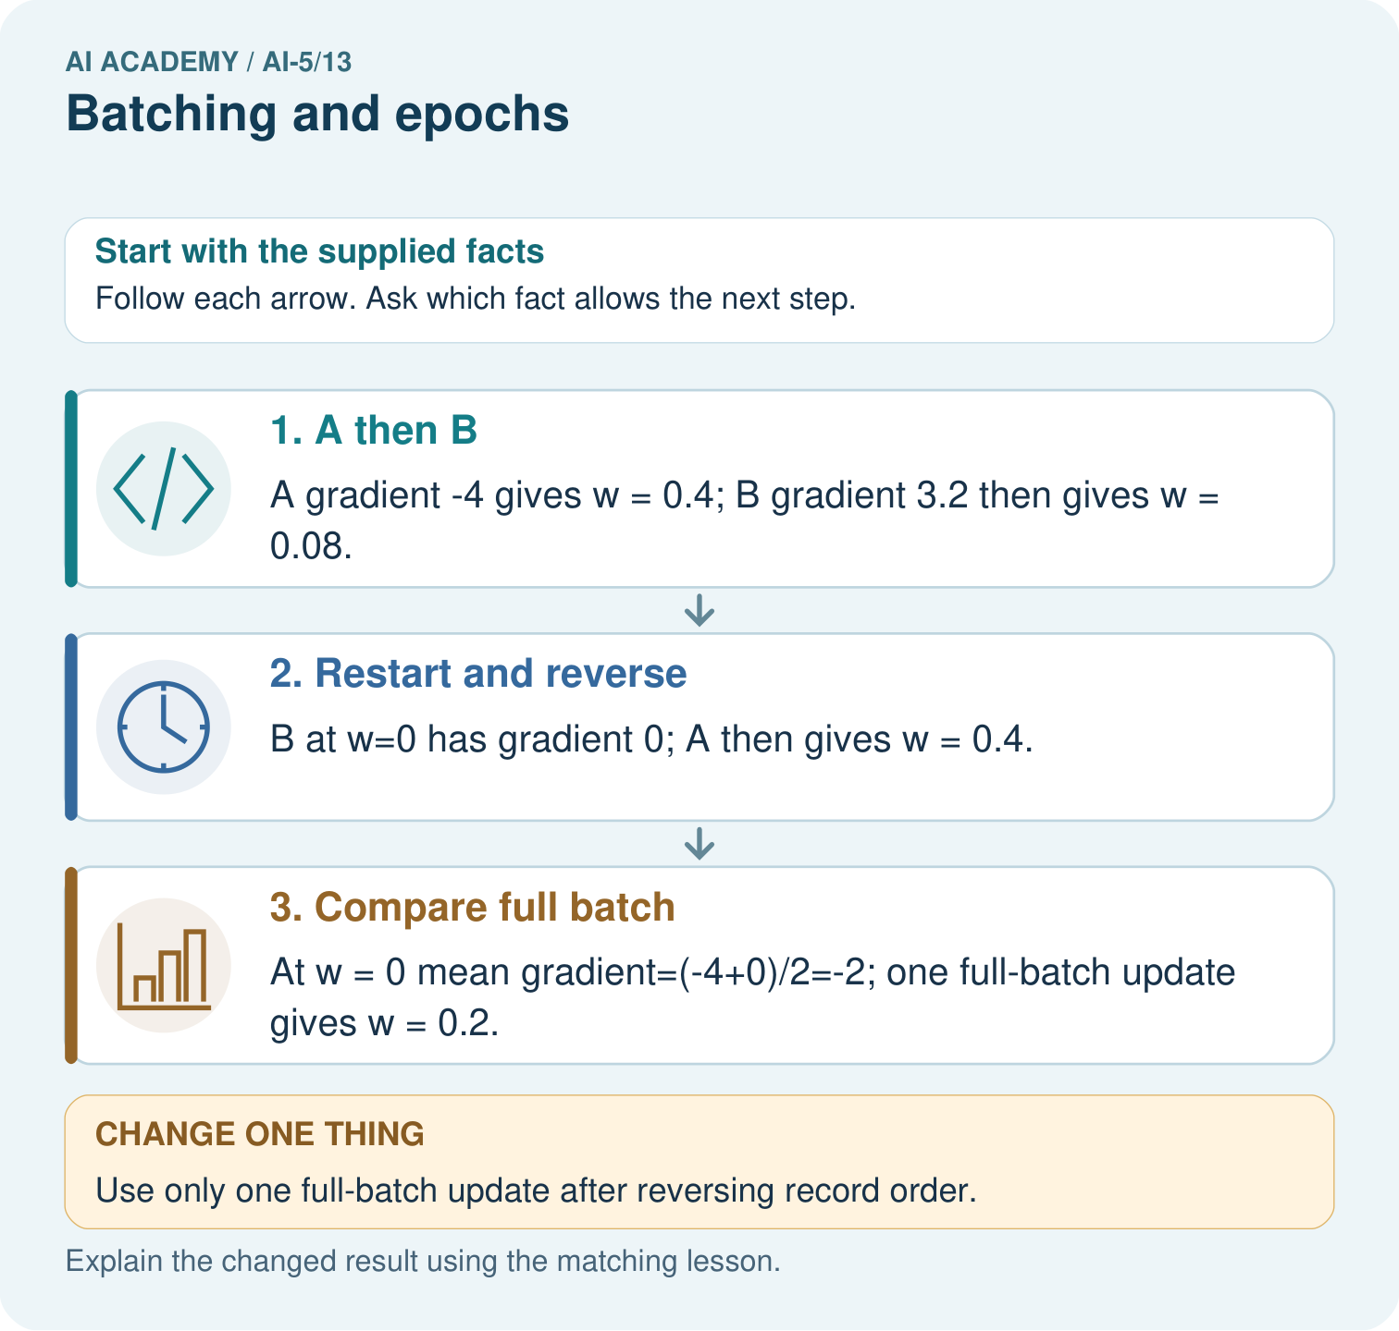

Read the picture one step at a time
Step | What happens and why
1. A then B | A gradient -4 gives w = 0.4; B gradient 3.2 then gives w = 0.08.
2. Restart and reverse | B at w=0 has gradient 0; A then gives w = 0.4.
3. Compare full batch | At w = 0 mean gradient=(-4+0)/2=-2; one full-batch update gives w = 0.2.
Match each pictured step to the supplied facts. This is a worked teaching case, not an independent assessment.

Why this result follows
A single-example update changes the weight before the next example’s gradient is calculated. Reversing the example order can therefore change the path. A full-batch update computes both gradients at the same starting weight and averages them before changing that weight. The distinction is when the update occurs, not whether the examples have different labels.

What this example does not establish
Different order effects do not mean a universally better batching strategy; compare declared schedules and budgets fairly.
Read the labelled picture: Why do the single-example orders finish at different weights? Point to the relevant step in the picture, then write the changed result and the rule or evidence that supports it.
Change one thing: Use only one full-batch update after reversing record order. Predict the result before checking the explanation. What remains the same?

07. Find and repair a mistake
Batch losses observed during training can refer to different parameter values and different examples. They are not automatically the full training loss of the final model. To compare final models, freeze each one and evaluate every training example again. Here full training MSE is 2.5 times (v - 2) squared: at v = 1 it is 2.5, and at v = 1.68 it is 0.256. These are training results only.
Even at one fixed model, averaging batch means without their sizes gives the wrong dataset mean when batches have different lengths. Suppose the squared errors on A to E are [1, 1, 4, 4, 9]. Batch means for lengths 2, 2, 1 are [1, 4, 9]. Full MSE is (2 times 1 + 2 times 4 + 1 times 9) / 5 = 3.8, not (1 + 4 + 9) / 3. Use example counts as weights.

Locate the earliest unsupported step
At one frozen model, batches of sizes 3 and 1 have mean squared errors 2 and 10. Find the full MSE and explain why the average of 2 and 10 is wrong.

State one repair and the checks you would rerun.
________________________________________________________________
________________________________________________________________
________________________________________________________________
________________________________________________________________
________________________________________________________________
________________________________________________________________

08. Practise together
For 10 rows, batch size 4 and three epochs, retaining the final batch, list batch lengths and count total updates and example visits.

For B then A separately, show both gradients and new parameter values. Why does one epoch still contain two updates?
________________________________________________________________
________________________________________________________________
________________________________________________________________
________________________________________________________________

Explain your prediction to a partner before comparing results.
________________________________________________________________
________________________________________________________________
________________________________________________________________
________________________________________________________________

Practise with less help: Repair a stale gradient
Use workbook W2 for the connected example “Batching and epochs”. First fill the input and rule boxes. Try the middle steps before asking for a hint. After a hint, try the next step yourself.
Plan | Do | Check
What is given? Which rule or procedure applies? | Record each intermediate step. | Does the result follow? What remains unknown?
Explain your trace to a partner. Your partner points to one step to check. Swap roles on the next case. Each person writes their own explanation.

Check your reasoning
Use the worked case for Batching and epochs. Proposed explanation: “One epoch always means one update”. Decide whether this explanation is supported. Point to the step or supplied fact that decides; explain your repair if needed.
Answer on your own before discussion. If you are unsure, say which step you need help with.

Explain the picture
Why do the single-example orders finish at different weights? Point to the relevant step in the picture, then write the changed result and the rule or evidence that supports it.

My explanation using a pictured step and the given facts
________________________________________________________________
________________________________________________________________
________________________________________________________________
________________________________________________________________
This is supported practice. Keep the separately named independent case for an attempt before feedback.

09. Run the investigation

Predict, investigate and preserve the evidence
For A then B separately in the lesson, a learner computes both gradients at v = 0, then applies them to get v = 2. Explain the error and give the correct final value.
def epoch(v, rows, size, rate):
if not rows or size < 1:
raise ValueError("Need rows and positive batch size")
trace = []
for start in range(0, len(rows), size):
batch = rows[start:start + size]
hs = [max(0.0, x) for x, target in batch]
gradient = sum(2 * (v * h - target) * h
for h, (x, target) in zip(hs, batch)) / len(batch)
v = v - rate * gradient
trace.append(v)
return trace
rows = [(1.0, 2.0), (2.0, 4.0)]
print([round(v, 6) for v in epoch(0.0, rows, 1, 0.1)]) # [0.4, 1.68]
print([round(v, 6) for v in epoch(0.0, rows, 2, 0.1)]) # [1.0]
Record | Your evidence
Given input and fixed rule
Prediction before checking
Actual result, or “not run”
First mismatch and one explanation
Boundary or missing input and expected response
On paper, trace the supplied procedure. If code is provided, predict before running it in a local practice file. Never write an expected answer as though it were an observed run.

Plan → try → check
Before trying: what do I expect, and why? While trying: which step could first go wrong? Afterwards: what did I actually observe, and what should change? Keep “not run” if you only traced the procedure.

10. Build your understanding

Explain → apply → challenge
For 10 rows, batch size 4 and three epochs, retaining the final batch, list batch lengths and count total updates and example visits.
At one frozen model, batches of sizes 3 and 1 have mean squared errors 2 and 10. Find the full MSE and explain why the average of 2 and 10 is wrong.
A program processes 11 rows using size 4 and drops the last incomplete batch. How many examples did it visit and how many updates occurred? What must its report disclose?

Explain which evidence supports your conclusion and which claim remains unproved.
________________________________________________________________
________________________________________________________________
________________________________________________________________
________________________________________________________________
________________________________________________________________

11. Connect your project
Add a labelled batching and epochs evidence sheet to Image-pattern Network Investigation. Show how you can distinguish an example a batch an update and an epoch. Use the supplied fictional case and keep its inputs, intermediate steps, calculation or prediction, and limitation. Connect this record to last week’s record; a matching answer without a trace is insufficient.
Project evidence | Record
Component and version
Inputs permitted at prediction time
Trace and comparison with earlier work
Failure, limit and human review

Evidence for your project
For your Image-pattern Network Investigation, save the input, procedure, observed result and limitation of this check. Label this worked example as practice; use a different, previously unreviewed case when checking independent understanding.

12. Show what you know
Equal epochs mean equal example visits under our rule, but changing batch size changes the number of updates. A comparison should report both counts, starting values, order, learning rate and the rule for the last batch. Neither smaller batches nor more updates guarantee better independent performance.

Two teams train on five rows for two epochs. One uses size 2 and the other size 5, retaining every row. Are their example visits and update counts equal? Explain what to record.
________________________________________________________________
________________________________________________________________
________________________________________________________________
________________________________________________________________
Next week holds the batch rule fixed while comparing learning rates.
A program processes 11 rows using size 4 and drops the last incomplete batch. How many examples did it visit and how many updates occurred? What must its report disclose?

My limited claim and a useful next check
________________________________________________________________
________________________________________________________________
________________________________________________________________
________________________________________________________________

13. Study a complete case

Complete evidence record

One pass can contain different numbers of updates
Batch rule | Parameter after each batch | Updates
A then B separately | 0 to 0.4 to 1.68 | 2
A and B together | 0 to 1 | 1
B then A separately | 0 to 1.6 to 1.68 | 2
All three passes visit two examples. The reversed order happens to end at the same value for these proportional targets; that coincidence is not a general order-invariance rule.
Follow the input through the stated procedure to its result. Cover the result first, predict it, then explain every intermediate step. The text/table accompanies the figure so the example can be read without colour.

My complete trace of the worked case
________________________________________________________________
________________________________________________________________
________________________________________________________________
________________________________________________________________
________________________________________________________________
________________________________________________________________

14. Try a new case independently

Independent case: Test order on a new case independently
Use A = (1, 1), B = (2, 0), h = ReLU(x), y = vh, v = 0 and rate 0.1. Train with size 1 for one epoch in A then B order, then restart at 0 and reverse the order. Show gradients and parameter values. Compare the final values.

My independent explanation, trace and limits
________________________________________________________________
________________________________________________________________
________________________________________________________________
________________________________________________________________
________________________________________________________________
________________________________________________________________
________________________________________________________________
Attempt this case before feedback. Record any help. Earlier examples below are further practice; a case already practised with feedback cannot establish fresh transfer.

Attempt this without hints
Use A = (1, 1), B = (2, 0), h = ReLU(x), y = vh, v = 0 and rate 0.1. Train with size 1 for one epoch in A then B order, then restart at 0 and reverse the order. Show gradients and parameter values. Compare the final values.

My independent procedure, result and limitation
________________________________________________________________
________________________________________________________________
________________________________________________________________
________________________________________________________________
________________________________________________________________
________________________________________________________________
________________________________________________________________
________________________________________________________________
Record support used: none, hint or teacher explanation. After feedback, a different case is needed to demonstrate independence.

Use feedback to improve
Attempt the independent case before hints. Record whether you worked alone, used a hint or followed a model. After feedback, fix the first unsupported step and explain why it changed. A later check uses a changed case, not a copied answer.

15. Your lesson route
Start with this question: Show why an epoch’s example order can matter for single-example updates.
By the end, I can | How I will show it
Distinguish an example a batch an update and an epoch | Explain the deciding step, show a trace or test, and state one limit.
Trace parameter changes across successive batches | Explain the deciding step, show a trace or test, and state one limit.
Calculate update counts and aggregate unequal batch losses correctly | Explain the deciding step, show a trace or test, and state one limit.
Remember → watch and explain → try with help → investigate → try independently → keep project evidence. Your teacher may spread this lesson across several classes.
Keep your first prediction. Compare it with what the evidence shows and explain any change.

16. Finish and return
Close your notes. Explain this goal in your own words: Distinguish an example a batch an update and an epoch

My deciding step, evidence and one remaining question
________________________________________________________________
________________________________________________________________
________________________________________________________________
________________________________________________________________
________________________________________________________________
If you are unsure, return to the worked picture and explain one arrow. If you are ready, change an input or assumption and justify your prediction.
Save your workbook evidence. At the next review, try a different case before opening your old answer.

