AI ACADEMY · STUDENT · ai-5/15

Training and validation curves
Project: Image-pattern Network Investigation

Before you start
Why does the lowest training loss in a learning-rate experiment not establish the best performance on new examples?

01. Your mission

Your learning target
I can compute comparable training and validation losses at saved checkpoints.
I can choose among observed checkpoints using a declared validation rule.
I can distinguish development evidence from final test evidence.

Remember before reading
Close your notes first. A rough first answer helps us choose the right starting point; it is not a score for your ability.
Without opening the old lesson, explain one key idea from Learning rate experiments. Give an example and a mistake that the idea helps you avoid.
Without opening the old lesson, explain one key idea from Training a small network. Give an example and a mistake that the idea helps you avoid.
Without opening the old lesson, explain one key idea from Slopes and local change. Give an example and a mistake that the idea helps you avoid.
After trying, check the relevant lesson or ask your teacher. Change the part of your explanation that the evidence shows was wrong.
This week you will practise:
Compute comparable training and validation losses at saved checkpoints
Choose among observed checkpoints using a declared validation rule
Distinguish development evidence from final test evidence

Retrieve what you already know
Why does the lowest training loss in a learning-rate experiment not establish the best performance on new examples?

My starting explanation
________________________________________________________________
________________________________________________________________
________________________________________________________________

This week’s end goal
By the end, I can explain training and validation curves using a traced example and a stated limitation.

02. Notice the evidence
Keep the restricted network h = ReLU(x), y = vh, with only v trained. Training pairs remain (1, 2) and (2, 4). Start v = 0 and make four full-data updates at rate 0.1. Save states v = 0, 1, 1.5, 1.75 and 1.875. At each saved state, evaluate both splits without changing v during evaluation.
For this deliberately constructed demonstration, validation pairs are (3, 4.5) and (4, 6). Their targets follow a different slope from the training pairs. This makes the two trends disagree visibly; it is not evidence that these few rows represent a real population. Validation labels do not enter the gradient.
Updates | v | Training MSE | Validation MSE
0 | 0 | 10 | 28.125
1 | 1 | 2.5 | 3.125
2 | 1.5 | 0.625 | 0
3 | 1.75 | 0.15625 | 0.78125
4 | 1.875 | 0.0390625 | 1.7578125
Both columns use ordinary MSE in the same target units, evaluated on their own fixed rows. Training MSE is 2.5(v - 2) squared; validation MSE is 12.5(v - 1.5) squared. Different input values and target rules affect the loss levels. A gap alone does not identify its cause.

List the given facts and one fact that is not supplied.
________________________________________________________________
________________________________________________________________
________________________________________________________________

03. See how it works
For checkpoint 3, v = 1.75. Training predictions are [1.75, 3.5], residuals [-0.25, -0.5], and MSE 0.15625. Validation predictions are [5.25, 7], residuals [0.75, 1], and MSE 0.78125. All four predictions must use the same saved value.
def mse(v, rows):
if not rows:
raise ValueError("Need evaluation rows")
return sum((v * max(0.0, x) - target) ** 2
for x, target in rows) / len(rows)
train = [(1.0, 2.0), (2.0, 4.0)]
valid = [(3.0, 4.5), (4.0, 6.0)]
checkpoints = [0.0, 1.0, 1.5, 1.75, 1.875]
validation_losses = []
for step, v in enumerate(checkpoints):
validation_losses.append(mse(v, valid))
print(step, mse(v, train), mse(v, valid))
best = min(range(len(checkpoints)),
key=lambda i: (validation_losses[i], i))
print("Selected checkpoint", best) # 2
The code evaluates supplied checkpoints; it does not train on validation data. It assumes finite numeric pairs and selects the lowest observed validation MSE, breaking exact ties in favour of the earlier checkpoint. The rule is chosen before inspecting the values.

Connect the picture and the explanation
Point to the input, the deciding step and the result in this week’s visual. Explain the same step in ordinary words. A picture helps when you can say what each part represents.

04. Compare the cases

Compare a familiar case with a changed case
Observed validation MSE at checkpoints 0 to 4 is [5, 2, 1, 1, 1.2]. Lowest loss wins with earlier exact ties. Which checkpoint is selected? What if training loss is lowest at checkpoint 4?

Keep the procedure fixed. Explain what changed in the inputs and result.
________________________________________________________________
________________________________________________________________
________________________________________________________________
________________________________________________________________
________________________________________________________________

Change one thing in the pictured case
Change: Epoch3 validation loss is instead1.5.
Prediction: Select epoch 3 under the unchanged criterion.
Reason: Its measured validation loss is now below epoch 2’s2; the training curve alone never settled selection.

05. Words that unlock the idea
Word | Meaning
Checkpoint | Saved model parameters and the information needed to identify a training state
Training curve | A record of a training measure at successive saved states
Validation curve | A record of a development measure on separate examples at those states
Selection rule | A declared procedure for choosing among candidate models or checkpoints

Use two terms to explain a step in this week’s example.
________________________________________________________________
________________________________________________________________
________________________________________________________________

06. Follow a worked example

Later updates improve only one split
Series | 2 | 3 | 4
Training solid line | 0.625 | 0.15625 | 0.0390625
Validation dashed line | 0 | 0.78125 | 1.7578125
This chart shows checkpoints 2 to 4 only, on one MSE scale from 0 to 2. Circles and a solid line mark training; squares and a dashed line mark validation. Lines connect measured checkpoints, not additional evaluations. The full table includes checkpoints 0 and 1.

Using the table, calculate the training and validation loss changes from checkpoint 2 to checkpoint 4. Which saved parameter does the selection rule choose?
________________________________________________________________
________________________________________________________________
________________________________________________________________
________________________________________________________________

Learn from the worked case
Cover the result before checking it. Say what is given, choose the procedure, and follow one step at a time. Then uncover the result and explain your first mismatch. Ask why a step is allowed, not only what number it produces.

A pictorial worked case: Training and validation curves
Plot training and validation loss for checkpoints before opening final cases.

The facts we will use
Supplied checkpoint losses: epoch 1 train4, val3; epoch 2 train2, val2; epoch 3 train1, val2.5. Selection: smallest validation loss.
All inputs and outcomes in this worked example are invented classroom data; no real model run is claimed.
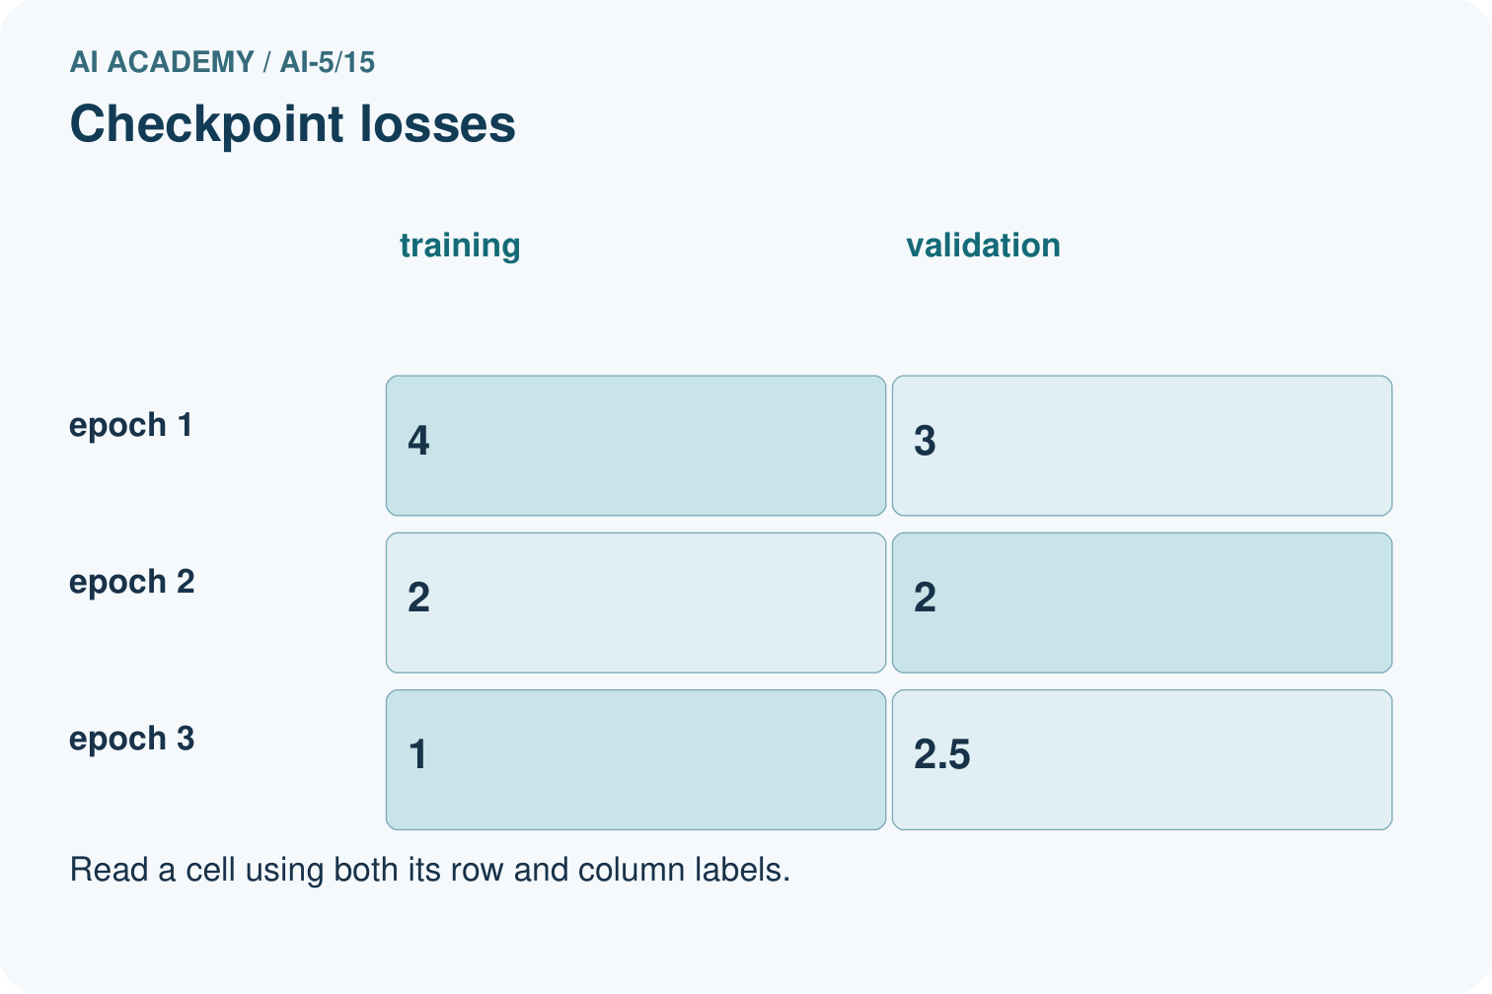
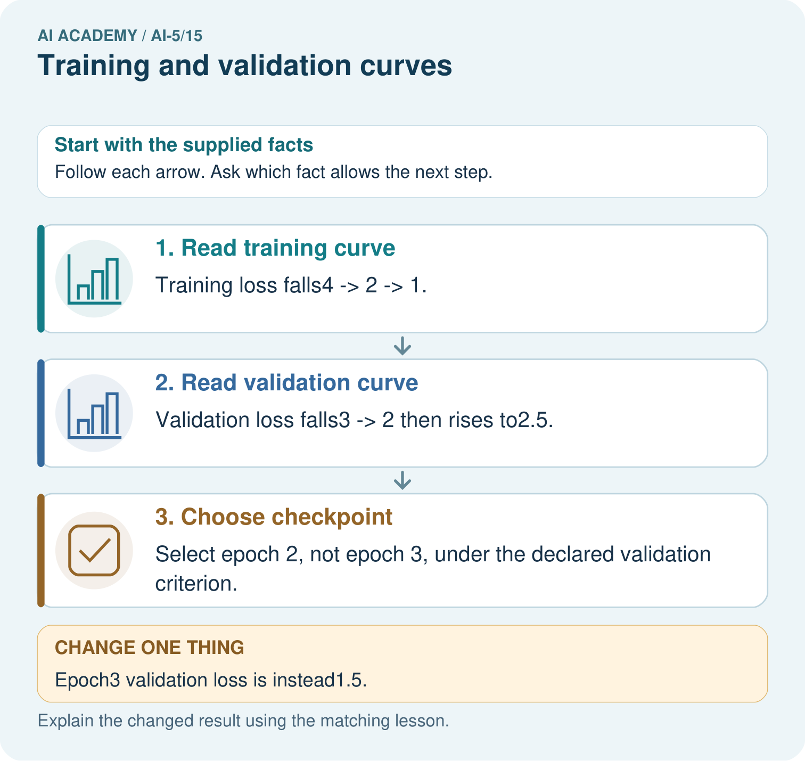

Read the picture one step at a time
Step | What happens and why
1. Read training curve | Training loss falls4→2→1.
2. Read validation curve | Validation loss falls3→2 then rises to2.5.
3. Choose checkpoint | Select epoch 2, not epoch 3, under the declared validation criterion.
Match each pictured step to the supplied facts. This is a worked teaching case, not an independent assessment.

Why this result follows
The training curve measures fit to examples used for learning. The validation curve measures a separate set used to choose a checkpoint. The final training loss is smallest here, but its validation loss has risen. Under the supplied selection rule, keep checkpoint two. A later final test must remain outside both learning and checkpoint selection.

What this example does not establish
A single curve has sampling and run variability; validation-selected checkpoints still require untouched final evidence.
Read the labelled picture: Can the original epoch 3 training loss 1 justify claiming best generalisation? Point to the relevant step in the picture, then write the changed result and the rule or evidence that supports it.
Change one thing: Epoch3 validation loss is instead1.5. Predict the result before checking the explanation. What remains the same?

07. Find and repair a mistake
Falling training loss with rising validation loss can be consistent with overfitting, but it is not a complete diagnosis. In this example the split-specific target rules are known to differ. In another dataset, inspect representativeness, preprocessing, leakage, label quality and evaluation settings before attributing the pattern to model capacity alone.
Evaluate comparable quantities: do not compare a training sum with a validation mean, or a training objective containing a penalty with unpenalised validation MSE. Keep the row sets fixed across checkpoints. Do not mix losses recorded before each batch update with a full-split evaluation of the final checkpoint.

Locate the earliest unsupported step
A training report shows sum of squared errors 12 over six rows. Validation shows mean squared error 3 over two rows in the same target units. A learner says training error is four times larger. Repair the comparison.

State one repair and the checks you would rerun.
________________________________________________________________
________________________________________________________________
________________________________________________________________
________________________________________________________________
________________________________________________________________
________________________________________________________________

08. Practise together
At v = 1, compute both validation predictions, residuals and MSE on (3, 4.5) and (4, 6).

Using the table, calculate the training and validation loss changes from checkpoint 2 to checkpoint 4. Which saved parameter does the selection rule choose?
________________________________________________________________
________________________________________________________________
________________________________________________________________
________________________________________________________________

Explain your prediction to a partner before comparing results.
________________________________________________________________
________________________________________________________________
________________________________________________________________
________________________________________________________________

Practise with less help: Use the declared rule
Use workbook W2 for the connected example “Training and validation curves”. First fill the input and rule boxes. Try the middle steps before asking for a hint. After a hint, try the next step yourself.
Plan | Do | Check
What is given? Which rule or procedure applies? | Record each intermediate step. | Does the result follow? What remains unknown?
Explain your trace to a partner. Your partner points to one step to check. Swap roles on the next case. Each person writes their own explanation.

Check your reasoning
Use the worked case for Training and validation curves. Proposed explanation: “The last checkpoint is always best”. Decide whether this explanation is supported. Point to the step or supplied fact that decides; explain your repair if needed.
Answer on your own before discussion. If you are unsure, say which step you need help with.

Explain the picture
Can the original epoch 3 training loss 1 justify claiming best generalisation? Point to the relevant step in the picture, then write the changed result and the rule or evidence that supports it.

My explanation using a pictured step and the given facts
________________________________________________________________
________________________________________________________________
________________________________________________________________
________________________________________________________________
This is supported practice. Keep the separately named independent case for an attempt before feedback.

09. Run the investigation

Predict, investigate and preserve the evidence
Observed validation MSE at checkpoints 0 to 4 is [5, 2, 1, 1, 1.2]. Lowest loss wins with earlier exact ties. Which checkpoint is selected? What if training loss is lowest at checkpoint 4?
def mse(v, rows):
if not rows:
raise ValueError("Need evaluation rows")
return sum((v * max(0.0, x) - target) ** 2
for x, target in rows) / len(rows)
train = [(1.0, 2.0), (2.0, 4.0)]
valid = [(3.0, 4.5), (4.0, 6.0)]
checkpoints = [0.0, 1.0, 1.5, 1.75, 1.875]
validation_losses = []
for step, v in enumerate(checkpoints):
validation_losses.append(mse(v, valid))
print(step, mse(v, train), mse(v, valid))
best = min(range(len(checkpoints)),
key=lambda i: (validation_losses[i], i))
print("Selected checkpoint", best) # 2
Record | Your evidence
Given input and fixed rule
Prediction before checking
Actual result, or “not run”
First mismatch and one explanation
Boundary or missing input and expected response
On paper, trace the supplied procedure. If code is provided, predict before running it in a local practice file. Never write an expected answer as though it were an observed run.

Plan → try → check
Before trying: what do I expect, and why? While trying: which step could first go wrong? Afterwards: what did I actually observe, and what should change? Keep “not run” if you only traced the procedure.

10. Build your understanding

Explain → apply → challenge
At v = 1, compute both validation predictions, residuals and MSE on (3, 4.5) and (4, 6).
A training report shows sum of squared errors 12 over six rows. Validation shows mean squared error 3 over two rows in the same target units. A learner says training error is four times larger. Repair the comparison.
Training loss falls while validation loss rises. Give two checks before declaring model complexity the cause, and explain why repeatedly selecting with validation makes it development evidence.

Explain which evidence supports your conclusion and which claim remains unproved.
________________________________________________________________
________________________________________________________________
________________________________________________________________
________________________________________________________________
________________________________________________________________

11. Connect your project
Add a labelled training and validation curves evidence sheet to Image-pattern Network Investigation. Show how you can compute comparable training and validation losses at saved checkpoints. Use the supplied fictional case and keep its inputs, intermediate steps, calculation or prediction, and limitation. Connect this record to last week’s record; a matching answer without a trace is insufficient.
Project evidence | Record
Component and version
Inputs permitted at prediction time
Trace and comparison with earlier work
Failure, limit and human review

Evidence for your project
For your Image-pattern Network Investigation, save the input, procedure, observed result and limitation of this check. Label this worked example as practice; use a different, previously unreviewed case when checking independent understanding.

12. Show what you know
Restore checkpoint 2, v = 1.5, if following the declared rule. Its zero validation MSE is a result on two constructed development examples. Choosing this checkpoint using those examples makes them part of model selection. After all choices are frozen, a separate untouched test set can provide final evidence within its own coverage limits.

A team calls checkpoint 2 independently proven because its validation MSE is zero, then uses the test results to choose another checkpoint. Identify both reporting problems and propose a clean procedure.
________________________________________________________________
________________________________________________________________
________________________________________________________________
________________________________________________________________
Next week adds a weight penalty and an early-stopping policy, keeping their roles distinct.
Training loss falls while validation loss rises. Give two checks before declaring model complexity the cause, and explain why repeatedly selecting with validation makes it development evidence.

My limited claim and a useful next check
________________________________________________________________
________________________________________________________________
________________________________________________________________
________________________________________________________________

13. Study a complete case

Complete evidence record

Later updates improve only one split
Series | 2 | 3 | 4
Training solid line | 0.625 | 0.15625 | 0.0390625
Validation dashed line | 0 | 0.78125 | 1.7578125
This chart shows checkpoints 2 to 4 only, on one MSE scale from 0 to 2. Circles and a solid line mark training; squares and a dashed line mark validation. Lines connect measured checkpoints, not additional evaluations. The full table includes checkpoints 0 and 1.
Follow the input through the stated procedure to its result. Cover the result first, predict it, then explain every intermediate step. The text/table accompanies the figure so the example can be read without colour.

My complete trace of the worked case
________________________________________________________________
________________________________________________________________
________________________________________________________________
________________________________________________________________
________________________________________________________________
________________________________________________________________

14. Try a new case independently

Independent case: Evaluate new checkpoints independently
Use h = ReLU(x), y = vh, candidate v values 1, 1.5 and 2. Training pairs are (1, 2), (2, 4); validation pairs are (1, 1), (2, 2). Calculate both MSE columns and select by minimum validation MSE. Explain the disagreement with selection by training loss.

My independent explanation, trace and limits
________________________________________________________________
________________________________________________________________
________________________________________________________________
________________________________________________________________
________________________________________________________________
________________________________________________________________
________________________________________________________________
Attempt this case before feedback. Record any help. Earlier examples below are further practice; a case already practised with feedback cannot establish fresh transfer.

Attempt this without hints
Use h = ReLU(x), y = vh, candidate v values 1, 1.5 and 2. Training pairs are (1, 2), (2, 4); validation pairs are (1, 1), (2, 2). Calculate both MSE columns and select by minimum validation MSE. Explain the disagreement with selection by training loss.

My independent procedure, result and limitation
________________________________________________________________
________________________________________________________________
________________________________________________________________
________________________________________________________________
________________________________________________________________
________________________________________________________________
________________________________________________________________
________________________________________________________________
Record support used: none, hint or teacher explanation. After feedback, a different case is needed to demonstrate independence.

Use feedback to improve
Attempt the independent case before hints. Record whether you worked alone, used a hint or followed a model. After feedback, fix the first unsupported step and explain why it changed. A later check uses a changed case, not a copied answer.

15. Your lesson route
Start with this question: Plot training and validation loss for checkpoints before opening final cases.
By the end, I can | How I will show it
Compute comparable training and validation losses at saved checkpoints | Explain the deciding step, show a trace or test, and state one limit.
Choose among observed checkpoints using a declared validation rule | Explain the deciding step, show a trace or test, and state one limit.
Distinguish development evidence from final test evidence | Explain the deciding step, show a trace or test, and state one limit.
Remember → watch and explain → try with help → investigate → try independently → keep project evidence. Your teacher may spread this lesson across several classes.
Keep your first prediction. Compare it with what the evidence shows and explain any change.

16. Finish and return
Close your notes. Explain this goal in your own words: Compute comparable training and validation losses at saved checkpoints

My deciding step, evidence and one remaining question
________________________________________________________________
________________________________________________________________
________________________________________________________________
________________________________________________________________
________________________________________________________________
If you are unsure, return to the worked picture and explain one arrow. If you are ready, change an input or assumption and justify your prediction.
Save your workbook evidence. At the next review, try a different case before opening your old answer.

