AI ACADEMY · STUDENT · ai-5/19

Learned representations
Project: Image-pattern Network Investigation

Before you start
Why should a debugging trace inspect scores before ReLU as well as final activations?

01. Your mission

Your learning target
I can trace an input through a hidden representation and a decision rule.
I can identify distinctions that a representation preserves or loses.
I can separate a useful constructed feature from evidence of successful learning.

Remember before reading
Close your notes first. A rough first answer helps us choose the right starting point; it is not a score for your ability.
Without opening the old lesson, explain one key idea from Debugging shapes and gradients. Give an example and a mistake that the idea helps you avoid.
Without opening the old lesson, explain one key idea from Regularisation and early stopping. Give an example and a mistake that the idea helps you avoid.
Without opening the old lesson, explain one key idea from Batching and epochs. Give an example and a mistake that the idea helps you avoid.
After trying, check the relevant lesson or ask your teacher. Change the part of your explanation that the evidence shows was wrong.
This week you will practise:
Trace an input through a hidden representation and a decision rule
Identify distinctions that a representation preserves or loses
Separate a useful constructed feature from evidence of successful learning

Retrieve what you already know
Why should a debugging trace inspect scores before ReLU as well as final activations?

My starting explanation
________________________________________________________________
________________________________________________________________
________________________________________________________________

This week’s end goal
By the end, I can explain learned representations using a traced example and a stated limitation.

02. Notice the evidence
Consider fictional rectangles with input [width, height] in cm. The task is to identify rectangles whose width is strictly greater than height. The target is 1 for wider rectangles and 0 otherwise. A square therefore has target 0. This is an arithmetic teaching task, not a claim that a network is needed to measure rectangles.
Define two hidden units: h1 = ReLU(width - height) and h2 = ReLU(height - width). Their weight rows are [1, -1] and [-1, 1], with zero biases. The representation h = [h1, h2] records excess width or excess height. Predict 1 when h1 > 0; otherwise predict 0.
Input | Hidden representation | Prediction
[4, 2] | [2, 0] | 1
[2, 4] | [0, 2] | 0
[3, 3] | [0, 0] | 0
[5, 3] | [2, 0] | 1
These weights were chosen by the lesson author. They demonstrate a representation that could be implemented by a network, but no training run has established that a model learned it. Learning would require adjusting parameters using training data and recording the procedure.

List the given facts and one fact that is not supplied.
________________________________________________________________
________________________________________________________________
________________________________________________________________

03. See how it works
A prediction head is the computation that reads the hidden vector and produces an output. Keeping it separate lets us inspect what information is available before making a decision. This example assumes two finite, positive measurements in cm; it is not a general input validator.
def represent(width, height):
return [max(0, width - height),
max(0, height - width)]
def predict(hidden):
return int(hidden[0] > 0)
examples = [(4, 2), (2, 4), (3, 3), (5, 3)]
for width, height in examples:
hidden = represent(width, height)
print([width, height], hidden, predict(hidden))
assert represent(4, 2) == represent(5, 3)
assert predict(represent(3, 3)) == 0
The raw difference width - height can be recovered as h1 - h2. The original width and height cannot in general be recovered: many rectangles share a difference. Two hidden components do not guarantee preservation of two input components.

Connect the picture and the explanation
Point to the input, the deciding step and the result in this week’s visual. Explain the same step in ordinary words. A picture helps when you can say what each part represents.

04. Compare the cases

Compare a familiar case with a changed case
Give the hidden vectors and areas for [4, 2] and [5, 3]. Explain why increasing only the complexity of a deterministic area head cannot make both exact predictions correct.

Keep the procedure fixed. Explain what changed in the inputs and result.
________________________________________________________________
________________________________________________________________
________________________________________________________________
________________________________________________________________
________________________________________________________________

Change one thing in the pictured case
Change: The head keeps both ordered hidden values instead of their sum.
Prediction: It can distinguish [3, 0] from [0, 3] in this example.
Reason: The representation retains the direction of brightness difference when coordinates stay separate.

05. Words that unlock the idea
Word | Meaning
Representation | An encoding of an example used by another computation
Hidden activation | A value produced inside a network after applying an activation function
Collision | Two different inputs receiving the same representation
Learned feature | A feature whose computation depends on parameters adjusted using training data

Use two terms to explain a step in this week’s example.
________________________________________________________________
________________________________________________________________
________________________________________________________________

06. Follow a worked example

Different rectangles can share a hidden vector
Input in cm | Hidden vector | Area in square cm
Width 4 height 2 | [2, 0] | 8
Width 5 height 3 | [2, 0] | 15
The representation preserves the wider-than-height answer for these examples but discards information needed to recover their different areas. A deterministic head receiving only this vector must give both examples the same output.

Encode [6, 4] and [7, 5]. Give their wider-than-height predictions and areas. Can a head that sees only h always recover the exact area? Explain using this pair.
________________________________________________________________
________________________________________________________________
________________________________________________________________
________________________________________________________________

Learn from the worked case
Cover the result before checking it. Say what is given, choose the procedure, and follow one step at a time. Then uncover the result and explain your first mismatch. Ask why a step is allowed, not only what number it produces.

A pictorial worked case: Learned representations
See when a representation preserves a distinction and when it destroys it.

The facts we will use
Toy input [left, right]; representation h=[ReLU(left-right), ReLU(right-left)]. A=[5, 2]; B=[2, 5]; target is left-brighter versus right-brighter.
All inputs and outcomes in this worked example are invented classroom data; no real model run is claimed.
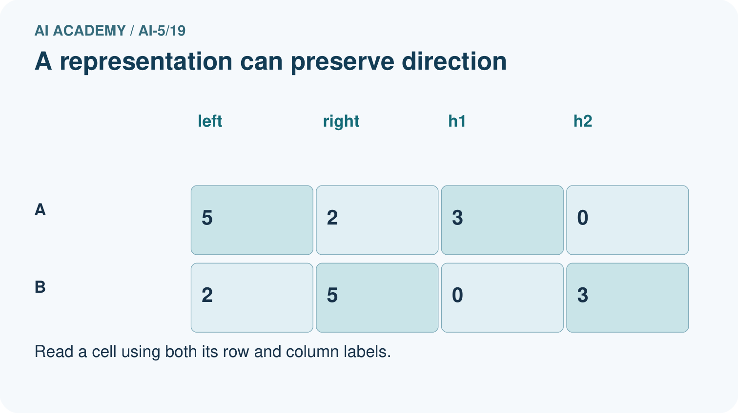
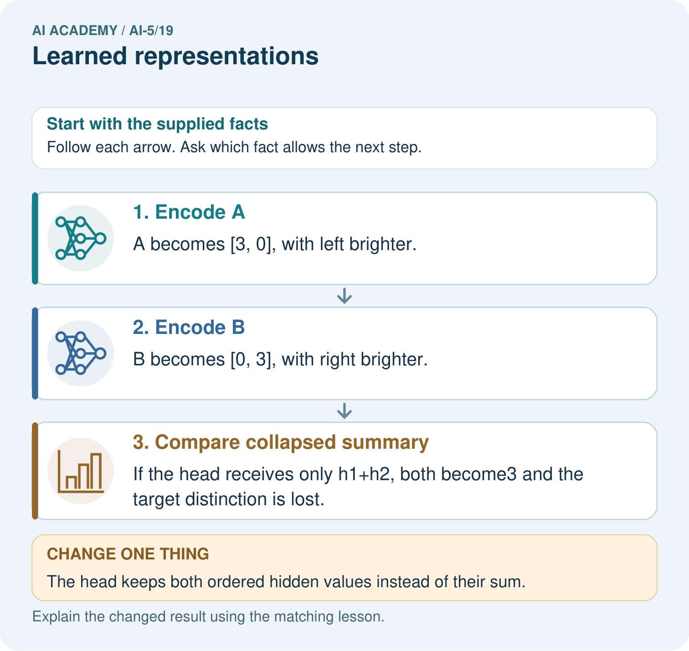

Read the picture one step at a time
Step | What happens and why
1. Encode A | A becomes [3, 0], with left brighter.
2. Encode B | B becomes [0, 3], with right brighter.
3. Compare collapsed summary | If the head receives only h1+h2, both become3 and the target distinction is lost.
Match each pictured step to the supplied facts. This is a worked teaching case, not an independent assessment.

Why this result follows
A hidden representation decides which distinctions remain available to an output head. These two hidden coordinates preserve whether the left or right side is brighter. Adding them discards that direction and gives both examples the same scalar. A deterministic head cannot assign different labels to identical inputs; retain the distinction or change the task.

What this example does not establish
This is a hand-chosen representation, not evidence that a trained image model actually learned these units.
Read the labelled picture: Why can no deterministic head using only the sum classify both correctly? Point to the relevant step in the picture, then write the changed result and the rule or evidence that supports it.
Change one thing: The head keeps both ordered hidden values instead of their sum. Predict the result before checking the explanation. What remains the same?

07. Find and repair a mistake
A representation can be sufficient for one task and insufficient for another. Our hidden vector supports the wider-than-height rule for every valid input under the stated formula. It fails to identify exact area for all rectangles because a collision can contain different areas. No more complicated deterministic head can recover information that is absent from its input.
Compare a second encoding s = width + height. Rectangles [4, 2] and [2, 4] both give s = 6 but have different wider-than-height targets. A head receiving only s must fail on at least one of them. Useful features depend on the question, not just the number of encoded values.
One repair for area is to retain the original measurements. Another is to append s to h. Since d = h1 - h2, width = (s + d) / 2 and height = (s - d) / 2. This works with exact valid measurements; it does not mean every added feature improves generalisation on noisy data.

Locate the earliest unsupported step
The alternative representation is s = width + height. Use [4, 2] and [2, 4] to decide whether s alone always supports the wider-than-height task.

State one repair and the checks you would rerun.
________________________________________________________________
________________________________________________________________
________________________________________________________________
________________________________________________________________
________________________________________________________________
________________________________________________________________

08. Practise together
Encode [8, 3], [3, 8] and [4, 4] with the lesson layer. Apply its prediction rule and explain the square boundary.

Encode [6, 4] and [7, 5]. Give their wider-than-height predictions and areas. Can a head that sees only h always recover the exact area? Explain using this pair.
________________________________________________________________
________________________________________________________________
________________________________________________________________
________________________________________________________________

Explain your prediction to a partner before comparing results.
________________________________________________________________
________________________________________________________________
________________________________________________________________
________________________________________________________________

Practise with less help: Prove an information loss
Use workbook W2 for the connected example “Learned representations”. First fill the input and rule boxes. Try the middle steps before asking for a hint. After a hint, try the next step yourself.
Plan | Do | Check
What is given? Which rule or procedure applies? | Record each intermediate step. | Does the result follow? What remains unknown?
Explain your trace to a partner. Your partner points to one step to check. Swap roles on the next case. Each person writes their own explanation.

Check your reasoning
Use the worked case for Learned representations. Proposed explanation: “Two hidden values preserve both input measurements”. Decide whether this explanation is supported. Point to the step or supplied fact that decides; explain your repair if needed.
Answer on your own before discussion. If you are unsure, say which step you need help with.

Explain the picture
Why can no deterministic head using only the sum classify both correctly? Point to the relevant step in the picture, then write the changed result and the rule or evidence that supports it.

My explanation using a pictured step and the given facts
________________________________________________________________
________________________________________________________________
________________________________________________________________
________________________________________________________________
This is supported practice. Keep the separately named independent case for an attempt before feedback.

09. Run the investigation

Predict, investigate and preserve the evidence
Give the hidden vectors and areas for [4, 2] and [5, 3]. Explain why increasing only the complexity of a deterministic area head cannot make both exact predictions correct.
def represent(width, height):
return [max(0, width - height),
max(0, height - width)]
def predict(hidden):
return int(hidden[0] > 0)
examples = [(4, 2), (2, 4), (3, 3), (5, 3)]
for width, height in examples:
hidden = represent(width, height)
print([width, height], hidden, predict(hidden))
assert represent(4, 2) == represent(5, 3)
assert predict(represent(3, 3)) == 0
Record | Your evidence
Given input and fixed rule
Prediction before checking
Actual result, or “not run”
First mismatch and one explanation
Boundary or missing input and expected response
On paper, trace the supplied procedure. If code is provided, predict before running it in a local practice file. Never write an expected answer as though it were an observed run.

Plan → try → check
Before trying: what do I expect, and why? While trying: which step could first go wrong? Afterwards: what did I actually observe, and what should change? Keep “not run” if you only traced the procedure.

10. Build your understanding

Explain → apply → challenge
Encode [8, 3], [3, 8] and [4, 4] with the lesson layer. Apply its prediction rule and explain the square boundary.
The alternative representation is s = width + height. Use [4, 2] and [2, 4] to decide whether s alone always supports the wider-than-height task.
For h = [2, 0] and s = 8, recover width, height and area. Does this algebra prove that a training program learned the representation or that it will work well on noisy measurements?

Explain which evidence supports your conclusion and which claim remains unproved.
________________________________________________________________
________________________________________________________________
________________________________________________________________
________________________________________________________________
________________________________________________________________

11. Connect your project
Add a labelled learned representations evidence sheet to Image-pattern Network Investigation. Show how you can trace an input through a hidden representation and a decision rule. Use the supplied fictional case and keep its inputs, intermediate steps, calculation or prediction, and limitation. Connect this record to last week’s record; a matching answer without a trace is insufficient.
Project evidence | Record
Component and version
Inputs permitted at prediction time
Trace and comparison with earlier work
Failure, limit and human review

Evidence for your project
For your Image-pattern Network Investigation, save the input, procedure, observed result and limitation of this check. Label this worked example as practice; use a different, previously unreviewed case when checking independent understanding.

12. Show what you know
In a trained network, hidden features depend on fitted weights and may not have simple human names. A strong output result does not by itself show that a unit represents a concept such as shape or fairness. Inspect activations on deliberately varied examples, compare with a baseline, and limit conclusions to the evidence.

A teammate calls the hand-chosen rectangle layer a learned area detector because all four wider-than-height predictions are correct. Identify two problems with this claim and propose one decisive area check.
________________________________________________________________
________________________________________________________________
________________________________________________________________
________________________________________________________________
When testing a learned representation, fit preprocessing and parameters on training data, use validation data for choices, and reserve the final test for the declared final evaluation. Compare representations with matched data, head rules and training budgets, and report collisions and failures. Next week makes the axis and channel meanings of image tensors explicit.
For h = [2, 0] and s = 8, recover width, height and area. Does this algebra prove that a training program learned the representation or that it will work well on noisy measurements?

My limited claim and a useful next check
________________________________________________________________
________________________________________________________________
________________________________________________________________
________________________________________________________________

13. Study a complete case

Complete evidence record

Different rectangles can share a hidden vector
Input in cm | Hidden vector | Area in square cm
Width 4 height 2 | [2, 0] | 8
Width 5 height 3 | [2, 0] | 15
The representation preserves the wider-than-height answer for these examples but discards information needed to recover their different areas. A deterministic head receiving only this vector must give both examples the same output.
Follow the input through the stated procedure to its result. Cover the result first, predict it, then explain every intermediate step. The text/table accompanies the figure so the example can be read without colour.

My complete trace of the worked case
________________________________________________________________
________________________________________________________________
________________________________________________________________
________________________________________________________________
________________________________________________________________
________________________________________________________________

14. Try a new case independently

Independent case: Audit a new representation independently
A different layer uses g = [ReLU(width - height - 1), ReLU(height - width - 1)]. Encode [4, 3] and [3, 4]. State their targets for width strictly greater than height. Can any deterministic head receiving only g classify both correctly?

My independent explanation, trace and limits
________________________________________________________________
________________________________________________________________
________________________________________________________________
________________________________________________________________
________________________________________________________________
________________________________________________________________
________________________________________________________________
Attempt this case before feedback. Record any help. Earlier examples below are further practice; a case already practised with feedback cannot establish fresh transfer.

Attempt this without hints
A different layer uses g = [ReLU(width - height - 1), ReLU(height - width - 1)]. Encode [4, 3] and [3, 4]. State their targets for width strictly greater than height. Can any deterministic head receiving only g classify both correctly?

My independent procedure, result and limitation
________________________________________________________________
________________________________________________________________
________________________________________________________________
________________________________________________________________
________________________________________________________________
________________________________________________________________
________________________________________________________________
________________________________________________________________
Record support used: none, hint or teacher explanation. After feedback, a different case is needed to demonstrate independence.

Use feedback to improve
Attempt the independent case before hints. Record whether you worked alone, used a hint or followed a model. After feedback, fix the first unsupported step and explain why it changed. A later check uses a changed case, not a copied answer.

15. Your lesson route
Start with this question: See when a representation preserves a distinction and when it destroys it.
By the end, I can | How I will show it
Trace an input through a hidden representation and a decision rule | Explain the deciding step, show a trace or test, and state one limit.
Identify distinctions that a representation preserves or loses | Explain the deciding step, show a trace or test, and state one limit.
Separate a useful constructed feature from evidence of successful learning | Explain the deciding step, show a trace or test, and state one limit.
Remember → watch and explain → try with help → investigate → try independently → keep project evidence. Your teacher may spread this lesson across several classes.
Keep your first prediction. Compare it with what the evidence shows and explain any change.

16. Finish and return
Close your notes. Explain this goal in your own words: Trace an input through a hidden representation and a decision rule

My deciding step, evidence and one remaining question
________________________________________________________________
________________________________________________________________
________________________________________________________________
________________________________________________________________
________________________________________________________________
If you are unsure, return to the worked picture and explain one arrow. If you are ready, change an input or assumption and justify your prediction.
Save your workbook evidence. At the next review, try a different case before opening your old answer.

