AI ACADEMY · STUDENT · ai-5/20

Image tensors and channels
Project: Image-pattern Network Investigation

Before you start
Why does a representation with two components not necessarily preserve two original measurements?

01. Your mission

Your learning target
I can read a pixel using declared row column and channel axes.
I can convert channel layout without changing pixel meaning.
I can distinguish fixed value scaling from information losing transformations.

Remember before reading
Close your notes first. A rough first answer helps us choose the right starting point; it is not a score for your ability.
Without opening the old lesson, explain one key idea from Learned representations. Give an example and a mistake that the idea helps you avoid.
Without opening the old lesson, explain one key idea from Initialisation and reproducibility. Give an example and a mistake that the idea helps you avoid.
Without opening the old lesson, explain one key idea from Learning rate experiments. Give an example and a mistake that the idea helps you avoid.
After trying, check the relevant lesson or ask your teacher. Change the part of your explanation that the evidence shows was wrong.
This week you will practise:
Read a pixel using declared row column and channel axes
Convert channel layout without changing pixel meaning
Distinguish fixed value scaling from information losing transformations

Retrieve what you already know
Why does a representation with two components not necessarily preserve two original measurements?

My starting explanation
________________________________________________________________
________________________________________________________________
________________________________________________________________

This week’s end goal
By the end, I can explain image tensors and channels using a traced example and a stated limitation.

02. Notice the evidence
A small fictional RGB image has height 2 pixels, width 2 pixels and three channels ordered red, green, blue. Store it as image[row][column][channel], abbreviated HWC. Use zero-based indices: the top row is 0, the left column is 0, and red, green and blue are channels 0, 1 and 2. Each stored component is an integer from 0 to 255.
Position | RGB triplet | Meaning
Row 0 column 0 | [255, 0, 0] | Red
Row 0 column 1 | [0, 255, 0] | Green
Row 1 column 0 | [0, 0, 255] | Blue
Row 1 column 1 | [255, 255, 255] | White
The shape is 2 by 2 by 3. There are four pixels and twelve channel values. The blue component of the bottom-left pixel is image[1][0][2] = 255. A single channel is a plane of values across positions; it is not a separate photograph or a label.
Shape needs a schema. A grayscale image might be stored as H by W or H by W by 1. An RGB image uses three channels here; other formats can include additional channels. Declare the format instead of assuming every three-dimensional array means the same thing.

List the given facts and one fact that is not supplied.
________________________________________________________________
________________________________________________________________
________________________________________________________________

03. See how it works
A channel-first layout uses image[channel][row][column], abbreviated CHW. Our image then has shape 3 by 2 by 2. A correct conversion preserves the rule chw[c][r][k] = hwc[r][k][c]. The code assumes a nonempty rectangular image with exactly three values per pixel.
hwc = [
[[255, 0, 0], [0, 255, 0]],
[[0, 0, 255], [255, 255, 255]],
]
height, width = len(hwc), len(hwc[0])
chw = [[[hwc[r][k][c] for k in range(width)]
for r in range(height)] for c in range(3)]
for channel in chw:
print(channel)
assert chw[2][1][0] == hwc[1][0][2] == 255
restored = [[[chw[c][r][k] for c in range(3)]
for k in range(width)] for r in range(height)]
assert restored == hwc
Reading nested values in order and merely regrouping them into a new shape does not perform this axis conversion. The first four flattened HWC values are [255, 0, 0, 0]. A naive regrouping makes these the first channel plane, but the correct red plane is [[255, 0], [0, 255]]. Shape agreement alone cannot detect this mistake.

Connect the picture and the explanation
Point to the input, the deciding step and the result in this week’s visual. Explain the same step in ordinary words. A picture helps when you can say what each part represents.

04. Compare the cases

Compare a familiar case with a changed case
A program flattens the lesson HWC array and groups the first four values into a 2 by 2 red plane. Give that incorrect plane and the correct plane. Identify a position where they disagree.

Keep the procedure fixed. Explain what changed in the inputs and result.
________________________________________________________________
________________________________________________________________
________________________________________________________________
________________________________________________________________
________________________________________________________________

Change one thing in the pictured case
Change: Add a batch containing three identical images in NHWC layout.
Prediction: Batch shape is [3, 2, 1, 3].
Reason: The new first dimension counts images; it does not add a fourth colour channel.

05. Words that unlock the idea
Word | Meaning
Tensor | A numerical array with a declared set of axes
Channel | One component plane of an image such as red green or blue
Axis order | The sequence of meanings assigned to array dimensions
Value scaling | A declared numerical conversion applied to stored values

Use two terms to explain a step in this week’s example.
________________________________________________________________
________________________________________________________________
________________________________________________________________

06. Follow a worked example

The same pixels in three channel planes
Channel | Top row | Bottom row
Red c 0 | [255, 0] | [0, 255]
Green c 1 | [0, 255] | [0, 255]
Blue c 2 | [0, 0] | [255, 255]
Each row describes one channel plane. Within a plane the first listed row is the image top and the second is the bottom. Combining the three values at the same position recovers its RGB triplet.

Use the planes to reconstruct the top-right and bottom-right RGB pixels. Give both HWC and CHW indices for the top-right green value.
________________________________________________________________
________________________________________________________________
________________________________________________________________
________________________________________________________________

Learn from the worked case
Cover the result before checking it. Say what is given, choose the procedure, and follow one step at a time. Then uncover the result and explain your first mismatch. Ask why a step is allowed, not only what number it produces.

A pictorial worked case: Image tensors and channels
Move colour values between tensor layouts without changing the pixels.

The facts we will use
Toy RGB image has 2 rows, 1 column. Top pixel [1, 4, 7]; bottom [2, 5, 8]. HWC means height, width, channel.
All inputs and outcomes in this worked example are invented classroom data; no real model run is claimed.
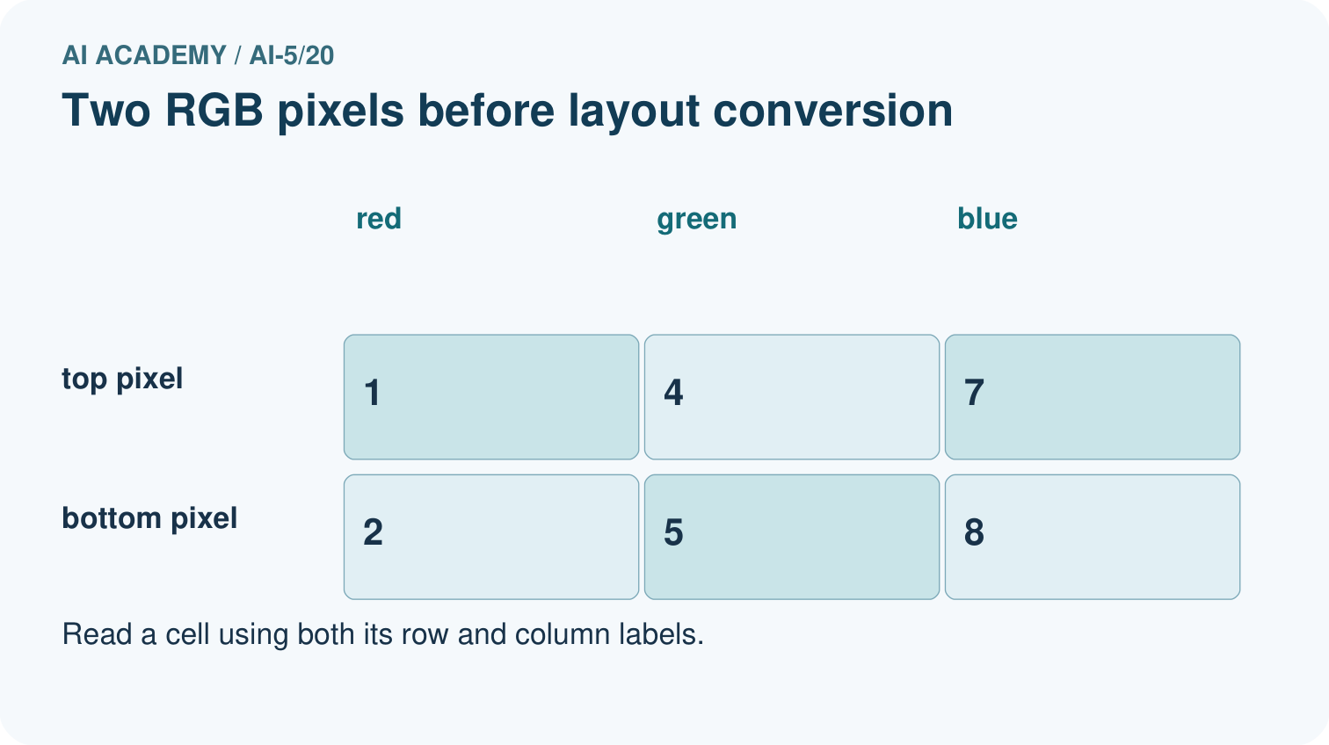
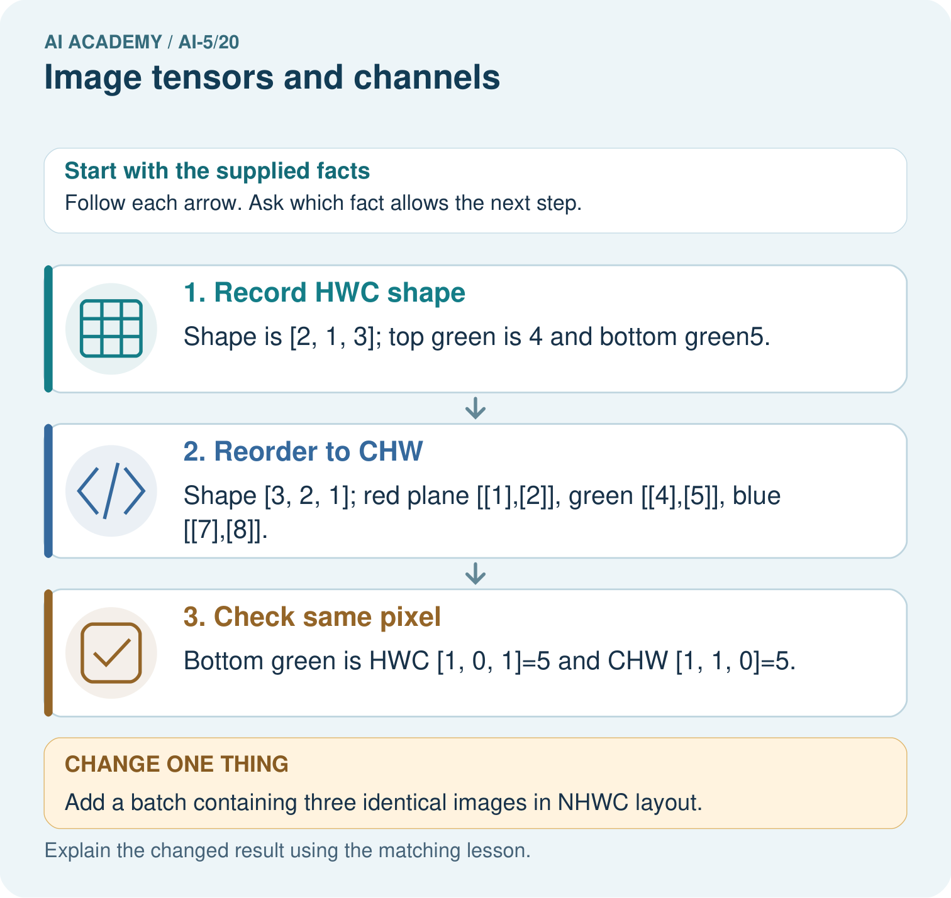

Read the picture one step at a time
Step | What happens and why
1. Record HWC shape | Shape is [2, 1, 3]; top green is 4 and bottom green5.
2. Reorder to CHW | Shape [3, 2, 1]; red plane [[1],[2]], green [[4],[5]], blue [[7],[8]].
3. Check same pixel | Bottom green is HWC [1, 0, 1]=5 and CHW [1, 1, 0]=5.
Match each pictured step to the supplied facts. This is a worked teaching case, not an independent assessment.

Why this result follows
A tensor is an array with named dimensions. HWC orders height, width and colour; CHW puts colour first. Rearranging the layout changes where values are stored, not the colour measurement itself. Trace a named pixel through both layouts using zero-based indices. Adding a batch dimension counts images and does not add a new colour channel.

What this example does not establish
Shape consistency does not prove correct colour order or value range; document channel names and preprocessing.
Read the labelled picture: Where is the bottom green pixel in the first batched image? Point to the relevant step in the picture, then write the changed result and the rule or evidence that supports it.
Change one thing: Add a batch containing three identical images in NHWC layout. Predict the result before checking the explanation. What remains the same?

07. Find and repair a mistake
For this lesson, divide every channel value by 255 to obtain floating-point values from 0 to 1. Thus [255, 128, 0] becomes [1, 128/255, 0], with the middle value approximately 0.502. This fixed conversion does not fit a statistic from data. Apply the same conversion during training and later use, and record whether an input is already scaled.
Dividing twice makes a raw value of 255 become 1/255, approximately 0.00392, instead of 1. Integer rounding after scaling can also erase distinctions. In exact arithmetic the declared division is reversible by multiplication; finite precision or deliberate rounding can limit exact recovery.
Averaging RGB channels is a different operation. The classroom mean gives red [255, 0, 0] and green [0, 255, 0] the same value 85, losing their colour distinction. It is a simple illustration, not a perceptual brightness formula. If preprocessing instead estimates means or spreads from a dataset, fit those statistics using training data only.

Locate the earliest unsupported step
Scale [255, 128, 0] by 255, keeping the middle value as a fraction. Then calculate the classroom RGB means of pure red and pure green. Which operation loses the distinction between those colours?

State one repair and the checks you would rerun.
________________________________________________________________
________________________________________________________________
________________________________________________________________
________________________________________________________________
________________________________________________________________
________________________________________________________________

08. Practise together
For the lesson image, give image[1][0], image[1][0][2], the HWC shape, pixel count and number of channel values.

Use the planes to reconstruct the top-right and bottom-right RGB pixels. Give both HWC and CHW indices for the top-right green value.
________________________________________________________________
________________________________________________________________
________________________________________________________________
________________________________________________________________

Explain your prediction to a partner before comparing results.
________________________________________________________________
________________________________________________________________
________________________________________________________________
________________________________________________________________

Practise with less help: Audit an axis conversion
Use workbook W2 for the connected example “Image tensors and channels”. First fill the input and rule boxes. Try the middle steps before asking for a hint. After a hint, try the next step yourself.
Plan | Do | Check
What is given? Which rule or procedure applies? | Record each intermediate step. | Does the result follow? What remains unknown?
Explain your trace to a partner. Your partner points to one step to check. Swap roles on the next case. Each person writes their own explanation.

Check your reasoning
Use the worked case for Image tensors and channels. Proposed explanation: “Three channels mean three images”. Decide whether this explanation is supported. Point to the step or supplied fact that decides; explain your repair if needed.
Answer on your own before discussion. If you are unsure, say which step you need help with.

Explain the picture
Where is the bottom green pixel in the first batched image? Point to the relevant step in the picture, then write the changed result and the rule or evidence that supports it.

My explanation using a pictured step and the given facts
________________________________________________________________
________________________________________________________________
________________________________________________________________
________________________________________________________________
This is supported practice. Keep the separately named independent case for an attempt before feedback.

09. Run the investigation

Predict, investigate and preserve the evidence
A program flattens the lesson HWC array and groups the first four values into a 2 by 2 red plane. Give that incorrect plane and the correct plane. Identify a position where they disagree.
hwc = [
[[255, 0, 0], [0, 255, 0]],
[[0, 0, 255], [255, 255, 255]],
]
height, width = len(hwc), len(hwc[0])
chw = [[[hwc[r][k][c] for k in range(width)]
for r in range(height)] for c in range(3)]
for channel in chw:
print(channel)
assert chw[2][1][0] == hwc[1][0][2] == 255
restored = [[[chw[c][r][k] for c in range(3)]
for k in range(width)] for r in range(height)]
assert restored == hwc
Record | Your evidence
Given input and fixed rule
Prediction before checking
Actual result, or “not run”
First mismatch and one explanation
Boundary or missing input and expected response
On paper, trace the supplied procedure. If code is provided, predict before running it in a local practice file. Never write an expected answer as though it were an observed run.

Plan → try → check
Before trying: what do I expect, and why? While trying: which step could first go wrong? Afterwards: what did I actually observe, and what should change? Keep “not run” if you only traced the procedure.

10. Build your understanding

Explain → apply → challenge
For the lesson image, give image[1][0], image[1][0][2], the HWC shape, pixel count and number of channel values.
Scale [255, 128, 0] by 255, keeping the middle value as a fraction. Then calculate the classroom RGB means of pure red and pure green. Which operation loses the distinction between those colours?
The lesson image is loaded with red and blue exchanged, then scaled twice. Give two expected checks that would expose these errors even though the shape is correct.

Explain which evidence supports your conclusion and which claim remains unproved.
________________________________________________________________
________________________________________________________________
________________________________________________________________
________________________________________________________________
________________________________________________________________

11. Connect your project
Add a labelled image tensors and channels evidence sheet to Image-pattern Network Investigation. Show how you can read a pixel using declared row column and channel axes. Use the supplied fictional case and keep its inputs, intermediate steps, calculation or prediction, and limitation. Connect this record to last week’s record; a matching answer without a trace is insufficient.
Project evidence | Record
Component and version
Inputs permitted at prediction time
Trace and comparison with earlier work
Failure, limit and human review

Evidence for your project
For your Image-pattern Network Investigation, save the input, procedure, observed result and limitation of this check. Label this worked example as practice; use a different, previously unreviewed case when checking independent understanding.

12. Show what you know
Stacking five same-size HWC images adds a leading example axis N. This batch has shape 5 by 2 by 2 by 3 and contains 60 channel values. With channel-first images, its shape is 5 by 3 by 2 by 2. The example axis is not another colour channel. Every axis must keep its meaning through the model.

A loader returns the expected shape, but red and blue channels were exchanged and already scaled values were divided by 255 again. Does the shape check establish correctness? Name an exact pixel check and a value check that expose these faults.
________________________________________________________________
________________________________________________________________
________________________________________________________________
________________________________________________________________
Use a tiny known image, named axis meanings and expected channel values to check a pipeline. Keep original images when testing transformations. Flattening can be reversed if shape and traversal order are retained; averaging colours generally cannot. Next week reads small neighbourhoods with a convolution operation.
The lesson image is loaded with red and blue exchanged, then scaled twice. Give two expected checks that would expose these errors even though the shape is correct.

My limited claim and a useful next check
________________________________________________________________
________________________________________________________________
________________________________________________________________
________________________________________________________________

13. Study a complete case

Complete evidence record

The same pixels in three channel planes
Channel | Top row | Bottom row
Red c 0 | [255, 0] | [0, 255]
Green c 1 | [0, 255] | [0, 255]
Blue c 2 | [0, 0] | [255, 255]
Each row describes one channel plane. Within a plane the first listed row is the image top and the second is the bottom. Combining the three values at the same position recovers its RGB triplet.
Follow the input through the stated procedure to its result. Cover the result first, predict it, then explain every intermediate step. The text/table accompanies the figure so the example can be read without colour.

My complete trace of the worked case
________________________________________________________________
________________________________________________________________
________________________________________________________________
________________________________________________________________
________________________________________________________________
________________________________________________________________

14. Try a new case independently

Independent case: Convert a new image independently
A one-row two-column RGB image has pixels [10, 20, 30] then [40, 50, 60]. State its HWC shape and all three CHW planes. Give the green value at row 0 column 1 in both layouts. A batch contains four copies: give its NHWC shape and total channel-value count.

My independent explanation, trace and limits
________________________________________________________________
________________________________________________________________
________________________________________________________________
________________________________________________________________
________________________________________________________________
________________________________________________________________
________________________________________________________________
Attempt this case before feedback. Record any help. Earlier examples below are further practice; a case already practised with feedback cannot establish fresh transfer.

Attempt this without hints
A one-row two-column RGB image has pixels [10, 20, 30] then [40, 50, 60]. State its HWC shape and all three CHW planes. Give the green value at row 0 column 1 in both layouts. A batch contains four copies: give its NHWC shape and total channel-value count.

My independent procedure, result and limitation
________________________________________________________________
________________________________________________________________
________________________________________________________________
________________________________________________________________
________________________________________________________________
________________________________________________________________
________________________________________________________________
________________________________________________________________
Record support used: none, hint or teacher explanation. After feedback, a different case is needed to demonstrate independence.

Use feedback to improve
Attempt the independent case before hints. Record whether you worked alone, used a hint or followed a model. After feedback, fix the first unsupported step and explain why it changed. A later check uses a changed case, not a copied answer.

15. Your lesson route
Start with this question: Move colour values between tensor layouts without changing the pixels.
By the end, I can | How I will show it
Read a pixel using declared row column and channel axes | Explain the deciding step, show a trace or test, and state one limit.
Convert channel layout without changing pixel meaning | Explain the deciding step, show a trace or test, and state one limit.
Distinguish fixed value scaling from information losing transformations | Explain the deciding step, show a trace or test, and state one limit.
Remember → watch and explain → try with help → investigate → try independently → keep project evidence. Your teacher may spread this lesson across several classes.
Keep your first prediction. Compare it with what the evidence shows and explain any change.

16. Finish and return
Close your notes. Explain this goal in your own words: Read a pixel using declared row column and channel axes

My deciding step, evidence and one remaining question
________________________________________________________________
________________________________________________________________
________________________________________________________________
________________________________________________________________
________________________________________________________________
If you are unsure, return to the worked picture and explain one arrow. If you are ready, change an input or assumption and justify your prediction.
Save your workbook evidence. At the next review, try a different case before opening your old answer.

