AI ACADEMY · STUDENT · ai-5/33

Capstone hypothesis and baseline
Project: Image-pattern Network Investigation

Before you start
Why must a checkpoint chosen using validation data still face an untouched final test?

01. Your mission

Your learning target
I can write a testable capstone hypothesis and a credible baseline.
I can specify data roles and a selection rule before inspecting results.
I can calculate baseline MSE and distinguish a success criterion from a result.

Remember before reading
Close your notes first. A rough first answer helps us choose the right starting point; it is not a score for your ability.
Without opening the old lesson, explain one key idea from Documenting a network experiment. Give an example and a mistake that the idea helps you avoid.
Without opening the old lesson, explain one key idea from Dataset shift in neural models. Give an example and a mistake that the idea helps you avoid.
Without opening the old lesson, explain one key idea from Similarity and normalisation. Give an example and a mistake that the idea helps you avoid.
After trying, check the relevant lesson or ask your teacher. Change the part of your explanation that the evidence shows was wrong.
This week you will practise:
Write a testable capstone hypothesis and a credible baseline
Specify data roles and a selection rule before inspecting results
Calculate baseline MSE and distinguish a success criterion from a result

Retrieve what you already know
Why must a checkpoint chosen using validation data still face an untouched final test?

My starting explanation
________________________________________________________________
________________________________________________________________
________________________________________________________________

This week’s end goal
Explain capstone hypothesis and baseline with a traceable toy-network case and a bounded conclusion.

02. Notice the evidence
A capstone needs a question that evidence can answer. “Build a better network” leaves better undefined. Here the question is: does two-update full-batch fitting of one scalar ReLU weight reduce validation mean squared error relative to the initial-weight baseline on a constructed positive-input task? Predict max(0, a*x), with no bias. The baseline has a = 1. The trained candidate starts at a = 1, uses learning rate 0.1 and exactly two updates. These choices are written before results are inspected.
The hypothesis is that the trained candidate has lower validation MSE. The plan does not guarantee that result. This task tests training and record keeping, not whether neural networks are preferable to every other model. A stronger comparison may also include an ordinary fitted line.

List the given facts and one fact that is not supplied.
________________________________________________________________
________________________________________________________________
________________________________________________________________

03. See how it works
Role and ID | x | y
Training T1 | 1 | 2
Training T2 | 2 | 4
Validation V1 | 3 | 6
Validation V2 | 4 | 8
Final test | Sealed | Sealed
Training rows determine updates. Validation rows compare the prespecified candidate with the baseline. The final-test inputs and targets remain sealed until the procedure and reporting plan are frozen. MSE = sum of squared prediction errors divided by the number of evaluated rows. Baseline predictions on V1 and V2 are 3 and 4. Errors are -3 and -4, squared errors 9 and 16, and validation MSE is 25/2 = 12.5. There are two validation cases.

Keep the evidence roles separate
Plan or input | Procedure | Permitted conclusion
T1 and T2 | Fit two updates | Training result only
V1 and V2 | Compare with a = 1 | Validation comparison
Sealed final rows | Evaluate frozen procedure | Final evidence on those rows
Each arrow preserves a distinct data role. Opening final rows to choose a learning rate changes their role.

Connect the picture and the explanation
Point to the input, the deciding step and the result in this week’s visual. Explain the same step in ordinary words. A picture helps when you can say what each part represents.

04. Compare the cases

Compare a familiar case with a changed case
Compute baseline predictions, errors, squared errors and MSE on V1 and V2. State the denominator.

Keep the procedure fixed. Explain what changed in the inputs and result.
________________________________________________________________
________________________________________________________________
________________________________________________________________
________________________________________________________________
________________________________________________________________

Change one thing in the pictured case
Change: Give only B the eight evaluation labels during training.
Prediction: The proposed comparison becomes contaminated rather than a valid held-out test.
Reason: One version has gained privileged information from the reserved evaluation set.

05. Words that unlock the idea
Word | Meaning
Hypothesis | A testable expectation with a stated comparison and outcome
Baseline | A specified reference procedure evaluated on the same cases
Success criterion | A rule written before evaluation for judging the measured result
Reserved test | Cases kept out of fitting, tuning and selection

Use two terms to explain a step in this week’s example.
________________________________________________________________
________________________________________________________________
________________________________________________________________

06. Follow a worked example
The validation criterion is candidate MSE strictly below baseline MSE on V1 and V2. Equality does not pass. The final criterion is lower MSE than the same baseline on the sealed final rows. Report both scores and every raw prediction whether or not the criterion passes. Record the rule, training rows, update count, learning rate, loss, data versions and code version. A criterion specifies how to judge a future result; it is not evidence that the result already happened.
Keep validation and final criteria separate. Do not silently add epochs or change preprocessing after seeing a weak result. A changed plan is a new version and needs an honest account of what evidence informed it.

Learn from the worked case
Cover the result before checking it. Say what is given, choose the procedure, and follow one step at a time. Then uncover the result and explain your first mismatch. Ask why a step is allowed, not only what number it produces.

A pictorial worked case: Capstone hypothesis and baseline
A testable image-pattern hypothesis. A team proposes that including the centre-pixel feature improves a small fixed network’s classification of toy image patterns.

The facts we will use
Two frozen versions are planned: A uses corner features only; B also uses the centre feature. Eight reserved toy patterns have labels defined before scoring.
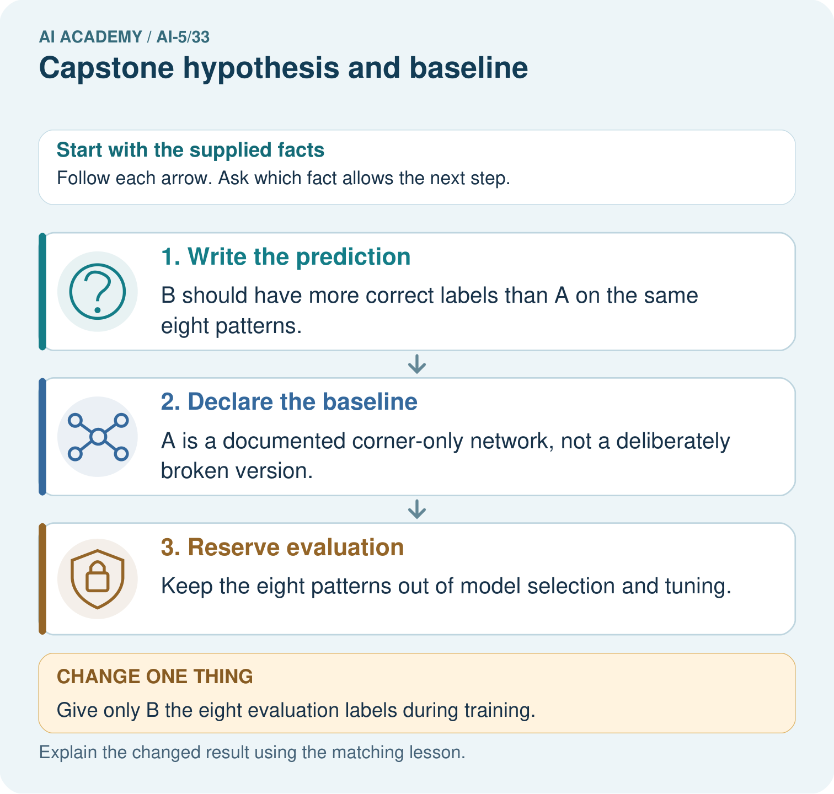

Read the picture one step at a time
Step | What happens and why
1. Write the prediction | B should have more correct labels than A on the same eight patterns.
2. Declare the baseline | A is a documented corner-only network, not a deliberately broken version.
3. Reserve evaluation | Keep the eight patterns out of model selection and tuning.
Match each pictured step to the supplied facts. This is a worked teaching case, not an independent assessment.

Why this result follows
A capstone hypothesis links a specific architectural change to a measured outcome. A baseline anchors the comparison; frozen labels and held-out patterns protect it from answer-key tuning.

What this example does not establish
Eight toy patterns support a narrow experiment, not claims about real photographs, children or universal architecture superiority.
Read the labelled picture: Name the intended change, the baseline and the measured outcome. Why must both versions avoid training on the eight reserved labels?
Change one thing: Give only B the eight evaluation labels during training. Predict the result before checking the explanation. What remains the same?

07. Find and repair a mistake
Supported example: a separate baseline predicts 2 and 4 for validation targets 5 and 7. Its errors are -3 and -3 and MSE is 9. A proposed plan says to train one fixed candidate and report both MSE values on those same two rows. It supplies no candidate predictions, so no improvement can yet be claimed.

Guided: compute that baseline MSE, name the missing evidence, and state whether the hypothesis has been confirmed.
________________________________________________________________
________________________________________________________________
________________________________________________________________
________________________________________________________________
________________________________________________________________

Locate the earliest unsupported step
A proposal says “try models until the test score looks good”. Identify the missing fixed choices and explain why that test is not independent.

State one repair and the checks you would rerun.
________________________________________________________________
________________________________________________________________
________________________________________________________________
________________________________________________________________
________________________________________________________________
________________________________________________________________

08. Practise together
State the prediction rule, baseline, candidate learning rate and update count, comparison data and metric. Write a testable hypothesis.

Guided: compute that baseline MSE, name the missing evidence, and state whether the hypothesis has been confirmed.
________________________________________________________________
________________________________________________________________
________________________________________________________________
________________________________________________________________
________________________________________________________________

Explain your prediction to a partner before comparing results.
________________________________________________________________
________________________________________________________________
________________________________________________________________
________________________________________________________________

Practise with less help: Calculate the reference score
Use workbook W2 for the connected example “Capstone hypothesis and baseline”. First fill the input and rule boxes. Try the middle steps before asking for a hint. After a hint, try the next step yourself.
Plan | Do | Check
What is given? Which rule or procedure applies? | Record each intermediate step. | Does the result follow? What remains unknown?
Explain your trace to a partner. Your partner points to one step to check. Swap roles on the next case. Each person writes their own explanation.

Check your reasoning
Use the worked case for Capstone hypothesis and baseline. Proposed explanation: “A hypothesis is a result”. Decide whether this explanation is supported. Point to the step or supplied fact that decides; explain your repair if needed.
Answer on your own before discussion. If you are unsure, say which step you need help with.

Explain the picture
Name the intended change, the baseline and the measured outcome. Why must both versions avoid training on the eight reserved labels?

My explanation using a pictured step and the given facts
________________________________________________________________
________________________________________________________________
________________________________________________________________
________________________________________________________________
This is supported practice. Keep the separately named independent case for an attempt before feedback.

09. Run the investigation

Predict, investigate and preserve the evidence
Compute baseline predictions, errors, squared errors and MSE on V1 and V2. State the denominator.
Record | Your evidence
Given input and fixed rule
Prediction before checking
Actual result, or “not run”
First mismatch and one explanation
Boundary or missing input and expected response
On paper, trace the supplied procedure. If code is provided, predict before running it in a local practice file. Never write an expected answer as though it were an observed run.

Plan → try → check
Before trying: what do I expect, and why? While trying: which step could first go wrong? Afterwards: what did I actually observe, and what should change? Keep “not run” if you only traced the procedure.

10. Build your understanding

Explain → apply → challenge
State the prediction rule, baseline, candidate learning rate and update count, comparison data and metric. Write a testable hypothesis.
A proposal says “try models until the test score looks good”. Identify the missing fixed choices and explain why that test is not independent.
A partner inspects final labels and changes the learning rate. Explain how to document this and obtain independent evidence.

Explain which evidence supports your conclusion and which claim remains unproved.
________________________________________________________________
________________________________________________________________
________________________________________________________________
________________________________________________________________
________________________________________________________________

11. Connect your project
For Image-pattern Network Investigation, use this week’s independent task as a rehearsal for the final evidence pack: A new task predicts max(0, a*x), with baseline a = 1. Training rows are (1,3) and (2,6); validation rows are (3,9) and (4,12); final rows are sealed. Specify a candidate starting at 1 with learning rate 0.1 and two full-batch updates. Calculate baseline validation MSE and write a strict improvement criterion. Has the candidate succeeded yet? Keep actual observations separate from expected results, preserve failures, compare a baseline and explain the limits.
Project evidence | Record
Component and version
Inputs permitted at prediction time
Trace and comparison with earlier work
Failure, limit and human review

Evidence for your project
For the Image-pattern Network Investigation, save the labelled trace and the changed-case explanation beside the experiment record. State exactly what this example supports before linking it to the wider capstone claim.

12. Show what you know
Before running, exchange a plan with a partner. The partner should be able to identify what is changed, what stays fixed, what metric is computed, which rows select the procedure and when the final test may be opened. A file name alone does not protect a split; record who can inspect it and how related examples were separated.

Exit: someone opens the final targets to choose between learning rates, then calls the winning score independent final evidence. Explain the change of role and the next honest step.
________________________________________________________________
________________________________________________________________
________________________________________________________________
________________________________________________________________
________________________________________________________________
A partner inspects final labels and changes the learning rate. Explain how to document this and obtain independent evidence.

My limited claim and a useful next check
________________________________________________________________
________________________________________________________________
________________________________________________________________
________________________________________________________________

13. Study a complete case

Complete evidence record

Keep the evidence roles separate
Plan or input | Procedure | Permitted conclusion
T1 and T2 | Fit two updates | Training result only
V1 and V2 | Compare with a = 1 | Validation comparison
Sealed final rows | Evaluate frozen procedure | Final evidence on those rows
Each arrow preserves a distinct data role. Opening final rows to choose a learning rate changes their role.
Follow the input through the stated procedure to its result. Cover the result first, predict it, then explain every intermediate step. The text/table accompanies the figure so the example can be read without colour.

My complete trace of the worked case
________________________________________________________________
________________________________________________________________
________________________________________________________________
________________________________________________________________
________________________________________________________________
________________________________________________________________

14. Try a new case independently

Independent case: Plan a new case independently
A new task predicts max(0, a*x), with baseline a = 1. Training rows are (1,3) and (2,6); validation rows are (3,9) and (4,12); final rows are sealed. Specify a candidate starting at 1 with learning rate 0.1 and two full-batch updates. Calculate baseline validation MSE and write a strict improvement criterion. Has the candidate succeeded yet?

My independent explanation, trace and limits
________________________________________________________________
________________________________________________________________
________________________________________________________________
________________________________________________________________
________________________________________________________________
________________________________________________________________
________________________________________________________________
Attempt this case before feedback. Record any help. Earlier examples below are further practice; a case already practised with feedback cannot establish fresh transfer.

Attempt this without hints
A new task predicts max(0, a*x), with baseline a = 1. Training rows are (1,3) and (2,6); validation rows are (3,9) and (4,12); final rows are sealed. Specify a candidate starting at 1 with learning rate 0.1 and two full-batch updates. Calculate baseline validation MSE and write a strict improvement criterion. Has the candidate succeeded yet?

My independent procedure, result and limitation
________________________________________________________________
________________________________________________________________
________________________________________________________________
________________________________________________________________
________________________________________________________________
________________________________________________________________
________________________________________________________________
________________________________________________________________
Record support used: none, hint or teacher explanation. After feedback, a different case is needed to demonstrate independence.

Use feedback to improve
Attempt the independent case before hints. Record whether you worked alone, used a hint or followed a model. After feedback, fix the first unsupported step and explain why it changed. A later check uses a changed case, not a copied answer.

15. Your lesson route
Start with this question: A testable image-pattern hypothesis. A team proposes that including the centre-pixel feature improves a small fixed network’s classification of toy image patterns.
By the end, I can | How I will show it
Write a testable capstone hypothesis and a credible baseline | Explain the deciding step, show a trace or test, and state one limit.
Specify data roles and a selection rule before inspecting results | Explain the deciding step, show a trace or test, and state one limit.
Calculate baseline MSE and distinguish a success criterion from a result | Explain the deciding step, show a trace or test, and state one limit.
Remember → watch and explain → try with help → investigate → try independently → keep project evidence. Your teacher may spread this lesson across several classes.
Keep your first prediction. Compare it with what the evidence shows and explain any change.

16. Finish and return
Close your notes. Explain this goal in your own words: Write a testable capstone hypothesis and a credible baseline

My deciding step, evidence and one remaining question
________________________________________________________________
________________________________________________________________
________________________________________________________________
________________________________________________________________
________________________________________________________________
If you are unsure, return to the worked picture and explain one arrow. If you are ready, change an input or assumption and justify your prediction.
Save your workbook evidence. At the next review, try a different case before opening your old answer.

