AI ACADEMY · STUDENT · ai-5/35

Capstone limitations and revision
Project: Image-pattern Network Investigation

Before you start
After selecting rate 0.2, may you change it after viewing final scores and keep calling those scores untouched?

01. Your mission

Your learning target
I can evaluate a frozen candidate and baseline on final rows.
I can identify a distribution limitation from raw errors.
I can distinguish revision checks from new independent evaluation.

Remember before reading
Close your notes first. A rough first answer helps us choose the right starting point; it is not a score for your ability.
Without opening the old lesson, explain one key idea from Capstone controlled experiments. Give an example and a mistake that the idea helps you avoid.
Without opening the old lesson, explain one key idea from Documenting a network experiment. Give an example and a mistake that the idea helps you avoid.
Without opening the old lesson, explain one key idea from Uncertainty and failure analysis. Give an example and a mistake that the idea helps you avoid.
After trying, check the relevant lesson or ask your teacher. Change the part of your explanation that the evidence shows was wrong.
This week you will practise:
Evaluate a frozen candidate and baseline on final rows
Identify a distribution limitation from raw errors
Distinguish revision checks from new independent evaluation

Retrieve what you already know
After selecting rate 0.2, may you change it after viewing final scores and keep calling those scores untouched?

My starting explanation
________________________________________________________________
________________________________________________________________
________________________________________________________________

This week’s end goal
Explain capstone limitations and revision with a traceable toy-network case and a bounded conclusion.

02. Notice the evidence
Freeze the Week 34 candidate: max(0, a*x), initial a = 1, rate 0.2, two full-batch updates on (1,2),(2,4), no bias. The final weight is 2. The baseline is unchanged at a = 1. Now open final rows F1=(5,10), F2=(6,12), F3=(-1,-2), F4=(-2,-4). These fictional rows deliberately include a condition absent from the positive training and validation inputs. Opening them is an evaluation event, not permission to tune on them while retaining an independent-test claim.
Write raw predictions for both procedures before summarising. A low overall error can hide a systematic problem in a condition. These four constructed examples do not estimate prevalence or real-world performance.

List the given facts and one fact that is not supplied.
________________________________________________________________
________________________________________________________________
________________________________________________________________

03. See how it works
ID | x | y | Baseline prediction | Candidate prediction
F1 | 5 | 10 | 5 | 10
F2 | 6 | 12 | 6 | 12
F3 | -1 | -2 | 0 | 0
F4 | -2 | -4 | 0 | 0
Baseline squared errors are 25,36,4,16, so MSE is 81/4 = 20.25. Candidate squared errors are 0,0,4,16, so MSE is 20/4 = 5. The candidate passes the strict lower-MSE final criterion on these four rows. On the two negative-input rows its MSE is (4+16)/2 = 10; on the positive rows it is zero.

Keep the evidence roles separate
Plan or input | Procedure | Permitted conclusion
Frozen candidate a = 2 | Final MSE = 5 | Improves on baseline 20.25
Negative x cases | Predictions forced to zero | A structural limitation
Change output rule | Check revealed failures | New final evidence needed
A passed aggregate criterion and a known structural failure can both be true.

Connect the picture and the explanation
Point to the input, the deciding step and the result in this week’s visual. Explain the same step in ordinary words. A picture helps when you can say what each part represents.

04. Compare the cases

Compare a familiar case with a changed case
Compute both overall MSE values and the candidate negative-input MSE. Apply the strict final criterion.

Keep the procedure fixed. Explain what changed in the inputs and result.
________________________________________________________________
________________________________________________________________
________________________________________________________________
________________________________________________________________
________________________________________________________________

Change one thing in the pictured case
Change: Train the revision on all eight failed-slice evaluation patterns and rescore them.
Prediction: Treat the score as exposed-case development, not independent evidence of shift robustness.
Reason: The evaluation records now influenced learning and model selection.

05. Words that unlock the idea
Word | Meaning
Frozen procedure | A recorded procedure fixed before final evaluation
Residual | Prediction minus observed target
Revision | A documented change informed by earlier evidence
Coverage limitation | A condition or group missing or poorly represented in the evidence

Use two terms to explain a step in this week’s example.
________________________________________________________________
________________________________________________________________
________________________________________________________________

06. Follow a worked example
The ReLU output cannot be negative. When targets are negative, no choice of this scalar weight can produce the required negative output. More epochs do not remove that output constraint. A proposed signed linear output a*x would represent negative targets, but it changes the architecture. It needs a new version, appropriate fitting and selection, and fresh reserved evaluation.
Running that proposal on F3 and F4 checks the revealed failures. It does not create new independent final evidence. Preserve the original test result and label later scores as revision or regression checks. Do not replace the earlier failure report with a score from a new model on already inspected rows.

Learn from the worked case
Cover the result before checking it. Say what is given, choose the procedure, and follow one step at a time. Then uncover the result and explain your first mismatch. Ask why a step is allowed, not only what number it produces.

A pictorial worked case: Capstone limitations and revision
Revise a limited claim after a slice failure. A toy network works better on centred patterns than on shifted patterns, so the team narrows its initial claim.

The facts we will use
Centred slice: 7/8 correct. Shifted slice: 3/8 correct. The network and label rubric are frozen.
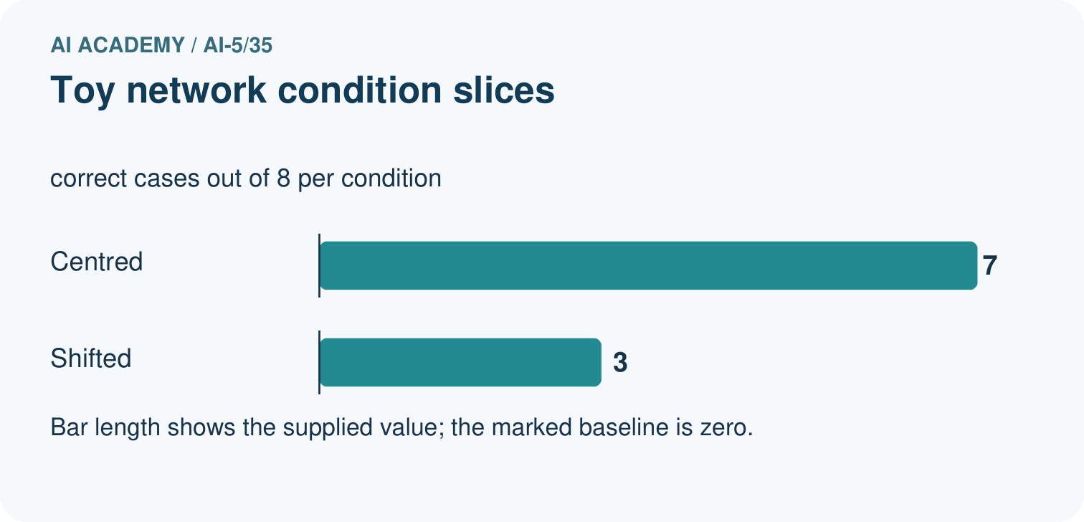
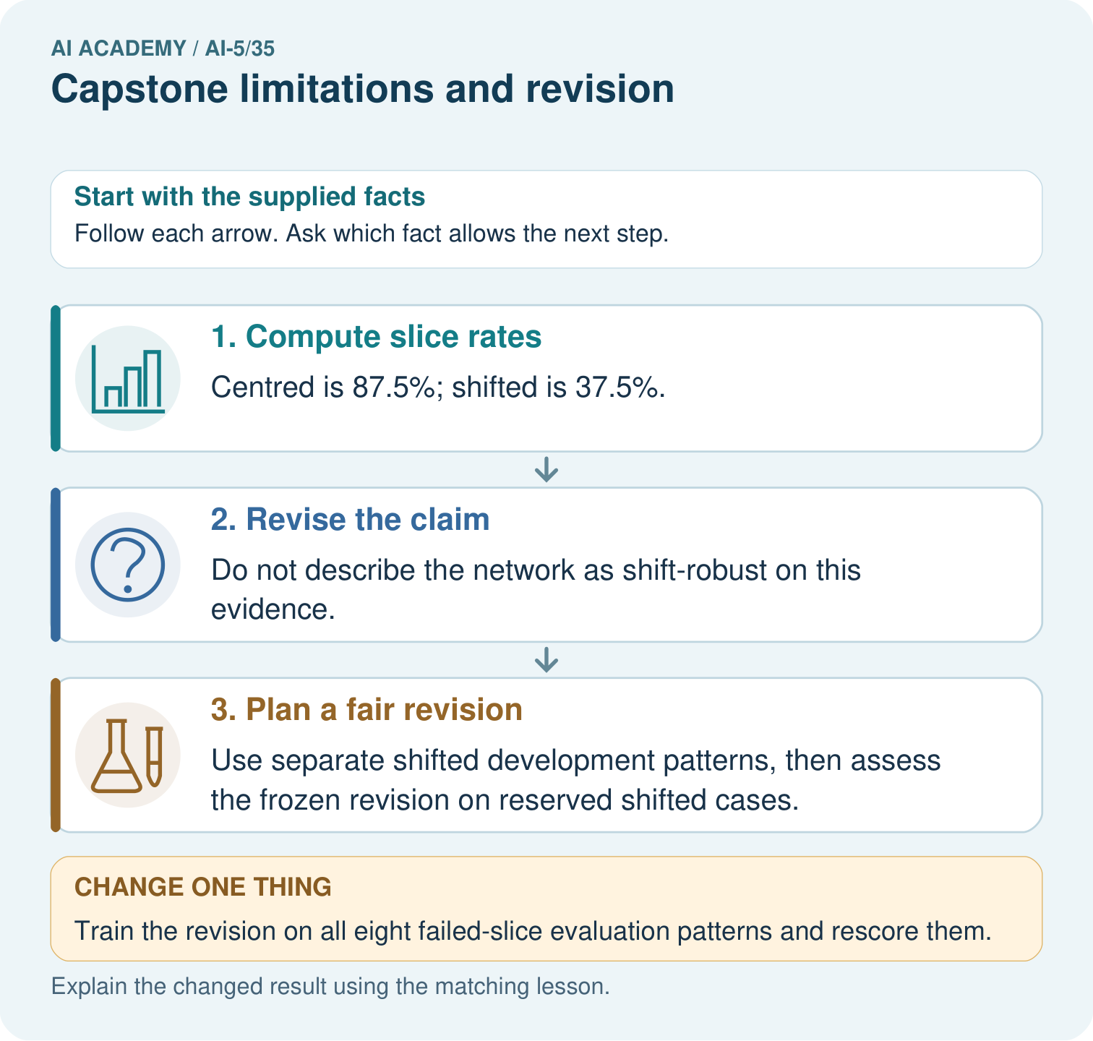

Read the picture one step at a time
Step | What happens and why
1. Compute slice rates | Centred is 87.5%; shifted is 37.5%.
2. Revise the claim | Do not describe the network as shift-robust on this evidence.
3. Plan a fair revision | Use separate shifted development patterns, then assess the frozen revision on reserved shifted cases.
Match each pictured step to the supplied facts. This is a worked teaching case, not an independent assessment.

Why this result follows
A limitation guides a better next experiment. Training on a failed evaluation example may help development, but that exposed example cannot remain the untouched evidence for the revision.

What this example does not establish
Small slices may vary; this example diagnoses an observed weakness without inventing a population rate or cause.
Read the labelled picture: Calculate the slice rates and explain the claim revision. If the team trains on the shifted evaluation patterns, what kind of evidence does their rerun provide?
Change one thing: Train the revision on all eight failed-slice evaluation patterns and rescore them. Predict the result before checking the explanation. What remains the same?

07. Find and repair a mistake
Supported example: for a = 2 on x = -3 with target -6, the ReLU prediction is 0, residual 6 and squared error 36. The signed proposal predicts -6 on this revealed case. This demonstrates that the alternative can represent the case; it does not establish how well a newly trained model will perform elsewhere.

Guided: calculate both predictions and errors and explain which claim the comparison supports.
________________________________________________________________
________________________________________________________________
________________________________________________________________
________________________________________________________________
________________________________________________________________

Locate the earliest unsupported step
Why cannot extra training alone make this ReLU output negative? Name a proposed change and the evidence it would require.

State one repair and the checks you would rerun.
________________________________________________________________
________________________________________________________________
________________________________________________________________
________________________________________________________________
________________________________________________________________
________________________________________________________________

08. Practise together
For F1–F4 calculate candidate residuals and squared errors.

Guided: calculate both predictions and errors and explain which claim the comparison supports.
________________________________________________________________
________________________________________________________________
________________________________________________________________
________________________________________________________________
________________________________________________________________

Explain your prediction to a partner before comparing results.
________________________________________________________________
________________________________________________________________
________________________________________________________________
________________________________________________________________

Practise with less help: Compare with the baseline
Use workbook W2 for the connected example “Capstone limitations and revision”. First fill the input and rule boxes. Try the middle steps before asking for a hint. After a hint, try the next step yourself.
Plan | Do | Check
What is given? Which rule or procedure applies? | Record each intermediate step. | Does the result follow? What remains unknown?
Explain your trace to a partner. Your partner points to one step to check. Swap roles on the next case. Each person writes their own explanation.

Check your reasoning
Use the worked case for Capstone limitations and revision. Proposed explanation: “Passing a criterion means no failures remain”. Decide whether this explanation is supported. Point to the step or supplied fact that decides; explain your repair if needed.
Answer on your own before discussion. If you are unsure, say which step you need help with.

Explain the picture
Calculate the slice rates and explain the claim revision. If the team trains on the shifted evaluation patterns, what kind of evidence does their rerun provide?

My explanation using a pictured step and the given facts
________________________________________________________________
________________________________________________________________
________________________________________________________________
________________________________________________________________
This is supported practice. Keep the separately named independent case for an attempt before feedback.

09. Run the investigation

Predict, investigate and preserve the evidence
Compute both overall MSE values and the candidate negative-input MSE. Apply the strict final criterion.
Record | Your evidence
Given input and fixed rule
Prediction before checking
Actual result, or “not run”
First mismatch and one explanation
Boundary or missing input and expected response
On paper, trace the supplied procedure. If code is provided, predict before running it in a local practice file. Never write an expected answer as though it were an observed run.

Plan → try → check
Before trying: what do I expect, and why? While trying: which step could first go wrong? Afterwards: what did I actually observe, and what should change? Keep “not run” if you only traced the procedure.

10. Build your understanding

Explain → apply → challenge
For F1–F4 calculate candidate residuals and squared errors.
Why cannot extra training alone make this ReLU output negative? Name a proposed change and the evidence it would require.
After inspecting F1–F4, a student changes to prediction 2*x and reports “new final MSE 0”. Explain the accurate label and the next evaluation step.

Explain which evidence supports your conclusion and which claim remains unproved.
________________________________________________________________
________________________________________________________________
________________________________________________________________
________________________________________________________________
________________________________________________________________

11. Connect your project
For Image-pattern Network Investigation, use this week’s independent task as a rehearsal for the final evidence pack: A frozen ReLU candidate with a = 3 is compared with baseline a = 1 on final rows (2,6),(4,12),(-1,-3),(-2,-6). Compute both MSE values and candidate MSE on negative inputs. Write a bounded conclusion. Keep actual observations separate from expected results, preserve failures, compare a baseline and explain the limits.
Project evidence | Record
Component and version
Inputs permitted at prediction time
Trace and comparison with earlier work
Failure, limit and human review

Evidence for your project
For the Image-pattern Network Investigation, save the labelled trace and the changed-case explanation beside the experiment record. State exactly what this example supports before linking it to the wider capstone claim.

12. Show what you know
A revision record names the observed failure, proposed mechanism, changed rule, preserved earlier results and new evaluation plan. Reserve fresh cases spanning the relevant input conditions. Include regression checks for earlier successes, and keep independent evaluation separate. Record any cases still missing from coverage.

Exit: write one sentence reporting the original final result and one sentence describing what remains unverified after the proposed architecture change.
________________________________________________________________
________________________________________________________________
________________________________________________________________
________________________________________________________________
________________________________________________________________
After inspecting F1–F4, a student changes to prediction 2*x and reports “new final MSE 0”. Explain the accurate label and the next evaluation step.

My limited claim and a useful next check
________________________________________________________________
________________________________________________________________
________________________________________________________________
________________________________________________________________

13. Study a complete case

Complete evidence record

Keep the evidence roles separate
Plan or input | Procedure | Permitted conclusion
Frozen candidate a = 2 | Final MSE = 5 | Improves on baseline 20.25
Negative x cases | Predictions forced to zero | A structural limitation
Change output rule | Check revealed failures | New final evidence needed
A passed aggregate criterion and a known structural failure can both be true.
Follow the input through the stated procedure to its result. Cover the result first, predict it, then explain every intermediate step. The text/table accompanies the figure so the example can be read without colour.

My complete trace of the worked case
________________________________________________________________
________________________________________________________________
________________________________________________________________
________________________________________________________________
________________________________________________________________
________________________________________________________________

14. Try a new case independently

Independent case: Evaluate new evidence independently
A frozen ReLU candidate with a = 3 is compared with baseline a = 1 on final rows (2,6),(4,12),(-1,-3),(-2,-6). Compute both MSE values and candidate MSE on negative inputs. Write a bounded conclusion.

My independent explanation, trace and limits
________________________________________________________________
________________________________________________________________
________________________________________________________________
________________________________________________________________
________________________________________________________________
________________________________________________________________
________________________________________________________________
Attempt this case before feedback. Record any help. Earlier examples below are further practice; a case already practised with feedback cannot establish fresh transfer.

Attempt this without hints
A frozen ReLU candidate with a = 3 is compared with baseline a = 1 on final rows (2,6),(4,12),(-1,-3),(-2,-6). Compute both MSE values and candidate MSE on negative inputs. Write a bounded conclusion.

My independent procedure, result and limitation
________________________________________________________________
________________________________________________________________
________________________________________________________________
________________________________________________________________
________________________________________________________________
________________________________________________________________
________________________________________________________________
________________________________________________________________
Record support used: none, hint or teacher explanation. After feedback, a different case is needed to demonstrate independence.

Use feedback to improve
Attempt the independent case before hints. Record whether you worked alone, used a hint or followed a model. After feedback, fix the first unsupported step and explain why it changed. A later check uses a changed case, not a copied answer.

15. Your lesson route
Start with this question: Revise a limited claim after a slice failure. A toy network works better on centred patterns than on shifted patterns, so the team narrows its initial claim.
By the end, I can | How I will show it
Evaluate a frozen candidate and baseline on final rows | Explain the deciding step, show a trace or test, and state one limit.
Identify a distribution limitation from raw errors | Explain the deciding step, show a trace or test, and state one limit.
Distinguish revision checks from new independent evaluation | Explain the deciding step, show a trace or test, and state one limit.
Remember → watch and explain → try with help → investigate → try independently → keep project evidence. Your teacher may spread this lesson across several classes.
Keep your first prediction. Compare it with what the evidence shows and explain any change.

16. Finish and return
Close your notes. Explain this goal in your own words: Evaluate a frozen candidate and baseline on final rows

My deciding step, evidence and one remaining question
________________________________________________________________
________________________________________________________________
________________________________________________________________
________________________________________________________________
________________________________________________________________
If you are unsure, return to the worked picture and explain one arrow. If you are ready, change an input or assumption and justify your prediction.
Save your workbook evidence. At the next review, try a different case before opening your old answer.

