AI ACADEMY · STUDENT · ai-5/36

Neural network experiment defense
Project: Image-pattern Network Investigation

Before you start
Can a revised model reuse inspected final rows as new independent evidence?

01. Your mission

Your learning target
I can defend a network experiment using traceable evidence.
I can separate selection, final evaluation and revision claims.
I can answer a challenge with a calculation and a bounded conclusion.

Remember before reading
Close your notes first. A rough first answer helps us choose the right starting point; it is not a score for your ability.
Without opening the old lesson, explain one key idea from Capstone limitations and revision. Give an example and a mistake that the idea helps you avoid.
Without opening the old lesson, explain one key idea from Capstone hypothesis and baseline. Give an example and a mistake that the idea helps you avoid.
Without opening the old lesson, explain one key idea from Dataset shift in neural models. Give an example and a mistake that the idea helps you avoid.
After trying, check the relevant lesson or ask your teacher. Change the part of your explanation that the evidence shows was wrong.
This week you will practise:
Defend a network experiment using traceable evidence
Separate selection, final evaluation and revision claims
Answer a challenge with a calculation and a bounded conclusion

Retrieve what you already know
Can a revised model reuse inspected final rows as new independent evidence?

My starting explanation
________________________________________________________________
________________________________________________________________
________________________________________________________________

This week’s end goal
Explain neural network experiment defense with a traceable toy-network case and a bounded conclusion.

02. Notice the evidence
A defense is not a sales pitch. Assemble the original question and criterion, data roles, baseline, model equation, settings, raw checkpoints, validation selection, frozen final predictions, limitations and revision history. Someone reading the record should be able to recompute a reported MSE and see which decisions each dataset informed.
For this capstone, two rates were compared under matched conditions. Rate 0.2 selected a = 2 with validation MSE 0 versus 0.78125 for rate 0.1. The frozen candidate then achieved final MSE 5 versus baseline 20.25 on four constructed cases. These are different comparisons and must not be collapsed into “the network was 100% accurate”.

List the given facts and one fact that is not supplied.
________________________________________________________________
________________________________________________________________
________________________________________________________________

03. See how it works
Stage | Evidence | Supported statement
Validation selection | Two positive rows; MSE 0 versus 0.78125 | Selected rate 0.2 by written rule
Frozen final comparison | Four rows; MSE 5 versus 20.25 | Lower MSE than initial-weight baseline on these rows
Condition check | Two negative rows; candidate MSE 10 | Nonnegative output fails to represent negative targets
Proposed revision | Signed output on revealed cases | A possible representational repair, not new final evidence

Keep the evidence roles separate
Plan or input | Procedure | Permitted conclusion
Question and settings | Replay calculations | Procedure can be checked
Frozen final predictions | Compare same four rows | Bounded baseline improvement
Known failures and changes | Preserve old results | Revision still needs evaluation
Every claim has an evidence source and a limit. A complete record is not a substitute for broader data.

Connect the picture and the explanation
Point to the input, the deciding step and the result in this week’s visual. Explain the same step in ordinary words. A picture helps when you can say what each part represents.

04. Compare the cases

Compare a familiar case with a changed case
State the validation selection and frozen final comparison using their correct metrics and scopes.

Keep the procedure fixed. Explain what changed in the inputs and result.
________________________________________________________________
________________________________________________________________
________________________________________________________________
________________________________________________________________
________________________________________________________________

Change one thing in the pictured case
Change: Change the second input from 1 to 2.
Prediction: z becomes 1-2+0.2=-0.8 and ReLU returns 0.
Reason: The negative weighted term grows; ReLU clips a negative pre-activation to zero.

05. Words that unlock the idea
Word | Meaning
Defense | An explanation of methods and claims supported by inspectable evidence
Evidence chain | The connection from inputs and procedure through raw outputs to a reported claim
Limitation | A condition restricting what evidence can establish
Reproduction | Repeating the documented procedure to check reported outputs

Use two terms to explain a step in this week’s example.
________________________________________________________________
________________________________________________________________
________________________________________________________________

06. Follow a worked example
Challenge: “Your validation error was zero, so why did the final test fail on negative targets?” Response: validation contained only positive inputs; the output max(0,a*x) cannot be negative. The final negative cases expose a coverage and architecture limitation. The overall criterion still passed, but that does not remove the failure.
Challenge: “Is a neural network better than linear regression?” Response: the supplied baseline was a fixed initial weight, not a fitted line. The evidence establishes improvement relative to that baseline only. A fitted signed line is a relevant additional comparison and needs a documented, fair evaluation. Challenge: “Was the candidate faster?” Response: no timing evidence was collected, so speed is unmeasured.

Learn from the worked case
Cover the result before checking it. Say what is given, choose the procedure, and follow one step at a time. Then uncover the result and explain your first mismatch. Ask why a step is allowed, not only what number it produces.

A pictorial worked case: Neural network experiment defense
Defend an individual network calculation. At the defence, a team shows a single toy neuron before describing the whole image-pattern experiment.

The facts we will use
Inputs are [2,1]; weights [0.5,-1]; bias 0.2; activation is ReLU, max(0,z). This is a demonstration, not a probability model.
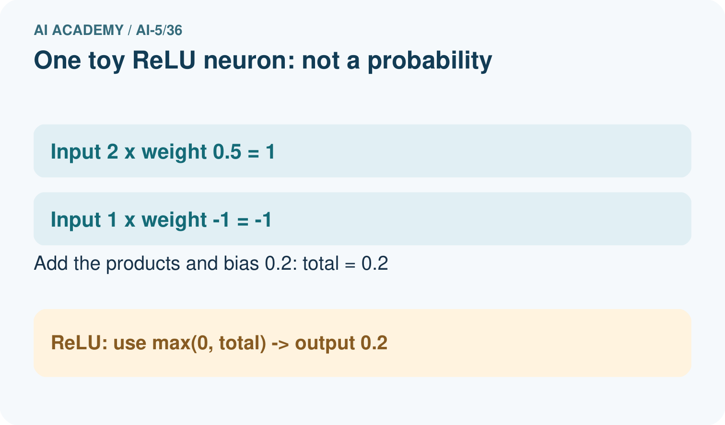
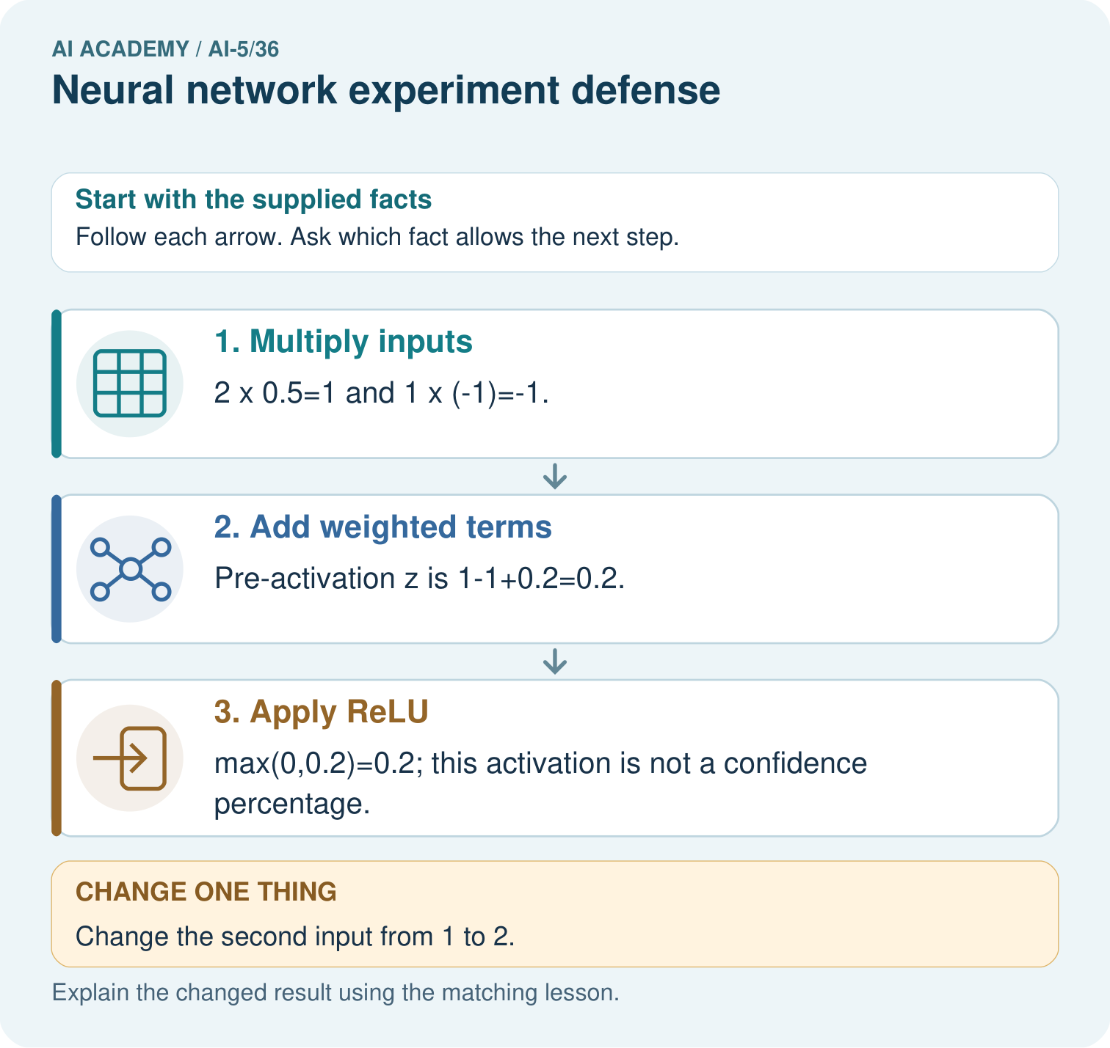

Read the picture one step at a time
Step | What happens and why
1. Multiply inputs | 2×0.5=1 and 1×(-1)=-1.
2. Add weighted terms | Pre-activation z is 1-1+0.2=0.2.
3. Apply ReLU | max(0,0.2)=0.2; this activation is not a confidence percentage.
Match each pictured step to the supplied facts. This is a worked teaching case, not an independent assessment.

Why this result follows
A defence should distinguish a traceable network calculation from a claim about classification quality. The neuron transforms supplied numbers; held-out labelled cases are needed to assess the complete system.

What this example does not establish
This one-neuron arithmetic does not establish how a trained image classifier generalises or why its full network makes a decision.
Read the labelled picture: Calculate both weighted terms, z and ReLU output. Predict the changed second input and explain why 0.2 cannot be called 20% accuracy.
Change one thing: Change the second input from 1 to 2. Predict the result before checking the explanation. What remains the same?

07. Find and repair a mistake
Supported case: another experiment reports baseline MSE 8 and candidate MSE 2 on four untouched final rows after freezing the candidate. The reduction is 6 MSE units, or 75% of the baseline MSE. That percentage is a relative reduction in MSE, not 75% classification accuracy. It cannot establish deployment performance.

Guided: calculate the absolute and relative MSE reduction, then write a sentence preserving the metric and four-row scope.
________________________________________________________________
________________________________________________________________
________________________________________________________________
________________________________________________________________
________________________________________________________________

Locate the earliest unsupported step
A presenter claims the experiment proves neural networks beat fitted lines and use less energy. What evidence is missing?

State one repair and the checks you would rerun.
________________________________________________________________
________________________________________________________________
________________________________________________________________
________________________________________________________________
________________________________________________________________
________________________________________________________________

08. Practise together
Name eight items needed to check the capstone from question through final result.

Guided: calculate the absolute and relative MSE reduction, then write a sentence preserving the metric and four-row scope.
________________________________________________________________
________________________________________________________________
________________________________________________________________
________________________________________________________________
________________________________________________________________

Explain your prediction to a partner before comparing results.
________________________________________________________________
________________________________________________________________
________________________________________________________________
________________________________________________________________

Practise with less help: Defend the result
Use workbook W2 for the connected example “Neural network experiment defense”. First fill the input and rule boxes. Try the middle steps before asking for a hint. After a hint, try the next step yourself.
Plan | Do | Check
What is given? Which rule or procedure applies? | Record each intermediate step. | Does the result follow? What remains unknown?
Explain your trace to a partner. Your partner points to one step to check. Swap roles on the next case. Each person writes their own explanation.

Check your reasoning
Use the worked case for Neural network experiment defense. Proposed explanation: “A polished demonstration is an evaluation”. Decide whether this explanation is supported. Point to the step or supplied fact that decides; explain your repair if needed.
Answer on your own before discussion. If you are unsure, say which step you need help with.

Explain the picture
Calculate both weighted terms, z and ReLU output. Predict the changed second input and explain why 0.2 cannot be called 20% accuracy.

My explanation using a pictured step and the given facts
________________________________________________________________
________________________________________________________________
________________________________________________________________
________________________________________________________________
This is supported practice. Keep the separately named independent case for an attempt before feedback.

09. Run the investigation

Predict, investigate and preserve the evidence
State the validation selection and frozen final comparison using their correct metrics and scopes.
Record | Your evidence
Given input and fixed rule
Prediction before checking
Actual result, or “not run”
First mismatch and one explanation
Boundary or missing input and expected response
On paper, trace the supplied procedure. If code is provided, predict before running it in a local practice file. Never write an expected answer as though it were an observed run.

Plan → try → check
Before trying: what do I expect, and why? While trying: which step could first go wrong? Afterwards: what did I actually observe, and what should change? Keep “not run” if you only traced the procedure.

10. Build your understanding

Explain → apply → challenge
Name eight items needed to check the capstone from question through final result.
A presenter claims the experiment proves neural networks beat fitted lines and use less energy. What evidence is missing?
Propose a fair next comparison with a fitted signed line. State how to preserve previous evidence and reserve new evaluation.

Explain which evidence supports your conclusion and which claim remains unproved.
________________________________________________________________
________________________________________________________________
________________________________________________________________
________________________________________________________________
________________________________________________________________

11. Connect your project
For Image-pattern Network Investigation, use this week’s independent task as a rehearsal for the final evidence pack: A separate experiment compares candidates C1 and C2 on two validation rows: MSE 1.5 and 1.0. The written rule selects lower MSE. After freezing C2, four fresh final rows give baseline squared errors 4,9,1,2 and C2 squared errors 1,1,2,0. Compute final MSE and relative reduction. Two condition-B rows are the last two rows; compare baseline and candidate MSE there. State what this record supports and what is unmeasured. Keep actual observations separate from expected results, preserve failures, compare a baseline and explain the limits.
Project evidence | Record
Component and version
Inputs permitted at prediction time
Trace and comparison with earlier work
Failure, limit and human review

Evidence for your project
For the Image-pattern Network Investigation, save the labelled trace and the changed-case explanation beside the experiment record. State exactly what this example supports before linking it to the wider capstone claim.

12. Show what you know
Use a short presentation: question; method and controls; selection; final result; failures; revision; next question. State the small constructed sample, absent real-world coverage, limited baseline and unmeasured resource use. A useful next question is whether a signed-output procedure improves on a fitted-line baseline under newly reserved evaluation conditions. Passing this capstone means explaining the evidence correctly, including an unsuccessful or limited result.

Exit: correct “our network is universally reliable, 100% accurate, faster than every baseline and repaired on the final test”. Give measured claims and identify the missing evidence.
________________________________________________________________
________________________________________________________________
________________________________________________________________
________________________________________________________________
________________________________________________________________
Propose a fair next comparison with a fitted signed line. State how to preserve previous evidence and reserve new evaluation.

My limited claim and a useful next check
________________________________________________________________
________________________________________________________________
________________________________________________________________
________________________________________________________________

13. Study a complete case

Complete evidence record

Keep the evidence roles separate
Plan or input | Procedure | Permitted conclusion
Question and settings | Replay calculations | Procedure can be checked
Frozen final predictions | Compare same four rows | Bounded baseline improvement
Known failures and changes | Preserve old results | Revision still needs evaluation
Every claim has an evidence source and a limit. A complete record is not a substitute for broader data.
Follow the input through the stated procedure to its result. Cover the result first, predict it, then explain every intermediate step. The text/table accompanies the figure so the example can be read without colour.

My complete trace of the worked case
________________________________________________________________
________________________________________________________________
________________________________________________________________
________________________________________________________________
________________________________________________________________
________________________________________________________________

14. Try a new case independently

Independent case: Defend a new record independently
A separate experiment compares candidates C1 and C2 on two validation rows: MSE 1.5 and 1.0. The written rule selects lower MSE. After freezing C2, four fresh final rows give baseline squared errors 4,9,1,2 and C2 squared errors 1,1,2,0. Compute final MSE and relative reduction. Two condition-B rows are the last two rows; compare baseline and candidate MSE there. State what this record supports and what is unmeasured.

My independent explanation, trace and limits
________________________________________________________________
________________________________________________________________
________________________________________________________________
________________________________________________________________
________________________________________________________________
________________________________________________________________
________________________________________________________________
Attempt this case before feedback. Record any help. Earlier examples below are further practice; a case already practised with feedback cannot establish fresh transfer.

Attempt this without hints
A separate experiment compares candidates C1 and C2 on two validation rows: MSE 1.5 and 1.0. The written rule selects lower MSE. After freezing C2, four fresh final rows give baseline squared errors 4,9,1,2 and C2 squared errors 1,1,2,0. Compute final MSE and relative reduction. Two condition-B rows are the last two rows; compare baseline and candidate MSE there. State what this record supports and what is unmeasured.

My independent procedure, result and limitation
________________________________________________________________
________________________________________________________________
________________________________________________________________
________________________________________________________________
________________________________________________________________
________________________________________________________________
________________________________________________________________
________________________________________________________________
Record support used: none, hint or teacher explanation. After feedback, a different case is needed to demonstrate independence.

Use feedback to improve
Attempt the independent case before hints. Record whether you worked alone, used a hint or followed a model. After feedback, fix the first unsupported step and explain why it changed. A later check uses a changed case, not a copied answer.

15. Your lesson route
Start with this question: Defend an individual network calculation. At the defence, a team shows a single toy neuron before describing the whole image-pattern experiment.
By the end, I can | How I will show it
Defend a network experiment using traceable evidence | Explain the deciding step, show a trace or test, and state one limit.
Separate selection, final evaluation and revision claims | Explain the deciding step, show a trace or test, and state one limit.
Answer a challenge with a calculation and a bounded conclusion | Explain the deciding step, show a trace or test, and state one limit.
Remember → watch and explain → try with help → investigate → try independently → keep project evidence. Your teacher may spread this lesson across several classes.
Keep your first prediction. Compare it with what the evidence shows and explain any change.

16. Finish and return
Close your notes. Explain this goal in your own words: Defend a network experiment using traceable evidence

My deciding step, evidence and one remaining question
________________________________________________________________
________________________________________________________________
________________________________________________________________
________________________________________________________________
________________________________________________________________
If you are unsure, return to the worked picture and explain one arrow. If you are ready, change an input or assumption and justify your prediction.
Save your workbook evidence. At the next review, try a different case before opening your old answer.

