AI ACADEMY · STUDENT · ai-6/29

Performance and cost experiments
Project: Grounded Learning Service

Before you start
Recall Accessibility and user feedback. Explain why a recorded result needs its input conditions and evidence source before it can support a claim.

01. Your mission

Your learning target
I can explain the mechanism and terminology of performance and cost experiments.
I can apply the stated procedure to a new case with a traceable result.
I can identify an assumption or limitation and design a revealing follow-up.

Remember before reading
Close your notes first. A rough first answer helps us choose the right starting point; it is not a score for your ability.
Without opening the old lesson, explain one key idea from Accessibility and user feedback. Give an example and a mistake that the idea helps you avoid.
Without opening the old lesson, explain one key idea from Incident investigation. Give an example and a mistake that the idea helps you avoid.
Without opening the old lesson, explain one key idea from Deployment environments. Give an example and a mistake that the idea helps you avoid.
After trying, check the relevant lesson or ask your teacher. Change the part of your explanation that the evidence shows was wrong.
This week you will practise:
Explain the mechanism and terminology of performance and cost experiments
Apply the stated procedure to a new case with a traceable result
Identify an assumption or limitation and design a revealing follow-up

Retrieve what you already know
Recall Accessibility and user feedback. Explain why a recorded result needs its input conditions and evidence source before it can support a claim.

My starting explanation
________________________________________________________________
________________________________________________________________
________________________________________________________________

This week’s end goal
Explain performance and cost experiments using the deciding step in this fictional service.

02. Notice the evidence
Performance experiments compare matched workloads with declared timing boundaries and quality constraints. Averages can hide slow cases.
Begin by writing the question the procedure is intended to answer. Identify the information already supplied, the information it will produce and the information still missing. These are constructed classroom examples; they do not require live accounts, private records or an external service. Do not treat a plausible explanation as a measured outcome.

List the given facts and one fact that is not supplied.
________________________________________________________________
________________________________________________________________
________________________________________________________________

03. See how it works
Use the same cases and environment; record every duration and success. For a simple median sort values and average the middle pair for even counts. Keep failed requests visible.

Performance and cost experiments — evidence trace
Input and scope | Check or calculation | Conclusion and limit
Durations A=[1, 1, 1, 9] seconds, B=[2, 2, 2, 2]. All pass. Compute mean and median. | Use the same cases and environment; record every duration and success. For a simple median sort values and average the middle pair for even counts. Keep failed requests visible. | A mean3, median1; B mean2, median2. B lowers mean but A has lower median; show the9-second tail instead of declaring one universal winner.
The figure connects this chapter's worked input, declared procedure and result. Read the complete worked reasoning for qualifiers and intermediate steps; the abbreviated labels do not replace that reasoning.
Before applying the procedure, write its units, denominator or decision boundary where relevant. A partner should be able to repeat each step using the same inputs. If a required input is absent or violates the stated contract, record that condition explicitly instead of quietly replacing it with a convenient value.

Connect the picture and the explanation
Point to the input, the deciding step and the result in this week’s visual. Explain the same step in ordinary words. A picture helps when you can say what each part represents.

04. Compare the cases

Compare a familiar case with a changed case
Durations A=[1, 1, 1, 9] seconds, B=[2, 2, 2, 2]. All pass. Compute mean and median. Show the intermediate steps and give the conclusion with its scope.

Keep the procedure fixed. Explain what changed in the inputs and result.
________________________________________________________________
________________________________________________________________
________________________________________________________________
________________________________________________________________
________________________________________________________________

Change one thing in the pictured case
Change: Require at most 2 cost units per case.
Prediction: A meets the budget; B does not.
Reason: The mandatory resource condition changes the decision.

05. Words that unlock the idea
Word | Meaning
Matched workload | The same task cases used for comparison
Median | The middle of ordered values under a declared convention
Tail latency | Slow outcomes hidden by typical-value summaries

Use two terms to explain a step in this week’s example.
________________________________________________________________
________________________________________________________________
________________________________________________________________

06. Follow a worked example
Durations A=[1, 1, 1, 9] seconds, B=[2, 2, 2, 2]. All pass. Compute mean and median.
A mean3, median1; B mean2, median2. B lowers mean but A has lower median; show the9-second tail instead of declaring one universal winner.
Compare the intermediate evidence with the final statement. Explain why each number or decision follows from the stated inputs. The conclusion belongs to this scenario and procedure; changing the inputs, evaluation population or authority can change what it establishes. Retain the raw record so a later revision can be compared honestly.

Learn from the worked case
Cover the result before checking it. Say what is given, choose the procedure, and follow one step at a time. Then uncover the result and explain your first mismatch. Ask why a step is allowed, not only what number it produces.

A pictorial worked case: Performance and cost experiments
Measure time and cost. Two fixed configurations answer the same six questions and meet the same quality rubric.

The facts we will use
A totals 18 seconds and 12 cost units. B totals 12 seconds and 18 units.
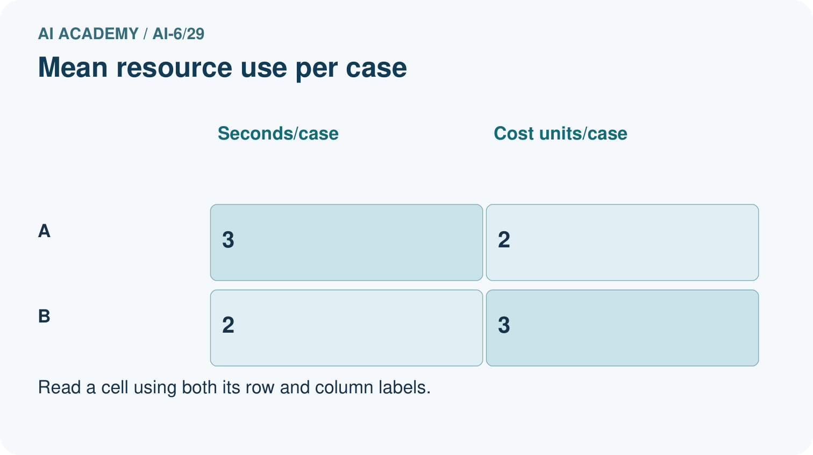
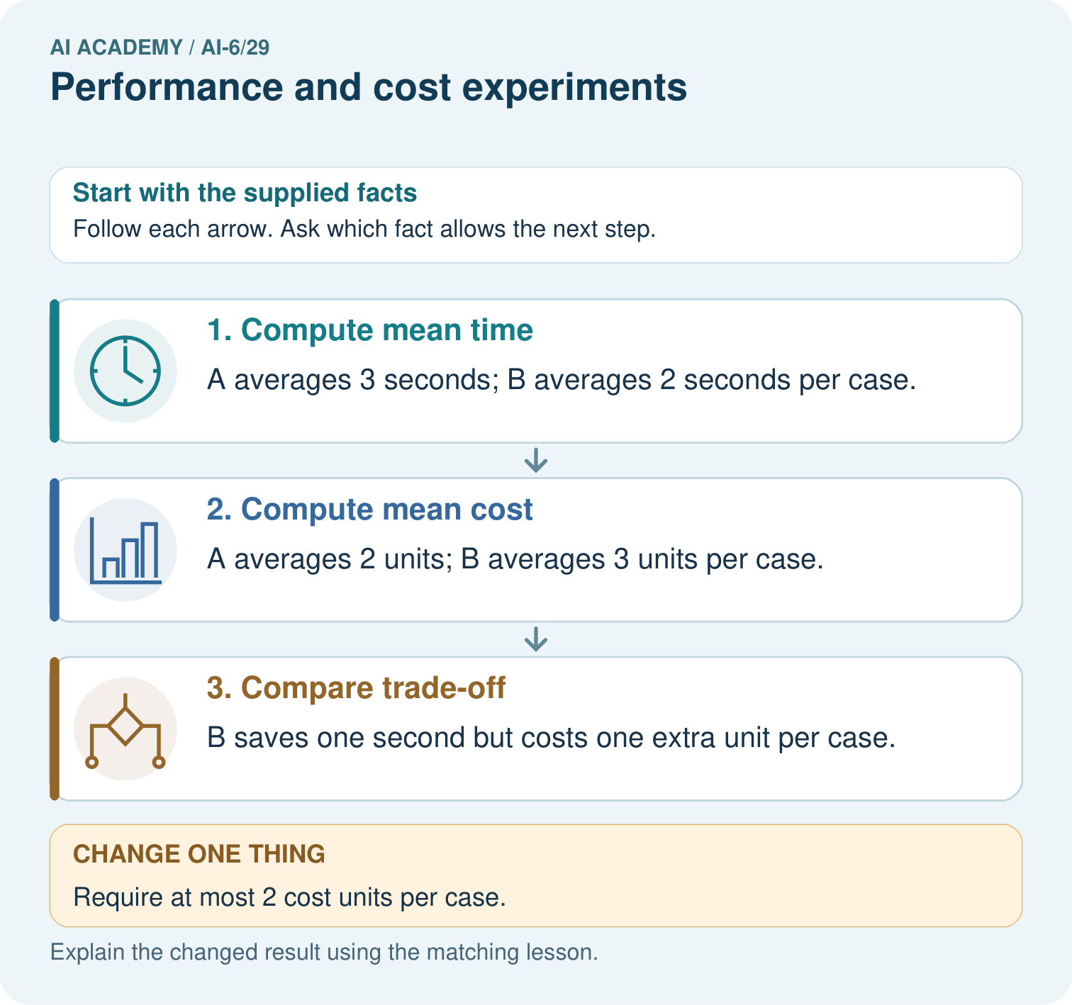

Read the picture one step at a time
Step | What happens and why
1. Compute mean time | A averages 3 seconds; B averages 2 seconds per case.
2. Compute mean cost | A averages 2 units; B averages 3 units per case.
3. Compare trade-off | B saves one second but costs one extra unit per case.
Match each pictured step to the supplied facts. This is a worked teaching case, not an independent assessment.

Why this result follows
A fair performance experiment holds the workload and measurement procedure fixed. Faster is not automatically preferable under a budget.

What this example does not establish
Means hide variation; disclose workload, repeated runs and slow-case results before generalising.
Read the labelled picture: Calculate per-case seconds and cost units for A and B. Which meets a budget of at most 2 cost units per case, and what speed trade-off does that choice make?
Change one thing: Require at most 2 cost units per case. Predict the result before checking the explanation. What remains the same?

07. Find and repair a mistake
Resource improvement under one workload is not universal efficiency or equal quality.
A useful check asks what would make the reasoning fail. Distinguish a failure to execute the declared procedure from a weakness in the procedure itself. The first may require a correction; the second requires an explicitly revised method and new evidence. Preserve unsuccessful cases so an improved result cannot hide the original problem.

Guided: restate the worked result, then name the assumption or limitation that prevents a broader conclusion.
________________________________________________________________
________________________________________________________________
________________________________________________________________
________________________________________________________________
________________________________________________________________

Locate the earliest unsupported step
A report omits this qualification: Resource improvement under one workload is not universal efficiency or equal quality. Explain how omitting it could change a reader's interpretation, and write an accurate replacement.

State one repair and the checks you would rerun.
________________________________________________________________
________________________________________________________________
________________________________________________________________
________________________________________________________________
________________________________________________________________
________________________________________________________________

08. Practise together
Explain the weekly mechanism in your own words. Use the worked scenario to name its input, decision rule and output.

Guided: restate the worked result, then name the assumption or limitation that prevents a broader conclusion.
________________________________________________________________
________________________________________________________________
________________________________________________________________
________________________________________________________________
________________________________________________________________

Explain your prediction to a partner before comparing results.
________________________________________________________________
________________________________________________________________
________________________________________________________________
________________________________________________________________

Practise with less help: Trace the worked case
Use workbook W2 for the connected example “Performance and cost experiments”. First fill the input and rule boxes. Try the middle steps before asking for a hint. After a hint, try the next step yourself.
Plan | Do | Check
What is given? Which rule or procedure applies? | Record each intermediate step. | Does the result follow? What remains unknown?
Explain your trace to a partner. Your partner points to one step to check. Swap roles on the next case. Each person writes their own explanation.

Check your reasoning
Use the worked case for Performance and cost experiments. Proposed explanation: “The worked result establishes every future case”. Decide whether this explanation is supported. Point to the step or supplied fact that decides; explain your repair if needed.
Answer on your own before discussion. If you are unsure, say which step you need help with.

Explain the picture
Calculate per-case seconds and cost units for A and B. Which meets a budget of at most 2 cost units per case, and what speed trade-off does that choice make?

My explanation using a pictured step and the given facts
________________________________________________________________
________________________________________________________________
________________________________________________________________
________________________________________________________________
This is supported practice. Keep the separately named independent case for an attempt before feedback.

09. Run the investigation

Predict, investigate and preserve the evidence
Durations A=[1, 1, 1, 9] seconds, B=[2, 2, 2, 2]. All pass. Compute mean and median. Show the intermediate steps and give the conclusion with its scope.
Record | Your evidence
Given input and fixed rule
Prediction before checking
Actual result, or “not run”
First mismatch and one explanation
Boundary or missing input and expected response
On paper, trace the supplied procedure. If code is provided, predict before running it in a local practice file. Never write an expected answer as though it were an observed run.

Plan → try → check
Before trying: what do I expect, and why? While trying: which step could first go wrong? Afterwards: what did I actually observe, and what should change? Keep “not run” if you only traced the procedure.

10. Build your understanding

Explain → apply → challenge
Explain the weekly mechanism in your own words. Use the worked scenario to name its input, decision rule and output.
A report omits this qualification: Resource improvement under one workload is not universal efficiency or equal quality. Explain how omitting it could change a reader's interpretation, and write an accurate replacement.
For the worked scenario, propose one additional case that could reveal a failure, describe its expected outcome before running it, and explain what would need to remain fixed for a fair comparison. Do not reuse W4 as a new final test after receiving feedback.

Explain which evidence supports your conclusion and which claim remains unproved.
________________________________________________________________
________________________________________________________________
________________________________________________________________
________________________________________________________________
________________________________________________________________

11. Connect your project
Add a labelled performance and cost experiments evidence sheet to Grounded Learning Service. Show how you can explain the mechanism and terminology of performance and cost experiments. Use the supplied fictional case and keep its inputs, intermediate steps, calculation or prediction, and limitation. Connect this record to last week’s record; a matching answer without a trace is insufficient.
Project evidence | Record
Component and version
Inputs permitted at prediction time
Trace and comparison with earlier work
Failure, limit and human review

Evidence for your project
For the Grounded Learning Service, retain an annotated trace and the changed-case result. Name the contract or evidence that makes the deciding step valid, so another team can review it.

12. Show what you know
Complete the supported workbook tasks before attempting W4 independently. Record any hints or help used. After feedback, use the teacher's fresh retry rather than copying the earlier answer. For a project, select a relevant new case, predict the outcome from the declared rule and preserve the result alongside any revision.

Exit: propose one revealing change to the worked scenario. State the expected outcome and the evidence that would make you revise your explanation.
________________________________________________________________
________________________________________________________________
________________________________________________________________
________________________________________________________________
________________________________________________________________
For the worked scenario, propose one additional case that could reveal a failure, describe its expected outcome before running it, and explain what would need to remain fixed for a fair comparison. Do not reuse W4 as a new final test after receiving feedback.

My limited claim and a useful next check
________________________________________________________________
________________________________________________________________
________________________________________________________________
________________________________________________________________

13. Study a complete case

Complete evidence record

Performance and cost experiments — evidence trace
Input and scope | Check or calculation | Conclusion and limit
Durations A=[1, 1, 1, 9] seconds, B=[2, 2, 2, 2]. All pass. Compute mean and median. | Use the same cases and environment; record every duration and success. For a simple median sort values and average the middle pair for even counts. Keep failed requests visible. | A mean3, median1; B mean2, median2. B lowers mean but A has lower median; show the9-second tail instead of declaring one universal winner.
The figure connects this chapter's worked input, declared procedure and result. Read the complete worked reasoning for qualifiers and intermediate steps; the abbreviated labels do not replace that reasoning.
Follow the input through the stated procedure to its result. Cover the result first, predict it, then explain every intermediate step. The text/table accompanies the figure so the example can be read without colour.

My complete trace of the worked case
________________________________________________________________
________________________________________________________________
________________________________________________________________
________________________________________________________________
________________________________________________________________
________________________________________________________________

14. Try a new case independently

Independent case: Apply a new case independently
C=[1, 2, 3, 10], D=[3, 3, 3, 3]. Compute means/medians; one D response is wrong.

My independent explanation, trace and limits
________________________________________________________________
________________________________________________________________
________________________________________________________________
________________________________________________________________
________________________________________________________________
________________________________________________________________
________________________________________________________________
Attempt this case before feedback. Record any help. Earlier examples below are further practice; a case already practised with feedback cannot establish fresh transfer.

Attempt this without hints
C=[1, 2, 3, 10], D=[3, 3, 3, 3]. Compute means/medians; one D response is wrong.

My independent procedure, result and limitation
________________________________________________________________
________________________________________________________________
________________________________________________________________
________________________________________________________________
________________________________________________________________
________________________________________________________________
________________________________________________________________
________________________________________________________________
Record support used: none, hint or teacher explanation. After feedback, a different case is needed to demonstrate independence.

Use feedback to improve
Attempt the independent case before hints. Record whether you worked alone, used a hint or followed a model. After feedback, fix the first unsupported step and explain why it changed. A later check uses a changed case, not a copied answer.

15. Your lesson route
Start with this question: Measure time and cost. Two fixed configurations answer the same six questions and meet the same quality rubric.
By the end, I can | How I will show it
Explain the mechanism and terminology of performance and cost experiments | Explain the deciding step, show a trace or test, and state one limit.
Apply the stated procedure to a new case with a traceable result | Explain the deciding step, show a trace or test, and state one limit.
Identify an assumption or limitation and design a revealing follow-up | Explain the deciding step, show a trace or test, and state one limit.
Remember → watch and explain → try with help → investigate → try independently → keep project evidence. Your teacher may spread this lesson across several classes.
Keep your first prediction. Compare it with what the evidence shows and explain any change.

16. Finish and return
Close your notes. Explain this goal in your own words: Explain the mechanism and terminology of performance and cost experiments

My deciding step, evidence and one remaining question
________________________________________________________________
________________________________________________________________
________________________________________________________________
________________________________________________________________
________________________________________________________________
If you are unsure, return to the worked picture and explain one arrow. If you are ready, change an input or assumption and justify your prediction.
Save your workbook evidence. At the next review, try a different case before opening your old answer.

