AI ACADEMY · STUDENT · python-bridge/9

Return values and local state
Project: Python readiness portfolio

Before you start
A function show_remaining(capacity, used) prints capacity - used. What does calling it with (9, 4) display? Does defining it alone display that result?

01. Your mission

Your learning target
I can use a returned value in a later calculation.
I can trace local variables separately for each function call.
I can detect a missing return and test repeated calls.

Remember before reading
Close your notes first. A rough first answer helps us choose the right starting point; it is not a score for your ability.
Without opening the old lesson, explain one key idea from Functions and arguments. Give an example and a mistake that the idea helps you avoid.
Without opening the old lesson, explain one key idea from Loops and trace tables. Give an example and a mistake that the idea helps you avoid.
Without opening the old lesson, explain one key idea from Expressions and operator order. Give an example and a mistake that the idea helps you avoid.
After trying, check the relevant lesson or ask your teacher. Change the part of your explanation that the evidence shows was wrong.
This week you will practise:
Use a returned value in a later calculation
Trace local variables separately for each function call
Detect a missing return and test repeated calls

Retrieve what you already know
A function show_remaining(capacity, used) prints capacity - used. What does calling it with (9, 4) display? Does defining it alone display that result?

My starting explanation
________________________________________________________________
________________________________________________________________
________________________________________________________________

This week’s end goal
Trace return values and local state and explain the changed program before running it.

02. Notice the evidence
Two fictional cupboards have spare spaces. We want to add their spare spaces without copying numbers from the screen. Last week a function printed each answer. This week a function returns its answer so the calling code can store it, combine it or choose to print it.
Assume nonnegative integer counts and used no greater than capacity. This calculation does not validate those assumptions. Work in a Python script so a call does not automatically display its return value as it might in an interactive console.

List the given facts and one fact that is not supplied.
________________________________________________________________
________________________________________________________________
________________________________________________________________

03. See how it works
def remaining(capacity, used):
spaces = capacity - used
return spaces
first = remaining(12, 4)
second = remaining(10, 7)
print(first + second)

Two calls return two values
Call | Inside this call | Back in the caller
remaining(12, 4) | spaces becomes 8 | first receives 8
remaining(10, 7) | spaces becomes 3 | second receives 3
The caller adds the returned values. Only print(first + second) displays 11.
return spaces ends the current function call and sends the value of spaces back. The assignment first = remaining(12, 4) waits for that value and stores 8. The next call stores 3 in second. Neither call prints. The final statement prints 11. A statement after an executed return in the same call is not reached.

Connect the picture and the explanation
Point to the input, the deciding step and the result in this week’s visual. Explain the same step in ordinary words. A picture helps when you can say what each part represents.

04. Compare the cases

Compare a familiar case with a changed case
Using the correct definition, store a = remaining(8, 3), b = remaining(8, 8), c = remaining(8, 3). State a, b and c. In a fresh script, explain why print(spaces) outside the function fails.

Keep the procedure fixed. Explain what changed in the inputs and result.
________________________________________________________________
________________________________________________________________
________________________________________________________________
________________________________________________________________
________________________________________________________________

Change one thing in the pictured case
Change: Add print(result) after the calls in a fresh script with no global result.
Prediction: NameError occurs because that local name is not defined in the caller.
Reason: A returned value and the function’s internal name are different things.

05. Words that unlock the idea
Word | Meaning
Return value | A value a function sends back to its caller
Caller | The code that calls a function
Local variable | A name assigned inside a function and used in that function call
Scope | The region of code in which a name can be looked up
None | A Python value representing no result value in this lesson

Use two terms to explain a step in this week’s example.
________________________________________________________________
________________________________________________________________
________________________________________________________________

06. Follow a worked example
Point in execution | Local spaces | Caller values
First call before return | 8 | first not assigned yet
Second call before return | 3 | first is still 8
After both calls | Not accessible by this local name | first is 8 and second is 3
capacity, used and spaces belong to the current call. The second call gets new parameter values and calculates its own spaces; it does not overwrite first. In a fresh script with no outside variable called spaces, adding print(spaces) after the calls raises NameError. Use the returned value stored in first or second instead.

Change the calls to remaining(9, 9) and remaining(9, 0). What values are stored and what does their sum print? What happens if only the final print statement is removed?
________________________________________________________________
________________________________________________________________
________________________________________________________________
________________________________________________________________
________________________________________________________________

Learn from the worked case
Cover the result before checking it. Say what is given, choose the procedure, and follow one step at a time. Then uncover the result and explain your first mismatch. Ask why a step is allowed, not only what number it produces.

A pictorial worked case: Return values and local state
Return values survive their calls. A function returns a local calculation that the caller stores.

The facts we will use
Python 3: def extra(a,b): result=a+b; return result. Then first=extra(2,5); second=extra(4,1); print(first,second).
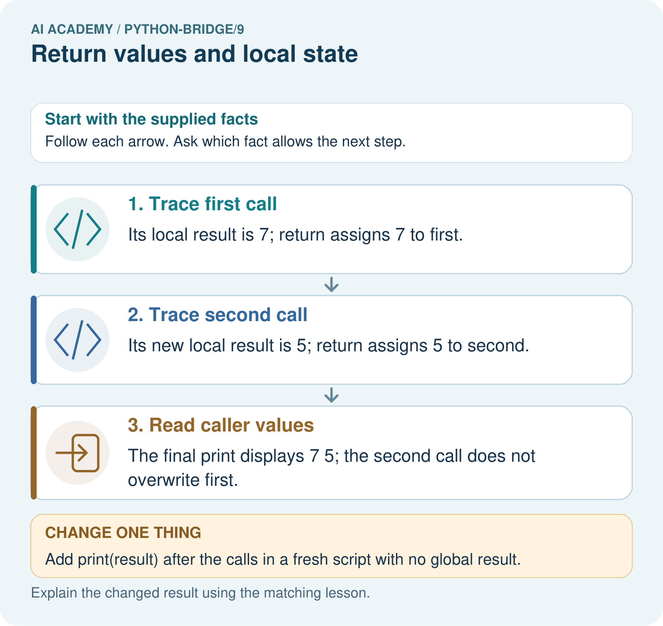

Read the picture one step at a time
Step | What happens and why
1. Trace first call | Its local result is 7; return assigns 7 to first.
2. Trace second call | Its new local result is 5; return assigns 5 to second.
3. Read caller values | The final print displays 7 5; the second call does not overwrite first.
Match each pictured step to the supplied facts. This is a worked teaching case, not an independent assessment.

Why this result follows
Returning passes a value back to the caller. Local names belong to a function call; storing the returned value creates a separate caller binding.

What this example does not establish
The example uses immutable integers; shared mutable objects require additional reasoning about references.
Read the labelled picture: Trace the two returned values and explain why first stays seven. What happens if the caller tries to print result directly?
Change one thing: Add print(result) after the calls in a fresh script with no global result. Predict the result before checking the explanation. What remains the same?

07. Find and repair a mistake
def remaining(capacity, used):
spaces = capacity - used
print(spaces)
answer = remaining(12, 4)
print(answer)
This faulty version displays 8 and then None. It reaches the end of its body without a return statement, so the call returns None. Printing 8 inside the function does not make 8 its return value. None is not zero. Trying answer + 1 raises TypeError in this example.
Replace print(spaces) inside the function with return spaces. Keep print(answer) in the caller. The repaired script prints 8 once, and the caller can calculate answer + 1. Test the stored value as well as what appears on screen.

Locate the earliest unsupported step
Use the faulty printing version with answer = remaining(11, 2). State the displayed number and the value stored in answer. Explain why print(answer + 1) fails, then repair the function and predict the repaired output.

State one repair and the checks you would rerun.
________________________________________________________________
________________________________________________________________
________________________________________________________________
________________________________________________________________
________________________________________________________________
________________________________________________________________

08. Practise together
Using the correct worked definition, execute result = remaining(15, 6), then doubled = result * 2. State both stored values and what the script displays before a print statement is added.

Change the calls to remaining(9, 9) and remaining(9, 0). What values are stored and what does their sum print? What happens if only the final print statement is removed?
________________________________________________________________
________________________________________________________________
________________________________________________________________
________________________________________________________________
________________________________________________________________

Explain your prediction to a partner before comparing results.
________________________________________________________________
________________________________________________________________
________________________________________________________________
________________________________________________________________

Practise with less help: Trace separate calls
Use workbook W2 for the connected example “Return values and local state”. First fill the input and rule boxes. Try the middle steps before asking for a hint. After a hint, try the next step yourself.
Plan | Do | Check
What is given? Which rule or procedure applies? | Record each intermediate step. | Does the result follow? What remains unknown?
Explain your trace to a partner. Your partner points to one step to check. Swap roles on the next case. Each person writes their own explanation.

Check your reasoning
Use the worked case for Return values and local state. Proposed explanation: “Printing a value returns that value”. Decide whether this explanation is supported. Point to the step or supplied fact that decides; explain your repair if needed.
Answer on your own before discussion. If you are unsure, say which step you need help with.

Explain the picture
Trace the two returned values and explain why first stays seven. What happens if the caller tries to print result directly?

My explanation using a pictured step and the given facts
________________________________________________________________
________________________________________________________________
________________________________________________________________
________________________________________________________________
This is supported practice. Keep the separately named independent case for an attempt before feedback.

09. Run the investigation

Predict, investigate and preserve the evidence
Using the correct definition, store a = remaining(8, 3), b = remaining(8, 8), c = remaining(8, 3). State a, b and c. In a fresh script, explain why print(spaces) outside the function fails.
def remaining(capacity, used):
spaces = capacity - used
return spaces
first = remaining(12, 4)
second = remaining(10, 7)
print(first + second)
def remaining(capacity, used):
spaces = capacity - used
print(spaces)
answer = remaining(12, 4)
print(answer)
Record | Your evidence
Given input and fixed rule
Prediction before checking
Actual result, or “not run”
First mismatch and one explanation
Boundary or missing input and expected response
On paper, trace the supplied procedure. If code is provided, predict before running it in a local practice file. Never write an expected answer as though it were an observed run.

Plan → try → check
Before trying: what do I expect, and why? While trying: which step could first go wrong? Afterwards: what did I actually observe, and what should change? Keep “not run” if you only traced the procedure.

10. Build your understanding

Explain → apply → challenge
Using the correct worked definition, execute result = remaining(15, 6), then doubled = result * 2. State both stored values and what the script displays before a print statement is added.
Use the faulty printing version with answer = remaining(11, 2). State the displayed number and the value stored in answer. Explain why print(answer + 1) fails, then repair the function and predict the repaired output.
A function body has spaces = capacity - used, then return spaces, then print("done"), all at the same indentation. What does answer = remaining(4, 4) store and display? Explain whether the final print can run.

Explain which evidence supports your conclusion and which claim remains unproved.
________________________________________________________________
________________________________________________________________
________________________________________________________________
________________________________________________________________
________________________________________________________________

11. Connect your project
Add a labelled return values and local state evidence sheet to Python readiness portfolio. Show how you can use a returned value in a later calculation. Use the supplied fictional case and keep its inputs, intermediate steps, calculation or prediction, and limitation. Connect this record to last week’s record; a matching answer without a trace is insufficient.
Project evidence | Record
Component and version
Inputs permitted at prediction time
Trace and comparison with earlier work
Failure, limit and human review

Evidence for your project
For Python readiness before the Responsible Plant Classifier, retain a trace of the values, the predicted outputs and the changed-case explanation. Use actual Python 3 results to check the prediction after reasoning first.

12. Show what you know
For a function that only calculates from these integer arguments, repeat the first call after a different call. remaining(12, 4), remaining(10, 7), remaining(12, 4) should return 8, 3, 8. Store each result and compare it with a prediction. These examples create fresh local variables each time; do not assume every possible function is independent of earlier calls.

A learner says that a function is correct because it prints 8. Explain how you would check that its caller actually receives 8. Include a second call and say why two passing tests are limited evidence.
________________________________________________________________
________________________________________________________________
________________________________________________________________
________________________________________________________________
________________________________________________________________
A function body has spaces = capacity - used, then return spaces, then print("done"), all at the same indentation. What does answer = remaining(4, 4) store and display? Explain whether the final print can run.

My limited claim and a useful next check
________________________________________________________________
________________________________________________________________
________________________________________________________________
________________________________________________________________

13. Study a complete case

Complete evidence record

Two calls return two values
Call | Inside this call | Back in the caller
remaining(12, 4) | spaces becomes 8 | first receives 8
remaining(10, 7) | spaces becomes 3 | second receives 3
The caller adds the returned values. Only print(first + second) displays 11.
Follow the input through the stated procedure to its result. Cover the result first, predict it, then explain every intermediate step. The text/table accompanies the figure so the example can be read without colour.

My complete trace of the worked case
________________________________________________________________
________________________________________________________________
________________________________________________________________
________________________________________________________________
________________________________________________________________
________________________________________________________________

14. Try a new case independently

Independent case: Use returns and keep local state local
Trace both calls and the final expression. If return total is removed from the function, does this final print complete? Would a separate print(total) outside the function have access to its local variable?
def twice(n):
total = 2 * n
return total
first = twice(3)
second = twice(5)
print(first, second, first + second)

My independent explanation, trace and limits
________________________________________________________________
________________________________________________________________
________________________________________________________________
________________________________________________________________
________________________________________________________________
________________________________________________________________
________________________________________________________________
Attempt this case before feedback. Record any help. Earlier examples below are further practice; a case already practised with feedback cannot establish fresh transfer.

Attempt this without hints
Each tray holds 5 counters. Define stock(trays, loose) to return the total using a local variable total. Assume nonnegative integer arguments. Store results for (2, 3), (0, 3) and (2, 0). Print the sum of the first two stored results. Predict that output and all three stored values. Call (2, 3) again to check fresh state.

My independent procedure, result and limitation
________________________________________________________________
________________________________________________________________
________________________________________________________________
________________________________________________________________
________________________________________________________________
________________________________________________________________
________________________________________________________________
________________________________________________________________
Record support used: none, hint or teacher explanation. After feedback, a different case is needed to demonstrate independence.

Use feedback to improve
Attempt the independent case before hints. Record whether you worked alone, used a hint or followed a model. After feedback, fix the first unsupported step and explain why it changed. A later check uses a changed case, not a copied answer.

15. Your lesson route
Start with this question: Return values survive their calls. A function returns a local calculation that the caller stores.
By the end, I can | How I will show it
Use a returned value in a later calculation | Explain the deciding step, show a trace or test, and state one limit.
Trace local variables separately for each function call | Explain the deciding step, show a trace or test, and state one limit.
Detect a missing return and test repeated calls | Explain the deciding step, show a trace or test, and state one limit.
Remember → watch and explain → try with help → investigate → try independently → keep project evidence. Your teacher may spread this lesson across several classes.
Keep your first prediction. Compare it with what the evidence shows and explain any change.

16. Finish and return
Close your notes. Explain this goal in your own words: Use a returned value in a later calculation

My deciding step, evidence and one remaining question
________________________________________________________________
________________________________________________________________
________________________________________________________________
________________________________________________________________
________________________________________________________________
If you are unsure, return to the worked picture and explain one arrow. If you are ready, change an input or assumption and justify your prediction.
Save your workbook evidence. At the next review, try a different case before opening your old answer.

