AI ACADEMY · STUDENT · python-bridge/10

Dictionaries and records
Project: Python readiness portfolio

Before you start
What does remaining(8, 3) return when its body returns capacity - used?

01. Your mission

Your learning target
I can read and update named dictionary fields.
I can connect a record to a function call.
I can distinguish missing fields from zero values.

Remember before reading
Close your notes first. A rough first answer helps us choose the right starting point; it is not a score for your ability.
Without opening the old lesson, explain one key idea from Return values and local state. Give an example and a mistake that the idea helps you avoid.
Without opening the old lesson, explain one key idea from Lists and indexing. Give an example and a mistake that the idea helps you avoid.
Without opening the old lesson, explain one key idea from Boolean conditions. Give an example and a mistake that the idea helps you avoid.
After trying, check the relevant lesson or ask your teacher. Change the part of your explanation that the evidence shows was wrong.
This week you will practise:
Read and update named dictionary fields
Connect a record to a function call
Distinguish missing fields from zero values

Retrieve what you already know
What does remaining(8, 3) return when its body returns capacity - used?

My starting explanation
________________________________________________________________
________________________________________________________________
________________________________________________________________

This week’s end goal
Trace dictionaries and records and explain the changed program before running it.

02. Notice the evidence
A fictional cupboard record has a name, capacity and used count. A list asks us to remember positions. Named fields make the intended meaning visible. Our schema requires name as text and capacity and used as nonnegative integers, with used no greater than capacity.

List the given facts and one fact that is not supplied.
________________________________________________________________
________________________________________________________________
________________________________________________________________

03. See how it works
cupboard = {"name": "Blue", "capacity": 12, "used": 4}
def remaining(capacity, used):
return capacity - used
print(remaining(cupboard["capacity"], cupboard["used"]))
cupboard["used"] = 6
print(remaining(cupboard["capacity"], cupboard["used"]))

Follow the evidence
Step or case | Evidence | Meaning
Read used | 4 | 12 - 4 = 8
Update used | 6 | 12 - 6 = 6
Read each row from left to right and connect the evidence to the stated rule.
Square brackets look up the value for a key. The quoted key "used" is text; its value is an integer. Assigning to an existing key replaces that field. Other fields remain the same. Dictionary syntax does not enforce our schema: the programmer must check it.

Connect the picture and the explanation
Point to the input, the deciding step and the result in this week’s visual. Explain the same step in ordinary words. A picture helps when you can say what each part represents.

04. Compare the cases

Compare a familiar case with a changed case
Change the Red record used to 9. State remaining spaces and whether capacity changes.

Keep the procedure fixed. Explain what changed in the inputs and result.
________________________________________________________________
________________________________________________________________
________________________________________________________________
________________________________________________________________
________________________________________________________________

Change one thing in the pictured case
Change: Add the field price with value 0.
Prediction: The price lookup now returns 0 instead of None.
Reason: A recorded zero is a present value, whereas the earlier lookup had no field.

05. Words that unlock the idea
Word | Meaning
Dictionary | A mapping from unique keys to values
Key | A name used to look up a value
Record | Related fields describing one item
KeyError | The error from looking up an absent dictionary key

Use two terms to explain a step in this week’s example.
________________________________________________________________
________________________________________________________________
________________________________________________________________

06. Follow a worked example

Set used to 12. Predict the returned spaces. Does a used value of 0 mean the field is missing?
________________________________________________________________
________________________________________________________________
________________________________________________________________
________________________________________________________________
________________________________________________________________
________________________________________________________________

Learn from the worked case
Cover the result before checking it. Say what is given, choose the procedure, and follow one step at a time. Then uncover the result and explain your first mismatch. Ask why a step is allowed, not only what number it produces.

A pictorial worked case: Dictionaries and records
A zero field is still present. A dictionary record describes a shelf. The program distinguishes missing data from an actual zero.

The facts we will use
Python 3: shelf={"count":0,"name":"Atlas"}; print(shelf["count"]); print(shelf.get("price")); print("count" in shelf).
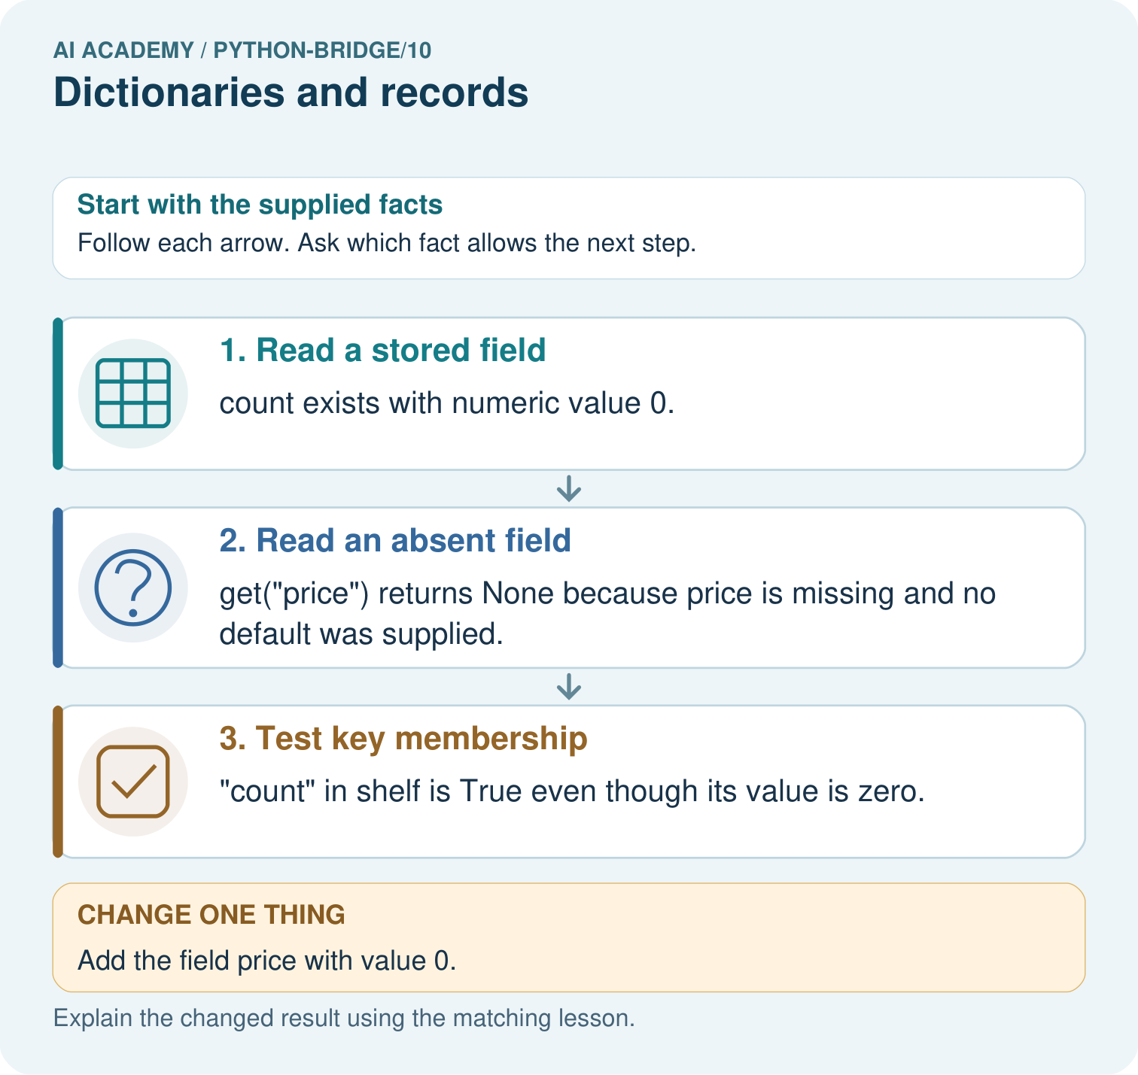

Read the picture one step at a time
Step | What happens and why
1. Read a stored field | count exists with numeric value 0.
2. Read an absent field | get("price") returns None because price is missing and no default was supplied.
3. Test key membership | "count" in shelf is True even though its value is zero.
Match each pictured step to the supplied facts. This is a worked teaching case, not an independent assessment.

Why this result follows
Dictionary keys name fields. Presence is different from truthiness of a value; a measured zero should not be discarded as if the field were absent.

What this example does not establish
None is also a possible explicitly stored value; real record contracts must define how missing and null values are represented.
Read the labelled picture: Predict all three original outputs. Explain the difference between count=0 and missing price, then predict the lookup after price=0 is added.
Change one thing: Add the field price with value 0. Predict the result before checking the explanation. What remains the same?

07. Find and repair a mistake
cupboard["Used"] raises KeyError here because keys are case sensitive. Correct it to "used". Adding a new field called "Used" would create a second key and leave the original unchanged; it would not repair the intended lookup.

Locate the earliest unsupported step
The code reads record["Used"] from the Red record. Explain the error and repair it without adding a field.

State one repair and the checks you would rerun.
________________________________________________________________
________________________________________________________________
________________________________________________________________
________________________________________________________________
________________________________________________________________
________________________________________________________________

08. Practise together
For {"name": "Red", "capacity": 9, "used": 2}, state the keys, value of used and remaining spaces.

Set used to 12. Predict the returned spaces. Does a used value of 0 mean the field is missing?
________________________________________________________________
________________________________________________________________
________________________________________________________________
________________________________________________________________
________________________________________________________________
________________________________________________________________

Explain your prediction to a partner before comparing results.
________________________________________________________________
________________________________________________________________
________________________________________________________________
________________________________________________________________

Practise with less help: Trace an update
Use workbook W2 for the connected example “Dictionaries and records”. First fill the input and rule boxes. Try the middle steps before asking for a hint. After a hint, try the next step yourself.
Plan | Do | Check
What is given? Which rule or procedure applies? | Record each intermediate step. | Does the result follow? What remains unknown?
Explain your trace to a partner. Your partner points to one step to check. Swap roles on the next case. Each person writes their own explanation.

Check your reasoning
Use the worked case for Dictionaries and records. Proposed explanation: “A successful run proves the conclusion”. Decide whether this explanation is supported. Point to the step or supplied fact that decides; explain your repair if needed.
Answer on your own before discussion. If you are unsure, say which step you need help with.

Explain the picture
Predict all three original outputs. Explain the difference between count=0 and missing price, then predict the lookup after price=0 is added.

My explanation using a pictured step and the given facts
________________________________________________________________
________________________________________________________________
________________________________________________________________
________________________________________________________________
This is supported practice. Keep the separately named independent case for an attempt before feedback.

09. Run the investigation

Predict, investigate and preserve the evidence
Change the Red record used to 9. State remaining spaces and whether capacity changes.
cupboard = {"name": "Blue", "capacity": 12, "used": 4}
def remaining(capacity, used):
return capacity - used
print(remaining(cupboard["capacity"], cupboard["used"]))
cupboard["used"] = 6
print(remaining(cupboard["capacity"], cupboard["used"]))
Record | Your evidence
Given input and fixed rule
Prediction before checking
Actual result, or “not run”
First mismatch and one explanation
Boundary or missing input and expected response
On paper, trace the supplied procedure. If code is provided, predict before running it in a local practice file. Never write an expected answer as though it were an observed run.

Plan → try → check
Before trying: what do I expect, and why? While trying: which step could first go wrong? Afterwards: what did I actually observe, and what should change? Keep “not run” if you only traced the procedure.

10. Build your understanding

Explain → apply → challenge
For {"name": "Red", "capacity": 9, "used": 2}, state the keys, value of used and remaining spaces.
The code reads record["Used"] from the Red record. Explain the error and repair it without adding a field.
A record has capacity 3 and used 4. It gives -1 spaces without an error. Should it be accepted? Explain.

Explain which evidence supports your conclusion and which claim remains unproved.
________________________________________________________________
________________________________________________________________
________________________________________________________________
________________________________________________________________
________________________________________________________________

11. Connect your project
Add a labelled dictionaries and records evidence sheet to Python readiness portfolio. Show how you can read and update named dictionary fields. Use the supplied fictional case and keep its inputs, intermediate steps, calculation or prediction, and limitation. Connect this record to last week’s record; a matching answer without a trace is insufficient.
Project evidence | Record
Component and version
Inputs permitted at prediction time
Trace and comparison with earlier work
Failure, limit and human review

Evidence for your project
For Python readiness before the Responsible Plant Classifier, retain a trace of the values, the predicted outputs and the changed-case explanation. Use actual Python 3 results to check the prediction after reasoning first.

12. Show what you know
Named fields reduce position mistakes but do not prove that a record is accurate. A capacity of 2 with used of 5 is representable in a dictionary and violates this schema.

A record has capacity 3 and used 4. It gives -1 spaces without an error. Should it be accepted? Explain.
________________________________________________________________
________________________________________________________________
________________________________________________________________
________________________________________________________________
________________________________________________________________
________________________________________________________________
A record has capacity 3 and used 4. It gives -1 spaces without an error. Should it be accepted? Explain.

My limited claim and a useful next check
________________________________________________________________
________________________________________________________________
________________________________________________________________
________________________________________________________________

13. Study a complete case

Complete evidence record

Follow the evidence
Step or case | Evidence | Meaning
Read used | 4 | 12 - 4 = 8
Update used | 6 | 12 - 6 = 6
Read each row from left to right and connect the evidence to the stated rule.
Follow the input through the stated procedure to its result. Cover the result first, predict it, then explain every intermediate step. The text/table accompanies the figure so the example can be read without colour.

My complete trace of the worked case
________________________________________________________________
________________________________________________________________
________________________________________________________________
________________________________________________________________
________________________________________________________________
________________________________________________________________

14. Try a new case independently

Independent case: Read, update and pass a dictionary record
Predict the three outputs and trace the named-field update. Explain why zero and a missing count produce different results. If the condition becomes if not count, which supplied record is first handled incorrectly?
def describe(record):
count = record.get("count")
if count is None:
return "missing"
return count
record = {"count": 0}
print(describe(record))
record["count"] = 3
print(describe(record))
print(describe({}))

My independent explanation, trace and limits
________________________________________________________________
________________________________________________________________
________________________________________________________________
________________________________________________________________
________________________________________________________________
________________________________________________________________
________________________________________________________________
Attempt this case before feedback. Record any help. Earlier examples below are further practice; a case already practised with feedback cannot establish fresh transfer.

Attempt this without hints
Create a Green record with capacity 15 and used 6. Pass its fields to remaining and store the result. Update used to 10 and repeat. Predict both results.

My independent procedure, result and limitation
________________________________________________________________
________________________________________________________________
________________________________________________________________
________________________________________________________________
________________________________________________________________
________________________________________________________________
________________________________________________________________
________________________________________________________________
Record support used: none, hint or teacher explanation. After feedback, a different case is needed to demonstrate independence.

Use feedback to improve
Attempt the independent case before hints. Record whether you worked alone, used a hint or followed a model. After feedback, fix the first unsupported step and explain why it changed. A later check uses a changed case, not a copied answer.

15. Your lesson route
Start with this question: A zero field is still present. A dictionary record describes a shelf. The program distinguishes missing data from an actual zero.
By the end, I can | How I will show it
Read and update named dictionary fields | Explain the deciding step, show a trace or test, and state one limit.
Connect a record to a function call | Explain the deciding step, show a trace or test, and state one limit.
Distinguish missing fields from zero values | Explain the deciding step, show a trace or test, and state one limit.
Remember → watch and explain → try with help → investigate → try independently → keep project evidence. Your teacher may spread this lesson across several classes.
Keep your first prediction. Compare it with what the evidence shows and explain any change.

16. Finish and return
Close your notes. Explain this goal in your own words: Read and update named dictionary fields

My deciding step, evidence and one remaining question
________________________________________________________________
________________________________________________________________
________________________________________________________________
________________________________________________________________
________________________________________________________________
If you are unsure, return to the worked picture and explain one arrow. If you are ready, change an input or assumption and justify your prediction.
Save your workbook evidence. At the next review, try a different case before opening your old answer.

