AI ACADEMY · STUDENT · python-bridge/11

Reading structured data
Project: Python readiness portfolio

Before you start
Which key stores the occupied count in {"capacity": 8, "used": 3}?

01. Your mission

Your learning target
I can process a list of records consistently.
I can compute a total from named fields.
I can preserve record meaning while tracing a loop.

Remember before reading
Close your notes first. A rough first answer helps us choose the right starting point; it is not a score for your ability.
Without opening the old lesson, explain one key idea from Dictionaries and records. Give an example and a mistake that the idea helps you avoid.
Without opening the old lesson, explain one key idea from Functions and arguments. Give an example and a mistake that the idea helps you avoid.
Without opening the old lesson, explain one key idea from Branching and boundary tests. Give an example and a mistake that the idea helps you avoid.
After trying, check the relevant lesson or ask your teacher. Change the part of your explanation that the evidence shows was wrong.
This week you will practise:
Process a list of records consistently
Compute a total from named fields
Preserve record meaning while tracing a loop

Retrieve what you already know
Which key stores the occupied count in {"capacity": 8, "used": 3}?

My starting explanation
________________________________________________________________
________________________________________________________________
________________________________________________________________

This week’s end goal
Trace reading structured data and explain the changed program before running it.

02. Notice the evidence
Two fictional cupboards are stored as a list of dictionaries. Each record uses the same keys and units. We want the total spare spaces. Treat the records as a dataset, and trace one record at a time before trusting a total.

List the given facts and one fact that is not supplied.
________________________________________________________________
________________________________________________________________
________________________________________________________________

03. See how it works
rows = [{"capacity": 8, "used": 3},
{"capacity": 6, "used": 6}]
total = 0
for row in rows:
spare = row["capacity"] - row["used"]
total = total + spare
print(total)

Follow the evidence
Step or case | Evidence | Meaning
First row | 8 - 3 = 5 | total becomes 5
Second row | 6 - 6 = 0 | total stays 5
Read each row from left to right and connect the evidence to the stated rule.
The loop variable row refers to each record in turn. We calculate spare from that record, then add it. total starts before the loop. An empty list produces 0 because there are no updates; it does not tell us whether no cupboards exist or records were not collected.

Connect the picture and the explanation
Point to the input, the deciding step and the result in this week’s visual. Explain the same step in ordinary words. A picture helps when you can say what each part represents.

04. Compare the cases

Compare a familiar case with a changed case
For spare contributions 2, 4 and 1, trace total starting at 0.

Keep the procedure fixed. Explain what changed in the inputs and result.
________________________________________________________________
________________________________________________________________
________________________________________________________________
________________________________________________________________
________________________________________________________________

Change one thing in the pictured case
Change: Add {"count":4} as a fourth row.
Prediction: Sum becomes 6, denominator 3, mean 2; coverage is 3 of 4.
Reason: Only the added recorded value contributes; the existing absent field remains skipped.

05. Words that unlock the idea
Word | Meaning
Dataset | A collection of records
Row | One record in a table
Field | One named part of a record
Accumulator | A variable updated to keep a running result

Use two terms to explain a step in this week’s example.
________________________________________________________________
________________________________________________________________
________________________________________________________________

06. Follow a worked example

Add a third record with capacity 10 and used 4. Predict the total and list each contribution.
________________________________________________________________
________________________________________________________________
________________________________________________________________
________________________________________________________________
________________________________________________________________
________________________________________________________________

Learn from the worked case
Cover the result before checking it. Say what is given, choose the procedure, and follow one step at a time. Then uncover the result and explain your first mismatch. Ask why a step is allowed, not only what number it produces.

A pictorial worked case: Reading structured data
Read rows with a missing-field policy. A toy table is represented as a list of dictionaries; count only rows with a recorded count.

The facts we will use
Python 3 records: [{"count":2},{"count":0},{}]. Policy: include existing numeric counts, including zero; skip an absent field.
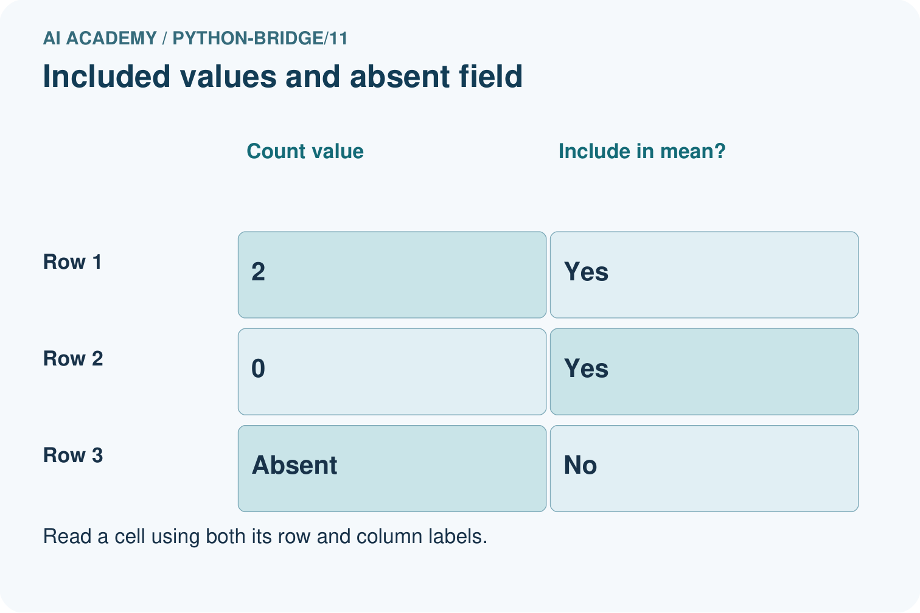
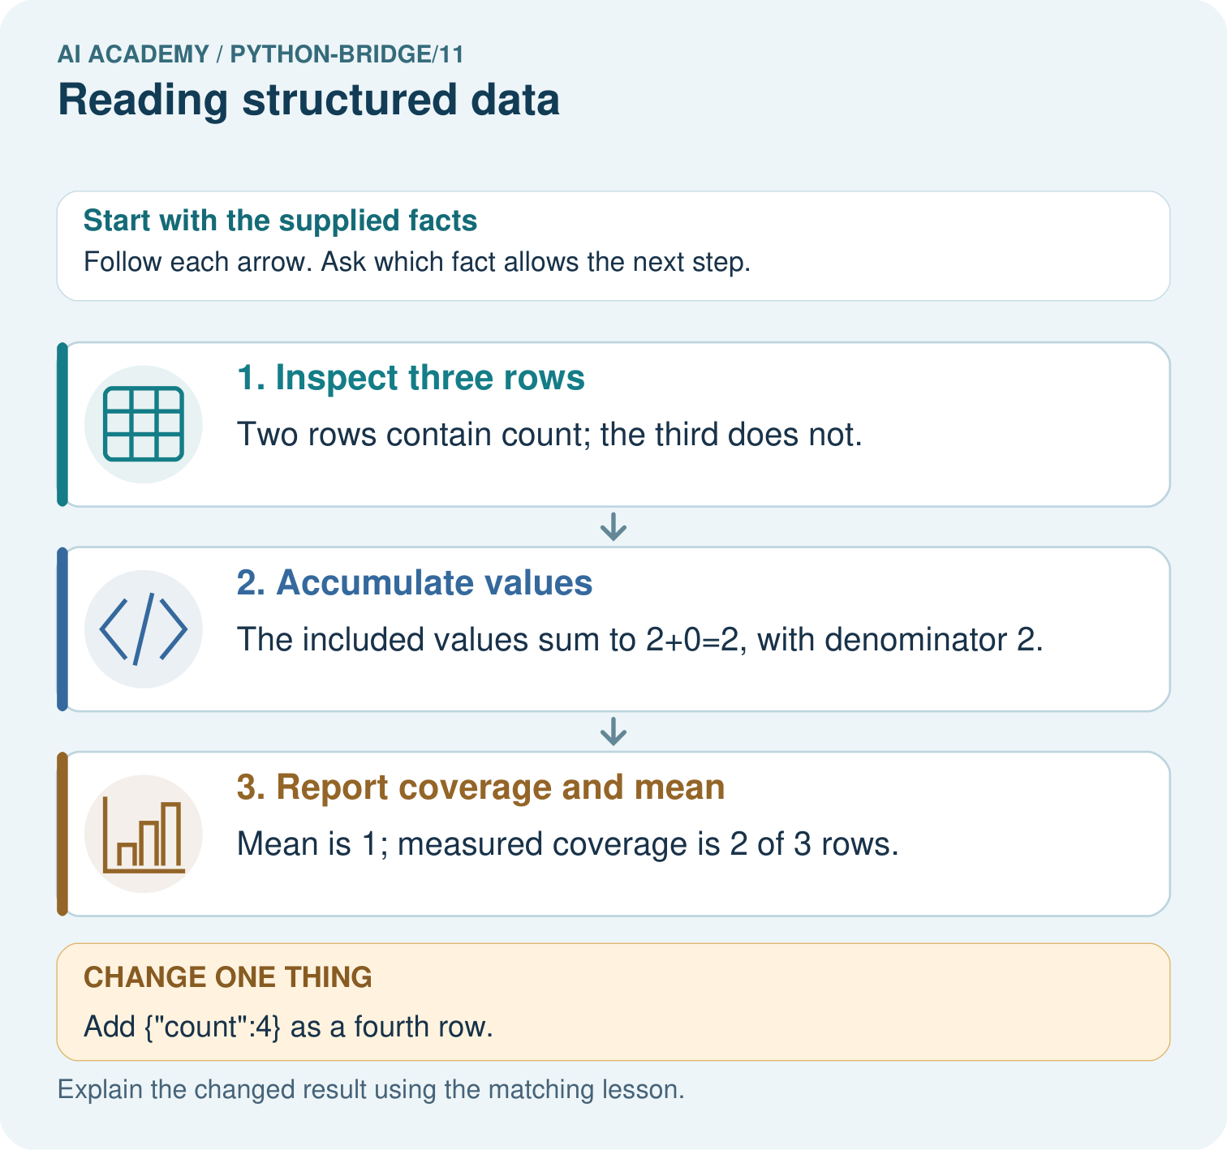

Read the picture one step at a time
Step | What happens and why
1. Inspect three rows | Two rows contain count; the third does not.
2. Accumulate values | The included values sum to 2+0=2, with denominator 2.
3. Report coverage and mean | Mean is 1; measured coverage is 2 of 3 rows.
Match each pictured step to the supplied facts. This is a worked teaching case, not an independent assessment.

Why this result follows
Structured data need a row policy before aggregation. Treating missing as zero changes the statistic and can conceal incomplete coverage; real zero remains an observation.

What this example does not establish
This worked row policy is explicit; file parsing, malformed values and data provenance require additional checks.
Read the labelled picture: Circle the included rows, calculate the sum and mean, and state coverage. Repeat after adding the fourth row with count four.
Change one thing: Add {"count":4} as a fourth row. Predict the result before checking the explanation. What remains the same?

07. Find and repair a mistake
Putting total = 0 inside the loop discards earlier contributions. With the original rows it finishes at 0, the second contribution. Move the initialization before the loop and rerun both the original and reversed row order.

Locate the earliest unsupported step
A loop resets total to 0 on each pass over contributions 2, 4, 1. What final total appears and how should it be fixed?

State one repair and the checks you would rerun.
________________________________________________________________
________________________________________________________________
________________________________________________________________
________________________________________________________________
________________________________________________________________
________________________________________________________________

08. Practise together
In the worked dataset, state the number of records and the spare spaces in the second record.

Add a third record with capacity 10 and used 4. Predict the total and list each contribution.
________________________________________________________________
________________________________________________________________
________________________________________________________________
________________________________________________________________
________________________________________________________________
________________________________________________________________

Explain your prediction to a partner before comparing results.
________________________________________________________________
________________________________________________________________
________________________________________________________________
________________________________________________________________

Practise with less help: Trace all updates
Use workbook W2 for the connected example “Reading structured data”. First fill the input and rule boxes. Try the middle steps before asking for a hint. After a hint, try the next step yourself.
Plan | Do | Check
What is given? Which rule or procedure applies? | Record each intermediate step. | Does the result follow? What remains unknown?
Explain your trace to a partner. Your partner points to one step to check. Swap roles on the next case. Each person writes their own explanation.

Check your reasoning
Use the worked case for Reading structured data. Proposed explanation: “A successful run proves the conclusion”. Decide whether this explanation is supported. Point to the step or supplied fact that decides; explain your repair if needed.
Answer on your own before discussion. If you are unsure, say which step you need help with.

Explain the picture
Circle the included rows, calculate the sum and mean, and state coverage. Repeat after adding the fourth row with count four.

My explanation using a pictured step and the given facts
________________________________________________________________
________________________________________________________________
________________________________________________________________
________________________________________________________________
This is supported practice. Keep the separately named independent case for an attempt before feedback.

09. Run the investigation

Predict, investigate and preserve the evidence
For spare contributions 2, 4 and 1, trace total starting at 0.
rows = [{"capacity": 8, "used": 3},
{"capacity": 6, "used": 6}]
total = 0
for row in rows:
spare = row["capacity"] - row["used"]
total = total + spare
print(total)
Record | Your evidence
Given input and fixed rule
Prediction before checking
Actual result, or “not run”
First mismatch and one explanation
Boundary or missing input and expected response
On paper, trace the supplied procedure. If code is provided, predict before running it in a local practice file. Never write an expected answer as though it were an observed run.

Plan → try → check
Before trying: what do I expect, and why? While trying: which step could first go wrong? Afterwards: what did I actually observe, and what should change? Keep “not run” if you only traced the procedure.

10. Build your understanding

Explain → apply → challenge
In the worked dataset, state the number of records and the spare spaces in the second record.
A loop resets total to 0 on each pass over contributions 2, 4, 1. What final total appears and how should it be fixed?
An empty dataset produces total 0. Can you conclude that every cupboard is full?

Explain which evidence supports your conclusion and which claim remains unproved.
________________________________________________________________
________________________________________________________________
________________________________________________________________
________________________________________________________________
________________________________________________________________

11. Connect your project
Add a labelled reading structured data evidence sheet to Python readiness portfolio. Show how you can process a list of records consistently. Use the supplied fictional case and keep its inputs, intermediate steps, calculation or prediction, and limitation. Connect this record to last week’s record; a matching answer without a trace is insufficient.
Project evidence | Record
Component and version
Inputs permitted at prediction time
Trace and comparison with earlier work
Failure, limit and human review

Evidence for your project
For Python readiness before the Responsible Plant Classifier, retain a trace of the values, the predicted outputs and the changed-case explanation. Use actual Python 3 results to check the prediction after reasoning first.

12. Show what you know
This loop assumes every record has the required integer fields. A missing used field causes KeyError. Do not silently treat a missing count as zero; that would invent unused capacity.

An empty dataset produces total 0. Can you conclude that every cupboard is full?
________________________________________________________________
________________________________________________________________
________________________________________________________________
________________________________________________________________
________________________________________________________________
________________________________________________________________
An empty dataset produces total 0. Can you conclude that every cupboard is full?

My limited claim and a useful next check
________________________________________________________________
________________________________________________________________
________________________________________________________________
________________________________________________________________

13. Study a complete case

Complete evidence record

Follow the evidence
Step or case | Evidence | Meaning
First row | 8 - 3 = 5 | total becomes 5
Second row | 6 - 6 = 0 | total stays 5
Read each row from left to right and connect the evidence to the stated rule.
Follow the input through the stated procedure to its result. Cover the result first, predict it, then explain every intermediate step. The text/table accompanies the figure so the example can be read without colour.

My complete trace of the worked case
________________________________________________________________
________________________________________________________________
________________________________________________________________
________________________________________________________________
________________________________________________________________
________________________________________________________________

14. Try a new case independently

Independent case: Preserve records and report measured coverage
Trace the named fields and missing-value policy. Predict the output, state the observed total and mean denominator, and report coverage. What changes if all three rows are empty records?
rows = [{"score": 2}, {"score": 6}, {}]
values = []
for row in rows:
value = row.get("score")
if value is not None:
values.append(value)
observed_total = sum(values)
if len(values) > 0:
mean = observed_total / len(values)
else:
mean = None
print(observed_total, len(values), len(rows), mean)

My independent explanation, trace and limits
________________________________________________________________
________________________________________________________________
________________________________________________________________
________________________________________________________________
________________________________________________________________
________________________________________________________________
________________________________________________________________
Attempt this case before feedback. Record any help. Earlier examples below are further practice; a case already practised with feedback cannot establish fresh transfer.

Attempt this without hints
Write a loop for records (capacity 9, used 2), (capacity 5, used 1), and (capacity 4, used 4). Predict the total. Reverse the order and test an empty list.

My independent procedure, result and limitation
________________________________________________________________
________________________________________________________________
________________________________________________________________
________________________________________________________________
________________________________________________________________
________________________________________________________________
________________________________________________________________
________________________________________________________________
Record support used: none, hint or teacher explanation. After feedback, a different case is needed to demonstrate independence.

Use feedback to improve
Attempt the independent case before hints. Record whether you worked alone, used a hint or followed a model. After feedback, fix the first unsupported step and explain why it changed. A later check uses a changed case, not a copied answer.

15. Your lesson route
Start with this question: Read rows with a missing-field policy. A toy table is represented as a list of dictionaries; count only rows with a recorded count.
By the end, I can | How I will show it
Process a list of records consistently | Explain the deciding step, show a trace or test, and state one limit.
Compute a total from named fields | Explain the deciding step, show a trace or test, and state one limit.
Preserve record meaning while tracing a loop | Explain the deciding step, show a trace or test, and state one limit.
Remember → watch and explain → try with help → investigate → try independently → keep project evidence. Your teacher may spread this lesson across several classes.
Keep your first prediction. Compare it with what the evidence shows and explain any change.

16. Finish and return
Close your notes. Explain this goal in your own words: Process a list of records consistently

My deciding step, evidence and one remaining question
________________________________________________________________
________________________________________________________________
________________________________________________________________
________________________________________________________________
________________________________________________________________
If you are unsure, return to the worked picture and explain one arrow. If you are ready, change an input or assumption and justify your prediction.
Save your workbook evidence. At the next review, try a different case before opening your old answer.

