AI ACADEMY · TEACHER · ai-1/5

Pictures Become Numbers
Project: Helpful Classroom Sorter

01. Pictures Become Numbers

Teach the learning cycle
Primary target: Encode and reconstruct a small image using an explicit grid convention
Session | Sequence and minutes | Resources
Session 1 · Understand · 45 min | 0–7: recall and prerequisite; 7–15: inspect the concrete case and predict; 15–30: teacher models the worked trace; 30–40: learners explain a step using the text and visual; 40–45: check the core idea. | Sections 1–6; record the brief recall in the workbook.
Session 2 · Practise · 45 min | 0–5: retrieve the procedure; 5–15: W2 completion practice; 15–23: explain and check with a partner; 23–30: each learner answers the misconception check; 30–40: targeted reteaching or a harder variation; 40–45: prepare the investigation. | Sections 7–10; use the matching workbook W2 and misconception check.
Session 3 · Investigate and transfer · 45 min | 0–5: retrieve the decision rule; 5–20: investigate or trace; 20–30: start the independent case; 30–38: connect the project; 38–43: act on feedback; 43–45: plan the return check. | Sections 9 and 11–14. Give extra time to finish the full task set; use Section 15 when the week includes a coding lab.
This is a starting allocation of 135 minutes, not a validated duration. Preserve all named topics. Schedule extra time for connected examples, the full investigation, independent cases and project building. Repeated copies of a case share one recorded attempt; they are not new evidence.

Retrieval answer guidance

Rules or Learned Patterns?
Without opening the old lesson, explain one key idea from Rules or Learned Patterns?. Give an example and a mistake that the idea helps you avoid.
Look for: Execute a stated rule including its boundary
Reference example, not the only acceptable wording: At least 5 gives narrow, wide, wide. Greater than 5 gives narrow, narrow, wide. Only the equality case changes among these inputs.

Input, Process, Output
Without opening the old lesson, explain one key idea from Input, Process, Output. Give an example and a mistake that the idea helps you avoid.
Look for: Trace information through a system without confusing information with a physical action
Reference example, not the only acceptable wording: Input includes both request fields and all three catalogue records. The process checks science AND pages<=120. Output contains A only; B fails the length condition and C fails the genre condition. Listing A does not establish that a copy was reserved.
Use the student module and workbook section with this exact week title. The worked case, independent question and answers below form one aligned lesson sequence.

What the learner must demonstrate
Encode a 2×3 monochrome image with top row black–white–black and bottom row white–black–white, using 1 for black. A partner reads columns first. Explain why the image changes although the six values are identical.

Concept to explain
A digital image is a grid of measured color values.
Term | Meaning
pixel | one picture element in a grid
grid | rows and columns that locate values
channel | one measured color component
resolution | number of pixels used to represent an image

Prepare the class
Use the supplied scenario, student illustrations and blank paper. For numeric work, offer counters or a calculator after learners show the setup. Fictional records are supplied; personal data and paid accounts are unnecessary.
Allow 80 minutes: recall 8; explanation 12; worked demonstration 15; guided practice 20; independent assessment 15; project and reflection 10. Extend the lab into a second session when needed.

Preparation for the connected explanation
The image is binary for transparency, not a claim that ordinary colour images contain only zeros and ones as pixel values. Distinguish bit-level storage from the image value convention. Grid reconstruction is assessed separately from interpretation. A learner may name the worked pattern differently while still reconstructing it correctly.

Readiness answer
No. The fitting examples may not distinguish the rules, and agreement on those examples does not settle every unseen case.
Squared paper and a dark pencil for each learner
The worked grid with its explicit reading convention
Two empty two-row four-column grids for independent assessment

End goal for the pictorial case
By the end, I can encode pixel positions and show why a count cannot reconstruct a picture.
This added worked case illustrates the week’s main idea. Retain all original and connected topics; schedule its practice within the teaching cycle.

02. Explain the mechanism

Explain the mechanism
Follow the information instead of imagining magic inside the machine.
INPUT light measured at grid locations
PROCESS store and transform pixel values
OUTPUT a displayed, resized, blurred, or classified image
CORE IDEA A digital image is a grid of measured color values.
UNDER THE HOOD Digital images sample a scene across a spatial grid. Each pixel stores channel values, commonly red, green, and blue. Resolution controls sampling density; transformations operate on numbers, not on an intact object inside the computer.
Draw a fresh example with all three stages:
Every step connects a claim to observable evidence.
CASE A 5 by 5 black-and-white picture can be stored as 25 numbers, one value for each pixel position.
STEP 1 — OBSERVE light measured at grid locations
STEP 2 — TRACE store and transform pixel values
STEP 3 — CONCLUDE a displayed, resized, blurred, or classified image
MODEL REASONING Each grid position becomes one displayed square. A blur combines nearby values, so isolated corners and thin lines disappear before large regions. The computer transforms numbers; the human viewer recognizes the shape.
DO NOT OVERCLAIM A pixel is a measurement at a location, not a tiny copy of the object.
What new evidence could change this answer?

Concrete teaching case
A 2 by 2 image has rows [0,1] and [1,0]. Zero means white and one means black.
Draw it, then change the top-left value to 1.

Exact explanation to model
Initially top-right and bottom-left are black. The change produces three black squares. Pixel values encode an image; object recognition is a separate interpretation.

Explain the added worked example
Imagine sending a small black-and-white sign using only numbers. We can divide the sign into a grid, record 1 for a black square and 0 for a white square, and read each row from left to right, starting at the top. The receiver needs the width, height and these conventions to reconstruct the same arrangement.
A pixel is a position with a recorded value. In our simplified binary image, one value selects black or white. Other image formats can record brightness levels or multiple colour channels. The convention 1 means black belongs to this exercise; it is not a universal rule for every digital image.
Encoding a picture does not recognise what it depicts. A program can store or display the numbers without calling the image a letter, an arrow or a person. Interpretation is another operation, just as displaying a book title was different from reading the entire book in Week 2.
The first row is 0,1,0, so only its middle pixel is black. The second row is 1,1,1, so all three are black. The third row repeats the first. This reconstructs the displayed cross-like pattern under our convention.
A flattened record would be 0,1,0,1,1,1,0,1,0. Without the grid dimensions, the same nine values could also be drawn in one row of nine. Keep the shape information with the values. Width times height counts pixels; it does not tell us their contents.

Key terms
Term | Meaning
Pixel | One position in a digital image grid with a recorded value or values
Encoding | A convention for representing information with symbols or numbers
Resolution | The number of positions in an image grid, often given as width by height
Spatial arrangement | Where elements are located relative to one another
Interpretation | A meaning or category assigned to a representation using a rule, model or human judgment

Model the reasoning aloud
Use the complete worked example below before asking learners to complete W2. Reveal a small part, invite a prediction, then explain the deciding step. These teacher notes contain solutions; do not reveal the independent case answer during modelling.
Suppose we discard the row records and retain only black pixel count=5. That count matches the cross, but it also matches rows 1,1,1 then 1,1,0 then 0,0,0. The second arrangement fills the top row and two positions below it. Both have five black pixels and nine pixels in total, yet they are different images.
Width 3 and height 3 | There are 9 positions | The value at each position
Black pixel count 5 | Five positions are black under this code | Which five positions
Dimensions and all three ordered rows | The full binary grid under this convention | What a viewer or model will call the picture
A pixel count can still be a useful feature for some tasks. For example, it can separate empty grids from grids with at least one mark. But it cannot separate every shape. To judge a feature, ask whether it retains the distinctions required by the task.
Thinking move | Teacher prompt
Plan | What is given? What is the question? Which procedure fits these facts?
Do | Point to each input and intermediate step in the worked trace. Name the rule that allows the next step.
Check | Does the output answer the question? Which assumption or limitation prevents a larger claim?
Use the diagram and verbal explanation together. Ask learners to match a sentence to a specific visual step; do not assign learners fixed visual or auditory learning styles.

A pictorial worked case: Pictures Become Numbers
Two fictional 2-by-3 pixel badges contain the same number of dark squares.

The facts we will use
Dark=1, light=0; rows are read top to bottom, left to right.
Badge A rows: 1,0,1 / 0,1,0. Badge B: 1,1,1 / 0,0,0.
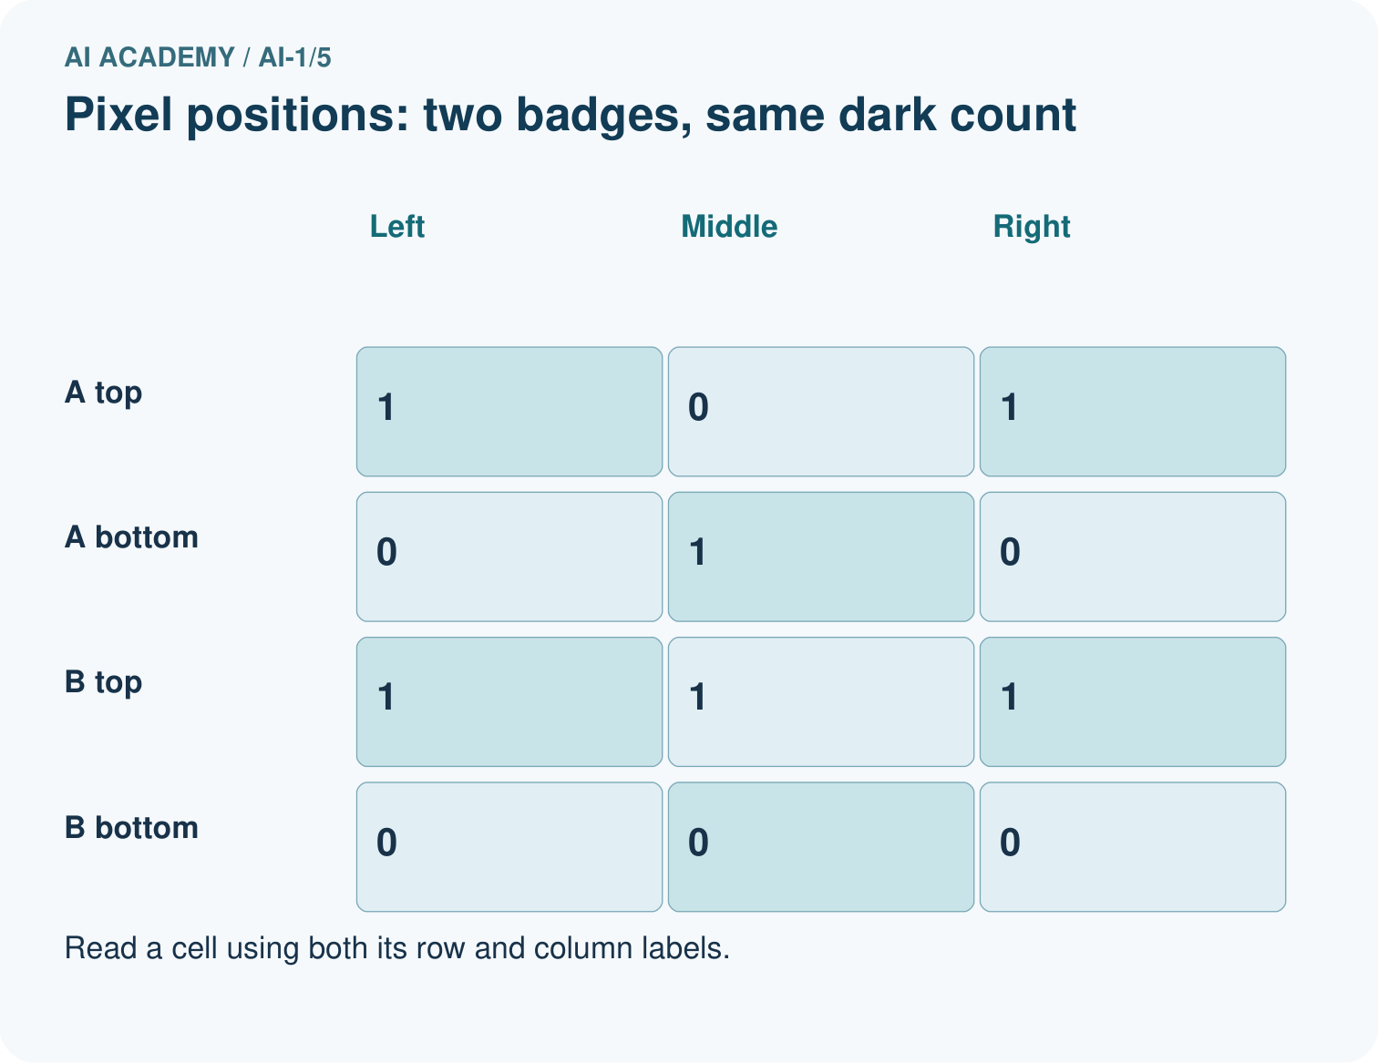
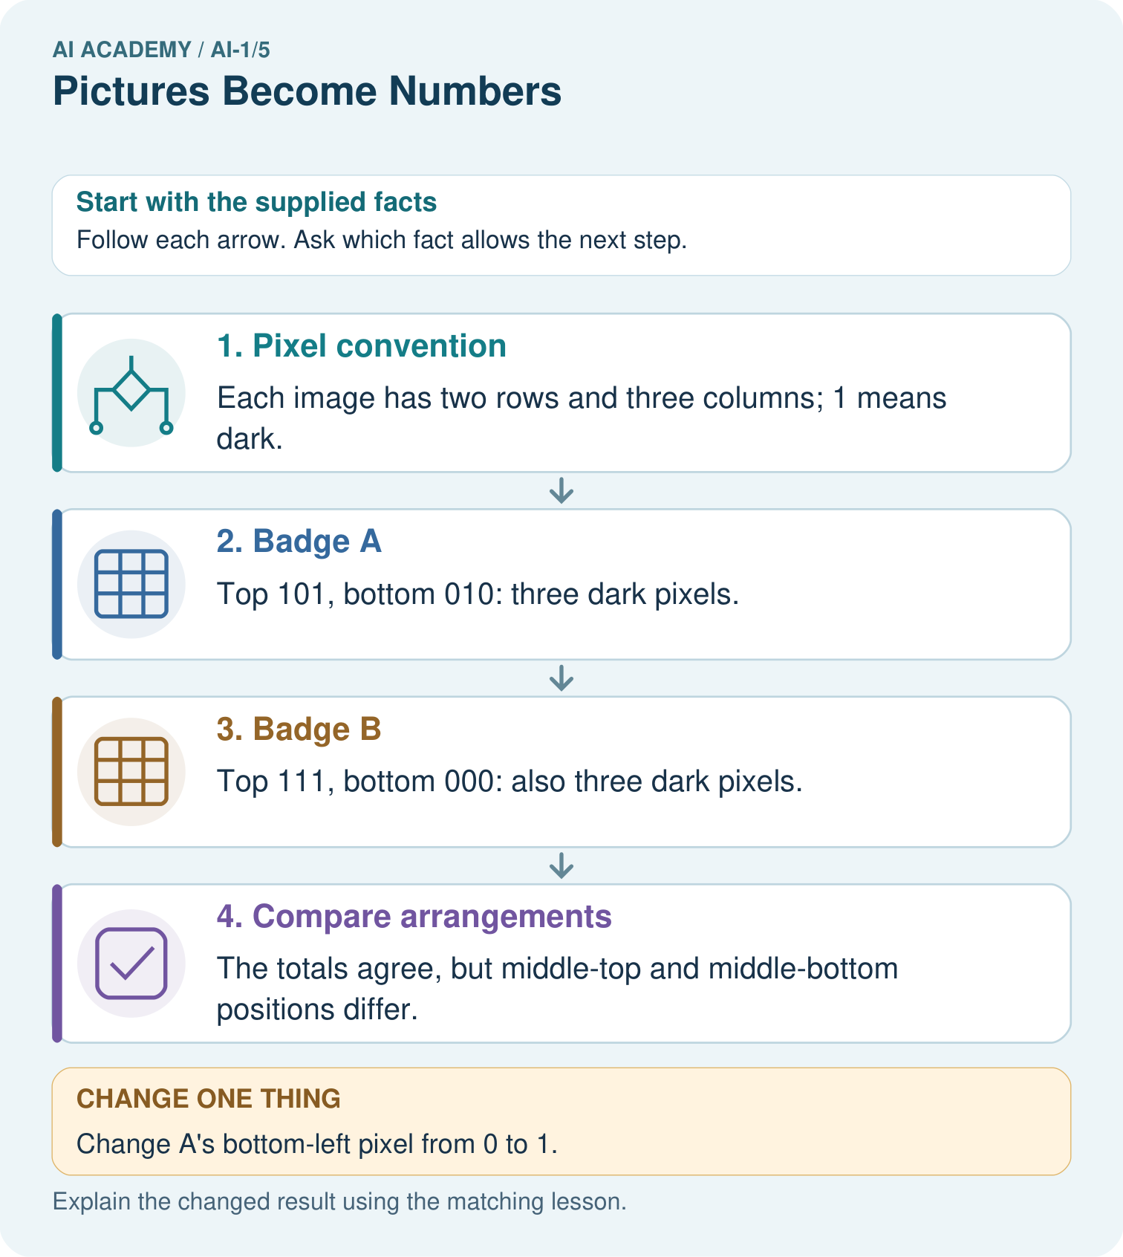

Read the picture one step at a time
Step | What happens and why
1. Pixel convention | Each image has two rows and three columns; 1 means dark.
2. Badge A | Top 101, bottom 010: three dark pixels.
3. Badge B | Top 111, bottom 000: also three dark pixels.
4. Compare arrangements | The totals agree, but middle-top and middle-bottom positions differ.
Match each pictured step to the supplied facts. This is a worked teaching case, not an independent assessment.

Why this result follows
A grid preserves where each brightness belongs. Adding the six values preserves only the dark count, which is 3 in both images. The total therefore cannot distinguish these badges. Dimensions and reading order belong to the representation, not to an optional caption.

What this example does not establish
This toy binary encoding does not include real photographs’ colour channels, compression or illumination effects.

Change one thing in the pictured case
Change: Change A’s bottom-left pixel from 0 to 1.
Prediction: A now has four dark pixels; its row encoding is 101 / 110.
Reason: Exactly one light pixel becomes dark; the other five positions remain unchanged.

Ask while showing the picture
Cover the result. Ask learners to name the inputs and predict the next step. Uncover one step, connect the icon to the actual procedure, and explain its evidence. Then change the supplied condition and compare. The picture is a representation; it does not document execution of a real AI model.

03. Demonstrate and guide practice

Demonstrate and guide practice

Board sequence
Write the given facts: A 2 by 2 image has rows [0,1] and [1,0]. Zero means white and one means black.
Write the question to explain: Draw it, then change the top-left value to 1.
Reveal after predictions: Initially top-right and bottom-left are black. The change produces three black squares. Pixel values encode an image; object recognition is a separate interpretation.
Keep for an independent attempt: Use 0 for dark and 1 for light. Draw a two-by-two image with rows [1,0] and [0,1]. Then change only the bottom-left pixel to light. Which number changes?

Classroom dialogue
Ask: Which facts are given, and which would we have to assume? Learners mark relevant details before discussing answers.
Say: Predict first. Show the rule, information path or calculation that would produce the result. A correct guess is not yet an explanation.
Reveal reasoning one step at a time. Explain why a tempting alternative fails. Write units and denominators for arithmetic, trace conditions for decisions, and identify supporting sources for claims.
In pairs, one learner solves while the other checks evidence; exchange roles. Remove the worked answer before independent assessment.

Model these guided questions
The two rows are black-white-black and white-black-white, giving three black pixels. Other arrangements share that count, so it cannot recover positions. For the exit, move one black pixel to a previously white position while preserving the total; the image changes but the count does not.

Case-specific teaching sequence
Stage | Teacher action
Session 1 start 0 to 7 minutes | Recall the tied-threshold example. Ask why indistinguishable evidence can leave different answers possible.
7 to 20 minutes | Agree on colour and reading conventions. Reconstruct the worked grid row by row.
20 to 33 minutes | Flatten the values and show why dimensions matter. Compare the two five-black-pixel patterns.
33 to 45 minutes | Pairs complete W1 and W2, exchanging encodings and reading them back.
Session 2 start 0 to 8 minutes | Show two equal-count grids and ask which input a count-only classifier would receive.
8 to 23 minutes | Complete W3 and diagnose a reversed convention. Require a specific counterexample.
23 to 38 minutes | Collect W4 independently. Check the dimensions and counts before evaluating the explanation.
38 to 45 minutes | Discuss W5 and the exit question. Distinguish stored values from assigned meaning.

Reduce help deliberately
Completion task: A message contains 1,0,0,1,1,0 but gives no dimensions. Show a one-row arrangement and a two-row arrangement using the same values. Name the extra information that would distinguish them.
Teacher check: One row of width 6 is [1,0,0,1,1,0]. Two rows of width 3 are [1,0,0] and [1,1,0]. Specify width and height, plus reading order and colour convention. The values alone do not choose the shape.
Start by identifying the given inputs together. Leave the intermediate steps blank. If needed, model one step, then withdraw that help on the next step. Move to a full trace only when the partial trace is understood. For partners, alternate explainer and checker; collect a response from every learner before discussion.

Individual reasoning check
Use the worked case for Images as numerical grids. Proposed explanation: “The number one always means black”. Decide whether this explanation is supported. Point to the step or supplied fact that decides; explain your repair if needed.
Expected correction: Our convention states that meaning. Other encodings use different scales or channels; read their specification.
Collect explanations, not only yes/no votes. If a misunderstanding is common, re-model the relevant step for the class. If it affects a few learners, give a short targeted group explanation while others solve a more demanding variation.

Pictorial practice question
Find a position where the original badges differ, then read the changed A back as a picture.

Reasoned teacher answer
The top-middle pixel is 0 in A and 1 in B. Changed A is dark at top-left, top-right, bottom-left and bottom-middle.
Changed-case reasoning: A now has four dark pixels; its row encoding is 101 / 110. Exactly one light pixel becomes dark; the other five positions remain unchanged.
Collect each learner’s explanation before discussion. Use the first missing connection between input, deciding step and result to choose support. This question is worked-case practice, not fresh mastery evidence.

04. Run the weekly evidence lab

Run the weekly evidence lab
Predict first, test honestly, and explain what the evidence means.
State your prediction before the result is known.
Complete the task: Decode a tiny pixel picture and predict a blurred version.
Keep a normal case and an edge case clearly separated.
Record what happened—even when it does not match your prediction.
Explain the result, one limitation, and the next useful test.
INDEPENDENCE After support is removed, repeat the proof with a fresh case.

Make the lab runnable
Use the concrete case as the shared normal case and the independent question as a second case. Each pair creates a boundary or missing-information case and predicts its result before testing. Keep the expected result separate from an observed mistake.
Record | What to capture
Input or evidence | Exact data, instruction or claim
Expected result | Answer or safe fallback declared before the run
Observed result | Actual result, including errors
Explanation | Rule, calculation or evidence explaining the outcome
Next test | One justified change and a new prediction

Diagnose and reteach
CLAIM TO REPAIR An image is stored as its object name.
For guessing, return to given facts and request a trace. For vocabulary without application, use one example and one non-example. For arithmetic errors, check the setup before the calculation. Finish with a different uncoached case before recording mastery.

Address these additional misconceptions
The number one always means black: Our convention states that meaning. Other encodings use different scales or channels; read their specification.
A pixel count is the picture: Have students reconstruct two different arrangements with the same count.
Storing pixels recognises the object: A grid decoder only reconstructs the representation. A separate interpretation step assigns a category.

Match the support to the first error
What the response shows | Next teaching action
Missing or misread facts | Read the case aloud, mark supplied versus unknown facts, and let the learner restate it.
Wrong procedure | Return to the deciding step in the worked case. Contrast it with the proposed incorrect explanation.
Arithmetic or implementation error | Trace intermediate values or lines; preserve the first mismatch and retry that step.
Correct result without a reason | Ask for a trace and a changed case before marking independent understanding.
An unsupported wider claim | Ask which supplied evidence supports the claim and which further observation would be needed.
Offer an oral explanation, drawing, enlarged visual or fewer examples when that removes a reading/writing barrier. Keep the same reasoning goal. Stretch secure learners by changing a boundary or assumption and asking them to defend the effect, not simply by assigning more of the same questions.

05. Assess and explain the answers

Assess and explain the answers

Worked case answer
Initially top-right and bottom-left are black. The change produces three black squares. Pixel values encode an image; object recognition is a separate interpretation.

Independent question
Use 0 for dark and 1 for light. Draw a two-by-two image with rows [1,0] and [0,1]. Then change only the bottom-left pixel to light. Which number changes?

Expected independent answer
The original light pixels are top-left and bottom-right. The bottom-left entry changes from 0 to 1, giving rows [1,0] and [1,1]. Position and value both matter.

What counts as evidence
Criterion | 0 points | 1 point | 2 points
Result | Incorrect or absent | Partly correct | Correct with necessary conditions
Reasoning | No supporting trace | Some steps | Clear mechanism, calculation or source support
Limit | Overclaims certainty | Vague limitation | Relevant uncertainty or missing fact
Transfer | Copies without adapting | Adapts with prompts | Solves a changed case independently
Use 6/8 as a classroom checkpoint, with 2 required for both Result and Reasoning. This is a proposed teaching rule, not a validated certification threshold. Do not count a coached answer as independent mastery; correct unsafe or unsupported claims regardless of total.

Feedback
Ask the learner to find the evidence that challenges this claim: “An image is stored as its object name.” Keep the first attempt and an uncoached retry separate.

Original transfer answer
Row-major encoding is [1,0,1,0,1,0], with shape 2×3. Interpreting the same list column-first gives top [1,1,1] and bottom [0,0,0]. Values need shape and ordering conventions; encoding alone does not recognise an object.

Explanations for the additional workbook examples

W1 Read and reconstruct
Using 1 for black and 0 for white, draw width 3, height 2 with rows 1,0,1 and 0,1,0. Read it back into numbers and count black pixels.
The upper row has black, white, black; the lower row has white, black, white. Reading back gives the supplied two rows. There are three black pixels among six total positions.

W2 Preserve the missing field
A message contains 1,0,0,1,1,0 but gives no dimensions. Show a one-row arrangement and a two-row arrangement using the same values. Name the extra information that would distinguish them.
One row of width 6 is [1,0,0,1,1,0]. Two rows of width 3 are [1,0,0] and [1,1,0]. Specify width and height, plus reading order and colour convention. The values alone do not choose the shape.

W3 Test a count feature
A classifier receives only the number of black pixels. Can it always distinguish the chapter's cross from every other three by three pattern? Construct a different pattern with the same count and explain.
No. Rows [1,1,1], [1,1,0], [0,0,0] have five black pixels, as does the cross, but a different arrangement. The classifier receives identical input counts for the two, so that feature alone cannot distinguish them.

W4 Design a new counterexample
Create two different images of width 4 and height 2, each with exactly three black pixels. Write both complete row encodings. Explain which fact their shared count retains and which difference it discards.
One valid pair is A [1,1,1,0]/[0,0,0,0] and B [1,0,0,0]/[0,1,0,1]. Both have two rows of four values and three ones. Count retains the number of black positions but discards their locations. Other valid pairs are accepted if dimensions, counts and arrangements meet the constraints.

W5 Locate an input problem
A program receives the correct grid but displays black wherever the code says 0 and white wherever it says 1. A student proposes collecting more classifier examples. Identify the earlier mismatch and the first check to perform.
The display uses the opposite colour convention from the sender. Check and align the encoding/decoding convention, then reconstruct a known grid. More classifier examples would not be the first repair for this identified input/display mismatch.

Assess independent transfer
Selected case: Create two different images of width 4 and height 2, each with exactly three black pixels. Write both complete row encodings. Explain which fact their shared count retains and which difference it discards.

Selected case answer
One valid pair is A [1,1,1,0]/[0,0,0,0] and B [1,0,0,0]/[0,1,0,1]. Both have two rows of four values and three ones. Count retains the number of black positions but discards their locations. Other valid pairs are accepted if dimensions, counts and arrangements meet the constraints.
Dimension | Evidence required
Explanation | Names the applicable idea or procedure and ties it to the supplied facts.
Trace and result | Preserves the given inputs and shows the relevant intermediate steps; distinguishes a prediction from an observed execution.
Limits | States the assumptions, missing evidence or conditions under which the result would change.
Record each dimension as not yet, with support, or independent. Accept a valid alternative procedure with a defensible trace. Do not penalise an honestly recorded model failure if the learner correctly explains its evidence and limits.

Feedback that the learner uses
Name the earliest unsupported step and give one action to repair it. Have the learner make that repair now and explain why. Then assess the relevant skill on a fresh, fully specified case. Confirm it was not previously practised with feedback; solve and check the new case before assigning it. A follow-up design prompt is a starting brief, not automatically an equivalent test.

06. Connect and extend learning

Connect and extend learning

Helpful Classroom Sorter
Choose which visible item features the Classroom Sorter may represent as image measurements and name one feature that lighting could distort.
Keep the decision, input, result, explanation and remaining limitation in the project evidence record. Retrieve this record next week rather than restarting the project.

Support and stretch
Use physical cards, spoken explanations and a three-stage drawing. Read aloud without giving the answer. Stretch: compare two mechanisms with the same visible output and explain what evidence distinguishes them.

Exit reflection
Ask for one decision the learner can now justify and one situation requiring more evidence or human review. Confidence ratings are separate from correct independent performance.

Bridge to the next week
Next: Week 6: Sound Becomes a Signal. Retrieve today’s evidence and identify what carries forward and what is new.

Support and fresh reassessment
Provide large tactile or printed cells, with numbers as well as shading so colour is unnecessary. Let learners dictate row values. Extension: construct two grids with equal counts in every row but different arrangements, showing that row totals still lose information.
W4 is secure when both images are two by four, each has three ones, the patterns differ and the explanation identifies lost location information. If a learner draws valid pictures but mismatches their code, reteach the round-trip check, then assess with fresh patterns.
Week 6 transfers the idea of ordered numerical representations to sound, where the positions refer to times rather than image locations.

Plan the delayed return
Suggested return points in this level: ai-1/6, ai-1/8, ai-1/11. Use actual classroom dates, adjusting for holidays and gaps. One, three and six teaching weeks are scheduling choices, not a claimed optimal spacing.
At a delayed check, ask for the idea from memory and a changed application. Compare with the earlier independent response and record support used. For a new level, revisit the previous capstone before checking the new prerequisites.
Record | Teacher evidence
Learner code and date
Concept and case used; prior exposure
Explanation / trace / limits
Support and first repair
Changed case and delayed outcome
Next teaching action
Use the evidence to choose reteaching or the next step. A completed page, confidence rating or attractive project does not by itself demonstrate understanding.

Project evidence from this case
If the sorter uses images, retain dimensions and arrangement rather than assuming a dark-pixel count describes shape.

07. Prepare, teach and assess
Teaching target: Encode and reconstruct a small image using an explicit grid convention
Prepare the labelled worked-case picture, the matching workbook, fictional input cards and a place for individual responses. No paid AI account is required for the paper reasoning activities.
Session | Plan | Resources
Session 1 · Understand · 45 min | 0–7: recall and prerequisite; 7–15: inspect the concrete case and predict; 15–30: teacher models the worked trace; 30–40: learners explain a step using the text and visual; 40–45: check the core idea. | Sections 1–6; record the brief recall in the workbook.
Session 2 · Practise · 45 min | 0–5: retrieve the procedure; 5–15: W2 completion practice; 15–23: explain and check with a partner; 23–30: each learner answers the misconception check; 30–40: targeted reteaching or a harder variation; 40–45: prepare the investigation. | Sections 7–10; use the matching workbook W2 and misconception check.
Session 3 · Investigate and transfer · 45 min | 0–5: retrieve the decision rule; 5–20: investigate or trace; 20–30: start the independent case; 30–38: connect the project; 38–43: act on feedback; 43–45: plan the return check. | Sections 9 and 11–14. Give extra time to finish the full task set; use Section 15 when the week includes a coding lab.
Before class, solve the supported practice: A message contains 1,0,0,1,1,0 but gives no dimensions. Show a one-row arrangement and a two-row arrangement using the same values. Name the extra information that would distinguish them.
Reasoned practice answer: One row of width 6 is [1,0,0,1,1,0]. Two rows of width 3 are [1,0,0] and [1,1,0]. Specify width and height, plus reading order and colour convention. The values alone do not choose the shape.
Check every learner before discussion: Use the worked case for Images as numerical grids. Proposed explanation: “The number one always means black”. Decide whether this explanation is supported. Point to the step or supplied fact that decides; explain your repair if needed.
Misconception repair: Our convention states that meaning. Other encodings use different scales or channels; read their specification.
Support: read the exact case aloud, enlarge the labelled picture, supply input cards and model only the first deciding step. Accept a spoken explanation or drawing; retain the reasoning goal.
Extension: Change A’s bottom-left pixel from 0 to 1. Require a prediction and a reason before comparing. Expected result: A now has four dark pixels; its row encoding is 101 / 110. Reason: Exactly one light pixel becomes dark; the other five positions remain unchanged.
Independent assessment: withhold the reserved answer until the learner has attempted the new case. Record support separately from correctness.
Criterion | Not yet | With support | Independent
Explanation | Names an answer without a deciding fact | Uses a hint to link fact and decision | Explains the deciding fact in own words
Trace or test | Cannot connect input and result | Completes steps with prompts | Traces or tests a changed case accurately
Limits and revision | Claims more than evidence supports | Names a limit after a prompt | States a defensible limit and useful next test
Project checkpoint: Frame the need. Name the user, the problem, allowed inputs and a safe simple starting method.
Use the weekly teacher answer for topic-specific reasoning. A saved progress tick is an activity record; judge mastery from the learner’s explanation and evidence.

