AI ACADEMY · TEACHER · ai-1/11

Repeating Efficiently
Project: Helpful Classroom Sorter

01. Repeating Efficiently

Teach the learning cycle
Primary target: Trace a loop by testing its condition before every repetition
Session | Sequence and minutes | Resources
Session 1 · Understand · 45 min | 0–7: recall and prerequisite; 7–15: inspect the concrete case and predict; 15–30: teacher models the worked trace; 30–40: learners explain a step using the text and visual; 40–45: check the core idea. | Sections 1–6; record the brief recall in the workbook.
Session 2 · Practise · 45 min | 0–5: retrieve the procedure; 5–15: W2 completion practice; 15–23: explain and check with a partner; 23–30: each learner answers the misconception check; 30–40: targeted reteaching or a harder variation; 40–45: prepare the investigation. | Sections 7–10; use the matching workbook W2 and misconception check.
Session 3 · Investigate and transfer · 45 min | 0–5: retrieve the decision rule; 5–20: investigate or trace; 20–30: start the independent case; 30–38: connect the project; 38–43: act on feedback; 43–45: plan the return check. | Sections 9 and 11–14. Give extra time to finish the full task set; use Section 15 when the week includes a coding lab.
This is a starting allocation of 135 minutes, not a validated duration. Preserve all named topics. Schedule extra time for connected examples, the full investigation, independent cases and project building. Repeated copies of a case share one recorded attempt; they are not new evidence.

Retrieval answer guidance

If/Then Decisions
Without opening the old lesson, explain one key idea from If/Then Decisions. Give an example and a mistake that the idea helps you avoid.
Look for: Evaluate a condition using the current state and trace only the selected branch
Reference example, not the only acceptable wording: Start 2: after adding 2 score is 4; at least 6 is false; add 4 and report 8. Start 5: after adding 2 score is 7; at least 6 is true; subtract 3 and report 4. Each run starts fresh and executes only its selected branch.

Features: Useful Clues
Without opening the old lesson, explain one key idea from Features: Useful Clues. Give an example and a mistake that the idea helps you avoid.
Look for: Choose recorded properties that preserve distinctions needed for a stated task
Reference example, not the only acceptable wording: Use length and width measured before the decision. State the order as length in cm, then width in cm; the record is 12, 8. The target is fits or too large under the guide, and this card is fits because both equalities are included. Colour and card number are not needed for this rule; the final inspection sticker copies the answer and is unavailable before inspection.

Pictures Become Numbers
Without opening the old lesson, explain one key idea from Pictures Become Numbers. Give an example and a mistake that the idea helps you avoid.
Look for: Encode and reconstruct a small image using an explicit grid convention
Reference example, not the only acceptable wording: The upper row has black, white, black; the lower row has white, black, white. Reading back gives the supplied two rows. There are three black pixels among six total positions.
Use the student module and workbook section with this exact week title. The worked case, independent question and answers below form one aligned lesson sequence.

What the learner must demonstrate
A robot stamps the next unstamped card until it has stamped five cards. Only three cards are available. Write a stopping rule that handles both limits and trace the number stamped.

Concept to explain
A loop repeats a useful step until a stopping condition is met.
Term | Meaning
loop | control structure that repeats steps
iteration | one pass through the loop
loop body | steps repeated each time
stopping condition | rule that ends repetition

Prepare the class
Use the supplied scenario, student illustrations and blank paper. For numeric work, offer counters or a calculator after learners show the setup. Fictional records are supplied; personal data and paid accounts are unnecessary.
Allow 80 minutes: recall 8; explanation 12; worked demonstration 15; guided practice 20; independent assessment 15; project and reflection 10. Extend the lab into a second session when needed.

Preparation for the connected explanation
Teach a pretest while loop with exact whole-number arithmetic. Track the instruction pointer, current state, test result and body count separately. Use both zero-iteration and boundary-crossing cases. The termination explanations depend on the stated update and condition; do not claim that every increasing counter terminates. Faulty loops are paper traces, stopped by the teacher once the reason for repetition is clear.

Readiness answer
The test is true, so add 3 and report 7. This single decision does not repeat. Another test must be explicitly specified.
A counter card, a while condition card and a separate body card with an arrow back to the condition
A trace sheet with current value, true or false and action columns, plus a separate iteration tally
Starting-value cards including 1, 6, 7 and 8, and an add 0 fault card

End goal for the pictorial case
By the end, I can check a loop condition before each update and count iterations.
This added worked case illustrates the week’s main idea. Retain all original and connected topics; schedule its practice within the teaching cycle.

02. Explain the mechanism

Explain the mechanism
Follow the information instead of imagining magic inside the machine.
INPUT starting state and repeat count
PROCESS run the loop body and update progress
OUTPUT finished pattern when the stop condition is met
CORE IDEA A loop repeats a useful step until a stopping condition is met.
UNDER THE HOOD A loop requires an initialization, body, update, and termination condition. Repetition is safe only when each iteration moves state toward stopping; otherwise the loop may run forever or the wrong number of times.
Draw a fresh example with all three stages:
Every step connects a claim to observable evidence.
CASE Instead of writing draw-side and turn four times, a square algorithm can repeat those steps four times.
STEP 1 — OBSERVE starting state and repeat count
STEP 2 — TRACE run the loop body and update progress
STEP 3 — CONCLUDE finished pattern when the stop condition is met
MODEL REASONING Place only the repeated steps inside the loop, initialize the counter, update it once per pass, and stop after the required count. Trace each iteration to catch one-too-many or one-too-few errors.
DO NOT OVERCLAIM Repeat forever is not an efficient algorithm unless endless operation is truly the goal and can be stopped safely.
What new evidence could change this answer?

Concrete teaching case
Repeat take the next unstamped card and stamp it four times.
How many cards are stamped? What assumption matters?

Exact explanation to model
Four, provided four unstamped cards exist and each repeat takes the next one. A limit or end-of-stack check prevents continuing indefinitely.

Explain the added worked example
A paper counter starts at 1. While the counter is below 7, add 2 to it. When the test is false, report the counter and stop. The word while means test first, run the body only if true, then return to the test using the updated value. The body here is just add 2.
The counter follows 1, 3, 5, 7. At 1, 3 and 5 the condition is true, so each test is followed by one addition. At 7 the condition is false. No addition follows that final test. The loop has three iterations and reports 7.
Compare the Week 10 instruction if counter is below 7, add 2, then report. From 1 that single decision reports 3. A while loop explicitly returns to its test; an if decision does not. Draw a pointer to the instruction being executed instead of deciding for yourself when to repeat.
The trace has four tests but only three iterations. The false test is evidence that this run stops. A list ending at 5 would be incomplete, while a list continuing to 9 would include an addition the loop did not authorise.
Write the current value, the test result and the action on every row. Repeated values can matter: if the body does not change the state used by the test, the same true test may occur again. Do not erase these rows simply because they look unhelpful.

Key terms
Term | Meaning
Loop | Instructions that repeat according to a stated rule
Iteration | One execution of the repeated body
Body | The instructions performed on each iteration
Stopping condition | The situation in which repetition ends
Progress | A change that brings the state closer to a stopping condition

Model the reasoning aloud
Use the complete worked example below before asking learners to complete W2. Reveal a small part, invite a prediction, then explain the deciding step. These teacher notes contain solutions; do not reveal the independent case answer during modelling.
5 | 5 true then 7 false | 1 iteration and report 7
6 | 6 true then 8 false | 1 iteration and report 8
7 | 7 false | 0 iterations and report 7
8 | 8 false | 0 iterations and report 8
While tests before the body. If the first test is false, the body runs zero times. Do not add 2 once just because a loop is present. Starting at 7 or 8 is a useful test of this rule.
A loop that stops when the counter is no longer below 7 does not promise to finish at exactly 7. Starting at 6 produces 8. Passing the boundary is allowed by these instructions. Always report the actual final state instead of replacing it with the threshold.
Thinking move | Teacher prompt
Plan | What is given? What is the question? Which procedure fits these facts?
Do | Point to each input and intermediate step in the worked trace. Name the rule that allows the next step.
Check | Does the output answer the question? Which assumption or limitation prevents a larger claim?
Use the diagram and verbal explanation together. Ask learners to match a sentence to a specific visual step; do not assign learners fixed visual or auditory learning styles.

A pictorial worked case: Repeating Efficiently
A fictional paper counter advances through a display until its condition becomes false.

The facts we will use
Start at 2. While the current counter is below 10, add 3.
Test before each addition; report when the condition is false.
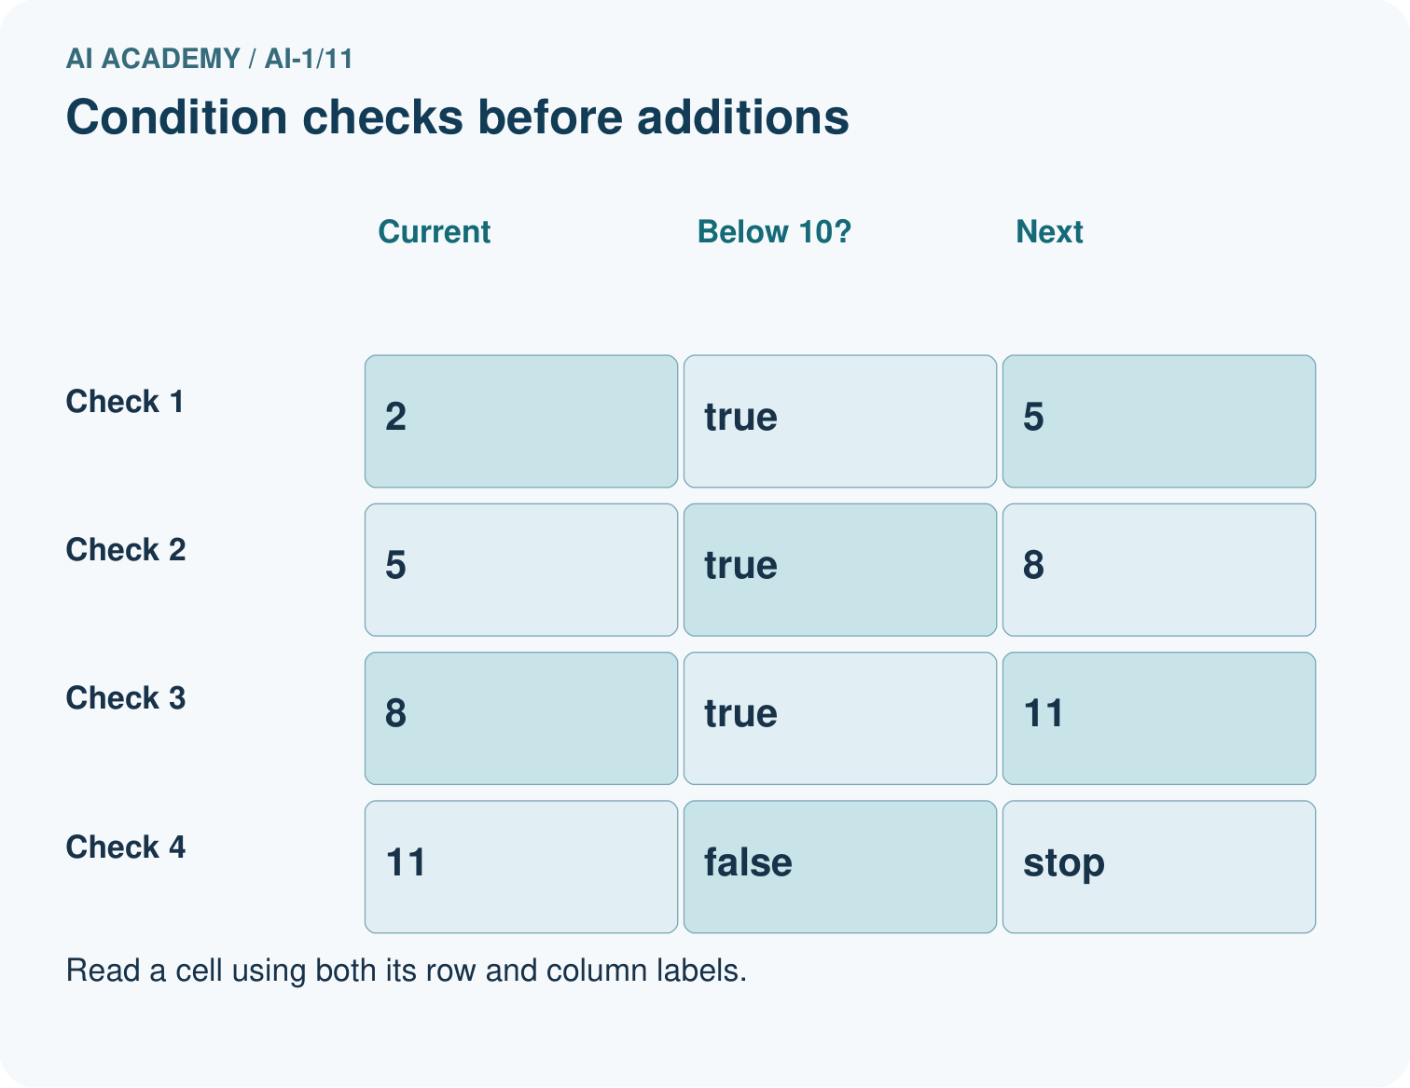
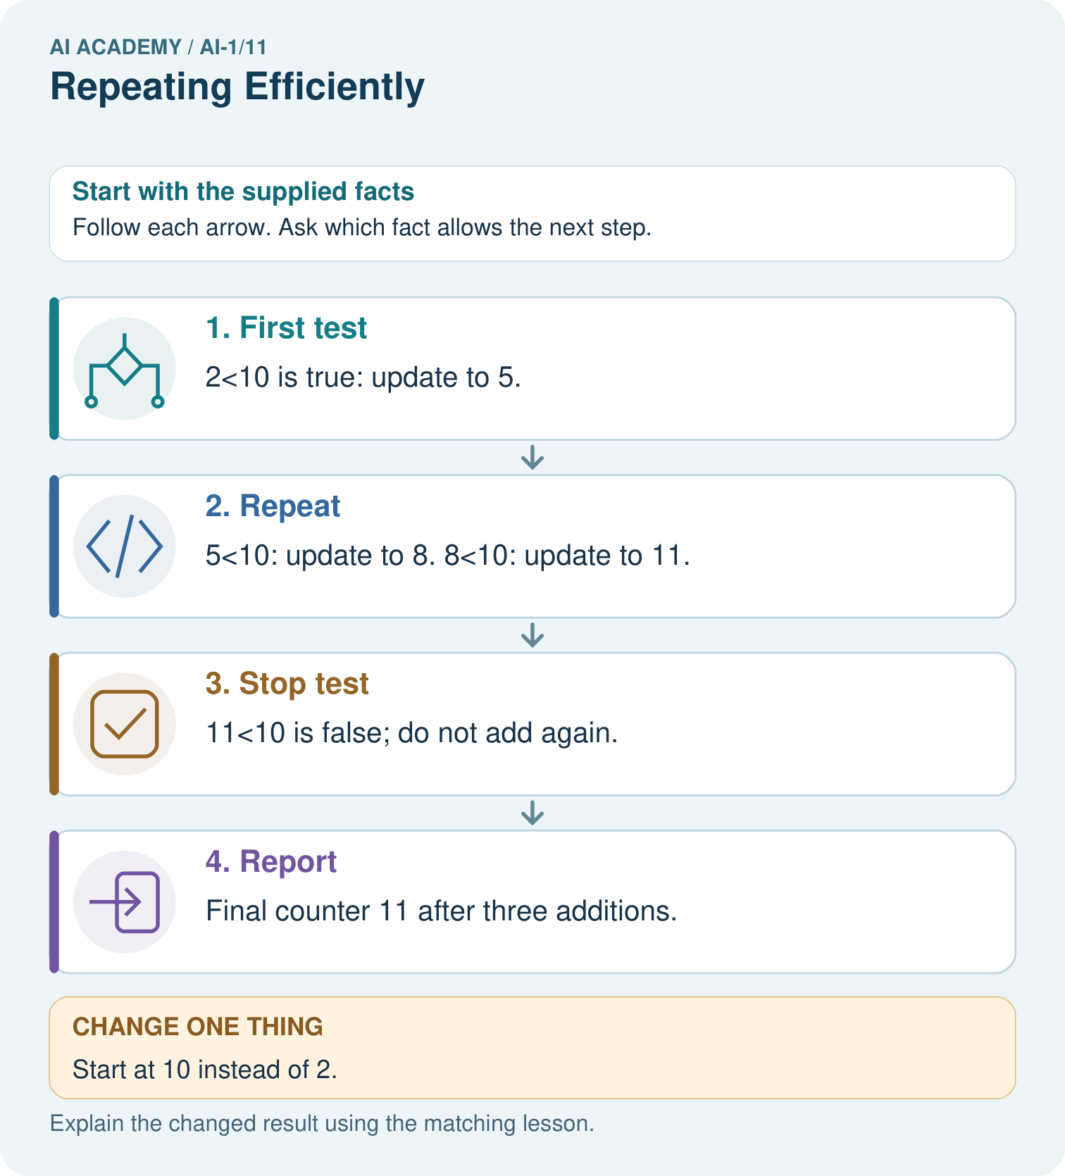

Read the picture one step at a time
Step | What happens and why
1. First test | 2<10 is true: update to 5.
2. Repeat | 5<10: update to 8. 8<10: update to 11.
3. Stop test | 11<10 is false; do not add again.
4. Report | Final counter 11 after three additions.
Match each pictured step to the supplied facts. This is a worked teaching case, not an independent assessment.

Why this result follows
The condition checks whether to do the next update; it does not constrain every resulting value to stay below 10. The final 11 is therefore allowed by this procedure. Record both the condition and counter to distinguish a correct stop from an assumed endpoint.

What this example does not establish
This loop stops because positive increments eventually cross the limit. Other updates can fail to make progress.

Change one thing in the pictured case
Change: Start at 10 instead of 2.
Prediction: The loop runs zero times and reports 10.
Reason: Its first condition is already false, so no addition happens.

Ask while showing the picture
Cover the result. Ask learners to name the inputs and predict the next step. Uncover one step, connect the icon to the actual procedure, and explain its evidence. Then change the supplied condition and compare. The picture is a representation; it does not document execution of a real AI model.

03. Demonstrate and guide practice

Demonstrate and guide practice

Board sequence
Write the given facts: Repeat take the next unstamped card and stamp it four times.
Write the question to explain: How many cards are stamped? What assumption matters?
Reveal after predictions: Four, provided four unstamped cards exist and each repeat takes the next one. A limit or end-of-stack check prevents continuing indefinitely.
Keep for an independent attempt: Repeat clap then tap three times. Write the complete sequence. How many actions occur? What would happen if the stopping instruction were missing?

Classroom dialogue
Ask: Which facts are given, and which would we have to assume? Learners mark relevant details before discussing answers.
Say: Predict first. Show the rule, information path or calculation that would produce the result. A correct guess is not yet an explanation.
Reveal reasoning one step at a time. Explain why a tempting alternative fails. Write units and denominators for arithmetic, trace conditions for decisions, and identify supporting sources for claims.
In pairs, one learner solves while the other checks evidence; exchange roles. Remove the worked answer before independent assessment.

Model these guided questions
From 3 under add 2: 3 true, 5 true, 7 false; two iterations and report 7. Under add 0: 3 true repeatedly, with no change and no report. Seeing 3 during that faulty run is not a returned result. For the exit, start 7 or any larger whole number checks zero iterations and reports that start. Start 6 checks crossing the boundary and reports 8 after one iteration.

Case-specific teaching sequence
Stage | Teacher action
Session 1 start 0 to 7 minutes | Retrieve the single-decision example from Week 10. Establish that reaching a different value does not create repetition without an instruction to return.
7 to 20 minutes | Model start 1, while below 7 add 2. Move a pointer between test and body and include the final false test at 7. Tally only body executions.
20 to 33 minutes | Compare starts 6, 7 and 8. Require students to predict before tracing. Explain overshoot and zero iterations using the written condition.
33 to 45 minutes | Complete W1 and W2 in pairs. Check that learners distinguish four tests from three iterations and never run the body after a false first test.
Session 2 start 0 to 8 minutes | Use W3 to retrieve stopping behaviour. Ask students to identify the first extra update before discussing the final answer.
8 to 23 minutes | Complete the guided comparison of add 2 and add 0. Stop the physical demonstration after repeated identical states and ask whether the program itself reached report.
23 to 38 minutes | Collect W4 independently. A decreasing countdown checks transfer beyond the upward counter. Require the final false test on each finite run.
38 to 45 minutes | Discuss W5 and the exit tests. Explain why exact equality may be unreachable. Preview finding the first step where expected and observed behaviour differ.

Reduce help deliberately
Completion task: Use the same below 8 loop with add 2. Make separate runs from 8 and 9. Explain how many times the body runs and what each run reports. Why would adding 2 once be an error?
Teacher check: Both first tests are false. Each run has zero iterations, reporting its unchanged starting value: 8 or 9. Adding 2 once would execute the body despite a false first test.
Start by identifying the given inputs together. Leave the intermediate steps blank. If needed, model one step, then withdraw that help on the next step. Move to a full trace only when the partial trace is understood. For partners, alternate explainer and checker; collect a response from every learner before discussion.

Individual reasoning check
Use the worked case for Loops and stopping rules. Proposed explanation: “Every loop runs at least once”. Decide whether this explanation is supported. Point to the step or supplied fact that decides; explain your repair if needed.
Expected correction: Point to the test before the body. From 7 under below 7 the first test is false, so no update is permitted.
Collect explanations, not only yes/no votes. If a misunderstanding is common, re-model the relevant step for the class. If it affects a few learners, give a short targeted group explanation while others solve a more demanding variation.

Pictorial practice question
Trace a fresh start of 9. How many additions occur, and must the report equal 10?

Reasoned teacher answer
9<10 is true, so it becomes 12. Then 12<10 is false: one addition, report 12; equality with 10 is not required.
Changed-case reasoning: The loop runs zero times and reports 10. Its first condition is already false, so no addition happens.
Collect each learner’s explanation before discussion. Use the first missing connection between input, deciding step and result to choose support. This question is worked-case practice, not fresh mastery evidence.

04. Run the weekly evidence lab

Run the weekly evidence lab
Predict first, test honestly, and explain what the evidence means.
State your prediction before the result is known.
Complete the task: Compress a repeated drawing algorithm using a loop card.
Keep a normal case and an edge case clearly separated.
Record what happened—even when it does not match your prediction.
Explain the result, one limitation, and the next useful test.
INDEPENDENCE After support is removed, repeat the proof with a fresh case.

Make the lab runnable
Use the concrete case as the shared normal case and the independent question as a second case. Each pair creates a boundary or missing-information case and predicts its result before testing. Keep the expected result separate from an observed mistake.
Record | What to capture
Input or evidence | Exact data, instruction or claim
Expected result | Answer or safe fallback declared before the run
Observed result | Actual result, including errors
Explanation | Rule, calculation or evidence explaining the outcome
Next test | One justified change and a new prediction

Diagnose and reteach
CLAIM TO REPAIR Three repetitions always mean three actions.
For guessing, return to given facts and request a trace. For vocabulary without application, use one example and one non-example. For arithmetic errors, check the setup before the calculation. Finish with a different uncoached case before recording mastery.

Address these additional misconceptions
Every loop runs at least once: Point to the test before the body. From 7 under below 7 the first test is false, so no update is permitted.
The final value must equal the threshold: Trace start 6 under add 2 and below 7. The loop reports 8 because the stopping requirement is no longer below 7.
Tests and iterations are the same count: Count body executions separately and show the last false test with no body action.
A changing number guarantees a stop: Compare below 7 with not equal to 7 from 6 under add 2. Even numbers pass 7 without equalling it.

Match the support to the first error
What the response shows | Next teaching action
Missing or misread facts | Read the case aloud, mark supplied versus unknown facts, and let the learner restate it.
Wrong procedure | Return to the deciding step in the worked case. Contrast it with the proposed incorrect explanation.
Arithmetic or implementation error | Trace intermediate values or lines; preserve the first mismatch and retry that step.
Correct result without a reason | Ask for a trace and a changed case before marking independent understanding.
An unsupported wider claim | Ask which supplied evidence supports the claim and which further observation would be needed.
Offer an oral explanation, drawing, enlarged visual or fewer examples when that removes a reading/writing barrier. Keep the same reasoning goal. Stretch secure learners by changing a boundary or assumption and asking them to defend the effect, not simply by assigning more of the same questions.

05. Assess and explain the answers

Assess and explain the answers

Worked case answer
Four, provided four unstamped cards exist and each repeat takes the next one. A limit or end-of-stack check prevents continuing indefinitely.

Independent question
Repeat clap then tap three times. Write the complete sequence. How many actions occur? What would happen if the stopping instruction were missing?

Expected independent answer
Clap, tap, clap, tap, clap, tap: six actions. Without a stopping instruction, the described repetition has no defined end.

What counts as evidence
Criterion | 0 points | 1 point | 2 points
Result | Incorrect or absent | Partly correct | Correct with necessary conditions
Reasoning | No supporting trace | Some steps | Clear mechanism, calculation or source support
Limit | Overclaims certainty | Vague limitation | Relevant uncertainty or missing fact
Transfer | Copies without adapting | Adapts with prompts | Solves a changed case independently
Use 6/8 as a classroom checkpoint, with 2 required for both Result and Reasoning. This is a proposed teaching rule, not a validated certification threshold. Do not count a coached answer as independent mastery; correct unsafe or unsupported claims regardless of total.

Feedback
Ask the learner to find the evidence that challenges this claim: “Three repetitions always mean three actions.” Keep the first attempt and an uncoached retry separate.

Original transfer answer
Continue while stamped<5 AND another unstamped card exists. Counts are 0,1,2,3; stop because the stack is empty. Report three completed and two unavailable. A loop needs a progress update and a termination condition; it must not invent missing inputs.

Explanations for the additional workbook examples

W1 Trace every test
Start counter at 2. While counter is below 8, add 2. When false, report and stop. Record the value and result at every test, including the final false test. State the number of iterations and the reported value.
Tests: 2 true, 4 true, 6 true, 8 false. Three additions are three iterations. The loop reports 8; the fourth test does not run the body.

W2 Check the first test
Use the same below 8 loop with add 2. Make separate runs from 8 and 9. Explain how many times the body runs and what each run reports. Why would adding 2 once be an error?
Both first tests are false. Each run has zero iterations, reporting its unchanged starting value: 8 or 9. Adding 2 once would execute the body despite a false first test.

W3 Find the extra repetition
Start counter at 3. While counter is below 8, add 2. A learner writes values 3, 5, 7, 9, 11 and reports 11. Identify the first unauthorised update. Give the correct final test, reported value and iteration count.
After 7 becomes 9, the next test 9 below 8 is false. The update from 9 to 11 is unauthorised. Report 9 after three iterations, with test rows 3 true, 5 true, 7 true, 9 false.

W4 Transfer to a countdown
A paper countdown starts at 7. While remaining is above 1, subtract 2. When false, report and stop. Trace the run and count iterations. Repeat from 6 and from 1. Explain why the final value need not equal 1. What happens from 7 if subtract 2 is replaced by subtract 0?
From 7: 7 true, 5 true, 3 true, 1 false; three iterations, report 1. From 6: 6 true, 4 true, 2 true, 0 false; three iterations, report 0. From 1: first test false, zero iterations, report 1. Above 1 stops at 1 or below. Subtracting 0 from 7 leaves every test true, so that faulty run never reports.

W5 Test a proposed stopping rule
A procedure says start at 4; while counter is not equal to 9, add 2; report and stop. Write the first four values tested. Explain why the loop will not reach 9 using whole numbers. Suggest a changed condition that would stop once the counter reaches or passes 9, and trace that repaired run.
The first four values are 4, 6, 8, 10. Adding 2 to an even number always gives another even number, so the counter cannot become the odd number 9. Change the condition to while counter is below 9. Then 4 true, 6 true, 8 true, 10 false; three iterations and report 10.

Assess independent transfer
Selected case: A paper countdown starts at 7. While remaining is above 1, subtract 2. When false, report and stop. Trace the run and count iterations. Repeat from 6 and from 1. Explain why the final value need not equal 1. What happens from 7 if subtract 2 is replaced by subtract 0?

Selected case answer
From 7: 7 true, 5 true, 3 true, 1 false; three iterations, report 1. From 6: 6 true, 4 true, 2 true, 0 false; three iterations, report 0. From 1: first test false, zero iterations, report 1. Above 1 stops at 1 or below. Subtracting 0 from 7 leaves every test true, so that faulty run never reports.
Dimension | Evidence required
Explanation | Names the applicable idea or procedure and ties it to the supplied facts.
Trace and result | Preserves the given inputs and shows the relevant intermediate steps; distinguishes a prediction from an observed execution.
Limits | States the assumptions, missing evidence or conditions under which the result would change.
Record each dimension as not yet, with support, or independent. Accept a valid alternative procedure with a defensible trace. Do not penalise an honestly recorded model failure if the learner correctly explains its evidence and limits.

Feedback that the learner uses
Name the earliest unsupported step and give one action to repair it. Have the learner make that repair now and explain why. Then assess the relevant skill on a fresh, fully specified case. Confirm it was not previously practised with feedback; solve and check the new case before assigning it. A follow-up design prompt is a starting brief, not automatically an equivalent test.

06. Connect and extend learning

Connect and extend learning

Helpful Classroom Sorter
Use a loop to process each item card in the test pile, with an explicit stop when no cards remain.
Keep the decision, input, result, explanation and remaining limitation in the project evidence record. Retrieve this record next week rather than restarting the project.

Support and stretch
Use physical cards, spoken explanations and a three-stage drawing. Read aloud without giving the answer. Stretch: compare two mechanisms with the same visible output and explain what evidence distinguishes them.

Exit reflection
Ask for one decision the learner can now justify and one situation requiring more evidence or human review. Confidence ratings are separate from correct independent performance.

Bridge to the next week
Next: Week 12: Debug the Cause. Retrieve today’s evidence and identify what carries forward and what is new.

Support and fresh reassessment
Let students move a token from the test card to the body and back. Use written true and false labels as well as arrows. Provide a separate tally box for body executions. Extension: explain why start 2, while not equal to 7 add 2 never reaches its reporting instruction with exact whole-number arithmetic.
W4 is secure when the learner traces the decrementing loop, includes zero iterations, accepts 0 as a valid final result from 6 and explains why subtract 0 cannot end the run from 7. After support, retry start 8, while above 2 subtract 3: tests 8, 5, 2; two iterations and report 2. A correct final number without test reasoning is incomplete evidence.
Week 12 develops debugging from traces. Students will compare expected steps with observed steps, identify the first divergence and retest a repair.

Plan the delayed return
Suggested return points in this level: ai-1/12, ai-1/14, ai-1/17. Use actual classroom dates, adjusting for holidays and gaps. One, three and six teaching weeks are scheduling choices, not a claimed optimal spacing.
At a delayed check, ask for the idea from memory and a changed application. Compare with the earlier independent response and record support used. For a new level, revisit the previous capstone before checking the new prerequisites.
Record | Teacher evidence
Learner code and date
Concept and case used; prior exposure
Explanation / trace / limits
Support and first repair
Changed case and delayed outcome
Next teaching action
Use the evidence to choose reteaching or the next step. A completed page, confidence rating or attractive project does not by itself demonstrate understanding.

Project evidence from this case
Give any repeated sorter step an explicit stopping condition and trace a zero-iteration example.

07. Prepare, teach and assess
Teaching target: Trace a loop by testing its condition before every repetition
Prepare the labelled worked-case picture, the matching workbook, fictional input cards and a place for individual responses. No paid AI account is required for the paper reasoning activities.
Session | Plan | Resources
Session 1 · Understand · 45 min | 0–7: recall and prerequisite; 7–15: inspect the concrete case and predict; 15–30: teacher models the worked trace; 30–40: learners explain a step using the text and visual; 40–45: check the core idea. | Sections 1–6; record the brief recall in the workbook.
Session 2 · Practise · 45 min | 0–5: retrieve the procedure; 5–15: W2 completion practice; 15–23: explain and check with a partner; 23–30: each learner answers the misconception check; 30–40: targeted reteaching or a harder variation; 40–45: prepare the investigation. | Sections 7–10; use the matching workbook W2 and misconception check.
Session 3 · Investigate and transfer · 45 min | 0–5: retrieve the decision rule; 5–20: investigate or trace; 20–30: start the independent case; 30–38: connect the project; 38–43: act on feedback; 43–45: plan the return check. | Sections 9 and 11–14. Give extra time to finish the full task set; use Section 15 when the week includes a coding lab.
Before class, solve the supported practice: Use the same below 8 loop with add 2. Make separate runs from 8 and 9. Explain how many times the body runs and what each run reports. Why would adding 2 once be an error?
Reasoned practice answer: Both first tests are false. Each run has zero iterations, reporting its unchanged starting value: 8 or 9. Adding 2 once would execute the body despite a false first test.
Check every learner before discussion: Use the worked case for Loops and stopping rules. Proposed explanation: “Every loop runs at least once”. Decide whether this explanation is supported. Point to the step or supplied fact that decides; explain your repair if needed.
Misconception repair: Point to the test before the body. From 7 under below 7 the first test is false, so no update is permitted.
Support: read the exact case aloud, enlarge the labelled picture, supply input cards and model only the first deciding step. Accept a spoken explanation or drawing; retain the reasoning goal.
Extension: Start at 10 instead of 2. Require a prediction and a reason before comparing. Expected result: The loop runs zero times and reports 10. Reason: Its first condition is already false, so no addition happens.
Independent assessment: withhold the reserved answer until the learner has attempted the new case. Record support separately from correctness.
Criterion | Not yet | With support | Independent
Explanation | Names an answer without a deciding fact | Uses a hint to link fact and decision | Explains the deciding fact in own words
Trace or test | Cannot connect input and result | Completes steps with prompts | Traces or tests a changed case accurately
Limits and revision | Claims more than evidence supports | Names a limit after a prompt | States a defensible limit and useful next test
Project checkpoint: Make a transparent first version. Keep a trace of how one input becomes an output; explain the rule or learned component.
Use the weekly teacher answer for topic-specific reasoning. A saved progress tick is an activity record; judge mastery from the learner’s explanation and evidence.

