AI ACADEMY · TEACHER · ai-1/27

Verify Important Outputs
Project: Helpful Classroom Sorter

01. Verify Important Outputs

Teach the learning cycle
Primary target: Separate an answer into claims and connect each claim to relevant evidence
Session | Sequence and minutes | Resources
Session 1 · Understand · 45 min | 0–7: recall and prerequisite; 7–15: inspect the concrete case and predict; 15–30: teacher models the worked trace; 30–40: learners explain a step using the text and visual; 40–45: check the core idea. | Sections 1–6; record the brief recall in the workbook.
Session 2 · Practise · 45 min | 0–5: retrieve the procedure; 5–15: W2 completion practice; 15–23: explain and check with a partner; 23–30: each learner answers the misconception check; 30–40: targeted reteaching or a harder variation; 40–45: prepare the investigation. | Sections 7–10; use the matching workbook W2 and misconception check.
Session 3 · Investigate and transfer · 45 min | 0–5: retrieve the decision rule; 5–20: investigate or trace; 20–30: start the independent case; 30–38: connect the project; 38–43: act on feedback; 43–45: plan the return check. | Sections 9 and 11–14. Give extra time to finish the full task set; use Section 15 when the week includes a coding lab.
This is a starting allocation of 135 minutes, not a validated duration. Preserve all named topics. Schedule extra time for connected examples, the full investigation, independent cases and project building. Repeated copies of a case share one recorded attempt; they are not new evidence.

Retrieval answer guidance

Prompts Are Design Instructions
Without opening the old lesson, explain one key idea from Prompts Are Design Instructions. Give an example and a mistake that the idea helps you avoid.
Look for: Write a prompt with a clear task, supplied evidence and checkable output requirements
Reference example, not the only acceptable wording: Possible omissions include audience, source facts, required fields, format, missing-value behaviour and limits on extra claims. C supplies evidence, Grade 6 specifies readers, and four labelled lines define visible fields and structure. These requirements support checks but do not guarantee compliance.

Privacy by Choosing Less
Without opening the old lesson, explain one key idea from Privacy by Choosing Less. Give an example and a mistake that the idea helps you avoid.
Look for: Justify which information a stated task needs and remove unnecessary fields
Reference example, not the only acceptable wording: Keep topic choice; remove name, full date of birth, address and photograph. The totals do not require identity or contact details. Collecting extra fields creates copies and exposure to manage even if those fields are later ignored or deleted.

Good Data, Bad Data
Without opening the old lesson, explain one key idea from Good Data, Bad Data. Give an example and a mistake that the idea helps you avoid.
Look for: Check records against a stated format, unit and meaning before using them
Reference example, not the only acceptable wording: Height 60 fails the whole-number range 1 through 10. Travel blank is missing; its value cannot be inferred. Travel 0 is valid in the whole-number range 0 through 10 and can represent observed no travel. Zero is a measurement, not a replacement for a blank.
Use the student module and workbook section with this exact week title. The worked case, independent question and answers below form one aligned lesson sequence.

What the learner must demonstrate
A generated report says 18 of 24 tests passed, so success was 80%. Verify the claim in two ways and write a corrected sentence.

Concept to explain
Fluent AI output is not evidence; important claims need independent support.
Term | Meaning
claim | statement that can be checked
source | origin of evidence
independent | not merely copying the same origin
corroborate | support a claim with separate evidence

Prepare the class
Use the supplied scenario, student illustrations and blank paper. For numeric work, offer counters or a calculator after learners show the setup. Fictional records are supplied; personal data and paid accounts are unnecessary.
Allow 80 minutes: recall 8; explanation 12; worked demonstration 15; guided practice 20; independent assessment 15; project and reflection 10. Extend the lab into a second session when needed.

Preparation for the connected explanation
Use the supplied fictional source cards to keep the activity accessible offline and separate evidence checking from internet search skill. Supported and contradicted are judgments relative to stated evidence and assumptions; unresolved is not a synonym for false. Emphasise that identical repeated claims may share one origin. This lesson checks exact paper models, not uncertain physical measurements.

Readiness answer
No. Format and factual support are separate criteria. A correct layout cannot make an unsupported time acceptable.
Current ribbon card R and old card Q details in the lesson
A metre strip marked into 100 centimetres or a paper drawing of one
The independent craft card M in W4 and paper for claim-by-claim audit notes

End goal for the pictorial case
By the end, I can verify quantities with consistent units and separate arithmetic from unsupported claims.
This added worked case illustrates the week’s main idea. Retain all original and connected topics; schedule its practice within the teaching cycle.

02. Explain the mechanism

Explain the mechanism
Follow the information instead of imagining magic inside the machine.
INPUT specific claim extracted from an output
PROCESS check independent suitable sources and reconcile differences
OUTPUT supported, corrected, uncertain, or removed claim
CORE IDEA Fluent AI output is not evidence; important claims need independent support.
UNDER THE HOOD Verification is claim-level evidence work. Source independence, authority, direct support, recency, and agreement matter. Multiple pages repeating the same upstream error are not independent confirmation.
Draw a fresh example with all three stages:
Every step connects a claim to observable evidence.
CASE A generated paragraph confidently claims that an animal lives in a region; the wording is not evidence that the claim is true.
STEP 1 — OBSERVE specific claim extracted from an output
STEP 2 — TRACE check independent suitable sources and reconcile differences
STEP 3 — CONCLUDE supported, corrected, uncertain, or removed claim
MODEL REASONING Check the exact claim, not the whole paragraph. Use sources with direct relevant evidence, note publication context, and explain whether they independently agree. If evidence is weak or conflicting, revise or remove the claim.
DO NOT OVERCLAIM Two search results are not two independent sources when both copy the same page.
What new evidence could change this answer?

Concrete teaching case
An answer says six groups of four make 28.
Verify independently.

Exact explanation to model
Six times four is 24. Draw six groups or add four six times. Confident wording does not change arithmetic.

Explain the added worked example
An answer can contain a mixture of correct, incorrect and unverified statements. Checking one sentence does not validate every other sentence. First separate the answer into individual claims. Then ask what evidence would support each one: a record, a measurement, a calculation or some combination.
Our fictional ribbon activity uses current materials card R. R states: four rolls of ribbon, each exactly 2 metres long; twelve pieces will each use 50 centimetres; no cutting loss is included in this paper model. One metre equals 100 centimetres. An old card Q describes a different activity with three rolls. These are provided classroom records, not instructions to cut real materials.
A draft says “R gives four rolls. The starting length is 8 metres. The pieces use 600 metres. Two metres remain. Every participant will enjoy the activity.” Do not approve or reject the whole paragraph at once. Inspect the roll count, starting length, used length, remaining length and enjoyment claim separately.
A citation is useful only if you can locate the source and confirm that it supports the specific claim. The title “Materials card R” beside a paragraph does not make the enjoyment claim part of R. If a cited card Z is not supplied or cannot be found, that citation cannot currently verify its claim. Record the gap rather than inventing Z’s contents.
Check whether the source covers the right activity, version, population or time. Q’s three rolls may be accurate for its own activity but irrelevant to the current four-roll task. In real work, also inspect who created the record, how they obtained the information and whether there is a correction or better source.

Key terms
Term | Meaning
Claim | A statement that can be examined against evidence
Verification | Checking whether a claim is supported by appropriate evidence
Citation | A reference that helps a reader locate a source
Unit | The agreed measurement scale attached to a quantity, such as centimetres
Corroboration | Additional evidence that supports a claim, with its origin checked

Model the reasoning aloud
Use the complete worked example below before asking learners to complete W2. Reveal a small part, invite a prediction, then explain the deciding step. These teacher notes contain solutions; do not reveal the independent case answer during modelling.
Starting length | 4 × 200 cm = 800 cm | 8 m
Length used | 12 × 50 cm = 600 cm | 6 m
Length remaining | 800 cm − 600 cm = 200 cm | 2 m
Convert to one length unit before subtracting. Two metres is 200 centimetres, so four rolls give 800 centimetres. The twelve pieces use 600 centimetres, leaving 200 centimetres, or 2 metres. Subtracting the bare numbers 8 − 600 would mix metres with centimetres and would not describe the remaining length correctly.
Use a second route as a check: 50 centimetres is half a metre, so twelve pieces use six metres. Eight minus six leaves two metres. A reasonableness check also asks whether the used length is at most the starting length and whether starting length equals used plus remaining. These checks can reveal mistakes; they do not replace checking the original inputs and assumptions.
Thinking move | Teacher prompt
Plan | What is given? What is the question? Which procedure fits these facts?
Do | Point to each input and intermediate step in the worked trace. Name the rule that allows the next step.
Check | Does the output answer the question? Which assumption or limitation prevents a larger claim?
Use the diagram and verbal explanation together. Ask learners to match a sentence to a specific visual step; do not assign learners fixed visual or auditory learning styles.

A pictorial worked case: Verify Important Outputs
A fictional craft sheet calculates ribbon left after making bookmarks.

The facts we will use
Four rolls each contain exactly 150 cm. Eight bookmarks use exactly 50 cm each.
No other ribbon loss is assumed; no competition result is recorded.
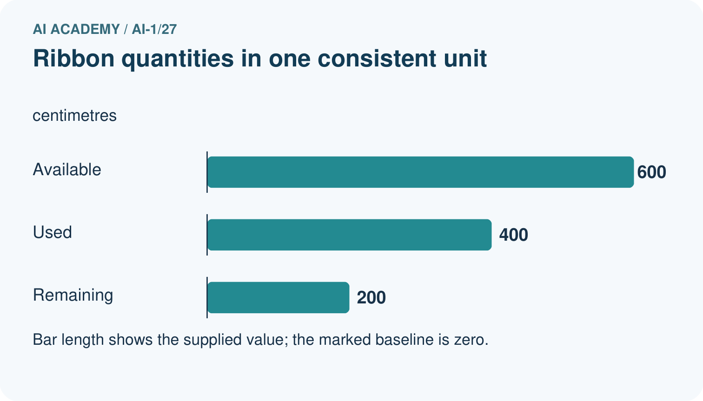
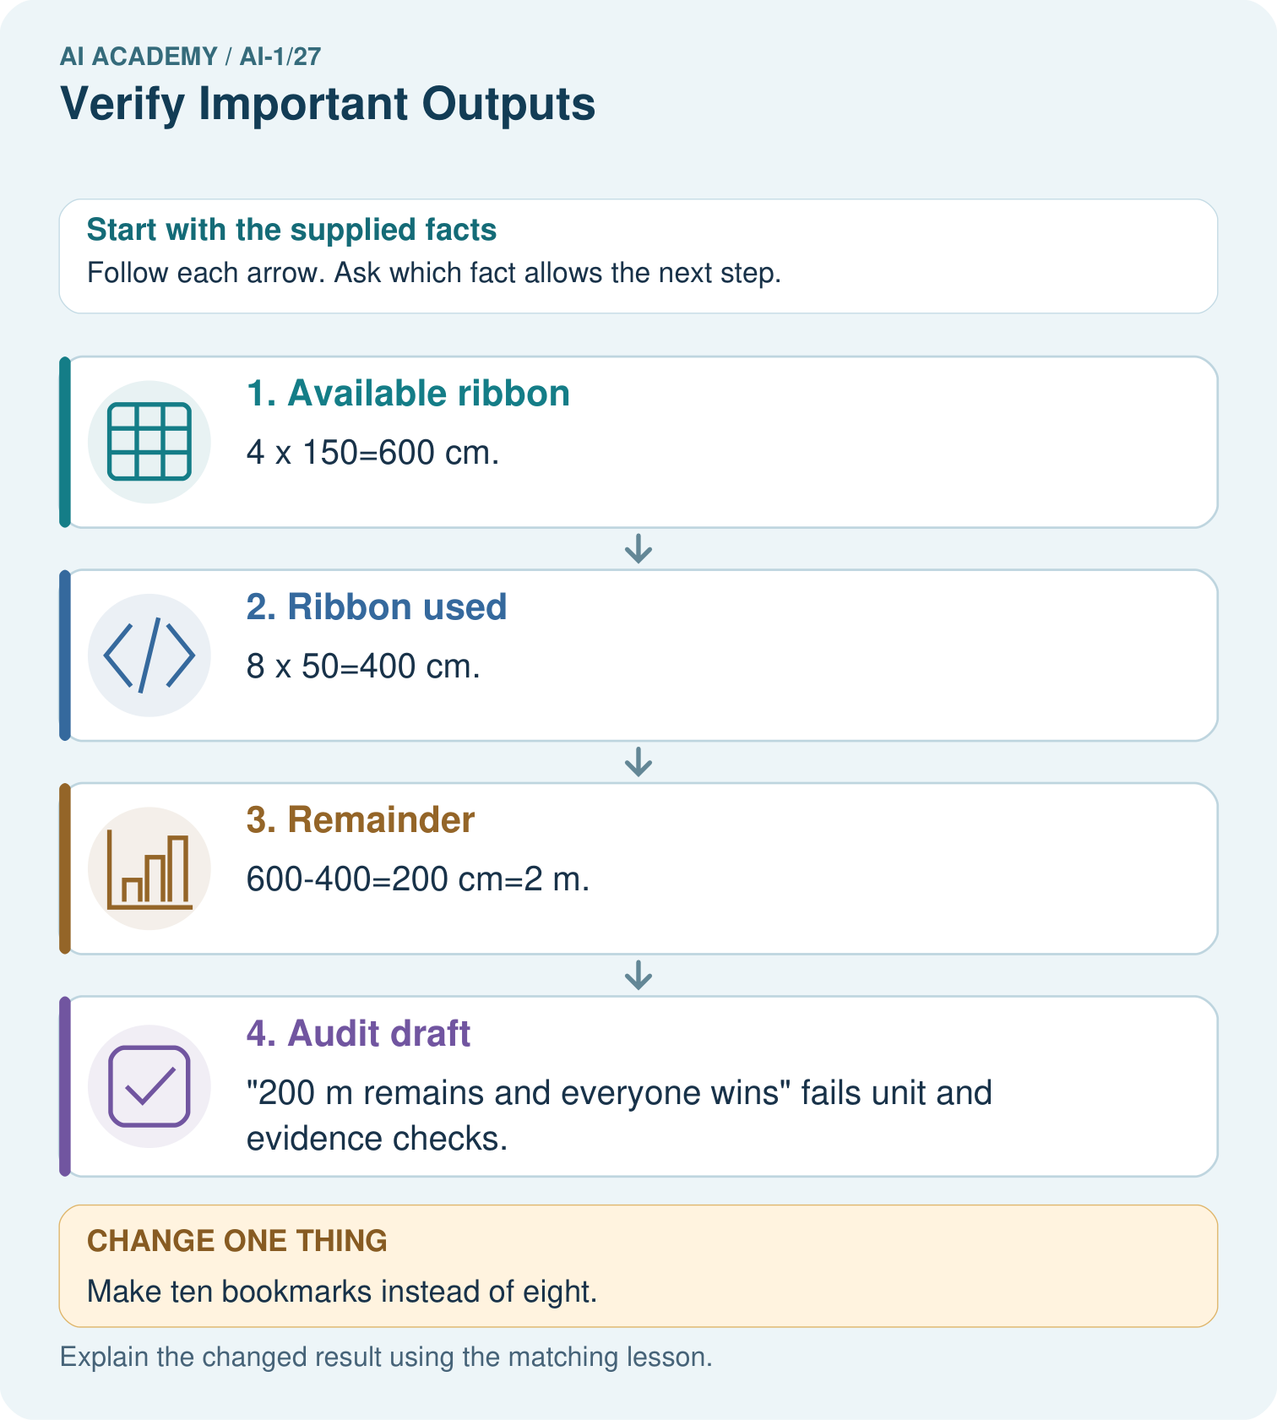

Read the picture one step at a time
Step | What happens and why
1. Available ribbon | 4×150=600 cm.
2. Ribbon used | 8×50=400 cm.
3. Remainder | 600−400=200 cm=2 m.
4. Audit draft | “200 m remains and everyone wins” fails unit and evidence checks.
Match each pictured step to the supplied facts. This is a worked teaching case, not an independent assessment.

Why this result follows
All arithmetic first uses centimetres. Converting only after subtraction avoids mixing units. The record supports available, used and remaining lengths under its no-loss assumption. It does not support a promise about winning. A numerically correct total elsewhere in a draft cannot rescue a wrong unit or an invented claim.

What this example does not establish
Real cutting losses or inaccurate roll lengths would change this toy calculation; the assumption must be declared.

Change one thing in the pictured case
Change: Make ten bookmarks instead of eight.
Prediction: 100 cm, or 1 m, remains.
Reason: 600−10×50=100 cm.

Ask while showing the picture
Cover the result. Ask learners to name the inputs and predict the next step. Uncover one step, connect the icon to the actual procedure, and explain its evidence. Then change the supplied condition and compare. The picture is a representation; it does not document execution of a real AI model.

03. Demonstrate and guide practice

Demonstrate and guide practice

Board sequence
Write the given facts: An answer says six groups of four make 28.
Write the question to explain: Verify independently.
Reveal after predictions: Six times four is 24. Draw six groups or add four six times. Confident wording does not change arithmetic.
Keep for an independent attempt: An assistant says the school library opens at 8, but today's official notice says 9. Which source should guide today's visit? Explain the check.

Classroom dialogue
Ask: Which facts are given, and which would we have to assume? Learners mark relevant details before discussing answers.
Say: Predict first. Show the rule, information path or calculation that would produce the result. A correct guess is not yet an explanation.
Reveal reasoning one step at a time. Explain why a tempting alternative fails. Write units and denominators for arithmetic, trace conditions for decisions, and identify supporting sources for claims.
In pairs, one learner solves while the other checks evidence; exchange roles. Remove the worked answer before independent assessment.

Model these guided questions
Four rolls: supported by R. Starting 8 m: supported by 4 × 2 m. Used 600 m: contradicted; it is 600 cm = 6 m. Remaining 2 m: supported by 8 − 6, with no cutting loss. Everyone enjoys it: unresolved. Correctness of one number does not validate another; show each calculation. Exit: loss is 12 × 2 cm = 24 cm. Remaining is 800 − 600 − 24 = 176 cm. The no-cutting-loss assumption changed.

Case-specific teaching sequence
Stage | Teacher action
Session 1 start 0 to 7 minutes | Retrieve format versus factual support from Week 26.
7 to 20 minutes | Split the ribbon draft into five claims and complete W1.
20 to 33 minutes | Trace the evidence diagram and work through centimetres and metres.
33 to 45 minutes | Complete W2 and check used plus remaining against starting length.
Session 2 start 0 to 8 minutes | Retrieve why unresolved does not mean false.
8 to 23 minutes | Complete the guided audit and W3. Trace repeated claims to their common origin.
23 to 38 minutes | Collect W4 independently, requiring calculations, units and separate claim judgments.
38 to 45 minutes | Complete W5 and the changed-loss exit; retain the changed assumption.

Reduce help deliberately
Completion task: A report calculates 12 × 50 = 600 and labels the result metres. Use R to correct the unit, convert the result to metres and calculate the remaining length. Give a second arithmetic route or a check using starting, used and remaining lengths.
Teacher check: Each piece is 50 cm, so 12 × 50 cm = 600 cm = 6 m. Starting length is 4 × 2 m = 8 m; remaining is 8 − 6 = 2 m. A check is 6 m used + 2 m remaining = 8 m starting; alternatively twelve half-metre pieces use 6 m.
Start by identifying the given inputs together. Leave the intermediate steps blank. If needed, model one step, then withdraw that help on the next step. Move to a full trace only when the partial trace is understood. For partners, alternate explainer and checker; collect a response from every learner before discussion.

Individual reasoning check
Use the worked case for Verifying claims and quantities. Proposed explanation: “A citation proves every nearby claim”. Decide whether this explanation is supported. Point to the step or supplied fact that decides; explain your repair if needed.
Expected correction: Inspect the actual source and the specific claim it supports.
Collect explanations, not only yes/no votes. If a misunderstanding is common, re-model the relevant step for the class. If it affects a few learners, give a short targeted group explanation while others solve a more demanding variation.

Pictorial practice question
Correct the draft and identify which part needs another source rather than a calculation.

Reasoned teacher answer
It should say 200 cm or 2 m remains. Winning needs genuine result evidence; remove the unsupported promise.
Changed-case reasoning: 100 cm, or 1 m, remains. 600−10×50=100 cm.
Collect each learner’s explanation before discussion. Use the first missing connection between input, deciding step and result to choose support. This question is worked-case practice, not fresh mastery evidence.

04. Run the weekly evidence lab

Run the weekly evidence lab
Predict first, test honestly, and explain what the evidence means.
State your prediction before the result is known.
Complete the task: Use a two-source checklist on a generated animal fact.
Keep a normal case and an edge case clearly separated.
Record what happened—even when it does not match your prediction.
Explain the result, one limitation, and the next useful test.
INDEPENDENCE After support is removed, repeat the proof with a fresh case.

Make the lab runnable
Use the concrete case as the shared normal case and the independent question as a second case. Each pair creates a boundary or missing-information case and predicts its result before testing. Keep the expected result separate from an observed mistake.
Record | What to capture
Input or evidence | Exact data, instruction or claim
Expected result | Answer or safe fallback declared before the run
Observed result | Actual result, including errors
Explanation | Rule, calculation or evidence explaining the outcome
Next test | One justified change and a new prediction

Diagnose and reteach
CLAIM TO REPAIR A confident answer is stronger evidence than a relevant notice.
For guessing, return to given facts and request a trace. For vocabulary without application, use one example and one non-example. For arithmetic errors, check the setup before the calculation. Finish with a different uncoached case before recording mastery.

Address these additional misconceptions
A citation proves every nearby claim: Inspect the actual source and the specific claim it supports.
The number is enough without a unit: 600 cm and 600 m differ by a factor of 100.
An unsupported claim must be false: Unresolved means the supplied evidence does not settle it.
Three copied claims are three independent checks: Find the origin and seek an independent record or calculation.

Match the support to the first error
What the response shows | Next teaching action
Missing or misread facts | Read the case aloud, mark supplied versus unknown facts, and let the learner restate it.
Wrong procedure | Return to the deciding step in the worked case. Contrast it with the proposed incorrect explanation.
Arithmetic or implementation error | Trace intermediate values or lines; preserve the first mismatch and retry that step.
Correct result without a reason | Ask for a trace and a changed case before marking independent understanding.
An unsupported wider claim | Ask which supplied evidence supports the claim and which further observation would be needed.
Offer an oral explanation, drawing, enlarged visual or fewer examples when that removes a reading/writing barrier. Keep the same reasoning goal. Stretch secure learners by changing a boundary or assumption and asking them to defend the effect, not simply by assigning more of the same questions.

05. Assess and explain the answers

Assess and explain the answers

Worked case answer
Six times four is 24. Draw six groups or add four six times. Confident wording does not change arithmetic.

Independent question
An assistant says the school library opens at 8, but today's official notice says 9. Which source should guide today's visit? Explain the check.

Expected independent answer
Use today's official notice, which directly addresses the current opening time. The assistant's fluent wording does not override the relevant checked source.

What counts as evidence
Criterion | 0 points | 1 point | 2 points
Result | Incorrect or absent | Partly correct | Correct with necessary conditions
Reasoning | No supporting trace | Some steps | Clear mechanism, calculation or source support
Limit | Overclaims certainty | Vague limitation | Relevant uncertainty or missing fact
Transfer | Copies without adapting | Adapts with prompts | Solves a changed case independently
Use 6/8 as a classroom checkpoint, with 2 required for both Result and Reasoning. This is a proposed teaching rule, not a validated certification threshold. Do not count a coached answer as independent mastery; correct unsafe or unsupported claims regardless of total.

Feedback
Ask the learner to find the evidence that challenges this claim: “A confident answer is stronger evidence than a relevant notice.” Keep the first attempt and an uncoached retry separate.

Original transfer answer
18/24=3/4=75%; also 0.75×24=18. Write '18 of 24 specified tests passed (75%).' Do not imply this guarantees future performance. The corrected arithmetic still depends on the test records being accurate.

Explanations for the additional workbook examples

W1 Separate source facts from derived quantities
Using R, identify a directly stated fact and a quantity that must be calculated. Give the source or expression for each. Explain why a citation to R does not verify the claim that every participant will enjoy the activity.
A directly stated fact is four rolls, 2 m per roll or twelve 50 cm pieces. A derived quantity is 8 m starting length, 6 m used or 2 m remaining, supported by the relevant calculation from R. R contains no enjoyment evidence, so citing it does not support everyone enjoying the activity.

W2 Repair a unit error
A report calculates 12 × 50 = 600 and labels the result metres. Use R to correct the unit, convert the result to metres and calculate the remaining length. Give a second arithmetic route or a check using starting, used and remaining lengths.
Each piece is 50 cm, so 12 × 50 cm = 600 cm = 6 m. Starting length is 4 × 2 m = 8 m; remaining is 8 − 6 = 2 m. A check is 6 m used + 2 m remaining = 8 m starting; alternatively twelve half-metre pieces use 6 m.

W3 Do not count copied claims as separate evidence
Three posters say 600 metres were used, but all copied one draft. A fourth poster cites card Z, which is unavailable. Explain why these posters do not settle the quantity. Name the available evidence and check you would use instead.
The first three are copies of one claim, not independent evidence. Z cannot be inspected, so the fourth citation cannot currently verify the result. Inspect supplied R and recompute twelve 50 cm pieces as 600 cm or 6 m; verify source, units and the no-loss assumption.

W4 Audit a new model with mass units
Fictional craft card M states five sealed bags of modelling material at exactly 250 g per bag. Three models each use 300 g, with no other loss. A draft says “M supplies 1250 g; the models use 900 g; 350 kg remains; every model will win a prize.” Check all four claims, show the remaining mass in grams, and explain the status of the prize claim. Use 1 kg = 1000 g.
1250 g is supported by 5 × 250 g; 900 g is supported by 3 × 300 g. Remaining mass is 1250 − 900 = 350 g, so 350 kg is contradicted by the inputs and unit conversion: 350 kg would be 350000 g, greater than the starting mass. The prize claim is unresolved because M gives no prize evidence; it is not established true or false by the material counts.

W5 State what a missing source prevents you from knowing
Another draft claims that the amount left in W4 accounts for all real-world waste, citing a missing instruction card. Explain which result can still be checked from M and which claim remains unresolved. What information would be needed before revising the no-loss model?
The no-other-loss model in M can be checked: 350 g remains under its stated assumptions. The assertion that this includes all real-world waste is unresolved without relevant waste information. Obtain the actual instruction or measurement record specifying additional loss, its units and what stage it covers; do not invent a waste amount or subtract it twice.

Assess independent transfer
Selected case: Fictional craft card M states five sealed bags of modelling material at exactly 250 g per bag. Three models each use 300 g, with no other loss. A draft says “M supplies 1250 g; the models use 900 g; 350 kg remains; every model will win a prize.” Check all four claims, show the remaining mass in grams, and explain the status of the prize claim. Use 1 kg = 1000 g.

Selected case answer
1250 g is supported by 5 × 250 g; 900 g is supported by 3 × 300 g. Remaining mass is 1250 − 900 = 350 g, so 350 kg is contradicted by the inputs and unit conversion: 350 kg would be 350000 g, greater than the starting mass. The prize claim is unresolved because M gives no prize evidence; it is not established true or false by the material counts.
Dimension | Evidence required
Explanation | Names the applicable idea or procedure and ties it to the supplied facts.
Trace and result | Preserves the given inputs and shows the relevant intermediate steps; distinguishes a prediction from an observed execution.
Limits | States the assumptions, missing evidence or conditions under which the result would change.
Record each dimension as not yet, with support, or independent. Accept a valid alternative procedure with a defensible trace. Do not penalise an honestly recorded model failure if the learner correctly explains its evidence and limits.

Feedback that the learner uses
Name the earliest unsupported step and give one action to repair it. Have the learner make that repair now and explain why. Then assess the relevant skill on a fresh, fully specified case. Confirm it was not previously practised with feedback; solve and check the new case before assigning it. A follow-up design prompt is a starting brief, not automatically an equivalent test.

06. Connect and extend learning

Connect and extend learning

Helpful Classroom Sorter
Require human confirmation for important sorter outputs and attach the evidence record used to approve each rule or label.
Keep the decision, input, result, explanation and remaining limitation in the project evidence record. Retrieve this record next week rather than restarting the project.

Support and stretch
Use physical cards, spoken explanations and a three-stage drawing. Read aloud without giving the answer. Stretch: compare two mechanisms with the same visible output and explain what evidence distinguishes them.

Exit reflection
Ask for one decision the learner can now justify and one situation requiring more evidence or human review. Confidence ratings are separate from correct independent performance.

Bridge to the next week
Next: Week 28: Humans Set Boundaries. Retrieve today’s evidence and identify what carries forward and what is new.

Support and fresh reassessment
Use a claim/evidence/decision frame and write units beside every number. Model the 100 cm to 1 m conversion before combining quantities. Extension: explain why a plausible-looking answer can pass a size check yet still be wrong, using a different incorrect remaining length.
W4 requires 1250 g, 900 g, 350 g remaining, rejection of 350 kg with a unit or size explanation, and an unresolved prize claim. After support change each model to use 350 g: require 1050 g used and 200 g remaining, still no evidence about prizes. Confirm that pupils change the affected quantities without changing unrelated claims.
Week 28 distinguishes checking whether an action is sensible from checking who has authority to approve it.

Plan the delayed return
Suggested return points in this level: ai-1/28, ai-1/30, ai-1/33. Use actual classroom dates, adjusting for holidays and gaps. One, three and six teaching weeks are scheduling choices, not a claimed optimal spacing.
At a delayed check, ask for the idea from memory and a changed application. Compare with the earlier independent response and record support used. For a new level, revisit the previous capstone before checking the new prerequisites.
Record | Teacher evidence
Learner code and date
Concept and case used; prior exposure
Explanation / trace / limits
Support and first repair
Changed case and delayed outcome
Next teaching action
Use the evidence to choose reteaching or the next step. A completed page, confidence rating or attractive project does not by itself demonstrate understanding.

Project evidence from this case
Check sorter calculations with explicit units and verify explanation claims against their actual catalogue evidence.

07. Prepare, teach and assess
Teaching target: Separate an answer into claims and connect each claim to relevant evidence
Prepare the labelled worked-case picture, the matching workbook, fictional input cards and a place for individual responses. No paid AI account is required for the paper reasoning activities.
Session | Plan | Resources
Session 1 · Understand · 45 min | 0–7: recall and prerequisite; 7–15: inspect the concrete case and predict; 15–30: teacher models the worked trace; 30–40: learners explain a step using the text and visual; 40–45: check the core idea. | Sections 1–6; record the brief recall in the workbook.
Session 2 · Practise · 45 min | 0–5: retrieve the procedure; 5–15: W2 completion practice; 15–23: explain and check with a partner; 23–30: each learner answers the misconception check; 30–40: targeted reteaching or a harder variation; 40–45: prepare the investigation. | Sections 7–10; use the matching workbook W2 and misconception check.
Session 3 · Investigate and transfer · 45 min | 0–5: retrieve the decision rule; 5–20: investigate or trace; 20–30: start the independent case; 30–38: connect the project; 38–43: act on feedback; 43–45: plan the return check. | Sections 9 and 11–14. Give extra time to finish the full task set; use Section 15 when the week includes a coding lab.
Before class, solve the supported practice: A report calculates 12 × 50 = 600 and labels the result metres. Use R to correct the unit, convert the result to metres and calculate the remaining length. Give a second arithmetic route or a check using starting, used and remaining lengths.
Reasoned practice answer: Each piece is 50 cm, so 12 × 50 cm = 600 cm = 6 m. Starting length is 4 × 2 m = 8 m; remaining is 8 − 6 = 2 m. A check is 6 m used + 2 m remaining = 8 m starting; alternatively twelve half-metre pieces use 6 m.
Check every learner before discussion: Use the worked case for Verifying claims and quantities. Proposed explanation: “A citation proves every nearby claim”. Decide whether this explanation is supported. Point to the step or supplied fact that decides; explain your repair if needed.
Misconception repair: Inspect the actual source and the specific claim it supports.
Support: read the exact case aloud, enlarge the labelled picture, supply input cards and model only the first deciding step. Accept a spoken explanation or drawing; retain the reasoning goal.
Extension: Make ten bookmarks instead of eight. Require a prediction and a reason before comparing. Expected result: 100 cm, or 1 m, remains. Reason: 600−10×50=100 cm.
Independent assessment: withhold the reserved answer until the learner has attempted the new case. Record support separately from correctness.
Criterion | Not yet | With support | Independent
Explanation | Names an answer without a deciding fact | Uses a hint to link fact and decision | Explains the deciding fact in own words
Trace or test | Cannot connect input and result | Completes steps with prompts | Traces or tests a changed case accurately
Limits and revision | Claims more than evidence supports | Names a limit after a prompt | States a defensible limit and useful next test
Project checkpoint: Prepare the demonstration. Gather reproducible instructions, evidence, access checks and remaining limitations.
Use the weekly teacher answer for topic-specific reasoning. A saved progress tick is an activity record; judge mastery from the learner’s explanation and evidence.

