AI ACADEMY · TEACHER · ai-1/33

Test Normal Cases
Project: Helpful Classroom Sorter

01. Test Normal Cases

Teach the learning cycle
Primary target: Plan routine cases with expected results derived from the requirements
Session | Sequence and minutes | Resources
Session 1 · Understand · 45 min | 0–7: recall and prerequisite; 7–15: inspect the concrete case and predict; 15–30: teacher models the worked trace; 30–40: learners explain a step using the text and visual; 40–45: check the core idea. | Sections 1–6; record the brief recall in the workbook.
Session 2 · Practise · 45 min | 0–5: retrieve the procedure; 5–15: W2 completion practice; 15–23: explain and check with a partner; 23–30: each learner answers the misconception check; 30–40: targeted reteaching or a harder variation; 40–45: prepare the investigation. | Sections 7–10; use the matching workbook W2 and misconception check.
Session 3 · Investigate and transfer · 45 min | 0–5: retrieve the decision rule; 5–20: investigate or trace; 20–30: start the independent case; 30–38: connect the project; 38–43: act on feedback; 43–45: plan the return check. | Sections 9 and 11–14. Give extra time to finish the full task set; use Section 15 when the week includes a coding lab.
This is a starting allocation of 135 minutes, not a validated duration. Preserve all named topics. Schedule extra time for connected examples, the full investigation, independent cases and project building. Repeated copies of a case share one recorded attempt; they are not new evidence.

Retrieval answer guidance

Build a Paper Prototype
Without opening the old lesson, explain one key idea from Build a Paper Prototype. Give an example and a mistake that the idea helps you avoid.
Look for: Build a runnable paper prototype with explicit instructions and visible state
Reference example, not the only acceptable wording: The kit contains labelled instructions and catalogue, request fields, a marker and a trace sheet with run and version labels. The request and catalogue stay fixed during the run; the current row and trace advance. The final output starts clear. The cards validate, check both conditions, return the first fit, advance after failure and stop with no match after exhaustion.

Choose Inputs and Outputs
Without opening the old lesson, explain one key idea from Choose Inputs and Outputs. Give an example and a mistake that the idea helps you avoid.
Look for: Turn the project outcome into precise input and output requirements
Reference example, not the only acceptable wording: Time required must be no more than available time; when quiet is required the activity must be quiet. Choose the first compatible activity in B1 to B4 order. No means quiet is not required, not forbidden, so quiet B1 is permitted if 10 minutes fits.

Verify Important Outputs
Without opening the old lesson, explain one key idea from Verify Important Outputs. Give an example and a mistake that the idea helps you avoid.
Look for: Separate an answer into claims and connect each claim to relevant evidence
Reference example, not the only acceptable wording: A directly stated fact is four rolls, 2 m per roll or twelve 50 cm pieces. A derived quantity is 8 m starting length, 6 m used or 2 m remaining, supported by the relevant calculation from R. R contains no enjoyment evidence, so citing it does not support everyone enjoying the activity.
Use the student module and workbook section with this exact week title. The worked case, independent question and answers below form one aligned lesson sequence.

What the learner must demonstrate
A sorter passes five routine cases and fails one. A team removes the failure as 'unusual' and reports 100%. Correct the report and propose a next test.

Concept to explain
Repeated success on ordinary cases is necessary but not sufficient.
Term | Meaning
test case | planned input and expected behavior
expected result | prediction written before running
actual result | observed behavior
reproducible | another tester can repeat the setup

Prepare the class
Use the supplied scenario, student illustrations and blank paper. For numeric work, offer counters or a calculator after learners show the setup. Fictional records are supplied; personal data and paid accounts are unnecessary.
Allow 80 minutes: recall 8; explanation 12; worked demonstration 15; guided practice 20; independent assessment 15; project and reflection 10. Extend the lab into a second session when needed.

Preparation for the connected explanation
The prototype remains an explicit rule system. This lesson focuses on prewritten expectations, repeatable conditions and honest records. Q version 0 and its comparison results are fictional worked examples. Pupils must record their own P1 observations, including operator errors, without copying invented successes. Judge both the output and its reason. Routine coverage is deliberately limited; boundary and variation tests follow next week.

Readiness answer
The expected result comes from the requirements; the observed result records what the saved version actually did. Disagreement is evidence to investigate, so neither record should be silently changed to match the other.
The saved P1 version 1 cards, catalogue B version 1 and manual checklist from Week 32
Paper test sheets with case ID, input, purpose, expected result, observed result, judgement and trace reference
A folder for all versions and results; keep any reserved final evaluation cases separate from development work

End goal for the pictorial case
By the end, I can test routine cases against expectations and count full passes honestly.
This added worked case illustrates the week’s main idea. Retain all original and connected topics; schedule its practice within the teaching cycle.

02. Explain the mechanism

Explain the mechanism
Follow the information instead of imagining magic inside the machine.
INPUT planned test input and expected result
PROCESS run unchanged prototype and observe
OUTPUT actual result, pass/fail, and notes
CORE IDEA Repeated success on ordinary cases is necessary but not sufficient.
UNDER THE HOOD A test case includes input, setup, expected behavior, actual behavior, and result. Precommitting expectations reduces hindsight bias. Repeated normal tests establish basic reliability but say little about uncommon conditions.
Draw a fresh example with all three stages:
Every step connects a claim to observable evidence.
CASE The sorter is tested on five common classroom items with expected bins written before each run.
STEP 1 — OBSERVE planned test input and expected result
STEP 2 — TRACE run unchanged prototype and observe
STEP 3 — CONCLUDE actual result, pass/fail, and notes
MODEL REASONING Write the expected output first, keep the prototype version fixed, record every actual output, and count passes without deleting failures. Explain that five normal successes are necessary evidence, not full proof.
DO NOT OVERCLAIM Do not change the prototype halfway through a test set and combine results as if one version was tested.
What new evidence could change this answer?

Concrete teaching case
Four routine cases are chosen before testing. Three are correct.
What can be reported?

Exact explanation to model
3/4 on those cases. Preserve the failure and trace its cause. This does not guarantee unfamiliar-case performance.

Explain the added worked example
This week you will turn separate paper traces into a test record. Choose several ordinary requests, write the required answers first, then run the same saved prototype on every request. Testing is useful when it can reveal a mistake, so keep failures as carefully as successes. A demonstration chosen because it works is not a complete evaluation.
Use catalogue B version 1 in order: B1 Bookmark drawing, 10 minutes, quiet Yes; B2 Story circle, 8 minutes, quiet No; B3 Pattern puzzle, 12 minutes, quiet Yes; B4 Tower challenge, 15 minutes, quiet No. These fictional values assume materials are available. Inputs are whole minutes from 0 to 30 and Quiet required Yes or No. Time must fit AND either quiet is not required or the activity is quiet. No allows either kind. Select the first fit with a correct reason; otherwise report no match. Missing or invalid input requires clarification. No booking or publishing takes place.
Keep the P1 version 1 instructions from Week 32: validate and stop with clarification if input is invalid; otherwise start at B1, check both conditions, suggest the first passing row and stop. After a failure advance one row; report no match only after all rows fail. Reset to validation and B1 for each new valid request. The manual baseline marks every row against both conditions and selects the first fit. Both methods must follow the same contract.
Give each case an ID. Record its exact input, purpose, expected output and expected explanation before running it. Then add observed output, observed explanation, pass or fail, and a trace reference. Put the prototype version, catalogue version and baseline method at the top of the sheet. A pass needs the correct result and a reason supported by the checked conditions; the right activity with a false reason is not a full pass.
Our routine set R contains four valid requests. R1 is 11 minutes Yes, checking an early quiet match. R2 is 9 minutes No, checking that the search reaches a later fitting row. R3 is 6 minutes No, checking that a valid request can exhaust the list. R4 is 9 minutes Yes, checking that a time fit alone is insufficient. These cases do not cover every accepted input or validation error.

Key terms
Term | Meaning
Test case | A specified input with an expected result and a reason for testing it
Test set | A collection of cases used together to check a version
Pass criterion | The requirement an observed result must meet to count as a pass
Coverage | Which conditions or behaviours the selected tests examine
Baseline | A simple comparison method tested under the same conditions

Model the reasoning aloud
Use the complete worked example below before asking learners to complete W2. Reveal a small part, invite a prediction, then explain the deciding step. These teacher notes contain solutions; do not reveal the independent case answer during modelling.
R1 11 minutes Yes | B1; 10 fits 11 and B1 is quiet | B1 with the same correct reason; pass
R2 9 minutes No | B2; 8 fits 9, quiet unrestricted, B1 too long | B2 with the same correct reason; pass
R3 6 minutes No | No match; all activities take longer | No match with the same correct reason; pass
R4 9 minutes Yes | No match; B2 is not quiet and other rows take longer | B2 because 8 fits 9; fail
This is an invented record for a comparison prototype Q version 0, not a claim about your P1 runs. Q ignores the quiet condition when searching. Its trace explains the R4 failure. In the same fictional comparison, the manual baseline produced the expected result and correct explanation on all four cases: 4 of 4 full passes. Q achieved 3 of 4. The denominator includes the failed case.
On this set Q has fewer full passes than the baseline. This supports investigating its quiet check; it does not establish performance on all requests. Do not claim a speed advantage because we did not measure time. Correct implementations of P1 and the baseline can both pass all four, in which case these results show no correctness advantage for either method.
Thinking move | Teacher prompt
Plan | What is given? What is the question? Which procedure fits these facts?
Do | Point to each input and intermediate step in the worked trace. Name the rule that allows the next step.
Check | Does the output answer the question? Which assumption or limitation prevents a larger claim?
Use the diagram and verbal explanation together. Ask learners to match a sentence to a specific visual step; do not assign learners fixed visual or auditory learning styles.

A pictorial worked case: Test Normal Cases
A fictional pencil-pouch finder has been run on four ordinary requests.

The facts we will use
Catalogue: P1 capacity 3, P2 capacity 7; first fitting pouch. Valid whole counts 1–9.
Requests 2,4,6,8; recorded outputs P1,P2,P1,none. These are invented records, not class results.
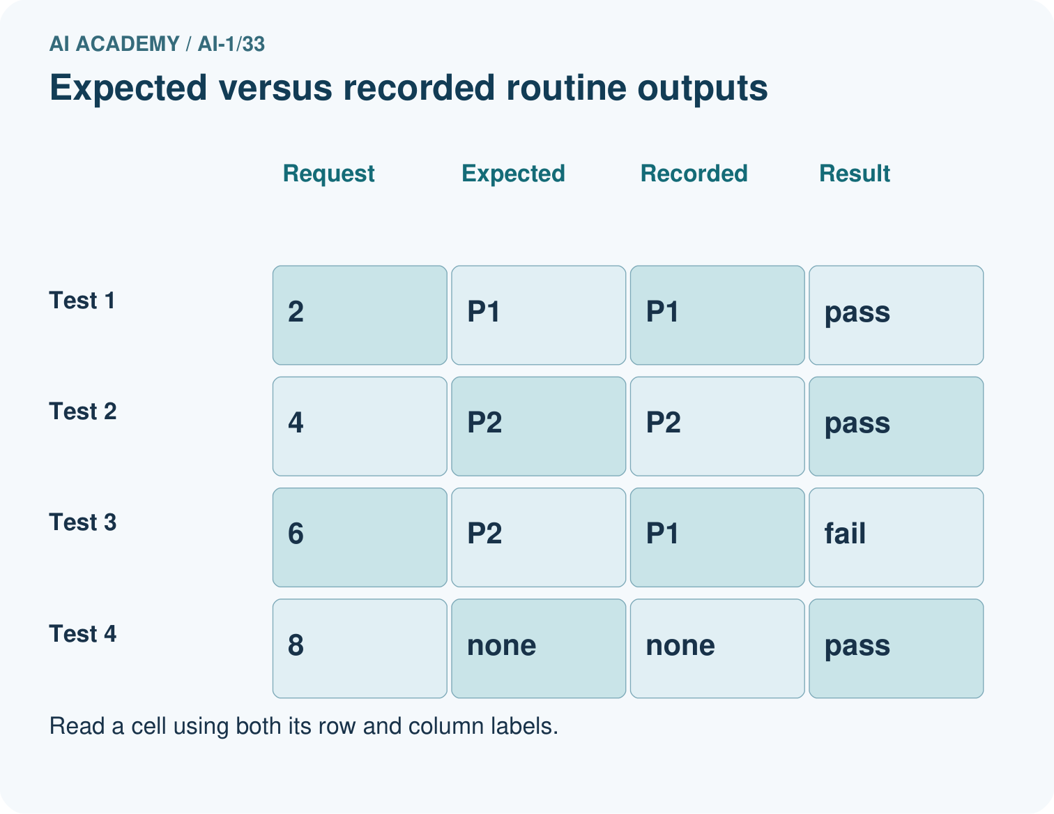
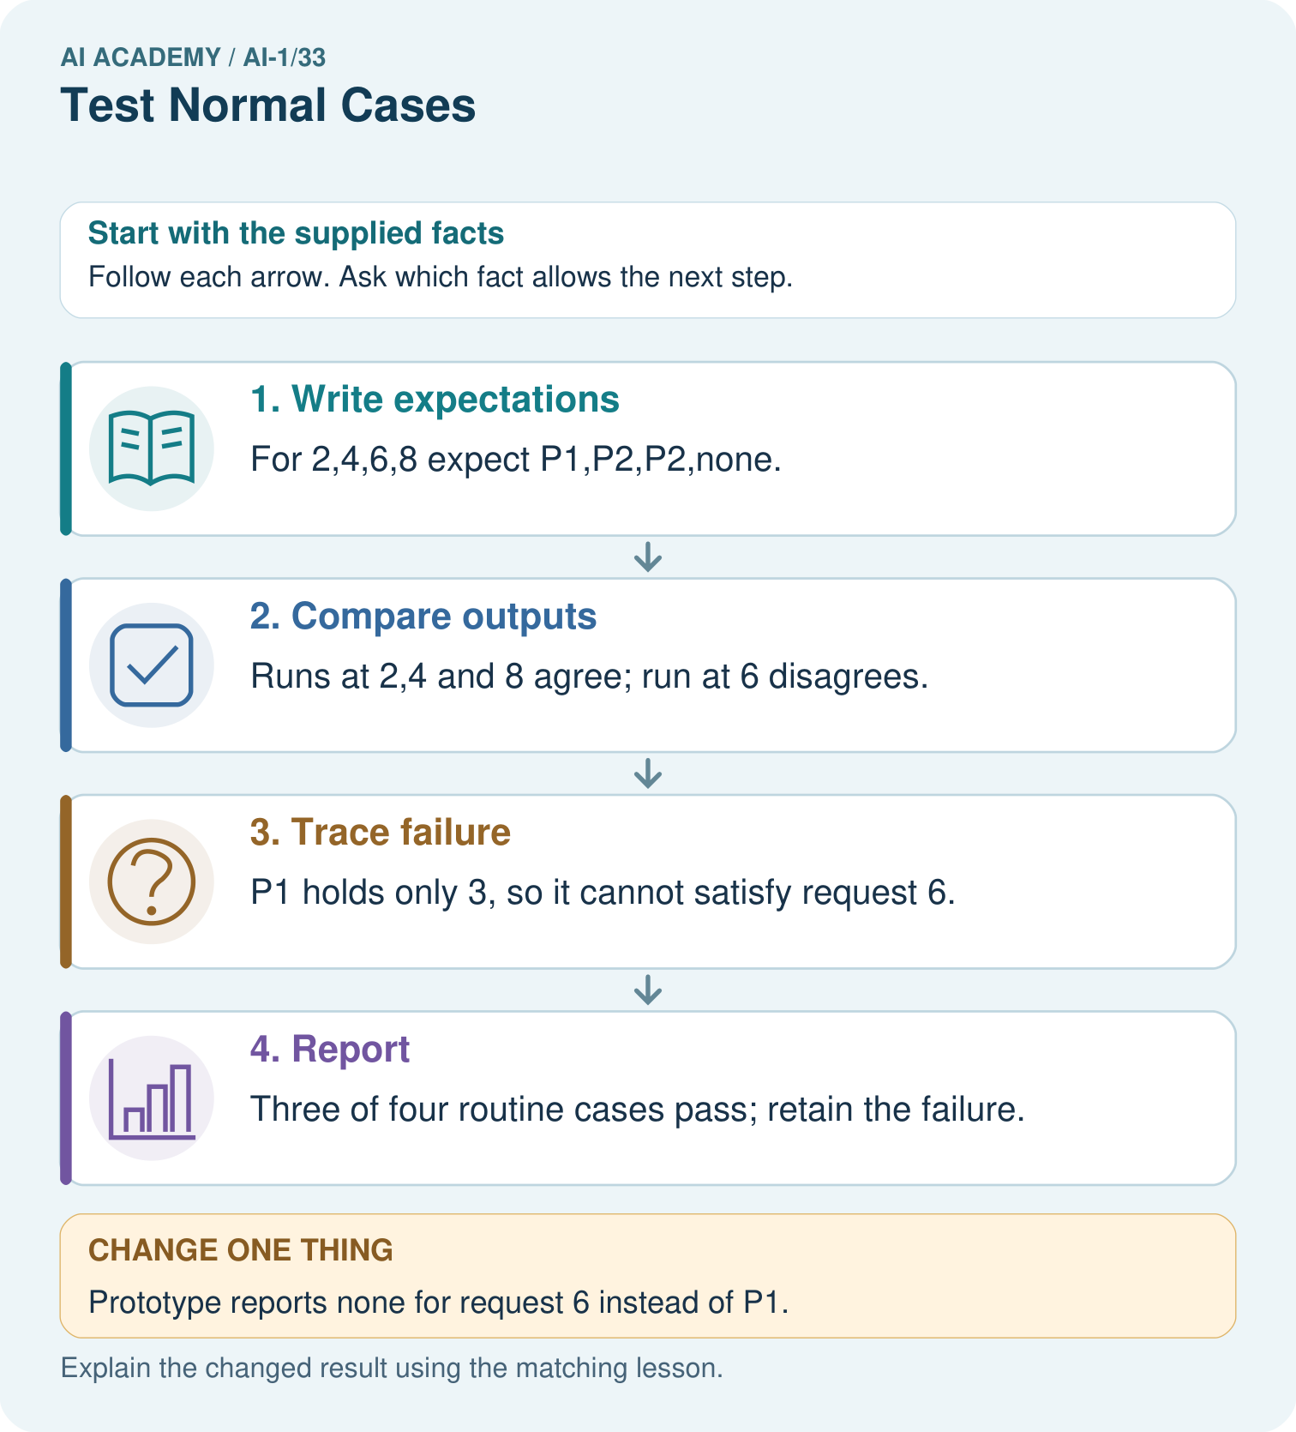

Read the picture one step at a time
Step | What happens and why
1. Write expectations | For 2,4,6,8 expect P1,P2,P2,none.
2. Compare outputs | Runs at 2,4 and 8 agree; run at 6 disagrees.
3. Trace failure | P1 holds only 3, so it cannot satisfy request 6.
4. Report | Three of four routine cases pass; retain the failure.
Match each pictured step to the supplied facts. This is a worked teaching case, not an independent assessment.

Why this result follows
An ordinary case is not automatically correct. Define expected outputs from the contract before reading prototype outputs. Checking both selected ID and eligibility catches the wrong P1 suggestion. A no-match output can be a full pass when that is exactly what the valid request requires.

What this example does not establish
Four routine tests do not cover equality, invalid inputs or every relevant classroom condition.

Change one thing in the pictured case
Change: Prototype reports none for request 6 instead of P1.
Prediction: That run still fails.
Reason: P2 can hold 6, so none is also wrong under the first-fit rule.

Ask while showing the picture
Cover the result. Ask learners to name the inputs and predict the next step. Uncover one step, connect the icon to the actual procedure, and explain its evidence. Then change the supplied condition and compare. The picture is a representation; it does not document execution of a real AI model.

03. Demonstrate and guide practice

Demonstrate and guide practice

Board sequence
Write the given facts: Four routine cases are chosen before testing. Three are correct.
Write the question to explain: What can be reported?
Reveal after predictions: 3/4 on those cases. Preserve the failure and trace its cause. This does not guarantee unfamiliar-case performance.
Keep for an independent attempt: Test a sorter on two clear pencil cards and two clear book cards. It gets one book wrong. Report the result and keep the failed case.

Classroom dialogue
Ask: Which facts are given, and which would we have to assume? Learners mark relevant details before discussing answers.
Say: Predict first. Show the rule, information path or calculation that would produce the result. A correct guess is not yet an explanation.
Reveal reasoning one step at a time. Explain why a tempting alternative fails. Write units and denominators for arithmetic, trace conditions for decisions, and identify supporting sources for claims.
In pairs, one learner solves while the other checks evidence; exchange roles. Remove the worked answer before independent assessment.

Model these guided questions
Q has 3 of 4 full passes and the fictional baseline 4 of 4. R4 selects B2 despite the quiet requirement. Dropping R4 answers how Q did on a selected three-case subset and conceals the failure in the original set. Gaps include missing or invalid fields, equality at thresholds, accepted range endpoints and successful later-row selection under a varied catalogue. Exit: this named version passed these four routine cases under the recorded conditions; all-input correctness and a speed advantage are not established. Two distinct useful checks could be invalid-input handling and equal-time boundaries. Measuring speed would require a separate fair timing comparison.

Case-specific teaching sequence
Stage | Teacher action
Session 1 start to 7 minutes | Retrieve expected versus observed results and why disagreement is retained.
7 to 20 minutes | Read the contract and diagram; prepare W1 expectations and agree the full-pass criterion.
20 to 33 minutes | Work through the fictional Q table and W3, including the denominator and failed quiet condition.
33 to 45 minutes | Begin W2 partner runs with fixed versions and one trace per request.
Session 2 start to 8 minutes | Finish W2 baseline comparison and audit whether any cases or failures were omitted.
8 to 23 minutes | Complete the guided explanation and discuss coverage gaps without claiming universal reliability.
23 to 38 minutes | Collect W4 independently before offering support; require reasons and the denominator.
38 to 45 minutes | Complete W5 and the exit; retain versioned records for boundary testing next week.

Reduce help deliberately
Completion task: Operate your saved P1 cards and the manual baseline on all four R cases. Record actual results and traces on your sheet. Summarise full passes over all attempted cases for each method, name any failures and explain why a tie would not prove the prototype improves correctness. Do not invent an observed run.
Teacher check: A correctly executed P1 and baseline both produce B1, B2, no match, no match with correct reasons, giving 4 of 4 each. Accept an honest record of different observed results when the pupil identifies and investigates the disagreements. Both methods must use the same requests, catalogue and pass criterion. A tie establishes no correctness advantage on this set; an unperformed run must remain unperformed.
Start by identifying the given inputs together. Leave the intermediate steps blank. If needed, model one step, then withdraw that help on the next step. Move to a full trace only when the partial trace is understood. For partners, alternate explainer and checker; collect a response from every learner before discussion.

Individual reasoning check
Use the worked case for Testing routine cases. Proposed explanation: “A correct label is always a full pass”. Decide whether this explanation is supported. Point to the step or supplied fact that decides; explain your repair if needed.
Expected correction: The agreed criterion also requires a correct explanation.
Collect explanations, not only yes/no votes. If a misunderstanding is common, re-model the relevant step for the class. If it affects a few learners, give a short targeted group explanation while others solve a more demanding variation.

Pictorial practice question
Why is none correct for 8 but incorrect for 6? Use both capacity cards.

Reasoned teacher answer
Neither capacity 3 nor 7 reaches 8. Capacity 7 does reach 6, so P2 is required for 6.
Changed-case reasoning: That run still fails. P2 can hold 6, so none is also wrong under the first-fit rule.
Collect each learner’s explanation before discussion. Use the first missing connection between input, deciding step and result to choose support. This question is worked-case practice, not fresh mastery evidence.

04. Run the weekly evidence lab

Run the weekly evidence lab
Predict first, test honestly, and explain what the evidence means.
State your prediction before the result is known.
Complete the task: Run five planned tests and log expected versus actual.
Keep a normal case and an edge case clearly separated.
Record what happened—even when it does not match your prediction.
Explain the result, one limitation, and the next useful test.
INDEPENDENCE After support is removed, repeat the proof with a fresh case.

Make the lab runnable
Use the concrete case as the shared normal case and the independent question as a second case. Each pair creates a boundary or missing-information case and predicts its result before testing. Keep the expected result separate from an observed mistake.
Record | What to capture
Input or evidence | Exact data, instruction or claim
Expected result | Answer or safe fallback declared before the run
Observed result | Actual result, including errors
Explanation | Rule, calculation or evidence explaining the outcome
Next test | One justified change and a new prediction

Diagnose and reteach
CLAIM TO REPAIR A failed test should be removed from the score.
For guessing, return to given facts and request a trace. For vocabulary without application, use one example and one non-example. For arithmetic errors, check the setup before the calculation. Finish with a different uncoached case before recording mastery.

Address these additional misconceptions
A correct label is always a full pass: The agreed criterion also requires a correct explanation.
Remove a failed run because something went wrong: Keep and investigate it; missing required output cannot count as success.
Four passes prove all inputs work: The conclusion is limited by the selected cases and conditions.
The prototype must beat the manual baseline: A correct simple baseline can tie or outperform a prototype; report the evidence.

Match the support to the first error
What the response shows | Next teaching action
Missing or misread facts | Read the case aloud, mark supplied versus unknown facts, and let the learner restate it.
Wrong procedure | Return to the deciding step in the worked case. Contrast it with the proposed incorrect explanation.
Arithmetic or implementation error | Trace intermediate values or lines; preserve the first mismatch and retry that step.
Correct result without a reason | Ask for a trace and a changed case before marking independent understanding.
An unsupported wider claim | Ask which supplied evidence supports the claim and which further observation would be needed.
Offer an oral explanation, drawing, enlarged visual or fewer examples when that removes a reading/writing barrier. Keep the same reasoning goal. Stretch secure learners by changing a boundary or assumption and asking them to defend the effect, not simply by assigning more of the same questions.

05. Assess and explain the answers

Assess and explain the answers

Worked case answer
3/4 on those cases. Preserve the failure and trace its cause. This does not guarantee unfamiliar-case performance.

Independent question
Test a sorter on two clear pencil cards and two clear book cards. It gets one book wrong. Report the result and keep the failed case.

Expected independent answer
It succeeds on 3 of 4 cards. Keep the mistaken book input, expected shelf output and actual output. Report the failure rather than dropping it from the total.

What counts as evidence
Criterion | 0 points | 1 point | 2 points
Result | Incorrect or absent | Partly correct | Correct with necessary conditions
Reasoning | No supporting trace | Some steps | Clear mechanism, calculation or source support
Limit | Overclaims certainty | Vague limitation | Relevant uncertainty or missing fact
Transfer | Copies without adapting | Adapts with prompts | Solves a changed case independently
Use 6/8 as a classroom checkpoint, with 2 required for both Result and Reasoning. This is a proposed teaching rule, not a validated certification threshold. Do not count a coached answer as independent mastery; correct unsafe or unsupported claims regardless of total.

Feedback
Ask the learner to find the evidence that challenges this claim: “A failed test should be removed from the score.” Keep the first attempt and an uncoached retry separate.

Original transfer answer
Report 5/6, about 83.3%, on the six specified routine cases, with the failure documented. Investigate its cause and test a related new case after any revision. If an exclusion is justified, disclose its reason and show results with and without it.

Explanations for the additional workbook examples

W1 Prepare the four cases
Create the test record for R1 11 Yes, R2 9 No, R3 6 No and R4 9 Yes. Before running anything, write each expected output, explanation and purpose using catalogue B version 1. Include blank places for observed output, observed reason, pass or fail and trace reference. State the version labels and pass criterion.
R1 B1 because time fits and it is quiet; early match. R2 B2 because B1 is too long, B2 fits and quiet is unrestricted; later match. R3 no match because every time exceeds 6; exhaustion. R4 no match because B2 fails quiet while other rows exceed 9; both conditions. Record P1 version 1, B version 1 and the manual baseline. A full pass needs the required output and a correct explanation.

W2 Run a fair comparison
Operate your saved P1 cards and the manual baseline on all four R cases. Record actual results and traces on your sheet. Summarise full passes over all attempted cases for each method, name any failures and explain why a tie would not prove the prototype improves correctness. Do not invent an observed run.
A correctly executed P1 and baseline both produce B1, B2, no match, no match with correct reasons, giving 4 of 4 each. Accept an honest record of different observed results when the pupil identifies and investigates the disagreements. Both methods must use the same requests, catalogue and pass criterion. A tie establishes no correctness advantage on this set; an unperformed run must remain unperformed.

W3 Keep the failed case in the total
Use the fictional Q version 0 record. Calculate its full-pass fraction and the baseline’s fraction. Explain why R4 fails and why dropping it to report 3 of 3 misrepresents the original four-case set. State what evidence you would inspect before changing Q.
Q passes 3 of 4; the baseline passes 4 of 4. R4 returns nonquiet B2 when quiet is required, so time alone is insufficient. Removing R4 changes the tested set and hides its known failure; 3 of 3 is not the original set’s result. Inspect the saved Q instructions and R4 trace to locate the missing quiet check, then label any repair separately.

W4 Audit a new test record
Independently audit this fictional equipment selector. Catalogue E has E1 first with capacity 4 and E2 second with capacity 8. Valid group sizes are whole numbers 1 to 10. Select the first item with capacity at least the group size, or no match; invalid input needs clarification. The saved prototype reports E1 for group 3 with reason “4 holds 3”; E1 for group 6 with reason “4 holds 6”; no match for group 9 with reason “both too small”. Write all expected results, mark full passes, calculate the fraction and explain the failure. Give one untested input category. No booking occurs.
Expected group 3: E1 because 4 holds 3. Group 6: E2 because E1 is too small and 8 holds 6. Group 9: no match because both capacities are too small. The first and third pass; the second fails both output and reason, giving 2 of 3 full passes. The record suggests a capacity-check problem but the saved instructions and trace are needed to locate it. Missing, nonwhole or out-of-range input is untested, as is equality with a capacity.

W5 State what the evidence leaves open
Explain why catalogue B cannot produce B3 or B4 as its first fitting output even if you try many ordinary requests. Distinguish checking a row during a failed search from successfully selecting it. Write a limited conclusion for a P1 run that passed all four R cases and name a useful next test category.
B3 needs at least 12 minutes and is quiet, so earlier B1 at 10 also fits whenever B3 fits. B4 needs 15 and is nonquiet, so a compatible request permits earlier B1 as well. Both later rows may be checked in no-match runs but are never first fits in catalogue B. Report 4 of 4 full passes on set R with named versions; broader reliability is unestablished. Next examine boundaries, invalid inputs or an explicitly labelled catalogue variation.

Assess independent transfer
Selected case: Independently audit this fictional equipment selector. Catalogue E has E1 first with capacity 4 and E2 second with capacity 8. Valid group sizes are whole numbers 1 to 10. Select the first item with capacity at least the group size, or no match; invalid input needs clarification. The saved prototype reports E1 for group 3 with reason “4 holds 3”; E1 for group 6 with reason “4 holds 6”; no match for group 9 with reason “both too small”. Write all expected results, mark full passes, calculate the fraction and explain the failure. Give one untested input category. No booking occurs.

Selected case answer
Expected group 3: E1 because 4 holds 3. Group 6: E2 because E1 is too small and 8 holds 6. Group 9: no match because both capacities are too small. The first and third pass; the second fails both output and reason, giving 2 of 3 full passes. The record suggests a capacity-check problem but the saved instructions and trace are needed to locate it. Missing, nonwhole or out-of-range input is untested, as is equality with a capacity.
Dimension | Evidence required
Explanation | Names the applicable idea or procedure and ties it to the supplied facts.
Trace and result | Preserves the given inputs and shows the relevant intermediate steps; distinguishes a prediction from an observed execution.
Limits | States the assumptions, missing evidence or conditions under which the result would change.
Record each dimension as not yet, with support, or independent. Accept a valid alternative procedure with a defensible trace. Do not penalise an honestly recorded model failure if the learner correctly explains its evidence and limits.

Feedback that the learner uses
Name the earliest unsupported step and give one action to repair it. Have the learner make that repair now and explain why. Then assess the relevant skill on a fresh, fully specified case. Confirm it was not previously practised with feedback; solve and check the new case before assigning it. A follow-up design prompt is a starting brief, not automatically an equivalent test.

06. Connect and extend learning

Connect and extend learning

Helpful Classroom Sorter
Create and run the sorter's normal-case test plan with unique IDs and version label.
Keep the decision, input, result, explanation and remaining limitation in the project evidence record. Retrieve this record next week rather than restarting the project.

Support and stretch
Use physical cards, spoken explanations and a three-stage drawing. Read aloud without giving the answer. Stretch: compare two mechanisms with the same visible output and explain what evidence distinguishes them.

Exit reflection
Ask for one decision the learner can now justify and one situation requiring more evidence or human review. Confidence ratings are separate from correct independent performance.

Bridge to the next week
Next: Week 34: Test Edge Cases and Fairness. Retrieve today’s evidence and identify what carries forward and what is new.

Support and fresh reassessment
Provide blank column headings and a separate copy of the requirements. Ask pupils to check time and quiet separately before combining them. Permit a spoken explanation recorded by the teacher, while retaining the pupil’s independent first attempt. Extension: explain why repeated R1 runs do not add coverage of a missing condition.
W4 must independently produce E1, E2 and no match, identify the group-6 capacity failure and report 2 of 3 full passes without diagnosing unseen code. After support, use a fresh record: groups 2, 7 and 10 produce observed E1 with “4 holds 2”, E2 with “8 holds 7”, and E2 with “8 holds 10”. Expected E1, E2, no match gives 2 of 3. Require the pupil to identify the final failure and propose an untested validation case.
Week 34 tests equality boundaries, accepted ranges, invalid inputs and explicitly labelled catalogue variations, then revisits what the evidence can support.

Plan the delayed return
Suggested return points in this level: ai-1/34, ai-1/36. Use actual classroom dates, adjusting for holidays and gaps. One, three and six teaching weeks are scheduling choices, not a claimed optimal spacing.
At a delayed check, ask for the idea from memory and a changed application. Compare with the earlier independent response and record support used. For a new level, revisit the previous capstone before checking the new prerequisites.
Record | Teacher evidence
Learner code and date
Concept and case used; prior exposure
Explanation / trace / limits
Support and first repair
Changed case and delayed outcome
Next teaching action
Use the evidence to choose reteaching or the next step. A completed page, confidence rating or attractive project does not by itself demonstrate understanding.

Project evidence from this case
Maintain sorter tests with input, independently derived expectation, actual output, version and full-pass judgment.

07. Prepare, teach and assess
Teaching target: Plan routine cases with expected results derived from the requirements
Prepare the labelled worked-case picture, the matching workbook, fictional input cards and a place for individual responses. No paid AI account is required for the paper reasoning activities.
Session | Plan | Resources
Session 1 · Understand · 45 min | 0–7: recall and prerequisite; 7–15: inspect the concrete case and predict; 15–30: teacher models the worked trace; 30–40: learners explain a step using the text and visual; 40–45: check the core idea. | Sections 1–6; record the brief recall in the workbook.
Session 2 · Practise · 45 min | 0–5: retrieve the procedure; 5–15: W2 completion practice; 15–23: explain and check with a partner; 23–30: each learner answers the misconception check; 30–40: targeted reteaching or a harder variation; 40–45: prepare the investigation. | Sections 7–10; use the matching workbook W2 and misconception check.
Session 3 · Investigate and transfer · 45 min | 0–5: retrieve the decision rule; 5–20: investigate or trace; 20–30: start the independent case; 30–38: connect the project; 38–43: act on feedback; 43–45: plan the return check. | Sections 9 and 11–14. Give extra time to finish the full task set; use Section 15 when the week includes a coding lab.
Before class, solve the supported practice: Operate your saved P1 cards and the manual baseline on all four R cases. Record actual results and traces on your sheet. Summarise full passes over all attempted cases for each method, name any failures and explain why a tie would not prove the prototype improves correctness. Do not invent an observed run.
Reasoned practice answer: A correctly executed P1 and baseline both produce B1, B2, no match, no match with correct reasons, giving 4 of 4 each. Accept an honest record of different observed results when the pupil identifies and investigates the disagreements. Both methods must use the same requests, catalogue and pass criterion. A tie establishes no correctness advantage on this set; an unperformed run must remain unperformed.
Check every learner before discussion: Use the worked case for Testing routine cases. Proposed explanation: “A correct label is always a full pass”. Decide whether this explanation is supported. Point to the step or supplied fact that decides; explain your repair if needed.
Misconception repair: The agreed criterion also requires a correct explanation.
Support: read the exact case aloud, enlarge the labelled picture, supply input cards and model only the first deciding step. Accept a spoken explanation or drawing; retain the reasoning goal.
Extension: Prototype reports none for request 6 instead of P1. Require a prediction and a reason before comparing. Expected result: That run still fails. Reason: P2 can hold 6, so none is also wrong under the first-fit rule.
Independent assessment: withhold the reserved answer until the learner has attempted the new case. Record support separately from correctness.
Criterion | Not yet | With support | Independent
Explanation | Names an answer without a deciding fact | Uses a hint to link fact and decision | Explains the deciding fact in own words
Trace or test | Cannot connect input and result | Completes steps with prompts | Traces or tests a changed case accurately
Limits and revision | Claims more than evidence supports | Names a limit after a prompt | States a defensible limit and useful next test
Project checkpoint: Present and defend. Demonstrate the system, explain one failure and justify the next improvement with evidence.
Use the weekly teacher answer for topic-specific reasoning. A saved progress tick is an activity record; judge mastery from the learner’s explanation and evidence.

