AI ACADEMY · TEACHER · ai-2/7

Rows Columns and Data Types
Project: Transparent Book Recommender

01. Rows, Columns, and Data Types

Teach the learning cycle
Primary target: Specify a table schema
Session | Sequence and minutes | Resources
Session 1 · Understand · 45 min | 0–7: recall and prerequisite; 7–15: inspect the concrete case and predict; 15–30: teacher models the worked trace; 30–40: learners explain a step using the text and visual; 40–45: check the core idea. | Sections 1–6; record the brief recall in the workbook.
Session 2 · Practise · 45 min | 0–5: retrieve the procedure; 5–15: W2 completion practice; 15–23: explain and check with a partner; 23–30: each learner answers the misconception check; 30–40: targeted reteaching or a harder variation; 40–45: prepare the investigation. | Sections 7–10; use the matching workbook W2 and misconception check.
Session 3 · Investigate and transfer · 45 min | 0–5: retrieve the decision rule; 5–20: investigate or trace; 20–30: start the independent case; 30–38: connect the project; 38–43: act on feedback; 43–45: plan the return check. | Sections 9 and 11–14. Give extra time to finish the full task set; use Section 15 when the week includes a coding lab.
This is a starting allocation of 135 minutes, not a validated duration. Preserve all named topics. Schedule extra time for connected examples, the full investigation, independent cases and project building. Repeated copies of a case share one recorded attempt; they are not new evidence.
Case exposure check: this source example appears in ai-2/7, ai-4/4. Reuse a familiar case for recall or modelling; verify that the case used to assess transfer has not already received feedback.

Retrieval answer guidance

Debugging Strategies
Without opening the old lesson, explain one key idea from Debugging Strategies. Give an example and a mistake that the idea helps you avoid.
Look for: Design revealing tests for a function
Reference example, not the only acceptable wording: 4, 0 and 6.

Trace Tables
Without opening the old lesson, explain one key idea from Trace Tables. Give an example and a mistake that the idea helps you avoid.
Look for: Trace variable values before and after each loop iteration
Reference example, not the only acceptable wording: 2, 3 and 4; the stop value is excluded. The body runs three times.

Precision in Algorithms
Without opening the old lesson, explain one key idea from Precision in Algorithms. Give an example and a mistake that the idea helps you avoid.
Look for: Translate a short paper calculation into a Python script
Reference example, not the only acceptable wording: packs = 4; per_pack = 6; total = packs * per_pack; print(total), each on its own line. The first two bind quantities, the third computes 24 and the fourth displays 24. Assignment alone produces no displayed output in this script.
Use the student module and workbook section with this exact week title. The worked case, independent question and answers below form one aligned lesson sequence.

What the learner must demonstrate
A row contains title='Sky', pages='120', available='false'. Explain why treating nonempty text as true can misread availability. Propose explicit conversions and a rejected-input case.

Concept to explain
Week 7: Rows, Columns, and Data Types
Term | Meaning
row | One record or example in a table.
column | A table field containing the same kind of information across rows.
data type | A category of values, such as number, text or Boolean, with defined operations.
schema | A specification of required fields, types and structural rules for data.

Prepare the class
Use the supplied scenario, student illustrations and blank paper. For numeric work, offer counters or a calculator after learners show the setup. Fictional records are supplied; personal data and paid accounts are unnecessary.
Allow 80 minutes: recall 8; explanation 12; worked demonstration 15; guided practice 20; independent assessment 15; project and reflection 10. Extend the lab into a second session when needed.

Preparation for the connected explanation
Teach Week 13 as a two-session investigation using fictional data. A fictional classroom logs the duration of each activity. Before comparing durations, define a schema: activity is nonempty text, minutes is an integer from 0 through 60, and each row describes one activity session. These decisions make data interpretable. Assess the three stated outcomes through the independent task, not by copying the worked result.

Readiness answer
Look up the value associated with the key "used" in that record.
Python 3 editor with a fresh local practice file
Paper trace table and the student workbook
Fictional input records from this lesson; no real student identifiers

End goal for the pictorial case
By the end, I can read a table schema and distinguish a numeric value from its text representation.
This added worked case illustrates the week’s main idea. Retain all original and connected topics; schedule its practice within the teaching cycle.

02. Explain the mechanism

Explain the mechanism
Input → Process → Output
Trace the information. At each stage, ask what changed and how you could test it.
Which stage could fail even when the other two are correct? Explain:
Predict first. Then check each step. A correct answer without visible reasoning is incomplete evidence.
1. Schema: title=text; pages=whole number; genre=category.
2. Bad record: pages=‘many’ cannot be compared numerically.
3. Repair: verify the source, then enter 128—not a guess.
4. Consistent types let sorting and calculations work predictably.
Recalculate, retrace, or restate the reasoning in your own representation:
CHECK Did the evidence answer the exact question? Did the total, path, or source record stay consistent?

Concrete teaching case
Fields are Title, Pages and Borrowed; a row contains River, ninety and yes.
Assign intended types and a repair.

Exact explanation to model
Text, numeric and Boolean. Confirm ninety means 90, then convert and record the change; use a consistent Boolean representation.

Explain the added worked example
A fictional classroom logs the duration of each activity. Before comparing durations, define a schema: activity is nonempty text, minutes is an integer from 0 through 60, and each row describes one activity session. These decisions make data interpretable.
The worked script prints True twice. type(value) is int checks the exact type here and avoids accepting a Boolean as a count. The chained comparison checks both boundaries. The example assumes both keys exist; next week handles missing fields. A zero duration is allowed by this written schema.

Key terms
Term | Meaning
Schema | Rules for the fields and values in records
Type | A category such as integer or text
Unit | The quantity scale attached to a number
Constraint | A rule a valid record must satisfy

Model the reasoning aloud
Use the complete worked example below before asking learners to complete W2. Reveal a small part, invite a prediction, then explain the deciding step. These teacher notes contain solutions; do not reveal the independent case answer during modelling.

Would minutes of 61, "12" and 12 each pass? Explain the type distinction.
________________________________________________________________
________________________________________________________________
________________________________________________________________
________________________________________________________________
________________________________________________________________
________________________________________________________________
Thinking move | Teacher prompt
Plan | What is given? What is the question? Which procedure fits these facts?
Do | Point to each input and intermediate step in the worked trace. Name the rule that allows the next step.
Check | Does the output answer the question? Which assumption or limitation prevents a larger claim?
Use the diagram and verbal explanation together. Ask learners to match a sentence to a specific visual step; do not assign learners fixed visual or auditory learning styles.

A pictorial worked case: Rows Columns and Data Types
A fictional approved book catalogue has three fields per row.

The facts we will use
Schema: id is nonempty text; pages is an integer 1–300; illustrated is Boolean True or False.
Rows A={id:"B7",pages:90,illustrated:True}; B={id:"B8",pages:"90",illustrated:False}; C={id:"",pages:80,illustrated:True}.
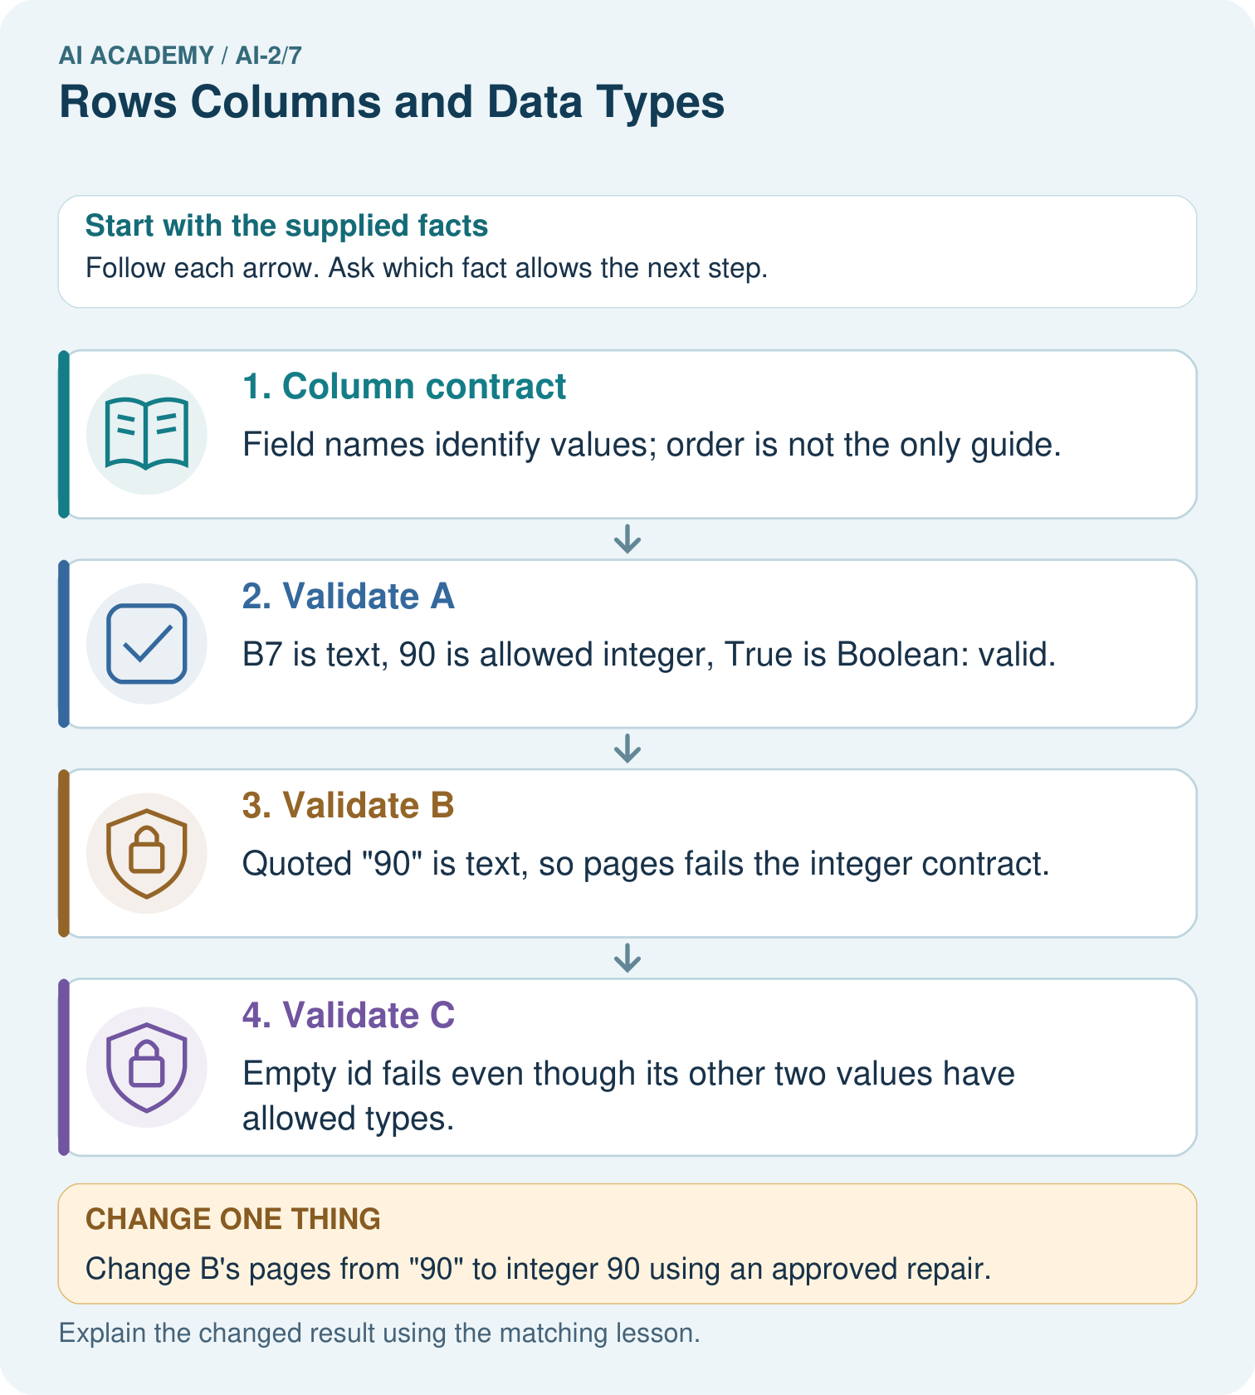

Read the picture one step at a time
Step | What happens and why
1. Column contract | Field names identify values; order is not the only guide.
2. Validate A | B7 is text, 90 is allowed integer, True is Boolean: valid.
3. Validate B | Quoted "90" is text, so pages fails the integer contract.
4. Validate C | Empty id fails even though its other two values have allowed types.
Match each pictured step to the supplied facts. This is a worked teaching case, not an independent assessment.

Why this result follows
A schema makes row meanings and expected types explicit. The string "90" looks like a number when printed but does not meet this strict integer schema. A repair can be authorised later, but must not be assumed silently. Missing or empty identifiers also prevent tracing an item back to its source.

What this example does not establish
Schema validity does not confirm that the book really has 90 pages or that its metadata is accurate.

Change one thing in the pictured case
Change: Change B’s pages from "90" to integer 90 using an approved repair.
Prediction: B now satisfies the declared schema.
Reason: Its id is nonempty and illustrated is Boolean; the page-type defect is removed.

Ask while showing the picture
Cover the result. Ask learners to name the inputs and predict the next step. Uncover one step, connect the icon to the actual procedure, and explain its evidence. Then change the supplied condition and compare. The picture is a representation; it does not document execution of a real AI model.

03. Demonstrate and guide practice

Demonstrate and guide practice

Board sequence
Write the given facts: Fields are Title, Pages and Borrowed; a row contains River, ninety and yes.
Write the question to explain: Assign intended types and a repair.
Reveal after predictions: Text, numeric and Boolean. Confirm ninety means 90, then convert and record the change; use a consistent Boolean representation.
Keep for an independent attempt: A table row is book_id B7, pages 84, available true. Name the type of each field and explain why pages stored as eighty-four complicates calculation.

Classroom dialogue
Ask: Which facts are given, and which would we have to assume? Learners mark relevant details before discussing answers.
Say: Predict first. Show the rule, information path or calculation that would produce the result. A correct guess is not yet an explanation.
Reveal reasoning one step at a time. Explain why a tempting alternative fails. Write units and denominators for arithmetic, trace conditions for decisions, and identify supporting sources for claims.
In pairs, one learner solves while the other checks evidence; exchange roles. Remove the worked answer before independent assessment.

Model these guided questions
61 fails the range; "12" fails the integer type; 12 passes. Exit: No. The value has a permitted structure but still needs trustworthy collection evidence.

Case-specific teaching sequence
Stage | Teacher action
Session 1 start to 7 minutes | Retrieve the prerequisite and explain the purpose in the opening section.
7 to 20 minutes | Read the worked example and diagram; ask learners to trace each step aloud.
20 to 33 minutes | Complete W1 and W2, then compare predictions with observed results.
33 to 45 minutes | Collect the guided prediction before running; discuss a mismatch and its cause.
Session 2 start to 8 minutes | Retrieve the main rule without showing the previous answer.
8 to 20 minutes | Use W3 to diagnose and repair the stated failure; rerun an earlier case.
20 to 35 minutes | Collect W4 independently, including code or plan, predictions and explanations, before hints.
35 to 45 minutes | Discuss W5 and the exit; use the fresh retry when support was needed.

Reduce help deliberately
Completion task: Classify minutes values 0, 60, -1 and 61 under this schema.
Teacher check: 0 and 60 pass; -1 and 61 fail.
Start by identifying the given inputs together. Leave the intermediate steps blank. If needed, model one step, then withdraw that help on the next step. Move to a full trace only when the partial trace is understood. For partners, alternate explainer and checker; collect a response from every learner before discussion.

Individual reasoning check
Use the worked case for Rows columns and schemas. Proposed explanation: “A successful run proves the conclusion”. Decide whether this explanation is supported. Point to the step or supplied fact that decides; explain your repair if needed.
Expected correction: A row can satisfy every schema rule and still be a wrong observation. Schema validation checks our stated structure and constraints, not whether someone measured honestly or selected a representative sample.
Collect explanations, not only yes/no votes. If a misunderstanding is common, re-model the relevant step for the class. If it affects a few learners, give a short targeted group explanation while others solve a more demanding variation.

Pictorial practice question
Which two rows originally fail, and do they fail for the same reason?

Reasoned teacher answer
B fails pages type; C fails empty id. A passes all three field checks.
Changed-case reasoning: B now satisfies the declared schema. Its id is nonempty and illustrated is Boolean; the page-type defect is removed.
Collect each learner’s explanation before discussion. Use the first missing connection between input, deciding step and result to choose support. This question is worked-case practice, not fresh mastery evidence.

04. Run the weekly evidence lab

Run the weekly evidence lab
Words You Can Use to Reason
A definition matters when you can recognize the idea, use it, and contrast it with a near-miss.
Predict → Test → Record → Explain
Keep expected and actual results separate. Surprises are useful data when recorded honestly.
Audit a 10-row book table. Circle mixed types, missing values, duplicated rows, and fields with unclear names; document each repair.
What did the hardest test teach you that the normal test did not?

Make the lab runnable
Use the concrete case as the shared normal case and the independent question as a second case. Each pair creates a boundary or missing-information case and predicts its result before testing. Keep the expected result separate from an observed mistake.
Record | What to capture
Input or evidence | Exact data, instruction or claim
Expected result | Answer or safe fallback declared before the run
Observed result | Actual result, including errors
Explanation | Rule, calculation or evidence explaining the outcome
Next test | One justified change and a new prediction

Diagnose and reteach
For guessing, return to given facts and request a trace. For vocabulary without application, use one example and one non-example. For arithmetic errors, check the setup before the calculation. Finish with a different uncoached case before recording mastery.

Address these additional misconceptions
A successful run proves the conclusion: A row can satisfy every schema rule and still be a wrong observation. Schema validation checks our stated structure and constraints, not whether someone measured honestly or selected a representative sample.
Matching the example is enough: Require the new W4 case, explicit predictions and an explanation. Fresh retry: define a tray label and integer count 0 through 20. Require tests at 0, 20, -1 and 21 and a text count.
A convenient shortcut preserves meaning: If one row records 120 seconds in the minutes field, a simple numeric total becomes misleading. Correct the source or explicitly convert and document it; renaming a column alone does not convert values.

Match the support to the first error
What the response shows | Next teaching action
Missing or misread facts | Read the case aloud, mark supplied versus unknown facts, and let the learner restate it.
Wrong procedure | Return to the deciding step in the worked case. Contrast it with the proposed incorrect explanation.
Arithmetic or implementation error | Trace intermediate values or lines; preserve the first mismatch and retry that step.
Correct result without a reason | Ask for a trace and a changed case before marking independent understanding.
An unsupported wider claim | Ask which supplied evidence supports the claim and which further observation would be needed.
Offer an oral explanation, drawing, enlarged visual or fewer examples when that removes a reading/writing barrier. Keep the same reasoning goal. Stretch secure learners by changing a boundary or assumption and asking them to defend the effect, not simply by assigning more of the same questions.

05. Assess and explain the answers

Assess and explain the answers

Worked case answer
Text, numeric and Boolean. Confirm ninety means 90, then convert and record the change; use a consistent Boolean representation.

Independent question
A table row is book_id B7, pages 84, available true. Name the type of each field and explain why pages stored as eighty-four complicates calculation.

Expected independent answer
book_id is text, pages is a number, and available is Boolean. Text words need conversion before numeric arithmetic or comparison.

What counts as evidence
Criterion | 0 points | 1 point | 2 points
Result | Incorrect or absent | Partly correct | Correct with necessary conditions
Reasoning | No supporting trace | Some steps | Clear mechanism, calculation or source support
Limit | Overclaims certainty | Vague limitation | Relevant uncertainty or missing fact
Transfer | Copies without adapting | Adapts with prompts | Solves a changed case independently
Use 6/8 as a classroom checkpoint, with 2 required for both Result and Reasoning. This is a proposed teaching rule, not a validated certification threshold. Do not count a coached answer as independent mastery; correct unsafe or unsupported claims regardless of total.

Feedback
Ask the learner to find the evidence that challenges this claim: “All table entries behave as numbers.” Keep the first attempt and an uncoached retry separate.

Original transfer answer
Parse pages as a number after validation. Map only agreed strings such as 'true' and 'false' to Booleans; reject 'unknown' or represent it explicitly as missing. Do not rely on nonempty-string truthiness. Type consistency does not prove that the catalogue's facts are correct.

Explanations for the additional workbook examples

W1 State a schema
List the required fields, types and duration boundaries for the worked table.
activity: nonempty text; minutes: integer from 0 to 60 inclusive.
Check both fields. activity must exist as nonempty text. minutes must be an exact integer and satisfy 0 <= minutes <= 60. Inclusive means equality is accepted at both ends. Structure, type and range are separate checks; passing them does not prove the duration was measured accurately.

W2 Classify records
Classify minutes values 0, 60, -1 and 61 under this schema.
0 and 60 pass; -1 and 61 fail.
Apply the inclusive range to each integer. Both 0 and 60 are on allowed boundaries. -1 is below the minimum and 61 is above the maximum. Require the reason for each rejection, not only pass/fail labels.

W3 Repair a unit problem
A source says 180 seconds but the row says minutes: 180. Give a documented correction.
Divide by 60 to record 3 minutes and retain the source value and conversion note.

W4 Design a schema independently
For a fictional shelf audit, define label and book_count fields. Require a nonempty text label and an integer count from 0 to 40. Give two valid and two invalid records with reasons.
Examples: A/0 and B/40 valid; empty label/5 invalid label; C/41 invalid range. Text "5" also fails the count type. Accept alternatives meeting the written rules.

W5 Separate validity and truth
A row says Reading, 12 and passes. Does that establish the session really lasted 12 minutes?
No. The value has a permitted structure but still needs trustworthy collection evidence.

Assess independent transfer
Selected case: For a fictional shelf audit, define label and book_count fields. Require a nonempty text label and an integer count from 0 to 40. Give two valid and two invalid records with reasons.

Selected case answer
Examples: A/0 and B/40 valid; empty label/5 invalid label; C/41 invalid range. Text "5" also fails the count type. Accept alternatives meeting the written rules.
Dimension | Evidence required
Explanation | Names the applicable idea or procedure and ties it to the supplied facts.
Trace and result | Preserves the given inputs and shows the relevant intermediate steps; distinguishes a prediction from an observed execution.
Limits | States the assumptions, missing evidence or conditions under which the result would change.
Record each dimension as not yet, with support, or independent. Accept a valid alternative procedure with a defensible trace. Do not penalise an honestly recorded model failure if the learner correctly explains its evidence and limits.

Feedback that the learner uses
Name the earliest unsupported step and give one action to repair it. Have the learner make that repair now and explain why. Then assess the relevant skill on a fresh, fully specified case. Confirm it was not previously practised with feedback; solve and check the new case before assigning it. A follow-up design prompt is a starting brief, not automatically an equivalent test.

06. Connect and extend learning

Connect and extend learning

Transparent Book Recommender
Store one book per row and keep reader preferences in a separate record.
Keep the decision, input, result, explanation and remaining limitation in the project evidence record. Retrieve this record next week rather than restarting the project.

Support and stretch
Trace one record or condition at a time with counters and labelled columns. Stretch: introduce a tie, boundary or missing field and declare its handling policy before rerunning.

Exit reflection
Ask for one decision the learner can now justify and one situation requiring more evidence or human review. Confidence ratings are separate from correct independent performance.

Bridge to the next week
Next: Week 8: Operational Labels. Retrieve today’s evidence and identify what carries forward and what is new.

Support and fresh reassessment
Use a schema card beside each record. Extension: explain how allowing decimal durations would change both type and rounding rules.
Independent W4 evidence: Examples: A/0 and B/40 valid; empty label/5 invalid label; C/41 invalid range. Text "5" also fails the count type. Accept alternatives meeting the written rules. Record whether the learner needed no help, a hint or explanation. Fresh retry: define a tray label and integer count 0 through 20. Require tests at 0, 20, -1 and 21 and a text count.
Next week: Missing values and validation. Reuse this week's explicit contracts and evidence.

Plan the delayed return
Suggested return points in this level: ai-2/8, ai-2/10, ai-2/13. Use actual classroom dates, adjusting for holidays and gaps. One, three and six teaching weeks are scheduling choices, not a claimed optimal spacing.
At a delayed check, ask for the idea from memory and a changed application. Compare with the earlier independent response and record support used. For a new level, revisit the previous capstone before checking the new prerequisites.
Record | Teacher evidence
Learner code and date
Concept and case used; prior exposure
Explanation / trace / limits
Support and first repair
Changed case and delayed outcome
Next teaching action
Use the evidence to choose reteaching or the next step. A completed page, confidence rating or attractive project does not by itself demonstrate understanding.

Project evidence from this case
Publish the recommender’s row schema and validation results before ranking books, preserving repair provenance.

07. Prepare, teach and assess
Teaching target: Specify a table schema
Prepare the labelled worked-case picture, the matching workbook, fictional input cards and a place for individual responses. No paid AI account is required for the paper reasoning activities.
Session | Plan | Resources
Session 1 · Understand · 45 min | 0–7: recall and prerequisite; 7–15: inspect the concrete case and predict; 15–30: teacher models the worked trace; 30–40: learners explain a step using the text and visual; 40–45: check the core idea. | Sections 1–6; record the brief recall in the workbook.
Session 2 · Practise · 45 min | 0–5: retrieve the procedure; 5–15: W2 completion practice; 15–23: explain and check with a partner; 23–30: each learner answers the misconception check; 30–40: targeted reteaching or a harder variation; 40–45: prepare the investigation. | Sections 7–10; use the matching workbook W2 and misconception check.
Session 3 · Investigate and transfer · 45 min | 0–5: retrieve the decision rule; 5–20: investigate or trace; 20–30: start the independent case; 30–38: connect the project; 38–43: act on feedback; 43–45: plan the return check. | Sections 9 and 11–14. Give extra time to finish the full task set; use Section 15 when the week includes a coding lab.
Before class, solve the supported practice: Classify minutes values 0, 60, -1 and 61 under this schema.
Reasoned practice answer: 0 and 60 pass; -1 and 61 fail.
Check every learner before discussion: Use the worked case for Rows columns and schemas. Proposed explanation: “A successful run proves the conclusion”. Decide whether this explanation is supported. Point to the step or supplied fact that decides; explain your repair if needed.
Misconception repair: A row can satisfy every schema rule and still be a wrong observation. Schema validation checks our stated structure and constraints, not whether someone measured honestly or selected a representative sample.
Support: read the exact case aloud, enlarge the labelled picture, supply input cards and model only the first deciding step. Accept a spoken explanation or drawing; retain the reasoning goal.
Extension: Change B’s pages from "90" to integer 90 using an approved repair. Require a prediction and a reason before comparing. Expected result: B now satisfies the declared schema. Reason: Its id is nonempty and illustrated is Boolean; the page-type defect is removed.
Independent assessment: withhold the reserved answer until the learner has attempted the new case. Record support separately from correctness.
Criterion | Not yet | With support | Independent
Explanation | Names an answer without a deciding fact | Uses a hint to link fact and decision | Explains the deciding fact in own words
Trace or test | Cannot connect input and result | Completes steps with prompts | Traces or tests a changed case accurately
Limits and revision | Claims more than evidence supports | Names a limit after a prompt | States a defensible limit and useful next test
Project checkpoint: Make a transparent first version. Keep a trace of how one input becomes an output; explain the rule or learned component.
Use the weekly teacher answer for topic-specific reasoning. A saved progress tick is an activity record; judge mastery from the learner’s explanation and evidence.

