AI ACADEMY · TEACHER · ai-2/15

Choose Informative Questions
Project: Transparent Book Recommender

01. Choose Informative Questions

Teach the learning cycle
Primary target: Fit a root question and leaf predictions from training examples
Session | Sequence and minutes | Resources
Session 1 · Understand · 45 min | 0–7: recall and prerequisite; 7–15: inspect the concrete case and predict; 15–30: teacher models the worked trace; 30–40: learners explain a step using the text and visual; 40–45: check the core idea. | Sections 1–6; record the brief recall in the workbook.
Session 2 · Practise · 45 min | 0–5: retrieve the procedure; 5–15: W2 completion practice; 15–23: explain and check with a partner; 23–30: each learner answers the misconception check; 30–40: targeted reteaching or a harder variation; 40–45: prepare the investigation. | Sections 7–10; use the matching workbook W2 and misconception check.
Session 3 · Investigate and transfer · 45 min | 0–5: retrieve the decision rule; 5–20: investigate or trace; 20–30: start the independent case; 30–38: connect the project; 38–43: act on feedback; 43–45: plan the return check. | Sections 9 and 11–14. Give extra time to finish the full task set; use Section 15 when the week includes a coding lab.
This is a starting allocation of 135 minutes, not a validated duration. Preserve all named topics. Schedule extra time for connected examples, the full investigation, independent cases and project building. Repeated copies of a case share one recorded attempt; they are not new evidence.
Case exposure check: this source example appears in ai-2/14, ai-2/15, ai-4/11. Reuse a familiar case for recall or modelling; verify that the case used to assess transfer has not already received feedback.

Retrieval answer guidance

Decision Trees
Without opening the old lesson, explain one key idea from Decision Trees. Give an example and a mistake that the idea helps you avoid.
Look for: Fit a root question and leaf predictions from training examples
Reference example, not the only acceptable wording: The root asks near, with branches 0 and 1. Leaves predict clear for 0 and blocked for 1. Depth is one. Training labels determined both leaf majorities and the error comparison that selected near rather than tall.

Accuracy as a Fraction
Without opening the old lesson, explain one key idea from Accuracy as a Fraction. Give an example and a mistake that the idea helps you avoid.
Look for: Explain why overall accuracy can hide failure on a less common class
Reference example, not the only acceptable wording: The training-majority rule always predicts clear. Matrix [[16,0],[4,0]] gives 16/20=80 percent, FP=0,FN=4. It misses all four blocked cases, so the overall score hides complete failure on that evaluated class.

Features and Distractors
Without opening the old lesson, explain one key idea from Features and Distractors. Give an example and a mistake that the idea helps you avoid.
Look for: Choose recorded properties that preserve distinctions needed for a stated task
Reference example, not the only acceptable wording: Use length and width measured before the decision. State the order as length in cm, then width in cm; the record is 12, 8. The target is fits or too large under the guide, and this card is fits because both equalities are included. Colour and card number are not needed for this rule; the final inspection sticker copies the answer and is unavailable before inspection.
Use the student module and workbook section with this exact week title. The worked case, independent question and answers below form one aligned lesson sequence.

What the learner must demonstrate
Six cards contain three animal and three space books; all have blue covers. Compare asking 'blue cover?' with 'animal subject?'. Is the better question guaranteed to work on inaccurately tagged books?

Concept to explain
Week 15: Choose Informative Questions
Term | Meaning
informative | Providing evidence that helps distinguish relevant possibilities or reduce uncertainty.
split | Separate a dataset into portions with different development or evaluation roles.
remaining possibilities | The options still consistent with the evidence after some have been ruled out.
efficiency | The resources required to achieve a result, such as time, memory or number of steps.

Prepare the class
Use the supplied scenario, student illustrations and blank paper. For numeric work, offer counters or a calculator after learners show the setup. Fictional records are supplied; personal data and paid accounts are unnecessary.
Allow 80 minutes: recall 8; explanation 12; worked demonstration 15; guided practice 20; independent assessment 15; project and reflection 10. Extend the lab into a second session when needed.

Preparation for the connected explanation
Teach two 45-minute sessions. Students fit a depth-one decision tree by learning branch majorities and selecting the question with the fewest total training mistakes. This transparent classroom algorithm is not a claim to reproduce CART or a library default. Explain tuple positions, list comprehension and the leaves dictionary; offer the full paper route for students who need it.

Readiness answer
The cutoff was selected using training labels. Matching those examples does not establish performance on new examples; validation can expose mistakes and support a baseline comparison.
Printed lesson and workbook
Six training row cards and four validation cards
Two branch areas labelled 0 and 1
Optional Python 3 editor with no packages required

End goal for the pictorial case
By the end, I can choose a question that separates possibilities rather than repeating a constant clue.
This added worked case illustrates the week’s main idea. Retain all original and connected topics; schedule its practice within the teaching cycle.

02. Explain the mechanism

Explain the mechanism
Input → Process → Output
Trace the information. At each stage, ask what changed and how you could test it.
Which stage could fail even when the other two are correct? Explain:
Predict first. Then check each step. A correct answer without visible reasoning is incomplete evidence.
1. Eight cards remain.
2. ‘Has wings?’ splits 4/4; worst branch leaves 4.
3. ‘Is red?’ splits 1/7; worst branch leaves 7.
4. For this set, wings is the more informative first question.
Recalculate, retrace, or restate the reasoning in your own representation:
CHECK Did the evidence answer the exact question? Did the total, path, or source record stay consistent?

Concrete teaching case
Eight blue cards contain four circles and four triangles; target is shape.
Which question is more useful: blue or circle?

Exact explanation to model
Circle separates target groups. Blue puts every card in one branch. Usefulness depends on the task and examples.

Explain the added worked example
A decision tree asks a feature question and follows a branch to a prediction. A tree with one question has depth one and is sometimes called a stump. Unlike Week 8, where the two output labels were fixed in advance, this week we fit both the question and the label stored at each leaf.
Our six fictional training rows have two binary sensor flags available before prediction: near and tall. A value of 1 means that flag is present; 0 means absent. The reviewed scene label is separate. Each row represents a different trip on a familiar route, including rows with identical values. Similar readings can have different scene labels. These are teaching examples, not robot control instructions.
Try near first and tall second. For each question, group the training rows by 0 and 1, then predict each group’s majority label; choose clear for tied label counts. Count all training mistakes and keep the first question if scores tie. Stop after one question. This is our stated classroom fitting procedure.
Feature 0 is near; feature 1 is tall; row[2] is the label. Output is 0 1, then 1 2, then 0 clear blocked. Near makes one training mistake: near=0 contains two clear labels and one blocked, so that leaf predicts clear. Near=1 contains three blocked labels. Tall makes two mistakes because both its groups have a blocked majority.
The stored tree contains the chosen feature and its two learned leaves. The code assumes nonempty data, binary flags, allowed labels and examples on both branches of each candidate. An empty branch would need a declared fallback; this small example does not implement one. The score is total training mistakes, not an average giving small and large branches equal weight.
This is an explicitly limited depth-one learner. General tree algorithms can repeat split selection within branches and often use impurity criteria such as Gini. Our code does not implement that full procedure. Keeping the scope small lets you inspect every decision.

Key terms
Term | Meaning
Root | The first question asked by a tree
Branch | A path selected by the answer to a question
Leaf | An endpoint that stores a prediction
Depth | The largest number of question steps from root to leaf

Model the reasoning aloud
Use the complete worked example below before asking learners to complete W2. Reveal a small part, invite a prediction, then explain the deciding step. These teacher notes contain solutions; do not reveal the independent case answer during modelling.

Two paths through the learned tree
Root question | Branch answer | Learned leaf
Is near equal to 1 | No near is 0 | Predict clear
Is near equal to 1 | Yes near is 1 | Predict blocked
Both paths start at the same root. Tall is not used by this fitted tree; the leaf labels came from training counts.
Validation rows are (near=1,tall=1,blocked), (0,0,clear), (0,1,blocked), (1,0,clear). Follow only near: predictions are blocked, clear, clear, blocked. Two of four match. The training-majority baseline predicts blocked, since training has four blocked and two clear; it also matches two of four validation labels.

Which validation rows does the tree miss, and which does the baseline miss? Explain why the tall value cannot change this tree’s prediction.
________________________________________________________________
________________________________________________________________
________________________________________________________________
________________________________________________________________
Keep the fitted root and leaves unchanged while scoring. Equal accuracy does not mean identical errors, and five correct training predictions out of six is not the validation result.
Thinking move | Teacher prompt
Plan | What is given? What is the question? Which procedure fits these facts?
Do | Point to each input and intermediate step in the worked trace. Name the rule that allows the next step.
Check | Does the output answer the question? Which assumption or limitation prevents a larger claim?
Use the diagram and verbal explanation together. Ask learners to match a sentence to a specific visual step; do not assign learners fixed visual or auditory learning styles.

A pictorial worked case: Choose Informative Questions
A fictional guessing game has eight catalogue cards and asks yes/no questions to narrow the target.

The facts we will use
Cards: four mystery, four science; six paperback, two hardback; all English.
Compare worst-case remaining group size after asking mystery?, paperback? or English?. No claim about unequal target probabilities is made.
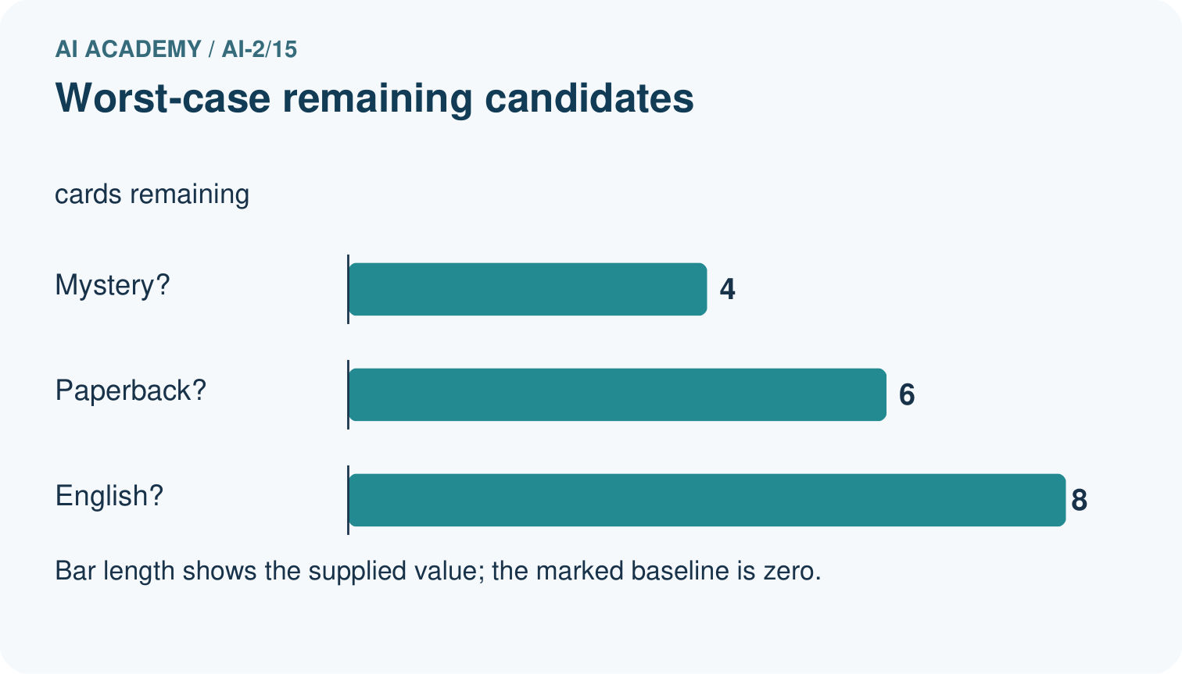
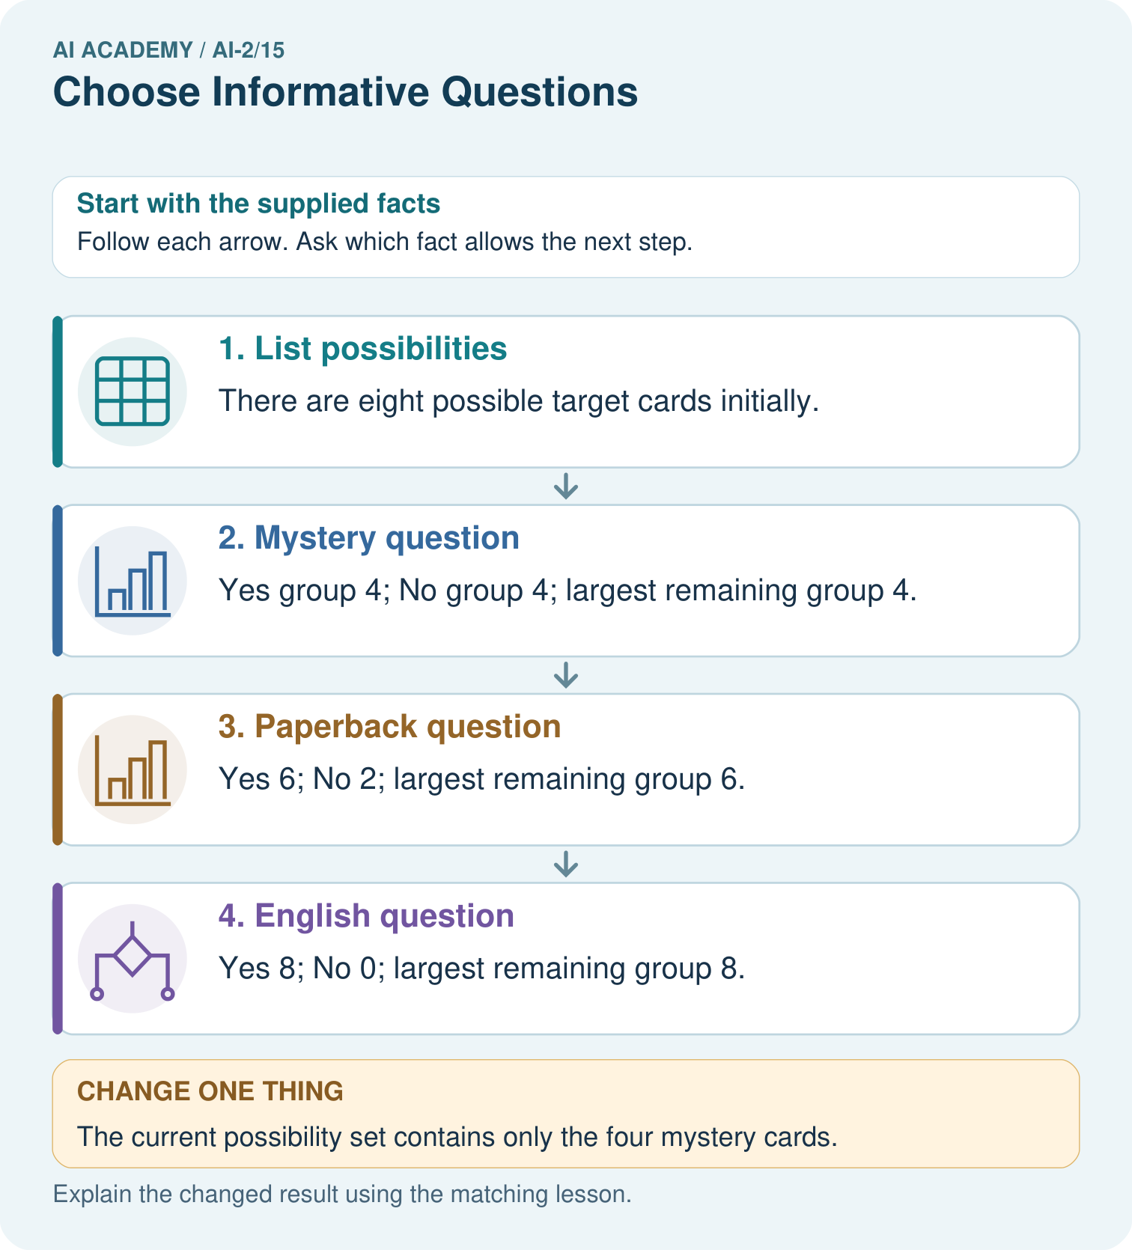

Read the picture one step at a time
Step | What happens and why
1. List possibilities | There are eight possible target cards initially.
2. Mystery question | Yes group 4; No group 4; largest remaining group 4.
3. Paperback question | Yes 6; No 2; largest remaining group 6.
4. English question | Yes 8; No 0; largest remaining group 8.
Match each pictured step to the supplied facts. This is a worked teaching case, not an independent assessment.

Why this result follows
Under the stated worst-case criterion, mystery is the most useful of these questions because it leaves at most four cards. The constant language clue never narrows the set. This is an identification-game criterion; a classifier fitting labels may instead compare prediction errors or another declared training measure.

What this example does not establish
Balanced groups do not guarantee a truthful user answer or optimal choices under every probability or cost model.

Change one thing in the pictured case
Change: The current possibility set contains only the four mystery cards.
Prediction: Asking mystery now leaves all four; it no longer narrows the set.
Reason: Question value depends on the remaining candidates, not just on its wording.

Ask while showing the picture
Cover the result. Ask learners to name the inputs and predict the next step. Uncover one step, connect the icon to the actual procedure, and explain its evidence. Then change the supplied condition and compare. The picture is a representation; it does not document execution of a real AI model.

03. Demonstrate and guide practice

Demonstrate and guide practice

Board sequence
Write the given facts: Eight blue cards contain four circles and four triangles; target is shape.
Write the question to explain: Which question is more useful: blue or circle?
Reveal after predictions: Circle separates target groups. Blue puts every card in one branch. Usefulness depends on the task and examples.
Keep for an independent attempt: Cards are two cats and two dogs, all red. Which question helps separate species: is it red or does it bark? State your assumption.

Classroom dialogue
Ask: Which facts are given, and which would we have to assume? Learners mark relevant details before discussing answers.
Say: Predict first. Show the rule, information path or calculation that would produce the result. A correct guess is not yet an explanation.
Reveal reasoning one step at a time. Explain why a tempting alternative fails. Write units and denominators for arithmetic, trace conditions for decisions, and identify supporting sources for claims.
In pairs, one learner solves while the other checks evidence; exchange roles. Remove the worked answer before independent assessment.

Model these guided questions
Guided: tree predictions blocked,clear,clear,blocked miss rows 3 and 4. Baseline blocked misses rows 2 and 4. Both get 2/4 or 50 percent. Tall cannot affect prediction because the stored root uses near only. Exit: the near=1 leaf contains three blocked training examples, but the whole tree gets 2/4 on this tiny validation set and misses one near=1 validation case. This does not establish reliability on future trips.

Case-specific teaching sequence
Stage | Teacher action
Session 1 start to 7 minutes | Retrieve training search versus validation. Introduce root, branch, leaf and depth with one question.
7 to 18 minutes | Sort the six cards by near. Count labels within each branch and assign its majority without using validation.
18 to 32 minutes | Repeat for tall and complete W1 and W2. Add branch mistakes to score the full training set.
32 to 45 minutes | Trace code and the diagram. Predict all four validation rows, complete the guided question and compare the baseline.
Session 2 start to 8 minutes | Retrieve why a leaf label is learned rather than dictated by the feature name.
8 to 20 minutes | Complete W3 and discuss depth limits, tied questions and the assumptions required by the short code.
20 to 35 minutes | Collect W4 independently before hints. Require branch counts, both candidate scores, learned leaves and validation comparison.
35 to 45 minutes | Use W5 and the exit claim. Give the fresh retry after feedback and record support.

Reduce help deliberately
Completion task: For each near branch and each tall branch, count blocked and clear labels and choose a leaf. Give the total errors for each candidate question.
Teacher check: Near=0 has 1 blocked and 2 clear, predicts clear with 1 error; near=1 has 3 blocked and 0 clear, predicts blocked with 0 errors. Tall=0 has 2 blocked and 1 clear; tall=1 also has 2 blocked and 1 clear. Both tall leaves predict blocked with 1 error each. Totals are near 1 and tall 2.
Start by identifying the given inputs together. Leave the intermediate steps blank. If needed, model one step, then withdraw that help on the next step. Move to a full trace only when the partial trace is understood. For partners, alternate explainer and checker; collect a response from every learner before discussion.

Individual reasoning check
Use the worked case for Fitting a decision tree. Proposed explanation: “A near branch must predict blocked”. Decide whether this explanation is supported. Point to the step or supplied fact that decides; explain your repair if needed.
Expected correction: The branch label is learned from its training labels; W4 deliberately reverses that relationship.
Collect explanations, not only yes/no votes. If a misunderstanding is common, re-model the relevant step for the class. If it affects a few learners, give a short targeted group explanation while others solve a more demanding variation.

Pictorial practice question
Choose the best original question and explain why its more balanced split matters here.

Reasoned teacher answer
Mystery gives 4/4 and worst case 4, better than paperback’s 6 and English’s 8 under the declared smallest-worst-case rule.
Changed-case reasoning: Asking mystery now leaves all four; it no longer narrows the set. Question value depends on the remaining candidates, not just on its wording.
Collect each learner’s explanation before discussion. Use the first missing connection between input, deciding step and result to choose support. This question is worked-case practice, not fresh mastery evidence.

04. Run the weekly evidence lab

Run the weekly evidence lab
Words You Can Use to Reason
A definition matters when you can recognize the idea, use it, and contrast it with a near-miss.
Predict → Test → Record → Explain
Keep expected and actual results separate. Surprises are useful data when recorded honestly.
For each proposed question, count yes/no groups and the largest remaining group. Choose, justify, then test on a changed card set.
What did the hardest test teach you that the normal test did not?

Make the lab runnable
Use the concrete case as the shared normal case and the independent question as a second case. Each pair creates a boundary or missing-information case and predicts its result before testing. Keep the expected result separate from an observed mistake.
Record | What to capture
Input or evidence | Exact data, instruction or claim
Expected result | Answer or safe fallback declared before the run
Observed result | Actual result, including errors
Explanation | Rule, calculation or evidence explaining the outcome
Next test | One justified change and a new prediction

Diagnose and reteach
For guessing, return to given facts and request a trace. For vocabulary without application, use one example and one non-example. For arithmetic errors, check the setup before the calculation. Finish with a different uncoached case before recording mastery.

Address these additional misconceptions
A near branch must predict blocked: The branch label is learned from its training labels; W4 deliberately reverses that relationship.
Every feature is used during prediction: Only questions in the stored tree are followed. Candidate questions rejected during fitting do not affect this tree’s output.
A deeper tree must work better: More questions can fit training detail. Future performance needs separate evaluation; depth choices must be documented.

Match the support to the first error
What the response shows | Next teaching action
Missing or misread facts | Read the case aloud, mark supplied versus unknown facts, and let the learner restate it.
Wrong procedure | Return to the deciding step in the worked case. Contrast it with the proposed incorrect explanation.
Arithmetic or implementation error | Trace intermediate values or lines; preserve the first mismatch and retry that step.
Correct result without a reason | Ask for a trace and a changed case before marking independent understanding.
An unsupported wider claim | Ask which supplied evidence supports the claim and which further observation would be needed.
Offer an oral explanation, drawing, enlarged visual or fewer examples when that removes a reading/writing barrier. Keep the same reasoning goal. Stretch secure learners by changing a boundary or assumption and asking them to defend the effect, not simply by assigning more of the same questions.

05. Assess and explain the answers

Assess and explain the answers

Worked case answer
Circle separates target groups. Blue puts every card in one branch. Usefulness depends on the task and examples.

Independent question
Cards are two cats and two dogs, all red. Which question helps separate species: is it red or does it bark? State your assumption.

Expected independent answer
Is it red separates nothing here. Does it bark could separate the example categories if the supplied facts consistently distinguish them; real behaviour is not a perfect species rule.

What counts as evidence
Criterion | 0 points | 1 point | 2 points
Result | Incorrect or absent | Partly correct | Correct with necessary conditions
Reasoning | No supporting trace | Some steps | Clear mechanism, calculation or source support
Limit | Overclaims certainty | Vague limitation | Relevant uncertainty or missing fact
Transfer | Copies without adapting | Adapts with prompts | Solves a changed case independently
Use 6/8 as a classroom checkpoint, with 2 required for both Result and Reasoning. This is a proposed teaching rule, not a validated certification threshold. Do not count a coached answer as independent mastery; correct unsafe or unsupported claims regardless of total.

Feedback
Ask the learner to find the evidence that challenges this claim: “Any question creates useful separation.” Keep the first attempt and an uncoached retry separate.

Original transfer answer
Blue sends all six to one branch and separates nothing. Animal subject separates the supplied labels into two groups of three. Its usefulness depends on accurate subject tags and the intended target; new data can expose missing or misleading tags.

Explanations for the additional workbook examples

W1 Name the parts and decisions
Identify the root, its two branches, leaf predictions and depth of the worked fitted tree. Which parts were selected using training labels?
The root asks near, with branches 0 and 1. Leaves predict clear for 0 and blocked for 1. Depth is one. Training labels determined both leaf majorities and the error comparison that selected near rather than tall.

W2 Verify the candidate scores
For each near branch and each tall branch, count blocked and clear labels and choose a leaf. Give the total errors for each candidate question.
Near=0 has 1 blocked and 2 clear, predicts clear with 1 error; near=1 has 3 blocked and 0 clear, predicts blocked with 0 errors. Tall=0 has 2 blocked and 1 clear; tall=1 also has 2 blocked and 1 clear. Both tall leaves predict blocked with 1 error each. Totals are near 1 and tall 2.

W3 Separate fitting from prediction
A learner sees a blocked validation case with near=0 and changes that leaf to blocked before reporting the score. Explain what changed and how to report the original fitted tree fairly.
The leaf was changed using validation evidence, so it is no longer the original training-fitted tree. Score the original stored leaves on all the same validation rows and record any later development change separately. Preserve a separate final test for final evaluation.

W4 Fit a new tree independently
New training rows (near,tall,label) are (1,0,clear),(1,1,clear),(1,0,clear),(0,1,blocked),(0,0,blocked),(0,1,clear). Use the same candidate order and tie policies. Give both candidates’ leaves and errors, then select the tree. Validation rows are (1,1,clear),(0,0,blocked),(0,1,clear),(1,0,blocked). List tree predictions and compare accuracy with the training-majority baseline.
Near=0 predicts blocked from 2 blocked and 1 clear; near=1 predicts clear from 3 clear. Near has 1 error. Both tall groups have 2 clear and 1 blocked, so both leaves predict clear and total errors are 2. Choose near with reversed leaf labels compared with the worked example. Validation predictions clear,blocked,blocked,clear match rows 1,2: 2/4. Baseline clear matches rows 1,3: 2/4. Both are 50 percent but errors differ.

W5 Audit a tie and a claim
If near and tall make the same training error count, which question does this code retain and why? Does retaining that question prove it will be better on future trips?
It retains near because near is tried first and strict < replaces only for fewer errors. This is a declared tie convention, not evidence of better future performance. Separate evaluation and relevant examples are still needed.

Assess independent transfer
Selected case: Ten cards have six pet subjects and four space subjects; all are green. Compare asking “green?” with asking “pet?” to identify a card. Give the largest remaining group and one limitation.

Selected case answer
Green splits 10/0, leaving as many as 10. Pet splits 6/4, leaving as many as 6, so it is more informative under these supplied counts. Incorrect subject tags can invalidate the split; one question does not uniquely identify every card.
Dimension | Evidence required
Explanation | Names the applicable idea or procedure and ties it to the supplied facts.
Trace and result | Preserves the given inputs and shows the relevant intermediate steps; distinguishes a prediction from an observed execution.
Limits | States the assumptions, missing evidence or conditions under which the result would change.
Record each dimension as not yet, with support, or independent. Accept a valid alternative procedure with a defensible trace. Do not penalise an honestly recorded model failure if the learner correctly explains its evidence and limits.

Feedback that the learner uses
Name the earliest unsupported step and give one action to repair it. Have the learner make that repair now and explain why. Then assess the relevant skill on a fresh, fully specified case. Confirm it was not previously practised with feedback; solve and check the new case before assigning it. A follow-up design prompt is a starting brief, not automatically an equivalent test.

06. Connect and extend learning

Connect and extend learning

Transparent Book Recommender
Ask first about preferences that remove the largest number of unsuitable books.
Keep the decision, input, result, explanation and remaining limitation in the project evidence record. Retrieve this record next week rather than restarting the project.

Support and stretch
Trace one record or condition at a time with counters and labelled columns. Stretch: introduce a tie, boundary or missing field and declare its handling policy before rerunning.

Exit reflection
Ask for one decision the learner can now justify and one situation requiring more evidence or human review. Confidence ratings are separate from correct independent performance.

Bridge to the next week
Next: Week 16: Overfitting Intuition. Retrieve today’s evidence and identify what carries forward and what is new.

Support and fresh reassessment
Use physical sorting before code. Explain row[feature] as selecting a flag and row[2] as reading its label. Supply empty branch-count tables. Extension: explain why an empty branch needs a fallback, and why this code would silently return clear if given an empty label list.
Require W4 near error 1, tall error 2, near=0 blocked and near=1 clear, with both validation scores 2/4. Fresh retry: training (0,0,clear),(0,1,blocked),(1,0,clear),(1,1,blocked). Near branches each tie and predict clear, giving 2 errors. Tall=0 predicts clear and tall=1 blocked with 0 errors; choose tall. Validation (0,1,blocked),(1,0,clear),(1,1,clear) gives blocked,clear,blocked: 2/3. The tied training baseline predicts clear and also gets 2/3, with different missed rows. Require the learned feature and both tie policies.
Week 10 introduces nearest neighbours and distances. Carry forward the training/validation split and baseline. Teacher reference: https://scikit-learn.org/stable/modules/generated/sklearn.tree.DecisionTreeClassifier.html (reviewed 2026-09-27); its library criteria differ from our stated classroom mistake-count procedure.

Plan the delayed return
Suggested return points in this level: ai-2/16, ai-2/18, ai-2/21. Use actual classroom dates, adjusting for holidays and gaps. One, three and six teaching weeks are scheduling choices, not a claimed optimal spacing.
At a delayed check, ask for the idea from memory and a changed application. Compare with the earlier independent response and record support used. For a new level, revisit the previous capstone before checking the new prerequisites.
Record | Teacher evidence
Learner code and date
Concept and case used; prior exposure
Explanation / trace / limits
Support and first repair
Changed case and delayed outcome
Next teaching action
Use the evidence to choose reteaching or the next step. A completed page, confidence rating or attractive project does not by itself demonstrate understanding.

Project evidence from this case
Choose recommender questions that distinguish feasible options, documenting the decision criterion rather than asking unnecessary personal details.

07. Prepare, teach and assess
Teaching target: Fit a root question and leaf predictions from training examples
Prepare the labelled worked-case picture, the matching workbook, fictional input cards and a place for individual responses. No paid AI account is required for the paper reasoning activities.
Session | Plan | Resources
Session 1 · Understand · 45 min | 0–7: recall and prerequisite; 7–15: inspect the concrete case and predict; 15–30: teacher models the worked trace; 30–40: learners explain a step using the text and visual; 40–45: check the core idea. | Sections 1–6; record the brief recall in the workbook.
Session 2 · Practise · 45 min | 0–5: retrieve the procedure; 5–15: W2 completion practice; 15–23: explain and check with a partner; 23–30: each learner answers the misconception check; 30–40: targeted reteaching or a harder variation; 40–45: prepare the investigation. | Sections 7–10; use the matching workbook W2 and misconception check.
Session 3 · Investigate and transfer · 45 min | 0–5: retrieve the decision rule; 5–20: investigate or trace; 20–30: start the independent case; 30–38: connect the project; 38–43: act on feedback; 43–45: plan the return check. | Sections 9 and 11–14. Give extra time to finish the full task set; use Section 15 when the week includes a coding lab.
Before class, solve the supported practice: For each near branch and each tall branch, count blocked and clear labels and choose a leaf. Give the total errors for each candidate question.
Reasoned practice answer: Near=0 has 1 blocked and 2 clear, predicts clear with 1 error; near=1 has 3 blocked and 0 clear, predicts blocked with 0 errors. Tall=0 has 2 blocked and 1 clear; tall=1 also has 2 blocked and 1 clear. Both tall leaves predict blocked with 1 error each. Totals are near 1 and tall 2.
Check every learner before discussion: Use the worked case for Fitting a decision tree. Proposed explanation: “A near branch must predict blocked”. Decide whether this explanation is supported. Point to the step or supplied fact that decides; explain your repair if needed.
Misconception repair: The branch label is learned from its training labels; W4 deliberately reverses that relationship.
Support: read the exact case aloud, enlarge the labelled picture, supply input cards and model only the first deciding step. Accept a spoken explanation or drawing; retain the reasoning goal.
Extension: The current possibility set contains only the four mystery cards. Require a prediction and a reason before comparing. Expected result: Asking mystery now leaves all four; it no longer narrows the set. Reason: Question value depends on the remaining candidates, not just on its wording.
Independent assessment: withhold the reserved answer until the learner has attempted the new case. Record support separately from correctness.
Criterion | Not yet | With support | Independent
Explanation | Names an answer without a deciding fact | Uses a hint to link fact and decision | Explains the deciding fact in own words
Trace or test | Cannot connect input and result | Completes steps with prompts | Traces or tests a changed case accurately
Limits and revision | Claims more than evidence supports | Names a limit after a prompt | States a defensible limit and useful next test
Project checkpoint: Test changed cases. Keep normal, boundary and failure cases; compare expected and observed results.
Use the weekly teacher answer for topic-specific reasoning. A saved progress tick is an activity record; judge mastery from the learner’s explanation and evidence.

