AI ACADEMY · TEACHER · ai-2/17

Noise and Outliers
Project: Transparent Book Recommender

01. Noise and Outliers

Teach the learning cycle
Primary target: Calculate mean and median
Session | Sequence and minutes | Resources
Session 1 · Understand · 45 min | 0–7: recall and prerequisite; 7–15: inspect the concrete case and predict; 15–30: teacher models the worked trace; 30–40: learners explain a step using the text and visual; 40–45: check the core idea. | Sections 1–6; record the brief recall in the workbook.
Session 2 · Practise · 45 min | 0–5: retrieve the procedure; 5–15: W2 completion practice; 15–23: explain and check with a partner; 23–30: each learner answers the misconception check; 30–40: targeted reteaching or a harder variation; 40–45: prepare the investigation. | Sections 7–10; use the matching workbook W2 and misconception check.
Session 3 · Investigate and transfer · 45 min | 0–5: retrieve the decision rule; 5–20: investigate or trace; 20–30: start the independent case; 30–38: connect the project; 38–43: act on feedback; 43–45: plan the return check. | Sections 9 and 11–14. Give extra time to finish the full task set; use Section 15 when the week includes a coding lab.
This is a starting allocation of 135 minutes, not a validated duration. Preserve all named topics. Schedule extra time for connected examples, the full investigation, independent cases and project building. Repeated copies of a case share one recorded attempt; they are not new evidence.

Retrieval answer guidance

Overfitting Intuition
Without opening the old lesson, explain one key idea from Overfitting Intuition. Give an example and a mistake that the idea helps you avoid.
Look for: Compare training and validation evidence for model capacity
Reference example, not the only acceptable wording: Teacher explanation: Choose the line with validation MAE 3. The curve training MAE 0 does not compensate for validation MAE 8.

Decision Trees
Without opening the old lesson, explain one key idea from Decision Trees. Give an example and a mistake that the idea helps you avoid.
Look for: Fit a root question and leaf predictions from training examples
Reference example, not the only acceptable wording: The root asks near, with branches 0 and 1. Leaves predict clear for 0 and blocked for 1. Depth is one. Training labels determined both leaf majorities and the error comparison that selected near rather than tall.

Training and Testing
Without opening the old lesson, explain one key idea from Training and Testing. Give an example and a mistake that the idea helps you avoid.
Look for: Choose a split unit that matches the intended prediction claim
Reference example, not the only acceptable wording: Training fits the model; validation compares development choices; test evaluates after choices are fixed. Repeatedly selecting by the test score uses that set for development, so it is no longer an untouched final evaluation.
Use the student module and workbook section with this exact week title. The worked case, independent question and answers below form one aligned lesson sequence.

What the learner must demonstrate
Page counts are 72,80,96,960. The last book may be an anthology. Should a cleaning script delete it automatically? Give a defensible investigation and document the outcome.

Concept to explain
Mistakes and unusual values should be investigated, not automatically erased.
Term | Meaning
noise | Variation or interference that obscures the information relevant to a task.
outlier | An observation far from a typical pattern under a stated comparison; it is not automatically an error.
duplicate | A repeated record or copy; copies are not independent new observations.
investigate | Collect and examine evidence to answer a question rather than assuming a cause.

Prepare the class
Use the supplied scenario, student illustrations and blank paper. For numeric work, offer counters or a calculator after learners show the setup. Fictional records are supplied; personal data and paid accounts are unnecessary.
Allow 80 minutes: recall 8; explanation 12; worked demonstration 15; guided practice 20; independent assessment 15; project and reflection 10. Extend the lab into a second session when needed.

Preparation for the connected explanation
Teach Week 17 as a two-session investigation using fictional data. Five fictional activity durations are 2, 3, 3, 4 and 18 minutes. Most are near 3, but one is much longer. Different summaries reveal different aspects. Keep all values while investigating whether 18 is a genuine long activity or a recording error. Assess the three stated outcomes through the independent task, not by copying the worked result.

Readiness answer
9.
Python 3 editor with a fresh local practice file
Paper trace table and the student workbook
Fictional input records from this lesson; no real student identifiers

End goal for the pictorial case
By the end, I can calculate mean and median and investigate an unusual value before changing it.
This added worked case illustrates the week’s main idea. Retain all original and connected topics; schedule its practice within the teaching cycle.

02. Explain the mechanism

Explain the mechanism
Input → Process → Output
Trace the information. At each stage, ask what changed and how you could test it.
Which stage could fail even when the other two are correct? Explain:
Predict first. Then check each step. A correct answer without visible reasoning is incomplete evidence.
1. Most books: 40–300 pages; one record: 3,200 pages.
2. Check the source: extra zero, box set, or real long work?
3. Repair confirmed error; keep real rare case and document it.
4. Retest to learn whether the system handles legitimate extremes.
Recalculate, retrace, or restate the reasoning in your own representation:
CHECK Did the evidence answer the exact question? Did the total, path, or source record stay consistent?

Concrete teaching case
Recorded lengths are 90,95,100,105,900 pages.
Is 900 automatically wrong?

Exact explanation to model
No. It is an outlier, but may be a real large book. Check catalogue, units and entry process.

Explain the added worked example
Five fictional activity durations are 2, 3, 3, 4 and 18 minutes. Most are near 3, but one is much longer. Different summaries reveal different aspects. Keep all values while investigating whether 18 is a genuine long activity or a recording error.
The script prints 6.0 and 3. sorted returns a sorted list without changing the original. This median expression works for a nonempty odd-length list only. For four sorted values, average the second and third. Do not use this odd-length shortcut for every dataset.

Key terms
Term | Meaning
Mean | Sum of numeric values divided by their count
Median | The middle of sorted values or mean of the two middle values
Unusual value | A value far from most others in a dataset
Variation | Differences among recorded values

Model the reasoning aloud
Use the complete worked example below before asking learners to complete W2. Reveal a small part, invite a prediction, then explain the deciding step. These teacher notes contain solutions; do not reveal the independent case answer during modelling.

Replace 18 with 8. Calculate the new mean and median.
________________________________________________________________
________________________________________________________________
________________________________________________________________
________________________________________________________________
________________________________________________________________
________________________________________________________________
Thinking move | Teacher prompt
Plan | What is given? What is the question? Which procedure fits these facts?
Do | Point to each input and intermediate step in the worked trace. Name the rule that allows the next step.
Check | Does the output answer the question? Which assumption or limitation prevents a larger claim?
Use the diagram and verbal explanation together. Ask learners to match a sentence to a specific visual step; do not assign learners fixed visual or auditory learning styles.

A pictorial worked case: Noise and Outliers
A fictional library records five book-processing times in minutes.

The facts we will use
Sorted times: 2,3,3,4,18.
All are recorded measurements; no evidence yet shows 18 is a mistake.
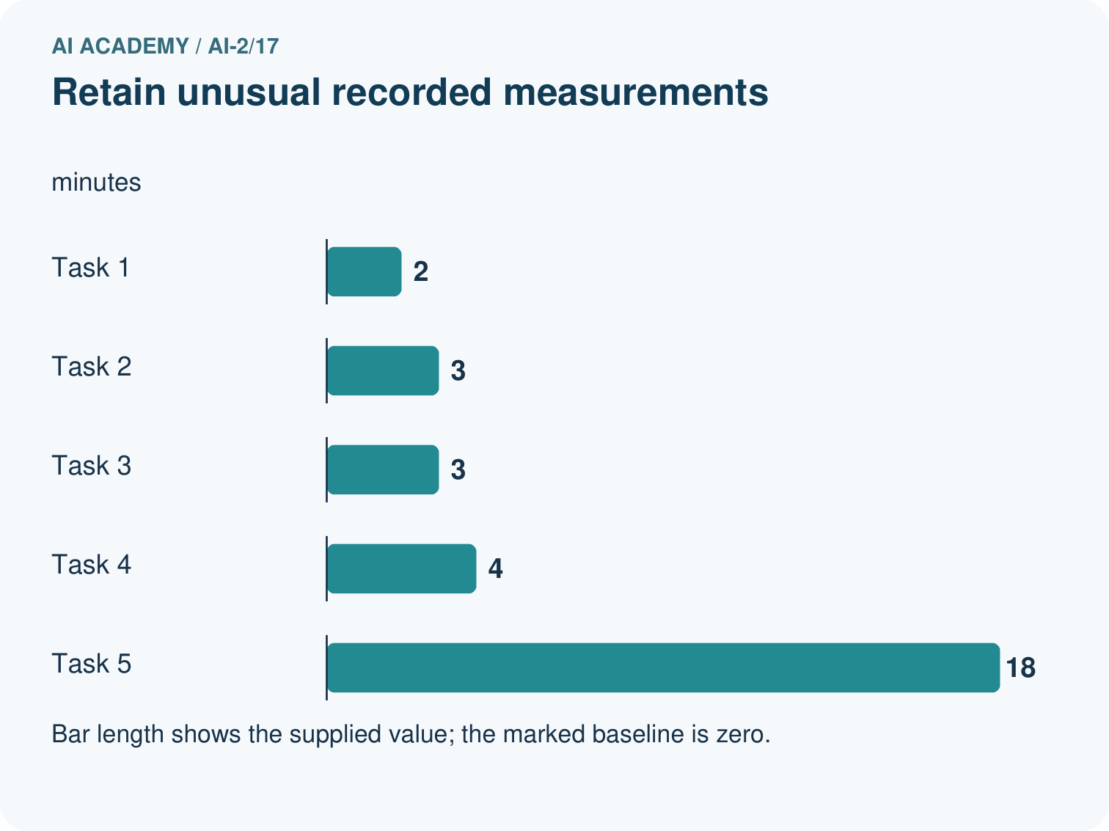
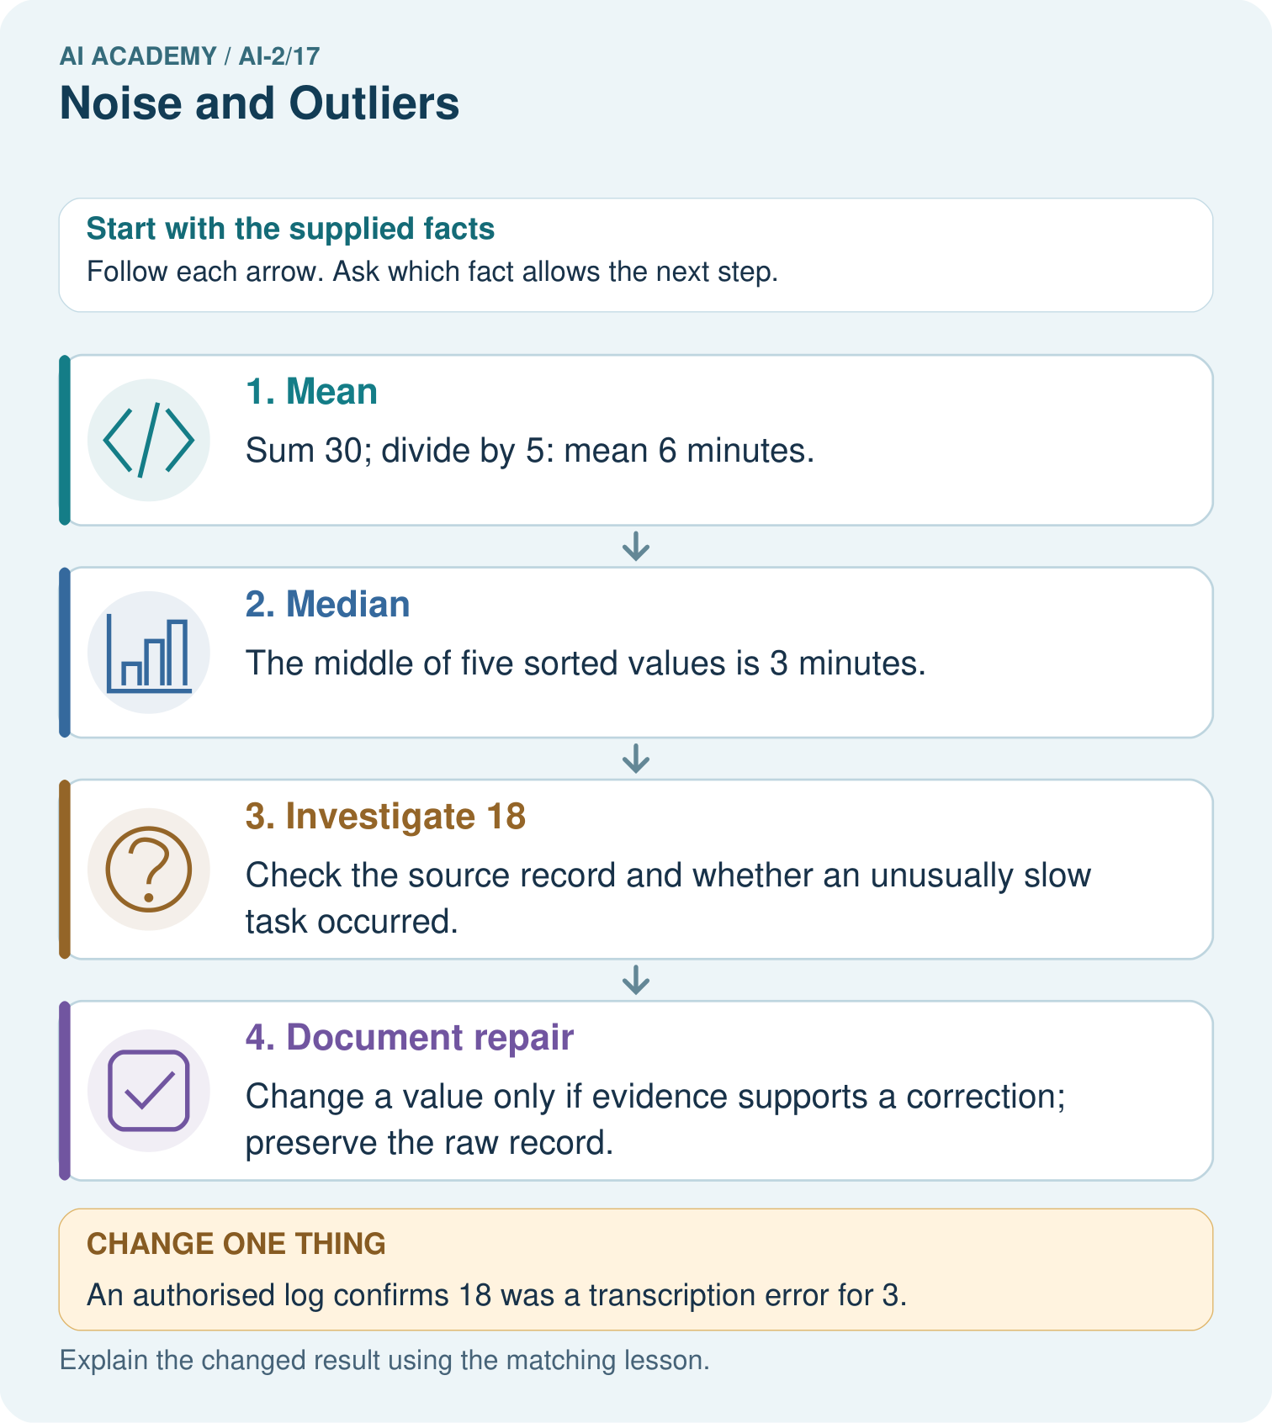

Read the picture one step at a time
Step | What happens and why
1. Mean | Sum 30; divide by 5: mean 6 minutes.
2. Median | The middle of five sorted values is 3 minutes.
3. Investigate 18 | Check the source record and whether an unusually slow task occurred.
4. Document repair | Change a value only if evidence supports a correction; preserve the raw record.
Match each pictured step to the supplied facts. This is a worked teaching case, not an independent assessment.

Why this result follows
The mean uses every value and is pulled upward by 18. The median identifies the middle recorded time and stays at 3. Neither statistic declares the unusual observation invalid. Deleting it simply because it changes the mean would hide potentially real slow work and change the question being answered.

What this example does not establish
Five task times do not estimate all library processing times reliably or prove which summary suits every decision.

Change one thing in the pictured case
Change: An authorised log confirms 18 was a transcription error for 3.
Prediction: Corrected mean is 3 minutes and median is 3.
Reason: Values become 2,3,3,4,3 with sum 15; sorted middle remains 3.

Ask while showing the picture
Cover the result. Ask learners to name the inputs and predict the next step. Uncover one step, connect the icon to the actual procedure, and explain its evidence. Then change the supplied condition and compare. The picture is a representation; it does not document execution of a real AI model.

03. Demonstrate and guide practice

Demonstrate and guide practice

Board sequence
Write the given facts: Recorded lengths are 90,95,100,105,900 pages.
Write the question to explain: Is 900 automatically wrong?
Reveal after predictions: No. It is an outlier, but may be a real large book. Check catalogue, units and entry process.
Keep for an independent attempt: Page counts are 40, 42, 43 and 900. Should 900 be deleted immediately? Give two explanations to investigate.

Classroom dialogue
Ask: Which facts are given, and which would we have to assume? Learners mark relevant details before discussing answers.
Say: Predict first. Show the rule, information path or calculation that would produce the result. A correct guess is not yet an explanation.
Reveal reasoning one step at a time. Explain why a tempting alternative fails. Write units and denominators for arithmetic, trace conditions for decisions, and identify supporting sources for claims.
In pairs, one learner solves while the other checks evidence; exchange roles. Remove the worked answer before independent assessment.

Model these guided questions
Sum 20; mean 4; median remains 3. Exit: No. Zero would be a measured summary; no numeric observations are available.

Case-specific teaching sequence
Stage | Teacher action
Session 1 start to 7 minutes | Retrieve the prerequisite and explain the purpose in the opening section.
7 to 20 minutes | Read the worked example and diagram; ask learners to trace each step aloud.
20 to 33 minutes | Complete W1 and W2, then compare predictions with observed results.
33 to 45 minutes | Collect the guided prediction before running; discuss a mismatch and its cause.
Session 2 start to 8 minutes | Retrieve the main rule without showing the previous answer.
8 to 20 minutes | Use W3 to diagnose and repair the stated failure; rerun an earlier case.
20 to 35 minutes | Collect W4 independently, including code or plan, predictions and explanations, before hints.
35 to 45 minutes | Discuss W5 and the exit; use the fresh retry when support was needed.

Reduce help deliberately
Completion task: Find medians of [9, 1, 3] and [8, 2, 4, 6].
Teacher check: Sorted first list 1, 3, 9 has median 3. Sorted second 2, 4, 6, 8 has median (4 + 6)/2 = 5.
Start by identifying the given inputs together. Leave the intermediate steps blank. If needed, model one step, then withdraw that help on the next step. Move to a full trace only when the partial trace is understood. For partners, alternate explainer and checker; collect a response from every learner before discussion.

Individual reasoning check
Use the worked case for Mean median and unusual values. Proposed explanation: “A successful run proves the conclusion”. Decide whether this explanation is supported. Point to the step or supplied fact that decides; explain your repair if needed.
Expected correction: Removing 18 merely because it raises the mean would hide evidence. Check collection notes, keep an audit trail and compare summaries with and without it only with a clear explanation.
Collect explanations, not only yes/no votes. If a misunderstanding is common, re-model the relevant step for the class. If it affects a few learners, give a short targeted group explanation while others solve a more demanding variation.

Pictorial practice question
If 18 was genuine, which summary better describes the middle observed task, and what extra fact should be shown?

Reasoned teacher answer
Median 3 describes the middle; also report the unusual 18-minute task and the mean 6 rather than concealing spread.
Changed-case reasoning: Corrected mean is 3 minutes and median is 3. Values become 2,3,3,4,3 with sum 15; sorted middle remains 3.
Collect each learner’s explanation before discussion. Use the first missing connection between input, deciding step and result to choose support. This question is worked-case practice, not fresh mastery evidence.

04. Run the weekly evidence lab

Run the weekly evidence lab
Words You Can Use to Reason
A definition matters when you can recognize the idea, use it, and contrast it with a near-miss.
Predict → Test → Record → Explain
Keep expected and actual results separate. Surprises are useful data when recorded honestly.
Audit four suspicious records using keep / correct / remove / ask labels. Require a reason and a source check for every action.
What did the hardest test teach you that the normal test did not?

Make the lab runnable
Use the concrete case as the shared normal case and the independent question as a second case. Each pair creates a boundary or missing-information case and predicts its result before testing. Keep the expected result separate from an observed mistake.
Record | What to capture
Input or evidence | Exact data, instruction or claim
Expected result | Answer or safe fallback declared before the run
Observed result | Actual result, including errors
Explanation | Rule, calculation or evidence explaining the outcome
Next test | One justified change and a new prediction

Diagnose and reteach
For guessing, return to given facts and request a trace. For vocabulary without application, use one example and one non-example. For arithmetic errors, check the setup before the calculation. Finish with a different uncoached case before recording mastery.

Address these additional misconceptions
A successful run proves the conclusion: Removing 18 merely because it raises the mean would hide evidence. Check collection notes, keep an audit trail and compare summaries with and without it only with a clear explanation.
Matching the example is enough: Require the new W4 case, explicit predictions and an explanation. Fresh retry: 2, 4, 4, 5, 15 has sum 30, mean 6 and median 4. Replacing 15 with 5 gives sum 20, mean 4 and median 4.
A convenient shortcut preserves meaning: Taking the middle item of an unsorted list can give the wrong median. For [18, 2, 4, 3, 3], the middle item is 4, but the sorted median is 3. Sort first. For an empty list, there is no mean or median under this lesson's rules.

Match the support to the first error
What the response shows | Next teaching action
Missing or misread facts | Read the case aloud, mark supplied versus unknown facts, and let the learner restate it.
Wrong procedure | Return to the deciding step in the worked case. Contrast it with the proposed incorrect explanation.
Arithmetic or implementation error | Trace intermediate values or lines; preserve the first mismatch and retry that step.
Correct result without a reason | Ask for a trace and a changed case before marking independent understanding.
An unsupported wider claim | Ask which supplied evidence supports the claim and which further observation would be needed.
Offer an oral explanation, drawing, enlarged visual or fewer examples when that removes a reading/writing barrier. Keep the same reasoning goal. Stretch secure learners by changing a boundary or assumption and asking them to defend the effect, not simply by assigning more of the same questions.

05. Assess and explain the answers

Assess and explain the answers

Worked case answer
No. It is an outlier, but may be a real large book. Check catalogue, units and entry process.

Independent question
Page counts are 40, 42, 43 and 900. Should 900 be deleted immediately? Give two explanations to investigate.

Expected independent answer
900 may be a genuine long book or a recording error. Check the original record and task scope before changing it; unusual does not automatically mean wrong.

What counts as evidence
Criterion | 0 points | 1 point | 2 points
Result | Incorrect or absent | Partly correct | Correct with necessary conditions
Reasoning | No supporting trace | Some steps | Clear mechanism, calculation or source support
Limit | Overclaims certainty | Vague limitation | Relevant uncertainty or missing fact
Transfer | Copies without adapting | Adapts with prompts | Solves a changed case independently
Use 6/8 as a classroom checkpoint, with 2 required for both Result and Reasoning. This is a proposed teaching rule, not a validated certification threshold. Do not count a coached answer as independent mastery; correct unsafe or unsupported claims regardless of total.

Feedback
Ask the learner to find the evidence that challenges this claim: “Every outlier is an error.” Keep the first attempt and an uncoached retry separate.

Original transfer answer
Check edition, catalogue and source entry. Retain 960 if verified; correct only if evidence establishes an error, recording original value, new value and reason. Automatic deletion can remove a legitimate category and distort the intended collection.

Explanations for the additional workbook examples

W1 Compute a mean
Find the mean of 4, 4, 6, 6 and 10.
Sum 30 divided by 5 gives 6.
Add all five observations: 4 + 4 + 6 + 6 + 10 = 30. Divide by the number of observations, five, to obtain a mean of 6. Keep the count beside the calculation. Do not divide by the three distinct values; repeated observations still count.

W2 Compute two medians
Find medians of [9, 1, 3] and [8, 2, 4, 6].
Sorted first list 1, 3, 9 has median 3. Sorted second 2, 4, 6, 8 has median (4 + 6)/2 = 5.

W3 Repair an explanation
A learner deletes 18 because it is above the mean. What evidence is needed before correcting or excluding it?
Check original measurement and collection rules. Being above the mean alone is not an error. Retain the raw record and document any justified correction.

W4 Compare summaries independently
For 1, 2, 2, 3 and 12, calculate mean and median. Then replace 12 with 2 and recalculate. Explain the change.
Original sum 20, mean 4, median 2. Revised sum 10, mean 2, median 2. The large value changes mean more than median in this example.

W5 Report missing evidence
A dataset is empty. Is reporting a mean of 0 justified?
No. Zero would be a measured summary; no numeric observations are available.

Assess independent transfer
Selected case: For 1, 2, 2, 3 and 12, calculate mean and median. Then replace 12 with 2 and recalculate. Explain the change.

Selected case answer
Original sum 20, mean 4, median 2. Revised sum 10, mean 2, median 2. The large value changes mean more than median in this example.
Dimension | Evidence required
Explanation | Names the applicable idea or procedure and ties it to the supplied facts.
Trace and result | Preserves the given inputs and shows the relevant intermediate steps; distinguishes a prediction from an observed execution.
Limits | States the assumptions, missing evidence or conditions under which the result would change.
Record each dimension as not yet, with support, or independent. Accept a valid alternative procedure with a defensible trace. Do not penalise an honestly recorded model failure if the learner correctly explains its evidence and limits.

Feedback that the learner uses
Name the earliest unsupported step and give one action to repair it. Have the learner make that repair now and explain why. Then assess the relevant skill on a fresh, fully specified case. Confirm it was not previously practised with feedback; solve and check the new case before assigning it. A follow-up design prompt is a starting brief, not automatically an equivalent test.

06. Connect and extend learning

Connect and extend learning

Transparent Book Recommender
Keep legitimate unusual books so the recommender can serve unusual readers.
Keep the decision, input, result, explanation and remaining limitation in the project evidence record. Retrieve this record next week rather than restarting the project.

Support and stretch
Trace one record or condition at a time with counters and labelled columns. Stretch: introduce a tie, boundary or missing field and declare its handling policy before rerunning.

Exit reflection
Ask for one decision the learner can now justify and one situation requiring more evidence or human review. Confidence ratings are separate from correct independent performance.

Bridge to the next week
Next: Week 18: Missing Data. Retrieve today’s evidence and identify what carries forward and what is new.

Support and fresh reassessment
Order number cards physically. Extension: write a median function with explicit empty, odd and even cases and test each.
Independent W4 evidence: Original sum 20, mean 4, median 2. Revised sum 10, mean 2, median 2. The large value changes mean more than median in this example. Record whether the learner needed no help, a hint or explanation. Fresh retry: 2, 4, 4, 5, 15 has sum 30, mean 6 and median 4. Replacing 15 with 5 gives sum 20, mean 4 and median 4.
Next week: Graphs and honest scales. Reuse this week's explicit contracts and evidence.

Plan the delayed return
Suggested return points in this level: ai-2/18, ai-2/20, ai-2/23. Use actual classroom dates, adjusting for holidays and gaps. One, three and six teaching weeks are scheduling choices, not a claimed optimal spacing.
At a delayed check, ask for the idea from memory and a changed application. Compare with the earlier independent response and record support used. For a new level, revisit the previous capstone before checking the new prerequisites.
Record | Teacher evidence
Learner code and date
Concept and case used; prior exposure
Explanation / trace / limits
Support and first repair
Changed case and delayed outcome
Next teaching action
Use the evidence to choose reteaching or the next step. A completed page, confidence rating or attractive project does not by itself demonstrate understanding.

Project evidence from this case
Investigate unusual recommender features and show evidence-backed repairs instead of removing inconvenient records.

07. Prepare, teach and assess
Teaching target: Calculate mean and median
Prepare the labelled worked-case picture, the matching workbook, fictional input cards and a place for individual responses. No paid AI account is required for the paper reasoning activities.
Session | Plan | Resources
Session 1 · Understand · 45 min | 0–7: recall and prerequisite; 7–15: inspect the concrete case and predict; 15–30: teacher models the worked trace; 30–40: learners explain a step using the text and visual; 40–45: check the core idea. | Sections 1–6; record the brief recall in the workbook.
Session 2 · Practise · 45 min | 0–5: retrieve the procedure; 5–15: W2 completion practice; 15–23: explain and check with a partner; 23–30: each learner answers the misconception check; 30–40: targeted reteaching or a harder variation; 40–45: prepare the investigation. | Sections 7–10; use the matching workbook W2 and misconception check.
Session 3 · Investigate and transfer · 45 min | 0–5: retrieve the decision rule; 5–20: investigate or trace; 20–30: start the independent case; 30–38: connect the project; 38–43: act on feedback; 43–45: plan the return check. | Sections 9 and 11–14. Give extra time to finish the full task set; use Section 15 when the week includes a coding lab.
Before class, solve the supported practice: Find medians of [9, 1, 3] and [8, 2, 4, 6].
Reasoned practice answer: Sorted first list 1, 3, 9 has median 3. Sorted second 2, 4, 6, 8 has median (4 + 6)/2 = 5.
Check every learner before discussion: Use the worked case for Mean median and unusual values. Proposed explanation: “A successful run proves the conclusion”. Decide whether this explanation is supported. Point to the step or supplied fact that decides; explain your repair if needed.
Misconception repair: Removing 18 merely because it raises the mean would hide evidence. Check collection notes, keep an audit trail and compare summaries with and without it only with a clear explanation.
Support: read the exact case aloud, enlarge the labelled picture, supply input cards and model only the first deciding step. Accept a spoken explanation or drawing; retain the reasoning goal.
Extension: An authorised log confirms 18 was a transcription error for 3. Require a prediction and a reason before comparing. Expected result: Corrected mean is 3 minutes and median is 3. Reason: Values become 2,3,3,4,3 with sum 15; sorted middle remains 3.
Independent assessment: withhold the reserved answer until the learner has attempted the new case. Record support separately from correctness.
Criterion | Not yet | With support | Independent
Explanation | Names an answer without a deciding fact | Uses a hint to link fact and decision | Explains the deciding fact in own words
Trace or test | Cannot connect input and result | Completes steps with prompts | Traces or tests a changed case accurately
Limits and revision | Claims more than evidence supports | Names a limit after a prompt | States a defensible limit and useful next test
Project checkpoint: Test changed cases. Keep normal, boundary and failure cases; compare expected and observed results.
Use the weekly teacher answer for topic-specific reasoning. A saved progress tick is an activity record; judge mastery from the learner’s explanation and evidence.

